

MX-19.4 respin

Raspberry Pi “Ragout2”

User name: pi
Password : pi

1. First steps
2. General Introduction
3. Touchscreen
4. Default Fluxbox and Openbox
5. Traditional Fluxbox
6. Links

This Help document supplements the MX Users Manual (Shift+F1), which covers general MX Linux topics such as basic use, software management, etc.

1. First steps

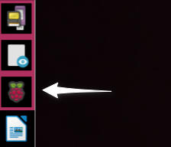
Raspberry Pi configuration
On the Dock, click the Raspberry icon to open the configuration window:

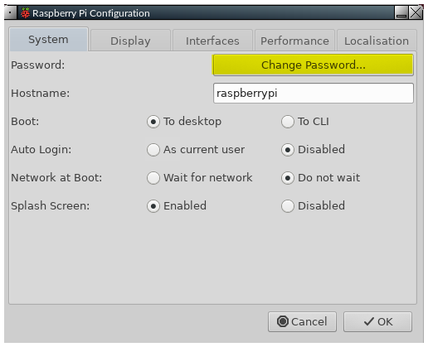
On the first tab, you can change from the default password. It is common sense to do this. You need to enter the new password twice, to check it has been entered correctly. Please make sure you remember it!

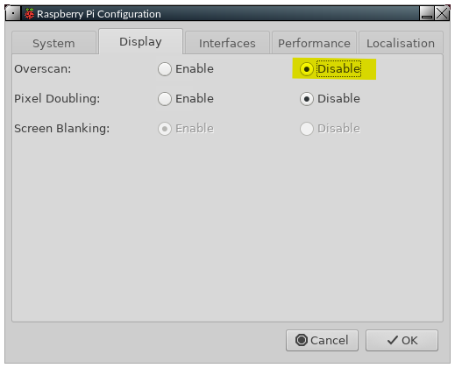
The Raspberry Pi was designed with the ability to work with a TV as the display. When used with a monitor, you may see a black border around the outside of the window. In this case, you need to enable Underscan. Select the Display tab, and click the Disable bullet button:

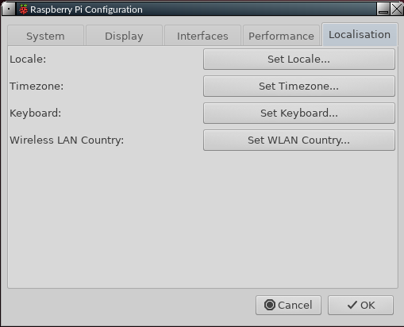
Finally, you need to set up various things to suit the country you are in, the timezone, and the keyboard layout you are using. Select the Localisation tab, then set and save each item as needed. To see uncommon letters rendered correctly, you may need to select UTF-8 as the character set

When you have made all the necessary changes, click OK. You will be prompted to allow a reboot, which you should do. When you next get back to the login page, remember to use your new password!

You can now begin to enjoy the slick, fast new operating system you have.

Sound

Sometimes, sound will not be heard at first from your TV or monitor. There are a number of things to try to correct this.
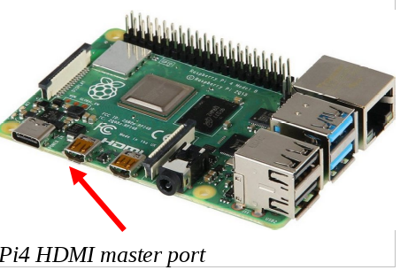
1) Firstly, both the Pi 4 and Pi 400 have two micro-HDMI output ports. The port on the Pi 4 that is nearest the power input connector is the master. The port on the Pi 400 that is farthest from the power input connector is the master. In both cases, the master connector is the left port of the two.
When using a single display, you should always use the master. To correct a wrong port, shut your Pi down, power it off, swap the HDMI cable to the master port, reboot, and see if sound now works.
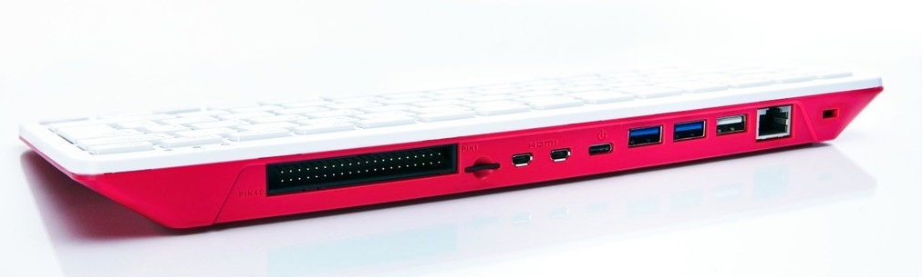Pi400 HDMI master port

2) If unsuccessful, the next thing to try is the Raspberry Pi's advanced configuration settings. The settings tool cannot be used with a mouse, so you need to use the arrow and tab keys to move around.

To access this, open Settings Manager and click the icon (or enter in a terminal: sudo raspi-config)

- Option 1, System Options, will be highlighted. Press Enter once.

- You will see that option S2 is for Audio configuration, so press the down arrow once, then press Enter.

- The highlighted entry will be 0 HDMI 1, and that is what is needed. Press the Tab key once, so OK is highlighted, then press Enter.

- You will be returned to the first screen. Press the Tab key twice, so that Finish is selected, then press Enter.

- You should now find that sound works OK. There is no need to reboot.

If this does not fix things, there is a lot of helpful information here:

https://www.raspberrypi.org/documentation/configuration/config-txt/video.md

Bluetooth
Bluetooth (=BT) devices generally work. For the Pi 4 and Pi 400, the good news is that the Debian app Blueman works. It has been set up so that its functions can be accessed by clicking the familiar BT icon in the system tray.
- Mouse. A BT mouse normally works without need for the user’s involvement.
- Keyboard. Log in the first time with a wired keyboard or use the on-screen keyboard “onboard” (click on the little human figure at the right end of the top bar). Make sure that the keyboard is turned on. Click the BT icon > Devices, and then click the “Scan” on the screen that pops up. When the keyboard appears on the list, right-click it > Setup.
- Do not Pair yet! Instead, select “Proceed without Pairing” so that the keyboard will work. Then use Setup again > Pair, and enter the code that is displayed in the message box. If the code entry does not work, use the MX menu to launch the on-screen keyboard for input.
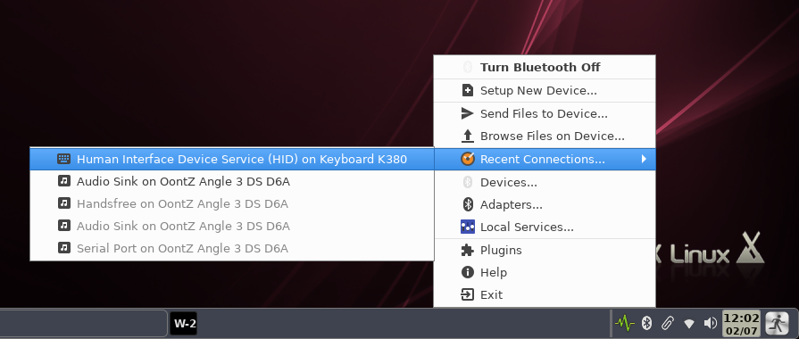
The keyboard will normally reconnect when logging out and back in, but may not reconnect with a reboot. You can again click on the little human figure at the right end of the top bar of the login screen to see the on-screen keyboard. Once logged in, enable the keyboard again by clicking the BT icon > Recent Connections > Human Interface etc.

If the keyboard is not visible when attempting to pair then the device file may become corrupted. In such a case, right-click the entry in the device screen > Remove. Then log out and back in and repeat the procedure described above for a new device.
- Speakers/Headphones. The desktop has been configured so that such a device is linked to Pulse Audio for mixer, and a blockage that normally interferes has been evaded by restarting the linkage every time the user logs in using a script in ~/.fluxbox/scripts named “BTheadphones_reset." Follow the setup process, making sure that the device is connected to the Audio Sink. It will normally reconnect upon login but, if it does not, click the BT logo in the system tray > Recent Connections > Audio Sink etc.
If you want to remove the BT icon from the system tray, open the Fluxbox “startup” file by right-clicking Menu > Settings > Configure > Startup, search for “blueman-applet” and comment out the line like this:
#blueman-applet &
Do the same on the Openbox side: Menu > Settings > Autostart.

Wifi
Click the wifi icon (from Network Manager) in the system tray and select the access point you want. If you run into problems, try this:
- Launch raspi-config (icon on Settings Manager or terminal)
- Click System Options > Wireless LAN
- Enter your SSID and password
It will update the config files and you should have wireless access. Further help: Ubuntu community documentation.

2. General Introduction

The MX Linux for Raspberry Pi “Ragout2” (=MXRPi2) remains for now based on the legacy Raspberry Pi (Buster) 32bit version in order to maximize stability and enable right-click function on the touchscreen. This greatly revised version offers the user for the first time a choice of Fluxbox (=FB) or Openbox (=OB) as window manager, selected on the login screen using the session manager icon in the upper right corner of the login box.
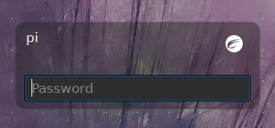Click to select FB or OB

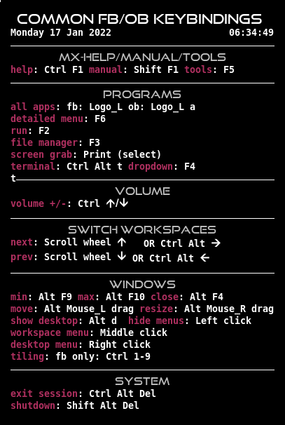
Their small memory footprint and quick loading time are very effective on low-resource systems--and very fast on higher-level machines. Measuring with the default Task manager (lxtask), typical memory load for FB or OB at rest after login is about 200, and about 350 after the default web browser has launched and settled down with no demanding plugins loaded.

Notes
- Most shortcuts (hot keys, keybindings) are identical for both window managers; to view and edit in OB, click Menu > Settings > Shortcuts; in FB, click Menu > Settings > Configure > Keys. For a convenient overview, click Menu > Appearance > Conky, and open one of the variants of FB_OB_Keys. There are two handy dashboards for easy access to common settings.
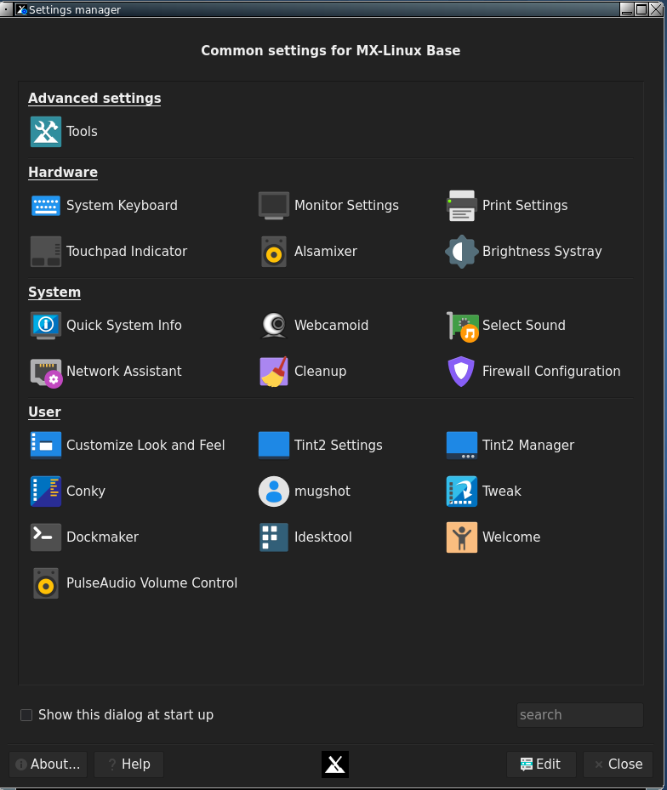
  - Settings Manager can be launched from Menu > Settings manager or Alt-F5. It unites many functions specific to MXRPi2.
  - MX Tools can be launched from the Settings Manager or F5. This collection is a well-regarded feature of MX Linux for its user-centered collection of handy aids.
- A virtual keyboard onboard is available for the login screen by clicking on Accessibility (human image) on the top panel or pressing F3. Once logged in, use the Menu or the touchscreen dock (see below) to launch a different keyboard kvxkb.
- Notification is enabled by Dunst, whose highly detailed user config is found in ~/.config/dunst/dunstrc/dunstrc.
- Help:
  - This MXRPi2-Manual can be opened with F1, Menu > Help or by clicking the dock icon with the red question mark. It exists in a number of translations created by DeepL.com.
  - Videos are easily available in the MX Fluxbox YouTube channel by right-clicking the desktop “Help videos” icon.
- To avoid interference between the two window managers, wallpapers are selected by Nitrogen in FB, by fehbg in OB. To have both use the same method, adjust Autostart (OB) or Startup (FB).
- Desktop icons will show on both window managers.
- Conkies are specific to the window manager so that it is possible to have different conkies on ob and fb or (default) a conky only on one.
- Multiple menus are available by default: all apps (rofi), root menu (right-click desktop), a detailed categorical menu (xfce4-appfinder) and a window manager (middle-click desktop). The simple and static root menu is both traditional and very handy.

CREDITS

MXRpi2 is a personal respin that assembles existing components from talented and generous developers over the last 20 years, here configured and arranged in an unique manner to produce a stable and user-centered OS based on Raspberry Pi and MX Linux. Sources include:

- Linux, Debian and Raspberry Pi developers
- Openbox, Fluxbox, Xfce, LXDE, BunsenLabs, Mepis and antiX
- Many individual developers of tools and apps that do just work
- MX Linux Devs, who have devoted time and effort to this project for no good reason at all
- MX-Fluxbox users, whose contributions and suggestions have been extremely valuable

Many thanks to all!

3. Touchscreen

Dedicated components and settings have been developed to facilitate touchscreen use:

- A special dock and panel are available that are set to autohide leaving an exposure large enough (11px) that the finger can catch it: Settings Manager > Tint2 Manager, deselect any running items and check the two whose name begins with “Touchscreen”
- The special dock has non-working down-arrow icons at the ends; these allow the dock to be opened without launching one of its apps.
- Menu fonts have been increased to make it easier to select the entry to launch.
- A virtual keyboard can be launched on the login screen by tapping the human figure (Accessibility) or pressing F3. Once logged in, tap the keyboard icon on the special dock.
- Click Menu > Settings > Touchscreen to start the special dock or show the virtual keyboard.



The following features work OOTB as tested on the 7” Raspberry Pi Official Display:
- Right-click on desktop, triggered by a long press.
  - Known issue: on elements inside a window (links, files, etc.) the context menu can often be seen but not used.
- 1 finger
  - Single tap to open folders and files, close windows
  - Drag windows by titlebar
  - Consider switching themes to improve any problems: Menu > Appearance > Theme.
- 2 fingers: drag vertically to scroll down/up in some apps such as Firefox or Settings Manager.
  - Dragging the screen does not work inside Thunar. To use the scrollbar you may need to change its dimensions in order to grab it easily: open in featherpad or another text editor ~/.config/gtk-3.0/gtk.css and adjust these values as you prefer. (Note that this will affect other gtk applications such as synaptic as well)

scrollbar, scrollbar button, scrollbar slider {
min-width: 12px;
min-height: 12px;
}

An experimental resource called touchégg is installed by default but not enabled; we have been unable to get it to function reliably so far on these window managers.

Known touchscreen issues:
- Various problems have been reported (Links) with the Official Display on Debian “Bullseye,” especially 64bit, which triggered our decision to stay with “Buster” and 32bit.
- Desktop icons fail to launch and are best hidden (Out of sight) or deleted (Appearance).

4. Default configs

4.1 Fluxbox
FB can be run in two basic configurations: Default, covered here; and Traditional (Section 5).

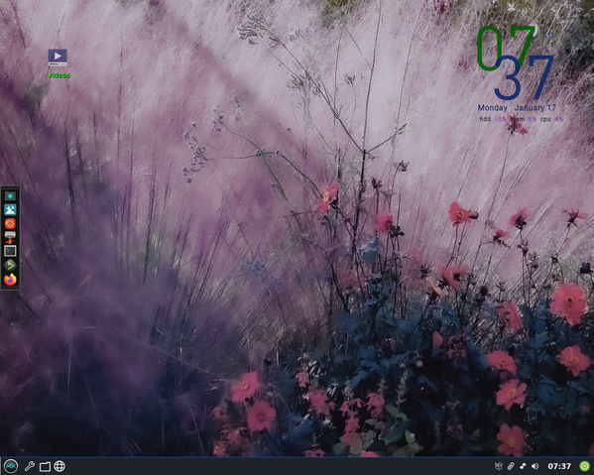

1

2

5
4

3

Going clockwise from the upper left corner, here are the principle components:

- Desktop icons (Section 4.1.1)
- System information display, called a “conky” (Section 4.1.2)
- The creative tint2 panel (Section 4.1.3)
- A dock managed by MX Dockmaker or tint2 (Section 4.1.4)
- The hidden FB “rootMenu” (Section 4.1.5)

The first stop for new users might well be the Settings manager, available from the dock, the panel or the desktop menu (roottMenu).
In addition to desktop and dock items, applications can be launched with any of the following tools:

- the traditional panel’s Start (MX logo) button for a full categorical menu (key combinagion Logog+x)
- the key combination Logo+a (Windows or Apple icon) to bring up a very fast tool called “rofi” for an alphabetical menu with handy properties (details in the Wiki)
- the shortcut F2 to bring up a small run window (fbrun) using the actual program name

The following sections will give users a basic understanding of how to use and manage each of these components. Note: the word “Menu” in the following sections refers to the desktop or root Menu that appears with a right-click on the desktop.

3.1.1 Desktop icons
Hide: Menu > Out of sight > Toggle icons
Remove (icon): middle-click icon to launch iDesktool
Stop: Menu > Out of sight > Toggle iDesk
Manage: Menu > Appearance > Desktop icons
Help: a dedicated video or in the Wiki

Desktop icons are enabled in MXRPi2 by iDesk, a program first developed in 2005 and designed to draw desktop icons for users of minimal window managers such as FB and OB. MX Linux Devs and users adapted, modernized and expanded an existing tool to produce iDesktool: Menu > Appearance > Desktop icons. This tool greatly facilitates the use of desktop icons on MXRPi2. It is very straightforward and should raise few questions about its use.

Here are the basic mouse actions for a desktop icon (config in ~/.ideskrc) using the default “Help PDF” icon as an example:
Action | Mouse | Example
Execute | Left single click | Opens to the MXRPi2 YouTube channel
Execute alt | Right single click | Opens this document
Manage | Middle (scroll button) single click | Opens iDesktool focused on the icon
Drag | Left click hold, release to stop

4.1.2 Conky

The desktop system display is enabled by default in FB.

Hide: Menu > Out of sight > Toggle conky
Remove (conky): Menu > Appearance > Conky
Stop: Menu > Out of sight > Toggle conky
Manage: Menu > Appearance > Conky
Help: in the Wiki: MX Conky, Conky Manager

MXRPi2 users can make use of the default conky set for MX Linux by launching MX Conky; Conky Manager can be accessed from it, or using any of the menus. Conky Manager is a handy method of basic management, while MX Conky supplies advanced features unique to MX Linux such as color manipulation.
In Conky Manager follow these simple steps to edit, view and display a conky:
- Highlight each conky and press the Preview button on the menu bar to see what it looks like. Be sure to close each preview before going to another.
- Click on the Settings icon (gears) to change basic properties such as location.
- Check the box to select any conky you want to use. It will be auto-installed.
- The configuration files are stored in the folder ~/.conky/ in individual theme files. They can be edited, though it is not easy for beginners, by highlighting the conky in Conky Manager and clicking on the edit icon (pencil).
For more complicated conkies, you may need to make use of a compositor. Click Menu > Settings > Config > Startup, and uncomment the line about a compositor so it looks like this: compton &

4.1.3 The tint2 panel
Hide: Menu > Out of sight > Toggle autohide panel
Remove: Manual: delete the config from ~/.config/tint2/
Stop: Manual: put a comment (#) in front of line in the “startup” file
Manage: Settings manager > Tint2 manager (icons on dock and in panel)
Help: in the Wiki

The original FB toolbar is very different from what today’s users expect in function and design. An alternative “traditional” toolbar is used here with a highly configurable app known as “tint2.”

To change the panel, launch the Settings Manager by clicking the wrench icon next to the Start button, the gear icon on the dock or selecting the listing in the Menu. Then click on “Tint2 manager.” You can also use Logo+a (rofi) to directly access it.
The screen opens showing all the tint2 configurations in the location ~/config/tint2/. MXRPi2 supplies a small set of very different configurations that you can try out, including two specialized for touchscreen use.
In addition to selecting an existing configuration you can also change the elements of any panel—in fact, that is one of the great pleasures of using tint2. Click on either the “Config” or the “Edit” button for graphical or direct-text editing.
The Graphical editor includes two applications:
- “Themes” displays all the tint2 configs in the user’s location as well as a few others brought in during installation.
- “Properties” displays the features of the running config. If the Properties window is not visible, click on the little gear icon in the upper left corner.
Here are a couple of common actions in the “Properties” window to get you started:
- Adding/Removing launchers from a panel-dock. Click the “Launcher” entry on the left side. The right panel has two columns: on the left a list of application icons currently displayed on the toolbar, while on the right a list of all desktop applications installed.
  - Add: select the application you want from the list in the right column, click the “left arrow” icon on the middle and then click the “Apply” button, to instantly add it to the toolbar.
  - Remove: reverse the procedure.
  - Use the up/down arrows to set the order of items on the panel-dock.
- Moving or resizing the panel. Click the “Panel” entry in the left panel and then choose its placement and size in the right panel. Click the “Apply” button. That is also where you can scroll down and check the “Autohide” box if desired.
- Changing to time/date format. Switch 12h/24h using the button at the bottom of the Tint2 Manager screen. For other changes, click the “Clock” entry in the left panel and then change the field “First line format” or “Second line format” to whatever you like. Time codes can be found in the Wiki.

NOTE: Back up your current configuration before changing it: click on ~/.config/tint2/tint2rc and then save it under a new name such as “tint2rc_BAK.” You can then copy all your customized lines from your backup file to the correct place on your new tint2rc configuration.

4.1.4 Dock
Hide: Menu > Out of sight > Toggle autohide dock
Remove/Add (a Dock item): Menu > Appearance > Dockmaker
Stop (Default dock): Menu > Out of sight > Disable Default dock
Manage: Menu > Appearance > Dockmaker (for the touchscreen dock: tint2)
Help: a dedicated video or the Wiki
MXRPi2 has a native app called Dockmaker which makes it easy for the user to create, modify and manage docks. A vertical dock appears on the desktop when the user logs in for the first time. Its configuration is set in ~/facebook/scripts/DefaultDock.mxdk
NOTE: a touchscreen dock (tint2) is being used as instead of Dockmaker so that when hidden an 11px edge can be revealed for touchscreen use. Such “panel-docks” can not be manipulated with Dockmaker.

4.1.5 The desktop (root) Menu
Hide: always hidden by default, right-click to show
Remove/Add (a menu item): Menu > Settings > Configure > Menus
Stop: put a comment (#) in front of the line in ~/.fluxbox/init that starts with:
session.menuFile
Manage: Menu > Settings > Configure > Menus
Help: Section 4 and Links
Note: middle-click desktop to show a window/desktop menu.
The static default rootMenu is composed of 4 separate units: a short main menu (~/.fluxbox/menu-mx) and three submenus (Appearance, Settings, Out of sight) located in ~/.facebook/submenus. These flat files are easy to read and completely under the user’s control.
The rootMenu’s sections are established by the separator lines:
- Top: All apps: a very fast menu (rofi) and Recent files
- Middle: a few highly-used apps
- Bottom: Appearance, Settings, Out of sight and Leave
The new user would do well to work through that menu.

4.1.6 Monitors (not shown by default)
See 4.2.6

4.2 OB
OB relies on just 3 files, located in ~/.config/openbox: autostart, menu.xml and rc.xml.

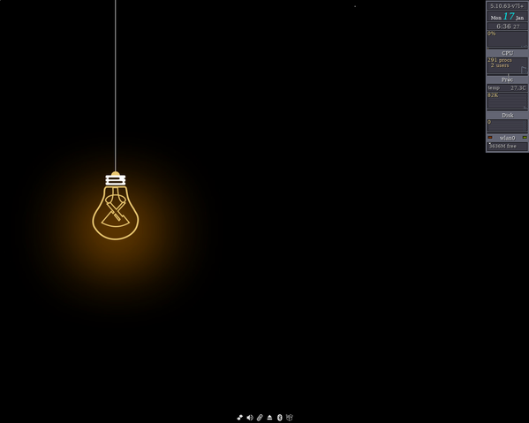
6

5

3

4.2.1 Desktop icons
See 4.1.1

4.2.2 Conky (not shown by default)

See 4.1.2

4.2.3 Systray
Autohide, position, etc.: Menu > Settings > Basic settings, Dock tab
Stop: Manual: put/remove a comment (#) in front of line in the autostart file
Config: ~/.stalonetrayrc (for possible parameters > man stalonetray)

The systray is created by stalonetray. Since it is treated as a dock, it will not easily co-exist with MX docks because both would be positioned at the same screen location (“slot”, called “slit” in FB).

4.2.4 Docks (not shown by default)
See 4.1.4.

4.2.5 The desktop (root) Menu
Hide: always hidden by default, right click to show
Remove/Add (a menu item): Menu > Settings > Configure > Menus
Manage: Menu > Settings > Configure > Menus
Help: Links
The menu file is in xml format that is less easy to read and modify that the FB one.
Note: middle-click desktop to show the window menu

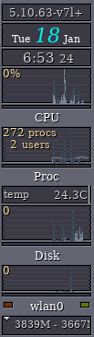
4.2.6 Monitors
The desktop monitor stack gkrellm, for which many skins and many plugins are available, is enabled by default in the OB version used in MXRPi2.
Show: Menu > Appearance > Monitor
Hide: N/A
Stop Autostart: comment out the line in the autostart/startup file so that it looks like this:
#gkrellm &

Config: right-click the top panel > Configuration. Individual elements can be configured with right-click as well.
Help: website.

It is supposedly possible to place gkrellm in the systray, see this explanation.

5. Traditional FB config
This section addresses the user who wants to run a traditional FB setup.

How do I start?
It is very easy to restore a traditional FB setup. Right-click anywhere on the desktop to see and use the desktop menu (rootMenu). The following changes are at your fingertips:
- Settings > Toolbar > Fluxbox: the traditional (tint2) panel will disappear and the FB toolbar will appear at the top of the screen.
- Out-of-sight > Kill dock*
- Out-of-sight > Kill conky*
- Out-of-sight > Toggle iDesk and Toggle icons*
*For persistent changes, comment out (#) the relevant lines in the file Settings > Configure > Startup so they look like this:

#$HOME/.FB/scripts/DefaultDock.mxdk
#$HOME/.FB/scripts/conkystart
#idesktoggle idesk on 1>/dev/null 2>&1 &

Let’s go through how to understand and use the changed desktop:

What is the toolbar across the top?
This FB toolbar offers MX users information about workspaces, open applications, a system tray, and the current time. Its width and placement can be set with the options available by middle-clicking (=scroll wheel) the clock or pager on the toolbar—if that doesn’t work for some reason, click Menu > Settings > Window, slit and toolbar > Toolbar. Height is set in ~/.FB/init/ :

session.screen0.toolbar.height: 0

If a zero is there, it means that the selected style will set the height. Otherwise, a value of 20 to 25 is often comfortable.

The toolbar contains the following default components (L-R):

pager
- Allows you to switch workspace up (right click) or down (left click); same as Control + F1/F2/ etc., Ctrl-Alt + ←/→ or using the scroll wheel over an empty section of the desktop. Number and name are set in the ~/.FB/init. “W” stands for “Workspace.” Not used by default.
iconbar
- Here open apps will show an icon, with various window options available by right-clicking the relevant icon (including the toolbar itself) > iconbar mode. Default for MX-FB is to show All Windows.

systemtray AKA systray
- Equivalent of Notification Area in Xfce. Default components set in ~/.FB/init; apps that have a systemtray option will show there when launched.

clock
- To adjust the clock to 12h or 24h, right-click and click 12h or 24h, whichever shows. If that doesn’t work, select "Edit clock format."
- 24h: %H:%M, 12h: %I:%M.
- The default is 12h time and date in day/short month format: %I:%M %b %d. Many other time/date options can be found in the Wiki.

You can move or delete any of the toolbar components in ~/.FB/init/ , which by default are set up in this way:

workspacename, iconbar, systemtray, clock

How can I make the toolbar look more like legacy systems such as Windows?
Click Menu > Appearance > Toolbar > Traditional (using tint2)

How can I get rid of desktop items I don’t want?
Menu > Out of sight > ...

This entry includes:
- Actual kill entries that stop the entire program. The next time you log in anything enabled in the startup file will re-appear except the default dock, which will be disabled.
- A disable entry to remove the default dock.
- Toggle entries, which can kill or re-launch a program.

How can I change or add a menu entry?
Menu > Settings > Configure > Menus. The syntax is: [category] (name) {command} – be sure to use brackets, parentheses and braces correctly.
Example 1: change “Music” to open Clementine instead of DeaDBeeF
- Find the line with the word Music (use Ctrl+F if necessary)
[exec] (Music) {deadbeef}
- Double-click the word “deadbeef” in the command part so it is highlighted, then type “clementine” and save, producing this result:
[exec] (Music) {clementine}
- Click Menu > Leave > Refresh to use the new settings
Example 2: add Skype to the menu
- Decide where you want it to show up; for this example, let’s assume you want to add a new category “Communicate” in the Common apps section and enter it there
- Create the category using the submenu commands (see below), introduce a new line and follow the pattern: [exec] (menu entry) {command}
- The result will look something like this:
[submenu] (Communicate)
[exec] (Skype) {skypeforlinux}
[end]
- Menu > Leave > Refresh
NOTE: as the second example shows, the command to use may not always be obvious, so if necessary open the Application Finder (F6), right-click the entry you are interested in > Edit and copy the correct full command for the menu.

What else should I know about the windows?
- Resize: Alt + right click near the corner you want to change and drag.
- Move: Alt + left click and drag.
- Stick: use the little square in the top left corner to limit the window to the current desktop.
- Options: right-click on the window’s toolbar at the top. Of special value is the ability to select to remember size and location (recorded in ~/.FB/apps).
- Tabbing: combine multiple windows into one window with tabs across the top by simply Ctrl-Clicking and holding the titlebar of one window and dragging and dropping it on another window. Reverse the procedure to separate them again.

I see styles in the menu, what are those?
Styles are simple text files that tell FB how to generate the appearance of the window and toolbar components, as well as the menu. FB ships with a large number in /usr/share/FB/styles/ that show in Menu > Look > Style, and many more can be found online with a web search on "FB styles."

Styles can include a background image, but that is blocked in MX-FB by default with the top lines in Menu > Settings > Configure > Overlay. To allow the style to determine the background, place a hash mark in front to the line so that it looks like this:

! The following line will prevent styles from setting the background.
#background: none

If you like a style but want to change certain traits, copy it to ~/.FB/styles, rename it, and make your changes (consult Ubuntu style guide under Links, below). You will find a few FB styles that have been modified for use in MX in that folder.

What are themes and how do I manage them?
A number of themes are installed by default in MX-FB and others can be found with a web search. A GTK theme controls items such as the panel color, the backgrounds for windows and tabs, how an application will look when it is active vs. inactive, buttons, check-boxes, etc. They range from very dark to very light.
The default theme for MX-FB is MX-Comfort. It can be changed by right-clicking on the desktop to bring up Menu > Appearance > Theme, bringing up a selector for themes, icons, fonts etc. which makes it very easy to see and choose the other possibilities.

I can’t read some of the texts, can I do something about that?
You can adjust the font being used by a theme or style using the theme selector; default for MXPi is Sans 11. More detailed control is available by using the ~/.FB/overlay file. For instance, this set of commands might be tried to make the text generally larger:
# fonts------------------------------------------
menu.frame.font: PT Sans-12:regular
menu.title.font: PT Sans-12:regular
toolbar.clock.font: PT Sans-11:regular
toolbar.workspace.font: PT Sans-11:regular
toolbar.iconbar.focused.font: PT Sans-11:regular
toolbar.iconbar.unfocused.font: PT Sans-11:regular
window.font: Lato-9

For other font options, consult the Links at the end of this document.

Can I change the wallpaper?
First make sure the overlay file is blocking the style from determining the background. Then click Menu > Appearance > Wallpapers > Select to see the available choices. The list that pops up from the menu entry includes user backgrounds (~/.facebook/backgrounds and ~/Pictures/Backgrounds) and system backgrounds (/usr/share/backgrounds).

What terminals are available?
- Ctrl+F4 and Menu = Xfce4-terminal
- Ctrl+Alt+t = Xterm

Can I use my own keystroke combinations?
Yes. Many are listed by default in Menu > Settings > Configure > Keys. The names of a couple of the keys are a bit obscure:
- Mod1 = Alt
- Mod4 = Logo key (Windows, Apple)
More: http://FB.sourceforge.net/docbook/en/html/c296.html

There are dedicated function key combinations in MX-FB (see top of keys file to change):
- Ctrl+F1: MX-FB documentation
- Ctrl+F2: Run command using the quick app runner “rofi”
- Ctrl+F3: File manager
- Ctrl+F4: Drop-down terminal
- vF5: MX Tools
Function keys alone are not programmed to avoid conflict with usage by apps.

What screen options exist?
- Brightness: Settings Manager > Tools > Brightness systray
- Capture: a dedicated icon in the dock runs MXRPi2-quickshot; if you have a Print Screen (AKA Print, PrtSc, etc.) key, that should work as well. It is set to select a region.

I have read about the slit: what is that?
The slit was originally conceived as a container for dockapps, but in MXRPi2 it is primarily used for the dock. It can be located at various locations on the desktop:
- TopLeft, TopCenter, TopRight
- LeftCenter, RightCenter
- BottomLeft, BottomCenter, BottomRight
You can search the default repo for dockapps with this terminal command:
apt-cache search dockapp
Many available in the repos may not work well, but it’s worth taking a look.

6. Links
The man files (in terminal or https://linux.die.net/man/): fluxbox, fluxbox-keys, fbrun, fluxstyle, fluxbox-remote.
http://fluxbox.sourceforge.net/docbook/en/pdf/fluxbook.pdf
Basic handbook, somewhat dated but still useful

http://openbox.org/wiki/Main_Page
Very helpful OB Wiki

https://bbs.archlinux.org/viewtopic.php?id=77729
Some good general explanations with examples

https://wiki.archlinux.org/index.php/fluxbox
Some commands are Arch-specific

https://wiki.ubuntu.com/HowToFluxboxStyles

https://ubuntuforums.org/showthread.php?t=617812
Excellent thread on FB keys

https://desertbot.io/blog/raspberry-pi-touchscreen-kiosk-setup
Kiosk setup for RPi Buster

https://raspberrypi.stackexchange.com/questions/tagged/touchscreen?tab=newest&page=1&pagesize=15
Recent problems with the Official Display

https://wiki.debian.org/FluxBox

http://fluxbox.sourceforge.net/docbook/en/html/chap-tabs.html
Window tabbing

https://fmirkes.github.io/articles/20190827.html
Right-click on an RPi touchscreen (but not Bullseye)

https://github.com/jerry3904/mx-fluxbox
The GitHub repo of MX-FB

https://mxlinux.org/wiki/help-files/help-mx-fluxbox/
The MX-FB Wiki entry

https://bit.ly/2Sm1PJl
YouTube: MX-FB channel

v. 22.02.14

