

MX-18.3 Users Manual
v. 20190614
manual AT mxlinux DOT org

Ctrl-F = Search this Manual
Ctrl+Home = Return to top

1 Introduction

1.1 About MX Linux
MX Linux is a cooperative venture between the antiX and former MEPIS communities, using the best tools and talents from each distro and including work and ideas originally created by Warren Woodford. It is a midweight OS designed to combine an elegant and efficient desktop with simple configuration, high stability, solid performance and medium-sized footprint.
Relying on the excellent upstream work by Linux and the open-source community, we deploy Xfce 4.12 as Desktop Environment on top of a Debian Stable base, drawing from the core antiX system. Ongoing backports and outside additions to our Repos serve to keep components current with developments.
The MX Dev Team is composed of a group of volunteers of various backgrounds, talents and interests. Details: About us.
Special thanks for strong ongoing support of this project go to the MX Linux Packagers; to video producers Dolphin_Oracle, richb and m_pav; to our great volunteers; and to all our Translators!

1.2 About this Manual
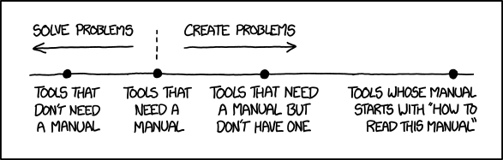

Figure 1-1: The *need* for manuals (xkcd.com)
This Users Manual is the product of large group of volunteers from the MX Linux community. As such, it will inevitably contain errors and omissions, although we have worked hard to minimize them. Please send us feedback, corrections or suggestions using one of the methods listed below. Updates will occur as needed.
The Manual is designed to walk new users through the steps of obtaining a copy of MX Linux, installing it, configuring it to work with one’s own hardware, and putting it to daily use. It aims to provide a readable general introduction, and purposely gives preference to graphical tools when available. For detailed or infrequent topics, the user should consult the Resources or post on the Forum.
New users may find some of the terms used in this Manual to be unfamiliar or confusing. We have tried to limit the use of difficult terms and concepts, but some are simply unavoidable. The Glossary located at the end of the document provides definitions and comments that will help in getting through difficult passages.
Feedback:
- Email: manual AT mxlinux DOT org
- Forum: MX Documentation and Videos
All content is © 2019 by MX Linux and released under GPLv3. Citation should read:
MX Linux Community Documentation Project. 2019. Users Manual for MX Linux.

1.3 System requirements
For an MX Linux system installed on a hard drive, you would normally need the following components.
Minimum
- A CD/DVD drive (and BIOS capable of booting from that drive), or a live USB (and BIOS capable of booting from USB)
- A modern i686 Intel or AMD processor
- 512 MB of RAM memory
- 5 GB free hard drive space
- For use as a LiveUSB, 4 GB free.
Recommended
- A CD/DVD drive (and BIOS capable of booting from that drive), or a live USB (and BIOS capable of booting from USB)
- A modern i686 Intel or AMD processor
- 2 GB of RAM memory or more
- At least 20 GB free hard drive space
- A 3D-capable video card for 3D desktop support
- A SoundBlaster, AC97 or HDA-compatible sound card
- For use as a LiveUSB, 8 GB free if using persistence.

1.4 Support
What kind of support is available for MX Linux? The answer to this question depends on the type of support you mean:
- User-based problems. A raft of support mechanisms exists for MX Linux, from documents and videos to forums and search engines. See the Community Support page for details.
- Hardware. Hardware is supported in the kernel, where continuous development goes on. Very new hardware may not yet be supported, and very old hardware, though still supported, may no longer be sufficient for the demands of the desktop and applications.
- Desktop. Xfce4 is a mature desktop that remains under development. The version shipped with MX Linux is considered stable; important updates will be applied as they become available.
- Applications. Applications continue to be developed after the release of any version of MX Linux, meaning that the shipped versions will get older as time passes. This problem is addressed through a combination of sources: Debian (including Debian Backports), individual Developers including MX Devs, and the Community Packaging Team, which accepts users’ upgrade requests as much as possible.
- Security. Security updates from Debian will cover MX Linux users well into the foreseeable future.

1.5 Bugs, issues and requests
Bugs are errors in a computer program or system that produce incorrect results or abnormal behavior. MX Linux defines “issues” as upstream bugs about which the Dev Team can do nothing. Finally, “requests” are additions requested by users, either as new applications or new features for existing applications. MX Linux deals with these in the following manner:
- Bugs are managed by means of the MX and antiX Linux Bug Tracker.
- Requests can be made with a post in the Bugs and Request Forum, being careful to provide information about hardware, system, and error details
- Devs as well as Community members will respond to those posts with questions, suggestions, etc.
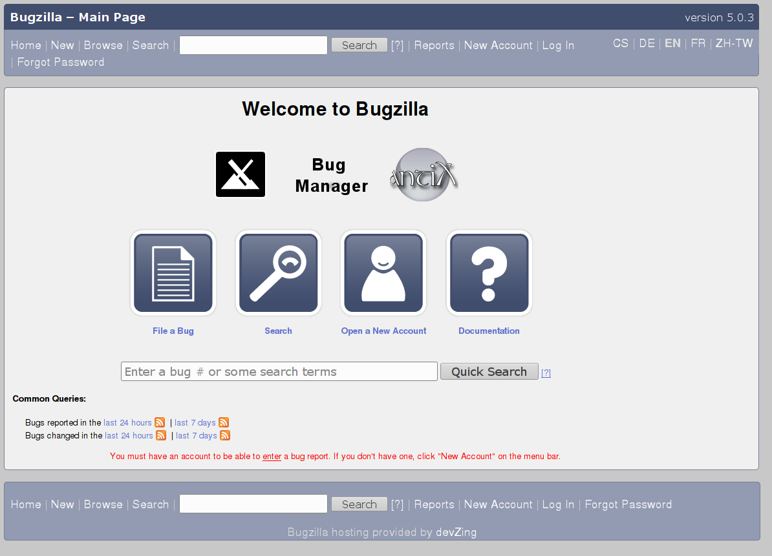

Figure 1-2: The MX and antiX bug manager

1.6 Migration
Whenever possible, a migration path is provided with distribution upgrades (i.e., apt-get dist-upgrade) so that users can avoid reinstallation. Check the migration page for the current procedure.
The exception to this standard procedure arises when the Debian base changes. Debian Stable is a wonderful solid distribution that can be upgraded in place from version to version automatically as long as the Debian Stable repos are used exclusively. MX uses Debian Stable as a base, but updates a lot of the userland programs & libraries, and backports newer programs from testing by building them against the Stable base. That gives a better user experience but interferes with Debian’s dist-upgrade path. Our current choice (to stick with sysvinit instead of going to full systemd) also interferes with that path.
So it’s a trade-off. You have a better desktop user experience at the expense of having to do a quick fresh install (which lets you save /home if desired) when the Debian base changes, typically every 2-3 years. MX-17.x and MX-18 use the same Debian base, so an easy upgrade path is offered.

1.7 Our positions

1.7.1 Systemd
Because the use of systemd as a system and service manager has been controversial, we want to be clear about its function in MX Linux. Systemd is included by default but not enabled. You can scan your MX system and discover files bearing systemd* names, but those simply provide a compatibility hook/entrypoint when needed.
MX Linux uses systemd-shim, which emulates the systemd functions that are required to run the helpers without actually using the init service. This means that SvsVinit remains the default init yet MX Linux can use Debian packages that have systemd dependencies such as CUPS and Network Manager. This approach also allows the user to retain the ability to choose his/her preferred init at boot by clicking on "Advanced options" and selecting the systemd one. We can not provide support for users who choose to run MX Linux using systemd.

1.7.2 Non-free software
MX Linux is fundamentally user-oriented, so includes a certain amount of non-free software to assure that the system works out of the box as much as possible. The user can see a list by opening a console or terminal and typing:
vrms

Examples:
- The “wl” driver (broadcom-sta) and non-free firmware with proprietary components.
- A dedicated tool for installing Nvidia graphic drivers.
- Adobe Flash Player (distributed by permission).
Our rationale: it is much easier for advanced users to remove these drivers than it is for regular users to install them. And it's particularly difficult to install a driver for a network card without Internet access!

1.8 Notes for Translators
Some orientation for people translating the Users Manual:
- The English texts behind the latest release are in this repo: a GitHub repo. Translations are stored in the directory "tr"
  - You can work within the GitHub system: clone that main repo, make changes and then make a pull request to have it reviewed for merging with the source.
  - Alternatively, you can download what you are interested in and work on it locally before notifying that it is ready either with an email to manual AT mxlinus DOT org or by posting on the Forum.
- In terms of importance, it is recommended that you begin with Sections 1-3 that provide the information most relevant to the new user. Once those are done, they can be distributed to users as a partial translation while the later Sections are being translated.
- Available translations are tracked in the MX/antiX Wiki.

