4 Basic use

4.1 Internet

4.1.1 Web browser
- MX Linux comes with the popular browser Firefox installed, which has a terrific set of add-ons to augment the user’s experience.
Firefox home page
Firefox add-ons
- Upgrades of Firefox come through the MX Linux repos, and are usually available to users within 24 hours of release.
- Firefox has a sync service that facilitates transferring bookmarks, cookies, etc. from an existing Firefox installation.
- Other browsers are available for easy download and installation via the MX Package Installer.

4.1.2 Email
- Thunderbird is installed by default in MX Linux. This popular email client integrates well with Google Calendar and Google Contacts.
- Other lightweight email clients are available from the repos.

4.1.3 Chat
- HexChat. This IRC chat program is installed by default in MX Linux, and makes the exchange of text messages easy for the user.
HexChat home page
- Pidgin. This graphical, modular instant messaging client is capable of using multiple networks at once. MX Package Installer.
Pidgin home page

Video Chat
- Skype. A popular proprietary program for instant messaging as well as voice and video chat. It is cross-platform and can be installed on MX Linux without problem using the MX Package Installer > Messaging. It integrates automatically with PulseAudio, which is installed by default.
Skype home page
- Jitsi. This free and open-source multiplatform application supports voice (VoIP), video-conferencing and instant messaging.
Jitsi home page
- Troubleshooting
  - Occasionally Skype does not pick up a particular webcam. That can often be solved by opening a terminal, becoming root, and issuing two commands one at a time that will first unload, then reload the driver. (If that works, then a script can be written to execute those commands automatically.)
modprobe -r uvcvideo

modprobe uvcvideo
  - If your voice is not being picked up even after you use the app’s own tools, try this:
    - Sign into Skype, click on Options in the left pane and go to the Sound Devices tab.
    - Click on the button to start a test call. While the call is going on, open PulseAudio Volume Control and go to the Recording tab.
    - Still while the test call is going on - change the Skype input to the Webcam microphone.
See also Section 4.10.6 Google Talk.

4.2 Multimedia
Listed here are some of the many multimedia applications available in MX Linux. Advanced professional applications also exist, and can be found through targeted searches in Synaptic.

4.2.1 Music

Figure 4-1: Playing a CD track with Clementine
- Players
  - Clementine. A modern music player and library organizer that can play every source from a CD to a Cloud Service. Installed by default.
Clementine home page
  - Audacious. A full-featured music player and manager. MX Package Installer.
Audacious home page
  - DeaDBeeF. A lightweight player with a small memory footprint, robust set of basic features, and a focus on music playback. MX Package Installer.
DeaDBeeF home page
- Rippers and editors
  - Asunder. A graphical Audio CD ripper and encoder that can be used to save tracks from Audio CDs. Installed by default.
Asunder home page
  - EasyTAG. A simple application for viewing and editing tags in audio files.
EasyTAG home page

4.2.2 Video
Netflix on 32 bit Linux
UPDATE: Netflix on 32 bit Linux
- Players
  - VLC. Plays a large range of video and audio formats, DVDs, VCDs, podcasts, and multimedia streams from various network sources. Installed by default.
VLC home page
  - A YouTube Browser for SM Player is installed by default.
SMplayer home page
  - Netflix. Desktop capability of streaming Netflix movies can be acquired by installing Google Chrome from MX Package Installer and simply navigating to the site.
Netflix home page

Figure 4-2: Running desktop Netflix in Google Chrome
- Rippers and editors
  - HandBrake. A video ripper that is easy to use, fast and simple.
HandBrake home page
  - DeVeDe. This utility automatically converts material to formats compatible with audio CD and video DVD standards.
DeVeDe home page
  - DVDStyler. Another good authoring utility. MX Package Installer.
DVDStyler home page
  - OpenShot. A simple-to-use and feature-rich video editor. MX Package Installer.
OpenShot home page

4.2.3 Photos
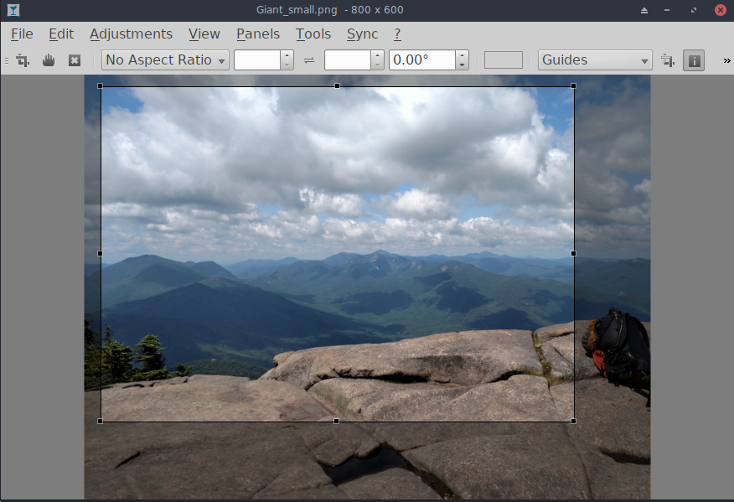
Figure 4-3: Using the crop tool in Nomacs
- Nomacs. A fast and powerful image viewer installed by default with MX-17.
Nomacs home page
- Mirage. This speedy application is easy to use and allows you to view and edit digital photos. MX Package Installer.
Mirage project page
- Fotoxx. This fast application allows easy photo editing and collection management while serving the needs of serious photographers.
Fotoxx home page
- GIMP. The premier image manipulation package for Linux. Help (gimp-help) must be installed separately, and is available in many languages. Basic package installed by default, full available from MX Package Installer.
GIMP home page

4.2.4 Screencasting

Figure 4-4: Main screen of SimpleScreenRecorder
- SimpleScreenRecorder. A simple but powerful program to record programs and games. MX Package Installer.
SimpleScreenRecorder home page
- RecordMyDesktop. Captures audio-video data of a linux desktop session. MX Package Installer.
RecordMyDesktop home page.

4.2.5 Illustrations
- mtPaint. An easily learned application for creating pixel art and manipulating digital photos.
mtPaint home page
- LibreOffice Draw. Diagrams, drawings and pictures can be created and modified with this application.
LO Draw home page
- Inkscape. This illustration editor has everything needed to create professional-quality computer art. MX Package Installer.
Inkscape home page

4.3 Office

4.3.1 Office suite
MX Linux comes with a great free office suite called LibreOffice, which is the Linux equivalent and near drop-in replacement for Microsoft Office®. The suite is available under Start Menu > Office > LibreOffice. LibreOffice supports the .docx, .xlsx and .pptx file formats of Microsoft Office 2007 and above.

Figure 4-5: Main dashboard in LibreOffice
- Installed by default.
  - Word Processor: LibreOffice Writer. An advanced word processor compatible with .doc and .docx files.
  - Spreadsheet: LibreOffice Calc. An advanced spreadsheet compatible with .xls and .xlsx files.
  - Presentation: LibreOffice Impress. Presentations, compatible with .ppt and .pptx files.
  - Draw: LibreOffice Draw. Used to create graphics and diagrams.
  - Math: LibreOffice Math. Used for for mathematical equations.
  - Base: LibreOffice Base. Used to create and manipulate databases. If using this application to create or use databases in the native LibreOffice format, you must also install libreoffice-sdbc-hsqldb and libreoffice-base-drivers matched to version.

4.3.2 Office finances
- GnuCash. Financial software for office use. It is easy to learn, and allows you to track bank accounts, stocks, income and expenses. Can import data in QIF, QFX and other formats, and supports double entry accounting. MX Package Installer. The Help package (gnucash-docs) needs to be installed separately.
- GnuCash home page

Figure 4-6: New account in GnuCash

4.3.3 PDF
- QPDFview. A fast and lightweight viewer that includes a number of basic tools. Installed by default.
QpdfView home page
- Adobe Reader for Linux offers greater functionality (such as commenting or form filling). MX Package Installer (under Office).
Adobe Reader home page
- PDFShuffler makes simple the reordering, deleting and adding of PDF pages. Installed by default.
PDFShuffler home page
- gscan2pdf is a handy method of scanning documents to PDF in addition to serving general scanning needs. Installed by default (see MX/antix Wiki).
gscan2pdf home page
- For other functions (e.g., creating a PDF form), see MX/antiX Wiki: PDF.

4.3.4 Desktop publication
- Scribus. Professional page layout that produces press-ready output. Available via MX Package Installer.
Scribus home page

4.3.5 Project time tracker
- Kapow punch clock. Simple but feature-rich app to record project time.
Kapow home page
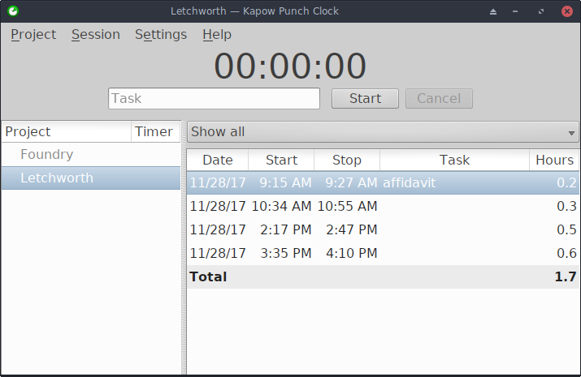

Figure 4.7 Kapow set to track work on a project

4.3.6 Video meeting and remote desktop
- TeamViewer. Cross-platform application for Remote Support and Online Meetings. Free for private use.
TeamViewer home page

4.4 Home

4.4.1 Finances
- Grisbi is very useful for the home. It can import QIF/QFX files, and has an intuitive interface.
Grisbi home page

4.4.2 Media Center
- Kodi Entertainment Center (formerly XBMC) allows users to play and view most videos, music, podcasts, and all common digital media files from local and network storage media.
Kodi home page

4.4.3 Organization
- Notes. This handy Xfce plugin (xfce4-notes-plugin) allows you to create and organize sticky notes for your desktop.
Notes home page
- Osmo. Nice compact application that includes calendar, tasks, contacts and notes.
Osmo home page

Figure 4-8: The personal information manager Osmo

4.5 Security

4.5.1 Firewall
- Gufw. A personal firewall configuration utility that makes it easier for the user to configure the firewall. Installed by default.
Gufw home page
Wikipedia: Personal firewall

4.5.2 Antivirus
- ClamAV. Useful to stop Linux users from unknowingly passing virus-infected emails and other documents to susceptible Windows users.
ClamAV home page

4.5.3 AntiRootkit
- chkrootkit. This application scans systems for known and unknown rootkits, backdoors, sniffers and exploits.
chkrootkit home page

4.5.4 Password protection
- Passwords and Keys. A password and key manager installed by default. Details on usage in the MX/antiX Wiki.
- KeePassX. A password manager or safe that helps you to manage your passwords in a secure way. Available via MX Package Installer.
KeePassX home page

4.5.5 Web access
- Dansguardian. Provides a flexible method of filtering web access for kids according to your needs.
Dansguardian home page

Figure 4-9: Web filter in action on Dansguardian

4.6 Accessibility
Various open-source utilities exist for MX Linux users with disabilities.
- Xfce. Click Start menu > Settings > Accessibility, and tick Enable Assistive Technologies. Change the available options to suit your liking.
Xfce4 documentation: Accessibility
- Debian. Many other tools are available within Debian itself.
Debian Wiki

4.7 System

4.7.1 Get root privileges
There are two commands to obtain root (AKA administrator, superuser) privileges that you need to make system changes (e.g., installing software) using a terminal.
- su: requires the root password and grants privileges for entire terminal session
- sudo: requires your user password and grants privileges for a short time period
In other words, su lets you switch user so that you’re actually logged in as root, while sudo lets you run commands in your own user account with root privileges. Also, su uses the environment (user-specific configuration) of the user root, while sudo allows root-level changes but keeps the environment of the user issuing the command. In general, MX Linux uses a “true root,” meaning that this Manual and the Forum will generally instruct the use of su.
MORE: click Start menu > enter “#su” or “#sudo” (without the quotes) in the search space and return to see the detailed man pages.

Running a root application
Some applications that can be found in the Start Menu require that the user have root privileges: gparted, grub customizer, lightdm gtk+ greeter, etc. Depending on how the launch command is written, the dialog box that pops up may show that root access will be stored (default setting) for as long as your session lasts (i.e., until you log out). That is the case with gksu, but not with others such as pkexec.
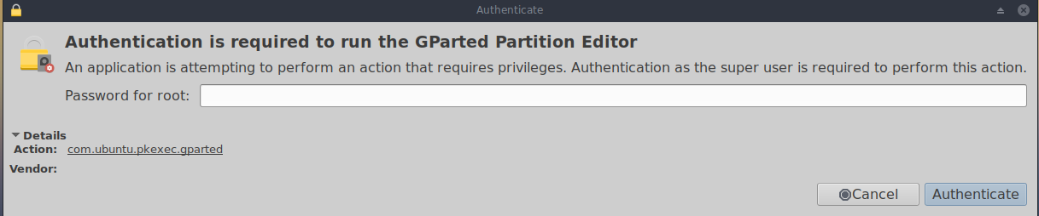
Figure 4-10: Dialog box when the command pkexec is used, showing no storage of root password
When the command gksu is used, the next time during the same session that you launch an application needing root privileges, you will see a dialog box telling you that they have been granted without the need for you to enter the password again; check to not show again. If you want to change this default behavior, uncheck “Remember password” the next time you see it.

4.7.2 Get hardware specs
- Click Start menu > System > System Profiler and Benchmark for a nice graphic display that includes the results of various tests.
- Open a terminal and enter this command:
inxi -F
See Section 6.5 for the many other features of inxi.

4.7.3 Create symbolic links
A symbolic link (also soft link or symlink) is a special kind of file that points to another file or folder, much like a shortcut in Windows or an alias in Macintosh. A symbolic link does not contain any actual data (as a hard link does), it just points to another location somewhere in the system.
There are two ways to create a symlink: Thunar or the command line.
- Thunar
  - Navigate to the file or folder (target of the link) that you want to point to from another location or under another name
  - Right-click what you want to link > Create Symlink, and a symlink is created where you currently are
  - Right-click the new symlink > Cut
  - Navigate to where you want the link to be, right-click an open area> Paste. Change if desired the link name.
- Command line: Open a terminal and type:
ln -s TargetFileOrFolder LinkName

  - For example, to symlink a file named “foo” in your Downloads folder to your Documents folder, enter this:
ln -s ~/Downloads/foo ~/Documents/foo

4.7.4 Find files and folders

GUI

Figure 4-11: Search screen of Catfish looking for “MX-16”
Catfish is installed by default in MX Linux, and can be launched from the Start menu > Accessories, or simply by starting to type “search” in the top search entry field. It is also integrated into Thunar so that the user can right-click a folder > Find files here.
Catfish home page

CLI
There are some very handy commands for use in a terminal.
- locate. For each given pattern, locate searches one or more databases of file names and displays the ones that contain the pattern. For example, typing:
locate firefox
will return an extremely long list with every single file that has the word “firefox” in its name or its path. This command is similar to find and is best used when the exact file name is known.
Locate examples
- whereis. Another command-line tool, installed by default. For each given pattern, whereis searches one or more databases of file names and displays the file names that contain the pattern, but it ignores paths so the return list is much shorter. For example, typing:
whereis firefox
will return a much shorter list something like this:
firefox: /usr/bin/firefox /etc/firefox /usr/lib/firefox
/usr/bin/X11/firefox /usr/share/firefox /usr/share/man/man1/firefox.1.gz
Whereis examples
- which: Arguably the most convenient tool of all, for a given pattern, which attempts to identify the executable. For example, typing:
which firefox
returns a single item:
/usr/bin/firefox
Which examples

4.7.5 Kill runaway programs
- Desktop
  - Press Ctrl-Alt-Esc to change the cursor into an “x”. Click on any open screen to kill it, right-click to cancel. Be careful not to click on the desktop or your session will end abruptly.
  - Task Manager: run from the Favorites pane, or click Start menu > System > Task Manager. Select the process you want and right-click to stop, terminate or kill.
  - A traditional tool is also available: click Start menu > System > Htop, which brings up a terminal showing all running processes. Locate the program you want to stop, highlight it, press F9, then Return.
- Terminal: Press Ctrl-C, which will usually stop a program/command you started in a terminal session.
- If the above solutions don’t work, try these more extreme methods (listed in increasing severity).
  - Restart X. Press Ctrl-Alt-Bksp to kill all session processes, leaving you back at the login screen. Any unsaved work will be lost.
  - Use magic SysRq key (REISUB). Hold down the Alt key (sometimes only the left Alt key will work) along with the SysRq (can be also labeled Print Screen or PrtScrn) key with another hand, then slowly, without releasing Alt-SysRq, press the keys R-E-I-S-U-B one after the other. Hold down each key of the REISUB sequence for about 1 or 2 second before moving on to the next key; your system should shut down correctly and reboot. The purpose of this magic key is to go through several stages that nurse your system safely out of a failure of some sort, and often only the first 2 letters are sufficient.
Wikipedia: REISUB
  - If nothing else works, hold down the power button of your computer for 10 seconds or so until it shuts down.

Figure 4-12: Task Manager main screen, ready to kill a process.

4.7.6 Track performance

General
- GUI
  - Click Start menu > System > System Profiler and Benchmark, where you can not only see a great many specifications but also run performance tests.
  - Xfce plugins. Xfce 4.12 brings a number of plugins for monitoring the system that can be placed in the Panel, including Battery Monitor, CPU Frequency Monitor, CPU Graph, Disk Performance Monitor, Free Space Checker, Network Monitor, Sensor plugin, System Load Monitor, and Wavelan. They can all be installed with the metapackage xfce4-goodies.
Xfce4 Goodies home page
  - Conky. See Section 3.8.3.
- CLI
  - lm-sensors. This hardware health monitoring package is installed by default in MX Linux. Open a terminal, become root, and enter:
sensors-detect
Click Return to answer yes to all questions. When it has finished, you will be able to get detailed information about the readings of the sensors that are available on your system by opening a terminal and entering: sensors.
Lm-sensors home page

Battery
Battery level is monitored by the Power Manager plugin on the Panel. A dedicated Panel plugin is also available.

4.7.7 Schedule tasks
- GUI
  - Scheduled tasks (gnome-schedule). A very handy way to schedule system tasks without having to directly edit system files. Not currently installed pending testing for Debian 9.
Gnome-schedule home page
- CLI
  - You can manually edit crontab, a simple text file that holds a list of commands that are to be run at specified times.
Crontab overview
Easy crontab generator

4.7.8 Correct time
If your clock time is always wrong, there are 4 possible issues:
- wrong timezone
- wrong selection of UTC versus local time
- BIOS clock set wrong
- time drift
These issues are most easily addressed by using MX Time Settings (Start menu > System); for command line techniques, see the MX/antiX Wiki.

Figure 4-13: Screen of Time Settings, showing various options.

4.7.9 Show Key Lock
On many laptops there is no indicator light for the activation of the CapsLock or NumLock keys, which can be very annoying. To solve this with an onscreen notifier, install indicator-keylock from the repos.

4.8 Good practices

4.8.1 Backup
The most important practice is to back up your data and configuration files regularly, a process that is easy in MX Linux. It is highly recommended that you back up to a different drive than the one your data is on! The average user will find one of the following graphical tools convenient.

Figure 4-14: Main screen of Lucky Backup
- LuckyBackup. An easy program to back up and sync your files. Installed by default.
LuckyBackup manual
- SystemBack. Makes it easy to create backups of system and users configuration files. Installed by default in MX-17.
SystemBack home page
- Cloud service. There are many cloud services that can be used for backing up or synching your data. DropBox and Google Drive are probably the best known, but many others exist.
- Cloning. Create a complete image of the hard drive.
  - Clonezilla. Download Clonezilla Live from the Clonezilla home page, and then reboot into it.
  - CLI tools. See the discussion in the Arch Wiki: Cloning
- CLI commands for doing backups (rsync, rdiff, cp, dd, tar, etc.).
Arch Wiki: Backup
See also Section 6.6.3 Save system to live ISO.

Data
Make sure you back up your data, including documents, graphics, music, and mail. By default, most of this is stored in your /home directory; we recommend that if possible you have a separate data partition, best in an external data location.

Configuration files
Here is a list of items to consider for backup.
- /home. Holds most of the personal configuration files.
- /root. Holds the changes you have made as root.
- /etc/X11/xorg.conf. X configuration file, if there is one.
- The GRUB2 files /etc/grub.d/ and /etc/default/grub.

List of installed program packages
It’s also a good idea to save in your /home directory or in the cloud (Dropbox, Google Drive, etc.) a file that contains the list of programs that you have installed with Synaptic, apt-get or Gdebi. If in the future you need to reinstall, you can recover the names of the files for reinstallation.
A handy tool to list packages installed since the system was initially installed can be found by right-clicking on the MX Updater icon in the Notification Area > Apt History. A list of programs you installed via the apt system will appear that you can copy and paste into a document for storage and reference.
You can create an inventory of all packages on your system installed since installation by copying this long command and running it in a terminal. That will create a text file in your home directory called “apps_installed.txt” that contains all the package names.
To reinstall ALL those packages at once: make sure that all needed repositories are enabled, then issue these commands one at a time:
su
dpkg \SpecialChar nobreakdash\SpecialChar nobreakdashset-selections < apps_installed.txt
apt-get update
apt-get dselect-upgrade
NOTE: this should not be attempted between MX releases based on different Debian versions (e.g., from MX-14.4 to MX-15 or MX-16)

4.8.2 Disk maintenance
As a system ages, it often accumulates data that is no longer being used and gradually fills up the disk. Such problems can be alleviated by periodic use of MX User Manager, Free Up Space tab.
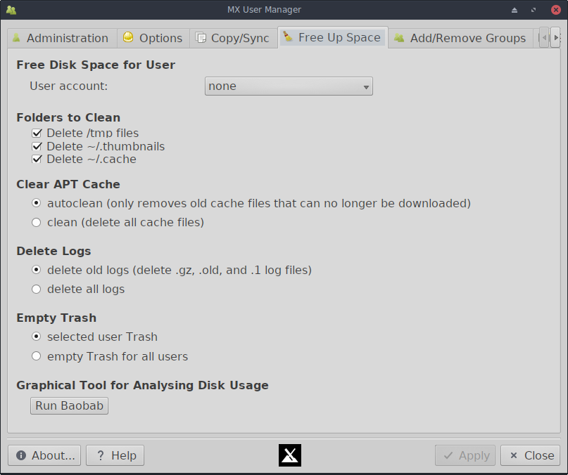

Figure 4-15. The Free Up Space tab of MX User Manager
Let us look at an example. When her machine was slowing down, one user checked free space on the disk using inxi -D and was startled to see that the disk was 96% full. Disk Usage Analyzer provided a good graphical analysis, and clicking on the big red segments revealed that the cache was bloated.
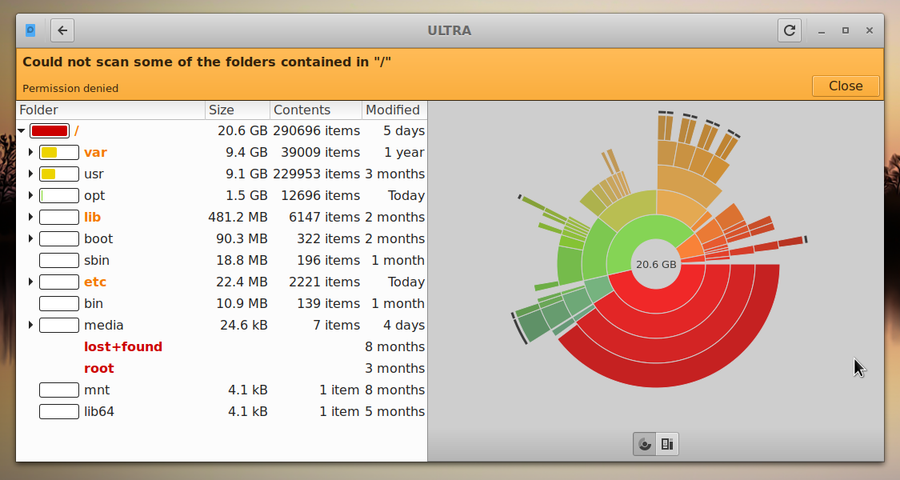

Figure 4-16. Disk Usage Analyzer displaying a root directory almost full
After it had been cleaned using MX User Manager, the percenttage dropped to about 63% and the sluggishness was gone.
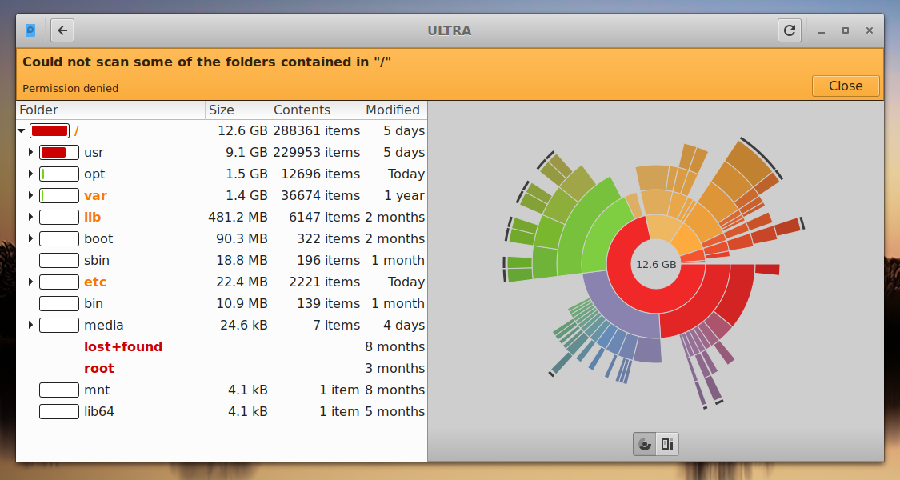

Figure 4-17. The results of clearing out the cache as represented by Disk Usage Analyzer

4.8.3 Error checking
Many error messages are written to the appropriate file in /var/log/ covering problems in applications, events, services and system. Some important ones include:
- /var/log/boot
- /var/log/dmesg
- /var/log/kern.log
- /var/log/messages
- /var/log/Xorg.0.log
They are not always easy to read, but often worth looking at if you suspect a problem. You can look at them in a terminal by using the command cat followed by the location of the log you want to see. It’s usually much easier for most users to install gnome-system-log from the repos for examining them.

4.9 Games
Browsing the extensive list of games available through Synaptic (click Sections >Games at the bottom of the left panel) or following the links below will bring up many other titles for your enjoyment.
The following list contains some examples to whet your appetite.

4.9.1 Adventure and Shooter Games
- Chromium B.S.U.: A fast paced, arcade-style, top-scrolling space shooter. Installed by default.
Chromium B.S.U. home page
- Beneath A Steel Sky: A science-fiction thriller set in a bleak post-apocalyptic future.
Beneath a Steel Sky home page
- Kq: A console-style role playing game, similar to Final Fantasy.
Kq home page
- Mars. “A ridiculous shooter.” Protect planet from your jealous neighbors!
Mars home page

Figure 4-18: Enemy warships on the attack in Chromium B.S.U

4.9.2 Arcade Games
- Defendguin: A clone of Defender, where your mission is to defend little penguins.
Defendguin home page
- Frozen Bubble: Colored bubbles are frozen at the top of the playing screen. As the Ice Press descends, you must pop out groups of frozen bubbles before the Press reaches your shooter.
Frozen Bubble home page
- Planet Penguin Racer: a fun racing game with your favorite penguin.
- Tuxracer home page
- Ri-li: A toy train game.
Ri-li home page
- Supertux: A classic 2D jump’n’run side-scrolling game in a style similar to the original SuperMario games.
Supertux home page
- Supertuxkart: A much improved version of tuxkart.
Supertuxcart home page

Figure 4-19: Ri-li train needs to turn soon

4.9.3 Board Games
- Gottcode games: of the ones available, Peg-E (Peg solitaire game) installed by default.
Gottcode home page
- Mines (gnomines): A minesweeper game for 1 player.
Mines home page
- Do’SSi Zo’la: The goal of the basic Isola game is to block the opponent by destroying the squares which surround him.
Do'SSi Zo'la home page
- Gnuchess: A chess game.
Gnuchess home page

Figure 4-20: High-tension moment in Mines.

4.9.4 Card Games
Here are some fun card games available from the repos.
- Hearts (gnome-hearts):The classic hearts game.
Gnome-hearts home page
- Pysolfc: Over 1,000 solitaire games from a single application.
Pysolfc home page

4.9.5 Desktop Fun
- Xpenguins. Penguins walk around your screen. Can be customized with other characters like Lemmings and Pooh Bear (need to allow programs to run in root window).
Xpenguins home page
- Oneko. A cat (neko) follows your cursor (the mouse) around the screen. Can be customized with a dog or other animal.
Wikipedia: Neko
- Algodoo. This free game presents a 2D physics sandbox where you can play with physics like never before. The playful synergy of science and art is novel, and makes it as educational as it is entertaining.
Algodoo home page
- Xteddy. Puts a cute teddy on your desktop. Alternatively you can add your own image.
Xteddy homepage
- Tuxpaint. A drawing program for kids of all ages.
Tuxpaint home page

Figure 4-21: Budding genius at work in Tuxpaint

4.9.6 Children
- Three packages of games and educational applications are available from MX Package Installer.
- In addition, Scratch is a free programming language and online community where you can create your own interactive stories, games, and animations. MX Package Installer.
Scratch home page

Figure 4-22: Coding screen for Dance Party using Scratch

4.9.7 Tactics & Strategy Games
- Freeciv: A clone of Sid Meyer’s Civilization© (version I), a turn-based multiplayer strategy game, in which each player becomes the leader of a stone age civilization, trying to gain ascendency as the ages progress.
Freeciv home page
- Lbreakout2: LBreakout2 is a breakout-style arcade game where you use your paddle to aim a ball at bricks until all bricks are destroyed. Many levels and surprises. Installed by default.
Lgames home page
- Lincity: A clone of the original Simcity. You must build and maintain a city and keep its people satisfied so that your population grows.
Lincity home page
- Battle for Wesnoth: A highly-rated turn-based strategy game with a fantasy theme. Build your army and fight to regain the throne.
Battle for Wesnoth home page

Figure 4-23: Trying to break through the first wall in Lbreakout

4.9.8 Windows games
A number of Windows games can be played in MX Linux by using a Windows emulator such as Cedega or DOSBox, or some may even run under Wine: see Section 6.1.

4.10 Google tools

Figure 4-24: Integrated Google Calendar and Contacts in Thunderbird

4.10.1 Gmail
Gmail accounts can be easily set up in Thunderbird following the prompts.

4.10.2 Google’s Contacts
Google’s Contacts can be linked into Thunderbird by using the add-on gContactSync.
gContactSync home page

4.10.3 Gcal
Gcal can be set up on a tab in Thunderbird with the add-ons Lightning and Google Calendar Tab.
Lightning calendar home page

4.10.4 Gtasks
Gtasks can be included in Thunderbird by ticking the Tasks entry of the calendar.

4.10.5 Google Earth
The easiest method of installing Google Earth is by using MX Package Installer, where it is in the “Misc” section.
There is also a manual method that may be useful in some installations.
- Install googleearth.package from the repos or directly from the Google repo.
- Open a terminal and enter:
make-googleearth-package
- Once that is finished, become root and type:
dpkg -i googleearth*.deb
- An error message will appear on screen about dependency problems. Correct that by entering this last command (still as root):
apt-get -f install
Now finally Google Earth will appear in Start menu > Internet.

4.10.6 Google Talk
There is a browser plugin called google-talkplugin available from the Google repos that allows you to make a voice or video call to someone from your Gmail account.

