3 Configuration
 Things to do after installation
This section covers configuration instructions in order to get your system running correctly from a fresh installation of MX Linux, and a short guide to personal customization.

3.1 Peripherals

3.1.1 Smartphone
Smartphones & MX-16 (samsung galaxy s5 and iphone 6s)
Android
Sharing files with an Android device.
- Many phones running Android 4.xx include mtp capability, and you can use the following procedure.
  - Connect phone, and make sure storage option id is set to MTP.
  - Open Thunar. When the upper left pane (Devices) shows your phone’s name (or: Storage), click on it. If you don’t see it, reboot the phone.
  - Navigate to the location you are looking for.
- Some files can be viewed and managed with MX Linux applications: click on Device in the left pane, then double-click CD Drive if necessary.
  - Music: use Clementine
  - Pictures: use Shotwell
- If problems, Android phones can be accessed via a web browser by installing an app from Google’s Play Store such as AirDroid.
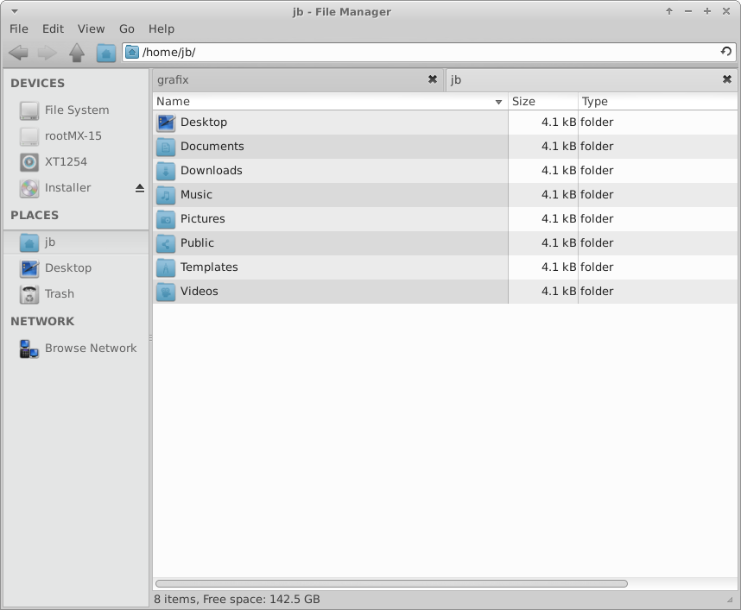
Figure 3-1: Thunar connected to an Android phone
iPhone
Through the iPhone 4 series, MX Linux is able to mount an iPhone in Thunar and reveal its contents for manipulation. Since iOS 5.0, iPhones will not allow a Linux installation to be recognized as a “trusted connection.” File transfer is still possible via an Apple wifi file transfer app or a cloud storage service. See also Section 4.2.
A successful strategy was described for iPhone 6 in this tutorial, but as of this writing it no longer appears to work. Users interested in trying to pursue that should install the package mx-iphone, pair with the command idevicepair pair and then try to continue with mounting iFuse.
As it is, photos can be retrieved by opening Shotwell with the phone attached, then clicking on the link that appears under Cameras. Note that the phone link may not work in Thunar.
Blackberry
Open Synaptic and search on blackberry to find the files that need to be installed.

3.1.2 Printer
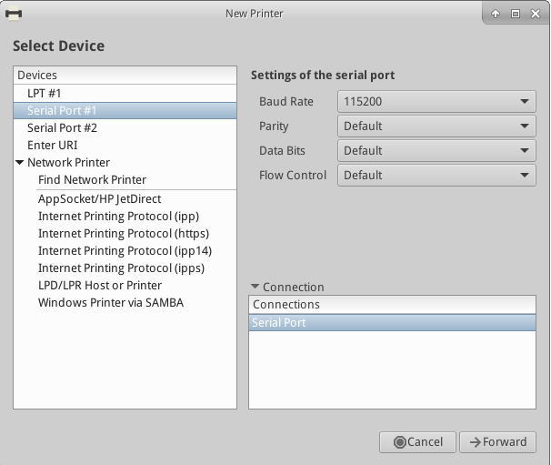
Figure 3-2: Print Setting’s New Printer screen
Attached
MX Linux offers two utilities for configuring and managing printers. Print Settings usually works well, but if problems arise it is recommended that you switch to CUPS in a browser.
- Print Settings application
  - Click Start menu > System > Print Settings
  - Click on the “+Add” button
  - Wait on the New Printer screen while the application searches for attached and wireless printers.
  - Once it has found the printer you want to install, it will also show recommended software.
  - Follow the prompts to conclude the printer installation.
  - HELP: the RedHat manual.
- CUPS in a browser
  - Click Start menu > System > Printers (CUPS)
- NOTE: If your printer is not recognized or does not function correctly, consult the MX/antiX Wiki for detailed help on getting the correct driver.
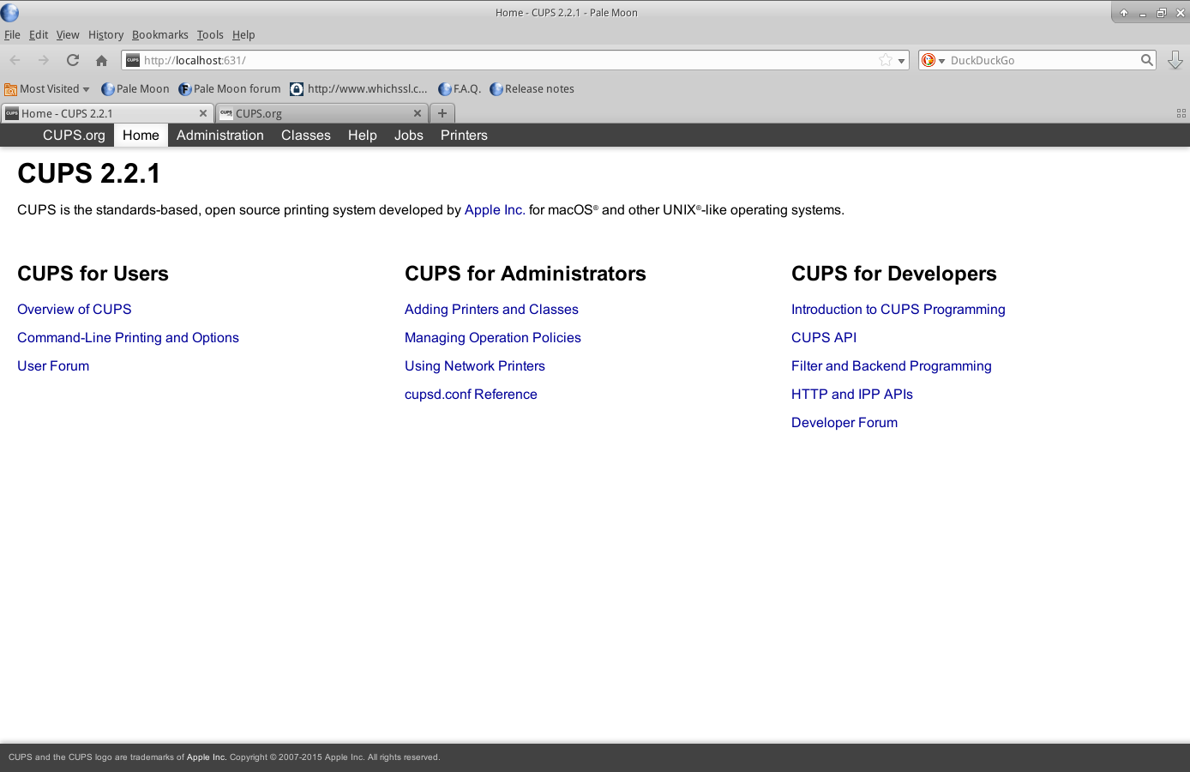
Figure 3-3: the CUPS administration screen for managing printers
Network
Samba on MX Linux allows printing via the network to shared printers on other computers (Windows, Mac, Linux) and NAS (Network Attached Storage) devices offering Samba services (Section 3.5). Other options exist, see the Red Hat Manual (link above to Attached).
Using Print Settings
- Click Start menu > System > Print Settings
- Select Server > New> Printer
- Select Network Printer > Windows Printer via SAMBA
- In the dialog window for smb:// enter either servername/printername or server-ipaddress/printername. For example: bigserver/usbprinter1 or 192.168.0.100/printer2
- If you have trouble identifying the server and printer names, click Start menu > System > MX Find Shares for details.
- Leave the button selected for Prompt user if authentication is required, then click Forward
- Leave the button selected for Select printer from database and then click Forward
- Select the driver and then Forward
- Describe Printer if necessary and then Apply
- When the printer appears in the window, right-click Properties > Print Test Page to make sure the connection and driver are operating correctly.

Using Printers (CUPS)
- Click Start menu > Printers (CUPS) — Manage Printers in a Browser utility
- Select Adding Printers and Classes > Add Printer
- In the dialog window enter root’s password
- In Add Printer > select appropriate choice (e.g., Windows Printer via SAMBA) > Continue
- In the Connection window, enter smb://servername/printername using same method of finding these names as in Printing utility instructions above > Continue
- Enter printer name and descriptions as you would like...Do not tick Share This Printer > Continue
- Select the printer Make > Continue > Add Printer > choose various options > Set Default Options
- Go to Maintenance > Print Test Page to make sure the connection and driver are operating correctly
Troubleshooting
- There is a troubleshooting utility integrated into the Print Settings application. Click Help > Troubleshoot.
- For HP printers, the extra package hplip-gui will install a useful applet into the Notification Area which provides troubleshooting tools.
- If your printer suddenly stops printing, check that is still enabled by clicking Start menu > System > Print settings, then right-click your printer and enable it again.

3.1.3 Scanner
Scanners are supported in Linux by SANE (Scanner Access Now Easy) which is an application programming interface (API) that provides standardized access to any raster image scanner hardware (flatbed scanner, hand-held scanner, video- and still-cameras, frame-grabbers, etc.).
Basic steps
You can manage your scanner in MX Linux with the default gscan2pdf. In addition to being a good general scanner manager, it can export directly to a PDF among other formats. Other scanners such as Simple Scan are available from the repos.
Troubleshooting
- Make sure your scanner is listed as supported by SANE on this list.
- If you have problems, check the MX/antiX Wiki for solutions.

3.1.4 Webcam
Most likely your webcam video will work in MX Linux. If not, there is a recent detailed discussion of drivers and setup in the Arch Wiki. Webcam audio is sometimes trickier, see Section 4.1 about Skype.

3.1.5 Storage
Disk drives (such as SCSI, SATA and SSD), cameras, USB drives, phones, etc. – these are all different forms of storage.
Mounting
By default, storage devices that are plugged into the system mount automatically in the /media/<username>/ directory, and then a file browser window opens for each (that behavior can be changed in Thunar: Edit > Preferences). Though it is turned off by default in MX Linux, you can also have an icon placed on your desktop for mounted devices place by right-clicking an empty space on the desktop > Desktop Settings... > Icons tab, Default Icons box: check Removable Devices.
Permissions
The extent of the user’s access to storage will depend on the file system that it contains. Most commercial external storage devices, especially hard drives, will come preformatted as fat32 or ntfs.
Storage Filesystem | Permissions
fat32 | None.
ntfs | By default, permissions/ownerships are granted to the user that mounts the device.
ext2, ext4, and most Linux  fileystems | Mounted by default with ownership set to Root. Permission adjustment: see Section 7.3.

SSDs
Increasingly, machines may have an internal SSD: a solid state drive that has no moving components. These drives tend to accumulate blocks of data that are no longer considered in use, slowing down this very fast drive. To prevent this from happening, MX Linux runs a TRIM operation on a weekly schedule that you can view by opening the file /etc/cron.weekly/fstrim-mx.

3.1.6 Bluetooth devices
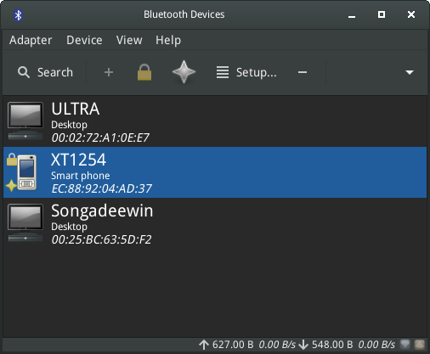
Figure 3-4: the Devices window of Bluetooth Manager, showing devices detected.
External bluetooth devices such as a keyboard, speaker, mouse, etc. will normally work automatically. If not, follow these steps:
- Click Start menu > Settings > Bluetooth Manager (or: right-click the Bluetooth icon in the Notification Area > Devices)
- Check that your adaptor is enabled and it is visible by clicking Start menu > Settings > Bluetooth Adapters
- Make sure the device you want is visible; in Bluetooth Manager click Adapter > Preferences and select your visibility setting.
- If the device you want in the Devices window, select it and then click Setup.
- If not, click the Search button, and press Connect on the line for the device to initiate pairing.
- For a phone, you will likely have to confirm the pairing number on both device and desktop.
- After pairing with the Bluetooth device, the Setup dialog asks you to confirm the type of bluetooth configuration to associate with it.
- When the Setup process is finished, the device should be working.

Object transfer
To be able to pass objects (documents, photos, etc.) back and forth between an MX Linux desktop and a device such as a phone using bluetooth, take the following steps:

3.2 Basic MX Tools
- MX Apps
- MX New utilities
- 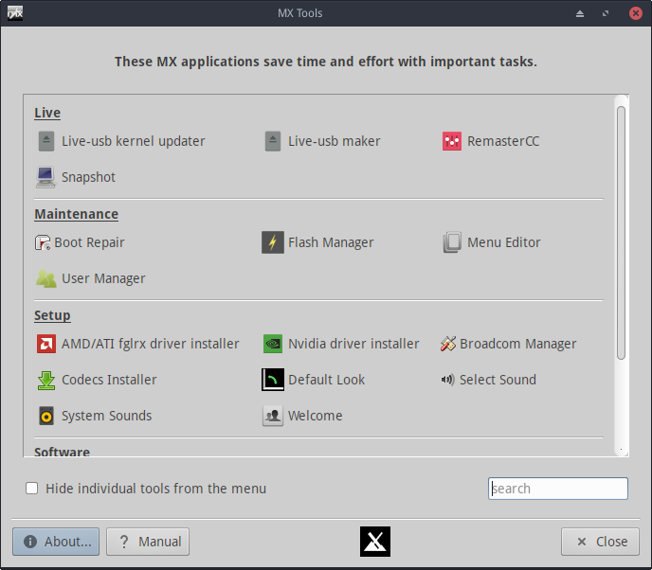
- Figure 3-5: MX Tools dashboard (running Live)
- A number of applications have been developed specifically for MX Linux, adapted or brought over from antiX, or adapted from outside sources to save the user effort with important tasks often involving unintuitive steps. (Advanced “Live” tools are treated in Section 6.6)

3.2.1 AMD/ATI and Nvidia driver installers
- These graphics driver installer vastly simplify an important procedure: to install a proprietary graphic driver. There are separate icons for AMD/ATI and Nvidia on the MX Tools dashboard, but they are using much of the same underlying code (ddm-mx) so are treated here together. Clicking on the appropriate icon brings up a terminal, and all the user need do in most cases is accept the default.
- 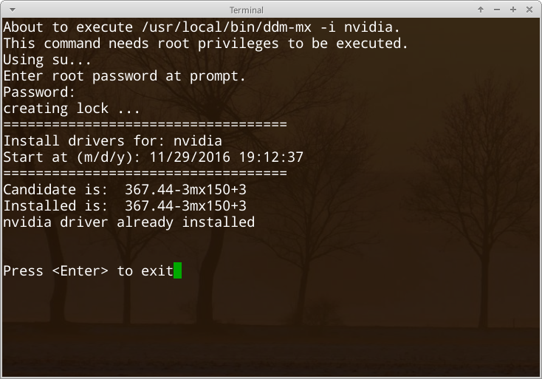
- Figure 3-6: MX Nvidia driver installer finding no need to continue
- HELP: here.

3.2.2 Apt-notifier
- Not shown on the MX Tools dashboard, this extremely handy and versatile applet (a box in white outline) sits in the Notification Area where it monitors package updates and notifies you when they are available by making the box green. It is much quicker than going through Synaptic (Section 5.3). Be sure to check the important options available through the context (right-click) menu.
- 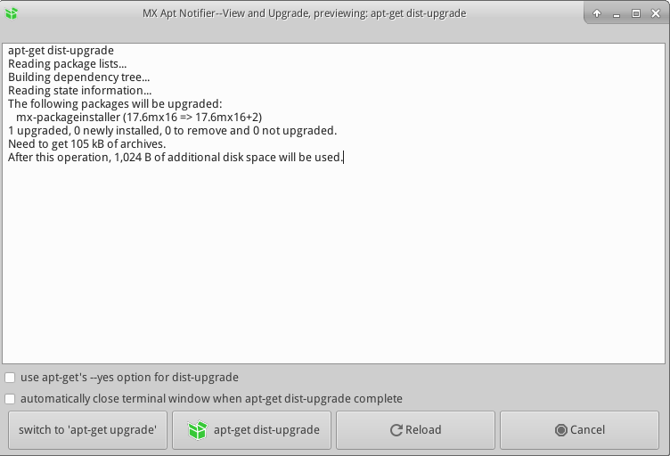
- Figure 3-7: View and upgrade screen from Apt-notifier
- HELP: here.

3.2.3 Boot repair
- The bootloader is the first software program to run and is responsible for loading and transferring control to the kernel. It sometimes happens that the bootloader on an installation (GRUB2) becomes dysfunctional, and this tool allows you to restore the bootloader to a functional state from a LIVE boot.
- 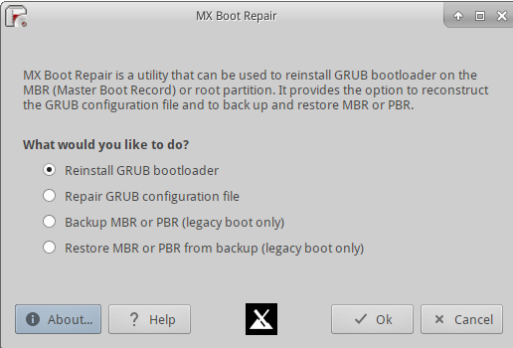
- Figure 3-8: Boot Repair main screen
- HELP: here.

3.2.4 Broadcom Manager
- MX Broadcom Manager
- Broadcom chipsets are often difficult to set up, and this application renders the process much easier by detecting hardware and permitting Linux and Windows drivers to be added, removed, and blacklisted. It provides good general network tools as well on the “Net diagnosis” tab.
- 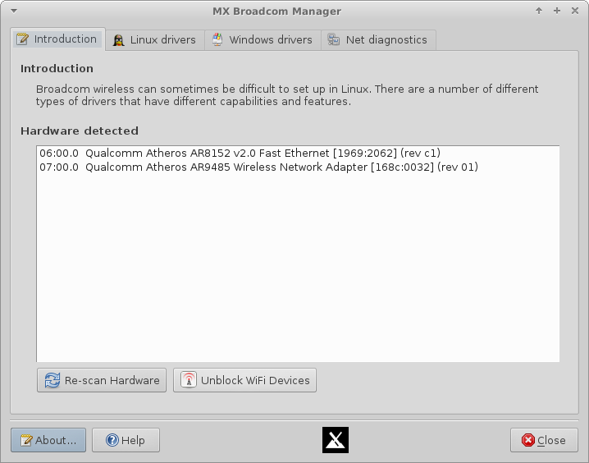
- Figure 3-9: Broadcom Manager detecting wireless and wired hardware
- HELP: here.

3.2.5 Check Apt GPG
- Apt (Apt-get) includes package authentication in order to improve security. You can still install non-authenticated packages, but you will run into an error: The following signatures couldn’t be verified because the public key is not available. This helpful utility saves carrying out the many steps necessary to obtain that key.
- 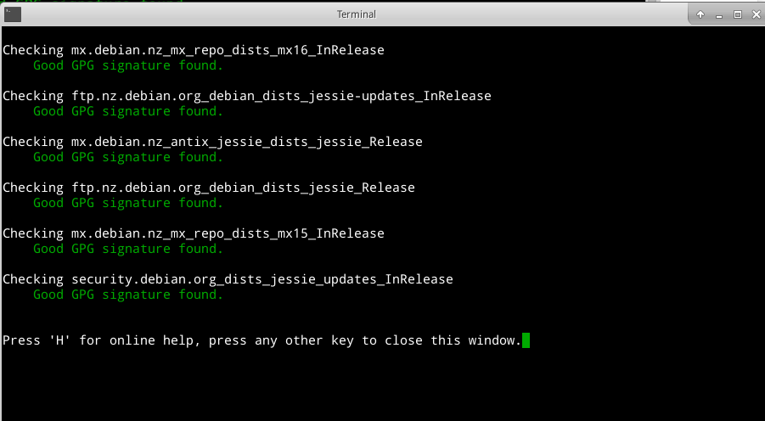
- Figure 3-10: Results of checking repo public keys with Check Apt GPG
- HELP: here.

3.2.6 Codecs Downloader
- A codec is a piece of software that enables encoding/decoding a digital data stream or signal. Most codecs will be installed in MX Linux by multimedia applications such as VLC, but some are restricted. This tool allows easy installation of certain restricted codecs while transferring the responsibility to the user.
- 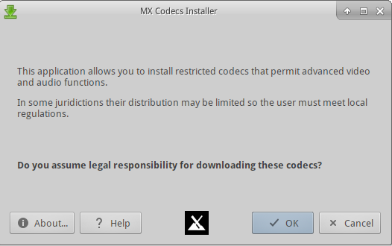
- Figure 3-11 Codecs installer main screen
- HELP: here.

3.2.7 Compton Manager
- MX Compton Manager
- MX Compton Manager gives you an easy way to start, stop, and configure the compton compositor to eliminate video tearing.
- 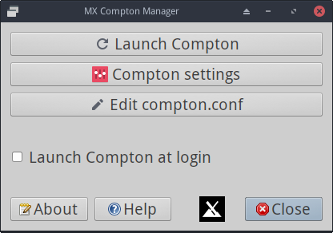
- Figure 3-12: Compton Manager
- HELP: here.

3.2.8 Debian Backports Installer
- This tool has been incorporated into Package Installer for MX-16.1.

3.2.9 Default Look
- On the Welcome screen and available through MX Tools, this little application allows you to quickly select the default theme you want to use as well as to decide how you want the panel oriented. It also offers quick links to related Xfce settings.
- 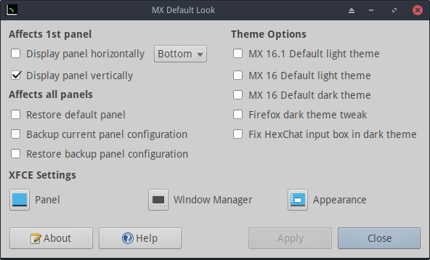
- Figure 3-13: ready to select the vertical panel orientation
- HELP: here.

3.2.10 Find Network Shares
- This utility has been removed with the point release MX 16.1 because of licensing concerns.

3.2.11 Flash Manager
- This utility has been removed with the point release MX-16.1 because Adobe® Flash® Player is now installed by default.
- MORE: here.

3.2.12 Live-usb Maker
- This straightforward tool allows you to create quickly a live-usb starting from an iso file, a live -cd/dvd or an existing live-usb or even a running live system.
- 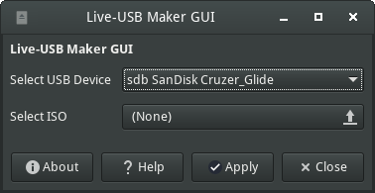
- Figure 3-14: Live-USB Maker
- HELP: here.

3.2.13 Menu Editor
- MX Menu Editor
- This simple menu editor makes it easy to edit, add or delete menu items. Any edits are saved to the user’s directory /.local/shared/applications/, which takes precedence over the /usr/share/application/ when the Xfce menu gets built during startup. Also available by right-clicking the Start menu icon > Edit Applications.
- 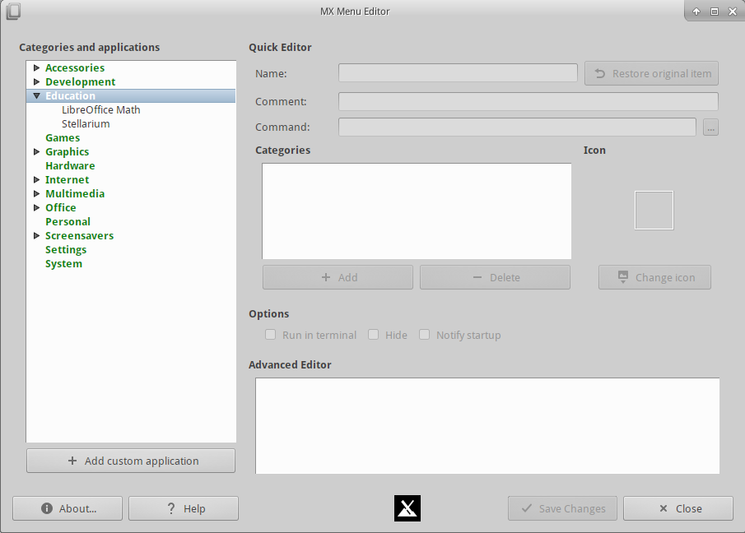
- Figure 3-15: Menu Editor with the category Education expanded
- Note: the MX Menu Editor can be easily accessed through the context menu of the Whisker icon in the lower left corner.
- HELP: here.

3.2.14 Package Installer
- Install Apps with MX Package Installer
- This application displays two tabs: Popular Applications and Full App Catalog. With it you can install (or remove) both popular packages and any package in the MX/Debian Stable, the MX Test, and the Debian Backports repos in a simplified manner. The first tab is particularly useful for installations that are not intuitive or require multiple packages. It is also very handy for installing language packs, which can be troublesome to chase down with other methods. The second, in addition, allows quick access to any of the repos without needing to go through the manual procedure of enabling repos, updating them, and disabling them again.
- 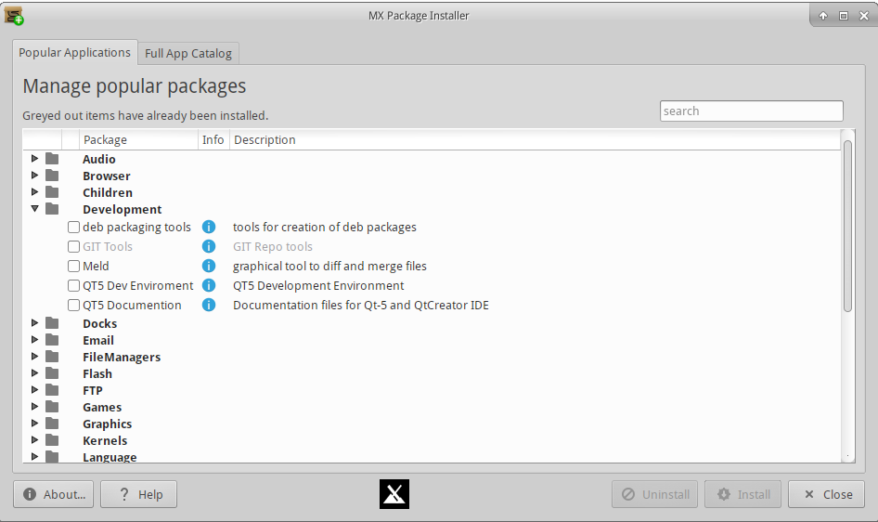
- Figure 3-16: Package Installer, showing original and new tabs
- If you would like to suggest changes in the Popular Applications list, please post on the MX Forum.
- HELP: here.

3.2.15 Panel Orientation
- This tool has been incorporated into Default Look with the point release MX 16.1.

3.2.16 Repo Manager
- Although the most appropriate repository for a user is selected automatically during installation, there are many reasons why the user might want later to change that choice, ranging from a server being offline to a change in the physical location of the computer. This great tool provides one-click switching of repos, saving a lot of time and effort.
- Starting with the point release MX-16.1, it also provides a button that will test all repos (MX or Debian) and select the fastest.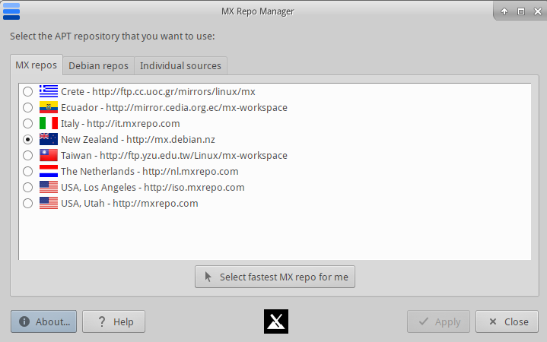
- Figure 3-17: Choosing a repository to use in Repo Manager
- HELP: here.

3.2.17 Sound Card
- Computers frequently have more than one sound card available. In a common situation, for instance, a separate card may be present for HDMI output. Unless the correct sound card is identified for the system, the user will hear nothing and conclude that sound is not working. This clever little application allows the user to select which sound card should be used by the system, whether in a particular instance or in general.
- 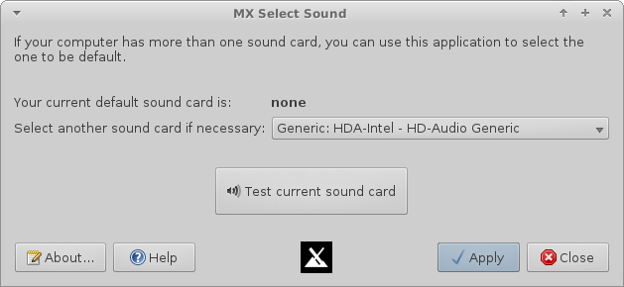
- Figure 3-18: Making the selection in Sound Card
- HELP: here.

3.2.18 System Sounds
- This little tool gathers into a single location the various actions and choices involved in setting up system sounds such as login/logout, actions, etc.
- 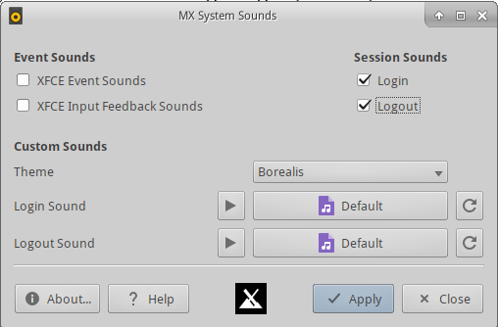
- Figure 3-19: Setting up login and logout sounds in System Sounds
- HELP: here.

3.2.19 Test Repo Installer
- This tool has been incorporated into Package Installer with the point release MX 16.1.

3.2.20 USB Unmounter
- This tool for quickly unmounting USB and optical media sits in the Notification Area when enabled (default). A single click displays available media for unmounting with a double-click.
- 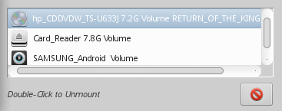
- Figure 3-20: USB Unmounter with a device highlighted for unmounting
- HELP: here.

3.2.21 User Manager
- Everything in Linux runs under a specific user, and each user’s permissions govern whether and how it runs. The superuser (“root”) can create users, give them specific passwords, restrict what they can do, etc. Moreover, each user belongs to one or more groups. This application aids in adding, editing, removing users and groups in your system.
- 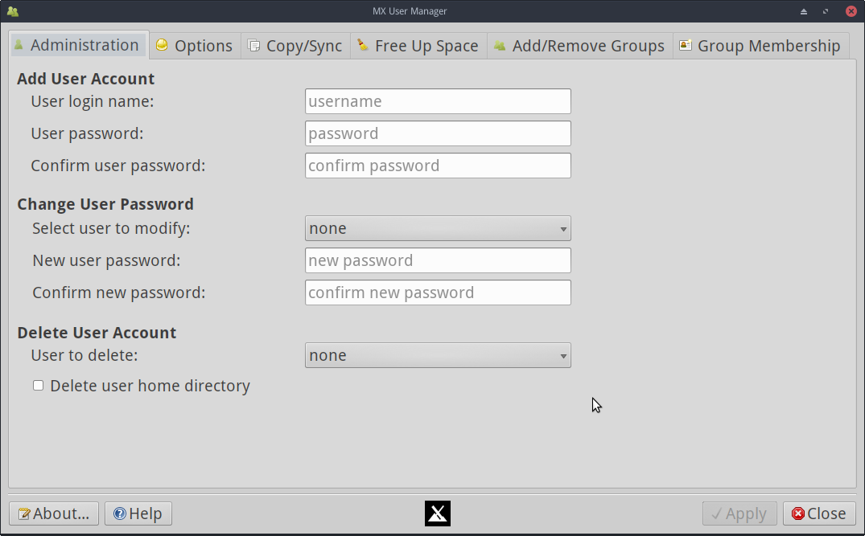
- Figure 3-21: User Manager, administration tab
- HELP: here.

3.3 Display

3.3.1 Resolution
- Resolution refers to the physical number of columns and rows of pixels creating the display (e.g., 1920x1200). In most cases, the resolution is correctly set by the kernel during installation or when a new monitor is connected. If not, you can change it in the following ways:
- Click Start Menu > Settings > Display. Use the pull-down menus to set the correct values for the monitor you want to adjust.
- For Nvidia cards, you can install the package nvidia-settings that will give you a graphic tool that you can use to alter settings as root with the command: nvidia-settings
- In difficult situations, it is possible to manually alter the configuration file /etc/X11/xorg.conf. Always back up the file before you change it, and check the Forum for help about the use of that file.

3.3.2 Graphic drivers
- If you are not satisfied with your display’s performance, you may need/want to upgrade your graphic driver (make sure to first back up the file /etc/X11/xorg.conf, if used). Note that after a kernel upgrade you may have to repeat this, see Section 7.6.3.
- There are various methods available to do this.
- For most Nvidia and AMD/ATI cards, by far the easiest method is to use the installers accessible from the MX Tools dashboard (see Section 3.2.1).
  - Some older or less common video cards require drivers (such as openchrome, mach64 & fbdev) that are only easily installable with sgfxi (Section 6.5.3).
  - Some Nvidia cards are no longer supported in Debian Stable (“Jessie”), see the MX/antiX Wiki. They are, however, supported by the nouveau and vesa drivers.
- It is also possible, but more complicated, to download directly from the manufacturer. This method will require you to select and download the correct driver for your system; for system info, open a terminal and enter: lspci | grep VGA.
Here are driver websites for the three most popular brands (do a web search on “<brandname> linux driver” for others):
  - Nvidia
  - ATI
  - Intel
Intel drivers must be compiled, but Nvidia and ATI drivers are easily installed:
  - Navigate in Thunar to the folder where the driver was downloaded
  - Right-click the file, select the Permissions tab, check Is executable
  - Press CTRL-ALT-F1 to exit X (the graphical environment) and get to a terminal prompt
  - Log in as root
  - Type: service lightdm stop
  - Type: sh <filename>.run (make sure to use the actual name of the file)
  - Allow the NVIDIA driver to turn off the nouveau kernel
  - When it finishes, type: service lightdm start to start lightdm and xorg again.
- Another important driver option is mesa, an open-source implementation of the OpenGL specification - a system for rendering interactive 3D graphics. Users on high-performance machines report that upgrading this brings a significant stabilization to their system. The most recent version is usually available in the test repo; use the MX Package Installer (Section 3.2.14) to get it. Alternatively, open a root terminal and paste in this command:
dpkg -l | grep $(dpkg -l libgl1-mesa-dri | awk ’{print $3}’ | tail -1) | awk ’{print $2}’ | xargs sudo apt-get install --force-yes -y
- Basic adjustment
- Click Start Menu > All Settings > Appearance, Fonts tab
- Click on the pull-down menu to see the list of fonts and point sizes
- Select the one you want, and click OK
- 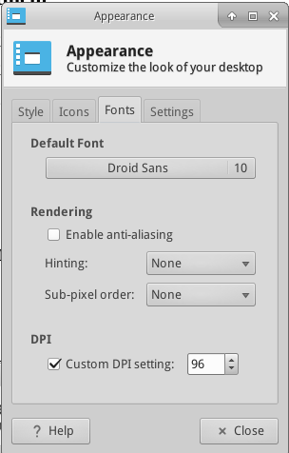
- Figure 3-22: Changing font details in All Settings
- Advanced adjustments
- A number of options are available by running in a root terminal: dpkg-reconfigure fontconfig-config
- Firefox: click Edit > Preferences > Content, and make any desired changes.
- For further adjustment, see the MX/antiX Wiki.

- Adding fonts
- Click Start Menu > System > Synaptic Package Manager.
- Use the search function for fonts.
- Select and download the ones you want. The Microsoft core fonts package ttf-mscorefonts-installer provides easy installation of the Microsoft True Type Core Fonts for use with websites and MS applications that run under Wine.
- Extract if necessary, then copy as root (easiest in a root Thunar) the font folder to /usr/share/fonts/.
- Your new fonts should be available in the pull-down menu in All Settings > Appearance, Fonts tab.

3.3.3 Dual monitors
- Multiple monitors are managed in MX Linux with Start menu > Settings > Display. You can use it to adjust resolution, select whether one clones the other, which ones will be turned on, etc. It is often necessary to log out and back in to see the display you select. Finer control of some features is sometimes available with lxrandr (install if necessary).
- Xfce 4.12 has some limitations with multiple monitors, so search the Xfce Forum and the MX/antiX Wiki if you are having unusual problems.
- 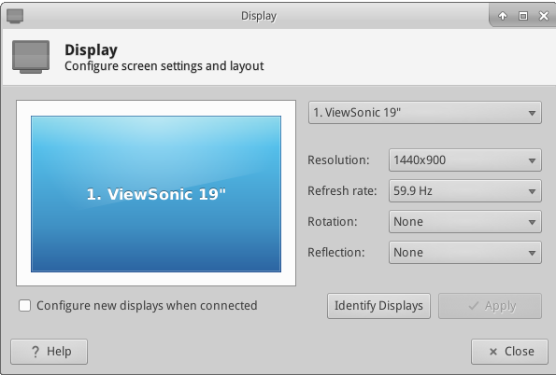
- Figure 3-23: Selecting display values in All Settings > Display

3.3.4 Power management
- Click the Power Manager plugins icon in the Panel. Here you can easily switch to Presentation mode, or go to the Settings to set when a display shuts down, when the computer goes into suspension, the action initiated by closing the lid of a laptop, brightness, etc. On a laptop, battery status and information is displayed and a brightness slider is available.
- Be careful about making changes to

3.4 Network
- Internet connections are handled by Network Manager; click the applet in the Notification Area to see status, connect and explore options.
- Right-click the applet > Edit Connections to open up a Settings box with five tabs.
- Wired. In most situations this requires no attention; highlight and click the Edit button for special setups.
- Wireless
  - Network Manager will usually automatically detect your network card and use it to find available access points. In some situations, the command-line tool Ceni in the repos may be helpful.
  - For details, see Section 3.4.2 below.
- Mobile Broadband. This tab allows you to use a 3G/4G mobile device for access to the web. Click the Add button to set up.
- VPN. Click the Add button to set up. If you experience setup problems, consult the MX/antiX Wiki.
- DSL. Click the Add button to set up.
- :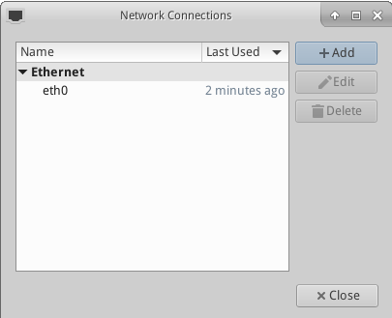
- Figure 3-24: Network Manager main screen
- MORE: Ubuntu Wiki: Network Manager

3.4.1 Wired access
- MX Linux typically picks up wired internet access upon boot without much problem. If a Broadcom driver is required (rare), then use MX Broadcom Manager (Section 3.2.4)
- Ethernet and cable
- MX Linux comes preconfigured for a standard LAN (Local Area Network) that uses DHCP (Dynamic Host Configuration Protocol) to assign IP addresses and DNS (Domain Name System) resolution. This will work in most cases as-is. You can change the configuration with Network Manager.
- When you boot MX Linux, your network adapters are assigned a short interface name by udev, the kernel’s device manager. For normal wired adapters this is usually eth0 (with subsequent adapters eth1, eth2, eth3, etc). USB adapters often come up on the eth0 interface in MX Linux, but the interface name can also depend on the adapter’s chipset. For instance, atheros cards often show up as ath0, while ralink usb adapters may be rausb0. For more a detailed list of all found network interfaces, open a terminal, become root, and enter: ifconfig -a.
- It is wise to connect to the Internet through a router, as nearly all wired routers contain optional firewalls. In addition, routers use NAT (Network Address Translation) to translate from big Internet addresses to local IP addresses. This affords another layer of protection. Connect to the router directly, or through a hub or switch, and your machine should autoconfigure via DHCP.
- ADSL or PPPoE
- If you use ADSL or PPPoE, connecting to the internet is easy in MX Linux. Right-click the Network Manager icon, then the DSL tab. Click the Add... button and fill in the required information, checking to connect automatically if you want.
- NOTE: if you encounter problems when using a USB device to connect, plug the unit into the computer, open a terminal and type:
- dmesg | tail
- Post a message on Forum with the output to get some help in finding the driver you need.
- 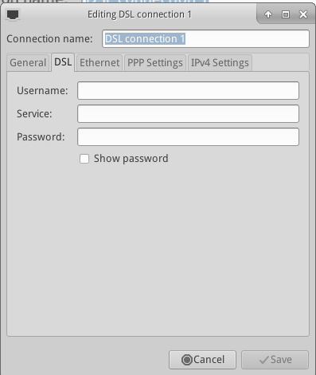
- Figure 3-25: Setting up DSL service

- Dial-Up
- On the Device tab you will need to set up the serial information. Accepting the default /dev/modem may work, but you might need to try another interface. These are the Linux equivalents of the COM ports under MS-DOS and MS-Windows:
- Table 3: Linux equivalents for COM ports
- Port | - Equivalent
- COM 1 | - /dev/ttyS0
- COM 2 | - /dev/ttyS1
- COM 3 | - /dev/ttyS2
- COM 4 | - /dev/ttyS3

3.4.2 Wireless access
- MX Linux comes preconfigured to autodetect a WiFi card, and in most cases your card will be found and set up automatically. There are two standard ways wireless can be supported in MX Linux:
- With a native driver that comes as part of the Linux kernel (example: ipw3945 for Intel).
- With a Windows driver using the application Ndiswrapper (available from the repos), which “wraps” your Windows driver so that it can be used in a Linux system (example: bcmwl5 for some Broadcom chipsets). See below for more.
- Sometimes there is both a native Linux driver and a Windows driver available. You may want to compare them for speed and connectivity, and you may have to remove the one you are not using to prevent a conflict. Wireless cards can be either internal or external. USB modems (wireless dongles) usually show up on the wlan interface, but if not then check others on the list. NOTE: The successful method varies for users because of the complicated interactions among the Linux kernel, wireless tools, and the local wireless card chipset and router.
- Basic Wireless Steps
- Click Start menu > Settings > Network Connections (or just click on the Network Manager icon in the Notification Area), and then the Wireless tab. One of 3 situations will arise.
- –A wireless network has been found.
- Click on the name of the network to use it.
  - Right-click the icon to access further options.
  - When done, click OK.
- –The found network does not function.
- If wireless networks are seen but your computer cannot connect them, this means that either 1) the wireless card is managed correctly by the right driver but you have problems concerning the connection to your modem/router, the firewall, the provider, DNS, etc.; or 2) the wireless card is managed abnormally because the driver is not the most appropriate for that card or there are problems of conflict with another driver. In this case you should gather information on your wireless card to see if the card drivers may have problems and then try to test the network with a set of diagnostic tools.
- Find out basic information by opening a terminal and entering one at a time:
- inxi -n
- lsusb | grep -i net
- lspci | grep -i net
- And as root:
- iwconfig
- The output from these commands will give you the name, model and version (if any) of your wireless card (example below), as well as the associated driver and the mac address of the wireless card. The output of the fourth will give you the name of the access point (AP) you are linked to and other connection information. For example:
- Network
Card-2:Qualcomm Atheros AR9462 Wireless Network Adapter driver: ath9k
IF: wlan0 state: up mac: 00:21:6a:81:8c:5a
- Sometimes you need the mac number of the chipset in addition to that of your wireless card. The easiest way to do that is to click Start menu > System > MX Broadcom Manager, Introduction tab. For example:
- Qualcomm Atheros AR9485 Wireless Network Adapter [168c:0032](rev 01)
- The number in brackets identifies the type of chipset in your wireless card. The numbers before the colon identify the manufacturer, those after it the product.
- Use the information you have gathered in one of the following ways:
- Do a web search using that information. Some examples using the above lspci output.
linux Qualcomm Atheros AR9462
linux 168c:0032
debian stable 0x168c 0x0034
  - Consult the Linux Wireless and the Linux Wireless LAN Support sites below to find out which driver your chipset needs, what conflicts might exist, and whether it needs firmware installed separately. Post your information on the Forum and ask for help.
  - Turn off the firewall, if any, until the linkage occurs between computer and router.
  - Try restarting the router.
  - Use the Diagnostic Section in MX Broadcom Manager to ping your router using the mac address, ping to any website such as Google or run traceroute. If you can ping a site using its IP (gotten from a web search) but you can not reach it with its domain name, then the problem may be in the configuration of the DNS. If you don’t know to interpret the results of ping and traceroute do a web search or post the results on the Forum.
  - Sometimes using the terminal application Ceni (in the repos) can reveal hidden access points and other difficult factors. NOTE: using Ceni to configure your network interface in MX Linux will interfere and/or disable management of that interface by the default Network Manager. Ceni stores its configuration info in /etc/network/interfaces. Any interface defined in /etc/network/interfaces will be ignored by Network Manager, as Network Manager assumes that if a definition exists, you want some other application managing the device.
- –No wireless interface is found.
- Open a terminal and type the 4 commands listed at the beginning of the previous section. Identify the card, chipset and driver you need by doing a web search and consulting the sites reported, according to the procedure described above.
  - Look for the network entry, and note the detailed information on your specific hardware, and look for more information about that from the LinuxWireless site listed below, or ask on the Forum.
  - If you have an external wifi device and no information on a network card is found, unplug the device, wait a few seconds then plug it back in. Open a terminal and enter:
dmesg | tail
Examine the output for information about the device (such as the mac address) that you can use to pursue your issue on the web or the Forum.
  - Probably the most common example of this situation arising is with the Broadcom wireless chipsets; see the MX/antiX Wiki.
- Firmware
- For some cards it is necessary to install firmware (for example, firmware-ti-connectivity for Texas Instruments WL1251). MX Linux comes with a good deal of firmware already available, but you may have to track down your particular need, again using the LinuxWireless website linked below.

- Ndiswrapper
- Ndiswrapper is an open-source software driver “wrapper” that enables the use of Windows drivers for wireless network devices in Linux. It does not come pre-installed in MX Linux, but is in the repos. NOTE: the Windows driver you use must match the OS architecture (e.g., Windows 32-bit driver for MX Linux 32-bit edition). In general, Windows XP drivers are required.
- The easiest method of managing Ndiswrapper is to use MX Broadcom Manager (Section 3.2.3). See also the extended discussion in the MX/antiX Wiki.
- Security
- Wireless security is handled by Network Manager. Here are the basic steps you need to follow:
- Right-click the Network Manager icon in the Notification Area > Edit connections
- Click on the Wireless tab
- Highlight the name of the access point you want to connect to (for example, “linksys” or “starbucks 2345”)
- Click the Edit button and then the Wireless Security tab
- Use the pull-down menu to select the security you want (for example: WPA and WPA2 Personal)
- Enter the password and click Save.
- 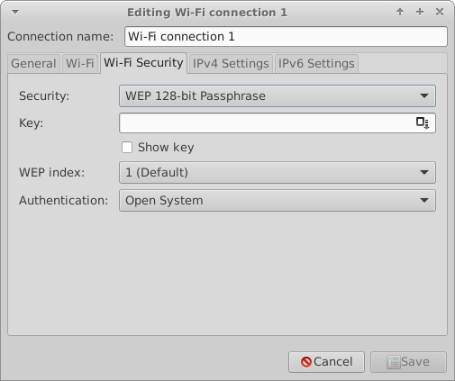
- Figure 3-26: Wireless security in Network Manager

- It is equally possible to use Ceni to handle wireless security, as long as subsequently you will not be using Network Manager, with which it interferes.
- Links
- Linux Wireless
- Linux Wireless LAN Support
- Debian Wiki: Wifi
- Arch Wiki: Wireless

3.4.3 Mobile Broadband
- For wireless internet access using a 3G/4G modem, please refer to the Debian Wiki’s 3G pages linked below for compatibility information. Many 3G/4G modems will be recognized on MX Linux by Network Manager.
- Troubleshooting
- On some systems, modem connections fail due to an upgrade of the packages udev and libudev1. To solve this, open Synaptic, highlight the packages, and then click Package> Force version... Use the pull-down menu to drop to a lower version and click the Apply icon.
- In some cases this solution has not worked consistently for users, but they have found that the complete removal of Network Manager solved the problems.
- MORE: Debian Wiki: 3G modem

3.4.4 Command line utilities
- Command line utilities are useful for seeing detailed information, and are also commonly used in troubleshooting. Detailed documentation available in the man pages. The most common ones below must be run as root.
- Table 4: Wireless utilities
- Command | - Comment
- ifconfig | - Main configuration utility for network interfaces.
- ifup <interface> | - Brings up the specified interface. For example:  - ifup eth0 will bring up the ethernet port eth0
- ifdown <interface> | - The opposite of ifup
- iwconfig | - Wireless network connection utility. Used by itself, displays wireless status. Can be applied to a specific interface, e.g. to select a particular access point
- rfkill | - Disable softblock for wireless network interfaces (e.g., wlan).
- depmod -a | - Probes all modules and, if they have changed, enables new configuration.

3.4.5 Static DNS
- It is sometimes desirable to change your internet setup from the default automatic DNS (Dynamic Name Service) configuration to a manual static one. Reasons for doing this may include greater stability, better speed, parental control, etc. You can make such a change either for the whole system or for individual devices. In either case, get the static DNS settings you are going to use from OpenDNS, Google Public DNS, etc., before you start.

- System
- You can make the change for everyone using your router using a browser. You will need:
- the router’s URL (list here if you have forgotten)
- its password, if you set one
- You will need to find and change your router’s configuration panel, following the directions for your particular router (list of guides here).
- Individual
- For single user change, you can use Network Manager.
- Right-click the connection icon in the Notification Area > Edit connections...
- Highlight your connection and click the Edit button.
- On the IPv4 tab, use the pull-down menu to change the Method to “Automatic (DHCP) addresses only”
- In the box for “DNS Servers” enter the static DNS settings you are going to use.
- Click Save to exit.

3.5 File management
- File management in MX Linux is carried out through Thunar, a fast and powerful tool. Much of its basic use is self-evident, but here are good things to know:
- Hidden files are out of sight by default, but can be made visible via the menu (View > Show Hidden Files) or by pressing Ctrl-H
- The Side Pane can be hidden, and directory (folder) shortcuts can be placed there by right-clicking > Send To
- The context menu has been populated with common procedures (“Custom Actions”) that vary by what is present or under focus.
- Root action is available via the context menu to open a terminal, edit as root, or open an instance of Thunar with root privileges.
- Thunar easily handles FTP transfers, see below.
- Custom Actionsgreatly increase the power and utility of Thunar. MX Linux comes with many pre-installed, but there are others available to copy and the individual can create them for individual needs. See Tips and Tricks (Section 3.5.1), below; and the MX/antiX Wiki.
- 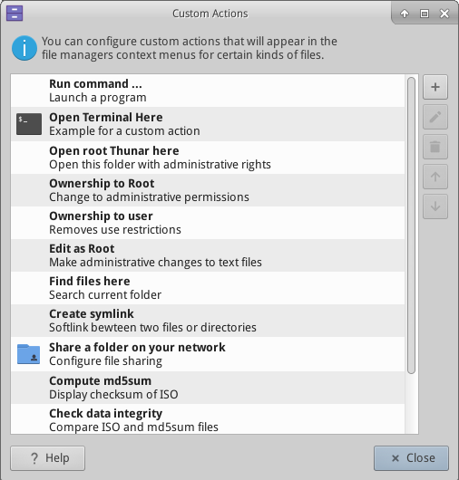
- Figure 3-27: Custom actions set up in Thunar

3.5.1 Tips and Tricks
- Enable thumbnail images in Thunar
- When working in a directory that requires superuser privileges, you can right-click > Open root Thunar here (or FIle > Open root Thunar here).
- You can set up tabs with File > New Tab (or Ctrl-T), then move items from one location to another by dragging them to a tab and releasing it.
- You can assign a keyboard shortcut key to the Custom Action “Open terminal here.”
  - Enable editable accelerators in All Settings > Appearance > Settings.
  - In Thunar, hover your mouse over the File > Open in Terminal menu item and press the keyboard combination that you would like to use for that action.
  - Then when browsing in Thunar, use the keyboard combination to open a terminal window in your active directory.
  - This applies equally to other items on Thunar’s File menu; for instance, you could assign Alt-S to create a symlink for a highlighted file, etc.
- Actions listed in the context menu can be edited/deleted, and new ones added, by clicking Edit > Configure custom actions...
- Various options and hidden commands are also visible, see Links below.
- Both Java and Python are sometimes used to produce applications, carrying the ending *.jar and *.py, respectively. New in MX-16: these files can be opened with a single click, like any other file; no more need to open a terminal, figure out what the command is, etc.
- Compressed files can be managed by a right-click on the file. The archiver working in the background is file-roller (Start menu > Accessories > Archive Manager).
- To find files, open Thunar and right-click any folder > Find files here. A dialog box will pop up to give you options. Running in the background is catfish (Start menu > Accessories > Catfish).
- To set up a soft link (AKA symlink), right-click the target (file or folder you want the link to point to) > Create symlink. Then right-click the new symlink, cut it and paste it to where you want it.
Thunar custom actions

3.5.2 FTP
- 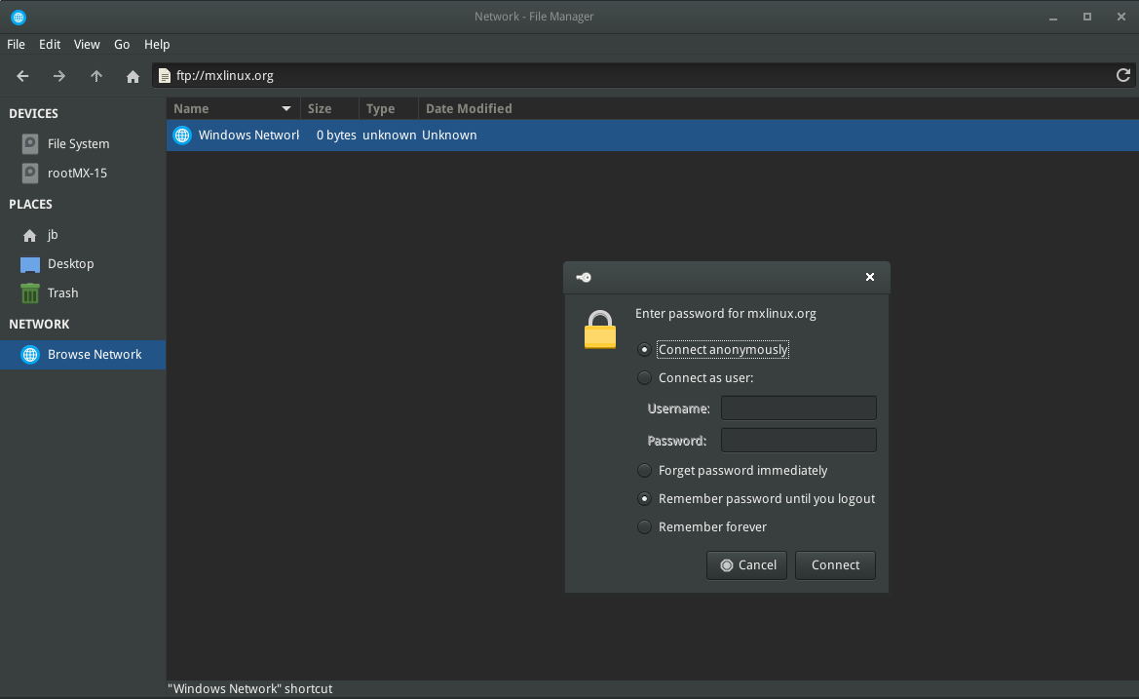
- Figure 3-28: Using Thunar to access an FTP site
- The File Sharing Protocol (FTP) is used to transfer files from one host to another host over a network.
- Open Thunar and click on the Browse Network icon in the left pane
- In the address field, type the server name with the ftp:// prefix. For example, to reach the MX documentation (if you have permission) you would enter this address: ftp://mxlinux.org
- Up pops an authorization dialog box. Fill in username and password, and let it save password if you are comfortable with that.
- That’s it. Once you have navigated to the folder you are always going to use, you can right-click the folder > Send to > Side Pane to create a very simple way to connect.
- Dedicated FTP applications can be installed with the MX Package Installer.
- For a discussion of how FTP works, see this page.

3.5.3 File sharing
- There are various possibilities to share files between computers or between a computer and a device
- Samba. SAMBA is the most complete solution to share files with Windows machines on your network without making changes to the Windows machines. SAMBA can also be used by many network media players and Network-attached storage (NAS)] devices. SAMBA offers some other services for interfacing with Windows networks, such as domain authentication, messaging services, and netbios name resolution. For details, see below.
- NFS. This is the standard Unix protocol for sharing files. Many feel it is better than Samba for sharing files, and it can be used with Windows (2000 & XP) machines if you install “Services for Unix” or a third-party NFS client on them. Details: see MX/antiX Wiki.
- Bluetooth: For file exchange, install blueman from the repos, reboot, pair with the device, then right-click the bluetooth icon in the Notification Area > Send Files to Device.

3.5.4 Shares (Samba)
- 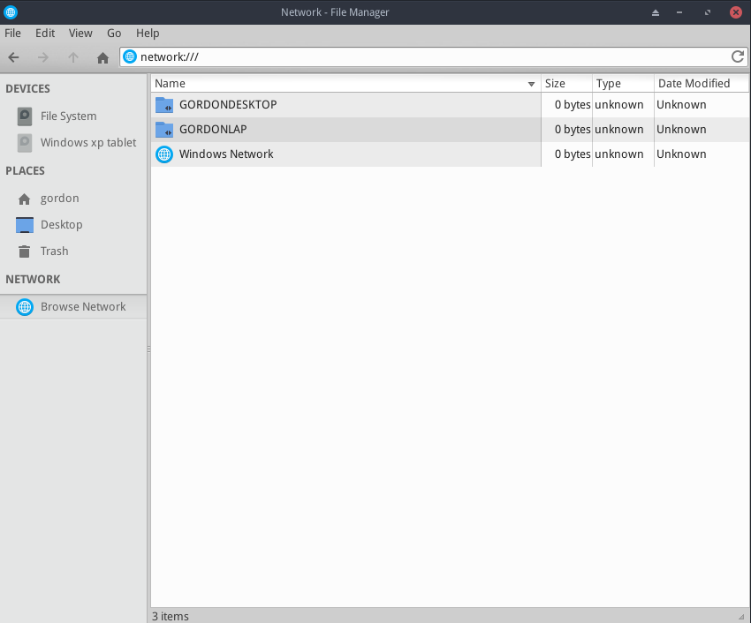
- Figure 3-29: Using Thunar to browse network shares
- Thunar can connect to shared folders (AKA Samba Shares) on Windows, Mac, Linux computers and NAS (Network Attached Storage) devices. For printing with Samba, see Section 3.1.2.
- Select Browse Network in the left pane to show various networks, including Windows Network
- Click the Network you want to see available Workgroups (often called WORKGROUP by default). Now drill down to find what you are looking for.
- Select a Workgroup for available Samba Servers
- Select a Server for available Samba Shares
- Select a Samba Share to see all the available folders
- A shortcut for the selected Share will be created in the Network sidebar section

3.5.5 Creating shares
- On MX, Samba can also be used to create Shares for other computers (Windows, Mac, Linux) to access. Creating Public Shares is fairly straightforward, but keep in mind that creating Samba Shares is a complex area from a configuration perspective. For example, the task creating Shares that are specific to individual users and are authenticated properly is beyond the scope of this help. Comprehensive reference guides can be found at Using Samba and Samba.org.
- Basic method
- Create a share with the Samba configuration tool
- Click Start menu > System > Samba to bring up the Samba Server Configuration tool. Click on the plus sign icon to add a share; details available by clicking on the Help icon. NOTE: users often find that the configuration tool must be augmented with the manual method, below.
- Manual method
- Create a share manually
- If for some reason you need or want to create shares manually, follow these steps.
- Use an existing /home/foldername or create a folder and make it Read & Write for Owner, Group: users, and Others. In other words, make it open to the world. Starting with a simple Public Share is a good place to learn. NOTE: If you are concerned about network security do not use this approach. Instead, study the references above to learn how to create secure shares.
- To establish the Samba Share, you must edit the configuration file as root. It can be found at: /etc/samba/smb.conf Edit the line: workgroup = xxxxx to match whatever Windows Workgroup name you are using (default is WORKGROUP)
- At the very end of the file add the following lines to establish your Share
[SHARENAME]
path = /home/username/foldername
guest ok = yes
read only = no
browseable = yes
force create mode = 777
force directory mode = 777

- Save the file. When adding a share, the Samba daemon should read it and implement the changes immediately. If you make changes to an existing share, you will need to restart Samba to make sure your changes take effect by going to the terminal and becoming root and entering: service samba restart
- You can also check for mistakes in smb.conf by running testparm from the terminal
- Go to another computer and test your ability to see your Samba Share by browsing the network and testing read & write to the Share
- MORE: Xfce Docs: Thunar

3.6 Sound
- MX Linux sound depends at the kernel level on Advanced Linux Sound Architecture (ALSA), and at the user level on PulseAudio. In most cases sound will work out of the box, though it may need some minor adjustment. Click on the speaker icon to mute all audio, then again to restore. Place cursor over speaker icon in the Notification Area and use scroll wheel to adjust volume. See also Sections 3.6.4, 3.6.5 and 3.8.9.

3.6.1 Sound Card Set-up
- If you have more than one sound card, be sure to select the one you want to adjust using the tool MX Select Sound (Section 3.2.16). The sound card is configured and volume of selected tracks adjusted by right-clicking the speaker icon in the Notification Area > Open Mixer. If problems persist after logging out and back in, see Troubleshooting, below.

3.6.2 Simultaneous card use
- There may be times when you would like to use more than one card simultaneously; for instance, you may want to hear music both through headphones and through speakers in another location. This is not easy to do in Linux, but check the PulseAudio FAQ. Also, the solutions on this MX/antiX Wiki page may work, if you are careful to adjust the card references to your own situation.

3.6.3 Troubleshooting
- No sound, though speaker icon is in the Notification Area.
  - Try raising all controls to a higher level.
  - Edit the configuration file directly: see Section 7.4.
- No sound, and no speaker icon is in the Notification Area. It could be that the sound card is missing or unrecognized, but the most common problem is that of multiple sound cards, which we address here.
  - Solution 1: click Start menu > Settings > MX Sound Card, and follow the screen to select and test the card you want to use.
  - Solution 2: use the volume control of PulseAudio (pavucontrol) to select the correct sound card
  - Solution 3: enter the BIOS and turn off HDMI
  - Check the ALSA sound card matrix listed below.

3.6.4 Sound servers
- Whereas the Sound Card is a hardware item accessible to the user, the Sound Server is software that works largely in the background. It permits general management of sound cards, and provides the ability carry out advanced operations on the sound. The most common is described here.
- Install PulseAudio
- PulseAudio. PulseAudio is an advanced open-source sound server that can work with several operating systems, and is installed by default in MX-16 and later. It has its own mixer that allows the user to control the volume and destination of the sound signal.
  - According to the Debian Wiki, it is possible to switch PulseAudio on/off if needed.
- 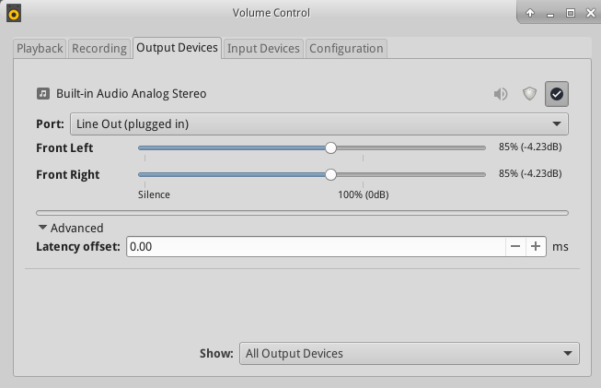
- Figure 3-30: Using PulseAudio Mixer

3.6.5 Links
- MX/antiX Wiki: Sound not working
- ALSA: SoundCard Matrix
- ArchLinux Wiki: PulseAudio Information
- PulseAudio Documentation: Free desktop

3.7 Localization
- MX Linux is maintained by an international Dev Team that constantly works to improve and expand the options for localization. There are many languages into which our documents have not yet been translated, and if you can help with this effort please post on the Translation Forum.

3.7.1 Installation
- The primary act of localization occurs during the use of the LiveMedium.
- When the bootloader screen first comes up, make sure to use the function keys to set your preferences.
  - F2. Select the language
  - F3. Select the timezone you wish to use.
  - If you have a complicated or alternative setup, you can use boot cheat codes. Here is an example to set a Tartar keyboard for Russian: lang=ru kbvar=tt . A full list of the boot parameters (=cheat codes) can be found in the MX/antiX Wiki.
- If you set the locale values at the boot screen, then Screen 7 should show them during installation. If not, or if you want to change them, select the language and timezone you want.

3.7.2 Post-installation
- 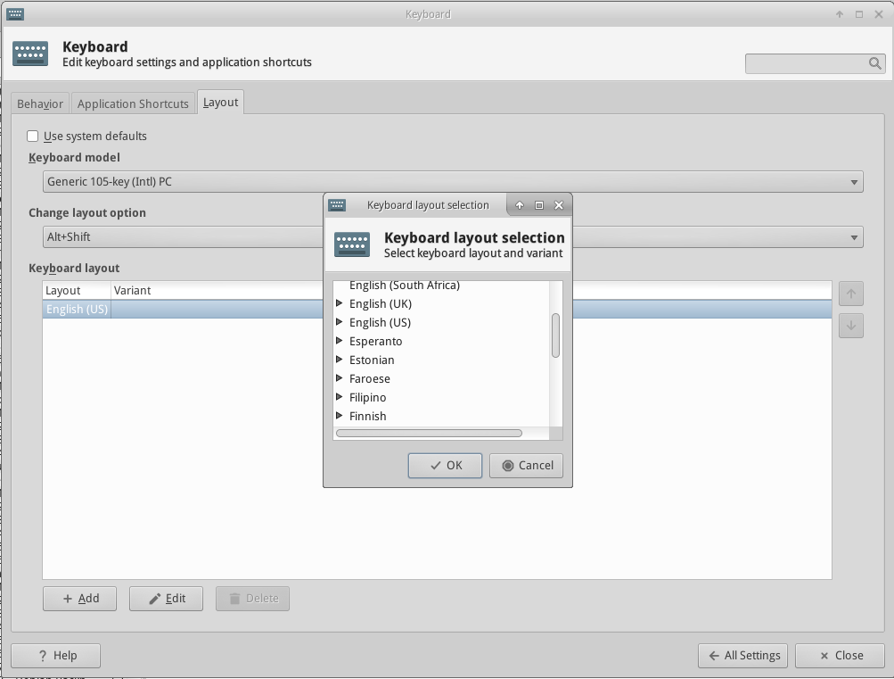
- Figure 3-31: Adding another keyboard layout in All Settings

- Here are the configuration steps you can take to localize your MX Linux after installation.
- Change the keyboard:
  - Click Start Menu > Settings > All Settings > Keyboard, Layout tab.
  - Uncheck Use system defaults, then click on the +Add button at the bottom and select the keyboard(s) you want available.
  - Exit, then click Keyboard Switcher (flag) in the Notification Area to select active keyboard.
- Get language packs for major applications: click Start menu > System > MX Package Installer, provide the root password, then click Language to find and install language packs for the applications you use.
  - Setting up Chinese SImplified Pinyin is a bit more complicated, see here.
- Change time settings: click Start Menu > System > MX Time Settings and select your preferences. If you are using the digital clock DateTime, right-click > Properties to choose 12h/24h and other local settings.
- Get spellchecker to use your language: install the aspell or myspell package for your language (e.g., myspell-es).
- Get local weather info: right-click the Panel > Panel > Add New Items > Weather Update. Right-click > Properties, and set the locale you want to see (it will guess by your IP address).
- For Firefox localization, install the appropriate firefox-l10n- package for your language of interest; e.g., for Spanish (Spain), install firefox-l10n-es.
- For Thunderbird, click Edit > Preferences >Advanced tab, Config Editor button: put general.useragent.locale in the search box, then set the preference to the name of the locale that you want to use (e.g., fr_FR).
- You may need or want to change the localization info (default language, etc.) available to the system. To do so, open a terminal, become root and enter:
dpkg-reconfigure locales
  - You a see list with all the locales that you can scroll through using the up and down arrow keys.
  - Enable and disable what you want (or don’t want), using the space bar to make the asterisk in front of the locale appear (or disappear).
  - When done, click OK to advance to the next screen.
  - Use arrows to select the default language you want to use. For US users, for instance, that would typically be en_US.UTF-8.
  - Click OK to save and exit.
- MORE: Ubuntu documentation
- 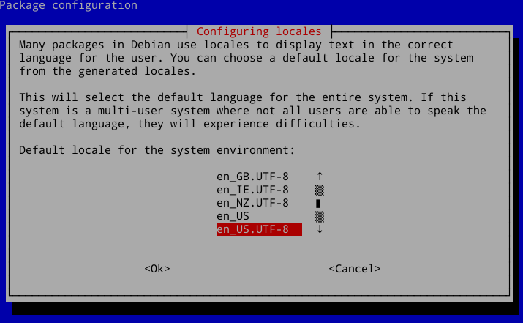
- Figure 3-32: Re-setting the default language for the installed system

3.7.3 Further notes
- You can temporarily change the language for a particular application by entering this code in a terminal (in this example, to change to Spanish):
LC_ALL=es_ES.UTF8 <command to launch>
This will work for most apps that are localized already.
- It may happen that an individual application may not have a translation in your language; unless it is an MX application, we can do nothing about that, so you should send a message to the developer.
- Some desktop files that are used to create the Start menu may be missing a comment in your language, even though the application itself does have a translation in that language; please let us know with a post in the Translation Forum that supplies the correct translation.

3.8 Customization
- Xfce4 makes it very easy to change basic function and look of a user’s configuration, and the integration of Xfce 4.12 has now provided additional features.
- Most importantly, remember: Right-click is your friend!
- Great control is available through the All Settings (Panel icon)
- User changes are stored in Xfce4 config files in the directory: /.config/
- Most system-wide Xfce4 config files are in /etc/skel/ or /etc/xdg/
- MORE: Xfce Tips and tricks (PDF)

3.8.1 Default Theming
- Default theming is controlled by a number of customized elements.
- Login screen (modify with All Settings > LightDM GTK+ Greeter Settings)
  - Theme: Ark-Dark (MX-16.1)
  - Login box: modified in default theme /usr/sbin/lightdm-gtk-greeter
- Desktop:
  - Wallpaper: All Settings > Desktop: kingfisher.jpg
  - All Settings > Appearance. Bundled settings in MX Default Look (Section 3.2.9).
  - Whisker menu settings
    - Personal in ~/.config/xfce4/xfconf/xfce-perchannel-xml/xfce4-panel.xml
    - System-wide in gtk-2.0 folder inside default theme folders

3.8.2 General look
- The overall appearance can be customized in Start menu > Settings > All Settings.
- Click on Appearance to change style, icons, fonts and some settings.
- Click on Window Manager to select the window treatment. For detailed manipulations (e.g., where does the window show up on the desktop, what desktop does the window appear on, how big should it be, etc.), install gdevilspie from the repos.
- Click on Desktop (also by right-clicking desktop) to change background, menus, and some icon settings.
- Manage default desktop icons such as Removable Devices by right-clicking desktop > Desktop Settings ... > Icons tab.
- MORE: Xfce4 docs: Appearance.

3.8.3 Panel
- 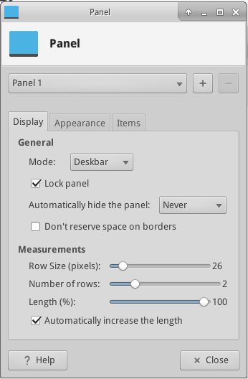
- Figure 3-33: Preferences screen for customization of panels
- To move the panel, unlock it by right-clicking a panel > Panel > Panel Preferences.
- Use MX-Default Look to change the location of the panel: vertical (left), top or bottom.
- To change display mode inside the Panel, select from the pull down menu: Horizontal, Vertical, or Deskbar.
- To automatically hide the panel, choose from pull down menu: Never, Always, or Intelligently (hides the panel when a window overlaps with it).
- Install new panel items by right-clicking an empty space > Panel > Add New Items.You then have 3 choices:
  - Select one of the items on the main list that pops up
  - If what you want is not there, select Launcher. Once it is in place, right-click > Properties, click the plus sign and select an item off the list that pops up.
  - If you want to add an item not on either list, then select the empty item icon below the plus sign and fill in the dialog box that pops up.
- New icons show up at the bottom of the vertical Panel; to move them, right-click > Move
- Change the look, orientation, etc. by right-clicking the panel > Panel > Panel Preferences.
- The Orage clock (default) as well as the Xfce plugin “Clock” use what are known as “strftime codes.” To change, consult this page or open a terminal and type man strftime.
- Create a double row of icons in the Notification Area by right-clicking it > Properties, and decreasing Maximum icon size until it changes.
- To show all open applications, click All Settings > Window Buttons, and enable “Show windows from all workspaces or viewports.”
- Add or delete a panel in Panel Preferences by clicking on the plus or minus button to the right of the top panel pull-down menu.
- One-click horizontal panel installation is available from MX Default Look (Section 3.2.8).
- MORE: Xfce4 docs: Panel.
- 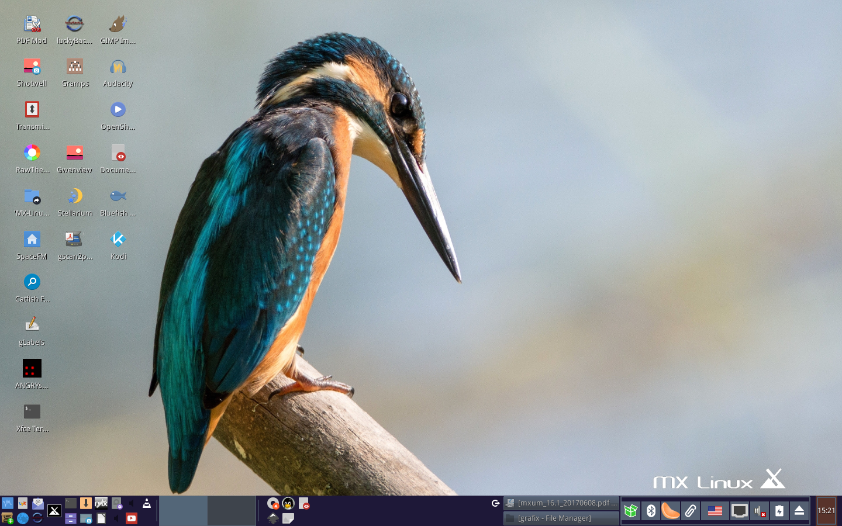
- Figure 3-34: Horizontal panel reoriented using MX Default Look.

3.8.4 Desktop
- Customizing the desktop
- The default desktop (AKA wallpaper, background) can be changed in various ways.
- Right-click any image > Set as wallpaper
- If you want the wallpapers available to all users, become root and put them in the /usr/share/xfce4/backdrops folder; you will probably have to create this folder, either in a root Thunar or in a root terminal using the command mkdir.
- If you want to restore the default wallpaper, it is in /usr/local/share/backgrounds/MX16/wallpaper/.
- Many other customizations are available in All Settings.
- Change the theme in Appearance. The default theme is a version of greybird that has larger borders and specifies the appearance of Whisker menu.
- Add standard icons such as Trash or Home to the desktop in Desktop, icons tab.
- Window behavior such as switching, tiling, and zooming can be customized in Window Manager Tweaks.
  - Window switching via Alt+Tab can be customized to use a compact list instead of traditional icons
  - Window switching via Alt+Tab can also be set to show thumbnails instead of icons or a list, but it requires turning on compositing which some older computers may have difficulty supporting. To enable, first deselect Cycle on a list list on the “Cycling” tab, then click on the “Compositor” tab and check ’Show windows preview in place of icons’ when cycling.
  - Window tiling can be accomplished by dragging a window to a corner and releasing it there..
  - If compositing is turned on, Window zooming is available by using the Alt + Mouse Wheel combination.
- To select a different wallpaper for each Workspace, got to Background and uncheck the option ’Apply to all workspaces.’ Then select a wallpaper and repeat the process for each workspace by dragging the dialog box to the next workspace and selecting another wallpaper.
- 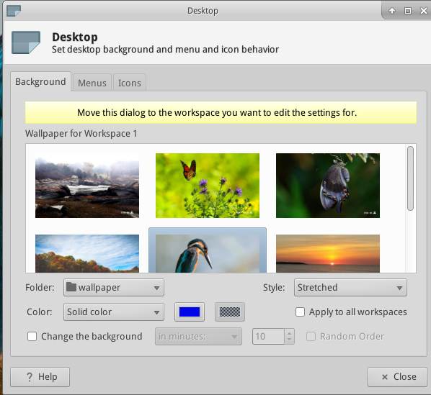
- Figure 3-35: Unchecked box allows different backgrounds for each workspace

- Conky
- You can display almost any kind of information on the desktop by using Conky
- Install conky-manager2 from the repos.
- Click Start menu > Accessories to find Conky Manager 2.
- Using the menu icon at the far right end, import the themepack /usr/share/conky-manager2/themepacks/default-themes-2.1.cmtp.7z. They are now available in a new directory ~/conky-manager.
- You can highlight each conky and hit Preview to see what it looks like. Be sure to close each preview before going to another.
- If it seems that Conky Manager has frozen, check for a window with the preview hiding behind it.
- Check the box to select any conky you want to use. It will be auto-installed.
- The configuration files are stored in the folder ~/.conky/ in individual theme files; they can be edited by clicking on the edit icon (pencil).
- MORE: Conky home page
- 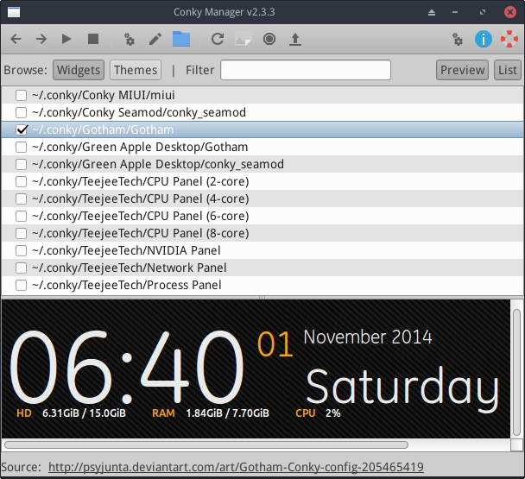
- Figure 3-36: Main screen showing one of the conkies available

- Hot Corner
- Opening programs or activating certain actions/effects can be facilitated by installing the Panel plugin HotCorner. Details on installation and use can be found in the Wiki.
- 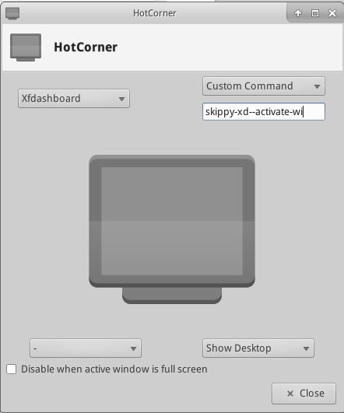
- Figure 3-37: The HotCorner settings dialog box

- Pull-down terminal
- Customizing the drop-down terminal
- MX Linux ships with a very handy drop-down terminal triggered with F4 (change if needed with Start menu > All Settings > Keyboard: Applications Shortcuts tab). Many options for look and function are available by right-clicking an empty location on the main screen > Preferences.

3.8.5 Keyboard
- By default, MX Linux uses the keyboard layout that matches the user’s language choice. To make another layout available, see Section 3.7.2.

3.8.6 Menu (“Whisker”)
- Customizing Whisker menu
- Fun with the Whisker menu
- MX Linux comes by default with the Whisker Menu, though a classic menu can be easily installed by right-clicking a panel > Panel > Add New Items > Applications Menu. Whisker Menu is highly flexible.
- Right-click the menu icon > Properties to set preferences, e.g.,
  - Move categories column to be next to the Panel.
  - Change location of Search box from top to bottom.
  - Decide which action buttons you want to show.
- Favorites are easy to add: right-click any menu item > Add to Favorites.
- Simply drag and drop Favorites to arrange them as wished. Right-click any entry to sort or remove.
Whisker menu features
- Menu entries can be edited with two applications (the menu entry “desktop” files are located in /usr/share/applications/ and can also be edited as root directly).
- MX Menu Editor (Section 3.2.8).
- A native Xfce application
  - Click Start menu > Accessories > Application Finder (or Alt-F3), and right-click any entry.
  - Context menu contains Edit and Hide (the latter can be very useful).
  - Selecting Edit brings up a screen where you can change name, comment, command and icon.
- 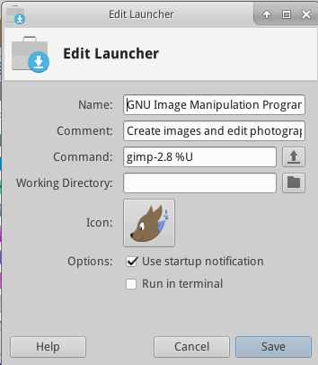
- Figure 3-38: Menu entry edit screen

3.8.7 Login greeter
- The user has a number of tools to customize the login greeter.
- Click Start menu > Settings > All Settings > LightDM GTK+ Greeter settings to adjust position, background, font, etc.
- Autologin can be (in)activated from MX User Manager > Options tab.
- Some properties of the default login box are set in the code for the default theme (greybird-thick-grip) and a few related themes. Change theme using All Settings > Appearance for greater choice.
- You can have the login greeter show an image as follows:
  - Create or select an image, and use Mirage to resize it to about 96x96 pixels
  - Save that image in your home folder as .face (make sure to include the dot and do not add any extension such as jpg or png).
  - Click All Settings > LightDM GTK+ Greeter Settings, Appearance tab: turn on the User image switch.
  - Log out, and you will see the image next to the login box; it will also show up in Whisker menu.

3.8.8 Bootloader
- The bootloader (GRUB) menu of an installed MX Linux can be modified by clicking Start menu > System > Grub customizer. This tool allows users to configure some important Grub settings such as the boot entry list configuration, names of partitions, etc. Background on functionality here.

3.8.9 System and Event sounds
- Computer beeps are silenced by default in the “blacklist” lines in the file /etc/modprobe.d/pc-speaker.conf. Comment out (# at the beginning) those lines as root if you wish to restore them.
- Event sounds can be enabled by clicking All Settings > Appearance, Settings tab, and checking the box “Enable event sounds.” If you do not start hearing small sounds when you close a window or logout, for instance, try these steps:
- Log out and back in.
- Click Start menu > Multimedia > PulseAudio Volume Control, Playback tab, and adjust the level as needed (start with 100%).
- Click the start menu, type "!alsamixer" (don’t forget the exclamation point). A terminal window will appear with a single audio control (Pulseaudio Master).
  - Use F6 to select your audio card, and then adjust the channels that appear to higher volumes.
  - Look for channels like "Surround", "PCM" "Speakers", "Master_Surround", "Master_Mono" or "Master". The channels that are available depend on your particular hardware.
- The sound file of reference is Borealis, located in /usr/share/sounds. Two others are in the repos, sound-theme-freedesktop and mx-sound-theme-fresh-and-clean, and others can be found with a web search.

3.8.10 Default applications
- General
- The default applications to be used for general operations are set by clicking Start menu > Settings > All Settings > Preferred Applications, where you can set four preferences.
- Web browser
- Mail reader
- File manager
- Terminal emulator
- Particular
- Many defaults for specific file types are set during an application’s installation. For instance, *.docx and *.xlsx files are associated with LibreOffice when it is installed. But often multiple options exist for a given file type, and a user would like to determine which application would launch the file. A common example is when a user wants to open an *.mp3 file with a different music player than Clementine (default). A simple method exists to make that change.
- Right-click any example of the file type you are interested in
- Make one of the following selections:
  - Open with <listed application>. This will open the file with the selected application for this particular instance, but will not affect the default application.
  - Open with Other Application. Scroll down the list to highlight the one you want (including “Use a custom command”), then check Open.
The box at the bottom “Use as default for this kind of file” is unchecked by default, so check it if you want your selection to become the new default application that is launched when you click on any file of that particular type. Keep it unchecked for one-time usage.
- 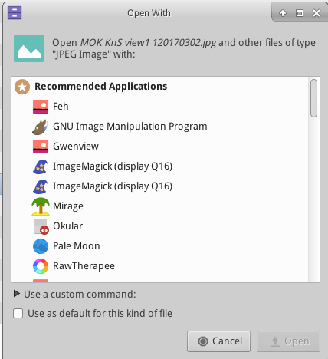
- Figure 3-39 Changing default application

3.8.11 Limited accounts
- For some purposes, it may be desirable to lock down an application or system in order to protect it from users. Examples include computers in a school or public location for general use, where the file system, desktop and internet access need to be closed. There are a number of options available.
- Some components of Xfce have support for kiosk mode. This can be enabled by creating and modifying a system kioskrc file to be located at /etc/xdg/xfce4/kiosk/kioskrc. Details in the Xfce Wiki.
- Firefox has a number of add-ons such as mKiosk.
- For simplified setup of more complex situations, the interested user might explore the dedicated kiosk distro Porteus.
- More: Alan D. Moore's guide.
- Install obex-data-server from the repos.
  - It will bring in libopenobex2 with it.
  - In rare cases, the obex-data-server package may block Bluetooth mouse or keyboard usage.
- Confirm that the phone and desktop both have bluetooth enabled and are visible.
- Send file
  - From the MX Linux desktop: right-click the Bluetooth icon in the Notification Area > Send file (or use Bluetooth Manager)
  - From the phone: follow the appropriate instructions for your device.
- Keep your eye on the receiving device to confirm acceptance of the object being transferred.
It is also possible to make use of hcitool on the command line.
Links
- Blueman Troubleshooting
- Arch Wiki
- Debian Wiki on Pairing

