

**MX Linux Users Manual**

**v. 20210925**

**manual AT mxlinux DOT org**

Ctrl-F = Search this Manual

Ctrl+Home = Return to top

**Translations from** [**DeepL**](https://www.deepl.com/translator)

# 1 Introduction

## 1.1 About this Manual

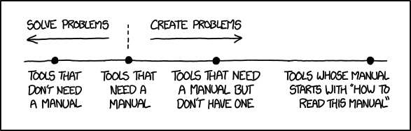

***Figure 1-1: The *need* for manuals (xkcd.com)***

This Users Manual is the product of large group of volunteers from the MX Linux community. As such, it will inevitably contain errors and omissions, although we have worked hard to minimize them. Please send us feedback, corrections or suggestions using one of the methods listed below. Updates will occur as needed.

The Manual is designed to walk new users through the steps of obtaining a copy of MX Linux, installing it, configuring it to work with one’s own hardware, and putting it to daily use. It aims to provide a readable general introduction, and purposely gives preference to graphical tools when available. For detailed or infrequent topics, the user should consult the Resources or post on the Forum.

MX Fluxbox is not inluded here because it differs from Xfce and KDE so greatly that it would lengthen and complicate this Manual. A separate Help document is included with every MX Fluxbox installation.

New users may find some of the terms used in this Manual to be unfamiliar or confusing. We have tried to limit the use of difficult terms and concepts, but some are simply unavoidable. The **Glossary** located at the end of the document provides definitions and comments that will help in getting through difficult passages.

All content is © 2021 by MX Linux Inc. and released under GPLv3. Citation should read:

**MX Linux Community Documentation Project. 2021. Users Manual for MX Linux.**

Feedback:

* Email: manual AT mxlinux DOT org
* Forum: [MX Documentation and Videos](https://forum.mxlinux.org/viewforum.php?f=101)

## 1.2 About MX Linux

Users are highly varied in their attitude toward MX Linux--or any operating system. Some may just want an appliance that simply works, like a coffee pot that produces a hot drink upon demand. Others may be curious about how it actually works, i.e., why they get coffee and not some thick sludge. This section is intended to get the second group oriented. The first group might prefer to jump ahead to Section 1.3: ”Get informed!”.

MX Linux is a desktop version of the fusion of the [Gnu](https://www.gnu.org/) collection of free software and the Linux kernel, both begun in the early 1990s. [Gnu-Linux](https://en.wikipedia.org/wiki/Linux), or more simply and commonly referred to as ”Linux,” is a free and open-source Operating System that has a unique and very successful approach to everything from kernel to tools to file structure (Section 7). It is delivered to users through [distributions](https://en.wikipedia.org/wiki/Linux_distribution) or ”distros”, of which one of the oldest and most popular is [Debian](https://en.wikipedia.org/wiki/Debian) upon which MX Linux is built.

### 1.2.1 Linux

To provide a quick overview, here is a simplified diagram and description of a Linux OS, adapted from *Anatomy of the Linux kernel*.

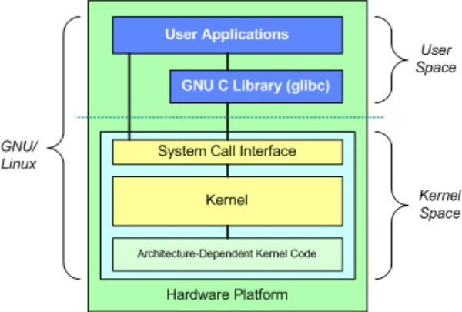

* At the top is the user space, AKA application space. This is where user applications provided by the distribution or added by the user are executed. There is also the GNU C Library (*glibc*) interface that connects applications with the kernel. (Hence the alternative name "GNU/Linux" seen in the diagram).
* Below the user space is the kernel space where the Linux kernel exists. The kernel is dominated by hardware drivers.

**File system**

One of the first problems many new Linux users struggle with is how the file system works. Many new users have looked in vain to find the C:\ drive or D:\ drive, for instance but Linux handles hard drives and other storage media differently than Windows. Rather than having a separate file system tree on every device, MX Linux has a single file system tree ( called the /root/ of the file system) which is marked “/” and contains every attached device. When a storage device is added to the system, its file system is attached to a directory or subdirectory of the file system; this is called mounting a drive or device. Also, every user has a dedicated subdirectory under **/home**, and by default this is where you would search for your own files. Details in Section 7.

Most program and system settings on MX Linux are stored in discrete plain text configuration files; there is no “Registry” which requires special tools to edit. The files are just simple lists of parameters and values that describe the behavior of programs when they launch.

**Cautions**

Brand new users come with expectations from their previous experience. This is natural, but it can lead at first to confusion and frustration. Two fundamental notions to keep in mind:

1. MX Linux is not Windows. As indicated above, there is no Registry, the C:\ drive does not exist and most drivers are already in the kernel.
2. MX Linux is not based on the Ubuntu family, but on Debian itself. This means that commands, programs and applications (especially those in “Personal Package Archives” or PPAs) from the Ubuntu family may not function correctly or even be missing.

### 1.2.2 MX Linux

MX Linux is a cooperative venture between the [antiX](https://antixlinux.com/) and former [MEPIS](https://en.wikipedia.org/wiki/MEPIS) communities first released in 2014, using the best tools and talents from each distro and including work and ideas originally created by Warren Woodford. It is a midweight OS designed to combine an elegant and efficient desktop with simple configuration, high stability, solid performance and medium-sized footprint.

Relying on the excellent upstream work by Linux and the open-source community, with MX-21 we deploy with our flagship [Xfce 4.16](https://docs.xfce.org/start) as Desktop Environment, along with KDE/plasma 5.20.5 and Fluxbox 1.3.7 as separate free-standing versions. All rest on top of a [Debian](http://www.debian.org/) [Stable](https://wiki.debian.org/DebianStable) (Debian 11, "Bullseye") base, drawing as well from the core antiX system. Ongoing backports and outside additions to our Repos serve to keep components current with developments as users require.

The MX Dev Team is composed of a group of volunteers of various backgrounds, talents and interests. Details: [About us](https://mxlinux.org/about-us). Special thanks for strong ongoing support of this project go to the MX Linux Packagers, to video producers, to our great volunteers and to all our Translators!

## 1.3 Get **informed**!

The desktop icons link to two helpful documents: the FAQs and the User Manual.

* The FAQs provides a quick orientation for new users by answering the questions most commonly asked on the Forum.
* The Users Manual provides a detailed look at the OS. Few people read it from front to back, but it can be consulted quickly 1) by using the outline to jump to the general topic that interests you, or 2) by pressing *Alt + F1* to open it and *Ctrl + F* to search for a particular item.
* Other information sources include the Forum, the Wiki, the online Video collection and various social media. Those sources are most easily reached through [the Home page](https://mxlinux.org/).

## 1.4 Support and EOL

What kind of support is available for MX Linux? The answer to this question depends on the type of support you mean:

* **User-based problems**. A raft of support mechanisms exists for MX Linux, from documents and videos to forums and search engines. See the [Community Support page](https://mxlinux.org/support) for details.
* **Hardware**. Hardware is supported in the kernel, where continuous development goes on. Very new hardware may not yet be supported, and very old hardware, though still supported, may no longer be sufficient for the demands of the desktop and applications. However, most users will find support for their hardware is available.
* **Desktop**. Xfce4 is a mature desktop that remains under development. The version shipped with MX Linux (4.16) is considered stable; important updates will be applied as they become available. KDE/plasma environment is maintained on an ongoing basis.
* **Applications**. Applications continue to be developed after the release of any version of MX Linux, meaning that the shipped versions will get older as time passes. This problem is addressed through a combination of sources: Debian (including Debian Backports), individual Developers including MX Devs, and the Community Packaging Team, which accepts users’ upgrade requests as much as possible. The MX Updater signals when new packages are available for download.
* **Security**. Security updates from Debian will cover MX Linux users well into the foreseeable future. Look to MX Updater again for notification of availability.

## Notes for translators

Some orientation for people translating the Users Manual:

* The English texts behind the latest release are in a [GitHub repo](https://github.com/jerry3904/mxum). Translations are stored in the directory "**tr**"
  + You can work within the GitHub system: [clone](https://help.github.com/articles/cloning-a-repository/) that main repo, make changes and then make a [pull request](https://help.github.com/articles/about-pull-requests/) to have it reviewed for merging with the source.
  + Alternatively, you can download what you are interested in and work on it locally before notifying that it is ready either with an email to *manual AT mxlinux DOT org* or by posting on the Forum.
* In terms of importance, it is recommended that you begin with Sections 1-3 that provide the information most relevant to the new user. Once those are done, they can be distributed to users as a partial translation while the later Sections are being translated.
* Available translations are tracked in the [MX/antiX Wiki](https://mxlinux.org/wiki/help-files-other/users-manual-translations).