# 2 Installation

## 2.1 Introduction

An MX Linux LiveMedium (USB or DVD) boots your computer without accessing the hard disk. It copies a virtual file system into RAM that acts as the center of a temporary operating system for the computer. When you end your Live session, everything about your computer is back to the way it was, unchanged (contrast Section 6.6.1).

This provides a number of benefits:

* It enables you to run MX Linux on your computer without installing it.
* It allows you to determine whether MX Linux is compatible with your hardware.
* It helps you to get a feel for how MX Linux works and to explore some of its features.
* You can decide whether MX Linux is what you want without permanently affecting your current system.

Running from a LiveMedium also has some disadvantages:

* Because the entire system is operating from a combination of RAM and the medium, MX Linux will require more RAM and may run more slowly than if it were installed on the hard drive.
* Some unusual hardware that requires specialized drivers or custom configuration may not work in a LiveMedium session that is read-only (like a DVD) where permanent files can’t be installed. Our LiveUSB with persistence solutions does not have that problem.

### 2.1.1 PAE or non-PAE?

MX Linux is available for two architectures: [32bit](https://en.wikipedia.org/wiki/32-bit) and [64bit](https://en.wikipedia.org/wiki/64-bit_computing), both of which have [PAE](http://en.wikipedia.org/wiki/Physical_Address_Extension) enabled. PAE stands for Physical Address Extension, a way of allowing 32 bit operating systems to access ram beyond around 4GB. It is possible to use a non-PAE version on a PAE system, but not vice versa. If your machine is unable to handle PAE (i.e., is very old), then we recommend that you install our sister distro [antiX Linux](https://antixlinux.com/) instead.

If unsure whether you need the PAE or non-PAE version, use the method below suitable for the OS you currently run.

* Linux. Open a terminal and enter this command (install **inxi** first if necessary): *inxi -f*. If the CPU Flags entry does not include PAE in the list, then you will not be able to install MX Linux.
* Mac. Intel versions of OS X support PAE.
* Windows®
  + Windows2000 and earlier: non-PAE
  + Windows XP and Vista. Right click My Computer > Properties, General tab. If it says Physical Address Extension (=PAE) at the bottom, then PAE is the correct version to install.
  + Windows 7. Open the Command Prompt window by clicking the Start button > All Programs > Accessories > Command Prompt. A terminal window will appear. Enter this code at the command prompt where the cursor is positioned:

*wmic os get PAEEnabled*

If PAE is enabled, you will get a return like this: *PAEEnabled.* That return may or may not be followed by the word TRUE.

* + Windows 8 and later. PAE enabled by default.

### 2.1.2 32 or 64 bit?

#### What is the architecture of your cpu?

Follow the appropriate method below to find out whether your machine is 32- or 64-bit.*

* **Linux**. Open a terminal and enter the command ***lscpu***, then examine the first few lines for architecture, number of cores, etc.
* **Windows**. Consult [this Microsoft document](https://support.microsoft.com/en-us/kb/827218).
* **Apple**. Consult [this Apple document](https://support.apple.com/en-us/HT201948).

*If you want to know the architecture of the OS instead, the command ***uname -m*** will probably work on all platforms.

In general, if you have a 64-bit cpu and the required RAM for your particular machine and processor, you should use the 64-bit version. This is because 64-bit is generally faster, though you may not actually notice the difference in daily use. In the long run, moreover, an increasing number of larger applications will likely be restricted to 64-bit versions. Note that a 32-bit application or OS can run on a 64-bit cpu, but not the reverse.

MORE: [here](https://www.techsupportalert.com/content/32-bit-and-64-bit-explained.htm)

#### How much memory (RAM) do you have?

* Linux. Open a terminal and enter the command ***free -h*** and look at the number in the Total column.
* Windows. Open the System window using whatever method is recommended for your version, and look for the entry “Installed memory (RAM).”
* Apple. Click the entry "About this Mac" in the Apple menu on Mac OS X and look for the RAM information.

### 2.1.3 System requirements

For an MX Linux system installed on a hard drive, you would normally need the following components.

**Minimum**

* A CD/DVD drive (and BIOS capable of booting from that drive), or a live USB (and BIOS capable of booting from USB)
* A modern i686 Intel or AMD processor
* 1GB of RAM memory
* 6 GB free hard drive space
* For use as a LiveUSB, 4 GB free.

**Recommended**

* A CD/DVD drive (and BIOS capable of booting from that drive), or a live USB (and BIOS capable of booting from USB)
* A modern i686 Intel or AMD processor
* 2 GB of RAM memory or more
* At least 20 GB free hard drive space
* A 3D-capable video card for 3D desktop support
* A SoundBlaster, AC97 or HDA-compatible sound card
* For use as a LiveUSB, 8 GB free if using persistence.

NOTE: Some MX Linux 64-bit users report 2GB of RAM to be sufficient for general use, although at least 4GB RAM is recommended if you will be running processes (such as remastering) or applications (such as an audio or video editor) that are memory-intensive.

## 2.2 Creating a bootable medium

### 2.2.1 Obtain the ISO

MX Linux is distributed as an ISO, a disk image file in the [ISO 9660](http://en.wikipedia.org/wiki/ISO_9660) file system format. It is available in two formats off the [Download page](http://www.mxlinux.org/download-links).

* The **original release** of a given version.
  + This is a *static* version that, once released, remains unaltered.
  + The longer the time since release, the less current it is.
* A **monthly update** of a given version. This monthly ISO is created from the original release using MX Snapshot (see Section 6.6.4).
  + It includes all upgrades since the original release, and thus removes the necessity of downloading a large number of files after installation.
  + It also enables users to run Live with the most recent version of the programs.
  + **Only available as direct download!**

 [Make a antiX/MX live-usb from Windows](https://youtu.be/GTxphqvKYss)

#### Purchase

It is unfortunately no longer possible to purchase a CD or USB (original release only) with the ISO already loaded and ready to use, as the company providing those has gone out of business. Other options exist:

* Preloaded and pretested laptops are available from [Starlabs](https://starlabs.systems/).
* Secure virtual desktop for use on any device from [Shells](https://www.shells.com/l/en-US/pricing?special=mx_linux).

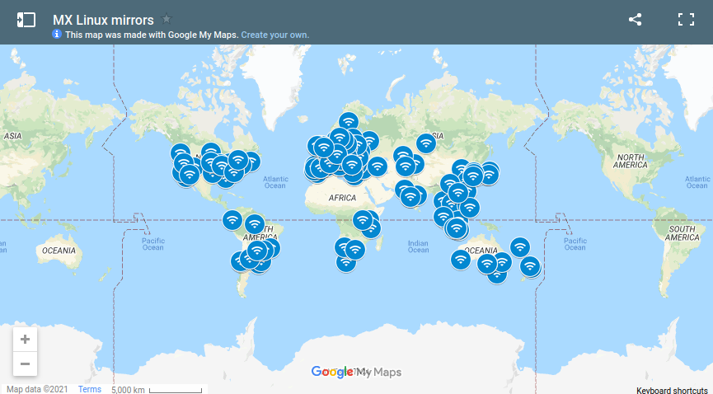

Figure 2-1: Distribution of MX Linux mirrors (Sep 2021)

#### **Download**

MX Linux can be downloaded in two ways from [the Download page](https://mxlinux.org/download-links).

* **Direct**. Direct downloads are available from our Direct Repo, or from our Mirrors. Save the ISO to your Hard Disk. If one source seems slow, try the other one. Available for both original release and monthly update.
* **Torrent**. [BitTorrent](http://en.wikipedia.org/wiki/BitTorrent) file sharing provides an internet protocol for efficient mass transfer of data. It decentralizes the transfer in such a way as to utilize good bandwidth connections and to minimize strain on low-bandwidth connections. An added benefit is all BitTorrent clients perform error checking during the download process, so there is no need to do a separate md5sum check after your download is complete. It has already been done!

The MX Linux Torrent Team maintains a seeded BitTorrent swarm of the latest MX Linux ISO (**original** **release only**), registered at archive.org within 24 hours at the latest of its official release. Links to the torrents will be on [the Download page](https://mxlinux.org/download-links).

* Go to the Download page and click on the correct Torrent link for your architecture. Your browser should recognize that it is a torrent, and ask you how you want to handle it.

If not, left-click the torrent for your architecture to see the page, right-click to save it. Clicking on the downloaded torrent will launch your torrent client (Transmission by default), showing the torrent in its list; highlight it and click Start to begin the download process. If you have already downloaded the ISO, make sure that it is in the same folder as the torrent you just downloaded.

### 2.2.2 Check validity of downloaded ISOs

After you have downloaded an ISO, the next step is to verify it. There are several methods available.

#### md5sum

Each ISO is accompanied by a matching md5sum file in the source, and you should check its **md5sum** against the official one. It will be identical to the official md5sum if your copy is authentic. The following steps will let you verify the integrity of the downloaded ISO on any OS platform.

* Windows

Users can check most easily with the [Rufus](https://rufus.akeo.ie/) bootable USB maker; a tool called [WinMD5FREE](http://www.winmd5.com/) is also available to download and use free of cost.

* Linux

In MX Linux, navigate to the folder where you have downloaded the ISO and the md5sum file. Right-click the md5sum file > Check data integrity. A dialog box will pop up saying “<name of ISO>: OK” if the numbers are identical. You can also right-click the ISO > Compute md5sum and compare it with another source.

For situations where that option is not available, open a terminal in the location where you downloaded the ISO (Linux File Managers usually have an Open Terminal Here option), then type:

*md5sum filename.iso*

Be sure to replace “filename” with the actual filename (type in the first couple of letters then hit Tab and it will be filled in automatically). Compare the number obtained by this calculation with the md5sum file downloaded from official site. If they are identical, your copy is identical to the official release.

* Mac

Mac users need to open up a console/terminal and change into the directory with the ISO and md5sum files. Then issue this command:

*md5 -c filename.md5sum*

Be sure to replace filename with the actual filename.

#### **sha256sum**

Increased security is provided by [sha256 and sha512](https://en.wikipedia.org/wiki/SHA-2) starting with MX-19. Download the file to check the integrity of the ISO.

* Windows: the method varies by version. Do a web search on "*windows <version> check sha256 sum*"
* Linux: follow the directions for md5sum, above, substituting "sha256sum" or "sha512sum"  for "md5sum."
* Mac: open a console, change to the directory with the ISO and sha256 files, and issue this command:

*shasum -a 256 /path/to/file*

#### **GPG signature**

As of March 16, 2016, MX Linux ISO files to be downloaded have been signed by their developers. This security method allows the user to be confident that the ISO is what is says it is: an official ISO from the developer. Detailed instructions about how to run this security check can be found in the [MX/antiX Technical Wiki](https://mxlinux.org/wiki/system/signed-iso-files).

### 2.2.3 Create the LiveMedium

#### DVD

Burning an ISO to a DVD is easy, as long as you follow some important guidelines.

* Do not burn the ISO onto a blank CD/DVD as if it were a data file! An ISO is a formatted and bootable image of an OS. You need to choose **Burn disk image** or **Burn ISO** in the menu of your CD/DVD burning program. If you just drag and drop it into a file list and burn it as a regular file, you will not get a bootable LiveMedium.
* Use a good quality writable DVD-R or DVD+R with a 4.7 GB capacity..

#### **USB**

You can easily create a bootable USB that works on most systems. MX Linux includes the tool **Live-usb maker** (see Section 3.2) for this work.

* If you want to create a USB on a Windows base, we suggest you use Rufus, which supports our bootloader, or a recent (post 625) Unetbootin version.
* If on a Linux base, we offer our Live-usb-maker-qt as a 64 bit appimage.
* If your USB starts but leaves you with an error message: *gfxboot.c32: not a COM32R image,* you should still be able to boot by typing "live" at the prompt in the next line. Reformatting the USB and reinstalling the ISO should remove the error.
* If the graphic USB creators fail, it is possible to use the command "dd," an option now in Live-usb maker.
  + WARNING: be careful to identify your destination USB correctly in the dd command line string listed above, as the dd command will completely write over the destination.
  + To ascertain the correct device name/letter for your destination USB, open a terminal, type *lsblk* and press Enter.  
    A list of all devices connected to your system will be listed. You should be able to identify your destination USB by its listed storage size.
* For details, see [the MX/antiX Wiki](https://mxlinux.org/wiki/system/dd-command).

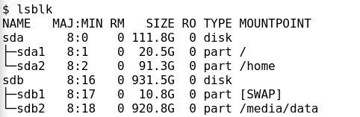

*Figure 2-3: typical output of the command lsblk, showing two harddisks each with two partitions*

## 2.3 Pre-Installation

### 2.3.1 Coming from Windows

If you are going to install MX Linux as a replacement for Microsoft Windows®, it is a good idea to consolidate and back up your files and other data currently stored in Windows. Even if you are planning to dual-boot, you should make a backup of this data in case of unforeseen problems during the install.

#### **Backing up files**

Locate all of your files, such as office documents, pictures, video, or music:

* Typically, most of these are located in My Documents folder.
* Search from the Windows Application Menu for various types of files to make sure you have found and saved them all.
* Some users back up their fonts for reuse in MX Linux with applications (such as LibreOffice) that can run Windows documents.
* Once you have located all such files, burn them to a CD or DVD, or copy them to an external device such as a USB thumb drive.

#### Backing up email, calendar, and contact data

Depending on the email or calendar program you use, your email and calendar data may not be saved in an obvious location or under an obvious file name. Most email or scheduling applications (such as Microsoft Outlook®) are able to export this data in one or more file formats. Consult your application’s help documentation to find out how to export the data.

* Email data: The safest format for email is plain text, since most mail programs support this feature; **be sure to zip the file** to ensure that all file attributes are maintained. If you are using Outlook Express, your mail is stored in a .dbx or .mbx file, either of which can be imported into Thunderbird (if installed) on MX Linux. Use the Windows search feature to locate this file and copy it to your backup. Outlook mail should be imported first into Outlook Express before being exported for use in MX Linux.
* Calendar data: export your calendar data to iCalendar or vCalendar format if you wish to use it in MX Linux.
* Contact data: the most universal formats are CSV (comma separated values) or vCard.

#### **Accounts and passwords**

Although not usually stored in readable files that can be backed up, it’s important to remember to make note of various account information you may have saved in your computer. Your automatic log-in data for websites or services like your ISP will have to be entered in all over again, so make sure to store off disk the information you need to access these services again. Examples include:

* ISP login information: You will need at least your username and password for your internet service provider, and the phone number to connect if you are on dial-up or ISDN. Other details might include a dial out number, dialing type (pulse or tone), and authentication type (for dialup); IP address and subnet mask, DNS server, gateway IP address, DHCP server, VPI/VCI, MTU, Encapsulation type, or DHCP settings (for various forms of broadband). If you are not sure what you need, consult your ISP.
* Wireless networking: You will need your passkey or passphrase, and network name.
* Web passwords: You will need your passwords to various web forums, online stores, or other secured sites.
* Email account details: You will need your username and password, and the addresses or URLs of the mail servers. You may also need the authentication type. This information should be retrievable from the Account settings dialog of your email client.
* Instant messaging: Your username and password for your IM account(s), your buddy list, and the server connection information if necessary.
* Other: If you have a VPN connection (such as to your office), a proxy server, or other configured network service, make sure you find out what information is necessary to reconfigure it in the event that you need to.

#### **Browser favorites**

Web browser favorites (bookmarks) are often overlooked during a backup, and they are not usually stored in a conspicuous place. Most browsers contain a utility to export your bookmarks to a file, which can then be imported into the web browser of your choice in MX Linux. Check the bookmarks division in the browser that you use for specific up-to-date directions.

#### **Software licenses**

Many proprietary programs for Windows are not installable without a license key or CD key. Unless you are set on doing away with Windows permanently, make sure you have a license key for any program that requires it. If you do decide to reinstall Windows (or if dual-boot setup goes awry), you will be unable to reinstall these programs without the key.

If you can not find the paper license that came with your product, you may be able to locate it in the Windows registry, or use a keyfinder such as [ProduKey](http://www.nirsoft.net/utils/product_cd_key_viewer.html). If all else fails, try contacting the computer’s manufacture for help.

#### Running Windows programs

Windows programs will not run inside a Linux OS, and MX Linux users are encouraged to look for native equivalents (see Section 4). Applications that are critical for a user may run under Wine (see Section 6.1), though it varies somewhat.

### 2.3.2 Apple Intel computers

Installing MX Linux on Apple computers with Intel chips can be problematic, though the situation varies to a certain degree with the exact hardware involved. Users interested in the question are advised to search and consult Debian materials and forums for recent developments. A number of Apple users have installed it successfully, so you should have good luck if you search or post questions on the MX Linux Forum.

#### **Links**

[Installing Debian on Apple Computers:](https://wiki.debian.org/InstallingDebianOn/Apple)

[Debian forums](http://forums.debian.net/)

### 2.3.3 Hard drive FAQs

#### Where should I install MX Linux?

Before starting the install, you need to decide where you are going to install MX Linux.

* Entire hard drive
* Existing partition on a hard drive
* New partition on a hard drive

You can simply select one of the first two during installation, but the third requires the creation of a new partition. You can do this during installation, but it is recommended that you do it before you start the installation. On MX Linux, you will usually be using **Gparted** (Xfce)or **PartitionManager** (KDE)to graphically create and manage partitions.

A traditional installation format for Linux has serveral partitions, one each for root, home and Swap, as in the Figure below, and you should begin with this if you are new to Linux. You may also need a fat-32 formatted ESP partition for UEFI-capable machines. Other partition arrangements are possible, for example some experienced users combine root and home, with a separate partition for data.

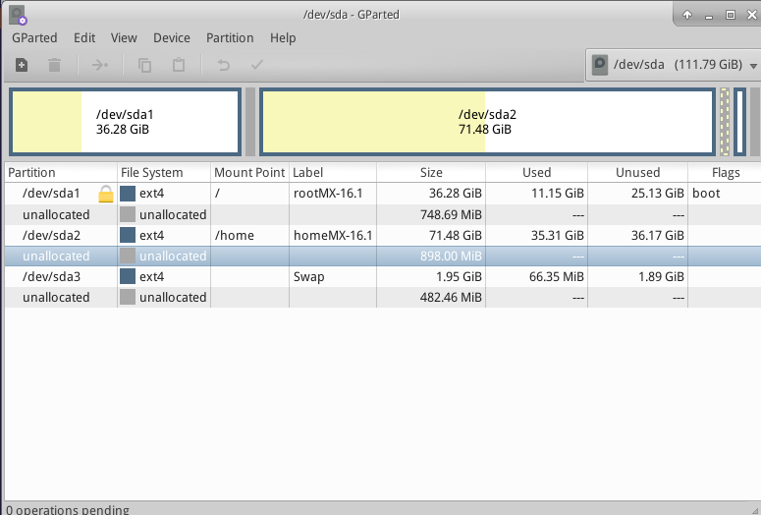

*Figure 2-2: Gparted showing three partitions (sda1), (sda2)* *and swap (sda3). Drive sizes are the user's preference (See Section 1.3 for minimum requirements)*

***MORE:*** [***GParted Manual***](http://gparted.org/display-doc.php?name=help-manual)



[Create a new partition with GParted](https://www.youtube.com/watch?v=lf8eXhCKghg)



[Partition a Multi-boot system](https://www.youtube.com/watch?v=khg6_sdrOBQ)

#### How can I edit partitions?

The very handy tool used in the past for such actions,Disk manager, is no longer available. In its place is recommended **Gnome Disks** (part of gnome-disk-utility). This utility provides a graphical presentation of all the partitions on the machine (excluding swap) with a simple interface for quickly and easily mounting, unmounting and editing some properties of disk partitions. Changes are automatically and immediately written to /etc/fstab and are thus preserved for the next boot.

HELP: [Gnome disks](https://linuxhint.com/gnome_disk_utility/)

#### **What are those other partitions on my Windows installation?**

Recent home computers with Windows are sold with a diagnostic partition and restore partition, in addition to the one that contains the OS installation. If you see multiple partitions showing up in GParted that you were not aware of, they are probably those and should be left alone.

#### Should I create a separate Home?

You do not have to create a separate home partition, since the Installer will create a /home directory within / (root). But having a separate partition makes upgrades easier and protects against problems caused by users filling up the drive with a lot of pictures, music, or video data.

#### How big should / (root) be?

* (In Linux, the slash mark "/" indicates the root partition.) The installed base size is a little under 5 GB, so we recommend a minimum of 6 GB to allow for basic functions.
* This minimum size will not allow you to install many programs, and may cause difficulty doing upgrades, running VirtualBox, etc. Recommended size for normal use is therefore 20 GB.
* If you have your Home (/home) located within the Root directory (/) and store a lot of big files, then you will need a larger root partition.
* Gamers playing big games (e.g., Wesnoth) should note that they will need a bigger root partition than usual for data, images, sound files; an alternative is to use a separate Data drive.

#### Do I need to create a SWAP partition?

SWAP is disk space used for Virtual Memory. This is similar to the "Page" file that windows uses for Virtual Memory. The Installer will create a SWAP partition for you (see Section 2.5.1). If you intend to hibernate (and not just suspend) the system here are the recommendations for the size of the swap space:

* For less then 1GB of physical memory (RAM), the swap space should at least be equal to the amount of RAM and a maximum twice the amount of RAM depending upon the amount of hard disk space available for the system.
* For systems with larger amounts of physical RAM, your swap space should at least be equal to the memory size.
* Technically a linux system can operate without swap, although some performance problems may occur even on systems with large amounts of physical RAM.

#### What do names like “sda” mean?

Before you begin installation, it is critical that you understand how Linux operating systems treat hard drives and their partitions.

* **Drive names**. Unlike Windows, which assigns a drive letter to each of your hard drive partitions, Linux assigns a short device name to each hard drive or other storage device on a system. The device names always start with **sd** plus a single letter. For instance, the first drive on your system will be sda, the second sdb, etc. There are also more advanced means of naming drives, the most common of which is the [UUID](https://en.wikipedia.org/wiki/Universally_unique_identifier) (Universally Unique IDentifier), used to assign a permanent name that will not be changed by the addition or removal of equipment.
* **Partition names**. Within each drive every partition is referred to as a number appended to the device name. Thus, for instance, **sda1** would be the first partition on the first hard drive, while **sdb3** would be the third partition on the second drive.
* **Extended partitions**. PC hard disks were originally permitted only four partitions. These are called primary partitions in Linux and are numbered 1 to 4. You can increase the number by making one of the primary partitions into an extended partition, then dividing that into logical partitions (limit 15) that are numbered from 5 onward. Linux can be installed into a primary or logical partition.

## 2.4 First look

**Live Medium** **login**

In case you want to log out and back in, install new packages, etc., here are the usernames and passwords:

* Regular user
  + name: demo
  + password: demo
* Superuser (Administrator)
  + name: root
  + password: root

### 2.4.1 Boot the LiveMedium

#### LiveCD/DVD

Simply place the DVD in the tray and reboot.

#### LiveUSB

You may need to take a few steps to get your computer to boot correctly using the USB.

* To boot with the USB Drive, many computers have special keys you can press during booting to select that device. Typical Boot Device Menu keys are Esc, one of the Function keys, Return or the Shift key. Look carefully at the first screen that shows up when rebooting to find the correct key.
* Alternatively, You may have to go into the BIOS to change the boot device order:
  + Boot the computer, and hit the required key (e.g., F2, F10 or Esc) at the beginning to get into the BIOS
  + Click on (or arrow over to) the Boot tab
  + Identify and highlight your USB device (usually, USB HDD), then move it to the top of the list (or enter, if your system is set for that). Save and exit
  + If unsure or uncomfortable about changing the BIOS, ask for assistance in the Forums.
* On older computers without USB support in the BIOS, you can use the [Plop Linux LiveCD](http://www.plop.at/) that will load USB drivers and present you with a menu. See the website for details.
* Once your system is set to recognize the USB Drive during the boot process, just plug in the Drive and reboot the machine.

#### UEFI

 [UEFI Boot Issues, and some settings to check!](https://www.youtube.com/watch?v=cLFUZ6LtqiE)

If the machine already has Windows 8 or later installed, then special steps must be taken to deal with the presence of [(U)EFI](https://en.wikipedia.org/wiki/Unified_Extensible_Firmware_Interface) and Secure Boot. Most users are urged to turn off Secure Boot by entering the BIOS as the machine starts to boot. Unfortunately, the exact procedure after that varies by manufacturer:

*Despite the fact that the UEFI specification requires MBR partition tables to be fully supported, some UEFI firmware implementations immediately switch to the BIOS-based CSM booting depending on the type of boot disk's partition table, effectively preventing UEFI booting to be performed from EFI System partitions on MBR-partitioned disks. (Wikipedia, “Unified Extensible Firmware Interface”, retrieved 10/12/19)*

UEFI booting and installation is supported on 32 bit and 64 bit machines, as well as 64 bit machines with 32 bit UEFI. Although the 32 bit UEFI implementations can still be problematic. For troubleshooting, please consult the [MX/antiX Wiki](https://mxlinux.org/wiki/system/uefi), or ask on the Forum.

#### **The Black Screen**

Occasionally it may happen that you end up looking at an empty black screen that may have a blinking cursor in the corner. This represents a failure to start X, the windows system used by Linux, and is most often due to problems with the graphics driver being used. Solution: reboot and select Safe Video or Failsafe boot options in the menu; details on these boot codes in [the Wiki](https://mxlinux.org/wiki/system/boot-parameters). See Section 3.3.2.

### 2.4.2 The standard opening screen

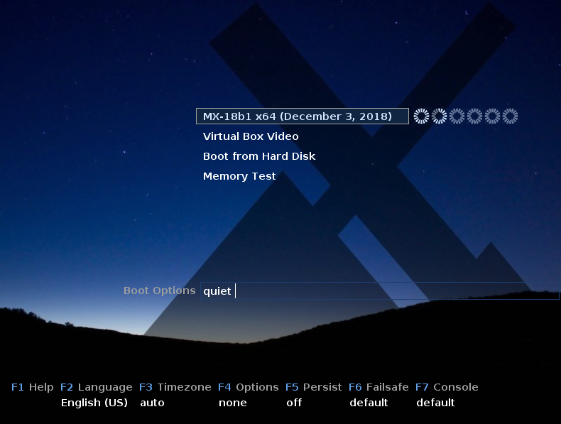

***Figure 2-3: LiveMedium boot screen of x64 ISO***

When the LiveMedium boots up, you will be presented with a screen similar to the Figure above; the *installed* screen looks quite different. Custom entries may also appear in the main menu.

#### Main Menu entries

**Table 1: Menu entries in Live boot**

|  |  |
| --- | --- |
| Entry | Comment |
| MX-XX.XX (<RELEASE DATE>) | This entry is selected by default, and is the standard way that most users will boot the Live system. Simply press Return to boot the system. |
| Boot from Hard Disk | Boots whatever is currently installed on the system's hard disk |
| Memory Test | Runs a test to check RAM. If this test passes then there may still be a hardware problem or even a problem with RAM but if the test fails then you know something is wrong. |

In the bottom row the screen displays a number of vertical entries, below which is a row of horizontal options; **press F1 when looking at that screen for details**.

#### **Options**

* **F2 Language**. Set the language for the bootloader and the MX system. This will automatically transfer to the hard drive when you install.
* **F3 Time Zone**. Set the timezone for the system. This will automatically transfer to the hard drive when you install.
* **F4 Options**. Options for checking and booting the Live system. Most of these options do not transfer to the hard drive when you install.
* **F5 Persist**. Options for retaining changes to the LiveUSB when the machine shuts down.
* **F6 Safe/Failsafe Video Options**. Options for machines that will not boot to X by default.
* **F7 Console**. Set resolution of virtual consoles. May conflict with Kernel Mode Setting. Can be useful if you are booting into Command Line Install or if you are trying to debug the early boot process. This option will transfer when you install.

Other cheat codes for LiveUSB can be found in the [MX/antiX Wiki](https://mxlinux.org/wiki/system/boot-parameters). The cheat codes for booting an installed system are different, and can be found in the same location.

MORE: [Linux startup process](http://en.wikipedia.org/wiki/Linux_startup_process)

### 2.4.3 The UEFI opening screen

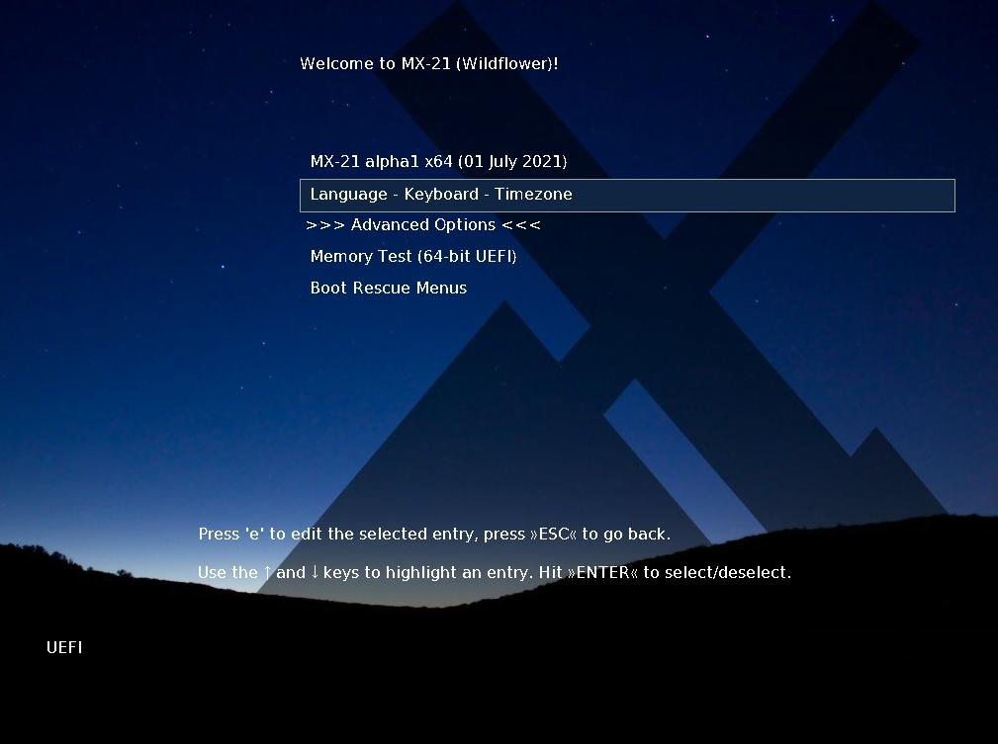

***Figure 2-4: LiveMedium boot screen of x64 (MX-21 and up) when UEFI detected***

If the user is using a computer set for UEFI boot (see [MX/antiX Wiki](https://www.mxlinux.org/wiki/system/uefi)), the opening screen for UEFI Live boot will appear instead with different choices.

* Menus are used to set boot options instead of F key menus
* The top option will launch the OS with any selected options enabled.
* Advanced Options sets things like Persistence and other items present in the legacy boot F menus.
* Language – Keyboard – Timezone sets those options

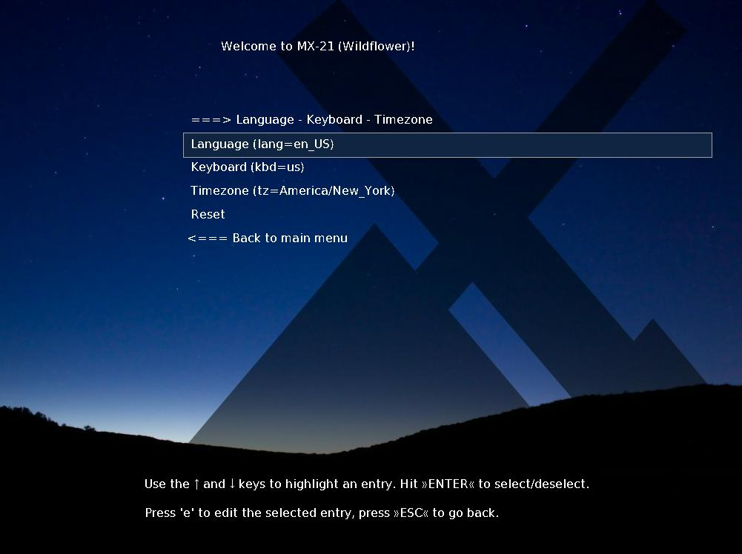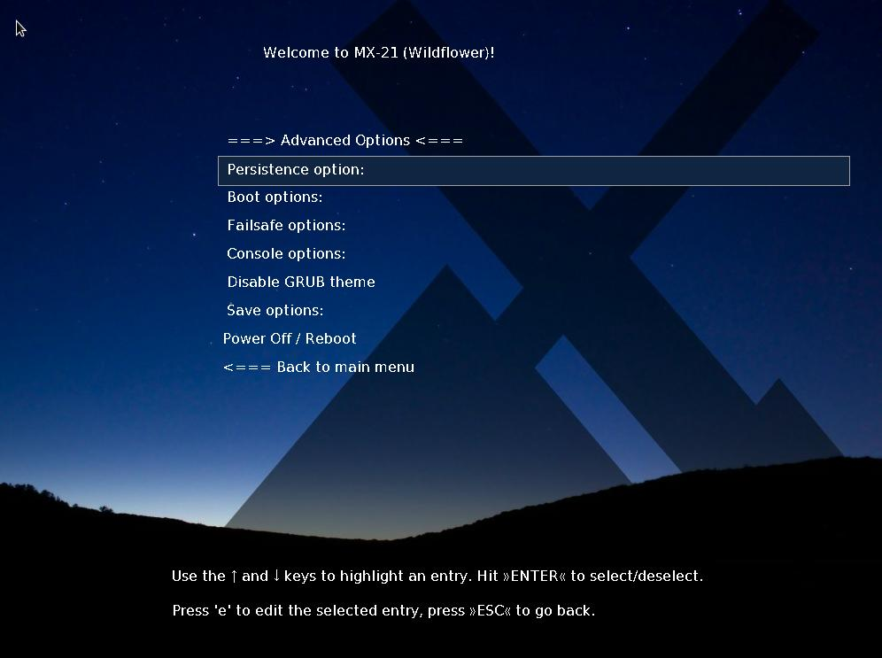

***Figure 2-5: Screen examples for LiveMedium (left) and installed options.***

If you want you boot options to be persitent, make sure to select a save option.

### 2.4.4 Login screen

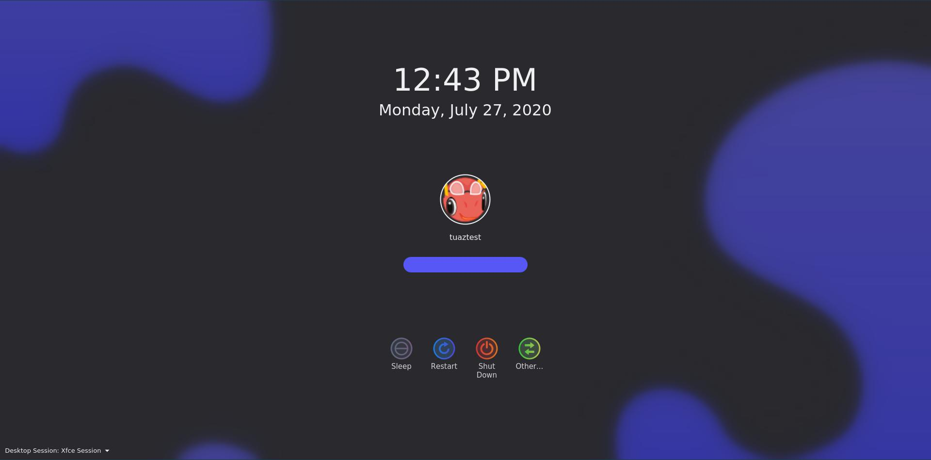 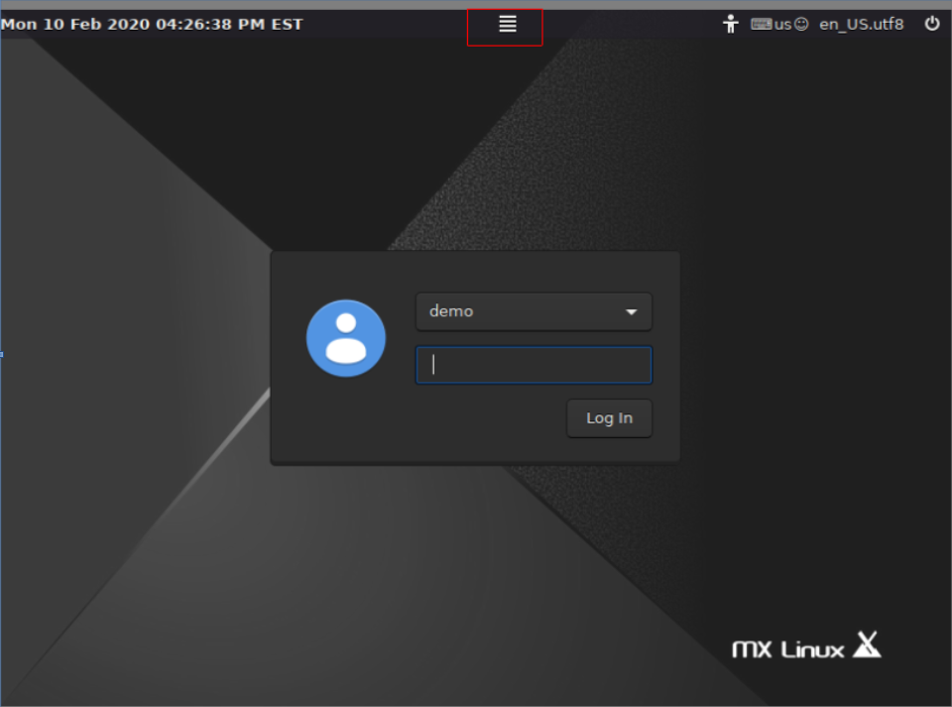

***Figure 2-6: Left: Xfce login screen, with session button top center Right: KDE/plasma login screen***

Unless you have selected autologin, the installed boot process finishes with the login screen; in a Live session only the background image is shown, but if you log out from the desktop you will see the complete screen. (The layout of the screen varies from MX version to version.) On small screens, the image may appear zoomed; this is a property of the display manager that is used by MX Linux.

You can see three small icons at the right end of the top bar; from right to left:

* The **power button** at the edge contains options to suspend, restart and shut down.
* The **language button** allows the user to select the appropriate keyboard for the login screen
* The **visual aids button** that accommodates special needs of some users.

In the middle there is the **session button** that allows you to choose which desktop manager you wish to use: Default Xsession, Xfce Session, along with any other you may have installed (Section 6.3). Fluxbox is no longer included by default, though it can be installed with MX Package Installer.

If you wish to avoid having to log in each time you boot up (not recommended where there are security concerns), you can change to autologin” on the “options” tab of MX User Manager.

MX KDE/plasma versions ship with a different login screen, containing a session chooser, onscreen keyboard, and power/shutdown/reboot functions.

### 2.4.5 Different Desktops

#### MX-Xfce

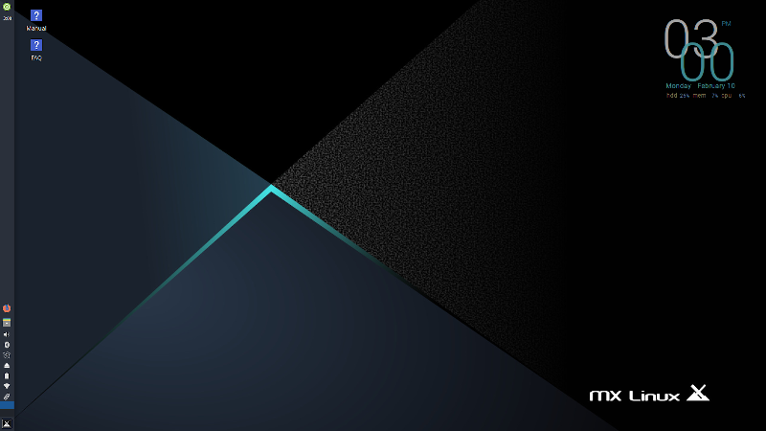

***Figure 2-7: The default Xfce desktop***

#### ***MX-KDE***

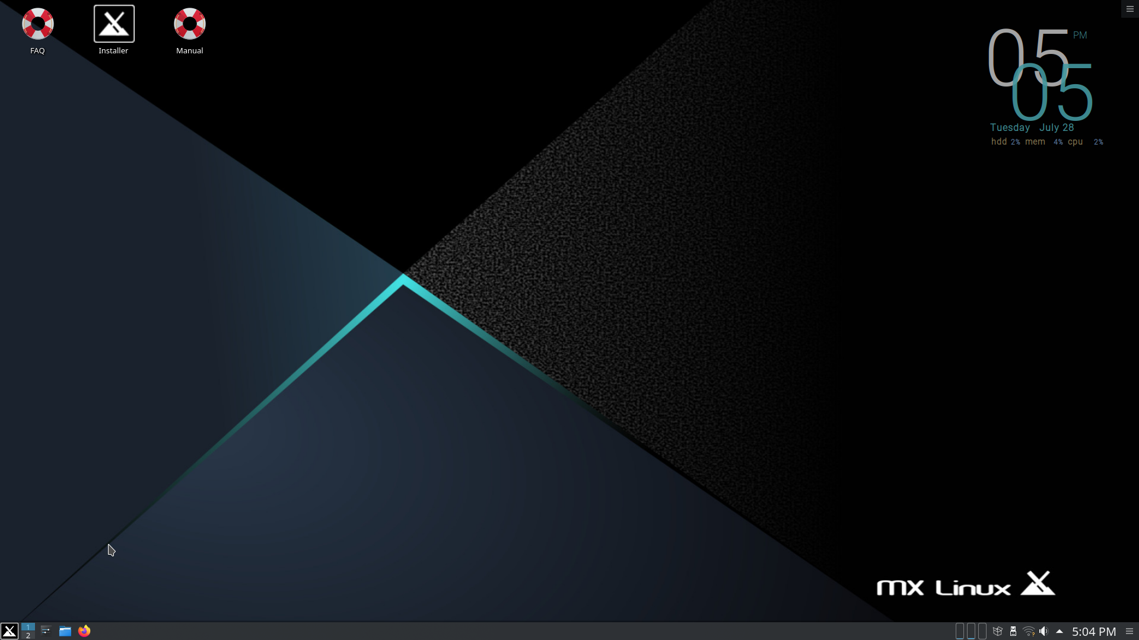

***Figure 2-8: the default KDE/plasma desktop***

The desktop is created and managed by [Xfce](http://docs.xfce.org/xfce/getting-started) or KDE/plasma, and each appearance and arrangement have been heavily modified for MX Linux. Note the two dominant features of your first look: panel and Welcome screen.

#### Panel

The default desktop of MX Linux has a single vertical panel on the screen. Panel orientation is easily changeable in **MX Tools > MX Tweak**. Common panel features are:

* Power button, opens to a dialog box for log out, restart, shut down, and suspend. (xfce)
* Clock in LCD format–click for a calendar (xfce)
* Taskswitcher/Window Buttons: area where open applications are shown
* Firefox browser
* File manager (Thunar)
* Notification Area
  + Update manager
  + Clipboard manager
  + Network manager
  + Volume manager
  + Power manager
  + USB ejector
* Pager: displays available workspaces (by default 2, right-click to change)
* Application menu (“[Whisker](http://gottcode.org/xfce4-whiskermenu-plugin)” on Xfce)
* Other applications may insert icons in the Panel or Notification Area when running.

To change the properties of the Panel, see Section 3.8.

#### Welcome screen

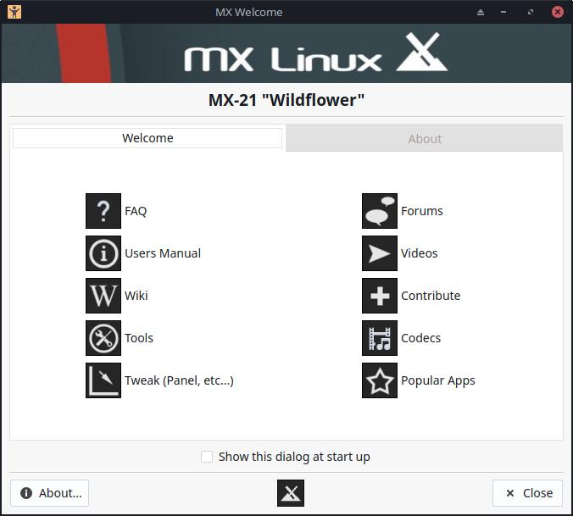

**[[ADD SECOND TAB]]**

***Figure 2-9: The Welcome and About screens in MX linux (installed)***

When the user boots up for the first time, a Welcome screen appears in the center of the screen with two tabs: „Welcome” offers quick orientation and help links (Figure 2-7). while „About” displays a digest of information about the OS, the running system, etc.. When running Live, the passwords for demo and root users will be shown at the bottom. Once closed, running live or installed, it can be displayed again using the menu or MX Tools.

It is very important for new users to work carefully through the buttons, as it will save much confusion and effort in the future use of MX-Linux. If time is limited, it is recommended that you scan through the FAQ document linked on the Desktop, where the most common questions are answered.

### Tips & Tricks

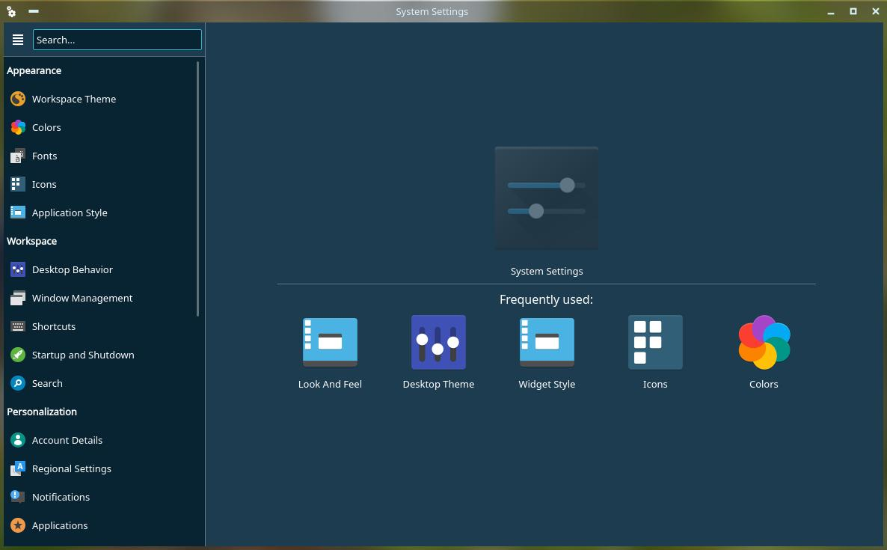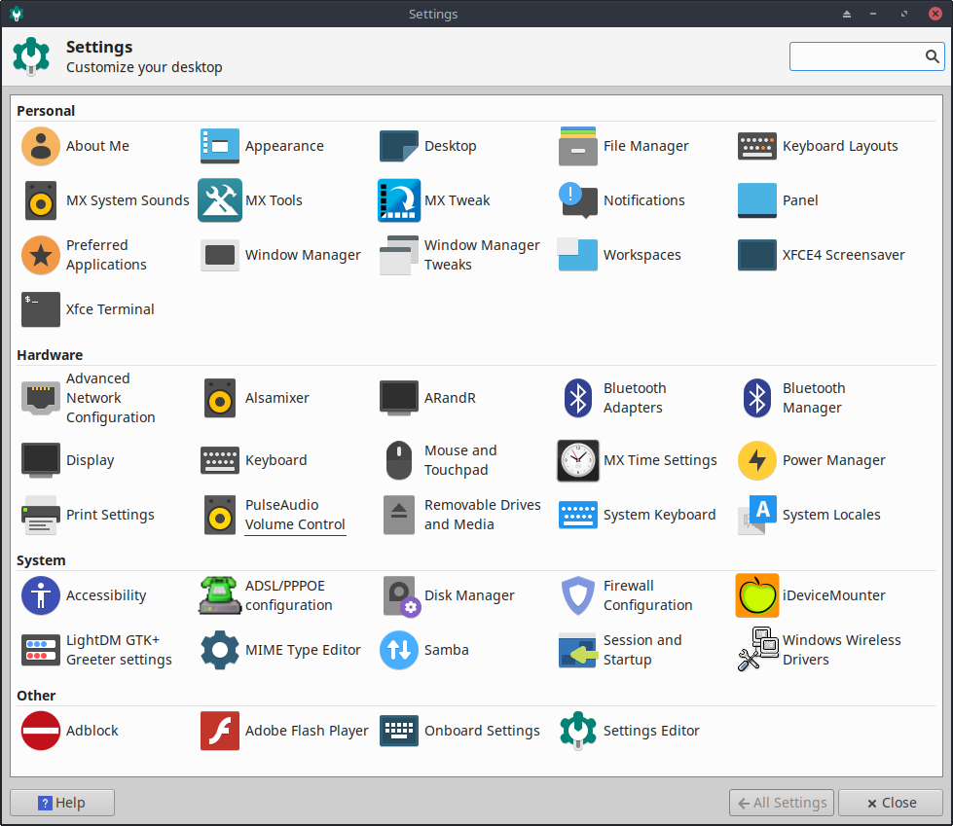

***Figure 2-10: Settings is your one-stop location to make changes. Contents vary.***

Some handy things to know at the beginning:

* If you are having problems with sound, network, etc., see Configuration (Section 3).
* Adjust sound general loudness by scrolling with the cursor over the speaker icon, or by right-clicking speaker icon > Open Mixer.
* Set the system to your particular keyboard layout by clicking **Application Menu > Settings > Keyboard**, Layout tab, and selecting the model with the pull-down menu. This is also where you can add other language keyboards.
* Adjust preferences for mouse or touchpad by clicking **Application Menu > Settings > Mouse and Touchpad**.
* Trash can be easily managed in the File Manager, where you will see its icon in the left pane. Right-click to empty. It can also be added to the Desktop or Panel. It is important to realize that using delete, whether by highlighting and hitting the delete button or via a context menu entry, removes the item forever and it will not be recoverable.
* Keep your system current by watching for the indicator (outlined box) of available updates on the MX Updater to turn green. See Section 3.2 for details.
* Handy key combinations (managed in All Settings > Keyboard > Application Shortcuts).

***Table 2: Handy key combinations***

|  |  |
| --- | --- |
| ***Keystrokes*** | ***Action*** |
| F4 | Drops a terminal down from top of screen |
| Windows key | Brings up the Application menu |
| Ctrl-Alt-Esc | Changes the cursor into a white x to kill any program |
| Ctrl-Alt-Bksp | Closes the session (without saving!) and returns you to the login screen |
| Ctrl-Alt-Del | Locks the desktop on Xfce. logout on KDE/plasma |
| Ctrl-Alt-F1 | Drops you out of your X session to a command line; use Ctrl-Alt-F7 to return. |
| Alt-F1 | Opens this MX Linux Users Manual (Xfce only, menu on KDE/plasma) |
| Alt-F2 | Brings up a dialog box to run an application |
| Alt-F3 | Opens the Application Finder which also allows some editing of menu entries (Xfce only) |
| Alt-F4 | Closes an application in focus; over the desktop, brings up the exit dialog. |
| PrtScr | Opens the Screenshooter for screen captures |

#### Applications

Applications can be started in various ways.

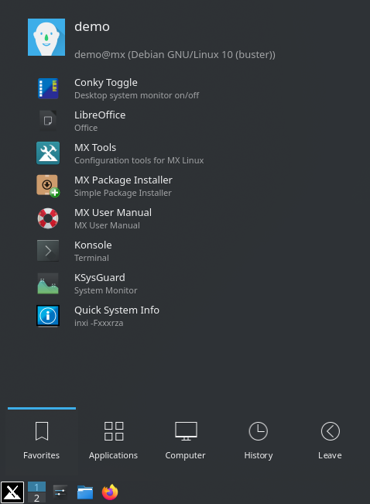

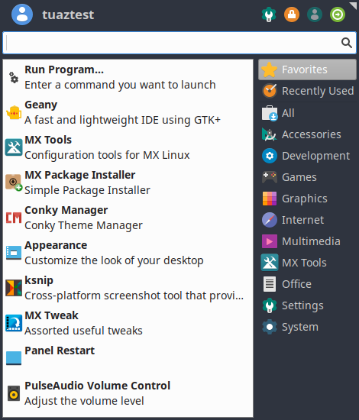

Figure 2-11: LEFT: Xfce Whisker menu (contents vary) RIGHT: KDE/plasma menu

* Click the Application menu icon, in lower left corner.
  + It opens to Favorites category, and you can hover mouse over other categories on right side to see contents in the left pane.
  + At the top is a powerful incremental search box: just type in a few letters to find any application without needing to know its category.
* Right-click the desktop > Applications.
* If you know the name of the application, you can use Application Finder, started easily in one of two ways.
  + Right-click the desktop > Run command ...
  + Alt-F2
  + Alt-F3 (Xfce) brings up an advanced version that lets you check commands, locations etc.
  + On KDE/plasma desktop, just start typing
* Use a keystroke you have defined to open a favorite application.
  + Xfce- Click **Application Menu > Settings**, then Keyboard, Application shortcuts tab.
  + KDE/plasma – Global Shortcuts in menu

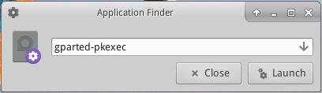

***Figure 2-12: Application Finder identifying application***

#### Other

##### System information

* Click **Application Menu > Quick System Info** that will put the results of the command *inxi -Fxrz* onto your clipboard ready to paste in Forum posts, text files, etc.
* KDE/plasma - Click **Application Menu > System > Infocenter** for a nice graphic display

##### **Video and audio**

* For basic monitor settings, click **Application Menu> Settings > Display**
* Sound adjustment is done through **Application Menu > Multimedia > PulseAudio Volume Control** (or right-click Volume manager icon)

**NOTE**: for troubleshooting areas such as display, sound or internet, consult Section 3: Configuration.

Links

* [Xfce documentation](http://www.xfce.org/about)
* [Xfce FAQs](https://wiki.xfce.org/faq)
* [KDE](https://userbase.kde.org/Welcome_to_KDE_UserBase)

### 2.4.7 Exiting

When you open Application menu, you will see by default four command buttons in the upper right corner (change what shows with a right click on the menu icon > Properties, Commands tab). From left to right:

* All Settings (All Settings)
* Lock Screen
* Switch Users
* Log Out

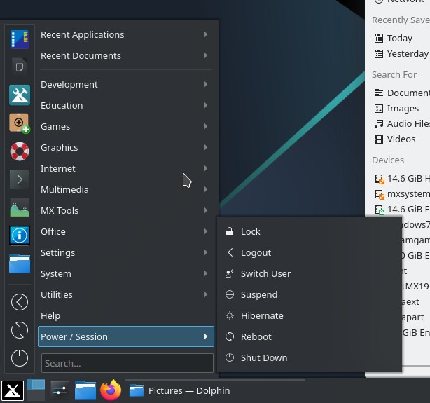



***Figure 2-13: command buttons***

***Top: Xfce***

***Right: KDE/plasma***

It is important to exit MX Linux correctly when you have finished your session so that the system can be brought down in a secure way. All running programs are first notified that the system is going down, giving them the time to save any file being edited, exit from mail and news programs, etc. If you just turn the power off, you risk the possibilities of damaging the operating system.

Similar options to the command buttons are available in the KDE/plasma LEAVE menu.

#### **Permanent**

To leave a session for good, select one of the following on the Log Out dialog box:

* **Log out**. Choosing this will terminate everything you are doing, asking you about saving open work if you have not closed the files yourself, and bring you back to the login screen with the system still running.
  + The command at the bottom of the screen, “Save session for future logins,” is checked by default. Its task is to save the state of your desktop (opened applications and their location) and restore it during the next startup. If you have had problems with your desktop function, you can uncheck this to get a fresh start; if that does not solve the problem, click All Settings > Session and Startup, Session tab, and press the Clear saved sessions button.
* **Restart** or **Shut Down**. Self-explanatory options that alter the system state itself. Also available using the icon in the upper right corner of the top bar on the login screen.

TIP: In the event of a problem, **Ctrl-Alt-Bksp** will kill your session and return you to the login screen, but any open programs and processes will not be saved.

#### **Temporary**

You can temporarily leave your session in one of the following ways:

* **Lock screen**. This option is easily available from an icon in the top right corner of the Application Menu. It protects your Desktop from unauthorized access while you are away by requiring your user password to return to the session.
* **Start a parallel session as a different user**. This is available from the Switch User command button in the top right corner of the Application Menu. You choose this to leave your current session where it is and allows a session for a different user to be started.
* **Suspend** using Power Button. This option is available from the Log Out dialog box, and places your system into a low-power state. Information on system configuration, open applications, and active files is stored in main memory (RAM ), while most of the system’s other components are turned off. It is very handy and generally works very well in MX Linux. Invoked by the Power Button, suspend works well for many users, though its success varies according to the complex interaction among a system’s components: kernel, display manager, video chip, etc. If you have problems, consider trying the following changes:
  + Switch graphical driver, e.g. from radeon to AMDGPU (for newer GPU's), or from nouveau to the proprietary Nvidia driver.
  + Adjust the settings in Application Menu > Settings > Power Manager. For instance: on the System tab, try unchecking "Lock screen when system is going for sleep."
  + Click Application Menu > Settings > Screensaver, and adjust the Display Power Management values on the Advanced tab.
  + AGP cards: add ***Option "NvAgp" "1"*** to the Device section of xorg.conf
* **Suspend** using laptop lid close. Some hardware configurations may experience trouble with this. Action on lid closing can be adjusted on the General tab of Power Manager, where “Switch off display” has proved reliable in MX users’ experience.
* **Hibernation.** The hibernation option was removed from the logout box in earlier MX Linux versions because users experienced multiple problems. It can be enabled in MX Tweak, Other tab. Consult also [the MX/antiX Wiki](https://mxlinux.org/wiki/system/hibernate).

## 2.5 The Installation process

### 2.5.1 Detailed installation steps

 [Basic Install of MX Linux (with partitioning)](https://youtu.be/jSYycsZPm_Q)

 [Encrypted Install of MX Linux (with partitioning)](https://youtu.be/tQjftZsoySg)

 [My Home Folder Setup](https://www.youtube.com/watch?v=twDhZFBMgJ0)

To begin, boot to the LiveMedium, then click on the Installer icon in the upper left corner. If the icon is missing, click F4 and enter: *minstall-pkexec* (root password on LiveMedium: **root**).

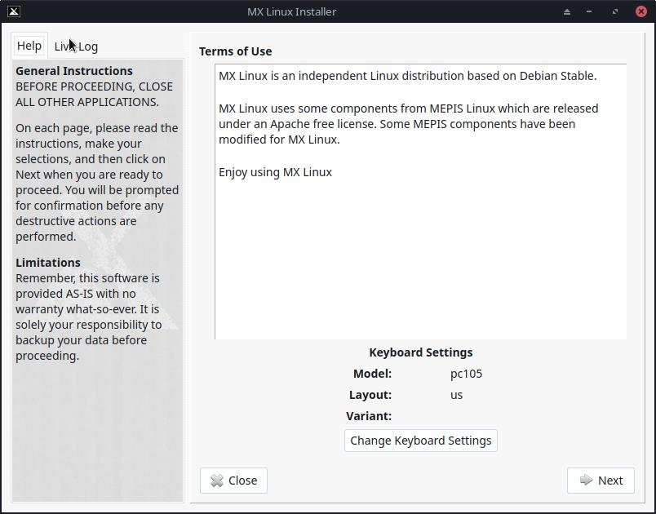

F***igure 2-14: Installer Screen Home***

#### Comments

* The right side of the Installer screen presents user choices as the installation proceeds; the left side provides clarification of the content of the right side.
* Keyboard Settings permits changing the keyboard for the installation process.

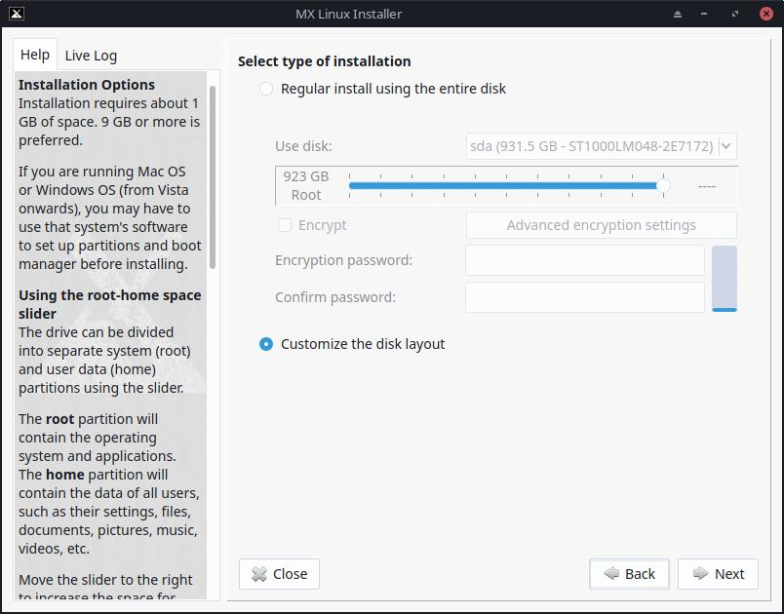

***Figure 2-15: Installer set to use existing partitions***

#### **Comments**

* **Use disk**. If unsure which is the partition you want, use the names you see in GParted. The disk you select will be examined cursorily for reliability by [SMART](https://en.wikipedia.org/wiki/S.M.A.R.T.). If problems are detected, you will see a warning screen. You will need to decide whether to accept that risk and continue, select another disk or terminate the installation. For more information, click **Application Menu > System > GSmartControl** and “Perform tests” on the drive.

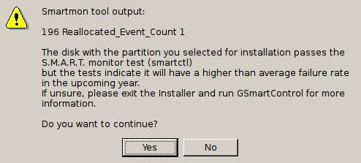

***Figure 2-16: SMART warning of risk of failure***

* **Regular install using entire disk**. Select this option if you plan to use the entire hard drive for MX Linux. The disk will be repartitioned and any existing data will be lost.
  + By default a root and swap partition will be created. A /boot partition will also be created if you choose to use encryption.
  + If you wish a seperate home partition, you can use the slider to divide the available space between root and home partitions.
  + A pop-up message asks you to confirm using the entire disk.
* **Customize the Disk Layout:** If existing partitions are detected on disk, this option will be the default. You will be able to use the partition selection screen to use existing partitions.

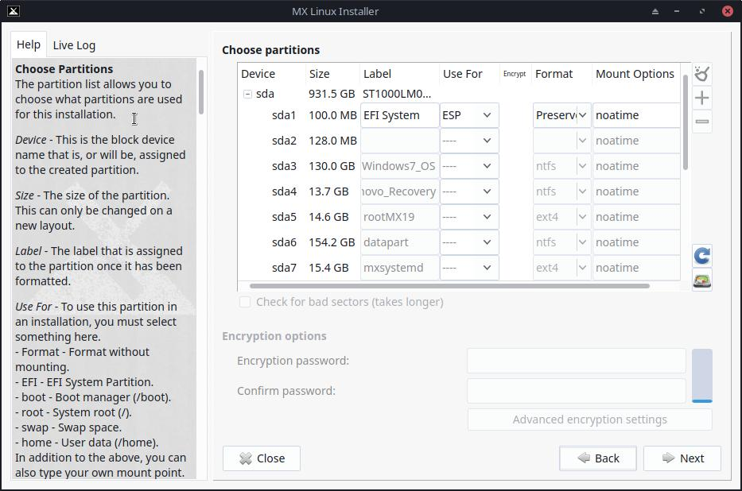

***Figure 2-17: Partition Selection***

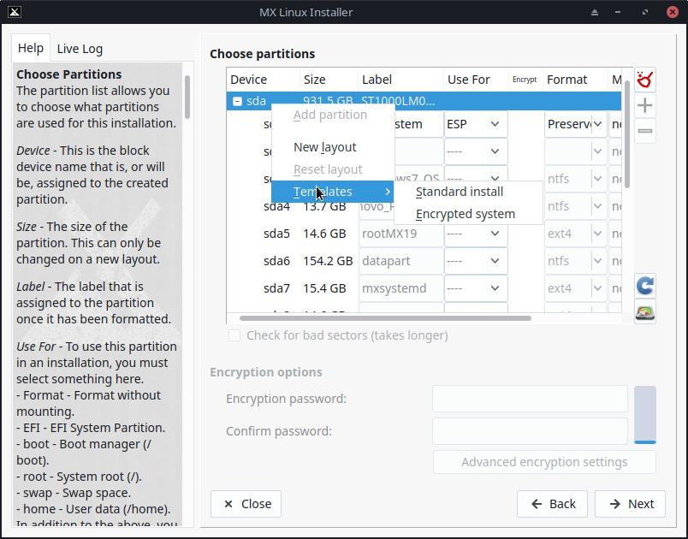

***Figure 2-18: Right click on a disk to show template options.***

#### **Comments**

* **Choose Partitions**. Specify the root and swap partitions you want to use. Use the **USE FOR** column to chose what you want to use a partition for. If you set up a separate partition for your home directory, specify it here, otherwise leave /home set to root.
  + Many users prefer to locate their home directory in a different partition than that of / (root), so that any problem with — or even total replacement of — the installation partition will leave all the user’s individual settings and files untouched.
  + Unless you are using encrpytion or know what you are doing, leave boot set to root.
  + There is simple partition management available on this screen. Right click a disk to show partition templates. The templates are only suitable for whole disk changes, so if you want to resize or otherwise fine tune partition layouts, use an external partition manager (ie: gparted) availabe by clicking the Partition Manager button in the lower right of the Partition Chooser.
* **Preferences**.
  + Check Preserve data in /home if you are doing an upgrade and already have data in an existing partition or folder. This option is not generally recommended because of the risk that old configurations will not match the new installation, but can be useful in specific situations, e.g. repairing an installation.
  + Select Check for bad blocks if you want to do a scan for physical defects on the hard drive during formatting. This is recommended for users with older drives.
  + You can change the label of the partition where you want to install (e.g., to “MX-21 Testing Installation”) in the **Label** colun.
  + Finally, you can optionally select the type of file system you want to use on the hard drive. The default ext4 is recommended in MX Linux if you have no particular choice.
  + You can fine-tune your encryption cipher settings with the "Advanced Encryption Settings” button or just keep the defaults.

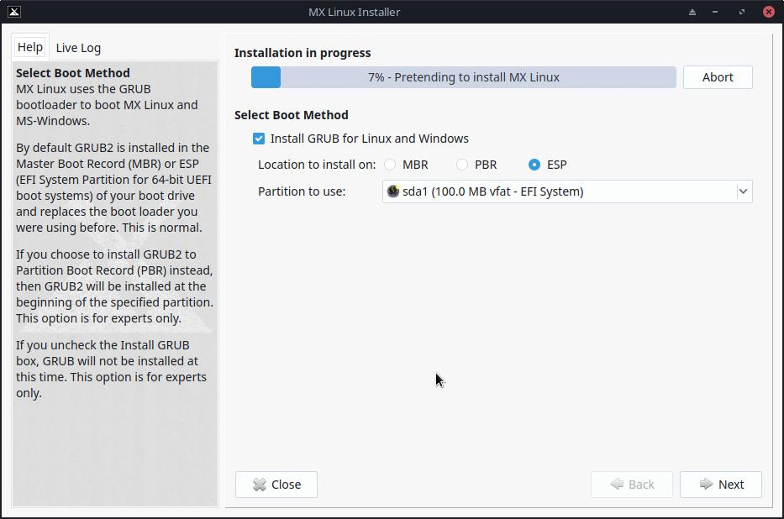

***Figure 2-19: Installer asking about boot method***

**Comments**

* While the main linux OS is being copied to hard drive, you can click the ”Next” button to fill in some additional configuration information. Figure 2-18 shows the GRUB bootloader installation options.
* Most average users will accept the defaults here, which will install the bootloader into the very beginning of the disk. This is the usual location and will cause no harm.
* UEFI users should choose whatever ESP partition they wish to use. Default is the first one found.
* When you click Next, a pop-up message will check to see that you accept the location of the bootloader GRUB. Installing GRUB can take a few minutes in some situations.
* Note that the partition shown (sda) is just an example; your particular selection of partition may well differ.

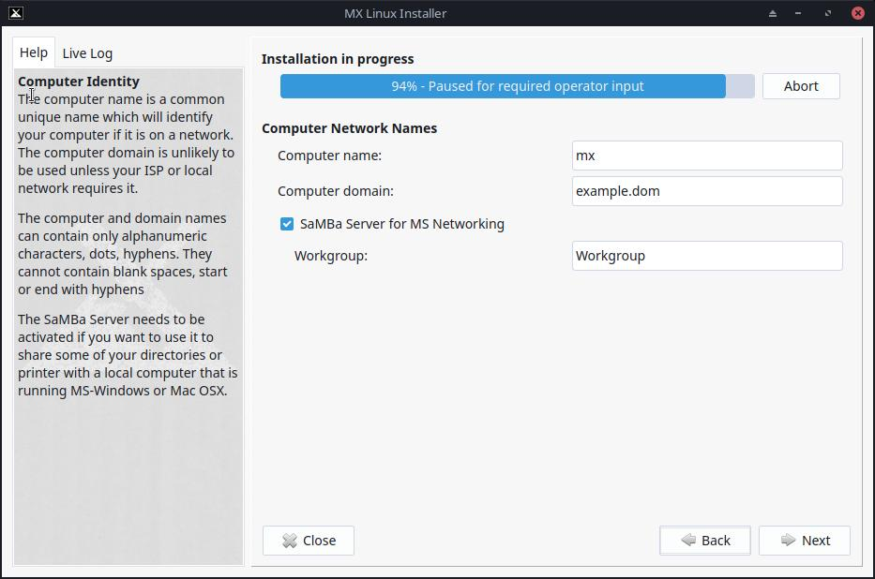

***Figure 2-20: Computer Network Names Setup***

#### **Comments**

* Many users choose a unique name for their computer: laptop1, MyBox, StudyDesktop, UTRA, etc. You may also just leave the default name as it is.
* You can just click Next here if you have no computer network.
* If you are not going to *host* shared network folders on your PC, then you can disable samba. This will not affect your PC's ability to access shares hosted elsewhere on your network.

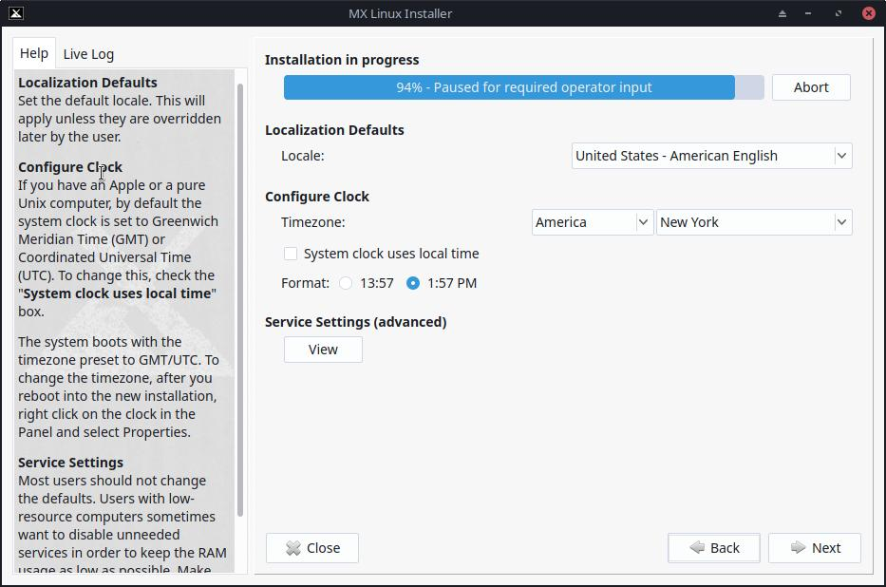

***Figure 2-21: Locale, Timezone, and Service Settings***

#### **Comments**

* The default settings will usually be correct here, as long as you were careful to enter any exceptions at the LiveMedium boot screen.
* The settings can be changed again once you have booted into Xfce.

***Figure 2-22: Enable/Disable Services***

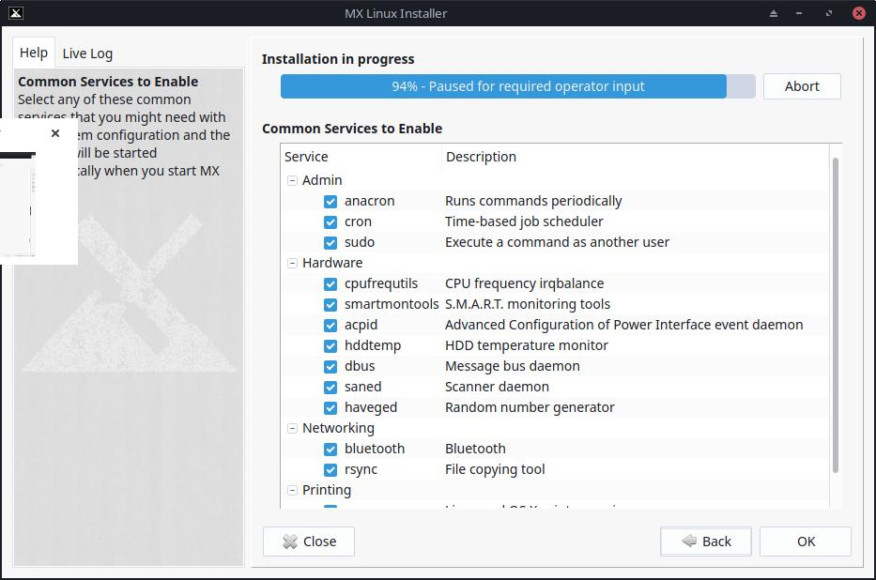

#### **Comments**

* This screen only shows if “View” was clicked on the Locale, Timezone & Services Setting screen.
* Services are applications and functions associated with the kernel that provide capabilities for upper-level processes. If you are not familiar with a service, you should leave it alone.
* These applications and functions require time and memory, so if you are concerned about the capacity of your computer, you can look at this list for items that you are sure you do not need.
* If you later want to change or adjust the startup services you can use a command-line tool called **sysv-rc-conf.** Sysv-rc-conf is installed by default and must be run as root.

***Figure 2-23: User Configuration***

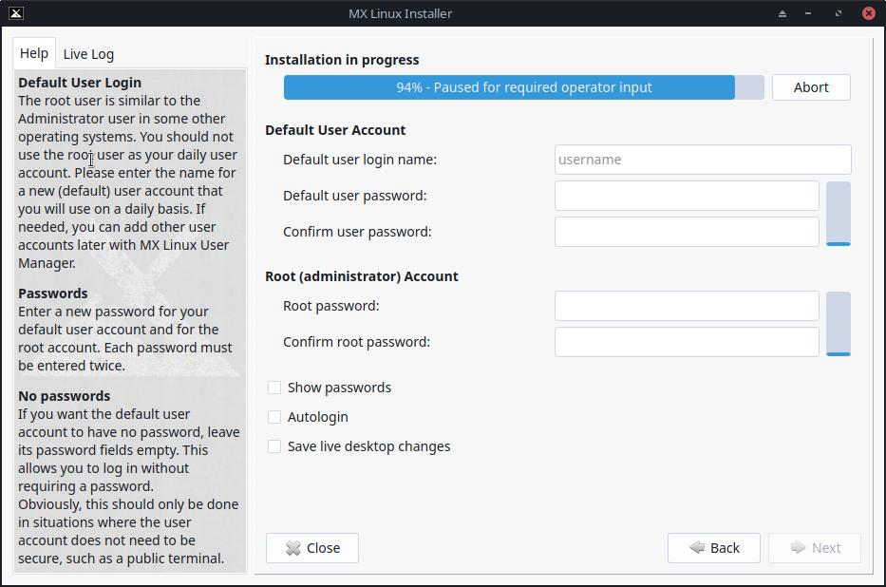

#### **Comments**

* The level of security on the passwords you choose here will depend greatly on the setting of the actual computer. A home desktop is generally less likely to be broken into.
* If you check Autologin, you will be able to bypass the login screen and speed up the boot process. The downside of that choice is that anyone with some kind of access to your computer would be able to log directly into your account. You can later change your autologin preferences on the “Options” tab of the MX User Manager.
* You can transfer any changes you make to your Live desktop to the HD installation by checking the last box. A small amount of critical information (e.g., the name of your wireless Access Point) will be translated automatically.
* If you do not set a root password, gui authentications will be set to user password if they haven't been already.

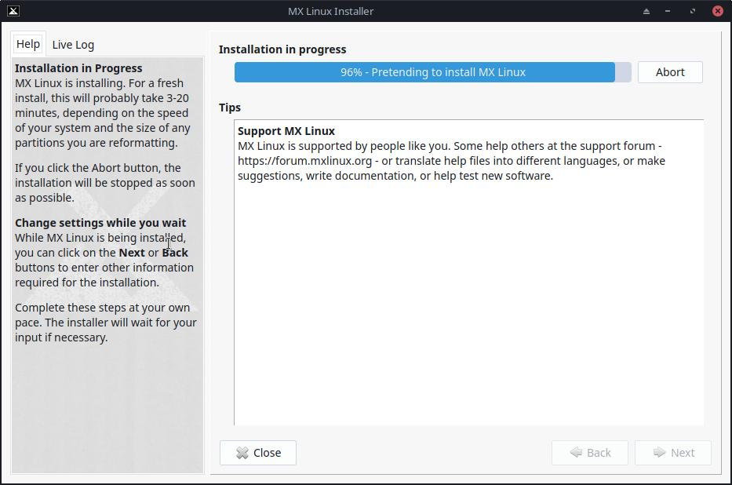

***Figure 2-24: Installation Complete***

#### **Comments**

* After the system copy is finished and the configuration steps are complete, an "Installation Complete” screen will be presented and you are ready to go!
* If you don't want to reboot after finishing installation, uncheck the automatic reboot option before clicking Finish.

## 2.6 Troubleshooting

### 2.6.1 No operating system found

When rebooting after an installation, it sometimes happens that your computer reports that no operating system or bootable disc was found. It also may not show another installed OS such as Windows. Usually, these problems mean that GRUB did not install properly, but that is easy to correct.

* If booting with UEFI, make sure Secure Boot is turned off in your system bios/UEFI settings.
* If you can boot into at least one partition, open there a root terminal and run this command:

*update-grub*

* Otherwise, proceed with MX Boot Repair.
  + Boot to the LiveMedium.
  + Launch **MX Tools > Boot Repair**.
  + Make sure that “Reinstall GRUB Bootloader” is selected, then click OK.
  + If this still does not fix it, you may have a faulty hard drive. Usually, you will have seen a SMART warning screen about it when you began your installation.

### 2.6.2 Data or other partition not accessible.

Partitions and drives other than the one designated as boot may not be booted or require root access after installation. There are a couple of ways to change this.

* For internal drives, use Start > Settings > MX Tweak, Other tab: check "Enable mounting of internal drives by non-root users."
* **GUI**. If you have installed Gnome Disks, click Application Menu > System > Disks. Check anything you want mounted at boot and save; when you reboot it should be mounted and you will have access in Thunar.
* **CLI**. Open a File Manager and navigate to the file /etc/fstab; use the right-click option to open it as root in a text editor. Look for the line containing the partition or drive to which you want access (you may need to type *blkid* in a terminal to identify the UUID). Change it following this example for a data partition.

*UUID=9501<snip>912 /data ext4 users 0 2*

This entry will cause the partition to be automatically mounted at boot time, and also allow you to mount it and umount it as a normal user. This entry will also cause the file system to be checked periodically at boot time. If you don’t want it mounted automatically at boot time then change the options field from "*user*" to "*user,noauto*".

* If you don’t want it checked regularly then change the final "2" to a "0". Since you have an ext4 filesystem it is suggested that you enable the automated checking.
* If the item is mounted but not showing in File Manager, add an additional "*comment=x-gvfs-show*" to the line in your fstab file, which will force the mount to be visible. In the example above, the change would look like this:

UUID=9501<snip>912 /data ext4 users,comment=x-gvfs-show 0 2

NOTE: neither of these procedures will change Linux permissions, which are enforced on the folder and file level. See Section 7.3.

### 2.6.3 Keyring problems

A default key ring should be created automatically and the user will not need to do anything. If using autologin, when an app accesses the keyring the user would be asked to enter a new password to create a new default keyring. Details in the [MX/Antix Technical Wiki](https://mxlinux.org/wiki/system/gnome-keyring).

Note that if malevolent agents get physical access to your machine, using a blank password will make it easier to break into. But it seems pretty clear that if a malevolent agent has physical access to your machine it’s all over anyway.

### 2.6.4 Locking up

If MX Linux is locking up during installation, it is usually due to a problem with faulty computer hardware, or a bad DVD. If you have determined that the DVD is not the problem, it may be due to faulty RAM, a faulty hard drive, or some other piece of faulty or incompatible hardware.

* Add one of the Boot Options using F4 at boot or consulting the [MX/antiX Wiki](https://mxlinux.org/wiki/system/boot-parameters). The most common problem arises from the graphic driver .
* Your DVD drive may be having problems. If your system supports it, create an MX Linux bootable USB flash drive and install from that.
* Systems often lock up due to overheating. Open the computer’s case and ensure that all the system’s fans are running when it is turned on. If your BIOS supports it, check the CPU and Motherboard temperatures (enter **sensors** in a root terminal if possible) and compare them to the temperature specifications for your system.
* Shut down your computer and remove any non-essential hardware, then attempt the installation again. Non-essential hardware may include USB, serial, and parallel-port devices; removable PCI, AGP, PCIE, modem slot, or ISA expansion cards (excluding video, if you do not have onboard video); SCSI devices (unless you are installing to or from one); IDE or SATA devices that you are not installing to or from; joysticks, MIDI cables, audio cables, and any other external multimedia devices.