# 3 Configuration

[Things to do after installing MX Linux](https://youtu.be/aESEb8lTvz4)

This section covers configuration instructions in order to get your system running correctly from a fresh installation of MX Linux, and a short guide to personal customization.

## 3.1 Peripherals

### 3.1.1 Smartphone

[Smartphones & MX-16 (samsung galaxy s5 and iphone 6s)](https://www.youtube.com/watch?v=YoMRRXP3Pic)

#### Android

Sharing files with an Android device.

* Most phones running Android 4.xx and later include [**mtp**](http://en.wikipedia.org/wiki/Media_Transfer_Protocol) capability, and you can use the following procedure.
  + Connect phone, and tap on the link that appears to make sure storage option id is set to “file exchange” or something similar.
  + Open File Manager. When the Devices shows your phone’s name (or: Storage), click on it. If you don’t see it, reboot the phone. Your phone may then show a dialog box asking if you allow access.
  + Navigate to the location you are looking for.
* Some files can be viewed and managed with MX Linux applications: click on Device in the left pane, then double-click CD Drive if necessary.
  + Music: use **the default music player (clementine)**
  + Pictures: use the default **image viewer application** **(gthumb, gwenview)** or install a different application like **Shotwell or digikam.**
* If problems, Android phones can be accessed via a web browser by installing an app from Google’s Play Store such as [AirDroid](http://web.airdroid.com/).

***Figure 3-1: Thunar connected to an Android phone***

#### iPhone

A dedicated MX iDevice Mounter provides access through Thunar. See Section 3.2.

### **3.1.2** Printer

***Figure 3-2: Print Setting’s New Printer screen***

#### Attached

MX Linux offers two utilities for configuring and managing printers. Print Settings usually works well, but if problems arise it is recommended that you switch to CUPS in a browser by entering “localhost:631: in a web browser address bar.

* Print Settings application
  + Click **Start menu > System > Print Settings**
  + Click on the “+Add” button
  + Wait on the New Printer screen while the application searches for attached and wireless printers.
  + It will show recommended software for any printer found.
  + Follow the prompts to conclude the printer installation.

HELP: [the Debian Wiki](https://wiki.debian.org/SystemPrinting).

#### Network

[Samba](https://wiki.samba.org/index.php/Main_Page) on MX Linux allows printing via the network to shared printers on other computers (Windows, Mac, Linux) and NAS (Network Attached Storage) devices offering Samba services (Section 3.5).

##### Using Print Settings

* Click **Start menu > System > Print Settings**
* Select **Server > New> Printer**
* Select Network Printer > Windows Printer via SAMBA
* In the dialog window for smb:// enter either servername/printername or server-ipaddress/printername. For example: *bigserver/usbprinter1* or *192.168.0.100/printer2*
* If you have trouble identifying the server and printer names, click **Start menu > System > Samba** for details.
* Leave the button selected for Prompt user if authentication is required, then click Forward
* Leave the button selected for Select printer from database and then click Forward
* Select the driver and then Forward
* Describe Printer if necessary and then Apply
* When the printer appears in the window, right-click Properties > Print Test Page to make sure the connection and driver are operating correctly.

**Troubleshooting**

* There is a troubleshooting utility integrated into the Print Settings application. Click Help > Troubleshoot.
* For HP printers, the extra package **hplip-gui** will install a useful applet into the Notification Area which provides troubleshooting tools.
* If your printer suddenly stops printing, check that it is still enabled by clicking **Start menu > System > Print settings**, then right-click your printer and enable it again.
* If your printer is not recognized or does not function correctly, consult the [MX/antiX Wiki](https://mxlinux.org/wiki/hardware/printer-drivers) for detailed help on getting the correct driver.

### 3.1.3 Scanner

Scanners are supported in Linux by SANE (Scanner Access Now Easy), which is an application programming interface (API) that provides standardized access to any raster image scanner hardware (flatbed scanner, hand-held scanner, video- and still-cameras, frame-grabbers, etc.).

#### Basic steps

You can manage your scanner in MX Linux with the default **Simple Scan**. It is very easy to use and can export to PDF with a single click.

#### Troubleshooting

* Some scanners require a different frontend (system interface to the scanner): you can install gscan2pdf, click Edit > Preferences, and use the pull-down menu to select another (e.g., scanimage).
* Make sure your scanner is listed as supported by SANE on [this list](http://www.sane-project.org/sane-mfgs.html).
* If you continue to have problems, check [the MX/antiX Wiki](https://mxlinux.org/wiki/hardware/scanner) for solutions.

### 3.1.4 Webcam

Most likely your webcam video will work in MX Linux; you can test it by launching **Start menu > Multimedia > webcamoid** and using the settings at the bottom of the window to adjust for your system. If it does not appear to work, there is a recent detailed discussion of drivers and setup in [the Arch Wiki](https://wiki.archlinux.org/index.php/Webcam). Webcam audio is sometimes trickier, see Section 4.1 about Skype.

### 3.1.5 Storage

Disk drives (such as SCSI, SATA and SSD), cameras, USB drives, phones, etc. – these are all different forms of storage.

#### Mounting

By default, storage devices that are plugged into the system mount automatically in the */media/<username>/* directory, and then a file browser window opens for each (that behavior can be changed in Thunar: Edit > Preferences or KDE: System Settings > Removable Storage).

Not all storage devices, especially extra internal drives and partitions, are mounted automatically when they are plugged into a system and may require root access. Options can be adjusted with MX Tweak > Other, and Settings > Removable Drives and Media.

#### Permissions

The extent of the user’s access to storage will depend on the file system that it contains. Most commercial external storage devices, especially hard drives, will come preformatted as fat32 or ntfs.

|  |  |
| --- | --- |
| ***Storage Filesystem*** | **Permissions** |
| **fat32** | None. |
| **ntfs** | By default, permissions/ownerships are granted to the user that mounts the device. |
| **ext2, ext4, and most Linux**  **fileystems** | Mounted by default with ownership **set to Root**. Permission adjustment: see Section 7.3. |

You can change the need to be Root for accessing internal storage devices with Linux filesystems by using MX Tweak, Other tab (Section 3.2).

#### SSDs

Newer machines may have an internal [SSD](https://en.wikipedia.org/wiki/Solid-state_drive): a solid state drive that has no moving components. These drives tend to accumulate blocks of data that are no longer considered in use, slowing down this very fast drive. To prevent this from happening, MX Linux runs a [TRIM](https://en.wikipedia.org/wiki/Trim_(computing)) operation on a weekly schedule that you can view by opening the file **/var/log/trim.log**.

### **3.1.6 Bluetooth devices**

External bluetooth devices such as a keyboard, speaker, mouse, etc. will normally work automatically. If not, follow these steps:

* Click Start menu > Settings > Bluetooth Manager (or: right-click the Bluetooth icon in the Notification Area > Devices)
* Check that your adapter is enabled and it is visible by clicking Start menu > Settings > Bluetooth Adapters
* Make sure the device you want is visible; in Bluetooth Manager click Adapter > Preferences and select your visibility setting.
* If the device you want is in the Devices window, select it and then click Setup.
* If not, click the Search button, and press Connect on the line for the device to initiate pairing.
* For a phone, you will likely have to confirm the pairing number on both device and desktop.
* After pairing with the Bluetooth device, the Setup dialog asks you to confirm the type of bluetooth configuration to associate with it.
* When the Setup process is finished, the device should be working.

#### Object transfer

To be able to pass objects (documents, photos, etc.) back and forth between an MX Linux desktop and a device such as a phone using bluetooth, take the following steps:

* Install **obex-data-server** from the repos.
  + It will bring in libopenobex2 with it.
  + In rare cases, the obex-data-server package may block Bluetooth mouse or keyboard usage.
* Confirm that the phone and desktop both have bluetooth enabled and are visible.
* Send file
  + From the MX Linux desktop: right-click the Bluetooth icon in the Notification Area > Send file (or use Bluetooth Manager)
  + From the phone: follow the appropriate instructions for your device.
* Keep your eye on the receiving device to confirm acceptance of the object being transferred.

It is also possible to [make use of hcitool](http://www.linuxjournal.com/content/bluetooth-hacks) on the command line.

#### Links

* [Blueman Troubleshooting](https://github.com/blueman-project/blueman/wiki/Troubleshooting)
* [Arch Wiki](https://wiki.archlinux.org/index.php/Blueman)
* [Debian Wiki on Pairing](https://wiki.debian.org/BluetoothUser" \l "Pairing)

### 3.1.7 Pen tablets

[Wacom](https://www.wacom.com/en-us/) pen tablets are auto-detected and natively supported on Debian. Details in t[he MX/antiX Wiki](https://mxlinux.org/wiki/hardware/wacom/).

#### Links

* [The Linux Wacom Project](https://linuxwacom.github.io/)

## 3.2 Basic MX Tools

A number of applications have been developed specifically for MX Linux, adapted or brought over from antiX, or adapted from outside sources to save the user effort with important tasks often involving unintuitive steps. (Snapshot and other Advanced tools are treated in Section 6.6)

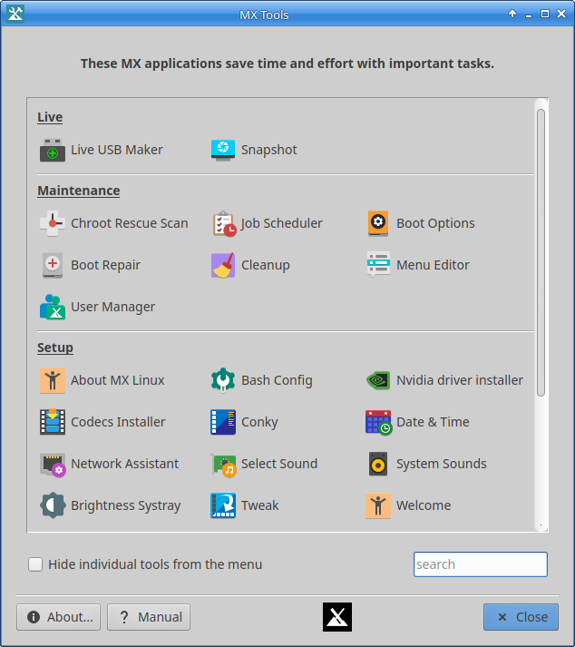

***Figure 3-3: MX Tools dashboard (Xfce installed). Live and KDE dashboards somewhat different.***

### 3.2.1 MX Updater (former Apt-Notifier)

This versatile applet (Xfce only, KDE uses [Discover](https://userbase.kde.org/Discover)) sits in the Notification Area where it notifies you when packages are available. Be sure to check the important options available through the context (right-click) menu. If it doesn’t appear, launch MX Updater to refresh. Xfce only, KDE uses

***Figure 3-4: View and upgrade screen from MX Updater***

Notice the choice between upgrade and dist-upgrade.

* **full-upgrade (dist-upgrade)**: the default action. Will upgrade all packages that have updates, even those where an update will result in the automatic removal of other existing packages or cause new packages to be added to your installation in order that all dependencies are resolved.
* **upgrade**: recommended only for more experienced users. Will only upgrade updateable packages that don't result in other packages being removed or installed. Using this option means some updateable packages may remain “held back” on your system.
* An option for unattended upgrade is available in Preferences. It happens in the background, and neither add new or remove existing packages, using the “upgrade” method rather than dist-upgrade.

HELP: [here.](https://mxlinux.org/wiki/help-files/help-mx-apt-notifier)

### 3.2.2 Bash config

Bash (the default shell language in MX Linux) can now be set up with this small application. It allows the advanced user to make changes to the aliases and terminal prompt theming in the user’s hidden *bashrc* file.

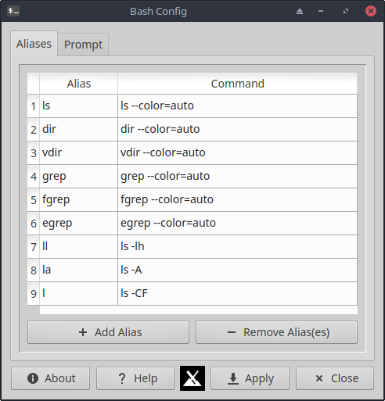

***Figure 3-5: the tab to add or change an alias***

Help: [here](https://mxlinux.org/wiki/help-files/help-bash-config/).

### 3.2.3 Boot options

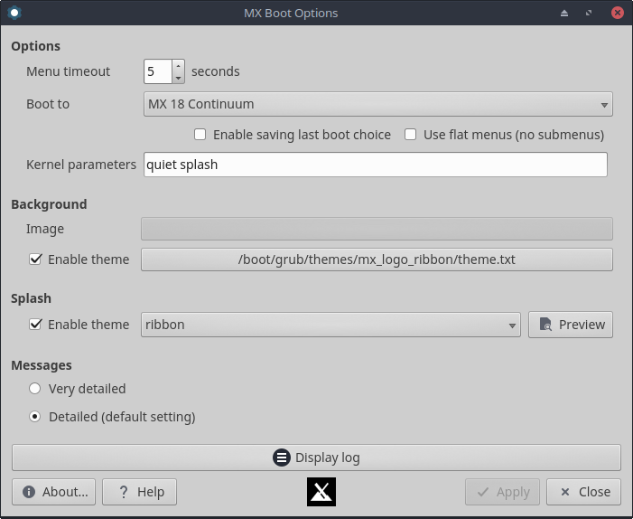

***Figure 3-6: Main screen showing various options***

Boot options include kernel parameters, GRUB themes, Splash images and other items. This app makes it quick qnd easy for users to manage these.

HELP: [here.](https://mxlinux.org/wiki/help-files/help-mx-boot-options)

### 3.2.4 Boot repair

The bootloader is the first software program to run and is responsible for loading and transferring control to the kernel. It sometimes happens that the bootloader on a conventional installation (GRUB2) becomes dysfunctional, and this tool allows you to restore the bootloader to a functional state from a LIVE boot.

***Figure 3-7: Boot Repair main screen, with the most common option selected***

HELP: [here.](https://mxlinux.org/wiki/help-files/help-mx-boot-repair)

### 3.2.5 Brightness Systray

This tool places an icon in the systray that displays a small app with which the user can adjust screen brightness.

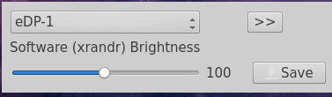

***Figure 3-8: ready to adjust brightness***

### 3.2.6 Chroot Rescue Scan

This tool allows you to get into a system even if its initrd.img is broken.

HELP: [here](https://mxlinux.org/wiki/system/chroot-rescue-scan/).

### 

***Figure 3-9: results of scan for Linux systems***

### 3.2.6 Fix GPG keys (formerly Check apt GPG)

If you try to install non-authenticated packages, you will run into an apt error: *The following signatures couldn’t be verified because the public key is not available.* This helpful utility saves carrying out the many steps necessary to obtain that key.

***Figure 3-10: Results of checking repo public keys with Fix GPG keys***

HELP: [here.](https://mxlinux.org/wiki/help-files/help-mx-check-apt-gpg)

### 3.2.**7** Cleanup

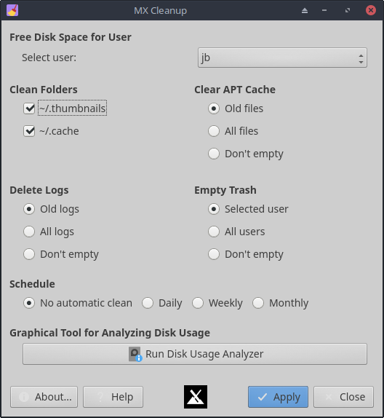

***Figure 3-11: Cleanup ready to go to work***

This handy little app offers an easy and safe way to remove unneeded files and restore space.

HELP: [here](https://mxlinux.org/wiki/help-files/help-mx-cleanup/).

### 3.2.**8** Codecs **Installer**

A codec is a piece of software that enables encoding/decoding a digital data stream or signal. Most codecs will be installed in MX Linux, but some are restricted. Libdvdcss2 (for reading commercial dvds) and libtxc-dxtn0 (for certain 3D game textures) will be installed as well. This tool allows easy installation of certain restricted codecs while transferring the responsibility to the user.

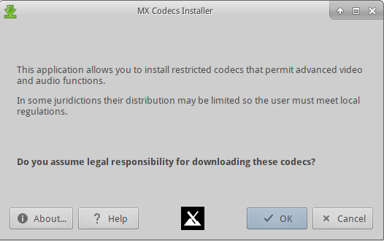

***Figure 3-12: Codecs installer main screen***

HELP: [here.](https://mxlinux.org/wiki/help-files/help-mx-codecs-installer)

### 3.2.**9** Conky

The app called **MX Conky** works in conjunction with [Conky Manager](https://teejeetech.in/conky-manager/) to manipulate details of a conky, especially color, in the MX conky collection very easily. A “conky-toggle” application to turn off and on any configured conky is also in the menu.

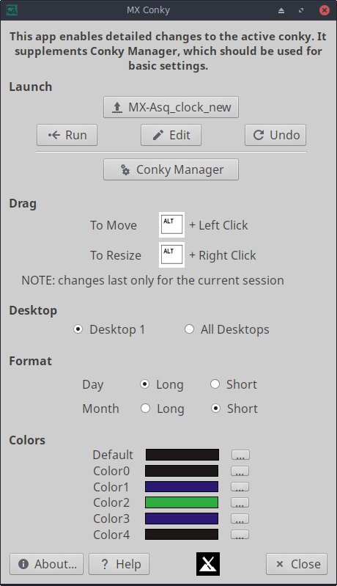

***Figure 3-13: Conky ready to edit details of a default conky***

**HELP:** [**here.**](https://mxlinux.org/wiki/help-files/help-mx-conky)

### 3.2.**10** iDevice Mounter

This app is able to show the contents of an iPhone or iPad in Thunar, a feat otherwise often difficult.

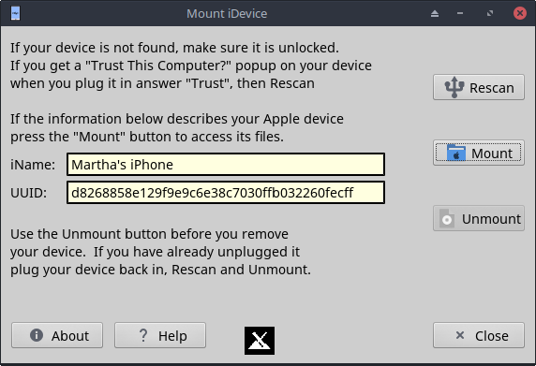

***Figure 3-14: iDevice Mounter ready to mount an iPhone 6***

HELP**:** [here**.**](https://mxlinux.org/wiki/help-files/help-mx-idevice-mounter)

### 3.2.1**1**  Job Scheduler

This handy app presents a graphic frontend to the command-line app [crontab](https://mxlinux.org/wiki/system/crontab/), easing the setup of jobs.

### 

***Figure 3-15: Job Scheduler***

HELP: local file: */usr/share/job-schduler/locale/*.

### 3.2.12 Live-usb Maker

This straightforward tool allows you to create quickly a live-usb starting from an iso file, a live -cd/dvd or an existing live-usb or even a running live system.

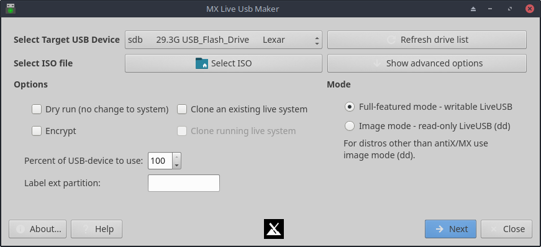

***Figure 3-16: Live USB Maker***

HELP: [here.](https://mxlinux.org/wiki/help-files/help-live-usb-maker)

### 3.2.13 Menu Editor

[MX Menu Editor](https://mxlinux.org/mx-menu-editor)

This simple menu editor makes it easy to edit, add or delete menu items. Any edits are saved to the user’s directory **/.local/shared/applications/**. Xfce only. KDE has its own Menu Editor.

Figure 3-17: Menu Editor with the category Multimedia expanded

HELP: [here.](https://mxlinux.org/wiki/help-files/help-mx-menu-editor)

### 3.2.14 Network Assistant

This application renders the process of troubleshooting network problems much easier by detecting hardware, changing the state of a hardware switch, permitting Linux and Windows drivers to be managed, and providing general network tools.

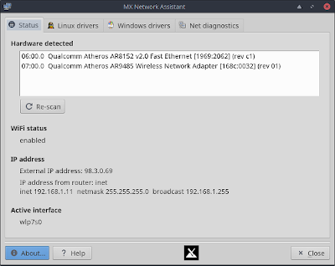

***Figure 3-18: Network Assistant detecting wireless and wired hardware***

HELP: [here.](https://mxlinux.org/wiki/help-files/help-mx-network-assistant)

### 3.2.15 Nvidia driver installer

The nvidia graphics driver installer vastly simplifies an important procedure: to install a proprietary graphic driver using the underlying ddm-mx script.. Clicking on the Nvidia driver installer icon brings up a terminal, and all the user need do in most cases is accept the default.

***Figure 3-19: MX Nvidia driver installer finding no need to continue***

HELP: [here](https://mxlinux.org/wiki/help-files/help-amdati-and-nvidia-installers).

### 3.2.16 Package Installer

[Install Apps with MX Package Installer](https://www.youtube.com/watch?v=4kXSMfPkQSA)

The custom simple package manager for MX Linux allows you to can search for, install, or remove both popular packages and any package in the MX/Debian Stable, the MX Test, Debian Backports, and Flatpak repositories quickly, safely, and easily.

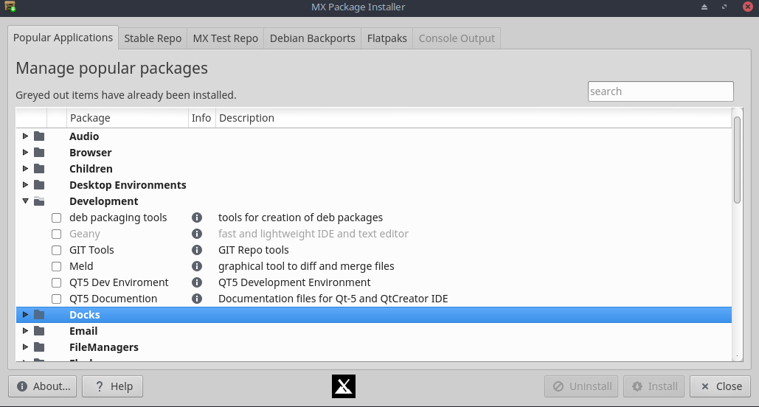

***Figure 3-20: Package Installer, showing popular packages for Development***

HELP: [here.](https://mxlinux.org/wiki/help-files/help-mx-package-installer)

### 3.2.17 Repo Manager

There are many reasons why the user might want to change the default mirror being used, ranging from a server being offline to a change in the physical location of the computer. This great tool provides one-click switching of repos, saving a lot of time and effort. It also provides a button that will test all repos (MX or Debian) and select the fastest.

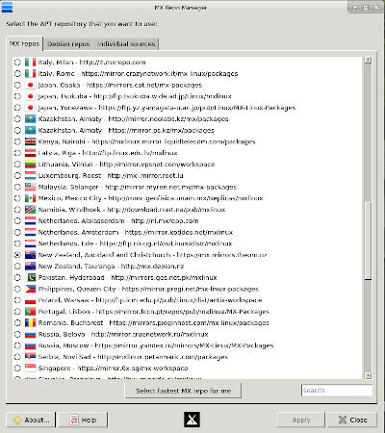

***Figure 3-21: Choosing a repository to use in Repo Manager***

HELP: [here.](https://mxlinux.org/wiki/help-files/help-mx-repo-manager)

### 3.2.1**8** Sound Card

Computers frequently have more than one sound card available, and the user who hears nothing may conclude that sound is not working. This clever little application allows the user to select which sound card should be used by the system.

***Figure 3-22: Making the selection in Sound Card***

HELP: [here.](https://mxlinux.org/wiki/help-files/help-sound-card)

### 3.2.1**9** System Keyboard

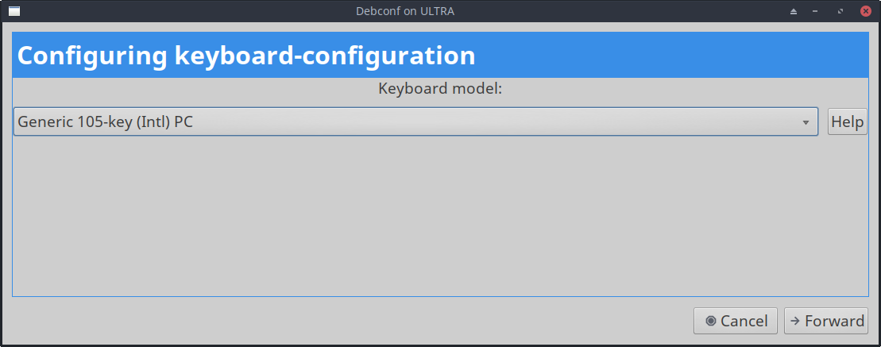

***Figure 3-23: Main screen ready for the user to select a different keyboard***

In case the user neglected to select system keyboard from the Login menu, missed setting it up on the Live session, or just needs to make a change, this little app provides an easy way to carry out that operation from the Start menu.

HELP: [here.](https://mxlinux.org/wiki/help-files/help-mx-system-keyboard)

### 3.2.20 System Locales

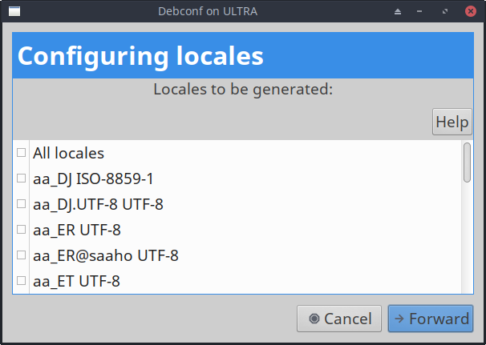

***Figure 3-24: Presentation of locales to be generated for the user.***

In case the user neglected to select system locale from the Login menu, missed setting it up on the Live session, or just needs to make a change, this little app provides an easy way to carry out that operation from the Start menu.

HELP: [here.](https://mxlinux.org/wiki/help-files/help-mx-system-locales)

### 3.2.21 System Sounds (Xfce only)

This little tool gathers into a single location the various actions and choices involved in setting up system sounds such as login/logout, actions, etc.

***Figure 3-25: Setting up login and logout sounds in System Sounds***

HELP: [here.](https://mxlinux.org/wiki/help-files/help-mx-system-sounds)

### 3.2.22 Date & Time

MX Date & Time requires root access, and allows adjustments of all kinds to be made from a single app. Xfce only.

***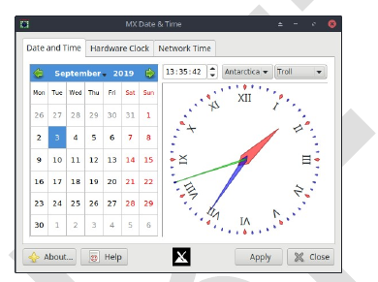***

***Figure 3-26: The main tab of Date & Time (running as root)***

HELP: [here](https://mxlinux.org/wiki/help-files/date-time/).

### 3.2.23 Tweak

MX Tweak brings together a number of small but often used customizations such as panel management, theme selection, compositor enabling and setup, etc. on a per-desktop basis.

***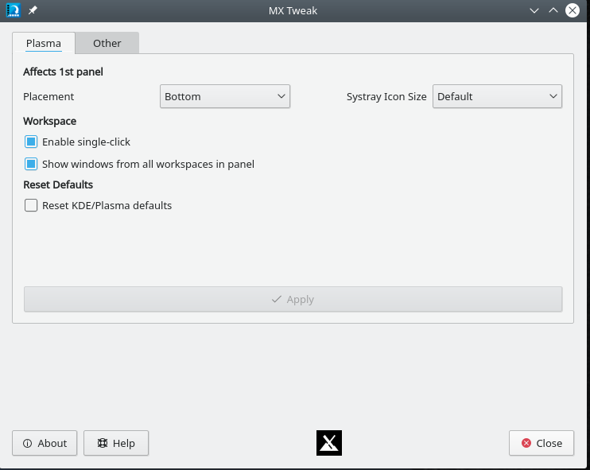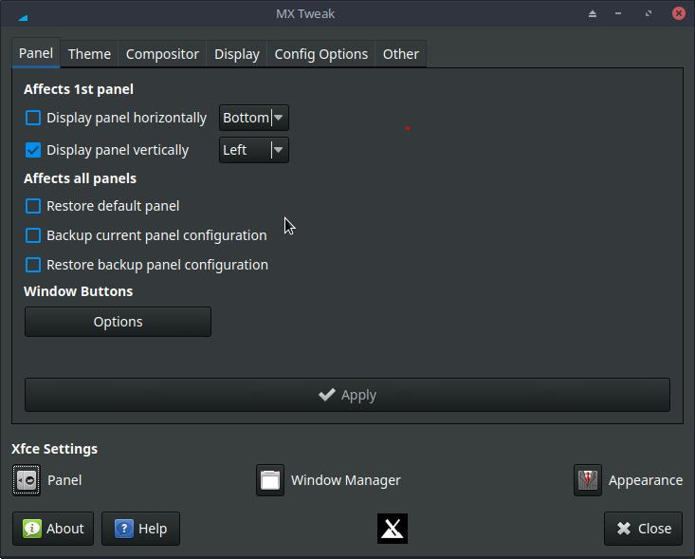***

***Figure 3-27: The faces of MX-Tweak. Right: Plasma, Left: XFCE***

HELP: [here](https://mxlinux.org/wiki/help-files/help-mx-tweak).

### 3.2.2**4** Format USB

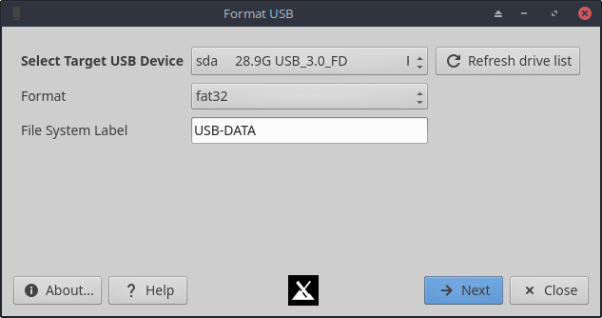

***Figure 3-28: USB Formatter ready to reformat with fat32***

This convenient little tool will clean out and reformat a USB drive in order to make it available for new purposes.

HELP: [here](https://mxlinux.org/wiki/help-files/help-mx-format-usb/).

### 3.2.25 USB Unmounter

This tool for quickly unmounting USB and optical media sits in the Notification Area when enabled (default). A single click displays available media for unmounting with a double-click.

***Figure 3-29: USB Unmounter with a device highlighted for unmounting***

HELP: [here](https://www.mxlinux.org/wiki/help-files/help-mx-usb-unmounter).

### 3.2.26 User Manager

This application aids in adding, editing and removing users and groups in your system.

***Figure 3-30: User Manager, Administration tab***

HELP: [here.](https://mxlinux.org/wiki/help-files/help-mx-user-manager)

### 3.2.3 Deprecated Tools

Some users will look for tools that either no longer exist or have been incorporated into new tools.

* ATI/AMD Driver Installer: removed for lack of suitable driver candidate.
* Broadcom Manager: rewritten for more general needs as Network Assistant.
* Compton Manager: incorporated into MX Tweak.
* Debian Backports Installer: incorporated into Package Installer.
* Default Look: incorporated into MX Tweak.
* Find Network Shares: removed because of licensing concerns.
* Flash Manager: Adobe® Flash® Player is now deprecated and has been completely removed.
* Panel Orientation: incorporated into MX Tweak.
* Test Repo Installer: incorporated into Package Installer .

## **3.3 Display**

### **3.3.1 Resolution**

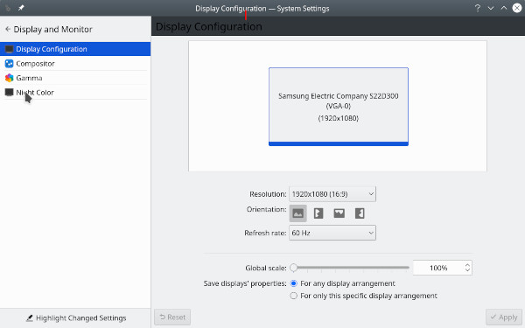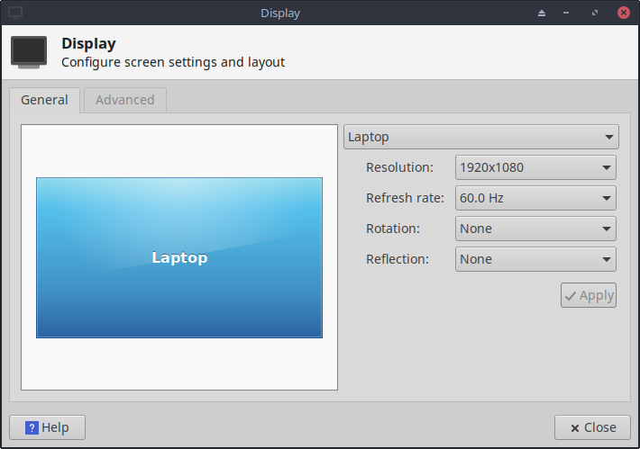

***Figure 3-31: Display utility . Left: Xfce, Right: KDE/plasma.***

Resolution refers to the physical number of columns and rows of pixels creating the display (e.g., 1920x1200). In most cases, the resolution is correctly set by the kernel during installation or when a new monitor is connected. If not, you can change it in the following ways:

* Click Start Menu > Settings > Display. Use the pull-down menus to set the correct values for the monitor you want to adjust. For more options and finer control, install [xrandr](https://xorg-team.pages.debian.net/xorg/howto/use-xrandr.html) from the repos.
* 4.16 Xfce’s Display now makes fractional scaling for HiDPI monitors possible. Click on the pull-down menu for “Scale” and select Custom.
* For Nvidia cards, you can install the package **nvidia-settings** that will give you a graphic tool that you can use to alter settings as root with the command: nvidia-settings
* In difficult situations, it is possible to manually alter the configuration file /etc/X11/xorg.conf. It may not exist, so you might need to [create it](https://wiki.debian.org/Xorg" \l "What_if_I_do_not_have_a_xorg_config_file.3F) first. Always back up the file before you change it, and check the Forum for help about the use of that file.

### 3.3.2 Graphic drivers

If you are not satisfied with your display’s performance, you may need/want to upgrade your graphic driver (make sure to first back up the file /etc/X11/xorg.conf, if used). Note that after a kernel upgrade you may have to repeat this, see Section 7.6.3.

There are various methods available to do this.

* For most **Nvidia** cards, by far the easiest method is to use the installers accessible from the MX Tools dashboard (see Section 3.2).
  + Some older or less common video cards require drivers (such as openchrome, mach64 & fbdev) that are only easily installable with **sgfxi** (Section 6.5.3).
  + Some Nvidia cards are no longer supported in Debian Stable (“Jessie”), see [the MX/antiX Wiki](https://mxlinux.org/wiki/hardware/unsupported-nvidia-gpus). They are, however, supported by the [nouveau](https://en.wikipedia.org/wiki/Nouveau_(software)) and vesa drivers.
* Consult [the Debian Wiki](https://wiki.debian.org/AtiHowTo) about open-source ati, radeon,and amdgpu drivers. Note that open drivers for AMD are no longer avalable.
* It is also possible, but more complicated, to download directly from the manufacturer. This method will require you to select and download the correct driver for your system; for system info, open a terminal and enter: *inxi -Gxx*.

Here are driver websites for the most popular brands (do a web search on “<brandname> linux driver” for others):

* + [Nvidia](http://www.nvidia.com/Download/index.aspx)
  + [Intel](https://www.intel.com/content/www/us/en/download-center/home.html)

Intel drivers *must* be [compiled](https://mxlinux.org/wiki/applications-system/compiling-software), but downloaded Nvidia drivers are easily installed:

* + Navigate in Thunar to the folder where the driver was downloaded
  + Right-click the file, select the Permissions tab, check Is **executable**
  + Press CTRL-ALT-F1 to exit X (the graphical environment) and get to a terminal prompt
  + Log in as root
  + Type: *service lightdm stop*
  + Type: *sh <filename>.run* (make sure to use the actual name of the file)
  + Allow the NVIDIA driver to turn off the nouveau kernel
  + When it finishes, type: *service lightdm start* to start lightdm and xorg again.
* Another important driver option is [**mesa**](https://docs.mesa3d.org/)**,** an open-source implementation of the [OpenGL](http://www.opengl.org/) specification - a system for rendering interactive 3D graphics. Users on high-performance machines report that upgrading this brings a significant stabilization to their system.
  + A more recent version may be available in the Test Repo; use the MX Package Installer (Section 3.2) to get it. Uncheck the box that hides the lib and dev packages, search for "mesa", and check off the packages that are upgradeable for installation.
* Hybrid graphics cards combine two graphic adapters on the same unit. A popular example is the [NVidia Optimus](https://en.wikipedia.org/wiki/Nvidia_Optimus), which is supported on Linux with Bumblee. Newer graphics cards can also use the primus functions built-in to the nvidia-driver through without the bumblee system. To run an application under primus functions use “nvidia-run-mx APP” to start an app with the graphics acceleration enabled.

### 3.3.3 Fonts

#### Basic adjustment

1. XFCE- Click **Start Menu > All Settings > Appearance**, Fonts tab
2. KDE/plasma - Click **Start Menu > SystemSettings >** Fonts
3. Click on the pull-down menu to see the list of fonts and point sizes
4. Select the one you want, and click OK

#### Advanced adjustments

1. A number of options are available by running in a root terminal: ***dpkg-reconfigure fontconfig-config***
2. Individual apps may have their own controls, often found in Edit (or Tools) > Preferences
3. For further adjustment, see [the MX/antiX Wiki](https://www.mxlinux.org/wiki/system/font-adjustment).
4. High Resolution Displays have special needs, see [the MX/antiX Wiki](https://mxlinux.org/wiki/other/high-resolution-displays).

#### Adding fonts

1. There are a few in MX Package Installer available with a single click. For more possibilities, click **Start Menu > System > Synaptic/Muon Package Manager**.
2. Use the search function for fonts.
3. Select and download the ones you want. The Microsoft core fonts package **ttf-mscorefonts-installer** (installed by default) provides easy installation of the Microsoft True Type Core Fonts for use with websites and MS applications that run under Wine.
4. Extract if necessary, then copy as root (easiest in a root Thunar) the font folder to **/usr/share/fonts/**.
5. Your new fonts should be available in the pull-down menu in All Settings > Appearance, Fonts tab.

### 3.3.4 Dual monitors

Multiple monitors are managed in MX Linux Xfce with Start menu > Settings > Display. You can use it to adjust resolution, select whether one clones the other, which ones will be turned on, etc. It is often necessary to log out and back in to see the display you select. Users should also look at the Display tab of MX Tweak. Finer control of some features is sometimes available with **xrandr**.

Xfce 4.16 has improved handling multiple monitors greatly, with settings on the Advanced tab of Display that permit detailed settings for each monitor and the ability to save monitor profiles and have them automatically used when the same hardware is connected again. If problems persist, search [the Xfce Forum](https://forum.xfce.org/), the MX Linux Forum and [the MX/antiX WIki](https://mxlinux.org/wiki/xfce/xfce-commands-and-other-useful-stuff) if you are having unusual problems.

in KDE/Plasma dual monitors are set up with the Display configuration tool.

Links

* [Xfce Docs: Display](https://docs.xfce.org/xfce/xfce4-settings/4.14/display)

### 3.3.5 Power management

Click the Power Manager plugins icon in the Panel. Here you can easily switch to Presentation mode (Xfce), or go to the Settings to set when a display shuts down, when the computer goes into suspension, the action initiated by closing the lid of a laptop, brightness, etc. On a laptop, battery status and information is displayed and a brightness slider is available.

### 3.3.6 Monitor adjustment

There are several tools available for adjusting the display for particular monitors.

* Screen brightness can be set with Start menu > Settings > Power Manager, Display tab or with MX Tweak. There is a new MX Tool called “Brightness systray” (3.that will place a handy widget in the systray.
* For users with Nvidia, use **nvidia-settings** as root for fine-tuning the display.
* To change the [gamma](https://en.wikipedia.org/wiki/Gamma_correction) (contrast), open a terminal and enter:

*xgamma -gamma 1.0*

1.0 is the normal level; change it up or down to decrease/increase contrast.

* Color of the display’s adaptation to the time of day can be controlled with [fluxgui](https://justgetflux.com/linux.html) or [Redshift](http://jonls.dk/redshift/).
* For more advanced adjustment and profile creation, install [DisplayCAL](https://displaycal.net/).
* Color profiles can be created: Start > Settings > Color Profiles. A color profile is a set of data that characterizes a color input or output device, and most are derived from [ICC profiles](https://en.wikipedia.org/wiki/ICC_profile).

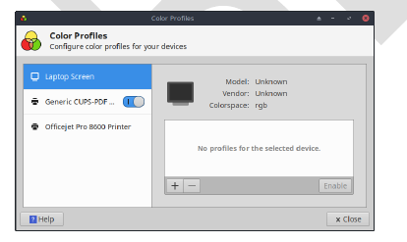

***Figure 3-32: Getting ready to add a color profile***

HELP: [here](https://docs.xfce.org/xfce/xfce4-settings/4.16/display).

### 3.3.7 Screen tearing

Screen tearing is a visual artifact in video display where a display device shows information from multiple frames in a single screen draw (Wikipedia). It tends to vary greatly depending on factors that include graphics hardware, particular application and user sensitivity. This problem has been greatly relieved with the release of Xfce 4.14 and later by default.

In MX Linux, various solutions are available:

* Click the Compositor tab in MX Tweak, and use the pull-down menu to switch from the default [xfwm](https://docs.xfce.org/xfce/xfwm4/start) to Compton, a free-standing [compositor](https://en.wikipedia.org/wiki/Compositing).
* Use the pull-down menu to alter the vertical spacing (vblank).
* When an Intel graphics driver is detected, a check box becomes available in MX Tweak > Config Options tab that switches the system away from the default "modesetting," a switch that enables the Intel driver's TearFree option. Tearfree options also exist for nouveau, radeon, and amdgpu, and are displayed as appropriate.

Links

* [MX/antiX Wiki](https://mxlinux.org/wiki/hardware/screen-tearing)

## 3.4 Network

Internet connections are handled by Network Manager:

--Left-click the applet in the Notification Area to see status, connect and explore options.

--Right-click the applet > Edit Connections to open up a Settings box with five tabs.

* Wired. In most situations this requires no attention; highlight and click the Edit button for special setups.
* Wireless
  + Network Manager will usually automatically detect your network card and use it to find available access points. In some situations, the command-line tool Ceni in the repos may be helpful.
  + For details, see Section 3.4.2 below.
* Mobile Broadband. This tab allows you to use a 3G/4G mobile device for access to the web. Click the Add button to set up.
* VPN. Click the Add button to set up. If you experience setup problems, consult [the MX/antiX Wiki](https://mxlinux.org/wiki/networking/vpn).
* DSL. Click the Add button to set up.

***Figure 3-33: Network Manager main screen***

MORE: [Ubuntu Wiki: Network Manager](https://help.ubuntu.com/community/NetworkManager)

### 3.4.1 Wired access

MX Linux typically picks up wired internet access upon boot without much problem. If a Broadcom driver is required (rare), then use MX Network Assistant (Section 3.2)

#### Ethernet and cable

MX Linux comes preconfigured for a standard LAN (Local Area Network) that uses DHCP (Dynamic Host Configuration Protocol) to assign IP addresses and DNS (Domain Name System) resolution. This will work in most cases as-is. You can change the configuration with Network Manager.

When you boot MX Linux, your network adapters are assigned a short interface name by udev, the kernel’s device manager. For normal wired adapters this is usually eth0 (with subsequent adapters eth1, eth2, eth3, etc). USB adapters often come up on the eth0 interface in MX Linux, but the interface name can also depend on the adapter’s chipset. For instance, atheros cards often show up as ath0, while ralink usb adapters may be rausb0. For more a detailed list of all found network interfaces, open a terminal, become root, and enter: *ifconfig -a*.

It is wise to connect to the Internet through a router, as nearly all wired routers contain optional firewalls. In addition, routers use NAT (Network Address Translation) to translate from big Internet addresses to local IP addresses. This affords another layer of protection. Connect to the router directly, or through a hub or switch, and your machine should autoconfigure via DHCP.

#### ADSL or PPPoE

If you use ADSL or PPPoE, connecting to the internet is easy in MX Linux. Right-click the Network Manager icon, then the DSL tab. Click the Add... button and fill in the required information, checking to connect automatically if you want.

NOTE: if you encounter problems when using a USB device to connect, plug the unit into the computer, open a terminal and type:

*dmesg* ***|*** *tail*

Post the output on the Forum with to get some help in finding the driver you need.

Figure 3-34: Setting up DSL service

#### Dial-Up

On the Device tab you will need to set up the serial information. Accepting the default /dev/modem may work, but you might need to try another interface. These are the Linux equivalents of the COM ports under MS-DOS and MS-Windows:

***Table 3: Linux equivalents for COM ports***

|  |  |
| --- | --- |
| ***Port*** | ***Equivalent*** |
| **COM 1** | /dev/ttyS0 |
| **COM 2** | /dev/ttyS1 |
| **COM 3** | /dev/ttyS2 |
| **COM 4** | /dev/ttyS3 |

### 3.4.2 Wireless access

MX Linux comes preconfigured to autodetect a WiFi card, and in most cases your card will be found and set up automatically. There are two standard ways wireless can be supported in MX Linux:

* With a native driver. That usually comes as part of the Linux kernel (example: ipw3945 for Intel), but on some, especially newer machines it may be necessary to download a driver using the information in Quick System Info > Network.
* With a Windows driver using the application Ndiswrapper (available from the repos), which “wraps” your Windows driver so that it can be used in a Linux system (example: bcmwl5 for some Broadcom chipsets). See below for more.

Sometimes there is both a native Linux driver and a Windows driver available. You may want to compare them for speed and connectivity, and you may have to blacklist or remove the one you are not using to prevent a conflict. Wireless cards can be either internal or external. USB modems (wireless dongles) usually show up on the wlan interface, but if not then check others on the list. NOTE: The successful method varies for users because of the complicated interactions among the Linux kernel, wireless tools, and the local wireless card chipset and router.

#### Basic Wireless Steps

Click **Start menu > Settings > Network Connections** (or just click on the Network Manager icon in the Notification Area), and then the Wireless tab. One of 3 situations will arise.

–**A wireless network has been found**.

* Click on the name of the network to use it.
  + Right-click the icon to access further options.
  + When done, click OK.

–**The found network does not function**.

If wireless networks are seen but your computer cannot connect them, this means that either 1) the wireless card is managed correctly by the right driver but you have problems concerning the connection to your modem/router, the firewall, the provider, DNS, etc.; or 2) the wireless card is managed abnormally because the driver is not the most appropriate for that card or there are problems of conflict with another driver. In this case you should gather information on your wireless card to see if the card drivers may have problems and then try to test the network with a set of diagnostic tools.

* Find out basic information by opening a terminal and entering one at a time:

*inxi -n*

*lsusb | grep -i net*

*lspci | grep -i net*

And as root:

*iwconfig*

The output from these commands will give you the name, model and version (if any) of your wireless card (example below), as well as the associated driver and the mac address of the wireless card. The output of the fourth will give you the name of the access point (AP) you are linked to and other connection information. For example:

*Network  
Card-2:Qualcomm Atheros AR9462 Wireless Network Adapter driver: ath9k   
IF: wlan0 state: up mac: 00:21:6a:81:8c:5a*

Sometimes you need the mac number of the chipset in addition to that of your wireless card. The easiest way to do that is to click **Start menu > System > MX Network Assistant**, Introduction tab. For example:

*Qualcomm Atheros AR9485 Wireless Network Adapter [168c:0032](rev 01)*

The number in brackets identifies the type of chipset in your wireless card. The numbers before the colon identify the manufacturer, those after it the product.

Use the information you have gathered in one of the following ways:

* Do a web search using that information. Some examples using the above lspci output.

*linux Qualcomm Atheros AR9462*

linux 168c:0032

debian stable 0x168c 0x0034

* + Consult the Linux Wireless and the Linux Wireless LAN Support sites below to find out which driver your chipset needs, what conflicts might exist, and whether it needs firmware installed separately. Post your information on the Forum and ask for help.
  + Turn off the firewall, if any, until the linkage occurs between computer and router.
  + Try restarting the router.
  + Use the Diagnostic Section in MX Network Assistant to ping your router using the mac address, ping to any website such as Google or run [traceroute](https://en.wikipedia.org/wiki/Traceroute). If you can ping a site using its IP (gotten from a web search) but you can not reach it with its domain name, then the problem may be in the configuration of the DNS. If you don’t know to interpret the results of ping and traceroute do a web search or post the results on the Forum.
  + Sometimes using the terminal application **Ceni** (in the repos) can reveal hidden access points and other difficult factors. **NOTE**: using Ceni to configure your network interface in MX Linux will interfere and/or disable management of that interface by the default Network Manager. Ceni stores its configuration info in /etc/network/interfaces. Any interface defined in /etc/network/interfaces will be ignored by Network Manager, as Network Manager assumes that if a definition exists, you want some other application managing the device.

–**No wireless interface is found.**

* Open a terminal and type the 4 commands listed at the beginning of the previous section. Identify the card, chipset and driver you need by doing a web search and consulting the sites reported, according to the procedure described above.
  + Look for the network entry, and note the detailed information on your specific hardware, and look for more information about that from the LinuxWireless site listed below, or ask on the Forum.
  + If you have an external wifi device and no information on a network card is found, unplug the device, wait a few seconds then plug it back in. Open a terminal and enter:

 dmesg | tail

Examine the output for information about the device (such as the mac address) that you can use to pursue your issue on the web or the Forum.

* + Probably the most common example of this situation arising is with the **Broadcom wireless chipsets**; see the [MX/antiX Wiki](https://mxlinux.org/wiki/hardware-networking/broadcom-wireless).

#### Firmware

For some cards it is necessary to install firmware (for example, **firmware-ti-connectivity** for Texas Instruments WL1251). MX Linux comes with a good deal of firmware already available, either installed or in the repos, but you may have to track down your particular need, again using the LinuxWireless website linked below or check the Forum.

#### Ndiswrapper

[Ndiswrapper](http://en.wikipedia.org/wiki/NDISwrapper) is an open-source software driver “wrapper” that enables the use of Windows drivers for wireless network devices in Linux. It does not come pre-installed in MX Linux, but is in the repos. **NOTE**: the Windows driver you use must match the OS architecture (e.g., Windows 32-bit driver for MX Linux 32-bit edition). In general, Windows XP drivers are required.

The easiest method of managing Ndiswrapper is to use **MX Network Assistant** (Section 3.2). See also the extended discussion in [the MX/antiX Wiki](https://mxlinux.org/wiki/applications-networking/ndiswrapper).

#### Security

Wireless security is handled by Network Manager. Here are the basic steps you need to follow:

* Right-click the Network Manager icon in the Notification Area > Edit connections
* Click on the Wireless tab, and highlight the name of the access point you want to connect to (for example, “linksys” or “starbucks 2345”)
* Click the Edit button and then the Wireless Security tab
* Use the pull-down menu to select the security you want (for example: WPA and WPA2 Personal)
* Enter the password and click Save.

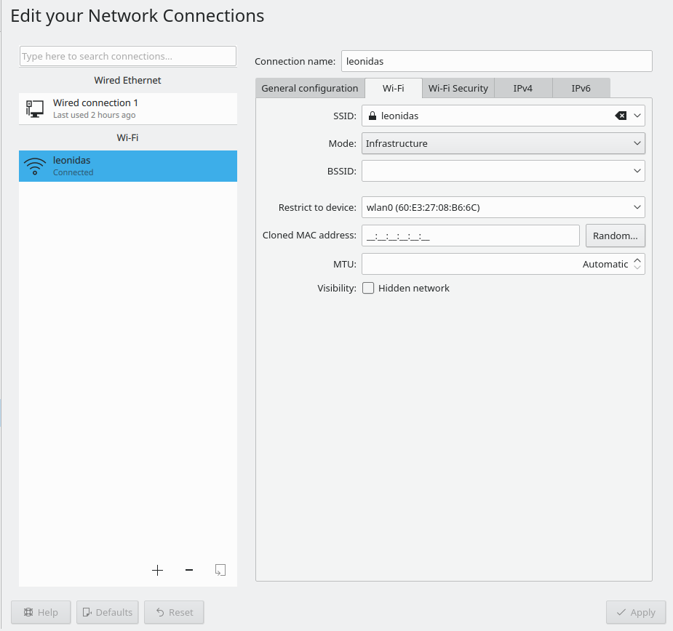

Figure 3-35: Wireless security in Network Manager (Left: Xfce, Right: KDE/plasma)

It is equally possible to use Ceni to handle wireless security, as long as subsequently you will not be using Network Manager, with which it interferes.

#### **Links**

* [Linux Wireless](https://wireless.wiki.kernel.org/)
* [Linux Wireless LAN Support](http://linux-wless.passys.nl/)
* [Debian Wiki: Wifi](http://wiki.debian.org/WiFi)
* [Arch Wiki: Wireless](https://wiki.archlinux.org/index.php/Wireless)

### 3.4.3 Mobile Broadband

For wireless internet access using a 3G/4G modem, please refer to the Debian Wiki’s 3G pages linked below for compatibility information. Many 3G/4G modems will be recognized on MX Linux by Network Manager.

### 3.4.4 Tethering

Tethering refers to the use of a device like a mobile phone or mobile wifi hotspot to provide mobile internet access to other devices, such as a laptop. A "hotspot" needs to be created on the device with access for the other device to use. It is easy to set up an Android phone as a hotspot, though directions vary to some extent depending on the Android version. In Android 9: Settings > Connections > Mobile Hotspot and Tethering > Mobile Hotspot. To make the laptop the hotspot, consult [this video](https://www.youtube.com/watch?v=WeKcWTQc7mY&feature=youtu.be).

#### Troubleshooting

On some systems, modem connections fail due to an upgrade of the packages **udev** and **libudev1**. To solve this, open Synaptic, highlight the packages, and then click Package> Force version... Use the pull-down menu to drop to a lower version and click the Apply icon.

In some cases this solution has not worked consistently for users, but they have found that the complete removal of **Network Manager** solved the problems.

MORE: [Debian Wiki: 3G modem](http://wiki.debian.org/Modem/3G)

### 3.4.5 Command line utilities

Command line utilities are useful for seeing detailed information, and are also commonly used in troubleshooting. Detailed documentation is available in the man pages. The most common ones below must be run as root.

***Table 4: Wireless utilities***

|  |  |
| --- | --- |
| ***Command*** | ***Comment*** |
| **ifconfig** | Main configuration utility for network interfaces. |
| **ifup <interface>** | Brings up the specified interface. For example:  **ifup eth0** will bring up the ethernet port eth0 |
| **ifdown <interface>** | The opposite of ifup |
| **iwconfig** | Wireless network connection utility. Used by itself, displays wireless status. Can be applied to a specific interface, e.g. to select a particular access point |
| **rfkill** | Disable softblock for wireless network interfaces (e.g., **wlan**). |
| **depmod -a** | Probes all modules and, if they have changed, enables new configuration. |

### 3.4.5 Static DNS

It is sometimes desirable to change your internet setup from the default automatic [**DNS**](https://en.wikipedia.org/wiki/Domain_Name_System) (Dynamic Name Service) configuration to a manual static one. Reasons for doing this may include greater stability, better speed, parental control, etc. You can make such a change either for the whole system or for individual devices. In either case, get the static DNS settings you are going to use from OpenDNS, Google Public DNS, etc., before you start.

#### System

You can make the change for everyone using your router using a browser. You will need:

* the router’s URL (list [here](http://www.techspot.com/guides/287-default-router-ip-addresses/) if you have forgotten)
* its password, if you set one

Find and change your router’s configuration panel, following the directions for your particular router (list of guides [here](https://support.opendns.com/forums/21618374)).

#### Individual

For single user change, you can use Network Manager.

* Right-click the connection icon in the Notification Area > Edit connections...
* Highlight your connection and click the Edit button.
* On the IPv4 tab, use the pull-down menu to change the Method to “Automatic (DHCP) addresses only”
* In the box for “DNS Servers” enter the static DNS settings you are going to use.
* Click Save to exit.

## 3.5 File management

File management in MX Linux is carried out through Thunar on Xfce and dolphin on KDE/plasma. Much of their basic use is self-evident, but here are good things to know:

* Hidden files are out of sight by default, but can be made visible via the menu (View > Show Hidden Files); or by pressing Ctrl-H
* The Side Pane can be hidden, and directory (folder) shortcuts can be placed there by right-clicking > Send To or drag-and-drop
* The context menu has been populated with common procedures (“Custom Actions” on Xfce and “Actions” & “Root Actions” on KDE/plasma) that vary by what is present or under focus.
* Root action is available via the context menu to open a terminal, edit as root, or open an instance of File Manager with root privileges.
* The File Managers easily handle FTP transfers, see below.
* [Custom Actions](http://docs.xfce.org/xfce/thunar/custom-actions) greatly increase the power and utility of the File Managers. MX Linux comes with many pre-installed, but there are others available to copy and the individual can create them for individual needs. See Tips and Tricks (Section 3.5.1), below; and [the MX/antiX Wiki](https://mxlinux.org/wiki/applications/thunar-custom-actions).

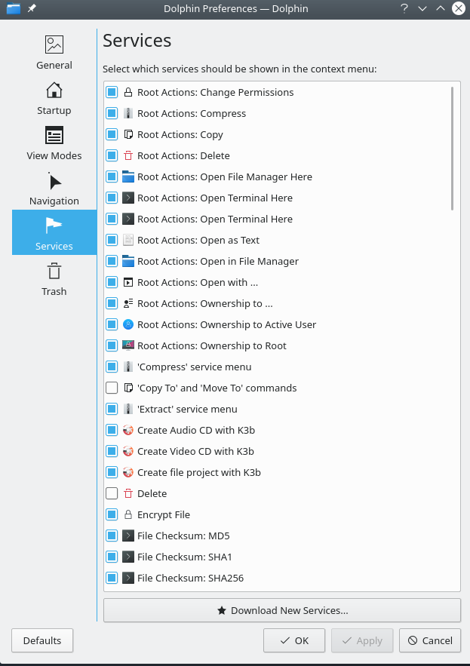

***Figure 3-36: Left: Custom actions set up in Thunar*** Right: Custom Services in Dolphin

### 3.5.1 Tips and Tricks

* When working in a directory that requires superuser privileges, you can right-click > Open root Thunar here (or File > Open root Thunar here) or the similar “Root Action” in dolphin.
* Superuser privilege can be changed in MX Tweak > Other tab from using either the user’s password (default) or an administrative password, if one has been set up.
* You can set up tabs with File > New Tab (or Ctrl-T), then move items from one location to another by dragging them to a tab and releasing it.
* You can assign a keyboard shortcut key to the Custom Action “Open terminal here.”

--Thunar/Xfce

* + - Enable editable accelerators in All Settings > Appearance > Settings.
    - In Thunar, hover your mouse over the File > Open in Terminal menu item and press the keyboard combination that you would like to use for that action.
    - Then when browsing in Thunar, use the keyboard combination to open a terminal window in your active directory.
    - This applies equally to other items on Thunar’s File menu; for instance, you could assign Alt-S to create a symlink for a highlighted file, etc.
    - Actions listed in the context menu can be edited/deleted, and new ones added, by clicking Edit > Configure custom actions...
* dolphin/KDE-plasma: select Settings > Configure Keyboard Shortcuts and find Terminal entry.
* Various options and hidden commands are also visible, see Links below.
* Both Java and Python are sometimes used to produce applications, carrying the ending \*.jar and \*.py, respectively. These files can be opened with a single click, like any other file; no more need to open a terminal, figure out what the command is, etc. CAUTION: be careful of potential security issues.
* Compressed files (zip, tar, gz, xz, etc…) can be managed by a right-click on the file.
* To find files:

--Thunar/Xfce: open Thunar and right-click any folder > Find files here. A dialog box will pop up to give you options. Running in the background is catfish (Start menu > Accessories > Catfish).

--dolphin/KDE-plasma: Use Edit > Search in the dolphin toolbar.

* Links/symlinks

--Thunar/Xfce: To set up a soft link (AKA symlink)--a file that points to another file or directory--right-click the target (file or folder you want the link to point to) > Create symlink. Then right-click the new symlink, cut it and paste it to where you want it.

--dolphin/KDE-plasma: Right click on on empty spot in the dolphin window and use Create New > Basic link to file or directory

* Thunar custom actions. This is a powerful tool to expand the file manager’s functions. To see the ones that are predefined during MX Linux development, click Edit > Configure Custom Actions. The dialogue box that pops up will show you what is predefined and give you an idea of what you can do yourself. To create a new Custom Action, click on the “+” button on the right. Details in [the MX/antiX wiki](https://mxlinux.org/wiki/applications/thunar-custom-actions).
* Folders can be displayed with images by placing an image that ends in \*.jpg or \*.png into the folder and renaming it “folder”

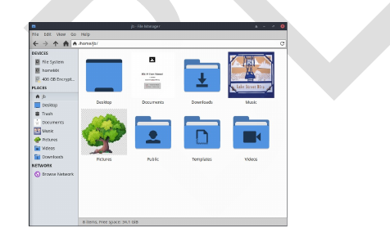

***Figure 3-37: using images to label folders***

### 3.5.2 FTP

Figure 3-38: Using Thunar to access an FTP site

The File Sharing Protocol (FTP) is used to transfer files from one host to another host over a network.

Xfce

* Open File Manager and click on Browse Network at the bottom of the left pane. Then click the Address bar at the top of the browser (or use Cntrl+L) and backspace to
* Backspace in the address field to delete what is there (network:///), then type the server name with the **ftp://** prefix. For example, to reach the MX documentation (if you have permission) you would enter this address: *ftp://mxlinux.org*
* Up pops an authorization dialog box. Fill in username and password, and let it save password if you are comfortable with that.
* That’s it. Once you have navigated to the folder you are always going to use, you can right-click the folder and in Thunar > Send to > Side Pane or in dolphin > Add to Places to create a very simple way to connect.

KDE

* Consult [the KDE userbase](https://userbase.kde.org/File_transfers).

Dedicated FTP applications such as Filezilla can be used as well. For a discussion of how FTP works, see [this page](http://www.ncftp.com/libncftp/doc/ftp_overview.html).

### 3.5.3 File sharing

There are various possibilities to share files between computers or between a computer and a device

* Samba. SAMBA is the most complete solution to share files with Windows machines on your network without making changes to the Windows machines. SAMBA can also be used by many network media players and Network-attached storage (NAS)] devices. SAMBA offers some other services for interfacing with Windows networks, such as domain authentication, messaging services, and netbios name resolution. For details, see below.
* NFS. This is the standard Unix protocol for sharing files. Many feel it is better than Samba for sharing files, and it can be used with Windows (2000 & XP) machines if you install “Services for Unix” or a third-party NFS client on them. Details: see [MX/antiX Wiki](https://mxlinux.org/wiki/networking/nfs).
* Bluetooth: For file exchange, install **blueman** from the repos, reboot, pair with the device, then right-click the bluetooth icon in the Notification Area > Send Files to Device.

### 3.5.4 Shares (Samba)

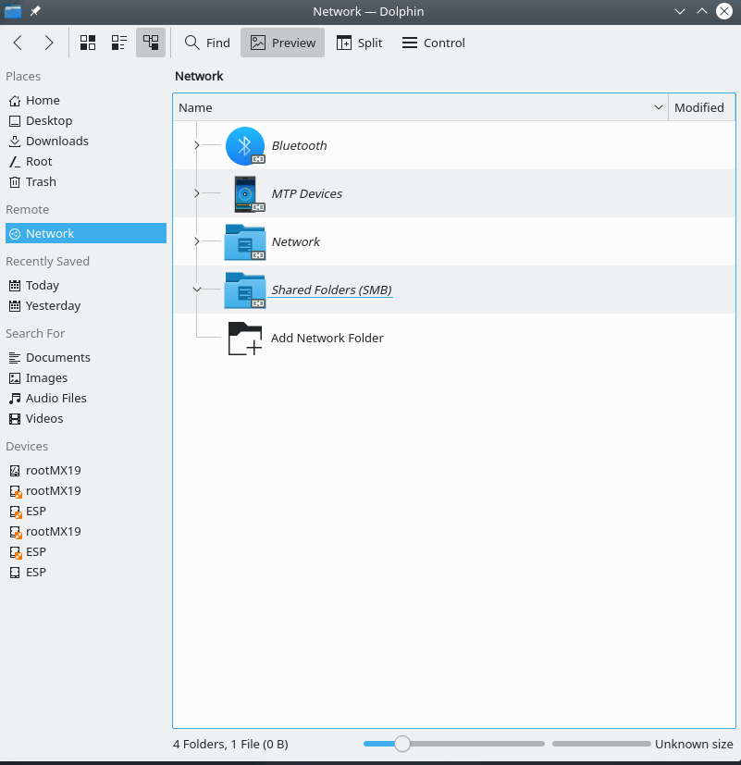

***Figure 3-39: Browing network shares*** Left: Thunar, Right: Dolphin

File Managers can connect to shared folders (AKA Samba Shares) on Windows, Mac, Linux computers and NAS (Network Attached Storage) devices. For printing with Samba, see Section 3.1.2.

* Click on Browse Network in the left pane to show various networks, including Windows Network
* Click the Network you want to see available Workgroups (often called WORKGROUP by default). Now drill down to find what you are looking for.
* Select a Workgroup for available Samba Servers
* Select a Server for available Samba Shares
* Select a Samba Share to see all the available folders
* A shortcut for the selected Share will be created in the Network sidebar section
* Sometimes browsing doesn’t work, especially in mixed environments (e.g., Linux-Windows). You can direct access a remote share by using the File Manager location bar (Ctrl+L) and using smb://servername/sharename. These places are bookmarkable in the side panes.

### 3.5.5 Creating shares

On MX, Samba can also be used to create Shares for other computers (Windows, Mac, Linux) to access. Creating Public Shares is fairly straightforward, but keep in mind that creating Samba Shares is a complex area from a configuration perspective. For example, the task of creating Shares that are specific to individual users and are authenticated properly is beyond the scope of this Manual. Comprehensive reference guides can be found at Using Samba and Samba.org.

#### Basic method

Thunar and KDE/plasma dolphin users can also use the “share” tab in the folder’s Properties dialog to set up a samba share.

**NOTE**: users often find that the configuration tool must be augmented with the manual method, below.

#### Manual method

[Create a share manually](https://www.youtube.com/watch?v=l3KYukPvP7U)

If for some reason you need or want to create shares manually, follow these steps.

* In your Home, use an existing folder or create a new one and right-click it to make it Read & Write for Owner, Group: users, and Others. In other words, make it open to the world. Starting with a simple Public Share is a good place to learn. **NOTE**: If you are concerned about network security do not use this approach. Instead, study the references above to learn how to create secure shares.
* To establish the Samba Share, you must edit the configuration file as root. It can be found at: **/etc/samba/smb.conf** Edit the line: *workgroup = xxxxx* to match whatever Windows Workgroup name you are using (default is WORKGROUP)
* At the very end of the file add the following lines to establish your Share

*[SHARENAME]*

*path = /home/username/foldername*

*guest ok = yes*

*read only = no*

*browseable = yes*

*force create mode = 777*

*force directory mode = 777*

* Save the file. When adding a share, the Samba daemon should read it and implement the changes immediately. If you make changes to an existing share, you will need to restart Samba to make sure your changes take effect by going to the terminal and becoming root and entering: *service samba restart*
* You can also check for mistakes in smb.conf by running *testparm* from the terminal
* Go to another computer and test your ability to see your Samba Share by browsing the network and testing read & write to the Share

MORE: [Xfce Docs: Thunar](http://docs.xfce.org/xfce/thunar/start)

## 3.6 Sound

[How to enable HDMI audio with Linux](https://youtu.be/gjqcmZK5SnE)

MX Linux sound depends at the kernel level on Advanced Linux Sound Architecture (ALSA), and at the user level on [PulseAudio](http://www.freedesktop.org/wiki/Software/PulseAudio/). In most cases sound will work out of the box, though it may need some minor adjustment. Click on the speaker icon to mute all audio, then again to restore--if that is how Preferences are set. Place cursor over speaker icon in the Notification Area and use scroll wheel to adjust volume. See also Sections 3.6.4, 3.6.5 and 3.8.9.

### 3.6.1 Sound Card Set-up

If you have more than one sound card, be sure to select the one you want to adjust using the tool MX Select Sound (Section 3.2). The sound card is configured and volume of selected tracks adjusted by right-clicking the speaker icon in the Notification Area > Open Mixer. If problems persist after logging out and back in, see Troubleshooting, below.

### 3.6.2 Simultaneous card use

There may be times when you would like to use more than one card simultaneously; for instance, you may want to hear music both through headphones and through speakers in another location. This is not easy to do in Linux, but check the PulseAudio [FAQ](http://www.freedesktop.org/wiki/Software/PulseAudio/FAQ/). Also, the solutions on [this MX/antiX Wiki page](https://mxlinux.org/wiki/sound-not-working) may work, if you are careful to adjust the card references to your own situation.

Sometimes it is necessary to switch sound cards, for instance when one is HDMI and the other analog. This can be done in PulseAudio, Configuration tab; be sure to select the Profile option that works for your system. To make that switch automatic, see the script on [this GitHub site](https://gist.github.com/3v1n0/ad3ad73e0bdd466d7f4a95b3aa376285).

### 3.6.3 Troubleshooting

* [Sound not working](https://mxlinux.org/wiki/sound-not-working)
* No sound, though speaker icon is in the Notification Area.
  + Try raising all controls to a higher level. For a System Sound such as a login, use the Playback tab in Pulseaudio.
  + Edit the configuration file directly: see Section 7.4.
* No sound, and no speaker icon is in the Notification Area. It could be that the sound card is missing or unrecognized, but the most common problem is that of multiple sound cards, which we address here.
  + Solution 1: click **Start menu > Settings > MX Sound Card**, and follow the screen to select and test the card you want to use.
  + Solution 2: use the volume control of PulseAudio (pavucontrol) to select the correct sound card
  + Solution 3: enter the BIOS and turn off HDMI
  + Check the ALSA sound card matrix listed below.

### 3.6.4 Sound servers

Whereas the Sound Card is a hardware item accessible to the user, the Sound Server is software that works largely in the background. It permits general management of sound cards, and provides the ability carry out advanced operations on the sound. The most commonly used by individual users is PulseAudio. This advanced open-source sound server can work with several operating systems, and is installed by default. It has its own mixer that allows the user to control the volume and destination of the sound signal. For professional use, [Jack audio](http://jackaudio.org/) is perhaps the best known.

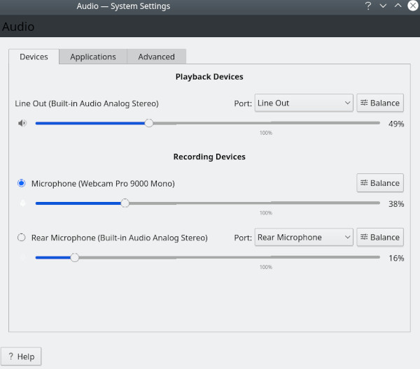

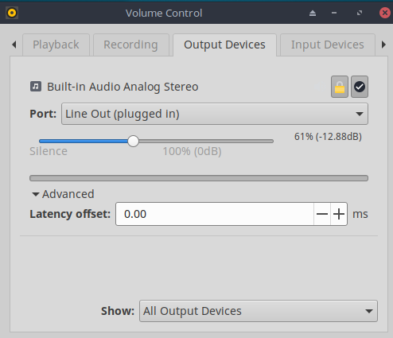

Figure 3-40: Using PulseAudio Mixer Left: Pavucontrol Right: KDE Audio Volume

### 3.6.5 Links

* [MX/antiX Wiki: Sound not working](https://mxlinux.org/wiki/sound-not-working)
* [ALSA: SoundCard Matrix](http://www.alsa-project.org/main/index.php/Matrix:Main)
* [ArchLinux Wiki: PulseAudio Information](https://wiki.archlinux.org/index.php/PulseAudio)
* [PulseAudio Documentation: Free desktop](http://www.freedesktop.org/wiki/Software/PulseAudio/Documentation/User/)

## 3.7 Localization

MX Linux is maintained by an international Dev Team that constantly works to improve and expand the options for localization. There are many languages into which our documents have not yet been translated, and if you can help with this effort please [register on Transifex](https://forum.mxlinux.org/viewtopic.php?f=96&t=38671) and/or post on the [Translation Forum](https://forum.mxlinux.org/viewforum.php?f=96).

### 3.7.1 Installation

The primary act of localization occurs during the use of the LiveMedium.

* When the boot screen first comes up, make sure to use the function keys to set your preferences.
  + F2. Select the language
  + F3. Select the timezone you wish to use.
  + If you have a complicated or alternative setup, you can use boot cheat codes. Here is an example to set a Tartar keyboard for Russian: *lang=ru kbvar=tt .* A full list of the boot parameters (=cheat codes) can be found in the [MX/antiX Wiki](https://mxlinux.org/wiki/system/boot-parameters).
* If you set the locale values at the boot screen, then Screen 7 should show them during installation. If not, or if you want to change them, select the language and timezone you want.

Two other methods are available after the boot screen.

* The first screen on the installer allows the user to select a particular keyboard for use.
* The login screen has pull-down menus in the upper right corner where where both keyboard and locale can be selected.

### **3.7.2 Post-installation**

MX Tools includes two tools for changing keyboard and locale. See Sections 3.2.15 and 3.2.16 above.

Xfce4 and KDE/plasma have their own methods as well:

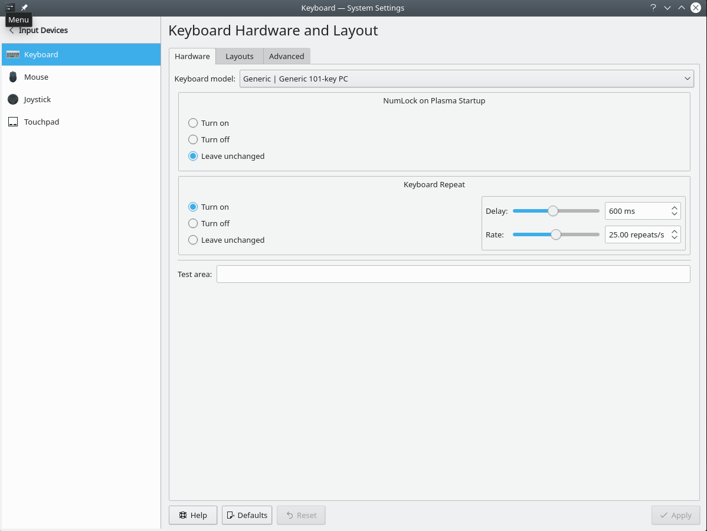

***Figure 3-41: Adding another keyboard layout Left: Xfce Right: KDE***

Here are the configuration steps you can take to localize your MX Linux after installation.

* Change the keyboard:

Xfce

* + Click **Start Menu > Settings > Keyboard**, Layout tab.
  + Uncheck “Use system defaults” then click on the **+Add** button at the bottom and select the keyboard(s) you want available.
  + Exit, then click Keyboard Switcher (flag) in the Notification Area to select active keyboard.

KDE/plasma

* + Click Start Menu > Settings > Input Devices > Keyboard Layouts Tab
  + Check “Configure Layouts” in the middle of the dialog, then click on the **+Add** button at the bottom and select the keyboard(s) you want available.
  + Exit, then click Keyboard Switcher (flag) in the Notification Area to select active keyboard.
* Get language packs for major applications: click **Start menu > System > MX Package Installer**, provide the root password, then click Language to find and install language packs for the applications you use.
  + Setting up Chinese Simplified Pinyin is a bit more complicated, see [here](https://mxlinux.org/wiki/other/chinese-simplified-input).
* Change time settings: click **Start Menu > System > MX Date & Time** and select your preferences. If you are using the digital clock DateTime, right-click > Properties to choose 12h/24h and other local settings.
* Get spellchecker to use your language: install the **aspell** or **myspell** package for your language (e.g., **myspell-es**).
* Get local weather info
  + Xfce: **right-click the Panel > Panel > Add New Items > Weather Update. Right-click > Properties**, and set the locale you want to see (it will guess by your IP address).
  + KDE: Right click on the desktop or panel depending on where the widget will appear and then Add Widget. Search for Weather and add the widget
* For Firefox localization, install the appropriate **firefox-l10n-** package for your language of interest; e.g., for Spanish (Spain), install firefox-l10n-es.
* For Thunderbird, click Edit > Preferences > General. Scroll down to the Language & Appearance section and select the one you want to use
* You may need or want to change the localization info (default language, etc.) available to the system. To do so, open a terminal, become root and enter: *dpkg-reconfigure locales* 
  + You will see a list with all the locales that you can scroll through using the up and down arrow keys.
  + Enable and disable what you want (or don’t want), using the space bar to make the asterisk in front of the locale appear (or disappear).
  + When done, click OK to advance to the next screen.
  + Use arrows to select the default language you want to use. For US users, for instance, that would typically be **en\_US.UTF-8**.
  + Click OK to save and exit.

MORE: [Ubuntu documentation](https://help.ubuntu.com/community/Locale)

***Figure 3-42: Re-setting the default language for the installed system***

### 3.7.3 Further notes

* You can temporarily change the language for a particular application by entering this code in a terminal (in this example, to change to Spanish):

LC\_ALL=es\_ES.UTF8 <command to launch>

This will work for most apps that are localized already.

* If you have selected the wrong language during installation you can change it once on the installed desktop, use MX Locales to correct it. You can also open a terminal and enter this command:

sudo update-locale LANG=en\_GB.utf8

Obviously you would need to change the language to the one that you want to use.

* It may happen that an individual application may not have a translation in your language; unless it is an MX application, we can do nothing about that, so you should send a message to the developer.
* Some desktop files that are used to create the Start menu may be missing a comment in your language, even though the application itself does have a translation in that language; please let us know with a post in the Translation Forum that supplies the correct translation.

## 3.8 Customization

Modern Linux Desktops like Xfce and KDE/plasma make it very easy to change basic function and look of a user’s configuration.

* Most importantly, remember: Right-click is your friend!
* Great control is available through the (Xfce) All Settings and (KDE/plasma) SystemSettings (Panel icons).
* User changes are stored in config files in the directory: ~/.config/. These can be queried in a terminal, see [the MX/antiX Wiki](https://mxlinux.org/wiki/xfce/xfce-commands-and-other-useful-stuff" \l "List configuration settings).
* Most system-wide config files are in /etc/skel/ or /etc/xdg/

MORE: [Xfce Tips and tricks](http://pclosmag.com/download.php?f=XfceTipsTricksSE.pdf) (PDF)

### 3.8.1 Default Theming

Default theming is controlled by a number of customized elements.

**Xfce**

* Login screen (modify with All Settings > LightDM GTK+ Greeter Settings)
  + Theme: Adwaita-dark (MX-21)
  + Background: in */usr/share/backgrounds/MXLinux/lightdm/*
  + Login box: modified default theme /usr/sbin/lightdm-gtk-greeter
* Desktop:
  + Wallpaper: All Settings > Desktop/. When selecting from another location, keep in mind that after using the entry "Other" you need to navigate to the folder you want, then click "Open"; only then can you select a particular file in that location.
  + All Settings > Appearance. Sets GTK Themes and Icons. Bundled settings in MX Tweak – Themes (Section 3.2).
  + All Settings > Window Manager. Sets window border themes.

**KDE/Plasma**

* Login screen (modify with System Settings > Startup and Shutdown then choose Login Screen, SDDM configuration)
  + Breeze
* Desktop:
  + Wallpaper: Right-click on desktop and select “Configure Desktop and Wallpaper”

Appearance

* + Global Themes – bundled theme set combinations  
    Plasma Style – Set theme of plasma desktop objects
  + Application Style

Application Style – Configure application elements

Window decorations – Minimize, maximize and close button styles

* + Colors, Fonts, Icons and cursors acan also be configured.
  + Application menu settings
    1. Right-click on menu icon to get configuration options. Default panel is in the standard application panel

### 3.8.3 Panels

#### 3.8.3.1 Xfce Panel

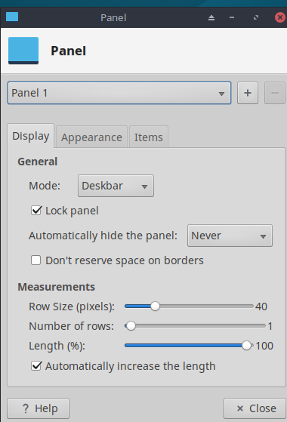

***Figure 3-43: Preferences screen for customization of panels***

MX Linux now ships by default with [Docklike Taskbar](https://mxlinux.org/wiki/docklike-taskbar/) (xfce4-docklike-plugin) replacing the Xfce Window Buttons used in previous MX releases. This lightweight, modern, and minimalist taskbar for Xfce provides the same functionality as Xfce Window Buttons, while also providing more advanced “dock” features.

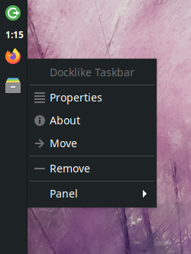Figure 3-44: The docklike taskbar with icons and context menu

To view docklike taskbar Properties: Ctrl + Right click any icon. Or: MX Tweak > Panel tab, click “Options” button under Docklike.

Window Buttons can be restored by right-clicking an empty space > Panel > Add New Items.

Tricks for panel customization

* To move the panel, unlock it by right-clicking a panel > Panel > Panel Preferences.
* Use MX Tweak to change the location of the panel: vertical or horizontal, top or bottom.
* To change display mode inside the Panel setting, select from the pull down menu: Horizontal, Vertical, or Deskbar.
* To automatically hide the panel, choose from pull down menu: Never, Always, or Intelligently (hides the panel when a window overlaps with it).
* Install new panel items by right-clicking an empty space in the panel > Panel > Add New Items. You then have 3 choices:
  + Select one of the items on the main list that pops up
  + If what you want is not there, select Launcher. Once it is in place, right-click > Properties, click the plus sign and select an item off the list that pops up.
  + If you want to add an item not on either list, then select the empty item icon below the plus sign and fill in the dialog box that pops up.
* New icons show up at the bottom of the vertical Panel; to move them, right-click > Move
* Change the look, orientation, etc. by right-clicking the panel > Panel > Panel Preferences.
* Right-click the clock plugin “DateTime” to change the format of layout, date or time. For a custom time format you need to use “strftime codes” (consult [this page](http://en.cppreference.com/w/c/chrono/strftime) or open a terminal and type *man strftime)*.
* Create a double row of icons in the Notification Area by right-clicking it > Properties, and decreasing Maximum icon size until it changes.
* Add or delete a panel in Panel Preferences, clicking on the plus or minus button to the right of the top panel pull-down menu.
* One-click horizontal panel installation is available from MX Tweak (Section 3.2).

MORE: [Xfce4 docs: Panel.](http://docs.xfce.org/xfce/xfce4-panel/start)

#### 3.8.3.2 KDE/plasma Panel

***Figure 3-45: Preferences screen for customization of panels***

Tricks for panel customization:

* To move the panel, Right click on panel then Edit panel. Hover over “Screen Edge” and move to location of your choice.
* Use MX Tweak to change the location of the panel: vertical (left), top or bottom. Or use the previous method to drag to any screen edge.
* To change display mode inside the Panel, once the Edit Panel dialog is open, Choose More Options Panel Alignment > left, center or right.
* To automatically hide the panel, once Edit Panel dialog is open, click “More Settings” and select “Auto Hide”
* Install new panel items by clicking on the panel >Add Widgets. You can select the desired widget to add from the dialog.
* Create a double row of icons in the Notification Area by using the Configure Panel dialog and selecting Height to change the height of the panel. Then using MX-Tweak > Plasma tab and setting the systray icon size larger or smaller as desired to create the double row effect. You can also have the System Tray icons scale automatically with the panel height by right clicking on the tray up arrow, Configure System tray and enabling scale with panel height.
* To show all open applications, click MX Tweak, Plasma tab, and enable “Show windows from all workspaces in panel.”

### 3.8.4 Desktop

[Customizing the desktop](https://www.youtube.com/watch?v=QWVd1-8xpYI)

[Things to do after installing MX Linux](https://youtu.be/aESEb8lTvz4)

The default desktop (AKA wallpaper, background) can be changed in various ways.

* Right-click any image > Set as wallpaper
* If you want the wallpapers available to all users, become root and put them in the /usr/share/backgrounds folder;
* If you want to restore the default wallpaper, it is in /usr/share/backgrounds/. There are also symlinks of the MX wallpaper sets in /usr*/s*hare/wallpapersfor easy MX-KDE usage.

Many other customization options are available.

* Change the theme
  + Xfce - **Appearance**. The default theme is an MX mx-comfort (light and dark) that has larger borders and specifies the appearance of Whisker menu. Be sure to select an icon theme that will show well, especially on the dark version.
  + KDE/plasma – **Global Theme–** MX theme is the default. You can also set individual theme elements in Plasma Style, Application Style, Colors, Fonts, Icons and cursors.
* To make thin borders easier to grab,
  + Xfce – Use one of the “thick border” **Window Manager** themes or consult [the MX/antiX Wiki](https://mxlinux.org/wiki/xfce/changing-border-size-with-xfce4-window-manager/).
  + KDE/plasma – In **Application Style** > **Window Decorations**, set the desired “Border Size” from the drop down menu provided.
* Xfce - Add standard icons such as Trash or Home to the desktop in **Desktop**, icons tab.
* Window behavior such as switching, tiling, and zooming can be customized
  + Xfce - **Window Manager Tweaks.**
    - Window switching via Alt+Tab can be customized to use a compact list instead of traditional icons
    - Window switching via Alt+Tab can also be set to show thumbnails instead of icons or a list, but it requires turning on [compositing](https://en.wikipedia.org/wiki/Compositing_window_manager) which some older computers may have difficulty supporting. To enable, first deselect Cycle on a list list on the “Cycling” tab, then click on the “Compositor” tab and check ’Show windows preview in place of icons’ when cycling.
    - Window tiling can be accomplished by dragging a window to a corner and releasing it there..
    - If compositing is turned on, Window zooming is available by using the Alt + Mouse Wheel combination.
  + KDE/plasma – **SystemSettings**
    - Window tiling can be accomplished by dragging a window to a corner and releasing it there.
    - Configuration of a variety of keystroke and mouse controls can be set as desired via the **Window Behavior** dialog**.**
    - Alt-tab configuration, including theme, can be done in the **Task Switcher** dialog.
* Wallpaper
  + Xfce – Use the Desktop settings to choose wallpapers. To select a different wallpaper for each Workspace, got to **Background** and uncheck the option ’Apply to all workspaces.’ Then select a wallpaper and repeat the process for each workspace by dragging the dialog box to the next workspace and selecting another wallpaper.
  + KDE/plasma – right click on the Desktop and select “Configure Desktop and Wallpaper”.

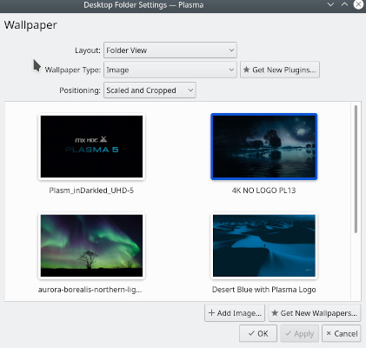

Figure 3-46: Unchecked box allows different backgrounds for each workspace Left: Xfce, ***Right: KDE.***

#### Conky

You can display almost any kind of information on the desktop by using Conky

* Both Conky Manager and MX Conky are installed by default.
* When you click on MX Conky, a dialog box will pop up if there are updates available.
* Click **Start menu > Accessories** to find Conky Manager. MX Conky is part of MX Tools.
* A set of conkies that will work OOTB is included by default. You can import other sets using the gear icon at the right end of the menu bar in Conky Manager
* Highlight each conky and hit Preview to see what it looks like. Be sure to close each preview before going to another.
* Check the box to select any conky you want to use. It will be auto-installed.
* The configuration files are stored in the folder  ~/.conky/ in individual theme files; they can be edited by highlighting the conky in the list and clicking on the edit icon (pencil).

HELP: [MX/antiX Technical Wiki](https://mxlinux.org/wiki/help-files/help-mx-conky)

MORE: [Conky home page](http://conky.sourceforge.net/index.html)

***Figure 3-47: Main screen of Conky Manager showing one of the conkies available***

#### Pull-down terminal

[Customizing the drop-down terminal](https://www.youtube.com/watch?v=_X4tVjO8uzo)

MX Linux ships with a very handy drop-down terminal triggered with F4. If you wish to disable it: Xfce - **Start menu > All Settings > Keyboard,** Applications Shortcuts tab.   
 KDE/plasma - System Settings > Startup and Shutdown > Startup and Shutdown deleteYakuake.

The drop down terminals are very configurable.

Xfce – right click on the terminal window and select Preferences  
 KDE/plasma – select the “hamburger” menu in the lower right-hand corner of the terminal.

### 3.8.5 Touchpad

Xfce - General options for the touchpad on a laptop are found by clicking Settings > Mouse and Touchpad. Systems that are more sensitive to touchpad interference have a couple of options:

* Use MX-Tweak, Other tab to change the touchpad driver
* Install **touchpad-indicator** to see fine control of behavior.. Right-click the icon in the Notification Area to set important options such as autostart.

KDE/Plasma – touchpad options are found in System Settings > Hardware > Input Devices. There is also a touchpad widget that can be added to the Panel (right click panel > add widgets)

Detailed changes be made manually by editing the 20-synaptics.conf file under */etc/X11/xorg.conf.d* (file is just "synaptics.conf on MX-19).

### 3.8.6 Menu

### 3.8.6.1 Xfce (“Whisker”)

[Customizing Whisker menu](https://www.youtube.com/watch?v=QWVd1-8xpYI)

[Fun with the Whisker menu](https://www.youtube.com/watch?v=bgPn68jMqd0)

MX Linux XFCE uses by default with the Whisker Menu, though a classic menu can be easily installed by right-clicking a panel > Panel > Add New Items > Applications Menu. Whisker Menu is highly flexible.

* Right-click the menu icon > Properties to set preferences, e.g.,
  + Move categories column to be next to the Panel.
  + Change location of Search box from top to bottom.
  + Decide which action buttons you want to show.
* Favorites are easy to add: right-click any menu item > Add to Favorites.
* Simply drag and drop Favorites to arrange them as wished. Right-click any entry to sort or remove.

MORE: [Whisker menu features](http://gottcode.org/xfce4-whiskermenu-plugin/)

#### Editing

Menu entries can be edited with two applications (the menu entry “desktop” files are located in */usr/share/applications/* and can also be edited as root directly).

* **MX Menu Editor** (Section 3.2).
* Right-click on an entry in Whisker menu and you can edit a launcher on a user-specific basis.
* Click **Start menu > Accessories > Application Finder** (or **Alt-F3**), and right-click any entry. Context menu contains Edit and Hide (the latter can be very useful). Selecting Edit brings up a screen where you can change name, comment, command and icon.

***Figure 3-48: Menu entry edit screen***

### 3.8.6.2 KDE/plasma (“kicker”)

MX Linux KDE/plasma uses the Application Launcher menu by default, although alternates are easily installable via right-click on the menu icon and choosing “Show Alternatives alternates”. “Favorite” applications are shown as icons on the left of the menu.

* Right-click the menu icon > Configure Application Menu to set preferences, e.g.,
  + Show applications as name only or Name/Description combinations
  + Change location of Search results
  + Show recent or often-used items
  + Flatten menu sublevels.
* Favorites are easy to add: right-click any menu item > Show in Favorites.
* Simply drag and drop Favorites to arrange them as wished. Right-click any entry to sort.To remove from Favorites right click the icon then Show in Favorites and deselect the appropriate Desktop or Activity.

#### Editing

Menu entries can be edited via Right-click on an entry in the menu and you can edit a launcher on a user-specific basis. The menu entry “desktop” files are located in */usr/share/applications/* and can also be edited as root directly.

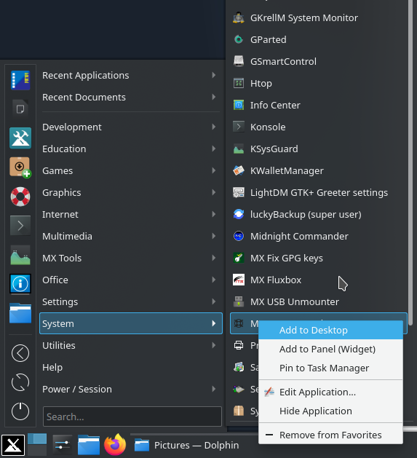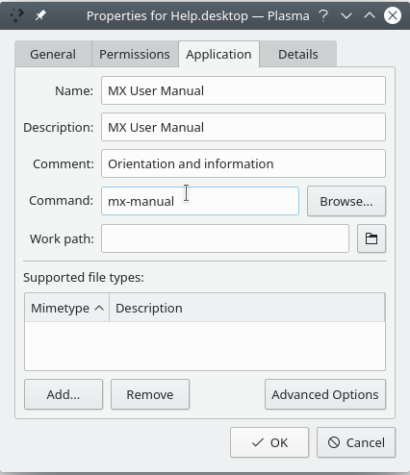

***Figure 3-49: Menu entry edit screen***

### 3.8.7 Login greeter

The user has a number of tools to customize the login greeter. Xfce isos use the lightdm greeter, while KDE/plasma isos use SDDM.

**Lightdm**

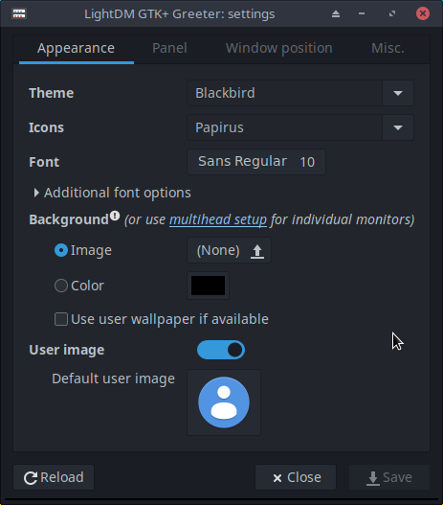

***Figure 3-50: the Lightdm configuration app***

* Click **Start menu > Settings > All Settings > LightDM GTK+ Greeter settings** to adjust position, background, font, etc.
* Autologin can be (in)activated from MX User Manager, Options tab.
* Some properties of the default login box are set in the code for the default theme (greybird-thick-grip) and a few related themes. Change theme for greater choice.
* You can have the login greeter show an image as follows:
  + **Start menu > Settings > About Me** (Mugshot)
    - Fill in details you want to add.
    - Click on the icon, navigate to the image you want to use.
    - Close
  + **Manual**
    - Create or select an image, and use gThumb or another photo editor to resize it to about 96x96 pixels
    - Save that image in your home folder as **.face** (make sure to include the dot and do not add any extension such as jpg or png).
    - Click All Settings > LightDM GTK+ Greeter Settings, Appearance tab: turn on the User image switch.
  + Whichever way you choose, log out, and you will see the image next to the login box; it will also show up in Whisker menu once you are logged back in.

**SDDM**

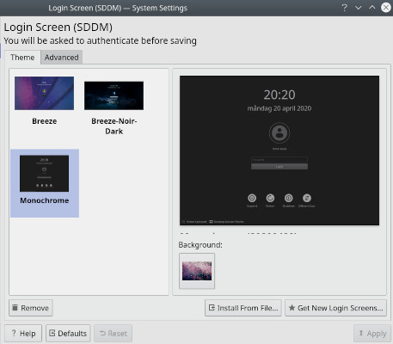

***Figure 3-51: the SDDM configuration app***

* + The sddm settings are all in Plasma desktop’s System Settings. A shortcut launcher for System Settings can be found on MX’s default panel, or you can in any case search for it in the Applications Menu. In the Settings, go to Startup and Shutdown >> Login Screen (SDDM).
  + The settings page for sddm will allow you to:
    - select between different themes if you have more than one installed;
    - choose to customise a background for your selected theme;
    - remove (ie delete) an installed theme; and
    - to get/install new themes either directly from KDE Store online or from a file on your storage drive/media (see below)
  + root password required – since desktop manager is a system program, any changes to it or its configuration will affect files in the root partition, which is why you will be asked for your root password.
  + background selection – you can change the background of your selected sddm theme. Some themes come with their own preinstalled default background picture which will be displayed if you do not make any changes. This will also require root password.
  + New sddm themes can be found i[n the KDE Store](https://store.kde.org/browse/cat/101/order/latest). You can also browse the themes directly from within the System Settings page for sddm.
  + In SystemSettings > Startup and Shutdown > Login Screen (SDDM), Get New Login Screens at the bottom of the window.
  + To install a theme:
    - from a downloaded zip file, click on the “Install from File” button in the System Settings page for sddm, then select the targeted zip file from file chooser that opens up.
    - While in the System Settings in-built sddm theme browser, simply click on the “Install” button of the selected theme.

TAKE NOTE: Some themes in KDE Store may be incompatible. MX 21 uses Plasma version 5.20, which is the stable version available for Debian, Bullseye but the latest version of Plasma is already at version 5.22 (as at beginning of January 2021). You may therefore find that some of the latest sddm themes built to utilize the latest features in Plasma may not work with Plasma 5.20’s sddm. Thankfully sddm comes with a fallback login screen so that if a theme that you applied does not work, you can still log back into your desktop and from there change to another sddm theme. Do some testing; some very new themes work while others don’t.

### 3.8.8 Bootloader

The bootloader (GRUB) of an installed MX Linux can be modified with common options by clicking **Start menu > MX Tools > MX Boot Options** (see Section 3.2.2). For other functions, install **Grub Customizer**. This tool should be used with caution, but it allows users to configure Grub settings such as the boot entry list configuration, names of partitions, color of menu entries, etc. Details [here](https://answers.launchpad.net/grub-customizer/+faq/1355).

### 3.8.9 Xfce System and Event sounds

Computer beeps are silenced by default in the “blacklist” lines in the file */etc/modprobe.d/pc-speaker.conf*. Comment out (# at the beginning) those lines as root if you wish to restore them.

Event sounds can be turned on system-wide by clicking **Start menu > Settings > Appearance, Other tab**: check Enable event sounds and, if you wish, Enable input feedback sounds. They can be managed with MX System Sounds (Section 3.2). If you do not start hearing small sounds when you close a window or logout, for instance, try these steps:

* Log out and back in.
* Click Start menu > Multimedia > PulseAudio Volume Control, Playback tab, and adjust the level as needed (start with 100%).
* Click the start menu, type "!alsamixer" (don’t forget the exclamation point). A terminal window will appear with a single audio control (Pulseaudio Master).
  + Use F6 to select your audio card, and then adjust the channels that appear to higher volumes.
  + Look for channels like "Surround", "PCM" "Speakers", "Master\_Surround", "Master\_Mono" or "Master". The channels that are available depend on your particular hardware.

Three sound files are supplied by default: Borealis, Freedesktop and Fresh and Clean. All are located in /usr/share/sounds. Find others in the repos or with a web search.

### 3.8.10 Default applications

#### General

The default applications to be used for general operations are set by clicking **Application menu > Settings > Default Applications (Xfce) or System Settings > Applications > Default Applications (KDE/plasma).** where you can set four preferences (Xfce: separate tabs for Internet and Utilities).

* Web browser
* Mail reader
* File manager
* Terminal emulator

#### Particular

Many defaults for specific file types are set during an application’s installation. But often multiple options exist for a given file type, and a user would like to determine which application would launch the file—such as the music player to open an \*.mp3 file.

Xfce’s Default Applications app has a third tab, “Others,” where these MIME types can be set using a handy searchable table to find the type, then double-clicking the Default Application space to set the desired application.

**General method**

* Right-click any example of the file type you are interested in
* Make one of the following selections:
  + **Open with <listed application>**. This will open the file with the selected application for this particular instance, but will not affect the default application.
  + **Open with Other Application**. Scroll down the list to highlight the one you want (including “Use a custom command”), then check Open. The box at the bottom “Use as default for this kind of file” is unchecked by default, so check it if you want your selection to become the new default application that is launched when you click on any file of that particular type. Keep it unchecked for one-time usage.

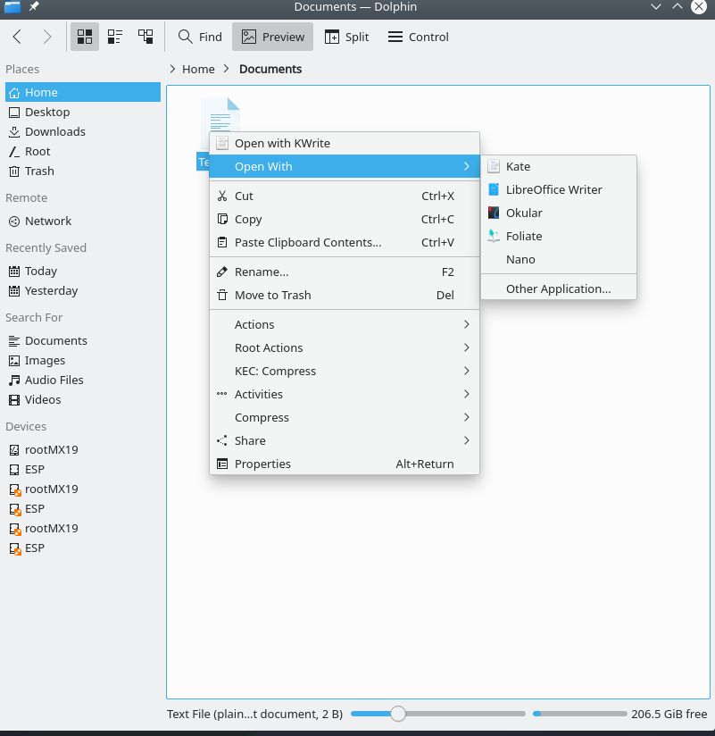

***Figure 3-52: Changing default application*** Left: Thunar Right: dolphin

### 3.8.11 Limited accounts

For some purposes, it may be desirable to lock down an application or system in order to protect it from users. Examples include computers in a school or public location for general use, where the file system, desktop and internet access need to be closed. There are a number of options available.

* Some components of Xfce that support kiosk mode. Details in [the Xfce Wiki](https://wiki.xfce.org/howto/kiosk_mode).
* KDE has an administrative mode, consult [the KDE Userbase](https://userbase.kde.org/KDE_System_Administration).
* Check the browser you use to see if it has a kiosk mode.
* The dedicated kiosk distro [Porteus](http://porteus-kiosk.org/index.html).

More: [Alan D. Moore's guide](http://www.alandmoore.com/blog/2011/11/05/creating-a-kiosk-with-linux-and-x11-2011-edition/) (somewhat dated).