FET Control Box

Jacky Chen

Luke Bethancourt

Max Garza

Sydney Naddy

**Functional System Requirements**

REVISION – Draft

24 September 2024

Functional System Requirements

for

FET Control Box

Team <Jacky Chen, Luke Bethancourt, Max Garza, Sydney Naddy>

Prepared by:

_____________________________

Author Date

Approved by:

_____________________________

Project Leader Date

_____________________________

John Lusher, P.E. Date

_____________________________

T/A Date

**Change Record**

|  |  |  |  |  |
| --- | --- | --- | --- | --- |
| **Rev.** | **Date** | **Originator** | **Approvals** | **Description** |
| **-** | 9/26/2024 | Team 16 |  | Draft Release |

Table of Contents

Table of Contents II

List of Figures III

1. Introduction 1

1.1. Purpose and Scope 1

1.2. Responsibility and Change Authority 2

2. Applicable and Reference Documents 3

2.1. Applicable Documents 3

2.2. Reference Documents 3

2.3. Order of Precedence 4

3. Requirements 5

3.1. System Definition 5

3.1.1. Power Supply 6

3.1.2. FET Operation Control 6

3.1.3. PWM Generation 6

3.1.4. Web Application 6

3.1.5. Display 6

3.2. Characteristics 7

3.2.1. Functional / Performance Requirements 7

3.2.2. Physical Characteristics 7

Electrical Characteristics 8

4. Support Requirements 10

4.1. Operations Manual 10

4.2. Construction Manual 10

4.3. Computer Interface Requirements 10

4.3.1. Windows 10

4.3.2. Linux 10

Appendix A: Acronyms and Abbreviations 11

List of Figures

Figure 1. FET Control Box Conceptual Rendering (Front) 1

Figure 2. FET Control Box Conceptual Rendering (Side) 1

Figure 3. Block Diagram of System 5

# Introduction

## Purpose and Scope

This specification defines the technical requirements for the development items and support subsystems delivered to the client for the FET control box.  Figure 1 shows a representative integration of the project in the proposed CONOPS. The verification requirements for the project are contained in a separate Verification and Validation Plan.

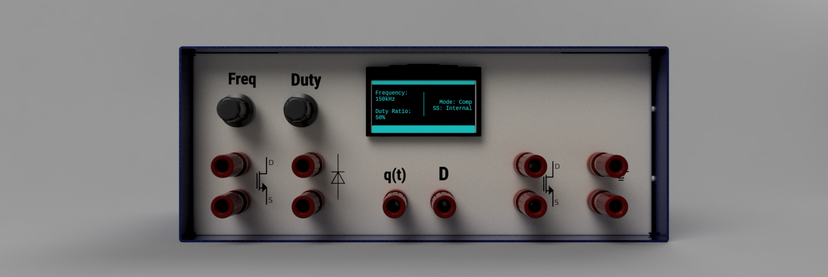

Figure 1. FET Control Box Conceptual Rendering (Front)

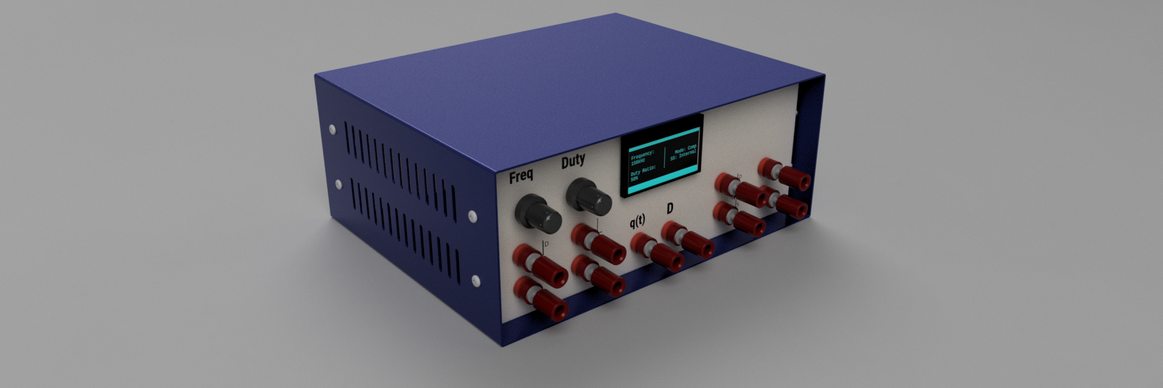

Figure 2. FET Control Box Conceptual Rendering (Side)

The following definitions differentiate between requirements and other statements.

Shall: This is the only verb used for the binding requirements.

Should/May: These verbs are used for stating non-mandatory goals.

Will: This verb is used for stating facts or declaration of purpose.

## Responsibility and Change Authority

The team leader Max Garza has the responsibility of making sure the project requirements are met. Furthermore, the group as a whole intends on keeping others in the group accountable for upholding the schedule and requirements of the project. The project sponsor Dr. Balog will also have authority to change the requirements of the project as he sees fit.

# Applicable and Reference Documents

## Applicable Documents

The following documents, of the exact issue and revision shown, form a part of this specification to the extent specified herein:

|  |  |  |
| --- | --- | --- |
| **Document Number** | **Revision/Release Date** | **Document Title** |
| IEEE 488.2 | 11/30/1992 | IEEE Standard Codes, Formats, Protocols, and Common Commands for Use With IEEE Std 488.1-1987, IEEE Standard Digital Interface for Programmable Instrumentation |
| IEC 60320 | 07/27/2021 | Appliance couplers for household and similar general purposes |

## Reference Documents

The following documents are reference documents utilized in the development of this specification. These documents do not form a part of this specification and are not controlled by their reference herein.

|  |  |  |
| --- | --- | --- |
| **Document Number** | **Revision/Release Date** | **Document Title** |
| DD00003 | 9/15/2004 | FET Control Box Redesign 2002 |
| 0885-8950 | 5/2/2005 | Modern Laboratory-Based Education for Power Electronics and Electric Machines |
|  | Version 1.4B –  8/2014 | ECEN 438 – Power Electronics Laboratory – Laboratory Manual |

## Order of Precedence

In the event of a conflict between the text of this specification and an applicable document cited herein, the text of this specification takes precedence without any exceptions.

All specifications, standards, exhibits, drawings or other documents that are invoked as “applicable” in this specification are incorporated as cited.  All documents that are referred to within an applicable report are considered to be for guidance and information only, except ICDs that have their relevant documents considered to be incorporated as cited.

# Requirements

This section defines the minimum requirements that the development item(s) must meet. The requirements and constraints that apply to performance, design, interoperability, reliability, etc., of the system, are covered.

## System Definition

This document describes the purpose and features of the FET Control Box, a device used to facilitate the construction and testing of power circuit topologies in a laboratory setting. The FET box controls the frequency and duty cycle of a PWM signal that is used to switch two power mosfets.

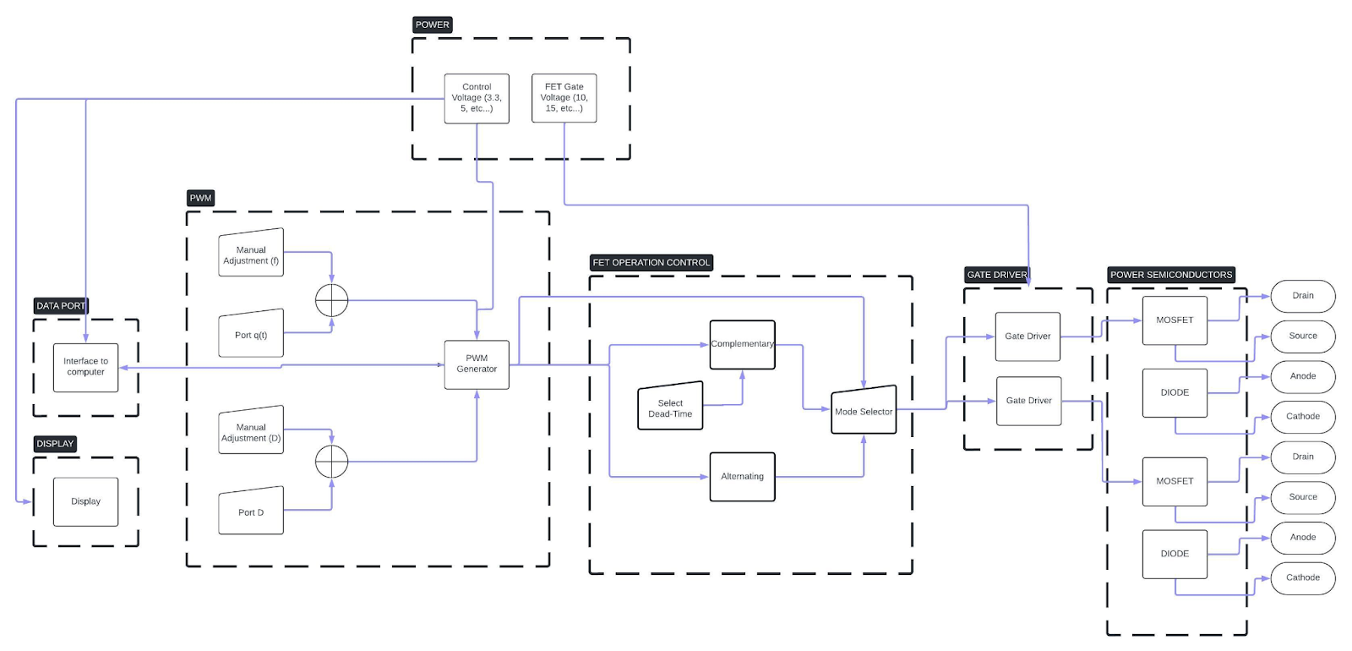

Figure 3. Block Diagram of System

There are four subsystems for the FET control box. The power semiconductors, gate drivers, and power supply is a subsystem; Jacky Chen will be responsible for implementing this subsystem. The microcontroller PWM generation and FET operation control logic is a subsystem; Luke Bethancourt will be responsible for implementing this subsystem. The PCB design, OLED display, and rotary encoder input is a subsystem; Max Garza will be responsible for implementing this subsystem. Finally, the last subsystem is web application which uses SCPI commands to interface with the FET control box is a subsystem; Sydney Naddy will be responsible for this subsystem.

### Power Supply

The power supply shall have the following requirements:

* Power from wall outlet shall be provided from an IEC power cord and receptacle
* Power supplied to the entire unit shall be isolated from mains power.
* Power supplied to the power mosfets and their gate drivers shall be isolated from control circuitry.
* The unit shall have a “Power On” LED, indicating that the unit is receiving power.
* Control circuitry shall be referenced to ground.

### FET Operation Control

The two mosfets shall have the following three modes of operation:

* **Matching** – The two mosfets are switched on and off at the same time.
* **Alternating** – The two mosfets are switched on and off opposite to each other (i.e. while one is one the other is off and vice versa).
* **Complimentary** – The two mosfets are switched on and off opposite to each other, with a short dead-time between switching.

### PWM Generation

The signal used to switch the power mosfets will be a PWM signal generated internally or an externally generated signal. The PWM generation system shall have the following requirements:

* Adjustable frequency range from 1kHz to 300kHz.
* Adjustable duty ratio range from 5% to 95%.
* BNC connector, “q”, to allow for external switching signal.
* BNC connector, “D”, to allow for modulation of “q”.
* Switch to toggle between the internal or an external switching signal.
* Push button to toggle between three mosfet modes of operation *(Section 3.3).*

Note: All BNC connectors shall have ESD protection

### Web Application

The FET Box shall be able to be controlled programmatically from a web application installed on a computer. The host computer shall interface with the FET Box over a USB-A port mounted on the FET Box. The web application shall have the following features:

Sends commands over USB-A conforming to SCPI *(Standard Commands for Programmable Instruments)* standard.

### Display

* PWM signal parameters shall be displayed on the OLED display mounted on the unit.
* Current FET operation mode shall be displayed on the OLED display mounted on the unit.
* Internal or external signal status (i.e. which signal is being used) shall be displayed on the OLED display mounted on the unit.

## Characteristics

### Functional / Performance Requirements

#### Power Mosfet Specifications

The two power mosfets shall have the following characteristics:

* Absolute maximum drain-source voltage of at least 800V
* Continuous drain current of at least 20A @ 25°C
* Acceptable packages:
  + TO-247
  + TO-220

#### Power Diode Specifications

The two power diodes shall have the following characteristics:

* Absolute maximum DC reverse voltage of at least 800V
* Average rectified current of at least 20A
* Acceptable packages:
  + TO-220-3
  + TO-247-3

#### Power Semiconductor Mounting

The power semiconductors shall be mounted using screw terminal blocks that have the following specifications:

* Single level
* Three positions
* Pitch greater than 3.50mm
* Voltage rating of at least 800V
* Current rating of at least 20A

### Physical Characteristics

#### Mass

The mass of the FET control box shall be less than or equal to 15 kg.

*Rationale:  Students and lab workers should be able to carry and lift the box without high risk of dropping them or hurting themselves.*

#### Volume Envelope

The volume envelope of the FET control box should be able to fit on a shelf with other equipment in a lab table.

*Rationale:  The intended use in a lab setting where it will be placed among other equipment, such as an oscilloscope and bench power supply.*

### Electrical Characteristics

#### Inputs

1. The presence or absence of any combination of the input signals in accordance with ICD specifications applied in any sequence shall not damage the FET Control Box, reduce its life expectancy, or cause any malfunction, either when the unit is powered or when it is not.
2. No sequence of command shall damage the FET Control Box, reduce its life expectancy, or cause any malfunction.

Rationale: By design, should limit the chance of damage or malfunction by user/technician error.

##### Power Consumption

1. The maximum peak power of the system shall not exceed 16000 watts.

*Rationale:  To limit the risk of damaging components, the maximum peak power that the components can handle is 800V and 20A. The device is designed to be operated at maximum 400V and 10A.*

##### Input Voltage Level

The input voltage level for the FET Control Box shall be 120VAC.

*Rationale: The FET Control Box will be plugged into the wall with Universal IEC connectors.*

##### Isolation

The FET Control Box shall not interfere with the components being used in experiments (i.e. the power mosfets and diodes)

*Rationale: The power given to the mosfet gate driver circuit, in addition to the switching signal applied must be electrically isolated.*

##### External Commands

The FET Control Box shall document all external commands in the appropriate ICD.

*Rationale:  The ICD will capture all interface details from the low level electrical to the high-level packet format.*

#### Outputs

##### Signal Input/Output

The FET Control Box has two BNC jacks available as input, “q” and “D”, where an external switching signal can be used to control the power mosfets, and an external signal can be used to modulate the switching signal.

*Rationale: These two inputs “q” and “D” are present in the original version of the design and are a key feature of the device.*

##### Data Transfer

The FET Control Box shall receive SCPI commands over USBTMC in compliance with IEEE 488.2.

Rationale:  This is a requirement specified by our customer in an effort to automate lab equipment operation. USBTMC was chosen over GPIB because of lower costs, higher data transfer speeds, and compatibility with modern computers. SCPI will be transmitted in accordance with IEEE 488.2..

##### Connectors

The FET Control Box shall use external connectors in accordance with IEC 60320-1.

*Rationale:  The IEC 60320-1 international standard defines power supply connectors and inlets used in electrical and electronic equipment, including laboratory equipment like the FET Control Box.*

.

# Support Requirements

## Operations Manual

The FET Control Box shall have an operations manual explaining how to use the following features of the device:

* PWM frequency adjustment
* Duty ratio adjustment
* Setting mosfet operation mode
* Using an external switching signal
* Modulation of duty ratio
* Automation using SCPI commands

## Construction Manual

The FET Control Box shall have a construction manual explaining step-by-step how to put together the device.

## Computer Interface Requirements

### Windows

In order for a computer using Windows to control the FET Box over USB, the following requirements must be met:

* Installation of the NI-VISA driver
* 1 USB port available

### Linux

In order for a computer using Linux to control the FET Box over USB, the following requirements must be met:

* 1 USB port available

# Appendix A: Acronyms and Abbreviations

FET Mosfet

USB Universal Serial Interface

LED Light Emitting Diode

kHz Kilohertz (1,000 Hz)

V Volt

VAC Volts Alternating Current

A Amp

OLED Organic Light Emitting Diode

PWM Pulse Width Modulation

SCPI Standard Commands for Programmable Instruments

USBTMC USB Test and Measurement Class

ICD Interface Control Document

GPIB General Purpose Interface Bus

ESD Electro-Static Discharge

kg Kilogram