第六次实验报告

陈鸣阳 517021910499

**Test1.txt 哈夫曼解码运行结果（另可见txt附件）**：

Educators, generals, dieticians, psychologists, and parents program. Armies, students, and some societies are programmed. An assault on large problems employs a succession of programs, most of which spring into existence en route. These programs are rife with issues that appear to be particular to the problem at hand. To appreciate programming as an intellectual activity in its own right you must turn to computer programming; you must read and write computer programs -- many of them. It doesn't matter much what the programs are about or what applications they serve. What does matter is how well they perform and how smoothly they fit with other programs in the creation of still greater programs. The programmer must seek both perfection of part and adequacy of collection.

**Test2.txt 哈夫曼解码运行结果（另可见txt附件）：**

As to this, his natural and not to be alienated inheritance, themessenger on horseback had exactly the same possessions as the King, the first Minister of State, or the richest merchant in London. Sowith the three passengers shut up in the narrow compass of onelumbering old mail coach; they were mysteries to one another, ascomplete as if each had been in his own coach and six, or his owncoach and sixty, with the breadth of a county between him and the next.

**Test3.txt 哈夫曼解码运行结果（另可见txt附件）：**

You know some birds are not meant to be caged, their feathers are just too bright. There is something inside, that they can't get to, that they can't touch. That's yours. Hope is a good thing and maybe the best of things. And no good thing ever dies.

Test1.txt getcode()运行结果如下：

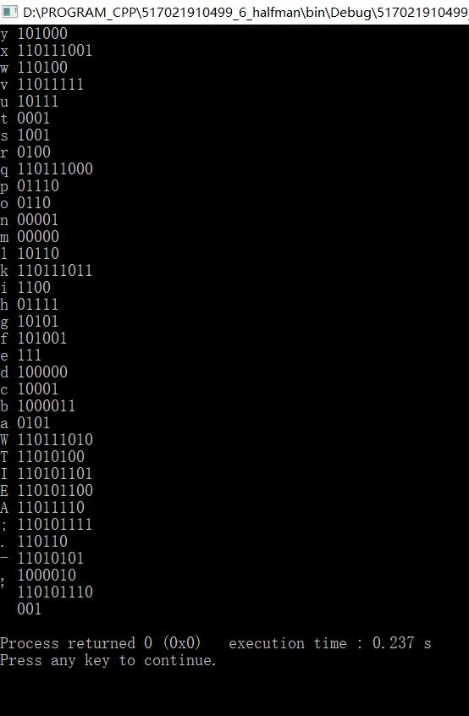

Test2.txt getcode()运行结果如下：

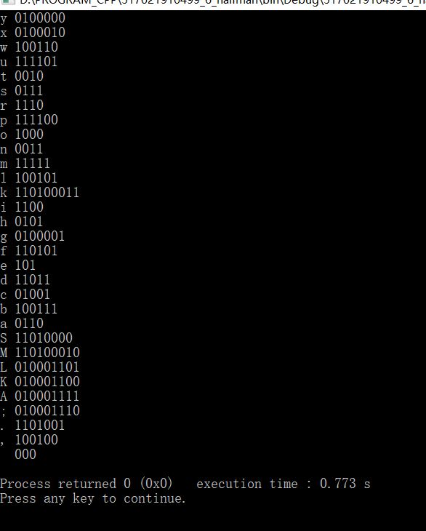

Test3.txt getcode()运行结果如下：

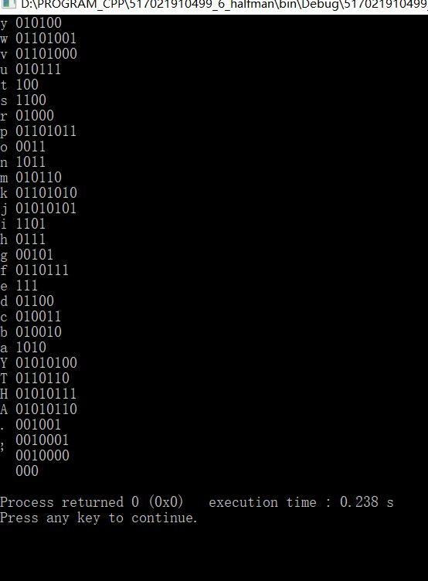

Test1.txt 字符出现频率及哈夫曼编码:

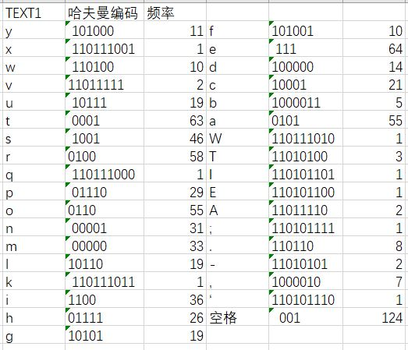

Test1.txt中共有35个字符，若采用等长编码，需要六位数字，各字母频率相加为780，

等长编码占用空间：6*780=4680 bit

哈夫曼编码占用空间为：

由程序得 哈夫曼编码占用空间：3347 bit；

节约空间 4680-3347=1333 bit

Test2.txt 字符出现频率及哈夫曼编码:

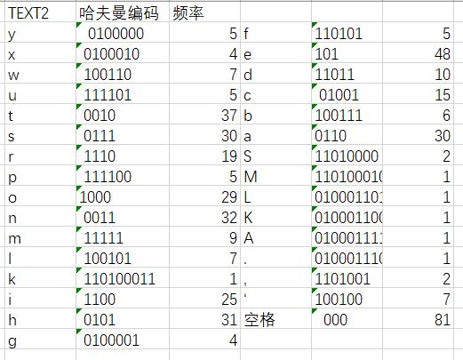

Test2.txt中共有31个字符，若采用等长编码，需要五位数字，各字母频率相加为461，

等长编码占用空间：5*461=2305 bit

哈夫曼编码占用空间为：

由程序得 哈夫曼编码占用空间：1916 bit；

节约空间 2305-1916=389 bit

Test3.txt 字符出现频率及哈夫曼编码:

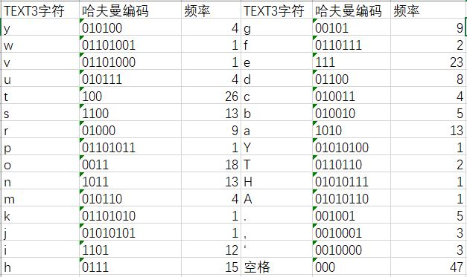

Test2.txt中共有30个字符，若采用等长编码，需要五位数字，各字母频率相加为250，

等长编码占用空间：5*250=1250 bit

哈夫曼编码占用空间为：

由程序得 哈夫曼编码占用空间：1044 bit；

节约空间 1250-1044=206 bit