
HASAN KALYONCU UNIVERSITY
FACULTY OF ENGINEERING
SOFTWARE DEPARTMENT

VPN PROJECT

GRADUATION THESIS
IN
SOFTWARE ENGINEERING

BY
Mustafa Yücel
Ömer Faruk Şahan
Rokan Fırat
APR 2026

I hereby declare that all information in this document has been obtained and presented in accordance with academic rules and ethical conduct. I also declare that, as required by these rules and conduct, I have fully cited and referenced all material and results that are not original to this work.

Mustafa Yücel
Ömer Faruk Şahan
Rokan Fırat

Table of Contents
1. INTRODUCTION 4
1.1. Purpose and Scope 4
1.2. Problem Statement 4
1.3. Solution Statement 4
1.4. Contribution 4
1.5. Glossary 4
2. LITERATURE REVIEW 5
2.1. VPN Technologies and Lightweight Tunneling 5
2.2. Identity and Authentication 6
2.3. Blockchain-based Verification Systems 6
3. Requirements Specification 7
3.1. Functional Requirements 7
3.2. Non-functional Requirements 7
3.3. Constraints 7
4. System Design 8
4.1. High-level Architecture Diagram 8
4.2. Session Flow 8
4.3. Module Breakdown 8
4.4. Session Lifecycle 9
5. Implementation Plan & Milestones 9
5.1. Codebase Structure 9
5.2. Milestones 9
5.3. Tools 9
5.4. Deployment Diagram 10
6. Conclusion 10
7. References 10

- INTRODUCTION
  - Purpose and Scope
We are building a secure communication infrastructure for team members working across far locations on a business idea. The system has two main components: a custom Virtual Private Network (VPN) and a private blockchain-based identity management system. A web interface will be provided to demonstrate the system functionality, and a mobile client development on the same backend is planned.

  - Problem Statement
Due to team members living across different countries, team cannot communicate through physical meetings. Existing VPN solutions may be restricted, complex, or depend on third-party services. Additionally, there is a need for an authentication system that does not rely on third party applications.

  - Solution Statement
We keep the tunnel small, fast, and secure; a lightweight UDP-based VPN tunnel will be developed using modern crypto techniques (AEAD and ECDH). A private blockchain is implemented to manage authentication. A web page displays the session status making the demo easy to follow.

  - Contribution
The contribution of this research is a custom protocol, plus chain-backed identity, packaged for a small distributed team. The focus is on clarity and operability rather than inventing a new technology.

  - Glossary
WireGuard® is an extremely simple yet fast and modern VPN that utilizes state-of-the-art cryptography. It aims to be faster, simpler, leaner, and more useful than IPsec, while avoiding the massive headache. It intends to be considerably more performant than OpenVPN. WireGuard is designed as a general-purpose VPN for running on embedded interfaces and super computers alike, fit for many different circumstances. Initially released for the Linux kernel, it is now cross-platform (Windows, macOS, BSD, iOS, Android) and widely deployable. It is currently under heavy development, but it might already be regarded as the most secure, easiest-to-use, and simplest VPN solution in the industry.

AEAD is an authenticated encryption algorithm that combines the ChaCha20 stream cipher and Poly1305 message authentication. It is used in modern VPN protocols for its efficiency and security.

Curve25519 or ECDH is an elliptic-curve cryptography algorithm used for secure key exchange. It is preferred due to its high performance, resistance to side-channel attacks, and strong security properties.

The Noise Protocol Framework is used for building cryptographic handshake protocols. It defines patterns for secure key exchange using Diffie–Hellman operations and supports forward secrecy and identity hiding.

Nebula is an open-source, scalable overlay networking tool developed by Slack. It enables secure, peer-to-peer communication between nodes across different networks using a mesh topology.
Tinc VPN is a mesh VPN solution that allows nodes to automatically discover each other and establish encrypted connections.

UDP is a connectionless transport protocol that provides fast communication without guaranteeing delivery or ordering

NAT Traversal techniques allow devices behind Network Address Translation (NAT) to establish direct communication with external peers.

Blockchain is a distributed ledger technology in which only authorized participants can access and validate transactions. In this project, it is used to securely store identity information and manage revocation without relying on a central authority.

Decentralized Identity is a model for digital identity management where users control their own identity credentials without relying on centralized providers such as Microsoft entraID, Okta or Auth0.

- LITERATURE REVIEW
Decentralized solutions are a key concept for secure communication. Recent solutions focus on reducing protocol complexity, improving performance over unreliable networks, and exploring alternative approaches to identity management in distributed environments. This project focuses on two areas: modern UDP-based VPN protocols and decentralized identity systems supported by blockchain technologies

  - VPN Technologies and Lightweight Tunneling
IPsec and OpenVPN have long been the baseline for secure tunneling, but they often come with considerable overhead in both configuration and runtime performance. Their reliance on complex negotiation phases, multiple cryptographic options, and in some cases TCP-based transport can lead to inefficiencies.

WireGuard softens this complexity. Instead of supporting a wide range of configurations, it intentionally restricts its design to a small set of primitives. It uses the Noise protocol framework which simplifies the handshake process by defining a fixed pattern for key exchange, improving performance and reducing the overhead seen in older protocols.

Other than WireGuard, there are also other similar systems like Nebula and Tinc which have more decentralized networking models. Nebula uses a certification-based identity system and a mesh networking method that allows nodes to discover and connect to each other without depending on a central routing point. It also has mechanisms for NAT traversal which enable communication between nodes behind firewalls or private networks. Tinc ,on the other hand, uses mesh topology, which provides automatic rerouting in the event of a node or link failure. These systems show that new VPN solutions are no longer limited to simple client-server models but are increasingly designed to be flexible, peer-to-peer overlay networks.

  - Identity and Authentication
Authentication is important in any VPN system because it determines which entities are allowed to join the network and communicate using the protocol. Classic approaches usually depend on centralized certificate authorities or third-party identity providers for authentication. Even though these methods are mature and used by many systems, third parties can become a failure point for the system.

There have been attempts to remove or reduce this dependency on external authentication. For example, some VPN architectures integrate identity providers for a simpler user management. However, if the identity provider is compromised or unavailable, the entire authentication mechanism can be affected. Another approach is to embed identity directly into the network layer, like in WireGuard, where public keys serve as identifiers. This reduces reliance on external systems but still requires a secure way to distribute and revoke keys.

Recent designs explore decentralized identity models, where identity verification does not depend on a single authority. These models align with zero-trust principles, where each participant must continuously prove its identity rather than relying on implicit trust within the network. However, implementing such systems in a practical and scalable way remains a challenge, particularly for key management and revocation.

  - Blockchain-based Verification Systems
Blockchain technology offers a different approach to identity management by providing a distributed and tamper-resistant data structure. In a permissioned blockchain, only authorized participants can write to or validate the ledger, making it suitable for controlled environments such as private networks or team-based systems.

The concept of decentralized identity, as proposed by the W3C, allows users to control their own identity credentials without relying on centralized systems. These systems support features such as identity verification, revocation, and auditability, which are critical for secure environments. One of the key advantages of using blockchain for identity is its ability to maintain a consistent and auditable record of all identity-related operations. This includes not only registration but also updates and revocation events. Unlike traditional systems, where revocation lists must be distributed and synchronized, a blockchain provides a single source of truth that is shared among all participants.

Concluding all the points mentioned above; existing VPN technologies demonstrate that it is possible to achieve both strong security and high performance, particularly with the adoption of UDP-based designs and modern cryptographic frameworks. At the same time, identity management remains an area where many systems still rely on centralized components. This project builds on these observations by combining a lightweight VPN tunnel with a private blockchain-based identity system. The goal is not to replace existing solutions, but to explore how these two components can be integrated into a single, coherent system in which communication and identity verification are tightly coupled. Such an approach is particularly relevant for small, distributed teams that require both security and autonomy without relying on external infrastructure.

- Requirements Specification
  - Functional Requirements
    - Secure tunnel: Setup and maintain UDP-based encrypted tunnels between client and server, with session initiation, keep-alive, and teardown.
    - Authentication & identity: Verify clients with private blockchain-backed identities.
    - Authorization: Enforce per-session auth based on enrolled identities. Reject unauthorized peers.
    - Key management: Generate, store, and rotate keys for tunnel encryption/integrity. Detect and handle key expiration.
    - Integrity & confidentiality: Encrypt all payloads and ensure integrity. Drop or flag tampered packets.
    - Session logging: Record connection events, auth results, and errors for audit and debugging.
    - Monitoring UI: Display active sessions, status, and basic metrics on the web dashboard.
    - Configuration: Allow basic server settings via config file/env.
    - Error handling: Gracefully handle packet loss/timeouts. Expose meaningful error states to logs/UI.
    - Demo workflows: Provide a minimal end-to-end demo flow.

  - Non-functional Requirements
    - Security: Apply authenticated encryption, avoid plaintext secrets, and validate inputs.
    - Performance: Support low-latency tunneling for small payloads, target acceptable round-trip time (RTT) overhead for a single-region virtual private server (VPS).
    - Availability: Single-server MVP, tolerating client reconnects; no HA requirement for first version.
    - Scalability: Design to add more clients/regions later; multi-vps not implemented in this version.
    - Reliability: Detect dropped sessions and clean up stale state. Retry handshakes within bounded attempts.
    - Observability: Provide structured logs.
    - Usability: Clear status indicators and human-readable error messages.
    - Compliance: Use only open-source libraries compatible with academic use.

  - Constraints
    - UDP-based custom protocol (no pre-made VPN protocol).
    - Single VPS/server for this version; limited client count for demo.
    - Minimal third-party services, open-source stack preferred.

- System Design
  - High-level Architecture Diagram
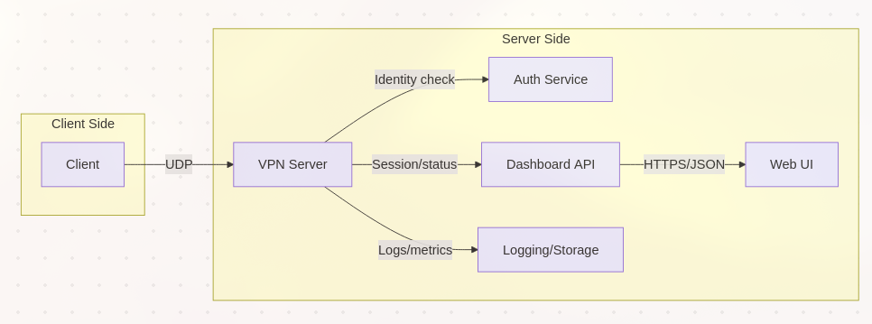
  - Session Flow
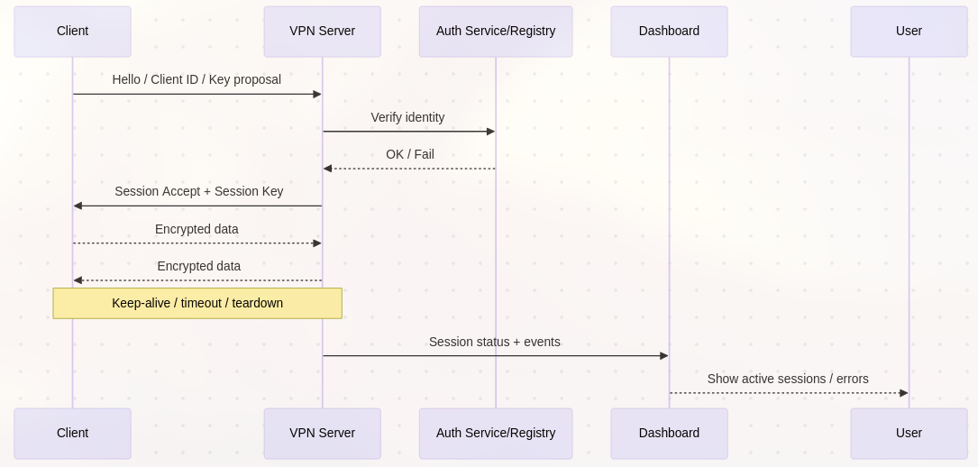
  - Module Breakdown
    - Tunnel Core: Handles UDP I/O, authenticated encryption (AEAD), sequence/nonce management, replay protection, and the in-memory session table. Implements handshake, keep-alive, and graceful teardown.
    - Auth Adapter: Mediates identity checks against the private blockchain/registry.
    - Config & Key Management: Loads port, cipher suite, and logging settings from config/env. Manages key material.
    - Monitoring API: Exposes a minimal https/json interface to retrieve session list, states, recent errors, and counters. Provides inputs to the dashboard without exposing sensitive payloads.
    - Web UI: Renders active sessions, status badges and recent events. Focuses on operator observability.
    - Logging: Collects structured logs for audit/debug. Rotatable.

  - Session Lifecycle

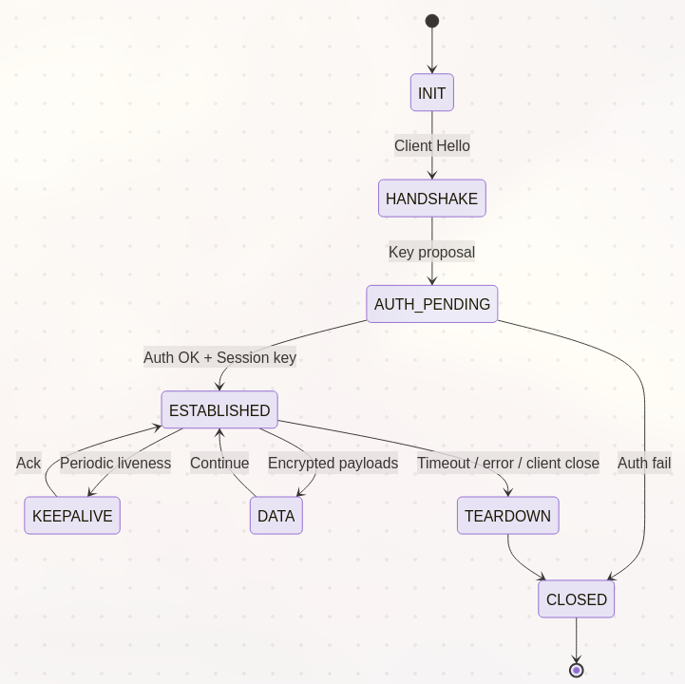

- Implementation Plan & Milestones
  - Codebase Structure
    - vpn-core/: UDP tunnel, handshake, AEAD crypto, session table, nonce/sequence management.
    - auth-adapter/: Private blockchain/registry client, auth cache, allow/deny decisions.
    - config/: Config loader.
    - api/: Monitoring API (HTTPS/JSON) for sessions, errors, counters.
    - web-ui/: Dashboard.
    - scripts/: Dev tooling and utility functions.

  - Milestones

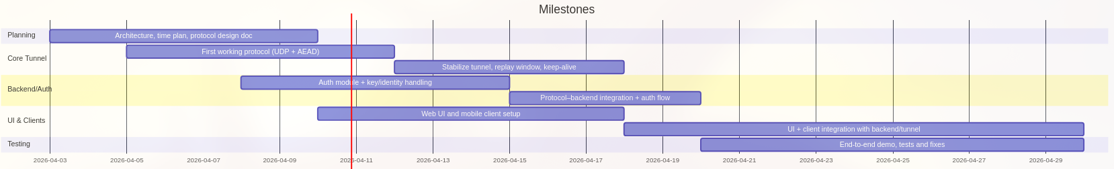

  - Tools
    - Languages: Go, Node.js, React, React-native.
    - Build: Go toolchain, npm/yarn for web UI.
    - Containers: Docker for reproducible dev/test.
    - Config via env/.env or YAML (ports, ciphers, log level).

  - Deployment Diagram

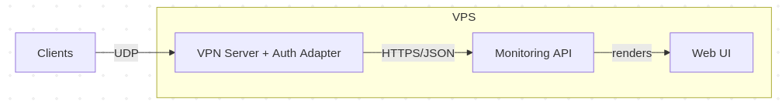

- Conclusion
This prototype delivers a secure communication path for a team ,whose members are away from each other, with a custom UDP-based tunnel, authenticated encryption, and a private blockchain-backed identity check. The system includes a monitoring API and a minimal web dashboard for observing, meeting the course requirements and demonstrating the system.

Key outcomes:
- Functional: Handshake, AEAD-protected data path, basic replay protection, and per-session auth decisions via the registry/blockchain.
- Operational: Single-VPS deployment with structured logging and a dashboard to surface session status and errors.
- Scope adherence: Features match the defined MVP; HA/scale-out and key rotation are explicitly deferred.

The implementation satisfies the objectives for demonstrating a VPN + identity layer with observable operation. Further improvements would prioritize key rotation, stronger NAT traversal, and, if needed, a migration to Rust for tighter safety/performance guarantees.

- References
- WireGuard paper and implementations: wireguard-go, boringtun.
- Nebula: https://github.com/slackhq/nebula
- Tinc VPN: https://www.tinc-vpn.org
- Outline server: https://github.com/Jigsaw-Code/outline-server
- udp2raw: https://github.com/wangyu-/udp2raw-tunnel
- badvpn: https://github.com/ambrop72/badvpn
- Private chain/ID references: Hyperledger Fabric/Quorum; W3C DID/VC.

