# JavaScript & Node.js Hiring Test – Nucont -- MUHAMMED YILMAZ

Test is about data transform. I created a text file and take input from this file. I used node.js and javascript es6 class for programming.

I created a folder named Level1 for level 1 test. I created 1 txt file named “InputData.txt” that is input file. I created 2 js files. The “main.js” contains algorithm that solves transformation problem. The “test.js” receives data from txt file, sends to main.js and takes the final results. I showed the schema of my program below.

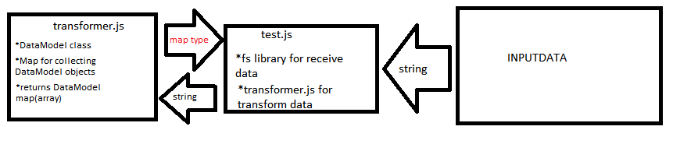

So finally,

i tried to explain my codes, inside of files. I am new at NodeJs and i am still try to learn. I used the ES6 classes for the first time. I've seen OOP before. I know theoretically that's why it didn't come hard. The part I hardly see are levels 2-3-4. It was not logically difficult to read through the text and then write on the array. I found a few solutions. But technically it was difficult for me.