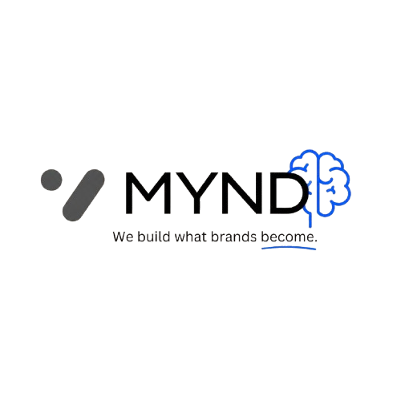
Technical & Financial Proposal
Premium Furniture Showcase Website Development
Hello,
This is Youssef Ahmed from MYND Agency.
We are pleased to present our proposal for designing and developing a premium showcase website for your furniture brand.
The goal of this project is to create a digital showroom that represents your brand professionally, highlights your furniture collections, and provides customers with a strong visual experience.
Project Scope
1. UI/UX Design
• Custom website design based on your brand identity.
• Luxury and modern style suitable for the furniture industry.
• Responsive design for Desktop, Tablet, and Mobile.
• Premium product presentation.
2. Front-End Development
• Modern HTML, CSS, and JavaScript development.
• Fast optimized structure.
• Smooth animations and transitions.
• Interactive sections and premium effects.
• Responsive design.
3. Custom Backend Development
• Custom admin system.
• Managing furniture collections, images, and content.
• Secure and scalable structure.
Furniture Showcase Features
• Furniture collections showcase.
• Product galleries.
• Categories and product details.
• Brand story section.
• Previous projects showcase.
• Contact section.
• WhatsApp integration.
Optimization & Website Launch
• Performance optimization.
• Basic SEO setup.
• Security configuration.
• Domain and hosting connection.
• Testing and deployment.
Deliverables
✓ Complete UI/UX Design
✓ Custom Front-End Development
✓ Custom Backend Development
✓ Premium Animations & Interactions
✓ Responsive Showcase Website
✓ Website Deployment & Launch
Estimated Timeline
3 - 5 Working Days
Timeline starts after receiving all required content and approvals.
Project Investment
Total Investment | 5,500 EGP
Initial Payment (25%) | 1,375 EGP - Project Start
Design Approval (25%) | 1,375 EGP - Development Start
Final Payment (50%) | 2,750 EGP - Before Launch
Final Note
The mentioned price includes all services listed above. Any additional features outside the agreed scope will be discussed separately.
Best regards,
Youssef Ahmed
MYND Agency Team
"We build what brands become."

