List of file inside repo PV/PVC
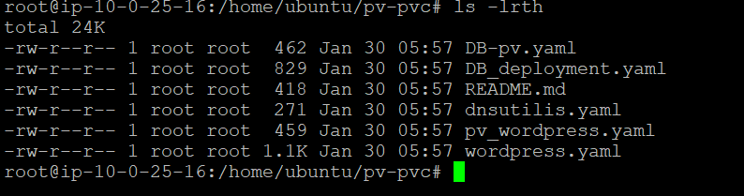
STEP 1 : Frist we have to lunch database pod
Created PV and PVC for Database and application
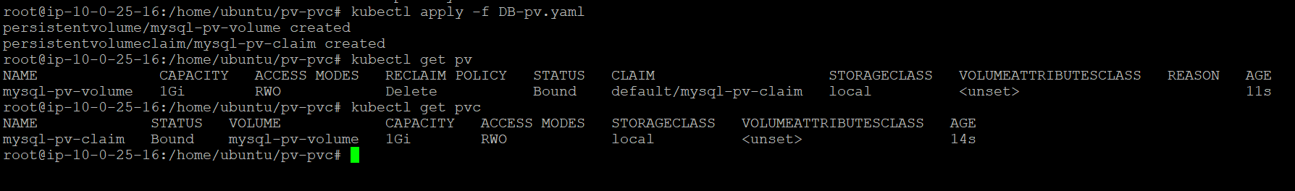
data base deployment is up and running
Take cluster IP of the Database and put it deployment file of the application. This is for establishing the connection between application and database.
Go to deployment file
in environment section we have specify the clusterIP and database credential
In ENV section, we define all database credential and Host Ip means cluster IP
DB_HOST: ClusterIP of database service (e.g., 10.1.77.51)
DB_PORT: Database port (3306, 5432, etc.)
DB_NAME: Database name
DB_USER: Database username
DB_PASSWORD: Database password (use Secret reference)
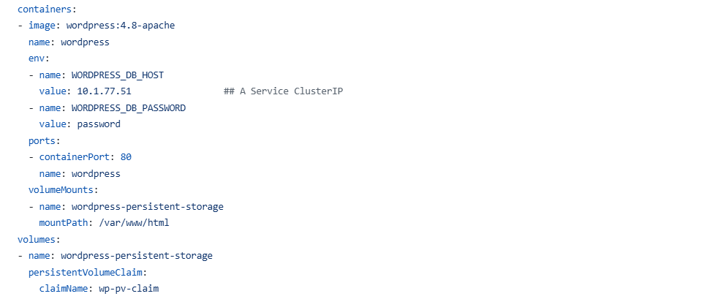
DB_NAME, DB_USER, and DB_PASSWORD depend on your database user setup.
DB_NAME: wordpress # Your created database
DB_USER: wordpress # Your created username
DB_PASSWORD: password123 # Your user password
Using the ENV section in Kubernetes Deployment/StatefulSet YAML establishes the database-application connection.
----------------------------------------------------------------------------------------------------------------------------------
STEP 2:
Run application deployment file (it contain PV ,PVC, deployment, service)
we can expose the application using ingress or NodePort outside the cluster
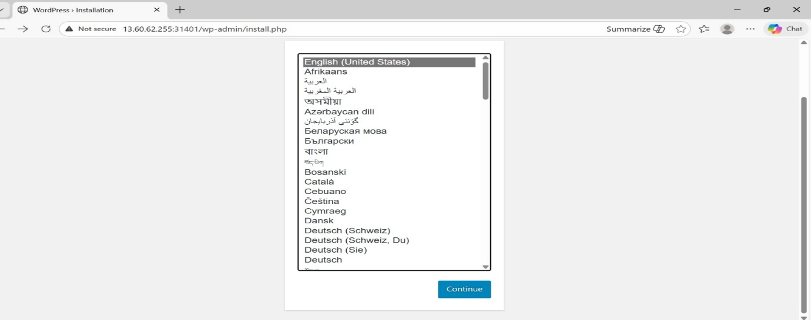
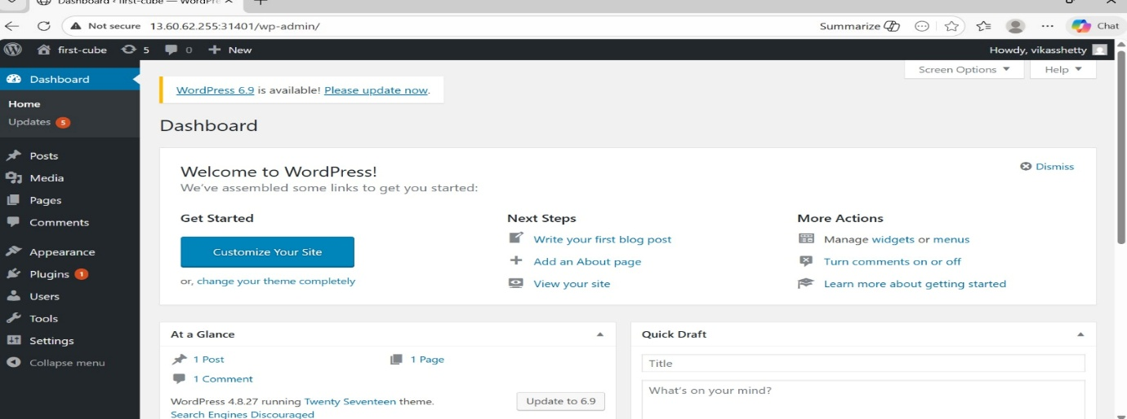
application has been launched and I have login to my email . The user credential is stored in database.
as soon as we create the data and application pods using pv /pvc.
it store the application data in cluster node or cloud . it is depend on the setup
In this example , we store the data in local machine
Both database and application data is stored inside the /mnt/ folder
data is the pvc of database
WP_data is the pvc of application
we check the weather data is exist or not
ls /mnt/data
ls/mnt/ wp_data
root@ip-10-0-25-16:/home/ubuntu/pv-pvc# ls /mnt/wp_data
--------------------------------------------------------------------------------------------------------------------------------------
We check the SQL inside the Database pod
kubectl describe deployment mysql
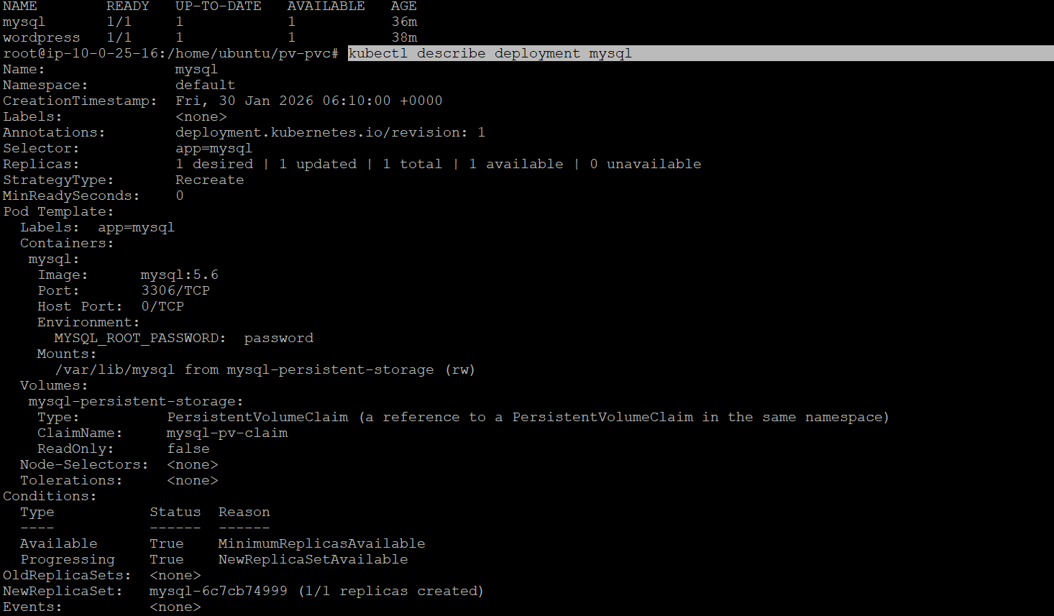
Kubectl describe pod <pod name> ##database pod
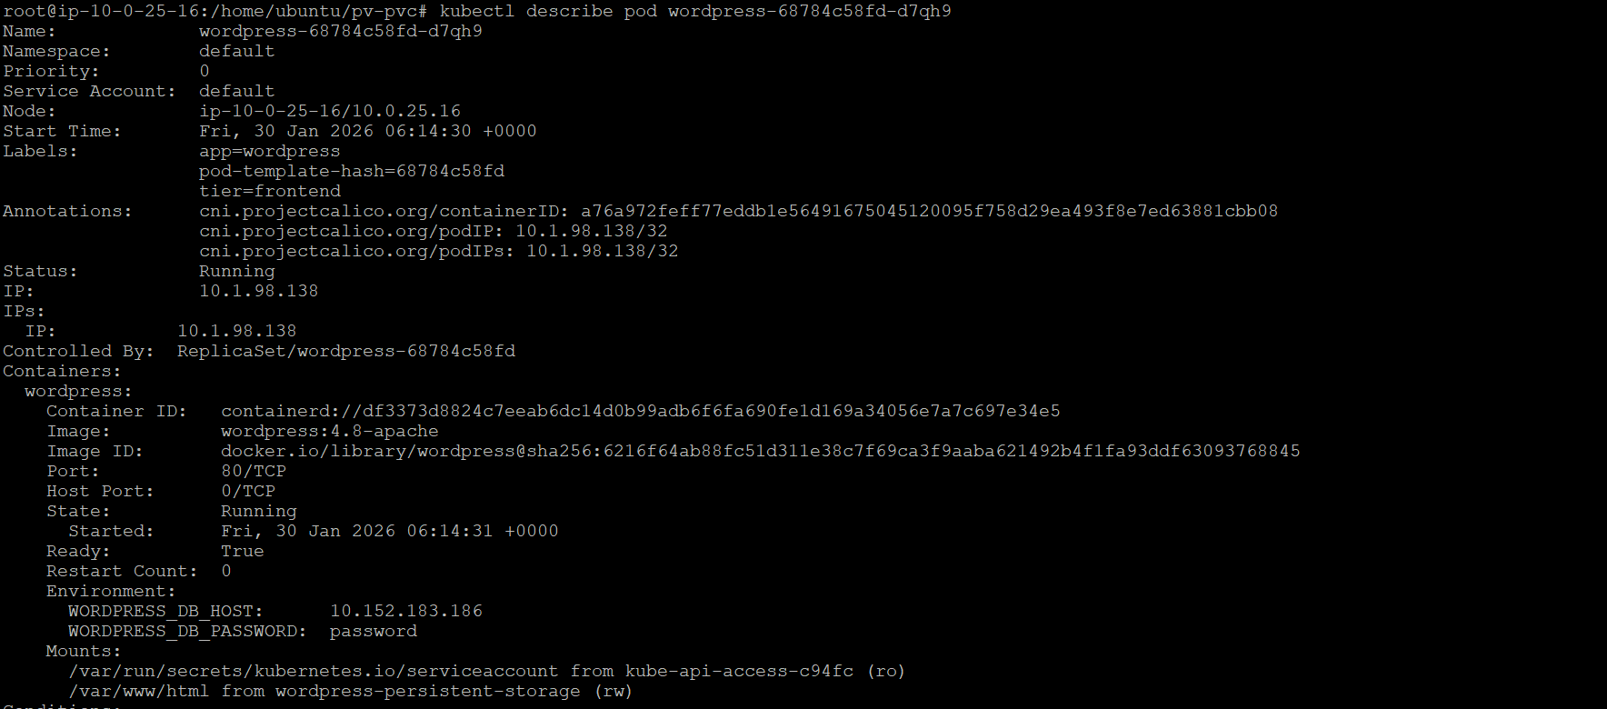Login to database
login to the database pod and check in MySQL table user data is exist or not
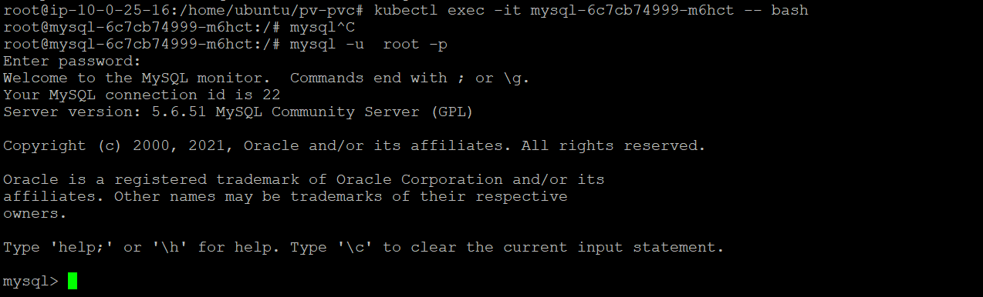
we have login to pod
root@wordpress-68784c58fd-d7qh9:/var/www/html# mysql -u root –p
enter the password to login
# Login
mysql -u root –p
SHOW DATABASES;
# List tables (after USE database_name;)
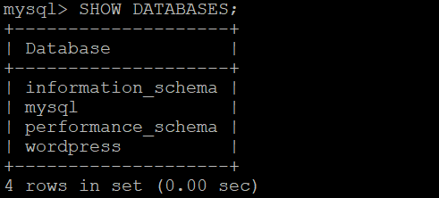
here, we can create our own database also
Create database vikas;
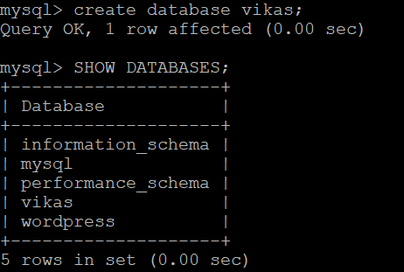
Select the database
syntax:
USE database_name;
use mssql;
now we are in the mssql data base , we see list of table inside the mssql.
show tables;
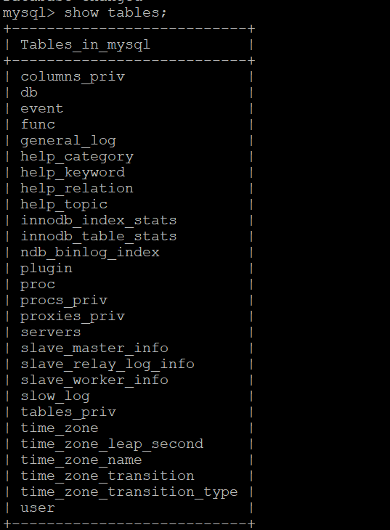
SELECT user FROM mysql.user;
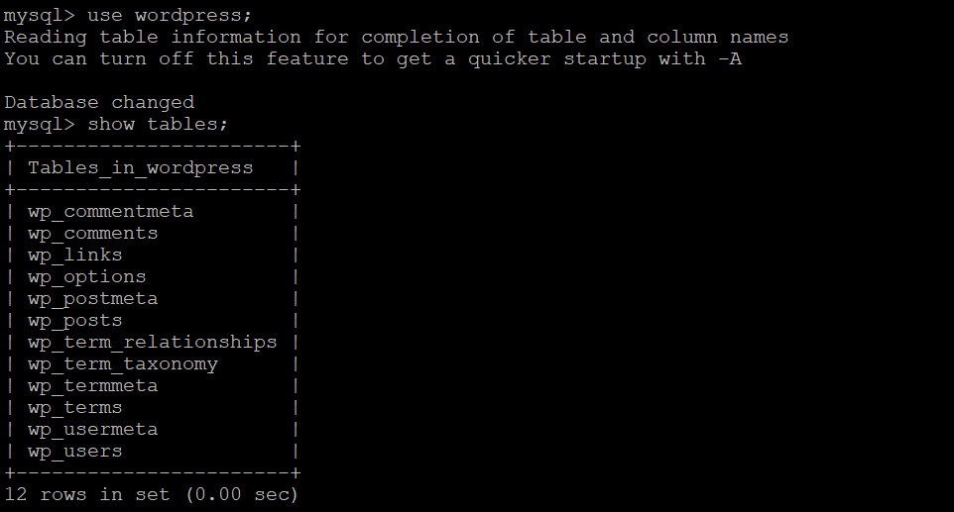
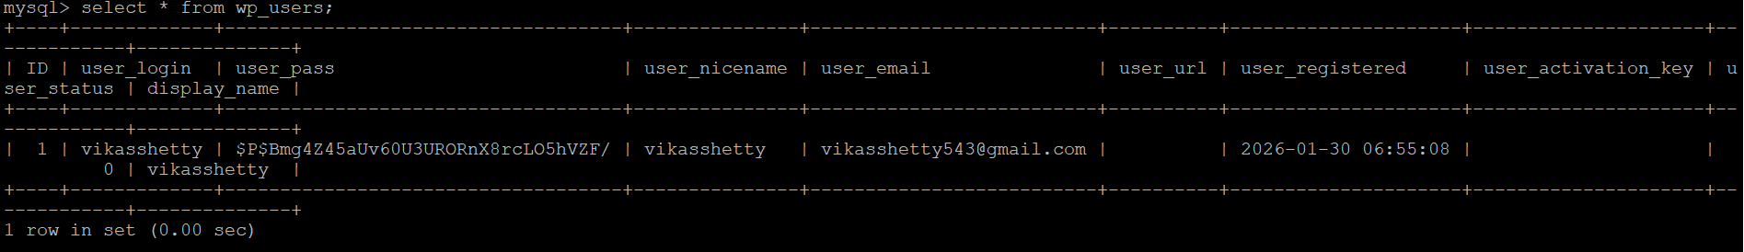
use details stored inside the data base .

