**BÀI TẬP 1: Sử dụng Animation từ file xml**

Bước 1: Sau khi tạo **projects**

- Tạo **anim**

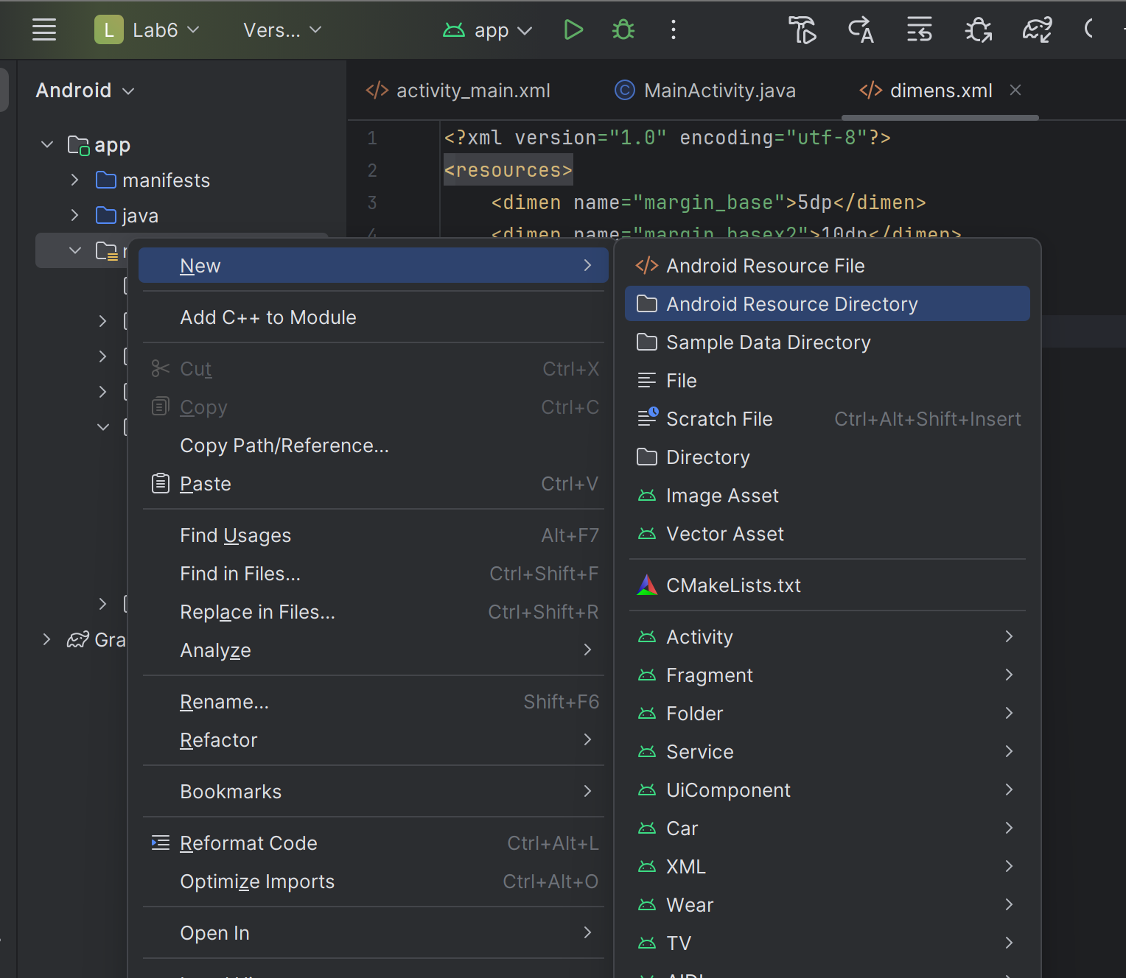

Bước 2: Tạo file **dimens.xml**

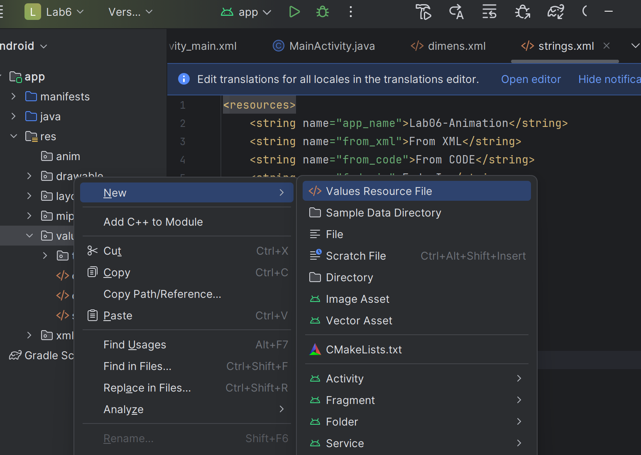

* viết code sau

<?xml version="1.0" encoding="utf-8"?>  
<resources>  
 <dimen name="margin_base">5dp</dimen>  
 <dimen name="margin_basex2">10dp</dimen>  
 <dimen name="text_medium">16sp</dimen>  
 <dimen name="image_base">100dp</dimen>  
</resources>

Bước 3: Thêm logo vào

Ảnh có chứa văn bản, ảnh chụp màn hình, phần mềm, Hệ điều hành

Nội dung do AI tạo ra có thể không chính xác.

* viết code sau

<?xml version="1.0" encoding="utf-8"?>  
<LinearLayout  
 xmlns:android="http://schemas.android.com/apk/res/android"  
 xmlns:tools="http://schemas.android.com/tools"  
 android:layout_width="match_parent"  
 android:layout_height="match_parent"  
 android:orientation="vertical"  
 tools:context=".MainActivity">  
 <FrameLayout  
 android:layout_width="match_parent"  
 android:layout_height="0dp"  
 android:layout_weight="6">  
 <ImageView  
 android:id="@+id/iv_uit_logo"  
 android:layout_width="@dimen/image_base"  
 android:layout_height="@dimen/image_base"  
 android:layout_gravity="center"  
 android:scaleType="fitCenter"  
 android:src="@drawable/logo_hcmunre"/>  
 </FrameLayout>  
 <LinearLayout  
 android:layout_marginTop="@dimen/margin_basex2"  
 android:layout_width="match_parent"  
 android:layout_height="wrap_content"  
 android:orientation="horizontal">  
 <TextView  
 android:layout_width="0dp"  
 android:layout_height="wrap_content"  
 android:layout_weight="1"  
 android:text="@string/from_xml"  
 android:gravity="center"  
 android:textStyle="bold"  
 android:layout_marginRight="@dimen/margin_base"/>  
 <TextView  
 android:layout_width="0dp"  
 android:layout_height="wrap_content"  
 android:layout_weight="1"  
 android:text="@string/from_code"  
 android:textStyle="bold"  
 android:gravity="center"  
 android:layout_marginRight="@dimen/margin_base"/>  
 </LinearLayout>  
 <ScrollView  
 android:layout_width="match_parent"  
 android:layout_height="0dp"  
 android:layout_weight="5">  
 <LinearLayout  
 android:layout_width="match_parent"  
 android:layout_height="wrap_content"  
 android:orientation="vertical">  
 <LinearLayout  
 android:layout_marginTop="@dimen/margin_base"  
 android:layout_width="match_parent"  
 android:layout_height="wrap_content"  
 android:orientation="horizontal">  
 <Button  
 android:id="@+id/btn_fade_in_xml"  
 android:layout_width="0dp"  
 android:layout_height="wrap_content"  
 android:layout_weight="1"  
 android:text="@string/fade_in"  
 android:gravity="center"  
 android:layout_marginRight="@dimen/margin_base"/>  
  
 <Button  
 android:id="@+id/btn_fade_in_code"  
 android:layout_width="0dp"  
 android:layout_height="wrap_content"  
  
 android:layout_weight="1"  
 android:text="@string/fade_in"  
 android:gravity="center"  
 android:layout_marginRight="@dimen/margin_base"/>  
  
 </LinearLayout>  
 <LinearLayout  
 android:layout_marginTop="@dimen/margin_base"  
 android:layout_width="match_parent"  
 android:layout_height="wrap_content"  
 android:orientation="horizontal">  
 <Button  
 android:id="@+id/btn_fade_out_xml"  
 android:layout_width="0dp"  
 android:layout_height="wrap_content"  
 android:layout_weight="1"  
 android:text="@string/fade_out"  
 android:gravity="center"  
  
 android:layout_marginRight="@dimen/margin_base"/>  
 <Button  
 android:id="@+id/btn_fade_out_code"  
 android:layout_width="0dp"  
 android:layout_height="wrap_content"  
  
 android:layout_weight="1"  
 android:text="@string/fade_out"  
 android:gravity="center"  
 android:layout_marginRight="@dimen/margin_base"/>  
  
 </LinearLayout>  
 <LinearLayout  
 android:layout_marginTop="@dimen/margin_base"  
 android:layout_width="match_parent"  
 android:layout_height="wrap_content"  
 android:orientation="horizontal">  
 <Button  
 android:id="@+id/btn_blink_xml"  
 android:layout_width="0dp"  
 android:layout_height="wrap_content"  
 android:layout_weight="1"  
 android:text="@string/blink"  
 android:gravity="center"  
 android:layout_marginRight="@dimen/margin_base"/>  
  
 <Button  
 android:id="@+id/btn_blink_code"  
 android:layout_width="0dp"  
  
 android:layout_height="wrap_content"  
 android:layout_weight="1"  
 android:text="@string/blink"  
 android:gravity="center"  
 android:layout_marginRight="@dimen/margin_base"/>  
  
 </LinearLayout>  
 <LinearLayout  
 android:layout_marginTop="@dimen/margin_base"  
 android:layout_width="match_parent"  
 android:layout_height="wrap_content"  
 android:orientation="horizontal">  
 <Button  
 android:id="@+id/btn_zoom_in_xml"  
 android:layout_width="0dp"  
 android:layout_height="wrap_content"  
 android:layout_weight="1"  
 android:text="@string/zoom_in"  
 android:gravity="center"  
  
 android:layout_marginRight="@dimen/margin_base"/>  
  
 <Button  
 android:id="@+id/btn_zoom_in_code"  
 android:layout_width="0dp"  
 android:layout_height="wrap_content"  
  
 android:layout_weight="1"  
 android:text="@string/zoom_in"  
 android:gravity="center"  
 android:layout_marginRight="@dimen/margin_base"/>  
  
 </LinearLayout>  
 <LinearLayout  
 android:layout_marginTop="@dimen/margin_base"  
 android:layout_width="match_parent"  
 android:layout_height="wrap_content"  
 android:orientation="horizontal">  
 <Button  
 android:id="@+id/btn_zoom_out_xml"  
 android:layout_width="0dp"  
 android:layout_height="wrap_content"  
 android:layout_weight="1"  
 android:text="@string/zoom_out"  
 android:gravity="center"  
 android:layout_marginRight="@dimen/margin_base"/>  
  
 <Button  
 android:id="@+id/btn_zoom_out_code"  
 android:layout_width="0dp"  
  
 android:layout_height="wrap_content"  
 android:layout_weight="1"  
 android:text="@string/zoom_out"  
 android:gravity="center"  
 android:layout_marginRight="@dimen/margin_base"/>  
 </LinearLayout>  
 <LinearLayout  
 android:layout_marginTop="@dimen/margin_base"  
 android:layout_width="match_parent"  
 android:layout_height="wrap_content"  
 android:orientation="horizontal">  
 <Button  
 android:id="@+id/btn_rotate_xml"  
 android:layout_width="0dp"  
  
 android:layout_height="wrap_content"  
 android:layout_weight="1"  
 android:text="@string/rotate"  
 android:gravity="center"  
 android:layout_marginRight="@dimen/margin_base"/>  
  
 <Button  
 android:id="@+id/btn_rotate_code"  
 android:layout_width="0dp"  
 android:layout_height="wrap_content"  
 android:layout_weight="1"  
 android:text="@string/rotate"  
 android:gravity="center"  
 android:layout_marginRight="@dimen/margin_base"/>  
  
 </LinearLayout>  
 <LinearLayout  
 android:layout_marginTop="@dimen/margin_base"  
 android:layout_width="match_parent"  
 android:layout_height="wrap_content"  
 android:orientation="horizontal">  
 <Button  
 android:id="@+id/btn_move_xml"  
 android:layout_width="0dp"  
 android:layout_height="wrap_content"  
 android:layout_weight="1"  
 android:text="@string/move"  
 android:gravity="center"  
 android:layout_marginRight="@dimen/margin_base"/>  
  
 <Button  
 android:id="@+id/btn_move_code"  
 android:layout_width="0dp"  
 android:layout_height="wrap_content"  
 android:layout_weight="1"  
 android:text="@string/move"  
 android:gravity="center"  
 android:layout_marginRight="@dimen/margin_base"/>  
  
 </LinearLayout>  
 <LinearLayout  
 android:layout_marginTop="@dimen/margin_base"  
 android:layout_width="match_parent"  
 android:layout_height="wrap_content"  
 android:orientation="horizontal">  
 <Button  
 android:id="@+id/btn_slide_up_xml"  
 android:layout_width="0dp"  
  
 android:layout_height="wrap_content"  
 android:layout_weight="1"  
 android:text="@string/slide_up"  
 android:gravity="center"  
 android:layout_marginRight="@dimen/margin_base"/>  
 <Button  
 android:id="@+id/btn_slide_up_code"  
 android:layout_width="0dp"  
 android:layout_height="wrap_content"  
 android:layout_weight="1"  
 android:text="@string/slide_up"  
 android:gravity="center"  
 android:layout_marginRight="@dimen/margin_base"/>  
  
 </LinearLayout>  
 <LinearLayout  
 android:layout_marginTop="@dimen/margin_base"  
 android:layout_width="match_parent"  
 android:layout_height="wrap_content"  
 android:orientation="horizontal">  
  
 <Button  
 android:id="@+id/btn_bounce_xml"  
 android:layout_width="0dp"  
 android:layout_height="wrap_content"  
 android:layout_weight="1"  
 android:text="@string/bounce"  
 android:gravity="center"  
  
 android:layout_marginRight="@dimen/margin_base"/>  
  
 <Button  
 android:id="@+id/btn_bounce_code"  
 android:layout_width="0dp"  
  
 android:layout_height="wrap_content"  
  
 android:layout_weight="1"  
 android:text="@string/bounce"  
 android:gravity="center"  
 android:layout_marginRight="@dimen/margin_base"/>  
 </LinearLayout>  
 <LinearLayout  
 android:layout_marginTop="@dimen/margin_base"  
 android:layout_width="match_parent"  
 android:layout_height="wrap_content"  
 android:orientation="horizontal">  
 <Button  
 android:id="@+id/btn_combine_xml"  
 android:layout_width="0dp"  
 android:layout_height="wrap_content"  
 android:layout_weight="1"  
 android:text="@string/combine"  
 android:gravity="center"  
 android:layout_marginRight="@dimen/margin_base"/>  
  
 <Button  
 android:id="@+id/btn_combine_code"  
 android:layout_width="0dp"  
  
 android:layout_height="wrap_content"  
 android:layout_weight="1"  
 android:text="@string/combine"  
 android:gravity="center"  
  
 android:layout_marginRight="@dimen/margin_base"/>  
 </LinearLayout>  
 </LinearLayout>  
 </ScrollView>  
</LinearLayout>

Bước 4. Tạo file **layout_buttons_row_1.xml**

- Chuột phải vào **layout** – chọn **layout resourch file**

Ảnh có chứa văn bản, ảnh chụp màn hình, phần mềm, Phần mềm đa phương tiện

Nội dung do AI tạo ra có thể không chính xác.

* viết code sau vào

<?xml version="1.0" encoding="utf-8"?>  
<LinearLayout xmlns:android="http://schemas.android.com/apk/res/android"  
 android:layout_width="match_parent"  
 android:layout_height="wrap_content"  
 android:orientation="horizontal">  
  
 <Button  
 android:id="@+id/btn_fade_in_xml"  
 android:layout_width="0dp"  
 android:layout_height="wrap_content"  
 android:layout_weight="1"  
 android:text="@string/fade_in" />  
  
 <Button  
 android:id="@+id/btn_fade_in_code"  
 android:layout_width="0dp"  
 android:layout_height="wrap_content"  
 android:layout_weight="1"  
 android:text="@string/fade_in" />  
</LinearLayout>

Bước 5: Ở **anim** tạo file **anim_fade_in.xml** , **anim_fade_out.xml** , **anim_blink.xml , anim_zoom_in.xml , anim_zoom_out.xml , anim_rotate.xml , anim_move.xml, anim_slide_up.xml, anim_bounce.xml, anim_combine.xml**

Ảnh có chứa văn bản, ảnh chụp màn hình, phần mềm, Phần mềm đa phương tiện

Nội dung do AI tạo ra có thể không chính xác.

* viết code sau

+ **anim_fade_in.xml**

<?xml version="1.0" encoding="utf-8"?>  
<alpha xmlns:android="http://schemas.android.com/apk/res/android"  
 android:duration="1000"  
 android:fromAlpha="0.0"  
 android:toAlpha="1.0" />

+ **anim_fade_out.xml**

<?xml version="1.0" encoding="utf-8"?>  
<alpha xmlns:android="http://schemas.android.com/apk/res/android"  
 android:duration="1000"  
 android:fromAlpha="1.0"  
 android:toAlpha="0.0" />

+ **anim_blink.xml**

<?xml version="1.0" encoding="utf-8"?>  
<alpha xmlns:android="http://schemas.android.com/apk/res/android"  
 android:duration="300"  
 android:fromAlpha="0.0"  
 android:repeatCount="3"  
 android:repeatMode="reverse"  
 android:toAlpha="1.0" />

+ **anim_zoom_in.xml**

<?xml version="1.0" encoding="utf-8"?>  
<scale xmlns:android="http://schemas.android.com/apk/res/android"  
 android:duration="1000"  
 android:fromXScale="1"  
 android:fromYScale="1"  
 android:pivotX="50%"  
 android:pivotY="50%"  
 android:toXScale="3"  
 android:toYScale="3" />

+ **anim_zoom_out.xml**

<?xml version="1.0" encoding="utf-8"?>  
<scale xmlns:android="http://schemas.android.com/apk/res/android"  
 android:duration="1000"  
 android:fromXScale="1.0"  
 android:fromYScale="1.0"  
 android:pivotX="50%"  
 android:pivotY="50%"  
 android:toXScale="0.5"  
 android:toYScale="0.5" />

**+ anim_rotate.xml**

<?xml version="1.0" encoding="utf-8"?>  
<rotate xmlns:android="http://schemas.android.com/apk/res/android"  
 android:duration="600"  
 android:fromDegrees="0"  
 android:interpolator="@android:anim/cycle_interpolator"  
 android:pivotX="50%"  
 android:pivotY="50%"  
 android:repeatCount="2"  
 android:repeatMode="restart"  
 android:toDegrees="360" />

**+ anim_move.xml**

<?xml version="1.0" encoding="utf-8"?>  
<translate xmlns:android="http://schemas.android.com/apk/res/android"  
 android:duration="800"  
 android:fromXDelta="0%p"  
 android:interpolator="@android:anim/linear_interpolator"  
 android:toXDelta="75%p" />

**+ anim_slide_up.xml**

<?xml version="1.0" encoding="utf-8"?>  
<scale xmlns:android="http://schemas.android.com/apk/res/android"  
 android:duration="500"  
 android:fromXScale="1.0"  
 android:fromYScale="1.0"  
 android:toXScale="1.0"  
 android:toYScale="0.0" />

**+ anim_bounce.xml**

<?xml version="1.0" encoding="utf-8"?>  
<scale xmlns:android="http://schemas.android.com/apk/res/android"  
 android:duration="500"  
 android:fromXScale="1.0"  
 android:fromYScale="0.0"  
 android:interpolator="@android:anim/bounce_interpolator"  
 android:toXScale="1.0"  
 android:toYScale="1.0" />

**+ anim_combine.xml**

<?xml version="1.0" encoding="utf-8"?>  
<set xmlns:android="http://schemas.android.com/apk/res/android"  
 android:interpolator="@android:anim/linear_interpolator">  
 <scale  
 android:duration="4000"  
 android:fromXScale="1"  
 android:fromYScale="1"  
 android:pivotX="50%"  
 android:pivotY="50%"  
 android:toXScale="3"  
 android:toYScale="3" />  
 <rotate  
 android:duration="500"  
 android:fromDegrees="0"  
 android:pivotX="50%"  
 android:pivotY="50%"  
 android:repeatCount="2"  
 android:repeatMode="restart"  
 android:toDegrees="360" />  
</set>

Bước 6: Mở file **MainActivity.java**

* viết code sau

package com.example.lab6;  
  
import androidx.appcompat.app.AppCompatActivity;  
import android.os.Bundle;  
import android.view.View;  
import android.view.animation.Animation;  
import android.view.animation.AnimationUtils;  
import android.widget.Button;  
import android.widget.ImageView;  
import android.widget.Toast;  
  
public class MainActivity extends AppCompatActivity {  
 private ImageView ivUitLogo;  
 private Button btnFadeInXml, btnFadeOutXml, btnBlinkXml, btnZoomInXml, btnZoomOutXml,  
 btnRotateXml, btnMoveXml, btnSlideUpXml, btnBounceXml, btnCombineXml;  
  
 private Animation.AnimationListener animationListener;  
  
 @Override  
 protected void onCreate(Bundle savedInstanceState) {  
 super.onCreate(savedInstanceState);  
 setContentView(R.layout.*activity_main*);  
  
 findViewsByIds();  
 initVariables();  
  
 // Handle clicks for XML-defined animations  
 handleClickAnimationXml(btnFadeInXml, R.anim.*anim_fade_in*);  
 handleClickAnimationXml(btnFadeOutXml, R.anim.*anim_fade_out*);  
 handleClickAnimationXml(btnBlinkXml, R.anim.*anim_blink*);  
 handleClickAnimationXml(btnZoomInXml, R.anim.*anim_zoom_in*);  
 handleClickAnimationXml(btnZoomOutXml, R.anim.*anim_zoom_out*);  
 handleClickAnimationXml(btnRotateXml, R.anim.*anim_rotate*);  
 handleClickAnimationXml(btnMoveXml, R.anim.*anim_move*);  
 handleClickAnimationXml(btnSlideUpXml, R.anim.*anim_slide_up*);  
 handleClickAnimationXml(btnBounceXml, R.anim.*anim_bounce*);  
 handleClickAnimationXml(btnCombineXml, R.anim.*anim_combine*);  
  
 // Code for other exercises will be added here  
 }  
  
 private void findViewsByIds() {  
 ivUitLogo = findViewById(R.id.*iv_uit_logo*);  
 btnFadeInXml = findViewById(R.id.*btn_fade_in_xml*);  
 // ... find other XML buttons ...  
 btnFadeOutXml = findViewById(R.id.*btn_fade_out_xml*);  
 btnBlinkXml = findViewById(R.id.*btn_blink_xml*);  
 btnZoomInXml = findViewById(R.id.*btn_zoom_in_xml*);  
 btnZoomOutXml = findViewById(R.id.*btn_zoom_out_xml*);  
 btnRotateXml = findViewById(R.id.*btn_rotate_xml*);  
 btnMoveXml = findViewById(R.id.*btn_move_xml*);  
 btnSlideUpXml = findViewById(R.id.*btn_slide_up_xml*);  
 btnBounceXml = findViewById(R.id.*btn_bounce_xml*);  
 btnCombineXml = findViewById(R.id.*btn_combine_xml*);  
 }  
  
 private void initVariables() {  
 animationListener = new Animation.AnimationListener() {  
 @Override  
 public void onAnimationStart(Animation animation) {  
 Toast.*makeText*(getApplicationContext(), "Animation Started", Toast.*LENGTH_SHORT*).show();  
 }  
  
 @Override  
 public void onAnimationEnd(Animation animation) {  
 Toast.*makeText*(getApplicationContext(), "Animation Ended", Toast.*LENGTH_SHORT*).show();  
 }  
  
 @Override  
 public void onAnimationRepeat(Animation animation) {  
 }  
 };  
 }  
  
 private void handleClickAnimationXml(Button btn, int animId) {  
 final Animation animation = AnimationUtils.*loadAnimation*(MainActivity.this, animId);  
 animation.setAnimationListener(animationListener);  
  
 btn.setOnClickListener(new View.OnClickListener() {  
 @Override  
 public void onClick(View v) {  
 ivUitLogo.startAnimation(animation);  
 }  
 });  
 }  
}

**BÀI TẬP 2: Sử dụng Animation từ Code**

**Bước 1: Ở MaiActivity.java**

* Viết thêm hàm **handleClickAnimationCode**

private void handleClickAnimationCode(Button btn, final Animation animation) {  
 btn.setOnClickListener(new View.OnClickListener() {  
 @Override  
 public void onClick(View v) {  
 ivUitLogo.startAnimation(animation);  
 }  
 });  
}

**\* Viết thêm hàm khởi tạo animation bằng code**

private Animation initFadeInAnimation() {  
 AlphaAnimation animation = new AlphaAnimation(0f, 1f);  
 animation.setDuration(1000);  
 animation.setFillAfter(true);  
 animation.setAnimationListener(animationListener);  
 return animation;  
}  
private Animation initFadeOutAnimation() {  
 AlphaAnimation animation = new AlphaAnimation(1f, 0f);  
 animation.setDuration(1000);  
 animation.setFillAfter(true);  
 animation.setAnimationListener(animationListener);  
 return animation;  
}

**BÀI TẬP 3: TẠO animation khi chuyển Activity**

**Bước 1:** Tạo **Activity** mới với tên **Main2Activity**

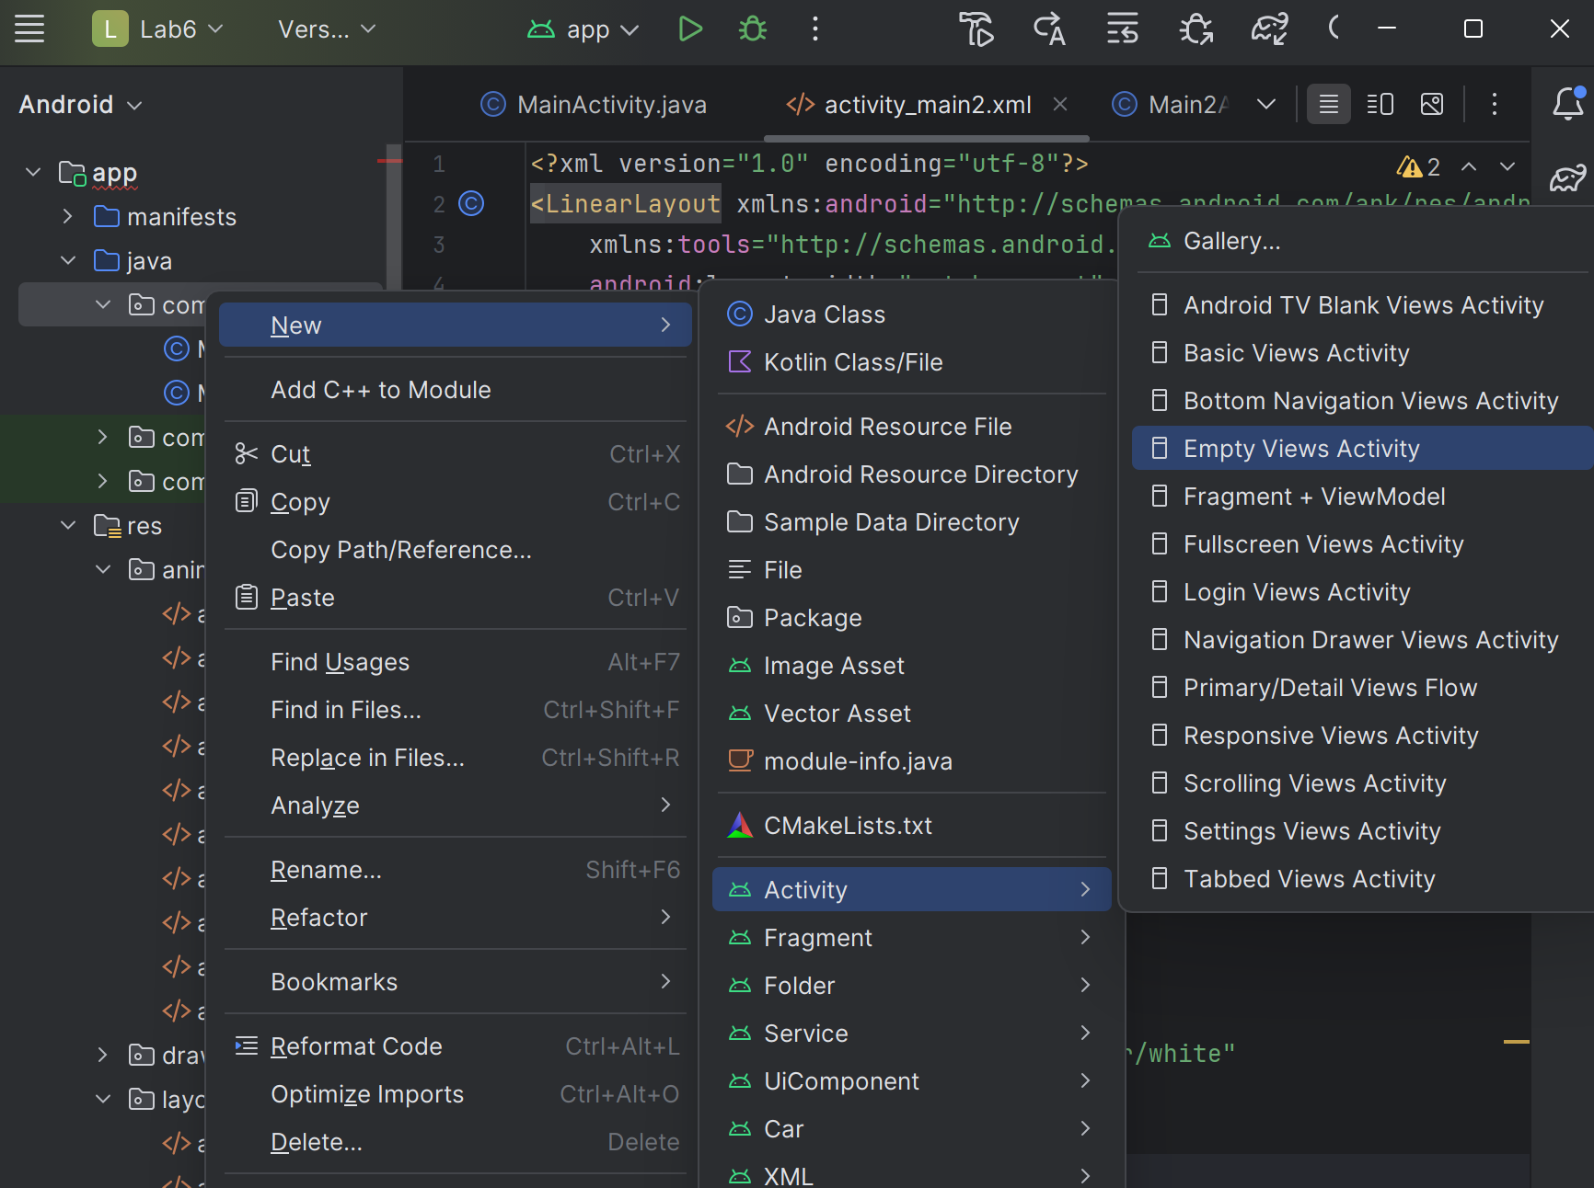

**Bước 2:** Ở **layout** tạo **activity_main2.xml**

**\* Viết code sau**

<?xml version="1.0" encoding="utf-8"?>  
<LinearLayout xmlns:android="http://schemas.android.com/apk/res/android"  
 xmlns:tools="http://schemas.android.com/tools"  
 android:layout_width="match_parent"  
 android:layout_height="match_parent"  
 android:background="#FF1493"  
 android:orientation="vertical"  
 android:padding="16dp"  
 tools:context=".Main2Activity">  
  
 <Button  
 android:id="@+id/btn_back"  
 android:layout_width="wrap_content"  
 android:layout_height="wrap_content"  
 android:text="BACK" />  
  
 <TextView  
 android:layout_width="wrap_content"  
 android:layout_height="wrap_content"  
 android:layout_gravity="center"  
 android:layout_marginTop="50dp"  
 android:text="New Activity"  
 android:textColor="@android:color/white"  
 android:textSize="24sp" />  
  
</LinearLayout>

**Bước 3:** Trong **anim** tạo file **slide_in_right.xml, slide_out_left.xml, slide_in_left.xml**

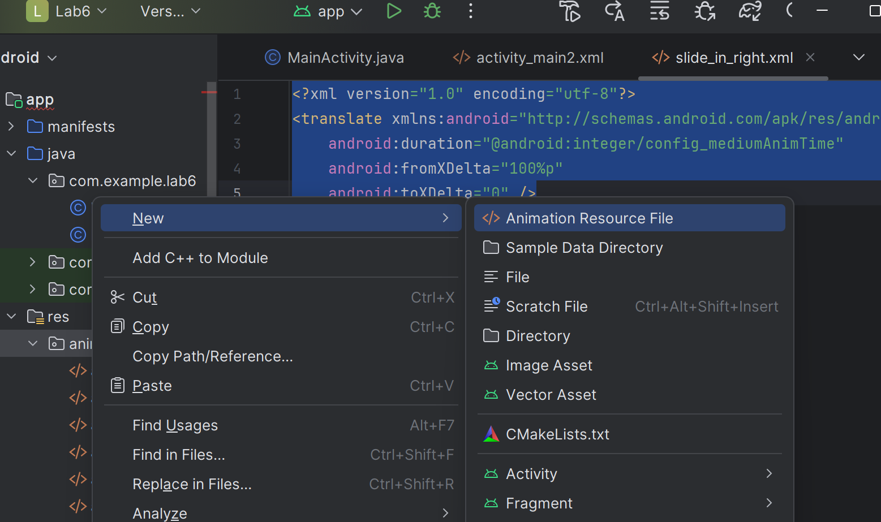

**\*** viết code **slide_in_right.xml** như sau

<?xml version="1.0" encoding="utf-8"?>  
<translate xmlns:android="http://schemas.android.com/apk/res/android"  
 android:duration="@android:integer/config_mediumAnimTime"  
 android:fromXDelta="100%p"  
 android:toXDelta="0" />

**\*** viết code **slide_out_left.xml**

<?xml version="1.0" encoding="utf-8"?>  
<translate xmlns:android="http://schemas.android.com/apk/res/android"  
 android:duration="@android:integer/config_mediumAnimTime"  
 android:fromXDelta="0"  
 android:toXDelta="-100%p" />

**\*** viết code **slide_in_left.xml**

<?xml version="1.0" encoding="utf-8"?>  
<translate xmlns:android="http://schemas.android.com/apk/res/android"  
 android:duration="@android:integer/config_mediumAnimTime"  
 android:fromXDelta="-100%p"  
 android:toXDelta="0" />

**\*** viết code **slide_out_right.xml**

<?xml version="1.0" encoding="utf-8"?>  
<translate xmlns:android="http://schemas.android.com/apk/res/android"  
 android:duration="@android:integer/config_mediumAnimTime"  
 android:fromXDelta="0"  
 android:toXDelta="100%p" />

**Bước 4: Trong Main2Activity.java**

**\*** viết code sau

package com.example.lab6;  
  
import androidx.appcompat.app.AppCompatActivity;  
import android.os.Bundle;  
import android.view.View;  
import android.widget.Button;  
  
public class Main2Activity extends AppCompatActivity {  
  
 @Override  
 protected void onCreate(Bundle savedInstanceState) {  
 super.onCreate(savedInstanceState);  
 setContentView(R.layout.*activity_main2*);  
  
 Button btnBack = findViewById(R.id.*btn_back*);  
 btnBack.setOnClickListener(new View.OnClickListener() {  
 @Override  
 public void onClick(View v) {  
 // Kết thúc activity hiện tại và quay về  
 finish();  
 overridePendingTransition(R.anim.*slide_in_left*, R.anim.*slide_out_right*);  
 }  
 });  
 }  
  
 @Override  
 public void finish() {  
 super.finish();  
 overridePendingTransition(R.anim.*slide_in_left*, R.anim.*slide_out_right*);  
 }  
}

**Bước 5:** Cập nhật **MainActivity.java**

**-** Thêm sự kiện **onClick** cho **ivUitLogo** trong hàm **onCreate()**

**\*** viết code sau

ivUitLogo.setOnClickListener(new View.OnClickListener() {  
 @Override  
 public void onClick(View v) {  
 Intent intent = new Intent(MainActivity.this, Main2Activity.class);  
 startActivity(intent);  
 overridePendingTransition(R.anim.*slide_in_right*, R.anim.*slide_out_left*);  
 }  
});

**BÀI TẬP 4:** Sử dụng **ViewPager2**

**Bước 1:** Trong **build.gradle(Module:app)**

**-** Đảm bảo bạn có **dependency** này:

*implementation*("androidx.viewpager2:viewpager2:1.0.0")

**Bước 2:** Ở **layout** tạo file **fragment_employee.xml**

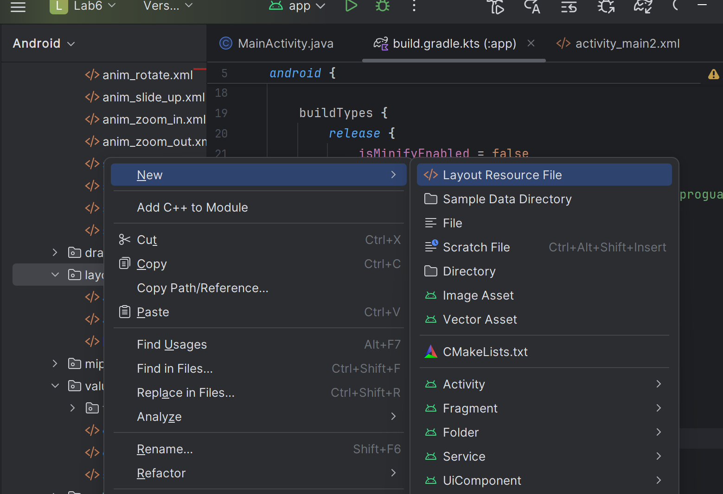

**\*** viết code sau

<?xml version="1.0" encoding="utf-8"?>  
<LinearLayout xmlns:android="http://schemas.android.com/apk/res/android"  
 android:layout_width="match_parent"  
 android:layout_height="match_parent"  
 android:background="#E6E6FA"  
 android:gravity="center"  
 android:orientation="vertical"  
 android:padding="16dp">  
  
 <TextView  
 android:id="@+id/tv_name"  
 android:layout_width="match_parent"  
 android:layout_height="wrap_content"  
 android:background="#C8E6C9"  
 android:padding="8dp"  
 android:text="Employee Name"  
 android:textSize="20sp"  
 android:textStyle="bold" />  
  
 <TextView  
 android:id="@+id/tv_position"  
 android:layout_width="wrap_content"  
 android:layout_height="wrap_content"  
 android:layout_marginTop="16dp"  
 android:text="Position: "  
 android:textSize="16sp" />  
  
</LinearLayout>

**Bước 3:** Tạo file **EmployeeFragment.java, EmployeePagerAdapter.java**

**Ảnh có chứa văn bản, ảnh chụp màn hình, phần mềm, Phần mềm đa phương tiện

Nội dung do AI tạo ra có thể không chính xác.**

**\*** viết code **EmployeeFragment.java**

package com.example.lab6;  
  
import android.os.Bundle;  
import android.view.LayoutInflater;  
import android.view.View;  
import android.view.ViewGroup;  
import android.widget.TextView;  
  
import androidx.annotation.NonNull;  
import androidx.annotation.Nullable;  
import androidx.fragment.app.Fragment;  
  
*/**  
 * A simple {@link Fragment} subclass that displays information about an employee.  
 * Use the {@link EmployeeFragment#newInstance} factory method to  
 * create an instance of this fragment.  
 */*public class EmployeeFragment extends Fragment {  
  
 // Các hằng số để làm key khi truyền dữ liệu qua Bundle  
 // Using constants is a good practice to avoid typos  
 private static final String *ARG_NAME* = "employee_name";  
 private static final String *ARG_POSITION* = "employee_position";  
  
 // Biến để lưu trữ dữ liệu của nhân viên  
 private String employeeName;  
 private String employeePosition;  
  
 public EmployeeFragment() {  
 // Required empty public constructor  
 }  
  
 */**  
 * Factory method để tạo một instance mới của Fragment này với các tham số cụ thể.  
 * Đây là cách được khuyến nghị để truyền dữ liệu vào một Fragment.  
 *  
 * @param name Tên của nhân viên.  
 * @param position Chức vụ của nhân viên.  
 * @return Một instance mới của EmployeeFragment.  
 */* public static EmployeeFragment newInstance(String name, String position) {  
 EmployeeFragment fragment = new EmployeeFragment();  
 Bundle args = new Bundle();  
 args.putString(*ARG_NAME*, name);  
 args.putString(*ARG_POSITION*, position);  
 fragment.setArguments(args);  
 return fragment;  
 }  
  
 @Override  
 public void onCreate(Bundle savedInstanceState) {  
 super.onCreate(savedInstanceState);  
 if (getArguments() != null) {  
 // Lấy dữ liệu từ Bundle khi Fragment được tạo  
 employeeName = getArguments().getString(*ARG_NAME*);  
 employeePosition = getArguments().getString(*ARG_POSITION*);  
 }  
 }  
  
 @Override  
 public View onCreateView(LayoutInflater inflater, ViewGroup container,  
 Bundle savedInstanceState) {  
 // Inflate (tạo) layout XML cho Fragment này  
 return inflater.inflate(R.layout.*fragment_employee*, container, false);  
 }  
  
 @Override  
 public void onViewCreated(@NonNull View view, @Nullable Bundle savedInstanceState) {  
 super.onViewCreated(view, savedInstanceState);  
  
 // Phương thức này được gọi ngay sau khi onCreateView() hoàn tất.  
 // Đây là nơi an toàn để thao tác với các View của Fragment.  
  
 // Ánh xạ các TextView từ layout  
 TextView tvName = view.findViewById(R.id.*tv_name*);  
 TextView tvPosition = view.findViewById(R.id.*tv_position*);  
  
 // Gán dữ liệu đã nhận được lên các TextView  
 if (employeeName != null) {  
 tvName.setText(employeeName);  
 }  
 if (employeePosition != null) {  
 // Thêm tiền tố "Position: " để giao diện rõ ràng hơn  
 tvPosition.setText("Position: " + employeePosition);  
 }  
 }  
}

**\*** viết code **EmployeePagerAdapter.java**

package com.example.lab6;  
  
import androidx.annotation.NonNull;  
import androidx.fragment.app.Fragment;  
import androidx.fragment.app.FragmentActivity;  
import androidx.viewpager2.adapter.FragmentStateAdapter;  
  
*/**  
 * Một FragmentStateAdapter đơn giản để cung cấp dữ liệu (dưới dạng EmployeeFragment)  
 * cho một ViewPager2.  
 */*public class EmployeePagerAdapter extends FragmentStateAdapter {  
  
 */**  
 * Tổng số trang (Fragments) mà ViewPager sẽ hiển thị.  
 */* private static final int *NUM_PAGES* = 5;  
  
 */**  
 * Constructor cho PagerAdapter.  
 * @param fragmentActivity Activity chứa ViewPager2.  
 */* public EmployeePagerAdapter(@NonNull FragmentActivity fragmentActivity) {  
 super(fragmentActivity);  
 }  
  
 */**  
 * Được gọi bởi ViewPager2 để tạo một Fragment mới cho một vị trí cụ thể.  
 *  
 * @param position Vị trí (trang) của Fragment cần được tạo.  
 * @return Một instance mới của EmployeeFragment được cấu hình cho vị trí đó.  
 */* @NonNull  
 @Override  
 public Fragment createFragment(int position) {  
 // Sử dụng một câu lệnh switch để cung cấp dữ liệu khác nhau cho mỗi trang.  
 // Mỗi case sẽ tạo một EmployeeFragment mới với tên và chức vụ riêng.  
 switch (position) {  
 case 0:  
 return EmployeeFragment.*newInstance*("Elizabeth Johnson", "Project Manager");  
 case 1:  
 return EmployeeFragment.*newInstance*("Catherine Williams", "President of Sales");  
 case 2:  
 return EmployeeFragment.*newInstance*("John Smith", "Lead Developer");  
 case 3:  
 return EmployeeFragment.*newInstance*("Anna Brown", "UX/UI Designer");  
 case 4:  
 return EmployeeFragment.*newInstance*("David Jones", "QA Engineer");  
 default:  
 // Trường hợp mặc định để tránh lỗi, mặc dù không bao giờ nên xảy ra  
 // nếu getItemCount() được triển khai đúng.  
 return EmployeeFragment.*newInstance*("Default Employee", "Default Position");  
 }  
 }  
  
 */**  
 * Trả về tổng số mục (trang) mà adapter sẽ quản lý.  
 *  
 * @return Tổng số trang.  
 */* @Override  
 public int getItemCount() {  
 return *NUM_PAGES*;  
 }  
}

**Bước 4:** Ở **layout** tạofile **activity_view_pager.xml**

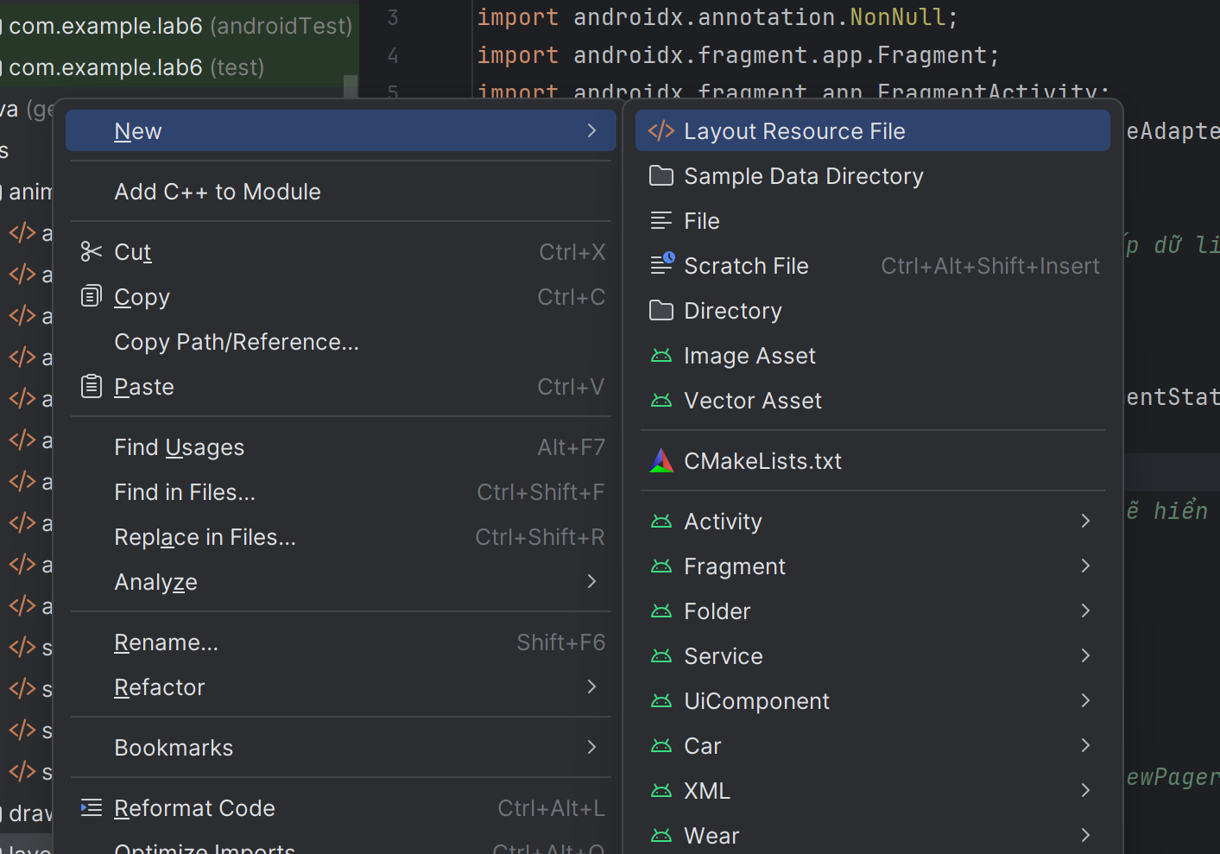

**\*** viết code sau

<?xml version="1.0" encoding="utf-8"?>  
<androidx.viewpager2.widget.ViewPager2  
 xmlns:android="http://schemas.android.com/apk/res/android"  
 android:id="@+id/view_pager"  
 android:layout_width="match_parent"  
 android:layout_height="match_parent" />

**Ảnh có chứa văn bản, ảnh chụp màn hình, phần mềm, Trang web

Nội dung do AI tạo ra có thể không chính xác.**

**Ảnh có chứa văn bản, ảnh chụp màn hình, phần mềm, máy tính

Nội dung do AI tạo ra có thể không chính xác.**