**Giao diện 1:**

Bước 1: Kéo Text View để ghi họ tên và mã sinh viên

|  |  |
| --- | --- |
| Hình 1: Kéo TextView | Hình 2: Căn chỉ bố cục |
| Hình 3: Điền tên | Hình 4: Điền mã sinh viên |
| Hình 5: Keo LinearLayout làm nền phía trên | Hình 6: Chọn màu nền |
| Hình : Tạo nút bấm “OK”, “CANCEL”, “FORGOT PASSWORD” |  |
| Code:  *<?*xml version="1.0" encoding="utf-8"*?>* <androidx.constraintlayout.motion.widget.MotionLayout xmlns:android="http://schemas.android.com/apk/res/android"  xmlns:app="http://schemas.android.com/apk/res-auto"  xmlns:tools="http-0//schemas.android.com/tools"  xmlns:tools2="http://schemas.android.com/tools"  android:id="@+id/main"  android:layout_width="match_parent"  android:layout_height="match_parent"  app:layoutDescription="@xml/activity_main_scene"  tools2:ignore="NamespaceTypo"  tools:context=".MainActivity">    <TextView  android:id="@+id/login_title"  android:layout_width="wrap_content"  android:layout_height="wrap_content"  android:layout_marginStart="205dp"  android:layout_marginTop="16dp"  android:layout_marginEnd="137dp"  android:text="LOGIN"  android:textSize="24sp"  android:textStyle="bold"  app:layout_constraintEnd_toEndOf="parent"  app:layout_constraintStart_toStartOf="parent"  app:layout_constraintTop_toBottomOf="@+id/linearLayout3"  tools2:ignore="HardcodedText" />   <EditText  android:id="@+id/username_input"  android:layout_width="250dp"  android:layout_height="47dp"  android:layout_marginTop="10dp"  android:layout_marginEnd="48dp"  android:hint="Enter id"  android:inputType="text"  app:layout_constraintEnd_toEndOf="parent"  app:layout_constraintTop_toBottomOf="@+id/login_title"  tools2:ignore="Autofill,HardcodedText" />   <EditText  android:id="@+id/password_input"  android:layout_width="249dp"  android:layout_height="50dp"  android:layout_marginTop="27dp"  android:layout_marginEnd="49dp"  android:hint="Enter password"  android:inputType="textPassword"  app:layout_constraintEnd_toEndOf="parent"  app:layout_constraintTop_toBottomOf="@+id/username_input"  tools2:ignore="HardcodedText,MissingConstraints" />   <LinearLayout  android:id="@+id/linearLayout2"  android:layout_width="wrap_content"  android:layout_height="wrap_content"  android:layout_marginStart="4dp"  android:layout_marginBottom="546dp"  android:orientation="horizontal"  app:layout_constraintBottom_toBottomOf="parent"  app:layout_constraintStart_toStartOf="parent">  </LinearLayout>   <TextView  android:id="@+id/textView2"  android:layout_width="wrap_content"  android:layout_height="wrap_content"  android:layout_marginStart="35dp"  android:layout_marginTop="68dp"  android:text="Username"  app:layout_constraintStart_toStartOf="parent"  app:layout_constraintTop_toBottomOf="@+id/linearLayout3"  tools2:ignore="HardcodedText" />   <Button  android:id="@+id/forgot_password_button"  android:layout_width="wrap_content"  android:layout_height="wrap_content"  android:layout_marginStart="24dp"  android:layout_marginBottom="340dp"  android:text="FORGOT PASSWORD"  app:layout_constraintBottom_toBottomOf="parent"  app:layout_constraintStart_toEndOf="@+id/cancel_button"  tools2:ignore="HardcodedText" />   <Button  android:id="@+id/cancel_button"  android:layout_width="wrap_content"  android:layout_height="wrap_content"  android:layout_marginStart="16dp"  android:layout_marginBottom="340dp"  android:text="CANCEL"  app:layout_constraintBottom_toBottomOf="parent"  app:layout_constraintStart_toEndOf="@+id/ok_button"  tools2:ignore="HardcodedText" />   <Button  android:id="@+id/ok_button"  android:layout_width="wrap_content"  android:layout_height="wrap_content"  android:layout_marginStart="4dp"  android:layout_marginBottom="340dp"  android:text="OK"  app:layout_constraintBottom_toBottomOf="parent"  app:layout_constraintStart_toStartOf="parent"  tools2:ignore="HardcodedText" />   <TextView  android:id="@+id/textView6"  android:layout_width="72dp"  android:layout_height="25dp"  android:layout_marginStart="27dp"  android:layout_marginTop="59dp"  android:text="Password"  app:layout_constraintStart_toStartOf="parent"  app:layout_constraintTop_toBottomOf="@+id/textView2"  tools2:ignore="HardcodedText,MissingConstraints" />   <LinearLayout  android:id="@+id/linearLayout3"  android:layout_width="900dp"  android:layout_height="87dp"  android:background="#FF9800"  android:orientation="vertical"  tools2:ignore="MissingConstraints"  tools2:layout_editor_absoluteX="0dp"  tools2:layout_editor_absoluteY="2dp">   <TextView  android:id="@+id/textView8"  android:layout_width="match_parent"  android:layout_height="wrap_content"  android:text="1150070037"  tools2:ignore="HardcodedText,MissingConstraints" />  </LinearLayout>   <TextView  android:id="@+id/textView7"  android:layout_width="match_parent"  android:layout_height="wrap_content"  android:layout_marginTop="32dp"  android:text="Trần Mỹ Quyên"  app:layout_constraintTop_toTopOf="parent"  tools2:layout_editor_absoluteX="-33dp"  tools2:ignore="HardcodedText" />  </androidx.constraintlayout.motion.widget.MotionLayout> | |
| Hình 8: Giao diện sau khi hoàn thành | |

**Giao diện 2**

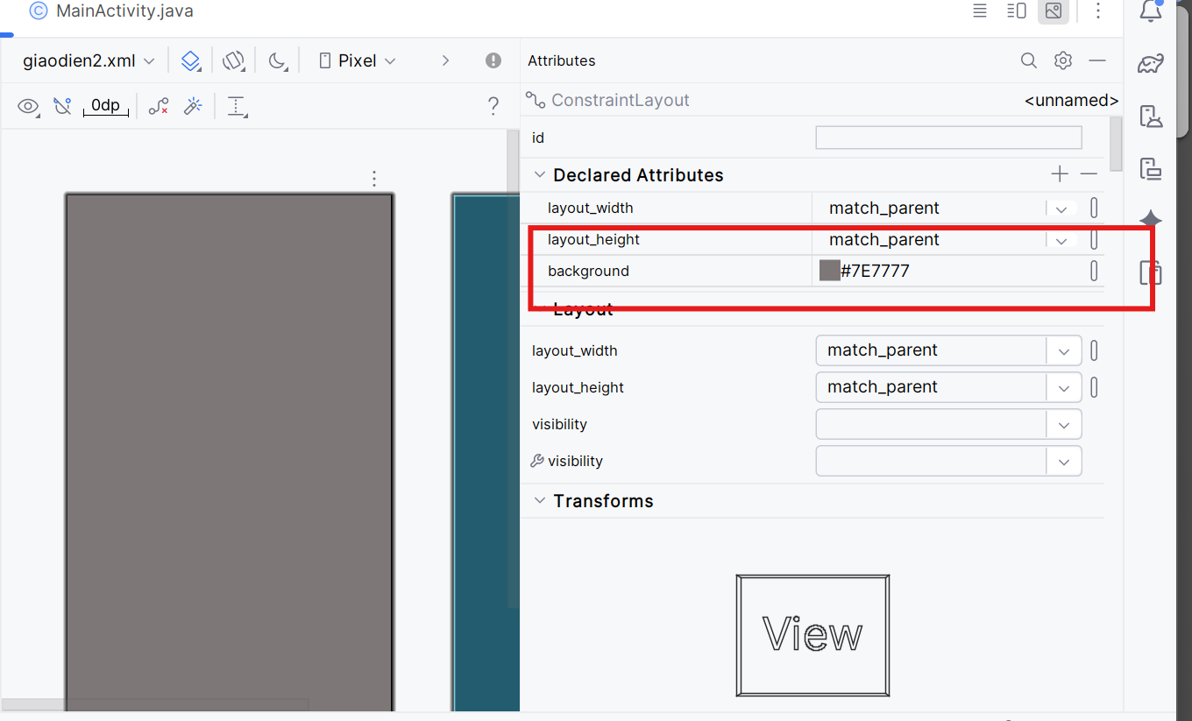

Hình 9: Tạo màu backgroud

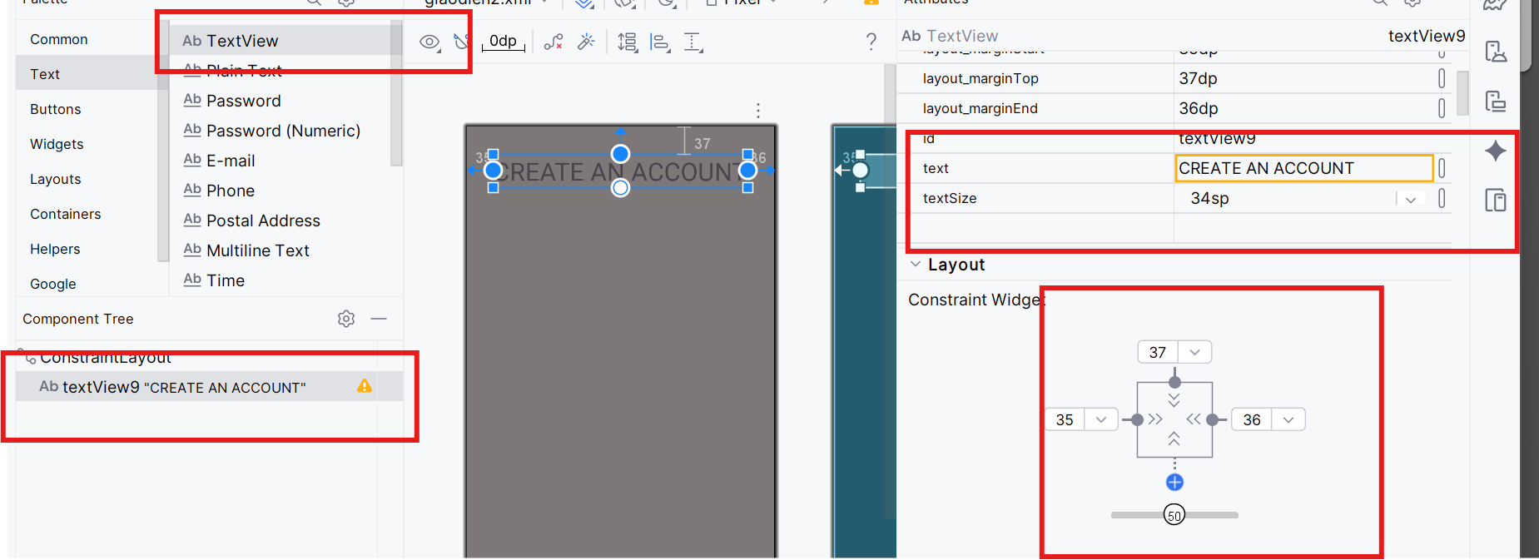

Hình 10: Keo TextView ghi tiêu đề “Create an account” tăng size chữ và cố định bố cục

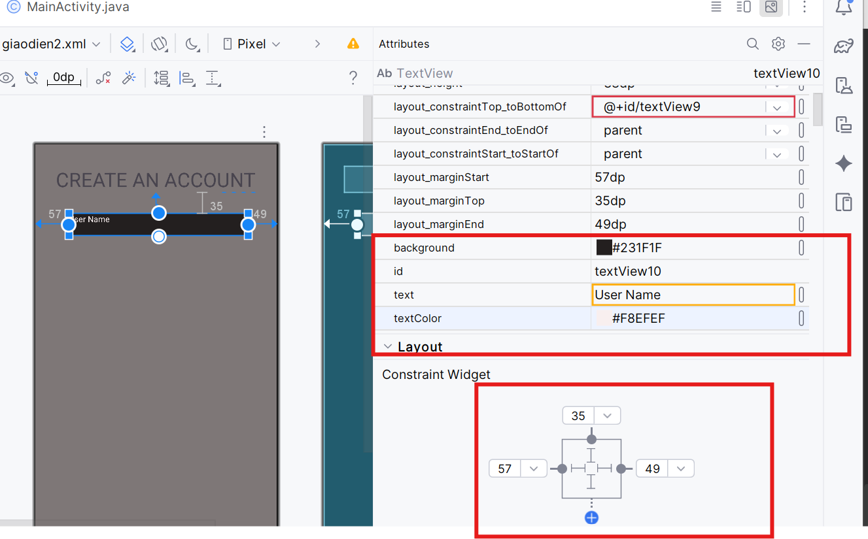

Hình 11: Tạo ô nhập UserName

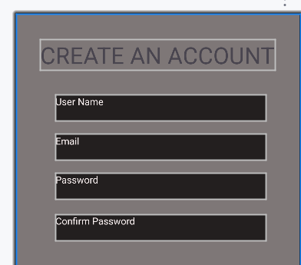

Hình 12 Tạo tương tự cho các ô còn lại như Username

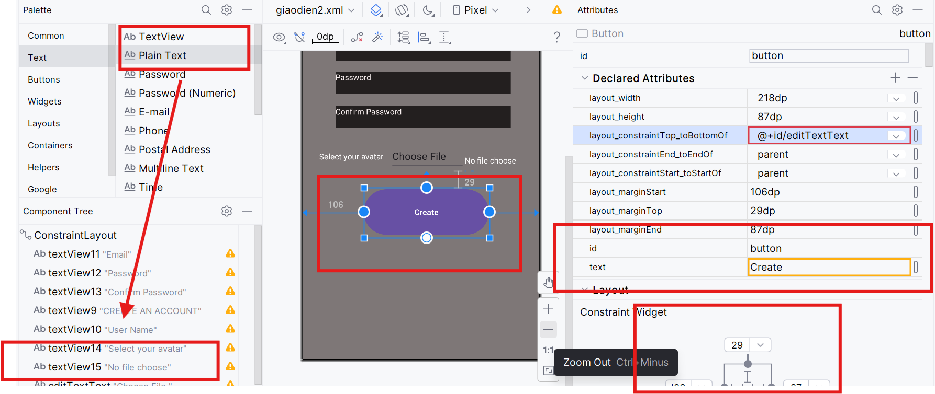

Hình 13: Tạo các thành phần còn lại

Code:

|  |
| --- |
| *<?*xml version="1.0" encoding="utf-8"*?>* <androidx.constraintlayout.widget.ConstraintLayout xmlns:android="http://schemas.android.com/apk/res/android"  xmlns:app="http://schemas.android.com/apk/res-auto"  xmlns:tools="http://schemas.android.com/tools"  android:layout_width="match_parent"  android:layout_height="match_parent"  android:background="#7E7777">   <TextView  android:id="@+id/textView11"  android:layout_width="305dp"  android:layout_height="38dp"  android:layout_marginStart="57dp"  android:layout_marginTop="92dp"  android:layout_marginEnd="49dp"  android:background="#231F1F"  android:text="Email"  android:textColor="#F8EFEF"  app:layout_constraintEnd_toEndOf="parent"  app:layout_constraintHorizontal_bias="0.0"  app:layout_constraintStart_toStartOf="parent"  app:layout_constraintTop_toBottomOf="@+id/textView9"  tools:ignore="HardcodedText" />   <TextView  android:id="@+id/textView12"  android:layout_width="305dp"  android:layout_height="38dp"  android:layout_marginStart="57dp"  android:layout_marginTop="148dp"  android:layout_marginEnd="49dp"  android:background="#231F1F"  android:text="Password"  android:textColor="#F8EFEF"  app:layout_constraintEnd_toEndOf="parent"  app:layout_constraintHorizontal_bias="0.0"  app:layout_constraintStart_toStartOf="parent"  app:layout_constraintTop_toBottomOf="@+id/textView9"  tools:ignore="HardcodedText" />   <TextView  android:id="@+id/textView13"  android:layout_width="305dp"  android:layout_height="38dp"  android:layout_marginStart="57dp"  android:layout_marginTop="208dp"  android:layout_marginEnd="49dp"  android:background="#231F1F"  android:text="Confirm Password"  android:textColor="#F8EFEF"  app:layout_constraintEnd_toEndOf="parent"  app:layout_constraintHorizontal_bias="0.0"  app:layout_constraintStart_toStartOf="parent"  app:layout_constraintTop_toBottomOf="@+id/textView9"  tools:ignore="HardcodedText" />   <TextView  android:id="@+id/textView9"  android:layout_width="wrap_content"  android:layout_height="wrap_content"  android:layout_marginStart="35dp"  android:layout_marginTop="37dp"  android:layout_marginEnd="36dp"  android:text="CREATE AN ACCOUNT"  android:textSize="34sp"  app:layout_constraintEnd_toEndOf="parent"  app:layout_constraintStart_toStartOf="parent"  app:layout_constraintTop_toTopOf="parent"  tools:ignore="HardcodedText" />   <TextView  android:id="@+id/textView10"  android:layout_width="305dp"  android:layout_height="38dp"  android:layout_marginStart="57dp"  android:layout_marginTop="35dp"  android:layout_marginEnd="49dp"  android:background="#231F1F"  android:text="User Name"  android:textColor="#F8EFEF"  app:layout_constraintEnd_toEndOf="parent"  app:layout_constraintStart_toStartOf="parent"  app:layout_constraintTop_toBottomOf="@+id/textView9"  tools:ignore="HardcodedText" />   <TextView  android:id="@+id/textView14"  android:layout_width="wrap_content"  android:layout_height="wrap_content"  android:layout_marginStart="29dp"  android:layout_marginTop="40dp"  android:text="Select your avatar"  app:layout_constraintStart_toStartOf="parent"  app:layout_constraintTop_toBottomOf="@+id/textView13"  tools:textColor="#FDFCFC"  tools:ignore="HardcodedText" />   <TextView  android:id="@+id/textView15"  android:layout_width="wrap_content"  android:layout_height="wrap_content"  android:layout_marginTop="47dp"  android:text="No file choose"  app:layout_constraintStart_toEndOf="@+id/editTextText"  app:layout_constraintTop_toBottomOf="@+id/textView13"  tools:textColor="#FDFCFC"  tools:ignore="HardcodedText" />   <EditText  android:id="@+id/editTextText"  android:layout_width="130dp"  android:layout_height="49dp"  android:layout_marginStart="11dp"  android:layout_marginTop="25dp"  android:ems="10"  android:inputType="text"  android:text="Choose File "  app:layout_constraintStart_toEndOf="@+id/textView14"  app:layout_constraintTop_toBottomOf="@+id/textView13"  tools:ignore="HardcodedText" />   <Button  android:id="@+id/button"  android:layout_width="218dp"  android:layout_height="87dp"  android:layout_marginStart="106dp"  android:layout_marginTop="29dp"  android:layout_marginEnd="87dp"  android:text="Create"  app:layout_constraintEnd_toEndOf="parent"  app:layout_constraintStart_toStartOf="parent"  app:layout_constraintTop_toBottomOf="@+id/editTextText"  tools:ignore="HardcodedText" />  </androidx.constraintlayout.widget.ConstraintLayout> |

Kết quả:

