**Using PSHELL to Represent Laminates/Structures With Known A,B,D**

Brian Esp and Victor Kemp

2025-08-27

**Objective**

For this discussion, we will discuss how to use the PSHELL card to represent laminates/structures with a known [A], [B], [D]. This may be the case for composite laminates or isotropic panels/plates that are “built up”.

This document was developed to support the MYSTRAN open-source finite element solver.

**Use Cases**

Let us first acknowledge that many times a layup/structure maybe be defined outside of the FEM. By doing so, the ABD values are available (membrane, membrane-bending coupling, bending). The first question to ask is why would we want to use a PSHELL (as opposed to PCOMP). Some scenarios:

* Layups with many plies. Structures with multiple materials (sandwiches, hybrids, unidirectional/fabric). If a PCOMP is used, these may be time consuming and error prone to input to the preprocessor. This is also more challenging to check.
* Skin-stiffened composite panels. Rather than use PCOMP, a PSHELL with effective properties may be more appropriate. This is also an effective strategy for isotropic materials.

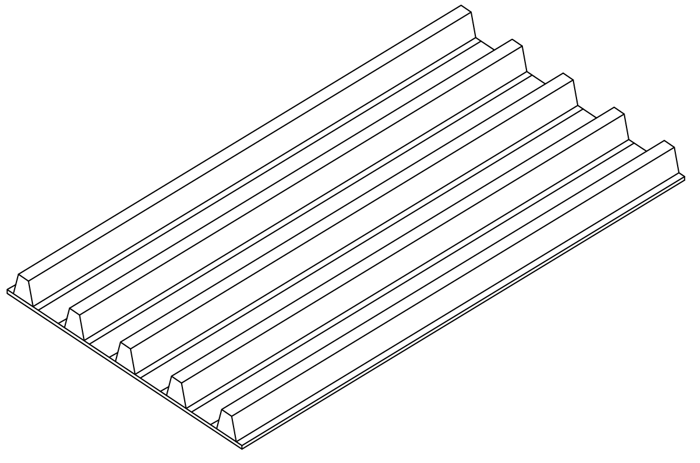

* Sometimes the analysis objective is related to just in-plane or out-of-plane stiffness. In these cases, it is easier to focus on just A11, A22, A66 or D11, D22, D66 and ensure those values are input correctly. This is faster, carries less risk, and is easier to check.
* Some approaches to failure analysis for composites are based on the remote/overall strains/stress in a laminate1 (as opposed to the ply strains/stresses). This is especially true for notched laminates and laminates with impact damage. In such cases, it may be more convenient to use a PSHELL.
* There may be a desire to understand the influence of a given component of the ABD matrices (for example, D11 or D22 or D66 in buckling).
* Unsymmetric Buckling: The “reduced bending stiffness matrix”, D*, can be substituted for D. Although approximate2, this is a relatively accurate solution. D*=D-BA-1B.

**Notes and Warnings**

MYSTRAN does not support PSHELL and MID4. However, the presented approaches are still valid for symmetric laminates, or any case where [B]=0. For SOL 105, an unsymmetric laminate may be considered via the use of the “reduced bending stiffness matrix”, as described above.

MSC supports PSHELL and MID4 for SOL 101. However, for SOL 105, the differential stiffness matrix does not use MID4 (although the static solution, necessary for input the SOL 105 Eigen solution, may use MID4 – TBD). For SOL 105, an unsymmetric laminate may be considered via the use of the “reduced bending stiffness matrix”, as described above.

**Option 1**

For a given laminate, use the actual thickness, t_total, of the laminate (or any desired thickness).

**Advantages:**

The laminate thickness is representative of the actual laminate. Therefore, the stress/strain is appropriate. Also, when using a pre/post and expanding the shell to show thickness, the thickness of the element is appropriate.

**Disadvantages:**

The ABD are not directly entered. They have to go through a conversion, which is less convenient and not easily recognized by checkers.

**Process:**

A reference unsymmetric laminate has the following ABD (details for the laminate provided at the end of this document).

[A], [B], [D] =

|  |  |  |  |  |  |
| --- | --- | --- | --- | --- | --- |
| 615,546 | 128,259 | 106,325 | -2,092 | 355 | 372 |
| 128,259 | 473,779 | 106,325 | 355 | 1,382 | 372 |
| 106,325 | 106,325 | 140,601 | 372 | 372 | 355 |
| -2,092 | 355 | 372 | 159.4 | 38.5 | 33.0 |
| 355 | 1,382 | 372 | 38.5 | 115.4 | 33.0 |
| 372 | 372 | 355 | 33.0 | 33.0 | 41.7 |

A PSHELL card is used, as follows, which calls 3 material cards (MID1, MID2, MID4). *Note that 1.0 is entered for field 6 for Option 1, but is 12.0 for Option 2.*

PSHELL Card:

|  |  |  |  |  |  |  |  |  |  |
| --- | --- | --- | --- | --- | --- | --- | --- | --- | --- |
| 1 | 2 | 3 | 4 | 5 | 6 | 7 | 8 | 9 | 10 |
| PSHELL | PID | MID1 | T | MID2 | 12I/T**3 | MID3 | TS/T | NSM |  |
|  | Z1 | Z2 | MID4 |  |  |  |  |  |  |

|  |  |  |  |  |  |  |  |  |  |
| --- | --- | --- | --- | --- | --- | --- | --- | --- | --- |
| 1 | 2 | 3 | 4 | 5 | 6 | 7 | 8 | 9 | 10 |
| PSHELL | 1 | 101 | 0.056 | 102 | 1.0 | 103 | TS/T | NSM |  |
|  | 0.028 | -.028 | 104 |  |  |  |  |  |  |

Next, consider the MAT2 card

MAT2 Card:

|  |  |  |  |  |  |  |  |  |  |
| --- | --- | --- | --- | --- | --- | --- | --- | --- | --- |
| 1 | 2 | 3 | 4 | 5 | 6 | 7 | 8 | 9 | 10 |
| MAT2 | MID | G11 | G12 | G13 | G22 | G23 | G33 | RHO |  |

And the stress-strain relationship is:

|  |  |  |
| --- | --- | --- |
| G11 | G12 | G13 |
| G12 | G22 | G23 |
| G13 | G23 | G33 |

For Option 1, we can not directly enter the ABD as inputs into for MID1, MID2, MID4. Instead, a conversion must take place, using the following equations3. These equations were validated with MSC Nastran and ComLab (Nastran-95 foundation).

|  |
| --- |
| [MID1] = $\frac{1}{t}$ [A] |
| [MID2] = $\frac{12}{t^{3}}$ [D] |
| [MID4] = − $\frac{1}{t^{2}}$ [B] |

After applying the above formulas, we have:

|  |  |  |  |  |  |
| --- | --- | --- | --- | --- | --- |
| 1.10E+07 | 2.29E+06 | 1.90E+06 | 6.67E+05 | -1.13E+05 | -1.19E+05 |
| 2.29E+06 | 8.46E+06 | 1.90E+06 | -1.13E+05 | -4.41E+05 | -1.19E+05 |
| 1.90E+06 | 1.90E+06 | 2.51E+06 | -1.19E+05 | -1.19E+05 | -1.13E+05 |
| 6.67E+05 | -1.13E+05 | -1.19E+05 | 1.09E+07 | 2.63E+06 | 2.25E+06 |
| -1.13E+05 | -4.41E+05 | -1.19E+05 | 2.63E+06 | 7.88E+06 | 2.25E+06 |
| -1.19E+05 | -1.19E+05 | -1.13E+05 | 2.25E+06 | 2.25E+06 | 2.85E+06 |

And the MAT2 cards are as follows:

|  |  |  |  |  |  |  |  |  |  |
| --- | --- | --- | --- | --- | --- | --- | --- | --- | --- |
| 1 | 2 | 3 | 4 | 5 | 6 | 7 | 8 | 9 | 10 |
| MAT2 | 101 | 1.10E7 | 2.29E6 | 1.90E6 | 8.46E6 | 1.90E6 | 2.51E6 |  |  |

|  |  |  |  |  |  |  |  |  |  |
| --- | --- | --- | --- | --- | --- | --- | --- | --- | --- |
| 1 | 2 | 3 | 4 | 5 | 6 | 7 | 8 | 9 | 10 |
| MAT2 | 102 | 1.09E7 | 2.63E6 | 2.25E6 | 7.88E6 | 2.25E6 | 2.85E6 |  |  |

|  |  |  |  |  |  |  |  |  |  |
| --- | --- | --- | --- | --- | --- | --- | --- | --- | --- |
| 1 | 2 | 3 | 4 | 5 | 6 | 7 | 8 | 9 | 10 |
| MAT2 | 104 | 6.67E5 | -1.13E5 | -1.19E5 | -4.41E5 | -1.19E5 | -1.13E5 |  |  |

The four necessary cards (shown previously) have a green header row.

**Option 2**

In this case, we will set T=1.0 in the PSHELL card, regardless of what the actual thickness is. The major advantage is the ABD values can be directly substituted into the MID1, MID2, MID4 cards (with a notable exception for the B matrix, as discussed below). This approach may be more appropriate when only the elastic response is desired (the stress/strain outputs may not be directly applicable. However, the running loads/moments are still expected to be applicable (further investigation TBD).

As shown in Option 1, the following equations are relevant3. These equations were validated with MSC Nastran and ComLab (Nastran-95 foundation). For T=1.0, we have:

|  |
| --- |
| [MID1] = $\frac{1}{t}$ [A] = [A] |
| [MID2] = $\frac{12}{t^{3}}$ [D] = 12.0*[D] |
| [MID4] = − $\frac{1}{t^{2}}$ [B] = −[B] |

*The factor of 12.0 for [MID2] can be directly addressed via the PSHELL entry in Field 6, but the sign for [B] must be reversed (discussed further later).*

**Advantages:**

This input is easily recognized and checked. Also, the values can be directly controlled for trade studies or to understand the influence changes have.

**Disadvantages:**

Setting T=1.0 presents two problems. The first is that the strain/stress output may not useful in a direct manner. A conversion may need to take place (further investigation TBD).

The second is that when using a pre/post processor, and expanding the shells in 3D, a thickness of 1.0 may not be representative (and hence potentially confusing).

**Process:**

A reference unsymmetric laminate has the following ABD (details for the laminate provided at the end of this document).

[A], [B], [D] =

|  |  |  |  |  |  |
| --- | --- | --- | --- | --- | --- |
| 615,546 | 128,259 | 106,325 | -2,092 | 355 | 372 |
| 128,259 | 473,779 | 106,325 | 355 | 1,382 | 372 |
| 106,325 | 106,325 | 140,601 | 372 | 372 | 355 |
| -2,092 | 355 | 372 | 159.4 | 38.5 | 33.0 |
| 355 | 1,382 | 372 | 38.5 | 115.4 | 33.0 |
| 372 | 372 | 355 | 33.0 | 33.0 | 41.7 |

A PSHELL card is used, as follows, which calls 3 material cards (MID1, MID2, MID4). *Note that 12.0 is entered for field 6 for Option 2, but is 1.0 for Option 1.* This is to address the MID2 conversion as shown in the previous equations.

PSHELL Card:

|  |  |  |  |  |  |  |  |  |  |
| --- | --- | --- | --- | --- | --- | --- | --- | --- | --- |
| 1 | 2 | 3 | 4 | 5 | 6 | 7 | 8 | 9 | 10 |
| PSHELL | PID | MID1 | T | MID2 | 12I/T**3 | MID3 | TS/T | NSM |  |
|  | Z1 | Z2 | MID4 |  |  |  |  |  |  |

|  |  |  |  |  |  |  |  |  |  |
| --- | --- | --- | --- | --- | --- | --- | --- | --- | --- |
| 1 | 2 | 3 | 4 | 5 | 6 | 7 | 8 | 9 | 10 |
| PSHELL | 1 | 101 | 1.0 | 102 | 12.0 | 103 | TS/T | NSM |  |
|  | 0.5 | -.05 | 104 |  |  |  |  |  |  |

Note that conversion formulas presented in Option 1 reduce to “nearly” ABD when T=1.0. *However, the sign for [B] must be reversed.*

The three MAT2 cards, which are [A], [D], −[B], are as follows:

|  |  |  |  |  |  |  |  |  |  |
| --- | --- | --- | --- | --- | --- | --- | --- | --- | --- |
| 1 | 2 | 3 | 4 | 5 | 6 | 7 | 8 | 9 | 10 |
| MAT2 | 101 | 615546.0 | 128259.0 | 106325.0 | 473779.0 | 106325.0 | 140601.0 |  |  |

|  |  |  |  |  |  |  |  |  |  |
| --- | --- | --- | --- | --- | --- | --- | --- | --- | --- |
| 1 | 2 | 3 | 4 | 5 | 6 | 7 | 8 | 9 | 10 |
| MAT2 | 102 | 159.4 | 38.5 | 33.0 | 115.4 | 33.0 | 41.7 |  |  |

|  |  |  |  |  |  |  |  |  |  |
| --- | --- | --- | --- | --- | --- | --- | --- | --- | --- |
| 1 | 2 | 3 | 4 | 5 | 6 | 7 | 8 | 9 | 10 |
| MAT2 | 104 | +2092.0 | -335.0 | +372.0 | -1382.0 | -372.0 | -355.0 |  |  |

The four necessary cards (shown previously) have a green header row.

**Buckling of Unsymmetric Laminates**

For the case of unsymmetric laminates, the buckling load will be reduced when compared to that of its [D] matrix. The “reduced bending stiffness” matrix, D*, may be substituted for [D] to obtain an approximate solution. This is approximate solution has been shown to be “relatively accurate” (within 1-5% of the actual capability), for “mildy” unsymmetric laminates. D*=D-BA-1B.

For the example laminate, provided later, we have the following:

[D]=

|  |  |  |
| --- | --- | --- |
| 159.4 | 38.5 | 33.0 |
| 38.5 | 115.4 | 33.0 |
| 33.0 | 33.0 | 41.7 |

[D*] = [D] – [B][A]-1[B] =

|  |  |  |
| --- | --- | --- |
| 147.7 | 37.0 | 32.4 |
| 37.0 | 111.3 | 31.8 |
| 32.4 | 31.8 | 40.8 |

For reference, the difference between the [D*] and [D], for the given laminate, is as follows:

[D*]/[D] =

|  |  |  |
| --- | --- | --- |
| 0.93 | 0.96 | 0.98 |
| 0.96 | 0.96 | 0.96 |
| 0.98 | 0.96 | 0.98 |

**PSHELL2**

The PSHELL2 is a potential addition to MYSTRAN. Internally, it would be equivalent to option 1. This would address the disadvantages of this Option 1. In addition, the card would consolidate everything and the ABD values would be directly input on a single card (no need for MID1, MID2, MID4 + PSHELL cards). This provides the best of both worlds and is easy for end-users and checkers. The downside is that is not compatible with Nastran and not compatible with any pre/post processors. We could add it to M3D and/or Mecway if we wanted, but it would likely be a niche card at its inception. The PSHELL2 may look something like the following:

|  |  |  |  |  |  |  |  |  |  |
| --- | --- | --- | --- | --- | --- | --- | --- | --- | --- |
| 1 | 2 | 3 | 4 | 5 | 6 | 7 | 8 | 9 | 10 |
| PSHELL2 | PID | T |  |  |  |  |  |  |  |
|  | A11 | A12 | A13 | A22 | A23 | A33 |  |  |  |
|  | D11 | D12 | D13 | D22 | D23 | D33 |  |  |  |
|  | B11 | B12 | B13 | B22 | B23 | B33 |  |  |  |
|  | Z1 | Z2 |  |  |  |  |  |  |  |

**Example Material and Unsymmetric Layup**

|  |  |  |
| --- | --- | --- |
| **Material** | **Layup** | t_total = 0.056 |
| E1 = 21.5 E+6 | 0/45/90/0/45/0/90/45 |  |
| E2 = 1.40 E+6 |  |  |
| v12 = 0.34 |  |  |
| G12 = 0.70 E+6 |  |  |
| t_ply = 0.007 |  |  |

[A]=

|  |  |  |
| --- | --- | --- |
| 615,546 | 128,259 | 106,325 |
| 128,259 | 473,779 | 106,325 |
| 106,325 | 106,325 | 140,601 |

[B]=

|  |  |  |
| --- | --- | --- |
| -2,092 | 355 | 372 |
| 355 | 1,382 | 372 |
| 372 | 372 | 355 |

[D]=

|  |  |  |
| --- | --- | --- |
| 159.4 | 38.5 | 33.0 |
| 38.5 | 115.4 | 33.0 |
| 33.0 | 33.0 | 41.7 |

[A], [B], [D] =

|  |  |  |  |  |  |
| --- | --- | --- | --- | --- | --- |
| 615,546 | 128,259 | 106,325 | -2,092 | 355 | 372 |
| 128,259 | 473,779 | 106,325 | 355 | 1,382 | 372 |
| 106,325 | 106,325 | 140,601 | 372 | 372 | 355 |
| -2,092 | 355 | 372 | 159.4 | 38.5 | 33.0 |
| 355 | 1,382 | 372 | 38.5 | 115.4 | 33.0 |
| 372 | 372 | 355 | 33.0 | 33.0 | 41.7 |

**References**

1. Esp, B., “Practical Analysis of Aircraft Composites”, Grand Oak Publishing, 2017.
2. Ashton, J.E., “Approximate Solutions for Unsymmetrically Laminated Plates”, General Dynamics Corporation, Fort Worth, Texas, October 28, 1968.
3. Asier Ruiz de Aguirre Malaxetxebarria, AERSYS Knowledge Unit, AERSYS-7001, “Transforming PCOMP to PSHELL”, 2011.