Appendix B: Equations for the reduction of the G-set to the A-set and solution for displacements and constraint forces

Introduction

As discussed in Section 3.6, MYSTRAN builds the original stiffness and mass matrices based on the G-set, which has 6 degrees of freedom per grid specified in the Bulk Data deck. The stiffness matrix is by definition singular as, at this point, there have been no constraints imposed. There are two type of constraints MYSTRAN allows; single point constraints and multi-point constraints as discussed earlier in this manual. In order to apply boundary conditions that restrain the model from rigid body motion, single point constraints must be used. Multi-point constraints (using rigid elements or Bulk Data MPC entries) are used to express some degrees of freedom (DOF’s) of the model as being rigidly restrained to some other DOF’s. Thus, MYSTRAN must reduce the G-set stiffness, mass, and loads to the independent A-set DOF’s

The discussion below shows the process that MYSTRAN uses to solve for the displacements and constraint forces by going through a systematic reduction of the G-set to the N-set then to the F-set and finally to the L-set which represent the independent DOF’s. These equations can then be solved for the L-set DOF’s. The other DOF displacements, as well as constraint forces, can then be recovered. Element forces and stresses are obtained from the displacements as discussed in Appendix C. The process in this appendix uses the displacement set notation developed in Section 3.6 which should be reviewed prior to this section. In general, the matrix notation used in this development is such that the matrix subscripts describe the matrix size. Thus, K_{GG} is a matrix which has G rows and columns, R_{CG} is a matrix that has C rows and G columns and R^{T}_{CG} is the transpose of R_{CG} and has G rows and C columns. If a matrix has only one column, it would exhibit only one subscript, as in Y_{S} which is an S x 1 matrix of single point constraint values

Reduction of the G-set to the N-set

In terms of this G-set, the equations of motion for the structure can be written as:

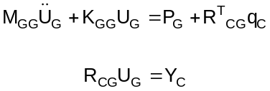

In the first of equations 8.1 M_{GG} is the G-set mass matrix, K_{GG} is the G-set stiffness matrix, U_{G} are the G-set displacements, P_{G} are the applied loads on the G-set DOF’s and q_{C} are the independent, generalized, constraint forces (due to single and multi-point constraints). The second of 8.1 expresses the constraints (both single and multi-point constraints) wherein C is the number of constraint equations, R_{CG} is a constraint coefficient matrix and Y_{C} is a vector of constraint values. For example, if all of the constraints were single point constraints, then all of the coefficients in any one row of R_{CG} would be zero except for one unity value. In addition, if all of these single point constraints were for DOF’s that are grounded, then all of the Y_{C} values would be zero and these single point constraints would all have the form of u_{i} = 0.

The unknowns in 8.1 are the U_{G} displacements and the q_{C} generalized constraint forces and there are G+C equations to solve for these unknowns. As will be explained later, direct solution of the q_{C} constraint forces will not be made.

The q_{C} generalized forces of constraint do not necessarily have any physical meaning. Rather, the G-set nodal forces of constraint are of interest and are expressed in terms of the q_{C} as:

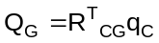

In order to reduce 8.1 the G-set is partitioned into the N and M-sets, where the M DOF’s are to be eliminated using the multi-point constraints (from rigid elements as well as MPC Bulk Data entries defined by the user in the input data deck). The U_{N} are the remainder of the DOF’s in the G-set. Thus, write U_{G} as:

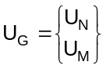

The number of constraints is C which is equal to M+S (where S is the number of DOF’s in the S set). Thus, partition q_{C} and Y_{C} as:

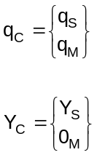

0_{M} is a column vector of M zeros. That is, only the S-set can have nonzero constraint values.

With the second of 8.4 in mind, partition the second of equations 8.1 using 8.3 as:

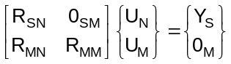

The 0_{SM} partition is an S x M matrix of zero’s. This is required by the form of the single point constraint equations which are all of the form u_{i} = Y_{i} where Y_{i} is a constant (zero or some enforced displacement value).

Using 8.3, partition the first of equations 8.1 as:

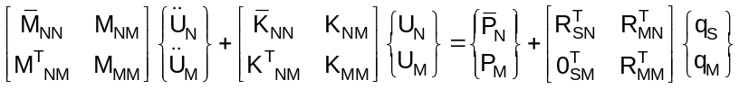

The bars over the N-set mass, stiffness and loads matrices are used for convenience to distinguish these terms from those that will result from the reduction of the G-set to the N-set. From the second of the constraint equations in 8.5 solve for U_{M} in terms of U_{N}:

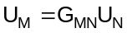

where

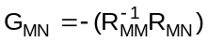

Using 8.7, equation 8.3 can be written as:

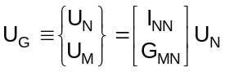

where I_{NN} is an identity matrix of size N.

Substitute 8.9 into 8.6 and premultiply the result by the transpose of the coefficient matrix in 8.9. The result can be written as:

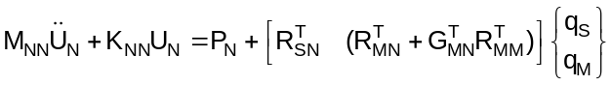

where:

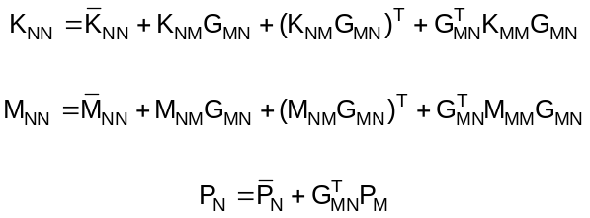

M_{NN} , K_{NN} and P_{N} are the reduced N-set mass stiffness and loads. Note that P_{N} is not the set of applied loads on the N-set if there are applied loads on the M-set as expressed by the second of equations 8.11 (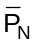 are the applied loads on the N set).

In addition, the second term in the square brackets in 8.10 is zero by the definition of G_{MN} in 8.8 so that 8.10 and 8.5 can be written as:

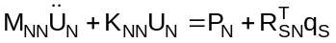

Reduction of the N-set to the F-set

The N-set can now be partitioned into the F and S-sets where the S DOF’s are to be eliminated using the single point constraints identified by the user in the input data deck. The F-set are the remainder of the DOF’s in the N-set and are known as the “free” DOF’s (i.e. those that have no constraints imposed on them). Thus, partition U_{N} into U_{F} and U_{S}:

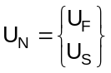

Rewrite equation 8.5 in terms of the F, S and M-sets with the restriction that the single point constraints are of the form u_{i} = Y_{i} where Y_{i} is a constant (zero or some enforced displacement value), using:

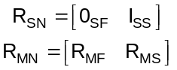

where O_{SF} is an S x F matrix of zeros and I_{SS} is an S size identity matrix. Equation 8.5 can be written as:

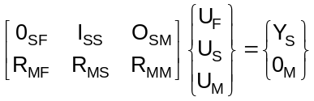

Substitute 8.13 and the first of 8.14 into 8.12 and partition the mass, stiffness and load matrices into the F and S-sets to get:

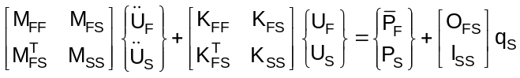

Note that 0_{SF} is the transpose of 0_{FS} and is an S x F matrix of zero’s. From the first of 8.15 it is seen that the single point constraints are of the form:



where Y_{S} is a column matrix of known constant displacement values (either zero or some enforced displacement). This agrees with the single point constraint form discussed above; that is, single point constraints express one DOF as being equal to a constant.

Substituting 8.17 into the first of 8.16 results in the equations for the F-set displacements:

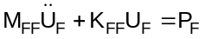

where

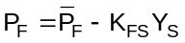

At this point the F-set equations in 8.18 can be solved for since there are F unknowns and F equations with which to solve for them. However, MYSTRAN also allows for a Guyan reduction which, although not generally used in static analysis, may be relevant for eigenvalue analysis. In eigenvalue analyses by the GIV method (see EIGR Bulk Data entry), the mass matrix must be nonsingular. In a situation where the model has no mass for the rotational DOF’s, the mass matrix would be singular. Guyan reduction to statically condense massless DOF’s will result in a nonsingular mass matrix. Thus, if the user identifies an O set, there is a further reduction; that from the F-set to the A-set

Reduction of the F-set to the A-set

The F-set is partitioned into the A and O-sets where the O DOF’s are to be eliminated using Guyan reduction identified by the user either through the use of ASET/ASET1 or OMIT/OMIT1 entries in the input data deck. The A-set are the remainder of the DOF’s in the F-set and are known as the “analysis” DOF’s. Thus, partition U_{F} into U_{A} and U_{O}:

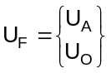

Substitute 8.20 into 8.18 and partition the stiffness and load matrices into the A and O-sets to get:

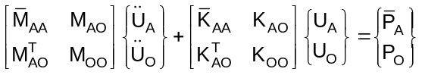

Guyan reduction is only exact, in general, for a statics problem. In a dynamic problem it is only exact if there is no mass on the O-set. In order to explain the Guyan reduction, consider equation 8.21 for a statics problem:

In a static analysis (=0) the second of 8.21 can be used to get:

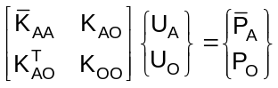

From the 2nd of 8.22 we can solve for 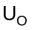 in terms of . We can then write:

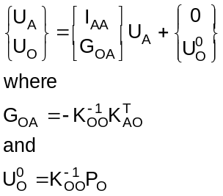

The first part of the first equation in 8.23 suggests the possibility of using:

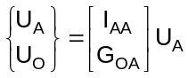

Using 8.24 in 8.22 and premutiplying by the transpose of the coefficient matrix in 8.24 yields:

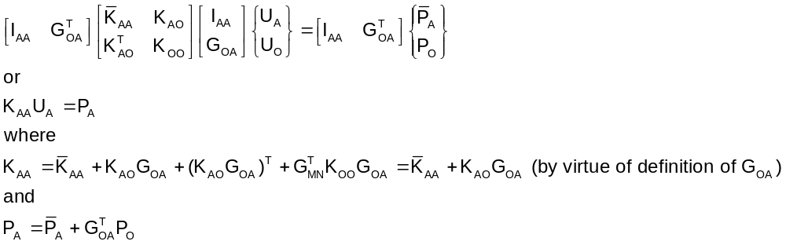

Which is exactly what would have been found if 8.23 had been substituted into 8.22 for .

Equation 8.24 to can be used as a way to eliminate the O-set degrees of freedom for the dynamic system of equations in 8.21. This would be an approximation unless there was no mass associated with the O-set degrees of freedom and is the classic Guyan reduction approximation made in dynamic analyses in which the O-set is eliminated by static condensation (i.e. using the 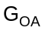 in equation 8.23). Using 8.24 in 8.21 yields

where:

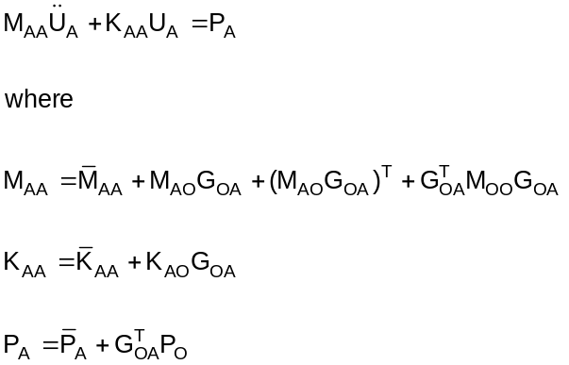

Now, equation 8.27 can be solved for the A-set DOF displacements. The process of recovering the displacements of the O, S and M-set displacements is accomplished by reversing the process we just went through in the reduction. First, the O set displacements are recovered using 8.23. The combination of the A and O-sets yields the F-set. The S-set is given by 8.17. The combination of the F and S-sets yields the N-set. The M-set is recovered from the N-set by 8.7 and the combination of the N and M-sets yield the complete model displacements in the G-set.

Reduction of the A-set to the L-set

The A-set is partitioned into the L and R-sets where the R DOF’s are boundary DOF’s where one substructure attaches to another in Craig-Bampton (CB) analyses. The modal properties of the substructure in CB analysis are fixed boundary modes so that, for the modal portion of CB, the R-set are constrained to zero. The development of the subsequent CB equations of motion in terms of the modal and boundary DOF’s will not be presented here. See Appendix D and reference 11 for a complete discussion of CB analyses. For other analyses there is no R-set so that the L set is the same as the A set for solution of the independent degrees of freedom

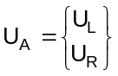

Solution for constraint forces

The constraint forces are recovered as follows. Rewrite 8.2 by partitioning Q_{G} into Q_{F}, Q_{N} and Q_{M} and partitioning q_{C} into q_{S} and q_{M}. Using the coefficient matrix in 8.15 for R_{CG} we get, for Q_{G}:

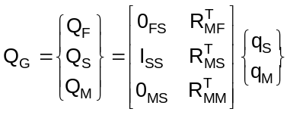

As discussed earlier, the distinction between the q and Q is that the former are generalized forces of constraint and the later are physical constraint forces on the DOF’s of the model. It is the Q constraint forces that are of interest.

Rewrite 8.28 as:

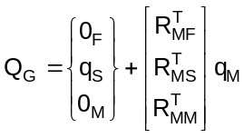

where 0_{F} and 0_{M} are null column matrices of size F and M.

Equation 8.29 can be written as:

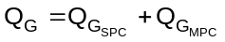

The first term in 8.30 represents the forces of single point constraint and the second the forces of multi-point constraint. Comparing 8.29 and 8.30:

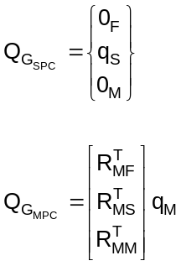

From the first of 8.31 it is seen that the grid point SPC constraint forces are equal to the generalized q_{S} forces. Using 8.17 and the second of 8.16 (keeping in mind that the derivatives of the S-set degrees of freedom are zero due to 8.17) the q_{S}, or Q_{S} is:

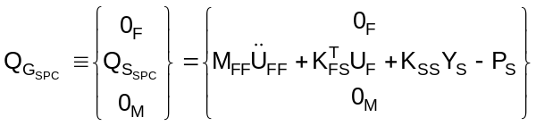

Thus, there are SPC forces only on the S-set DOF’s

From the second of 8.31 and using 8.14 it is seen that the MPC forces can be written as:

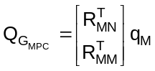

From 8.7 and the second of 8.6, solve for q_{M} :

Substituting 8.34 into 8.33 yields:

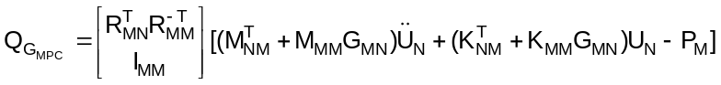

Using 8.8 this becomes:

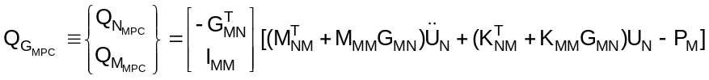

This can also be written as:

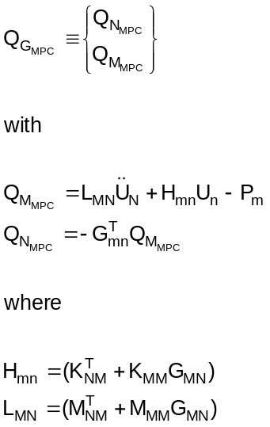

There are MPC forces on the N-set (which includes the F and S-sets) as well as on the M-set. Equations 8.32 and 8.36 (or 8.37) are used to determine the constraint forces once the U_{G} are found.

This completes the derivation of the solution for the G-set displacements and the constraint forces. However, it is of interest to demonstrate that the constraint forces satisfy the principal of virtual work (that is, constraint forces do no virtual work).

Let W_{C} be the work done by the constraint forces and 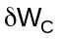 the virtual work done by the constraint forces. Write as:

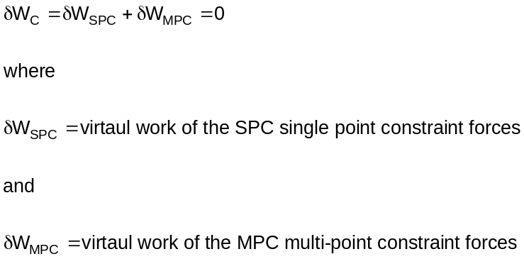

The virtual work of the constraint forces is equal to the constraint forces moving through a virtual displacement, 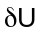. Thus:

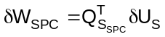
By virtue of 8.17:

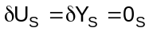

That is, the virtual displacements of the S-set are zero since Y_{S} contains specified values (zero or some enforced displacement). Therefore:

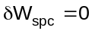

Thus 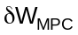 must also be zero by virtue of the first of 8.38. This virtual work of the MPC forces can be written as a combination of the virtual work of the MPC forces on the N and M-sets as follows:

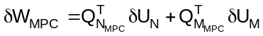

Using 8.7 this can be written as:

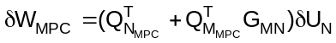

using 8-41:

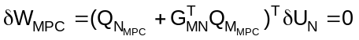

Since the virtual displacements of the N-set are not necessarily zero this requires that:

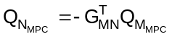

This agrees with 8.36. Thus, the constraint forces developed above are consistent with the principal of virtual work.

