Appendix D: Craig-Bampton Model Generation

Craig-Bampton Equations of Motion for Substructures

MYSTRAN has the capability to generate Craig-Bampton (CB) models via SOL 31 (or SOL GEN CB MODEL). This solution sequence calculates the fixed-base modes of a substructure and generates all of the matrices needed to couple the substructure to other CB models. This appendix describes the Craig-Bampton method and its implementation in MYSTRAN and includes an example problem to explain the input and output for SOL 31.

Craig and Bampton are credited with the first unified approach to modal synthesis, or substructuring for dynamic analysis, using fixed interface flexible modes augmented by boundary constraint modes to describe each substructure. Their work was a simplification of earlier work by Hurty who first introduced the concept for substructures with redundant boundary degrees of freedom (DOF’s).

In order to explain the Craig-Bampton (CB) method, consider a structure represented by the picture below that is comprised of several (in this case 5) substructures connected at an arbitrary number of points:

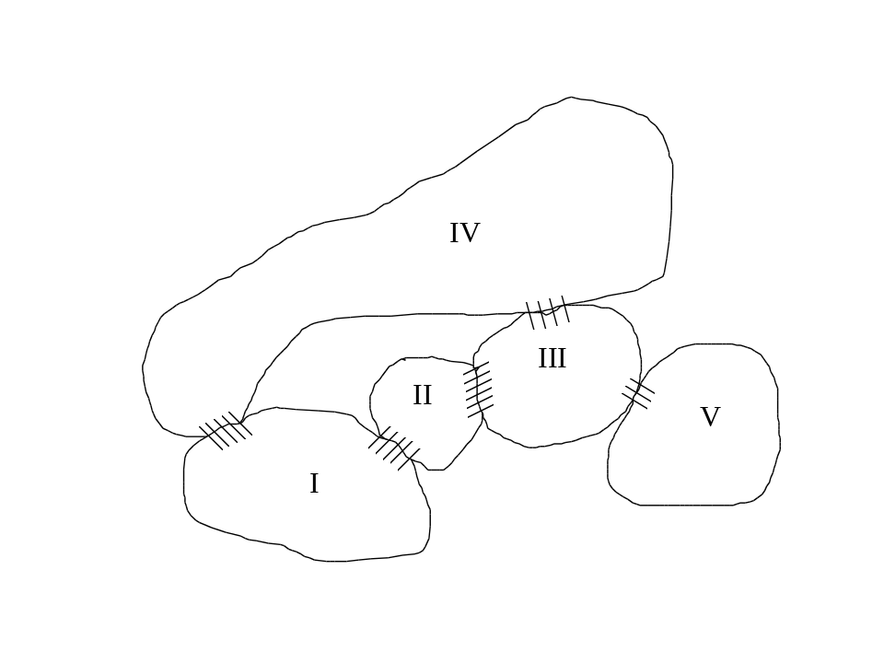
Figure 10.1 - Overall Structure Composed of Several Substructures

Each substructure is joined to one or more other substructures at some number of interface, or boundary, DOF’s (indicated by the hatched areas in the above picture. The complete structure, consisting of the connected substructures, may or may not be restrained from free body motion. For any one of the substructures ( j = I, II, III, etc.) the G-set equations of motion (ignoring damping for the moment) are:

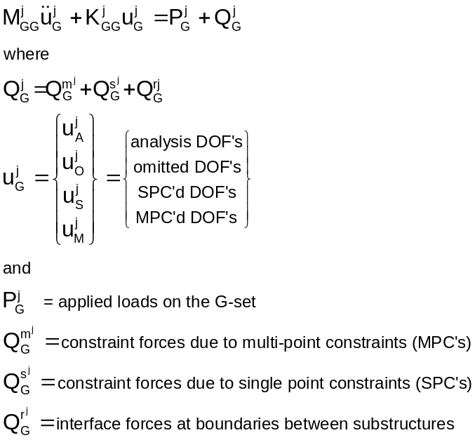

In MYSTRAN nomenclature, the G-set is reduced to the A-set by the elimination of the M-set multi-point constraints, the S-set single point constraints and the O-set omitted DOF’s (using OMIT’s or ASET’s). The A-set DOF’s for this substructure must contain all DOF’s that will be connected to other substructures The resulting A-set equations of motion (dropping the j superscript notation for each substructure) are:

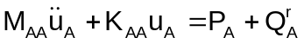

where the A set matrices are mathematical reductions from the G-set (see Appendix B for details)

Partition 2 into the R-set and L-set, where, the R-set represents the boundary DOF’s in which this substructure connects with other substructures and the L-set are all free interior DOF’s in this substructure

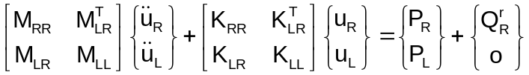

Notice at this point that there remain forces of constraint only at the substructure attach points as the L-set represents all free DOF’s for this substructure.

At this point we can introduce the transformation from the physical displacements in equation (3) to what are known as the CB DOF’s; namely the flexible mode DOF’s and the boundary (R-set) DOF’s. In order to show that this is not any further approximation to equation 3, consider the following argument:

1) the 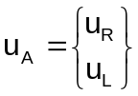 DOF’s are clearly a complete set of DOF’s for the substructure in that, once they are known, the complete g-set DOF’s for this substructure can be determined.

2) similarly, a new set of DOF’s for the substructure,
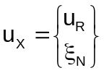

are a complete set of DOF’s if 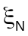 are the generalized DOF’s for flexible modes when 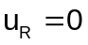

3) Thus we can take 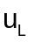to be a linear combination of 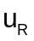 and or:

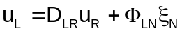

if we insist that:

a) 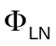are shapes when and are modal DOF’s. That is, the columns of are the flexible modes, 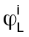, when the boundary is fixed. The i-th column of the modal matrix is .

b) 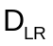 are shapes when 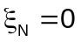. That is, the columns of are the L-set shapes for unit motions of the R-set when the flexible mode DOF’s are zero.

The are easy to understand. They are the eigenvectors resulting from solving an eigenvalue problem from equations 3 with . This eigenvalue problem would be:

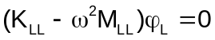

This requires that the determinant of the coefficient matrix on the left side of equation 6 be zero:

The i-th eigenvector,, is then determined by solving the equation:

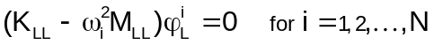

Solution of equation 8 requires that one element of be arbitrarily set (the are shapes and their amplitude does not matter). Once equation 8 is solved, the modal matrix is:

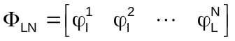

The can also be explained easily. As stated above, the are shapes when the flexible mode response is zero. We can see from equation 5 that a column of represents the displacements at the L-set DOF’s due to motion at one of the R-set DOF’s while all other R-set DOF’s are zero (as well as all ). We can therefore solve for from equation 3 by taking all applied forces and accelerations equal to zero and solving the statics problem:

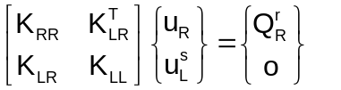

where 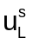are static displacements of the L-set. From the second row of equation 10, solve for in terms of :

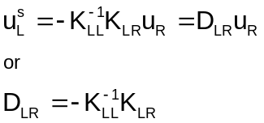

Thus, the CB DOF’s are contained in 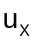 (equation 4) and the transformation between and is:

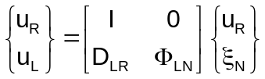

where I is an R x R identity matrix. Equation 12 can be written as:

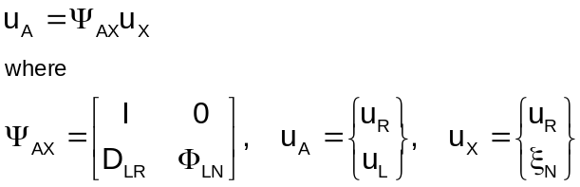

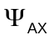is the CB transformation matrix and is of A-set size. In MYSTRAN this is called matrix PHIXA. When expanded to G-set size, PHIXA becomes matrix PHIXG:

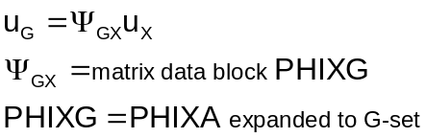

Note that when all flexible modes of the substructure are used in equation 13 is exact. In practice, all modes are never used since this would defeat the purpose of making the transformation (which is to find a smaller set of DOF’s which are nonetheless an accurate representation of the A-set). Substituting equation 13 into equation 2 and premultiplying the result by the transpose of yields:

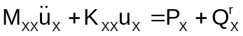

where:

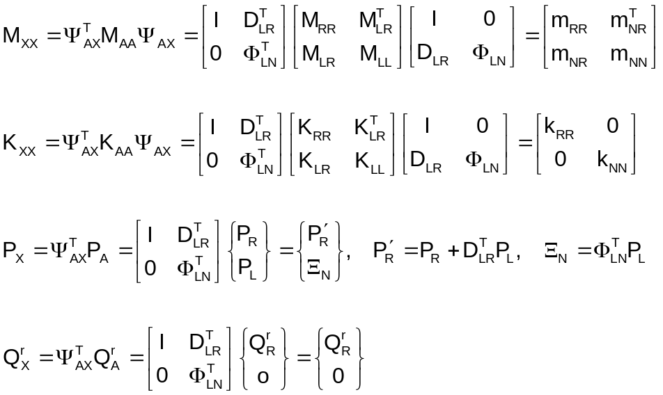

and:

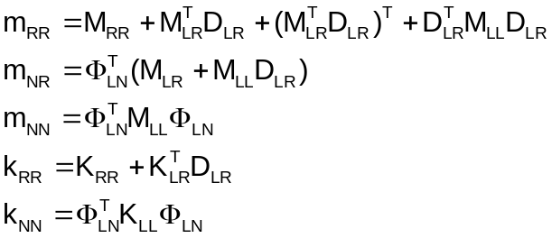

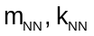 are diagonal matrices of generalized maesses and stiffnesses, respectively.

Equations 15 for the i-th substructure can be written as:

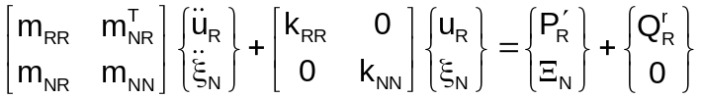

The off-diagonal terms in the above stiffness matrix are zero due to the definition of in equation 11. In addition, matrix 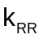in equation 18 is null if the boundary is a determinant interface. Equations 14 and 18 are the Craig-Bampton equations of motion for the i-th substructure. The 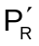 are due to applied loads on the R and L-set DOF’s (see equation 16) and the 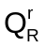are the interface forces where substructures connect. Once the equations are developed for all substructures, the individual substructures can be connected and the resulting equations solved for the combined R-set and N-set DOF’s 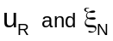 for all substructures. Once this is done, the forces of inter-connection, or substructure interface forces, (that is, the ) can be solved from the individual substructure equations in the top row of equation 18. Equation 14 is used to obtain displacements for all G-set DOF’s.

Each organization that is developing a substructure in CB format would deliver the above coefficient matrices in equations 14 and 18 to the organization that is doing the combined structure analysis. In addition, Displacement and Load Transformation Matrices (DTM’s and LTM’s) collectively known as Output Transformation Matrices, (OTM’s), described below, are also delivered as part of the CB model.

Development of Displ Output Transformation Matrices (Displ OTM’s)

Typically, a set of displacement output transformation matrices (displ OTM’s, or DTM’s for short), is delivered with a Craig-Bampton model to the organization that will couple all substructures and solve for the primary unknowns ( and ) in order that desired displacements at some of the substructure G-set DOF’s may be obtained along with the coupled solution.

Once the combined structure has been solved for the primary variables, the original physical DOF’s could be determined from equation 5 and then element forces and stresses could be determined from the 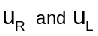 displacements . This is called recovery of the DOF’s and element forces and stresses using the Modal Displacement Method (MDM). However, as is often the case, equations 18 are solved using a severely truncated set of modes for each substructure. While this may not compromise the accuracy of the solutions for , it could compromise the accuracy of element forces and stresses calculated using displacements determined from equation 5 with the truncated set of modes. In order to avoid this problem, the DOF’s can be found using the Modal Acceleration Method (MAM), described below. It should be noted that the MAM described below ignores damping forces so that it is only useful when the damping is small (e.g. less than 10% or so).

From the bottom row of equation 3, solve for in terms of the other variables in the equation:

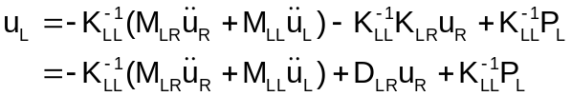

Differentiate equation 5 twice and use the result for 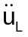 in equation 19, to get:

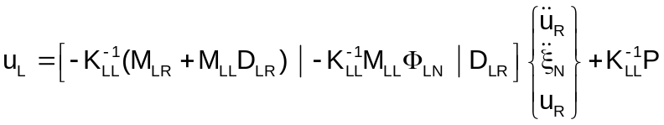

The term 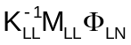 in equation 20. can be written in a form more convenient for calculation. From equation 8 it can be seen that:

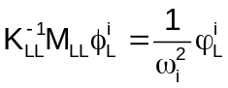

so that

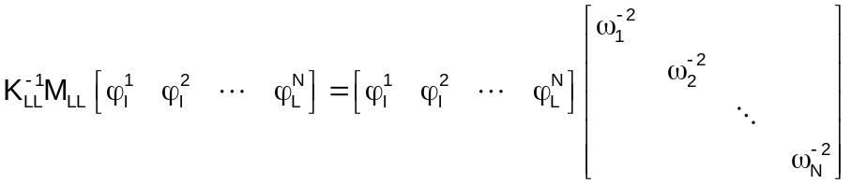

or

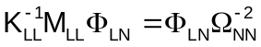

where

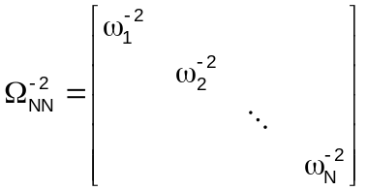

substitute equation 21 into equation 20 to get:

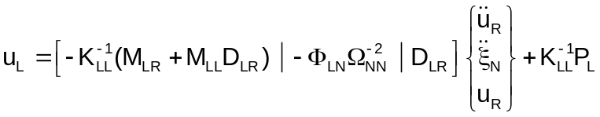

The various terms in the coefficient matrices in equation 23 are known as Displacement Transformation Matrices (DTM’s). Equation 23 can be written as:

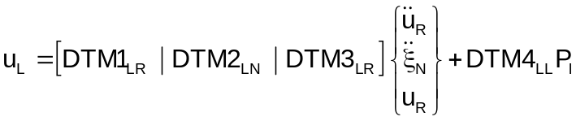

where

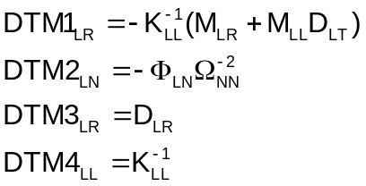

Equations 24 and 25 represent the MAM for recovering displacements for the L-set, for the i-th substructure, once the assembled substructure equations have been solved for the 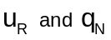 DOF’s. Once the L-set displacements have been found, recovery of the remaining displacements in the G-set is accomplished through the transformation matrices used in their elimination from equation 1 (for details see Appendix B). At the G-set level, equation 24 is:

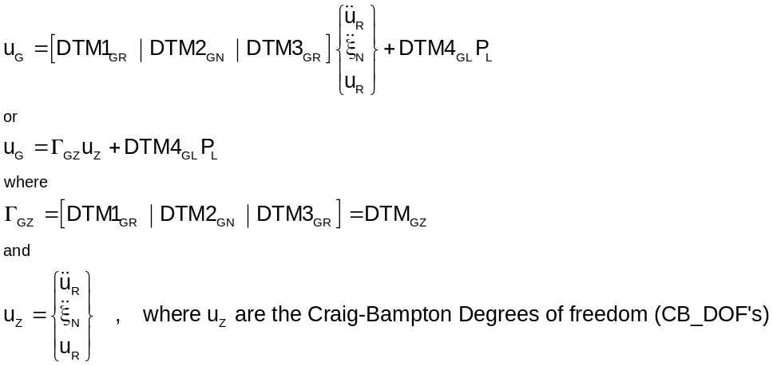
.

where each of the G-set DTM’s in equation 26 is obtained from the L-set DTM’s in equation 25 through the normal recovery operations to build back up to the G-set from the L-set. The coefficient matrix in equation 26 that has DTM’s 1 - 3 in it is called matrix PHIZG. The table below explains the meaning of each of the DTM’s in equation 26:

Table 10.1

i-th col of: | Represents:
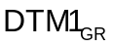 | displ’s of G-set due to a unit accel of the i-th interface DOF (all other R, N set DOF’s zero)
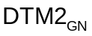 | displ’s of G-set due to a unit accel of the i-th flex mode DOF (all other R, N set DOF’s zero)
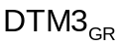 | displ’s of G-set due to a unit displ of the i-th interface DOF (all other R, N set DOF’s zero)
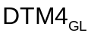 | displ’s of G-set due to a unit force on the i-th L-set DOF (all other L-set forces zero)

Development of Load Output Transformation Matrices (Load OTM’s)

Once the G-set displacements have been found, substructure element forces and stresses, as well as grid point forces, can be recovered and assembled into a Loads Output Transformation Matrix, or Load OTM (more commonly referred to as LTM). There are several types of quantities one may desire in an LTM. Equations are developed, below, for several types of LTM quantities typically used in CB analyses.

LTM Terms for Substructure Interface Forces

From the top row of equation 18, the interface forces can be determined once the substructures have been coupled and the solved. The interface forces are:

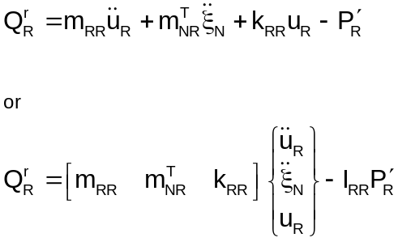

where is an RxR identity matrix. Equation 27 can be written as:

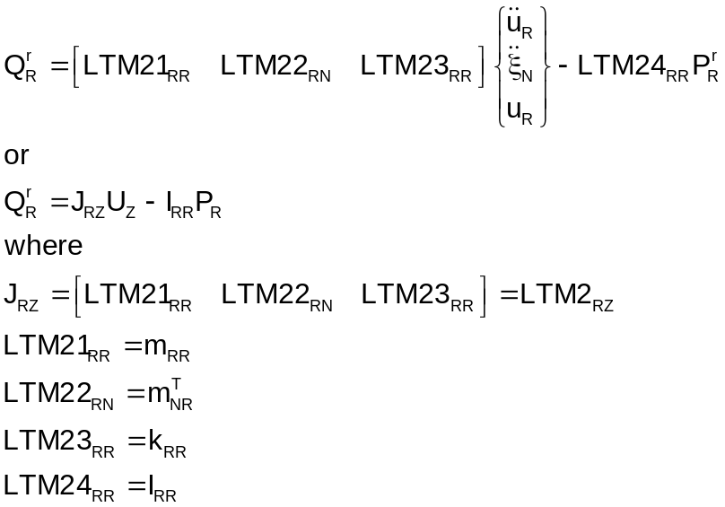

LTM Terms for Net cg Loads

Terms can also be included in the overall LTM that will recover what are known as “net” accelerations at the center of gravity (cg) of the CB model. These are termed Net Load factors (NLF’s) and represent rigid body accelerations of the cg due to the reaction (or interface) forces, . The development below demonstrates how these are determined.

Define:

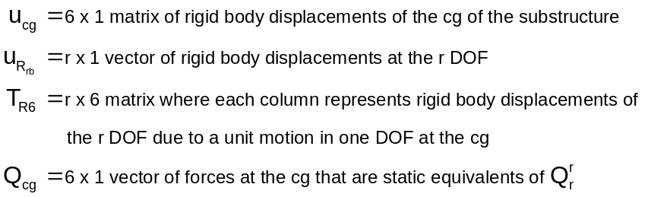

Then:

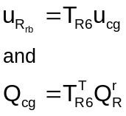

Substitute equation 27 into 30 for :

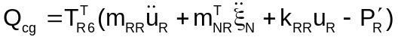

For rigid body motion:

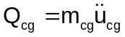

where 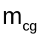 is the 6 x 6 rigid body mass matrix relative to the cg and is equal to:

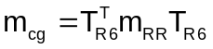

and 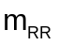 is given in equation 17. From equations 31 through 33 we can write the cg acceleration net load factors (NLF’s) as:

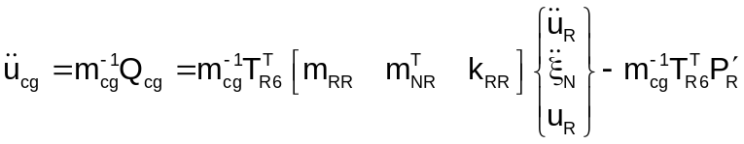

However, 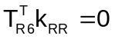since the columns of 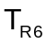 are rigid body modes. Therefore:

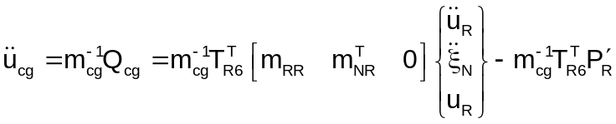

which can be written as:

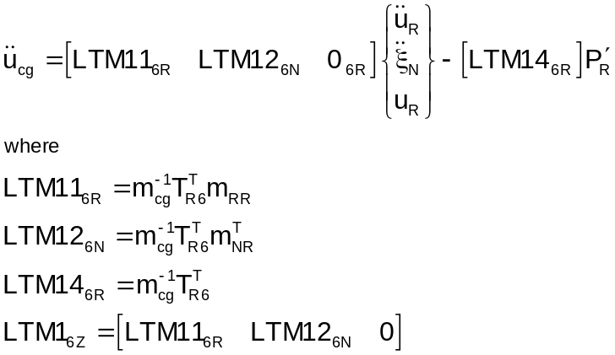

LTM Terms for Element Forces and Stresses

In MYSTRAN, element forces and stresses are obtained from the G-set displacement vector and the individual element stiffness matrices. Equation 26 is the G-set displacement vector:

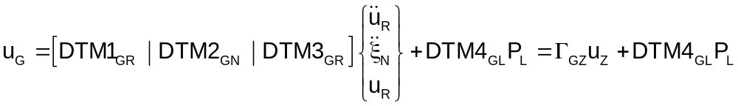

Thus the columns of each of the DTM’s represents G-set displacements per unit value of one of the variables 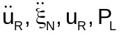as described in Table 10.1. Therefore, each of the DTM’s can be used as if they were a matrix of displacements in calculating element forces and stresses to give:

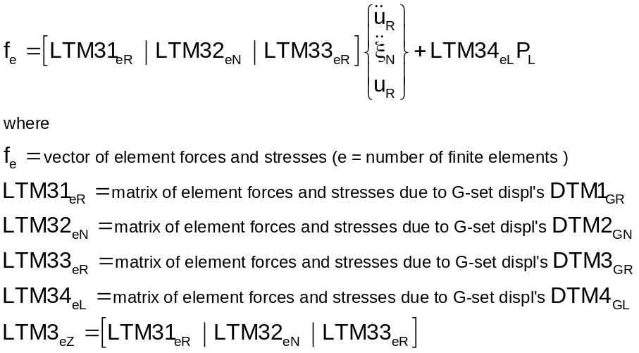

LTM Terms for Grid Point Forces due to multi-point constraints (MPC’s)

There are cases in CB analyses in which the forces due to MPC’s are of interest. As an example, if a user wishes to determine a load in a bolt at an interface between components, it is common to model the bolt as an MPC where two coincident grids are constrained to have the same displacements. This section develops the equations for determining an LTM for grid point MPC forces.

Equation 1 for the i-th substructure (dropping the superscript-j notation):

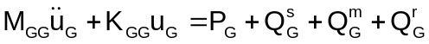

As described in section 10.1 the Q constraint forces on the right side of equation 38 are the constraint forces on the S-set SPC DOF’s, the M-set MPC DOF’s and on the R-set boundary DOF’s respectively. Since all of the boundary DOF’s are contained in the R-set there should be no constraint forces on the S-set. That is, all S-set DOF’s should be the result of removing singularities and not the result of grounding the model. With this assumption, as well as the assumption that there are no applied loads on the M-st degrees of freedom the following equation is valid for the MPC forces on the M-set grids:

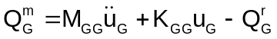

We want to get 39 in a form like the other LTM’; that is, in terms of 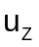.

From equation 26 with applied loads zero:

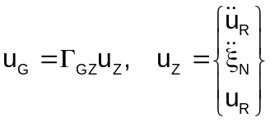

The g-set DOF vector can also be written using equation 14:

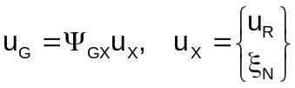

Differentiating twice:

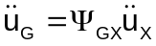

This can also be written as:

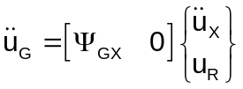

Partition the x DOF’s into R and N as in equation 13. This will require partitioning 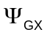 into sub-matrices for the R and N also, so that equation 42 can be written as:

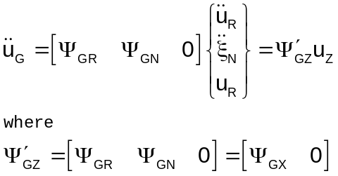

.

Substitute equations 40 and 43 into 39 for 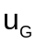 and 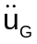 respectively to get:

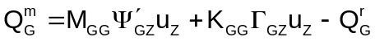

We need to express the boundary constraint forces in equation 44 in terms of the vector as we did for the inertia and stiffness terms. From 28:

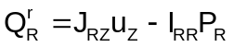

Theboundary forces on the R-set can be expanded from the R-set to the G-set 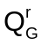by adding zero rows to 45 for the M, S, O-sets (all of the G-set but the R degrees of freedom) to give

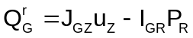

where 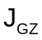 is 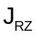expanded to G-set size by addition of zero rows for M, S, O-sets and 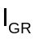is expanded from in the same fashion (recall is an R size identity matrix). Substituting 46 into 44 we get::

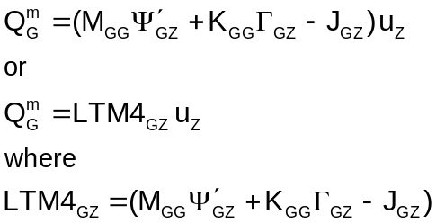

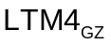 is the LTM for MPC forces at grids that have no applied load

Development of Acceleration Output Transfer Matrices (Accel OTM)

In addition to the displacement and load output transformation matrices (DTM’s and LTM’s) it is common to supply acceleration output transformation matrices (accel OTM’s or ATM’s for short). From equation 10-12 and differentiating twice we obtain:

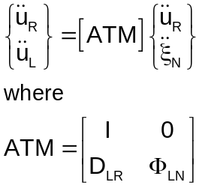

ATM is the acceleration transfer matrix. Notice that the “degrees of freedom” for the ATM are the accelerations of the boundary and modal degrees of freedom whereas all of the other OTM’s have as degrees of freedom: boundary accelerations, modal accelerations and boundary displacements. This is due to the use of the modal acceleration method for recovery of displacements and element forces.

Correspondence between matrix names and CB Equation Variables

The table below shows the correspondence between variables introduced in the above equations and matrix data block names in the DMAP program in Section 10.5. Any of these may be output in a MYSTRAN CB model generation analysis using the Executive Control entry OUTPUT4.

Table 10-2
Matrices that can be written to OUTPUT4 files

 | MYSTRAN  Matrix Name  (OUTPUT4 matrices) | NASTRAN  DMAP  Name | CB equation variable in Appendix D  (where applicable) | Matrix size¹ | Partition  rows  and/or  cols
1 | CG_LTM |  | 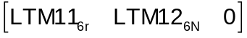 | 6x(2R+N)
2 | DLR | DM |  | LxR | rows and  cols
3 | EIGEN_VAL | LAMA | 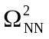 | NxN
4 | EIGEN_VEC | PHIG |  | GxN | rows
5 | GEN_MASS | MI | 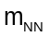 | Nx1 vector of diag. terms
6 | IF_LTM |  | 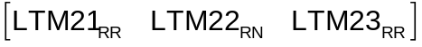 | Rx(2R+N) | rows
7 | KAA | KAA | 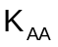 | AxA | rows and  cols
8 | KGG | KGG | 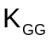 | GxG | rows and  cols
9 | KLL | KLL | 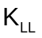 | LxL | rows and  cols
10 | KRL | KLR(t) | 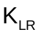 | LxR | rows and  cols
11 | KRR | KRR | 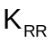 | RxR | rows and  cols
12 | KRRcb | KBB | 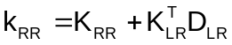 | RxR | rows and  cols
13 | KXX | KRRGN | 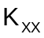 | (R+N)x(R+N)
14 | LTM | LTM | CG_LTM and IF_LTM merged | (6+R)x(2R+N)
15 | MCG | RBMCG |  | 6x6
16 | MEFFMASS |  | Modal effective mass | Nx6
17 | MPFACTOR |  | Modal participation factors | Nx6 or NxR
18 | MAA |  | 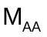 | AxA | rows and  cols
19 | MGG |  | 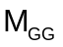 | GxG | rows and  cols
20 | MLL | MLL | 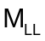 | LxL | rows and  cols
21 | MRL | MRL | 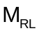 | RxL | rows and  cols
22 | MRN |  | 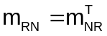 | RxN | rows
23 | MRR | MRR | 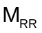 | RxR | rows and  cols

Table 10-2 (con’t)

 | MYSTRAN  Matrix Name  (OUTPUT4 matrices) | NASTRAN  DMAP Name | CB equation variable in Appendix D  (where applicable) | Matrix size | Partition  rows  and/or  cols
24 | MRRcb | MBB |  | RxR | rows and  cols
25 | MXX | MRRGN | 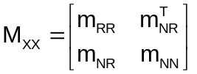 | (R+N)x(R+N)
26 | PA |  | (A-set static reduced loads - only used in statics) |  | Rows
27 | PG |  | (G-set static loads - only used in statics) |  | Rows
28 | PL |  | (L-set static reduced loads - only used in statics) |  | rows
29 | PHIXG | PHIXG |  | Gx(R+N) | rows
30 | PHIZG |  | The G-set displacement transformation matrix is written out in the F06 file under  “C B D I S P L A C E M E N T O T M” | Gx(2R+N) | rows
31 | RBM0 |  | Rigid body mass matrix relative to the basic origin | 6x6
32 | TR6_0 | RBR | 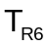: rigid body displacement matrix for R-set relative to the model basic coordinate system | Rx6 | rows
33 | TR6_CG | RBRCG | : rigid body displacement matrix for R-set relative to the model CG | Rx6 | rows

Notes:
- (t) indicates matrix transposition

- Matrix will be singular if there are rotational DOF’s but no rotational inertia in the R-set, in which case small rotational inertias may have to be added at these DOF’s.

- Matrix is null if the boundary is a determinant set of DOF’s.

- Matrix is the rigid body mass matrix if the boundary is a determinant set of DOF’s

Craig-Bampton model generation example problem

The figure below shows a small example problem that is a frame made of CBAR’s that is a substructure assumed to be attached to some other structure in DOF’s 1,2,3 at grids 11 and 13 and in DOF’s 2,3 at grid 12. The example problem F06 file (with the input echo’d) is shown on the following pages. This section will discuss the input and output in an effort to explain the Craig-Bampton model generation process.

Equation 10.26 defines the Craig-Bampton degrees of freedom (CB-DOF’s) as U_{z} which, for this example, consists of the 18 DOF’s:

- 8 boundary acceleration DOF’s, 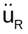
- 2 modal acceleration DOF’s, 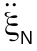 (see EIGRL request for 2 modes to be extracted)
- 8 boundary displacement DOF’s,

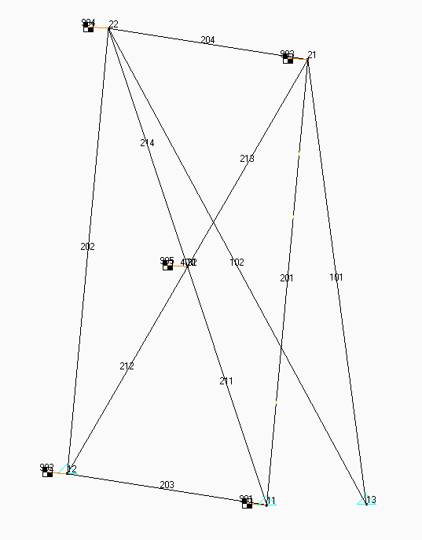
Figure 10.2 – Example CB model: CB-EXAMPLE-12b.DAT

Notes on section 10.6.1: CB-EXAMPLE-12b.F06

The echo of the input shows the following salient points for a CB model generation (much like a SOL 3 eigenvalue analysis in terms of input data):

- Executive Control:

  - SOL 31 indicates CB model generation

  - The OUTPUT4 commands show the matrices that will be written in a format the same as NASTRAN OUTPUT4 files. These matrix data blocks are ones that are listed on Table 10.2 as allowable OUTPUT4 matrices. Notice that several are written to unit 21 while others are written to unit 22. As explained in section 5.1 of the MYSTRAN Users Reference Manual, unit numbers 21 through 27 are valid for writing OUTPUT4 matrices.

- Case Control:

- METHOD = 1 is to be used for a normal eigenvalue analysis (same as if SOL were 3)

- Outputs (ACCE, DISP, ELFORCE, STRESS) are for Output Transformation Matrices (OTM’s) for the specified sets. These will be written to the text F06 file. In addition they will be written to binary files (same name, CB-EXAMPLE-12b) with extension OP8 for the element related OTM;s (ELFORCE, STRESS in this case and OP9 for the grid related OTM’s (ACCE, DISP in this case)

- Bulk Data:

- Shows the model for this example (notice it has mostly CBAR’s but there is also a RBE2)

- Degrees of freedom at the boundary where this substructure attaches to other substructures are defined with the SUPORT Bulk Data entry. This is the same procedure that is used in CB analyses by the NASTRAN DMAP (Direct Matrix Abstraction Program) method familiar to NASTRAN CB analysts.

- Eigenvalue extraction, EIGRL requesting 2 modes to be extracted

The delineated F06 output begins on the page following the input model echo and shows the following:

- Eigenvalues extracted

- Messages on the matrices requested to be written to OUTPUT4 files

- For the first 3 of the 18 CB_DOF’s in this example the following output (requested in Case Control) is shown (other 15 were left out for clarity):

- Displacement OTM for the requested grids (see Case Control command DISP = 102)

- Element engineering force OTM (see Case Control command ELFORCE = 201)

- Element stress OTM (see Case Control command STRESS = 202)

- Acceleration OTM. As shown in equation 10.48 the acceleration OTM has columns for and but not . For this example, there are 10 columns in the acceleration OTM (8 boundary acceleration DOF’s and 2 modal acceleration DOF’s)

Notes on section 10.6.2: OUTPUT4 matrices written to CB-EXAMPLE-12b.OP1 and OP2

As shown in the Executive Control section of the F06 file in section 10.6.1, there were 3 matrices requested to be written to unit 21 and 4 to unit 22. These binary files, translated to text, are shown in section 10.6.2. The number of actual columns for each matrix is indicated in Table 10.2 but only the first 5 of the columns are shown here for the sake of brevity. These are several of the important CB matrices needed to couple this CB substructure to other substructures in a combined analysis. The binary OUTPUT4 files are written in the same format as the NASTRAN OUTPUT4 binary files.

Notes on section 10.6.3: Displ and elem force/stress OTM’s written to CB-EXAMPLE-12b.OP1, OP2

Any output requests in Case Control for grid related outputs (e.g. DISPL, ACCEL) and element force/stress outputs (e.g. ELFORCE, STRESS) are written to the text F06 file and also written to OUTPUT4 binary files (automatically; that is, no formal OUTPUT4 request is needed). The element related OTM’s are always written to a file with the same filename as the F06 file but with extension OP8. The grid related OTM’s are written to a file with extension OP9.

The first page of section 10.6.3 is a text translation of the element related OTM’s written to file
CB-EXAMPLE-12b.OP8. The values are the same as was written to the F06 file for element forces and stresses but are also written to binary files in OUTPUT4 format to be used in analyses that couple the CB substructures. In order to explain the contents of the binary OP8 file, a text file with extension OT8 is also automatically written (provided any Case Control requests are included for element forces/stresses) describing the contents of the OP8 binary file. This OT8 text file gives an overview of the OP8 binary file and then goes on to describe each row written to the OP8 file.

The next several pages show the same type of information on the grid related OTM’s written to binary file with extension OP9 (with text description in OT9). Again, this is the grid related outputs requested in Case Control and also written to the F06 text file.
*

CB-EXAMPLE-12-b.F06

(delineated – some output not included here for the sake of clarity)

1030180330

MYSTRAN Version 3.00 Oct 20 2006 by Dr Bill Case (this TRIAL edition is SP protected)

>> MYSTRAN BEGIN : 10/30/2006 at 18: 3:30.640 The input file is CB-EXAMPLE-12-b.DAT

>> LINK 1 BEGIN

SOL 31
$
OUTPUT4 CG_LTM , IF_LTM , , , //-1/21 $
OUTPUT4 KRRGN , RBMCG , MRRGN , , RBRCG //-1/22 $
OUTPUT4 MR , , , , //-1/21 $
CEND
TITLE = TEST OF CRAIG-BAMPTON SOLUTION
SUBTI = FRAME USING CBAR's
SPC = 1
METHOD = 1
ECHO = UNSORT
$
SET 101 = 32
SET 102 = 22, 32
SET 201 = 211, 212
SET 202 = 201
$
ACCE = 101
DISP = 102
ELFORCE = 201
STRESS = 202
MEFFMASS = ALL
MPFACTOR = ALL
$
BEGIN BULK
$
EIGRL 1 2 2 DPB -1. MASS
$
EIGR 2 MGIV 1 24 +E1
+E1 MASS
GRID 11 0. 0. 0.
GRID 12 100. 0. 0.
GRID 13 50. 0. 50.
GRID 21 0. 100. 0.
GRID 22 100. 100. 0.
GRID 31 50. 50. 0.
GRID 32 50. 50. 0.
$
RBE2 401 31 123456 32
$
$ Frame support bars
$
CBAR 101 1 13 21 0.0 0.5 1.0 +C1
+C1 56 456
CBAR 102 1 13 22 0.0 0.5 1.0 +C2
+C2 56 456
$
$ Edge bars
$
CBAR 201 2 11 21 0.0 0.0 1.0
CBAR 202 2 12 22 0.0 0.0 1.0
CBAR 203 2 11 12 0.0 0.0 1.0
CBAR 204 2 21 22 0.0 0.0 1.0
$
$ Diag bars
$
CBAR 211 3 11 31 0.0 0.0 1.0
CBAR 212 3 12 31 0.0 0.0 1.0
CBAR 213 3 21 31 0.0 0.0 1.0
CBAR 214 3 22 31 0.0 0.0 1.0
$
PBAR 1 1 0.36 0.09 0.09 0.18
PBAR 2 1 0.10 10.0 10.0 20.0
PBAR 3 1 6.0 6.0 6.0 12.0
$
MAT1 1 10.+6 0.3 0.1
*INFORMATION: MAT1 ENTRY 1 HAD FIELD FOR G BLANK. MYSTRAN CALCULATED G = 3.846154E+06
$
CONM2 901 11 150.0 0.0 0.0 -5.0
CONM2 902 12 150.0 0.0 0.0 -5.0
CONM2 903 21 150.0 0.0 0.0 -5.0
CONM2 904 22 150.0 0.0 0.0 -5.0
CONM2 905 32 150.0 0.0 0.0 -5.0
$
SPC1 1 456 13
$
$ BOUNDARY DOF'S
$
SUPORT 11 123 12 23 13 123
$
PARAM WTMASS .002591
$
ENDDATA

E I G E N V A L U E A N A L Y S I S S U M M A R Y (LANCZOS Mode 2 DPB Shift eigen = -1.00E+00)

NUMBER OF EIGENVALUES EXTRACTED . . . . . . 2

LARGEST OFF-DIAGONAL GENERALIZED MASS TERM -2.7E-13 (Vecs renormed to 1.0 for gen masses)

. . . 2
MODE PAIR . . . . . . . . . .
. . . 1

NUMBER OF OFF DIAGONAL GENERALIZED MASS
TERMS FAILING CRITERION OF 1.0E-04. . . . . 0

R E A L E I G E N V A L U E S
MODE EXTRACTION EIGENVALUE RADIANS CYCLES GENERALIZED GENERALIZED
NUMBER ORDER MASS STIFFNESS

1 1 3.895211E+03 6.241163E+01 9.933119E+00 1.000000E+00 3.895211E+03
2 2 7.011163E+03 8.373269E+01 1.332647E+01 1.000000E+00 7.011163E+03

>> LINK 4 END

>> LINK 6 BEGIN

*INFORMATION: THE FOLLOWING 7 MATRICES WILL BE WRITTEN TO 2 OUTPUT4 FILES IN THE ORDER LISTED BELOW:

OUTPUT4 file on unit 21 has been created as: CB-EXAMPLE-12-b.OP1 and will contain the matrices:
( 1) CG_LTM : 6 rows and 18 cols This is MYSTRAN matrix CG_LTM
( 2) IF_LTM : 8 rows and 18 cols This is MYSTRAN matrix IF_LTM
( 3) MR : 8 rows and 8 cols This is MYSTRAN matrix MRRcb

OUTPUT4 file on unit 22 has been created as: CB-EXAMPLE-12-b.OP2 and will contain the matrices:
( 1) KRRGN : 10 rows and 10 cols This is MYSTRAN matrix KXX
( 2) RBMCG : 6 rows and 6 cols This is MYSTRAN matrix MCG
( 3) MRRGN : 10 rows and 10 cols This is MYSTRAN matrix MXX
( 4) RBRCG : 8 rows and 6 cols This is MYSTRAN matrix TR6

>> LINK 6 END

>> LINK 5 BEGIN

>> LINK 5 END

>> LINK 9 BEGIN

OUTPUT FOR CRAIG-BAMPTON DOF 1 OF 18

C B D I S P L A C E M E N T O T M
(in global coordinate system at each grid)
GRID COORD T1 T2 T3 R1 R2 R3
SYS
22 0 -1.412939E-05 1.622140E-05 8.242222E-05 5.883709E-07 -1.667433E-06 5.125151E-07
32 0 1.051041E-05 -9.465944E-06 -3.182887E-06 -1.086181E-07 -9.450720E-07 2.106009E-07

C B E L E M E N T E N G I N E E R I N G F O R C E O T M
F O R E L E M E N T T Y P E B A R
Element Bend-Moment End A Bend-Moment End B - Shear - Axial Torque
ID Plane 1 Plane 2 Plane 1 Plane 2 Plane 1 Plane 2 Force
211 2.091876E-01 7.894539E-01 1.515607E+00 -1.439344E+00 -1.847556E-02 3.151997E-02 6.266800E-01 9.672846E-03
212 -1.133151E-01 -1.008960E-02 -1.725401E+00 -6.166148E-02 2.279833E-02 7.293366E-04 -2.953611E-01 -4.720428E-03

C B E L E M E N T S T R E S S O T M I N L O C A L E L E M E N T C O O R D I N A T E S Y S T E M
F O R E L E M E N T T Y P E B A R
Element SA1 SA2 SA3 SA4 Axial SA-Max SA-Min M.S.-T
ID SB1 SB2 SB3 SB4 Stress SB-Max SB-Min M.S.-C

201 0.000000E+00 0.000000E+00 0.000000E+00 0.000000E+00 -2.748670E+00 -2.748670E+00 -2.748670E+00
0.000000E+00 0.000000E+00 0.000000E+00 0.000000E+00 -2.748670E+00 -2.748670E+00

OUTPUT FOR CRAIG-BAMPTON DOF 2 OF 18

C B D I S P L A C E M E N T O T M
(in global coordinate system at each grid)
GRID COORD T1 T2 T3 R1 R2 R3
SYS
22 0 -7.600290E-05 8.243595E-05 3.128787E-04 1.925291E-06 2.220055E-06 1.292053E-07
32 0 -5.990878E-05 6.308617E-05 3.224179E-04 3.643362E-06 4.904270E-07 3.218612E-08

C B E L E M E N T E N G I N E E R I N G F O R C E O T M
F O R E L E M E N T T Y P E B A R
Element Bend-Moment End A Bend-Moment End B - Shear - Axial Torque
ID Plane 1 Plane 2 Plane 1 Plane 2 Plane 1 Plane 2 Force
211 3.640634E+00 -2.875040E+00 -7.752079E+00 4.486528E+00 1.611173E-01 -1.041083E-01 1.906435E+00 -5.333935E-03
212 3.789705E+00 2.992877E+00 -6.061077E+00 -4.713484E+00 1.393111E-01 1.089844E-01 1.808077E+00 5.333935E-03

C B E L E M E N T S T R E S S O T M I N L O C A L E L E M E N T C O O R D I N A T E S Y S T E M
F O R E L E M E N T T Y P E B A R
Element SA1 SA2 SA3 SA4 Axial SA-Max SA-Min M.S.-T
ID SB1 SB2 SB3 SB4 Stress SB-Max SB-Min M.S.-C

201 0.000000E+00 0.000000E+00 0.000000E+00 0.000000E+00 7.582667E+00 7.582667E+00 7.582667E+00
0.000000E+00 0.000000E+00 0.000000E+00 0.000000E+00 7.582667E+00 7.582667E+00
OUTPUT FOR CRAIG-BAMPTON DOF 3 OF 18

C B D I S P L A C E M E N T O T M
(in global coordinate system at each grid)
GRID COORD T1 T2 T3 R1 R2 R3
SYS
22 0 3.800145E-05 -4.121798E-05 -1.564393E-04 -9.626456E-07 -1.110028E-06 -6.460267E-08
32 0 2.995439E-05 -3.154308E-05 -1.612090E-04 -1.821681E-06 -2.452135E-07 -1.609306E-08

C B E L E M E N T E N G I N E E R I N G F O R C E O T M
F O R E L E M E N T T Y P E B A R
Element Bend-Moment End A Bend-Moment End B - Shear - Axial Torque
ID Plane 1 Plane 2 Plane 1 Plane 2 Plane 1 Plane 2 Force
211 -1.820317E+00 1.437520E+00 3.876039E+00 -2.243264E+00 -8.055864E-02 5.205414E-02 -9.532175E-01 2.666968E-03
212 -1.894852E+00 -1.496438E+00 3.030538E+00 2.356742E+00 -6.965554E-02 -5.449220E-02 -9.040385E-01 -2.666968E-03

C B E L E M E N T S T R E S S O T M I N L O C A L E L E M E N T C O O R D I N A T E S Y S T E M
F O R E L E M E N T T Y P E B A R
Element SA1 SA2 SA3 SA4 Axial SA-Max SA-Min M.S.-T
ID SB1 SB2 SB3 SB4 Stress SB-Max SB-Min M.S.-C

201 0.000000E+00 0.000000E+00 0.000000E+00 0.000000E+00 -3.791334E+00 -3.791334E+00 -3.791334E+00
0.000000E+00 0.000000E+00 0.000000E+00 0.000000E+00 -3.791334E+00 -3.791334E+00

.
.
.
.
.
.
.
.
.
(output for the 4th – 18th CB DOF deleted)

OUTPUT FOR CRAIG-BAMPTON ACCEL OTM COL 1 OF 10

C B A C C E L E R A T I O N O T M
(in global coordinate system at each grid)
GRID COORD T1 T2 T3 R1 R2 R3
SYS
32 0 2.199853E-02 -2.028331E-02 -1.681579E-02 -3.363157E-04 8.006145E-03 5.254334E-04

OUTPUT FOR CRAIG-BAMPTON ACCEL OTM COL 2 OF 10

C B A C C E L E R A T I O N O T M
(in global coordinate system at each grid)
GRID COORD T1 T2 T3 R1 R2 R3
SYS
32 0 0.000000E+00 0.000000E+00 -1.000000E+00 -2.000000E-02 0.000000E+00 0.000000E+00

OUTPUT FOR CRAIG-BAMPTON ACCEL OTM COL 3 OF 10

C B A C C E L E R A T I O N O T M
(in global coordinate system at each grid)
GRID COORD T1 T2 T3 R1 R2 R3
SYS
32 0 0.000000E+00 0.000000E+00 5.000000E-01 1.000000E-02 0.000000E+00 0.000000E+00

.
.
.
.
.
.
.
.
.
(output for the 4th – 10th Accel OTM columns deleted)

M O D A L P A R T I C I P A T I O N F A C T O R S
(dimensionless, in coordinate sys 0)
MODE T1 T2 T3 R1 R2 R3
NUM
1 1.227574E-01 -1.758352E+00 8.791759E-01 1.259087E+00 6.535370E-02 -5.341716E-01
2 6.061630E-01 1.829524E-01 -9.147622E-02 -4.910542E-01 -1.366914E-01 -4.626569E-01

------------------------------------------------------------------------------------------------------------------------------------

E F F E C T I V E M O D A L M A S S E S O R W E I G H T S
(in coordinate system 0)
Units are same as units for mass input in the Bulk Data Deck
MODE T1 T2 T3 R1 R2 R3
NUM
1 6.532677E+01 4.179096E+01 4.694259E+02 3.836785E+05 3.287406E+04 3.611917E+02
2 7.948285E+00 9.016521E-01 1.363070E+01 1.674257E+00 6.082279E+05 4.781873E+05
------------- ------------- ------------- ------------- ------------- -------------
Sum all modes: 7.327506E+01 4.269261E+01 4.830566E+02 3.836801E+05 6.411019E+05 4.785485E+05
Total model mass: 9.325238E+02 9.325238E+02 9.325238E+02 4.105260E+06 4.094237E+06 8.139951E+06
Modes % of total mass*: 7.86 4.58 51.80 9.35 15.66 5.88

*If all modes are calculated the % of total mass should be 100% of the free mass (i.e. not counting mass at constrained DOF's).
Percentages are only printed for components that have finite model mass.
-----

>> LINK 9 END

>> MYSTRAN END : 10/30/2006 at 18: 3:31.562

OUTPUT4 matrices written to CB-EXAMPLE-12-b.OP1 and OP2

(OUTPUT4 matrices requested in Exec Control)

OUTPUT4 matrices requested in Exec Control to be written to file CB-EXAMPLE-12-b.OP1 (on unit 21)

(note: only 1st 5 columns written here for the sake of clarity)

CG_LTM NCOLS = 18 NROWS = 6 FORM = 2 PREC = 2
1 2 3 4 5
1 -6.65821789802521E-05 1.29562159612018E-17 -6.47810798060089E-18 -1.29549999999999E-03 6.47766872193621E-05 .......
2 -2.99785601343913E-05 -1.96135553418977E-04 1.04193052213477E-04 1.39356777670951E-03 -6.70858061739371E-05 .......
3 -4.35697030582909E-05 -2.59100000000000E-03 1.30775055100798E-03 1.29550000000001E-03 6.19839872966866E-04 .......
4 -3.33844454038618E-04 -2.00000000000000E-02 9.80743672854175E-03 1.00000000000000E-02 -5.07064059129018E-03 .......
5 8.13687816036514E-03 1.47885176327023E-16 -7.39425881635114E-17 -7.78457159844592E-17 -5.93156091981744E-03 .......
6 5.63393757592496E-04 8.55130582230051E-17 -4.27565291115026E-17 9.99999999999996E-03 2.81696878796245E-04 .......

IF_LTM NCOLS = 18 NROWS = 8 FORM = 2 PREC = 2
1 2 3 4 5
1 6.02957424769077E-01 7.32039059471622E-02 -3.66019529735811E-02 3.35492666170908E-02 -7.19015457719424E-02 .......
2 7.32039059471623E-02 4.25469107253153E+00 -2.12163357113457E+00 -2.21879607113459E+00 -1.10665832128050E-01 .......
3 -3.66019529735811E-02 -2.12163357113457E+00 1.07224071582968E+00 1.10939803556729E+00 5.53329160640251E-02 .......
4 3.35492666170908E-02 -2.21879607113459E+00 1.10939803556729E+00 3.26418464157067E+00 1.75366508593570E-02 .......
5 -7.19015457719424E-02 -1.10665832128050E-01 5.53329160640251E-02 1.75366508593570E-02 4.96481812094837E-01 .......
6 -6.65046890695409E-01 -7.32039059471504E-02 3.66019529735752E-02 -1.24163383728600E+00 1.32307347677584E-01 .......
7 -1.34708893096271E-01 -2.21879607113459E+00 1.10939803556729E+00 2.54146535101691E-01 3.05700710026811E-02 .......
8 6.78737140960850E-02 -1.83869738075211E-01 9.19348690376054E-02 8.11498842422746E-02 2.62006997196796E-02 .......

MR NCOLS = 8 NROWS = 8 FORM = 1 PREC = 2
1 2 3 4 5
1 6.02957424769077E-01 7.32039059471622E-02 -3.66019529735811E-02 3.35492666170908E-02 -7.19015457719424E-02 .......
2 7.32039059471623E-02 4.25469107253153E+00 -2.12163357113457E+00 -2.21879607113459E+00 -1.10665832128050E-01 .......
3 -3.66019529735811E-02 -2.12163357113457E+00 1.07224071582968E+00 1.10939803556729E+00 5.53329160640251E-02 .......
4 3.35492666170908E-02 -2.21879607113459E+00 1.10939803556729E+00 3.26418464157067E+00 1.75366508593570E-02 .......
5 -7.19015457719424E-02 -1.10665832128050E-01 5.53329160640251E-02 1.75366508593570E-02 4.96481812094837E-01 .......
6 -6.65046890695409E-01 -7.32039059471504E-02 3.66019529735752E-02 -1.24163383728600E+00 1.32307347677584E-01 .......
7 -1.34708893096271E-01 -2.21879607113459E+00 1.10939803556729E+00 2.54146535101691E-01 3.05700710026811E-02 .......
8 6.78737140960850E-02 -1.83869738075211E-01 9.19348690376054E-02 8.11498842422746E-02 2.62006997196796E-02 .......

OUTPUT4 matrices requested in Exec Control to be written to file CB-EXAMPLE-12-b.OP2 (on unit 22)

(note: only 1st 5 columns written here the sake of clarity)

KRRGN NCOLS = 10 NROWS = 10 FORM = 1 PREC = 2
1 2 3 4 5
1 1.19504240447136E+03 -3.63797880709171E-12 1.81898940354586E-12 1.54614099301398E-11 5.97521202235677E+02 .......
2 -5.45696821063757E-12 0.00000000000000E+00 0.00000000000000E+00 1.81898940354586E-12 0.00000000000000E+00 .......
3 2.72848410531878E-12 0.00000000000000E+00 0.00000000000000E+00 -9.09494701772928E-13 0.00000000000000E+00 .......
4 2.08011385893769E-11 0.00000000000000E+00 0.00000000000000E+00 -1.16415321826935E-10 9.43778388773353E-12 .......
5 5.97521202235677E+02 -1.13686837721616E-13 5.68434188608080E-14 -1.59161572810262E-12 2.98760601117838E+02 .......
6 -1.19504240447137E+03 0.00000000000000E+00 0.00000000000000E+00 -1.79397829924710E-10 -5.97521202235685E+02 .......
7 -2.98427949019242E-13 0.00000000000000E+00 0.00000000000000E+00 -4.31782609666698E-10 -2.76401124210679E-12 .......
8 -5.97521202235677E+02 -1.81898940354586E-12 9.09494701772928E-13 1.36424205265939E-12 -2.98760601117839E+02 .......
9 0.00000000000000E+00 0.00000000000000E+00 0.00000000000000E+00 0.00000000000000E+00 0.00000000000000E+00 .......
10 0.00000000000000E+00 0.00000000000000E+00 0.00000000000000E+00 0.00000000000000E+00 0.00000000000000E+00 .......

RBMCG NCOLS = 6 NROWS = 6 FORM = 2 PREC = 2
1 2 3 4 5
1 2.41616914133782E+00 -3.35287353436797E-14 -6.52256026967279E-15 -1.34114941374719E-13 -3.97903932025656E-13 .......
2 -3.30846461338297E-14 2.41616914133786E+00 2.33146835171283E-14 7.74491581978509E-13 2.89102075612391E-13 .......
3 -6.52256026967279E-15 2.27734497926235E-14 2.41616914133783E+00 -9.59232693276135E-14 -7.10542735760100E-14 .......
4 -1.35891298214119E-13 7.81374964731185E-13 -1.24344978758018E-13 4.56169135583651E+03 -3.86535248253495E-12 .......
5 -3.92130772297605E-13 2.88435941797616E-13 -6.75015598972095E-14 -4.09272615797818E-12 4.53313153018053E+03 .......
6 1.99662508748588E-12 4.26325641456060E-14 -3.62376795237651E-13 -1.36424205265939E-11 2.85598256559946E+01 .......

MRRGN NCOLS = 10 NROWS = 10 FORM = 1 PREC = 2
1 2 3 4 5
1 6.02957424769077E-01 7.32039059471622E-02 -3.66019529735811E-02 3.35492666170908E-02 -7.19015457719424E-02 .......
2 7.32039059471623E-02 4.25469107253153E+00 -2.12163357113457E+00 -2.21879607113459E+00 -1.10665832128050E-01 .......
3 -3.66019529735811E-02 -2.12163357113457E+00 1.07224071582968E+00 1.10939803556729E+00 5.53329160640251E-02 .......
4 3.35492666170908E-02 -2.21879607113459E+00 1.10939803556729E+00 3.26418464157067E+00 1.75366508593570E-02 .......
5 -7.19015457719424E-02 -1.10665832128050E-01 5.53329160640251E-02 1.75366508593570E-02 4.96481812094837E-01 .......
6 -6.65046890695409E-01 -7.32039059471504E-02 3.66019529735752E-02 -1.24163383728600E+00 1.32307347677584E-01 .......
7 -1.34708893096271E-01 -2.21879607113459E+00 1.10939803556729E+00 2.54146535101691E-01 3.05700710026811E-02 .......
8 6.78737140960850E-02 -1.83869738075211E-01 9.19348690376054E-02 8.11498842422746E-02 2.62006997196796E-02 .......
9 1.22757372107055E-01 -1.75835189695839E+00 8.79175948479194E-01 1.25908689725916E+00 6.53537005701318E-02 .......
10 6.06162990294928E-01 1.82952442095713E-01 -9.14762210478567E-02 -4.91054200271590E-01 -1.36691428775775E-01 .......

RBRCG NCOLS = 6 NROWS = 8 FORM = 2 PREC = 2
1 2 3 4 5
1 1.00000000000000E+00 0.00000000000000E+00 0.00000000000000E+00 0.00000000000000E+00 5.37849392786371E+01 .......
2 0.00000000000000E+00 1.00000000000000E+00 0.00000000000000E+00 -5.37849392786371E+01 0.00000000000000E+00 .......
3 0.00000000000000E+00 0.00000000000000E+00 1.00000000000000E+00 -5.00000000000000E+01 0.00000000000000E+00 .......
4 0.00000000000000E+00 1.00000000000000E+00 0.00000000000000E+00 -3.78493927863709E+00 0.00000000000000E+00 .......
5 0.00000000000000E+00 0.00000000000000E+00 1.00000000000000E+00 -5.00000000000000E+01 -5.00000000000000E+01 .......
6 1.00000000000000E+00 0.00000000000000E+00 0.00000000000000E+00 0.00000000000000E+00 3.78493927863709E+00 .......
7 0.00000000000000E+00 1.00000000000000E+00 0.00000000000000E+00 -3.78493927863709E+00 0.00000000000000E+00 .......
8 0.00000000000000E+00 0.00000000000000E+00 1.00000000000000E+00 -5.00000000000000E+01 5.00000000000000E+01 .......

Displ and Element force/stress OTM’s written to CB-EXAMPLE-12-b.OP8 and OP9

(OTM’s requested in Case Control)
CB-EXAMPLE-12-b.OP8 binary file of element force/stress OTM’s requested in Case Control

(note: only 1st 5 columns written here the sake of clarity)

OTM_ELFE NCOLS = 18 NROWS = 16 FORM = 2 PREC = 2
1 2 3 4 5
1 2.09187572390564E-01 3.64063384390388E+00 -1.82031692195194E+00 -1.84227921264778E+00 -9.14925412689932E-01 .......
2 7.89453912890167E-01 -2.87503976462738E+00 1.43751988231369E+00 1.92080844772306E+00 -1.26234542491864E-01 .......
3 1.51560714339846E+00 -7.75207867487571E+00 3.87603933743785E+00 3.62690741509324E+00 1.45527637571713E+00 .......
4 -1.43934432738336E+00 4.48652751792572E+00 -2.24326375896286E+00 -2.73874759882899E+00 2.35906653084923E-01 .......
5 -1.84755627546901E-02 1.61117285562758E-01 -8.05586427813792E-02 -7.73459790410093E-02 -3.35197151472623E-02 .......
6 3.15199669918811E-02 -1.04108282913086E-01 5.20541414565432E-02 6.58960735567147E-02 -5.12144990278700E-03 .......
7 6.26679968599842E-01 1.90643492900070E+00 -9.53217464500349E-01 -1.19040949990613E-01 -1.14791218537626E-01 .......
8 9.67284596743351E-03 -5.33393540270422E-03 2.66696770135211E-03 -5.34876839175438E-02 8.35971431688627E-04 .......
9 -1.13315069892136E-01 3.78970456518829E+00 -1.89485228259414E+00 -1.26147862482940E+00 -9.55864075040792E-01 .......
10 -1.00896004659258E-02 2.99287680850590E+00 -1.49643840425295E+00 -4.03697533588189E+00 -1.41398274167766E-02 .......
11 -1.72540058669802E+00 -6.06107677196644E+00 3.03053838598322E+00 2.53928832803047E+00 1.96715396237338E+00 .......
12 -6.16614847670031E-02 -4.71348398353008E+00 2.35674199176504E+00 6.82365970711492E+00 3.39064169416761E-02 .......
13 2.27983320157212E-02 1.39311085669760E-01 -6.96555428348799E-02 -5.37509617215390E-02 -4.13377175157231E-02 .......
14 7.29336582157196E-04 1.08984399486375E-01 -5.44921997431877E-02 -1.53592573737906E-01 -6.79476503928156E-04 .......
15 -2.95361107284698E-01 1.80807707871691E+00 -9.04038539358453E-01 -1.95832712226347E+00 3.00896480121837E-03 .......
16 -4.72042770150405E-03 5.33393540270377E-03 -2.66696770135189E-03 -1.12160973347287E-01 -3.69369770142806E-03 .......

OTM_STRE NCOLS = 18 NROWS = 18 FORM = 2 PREC = 2
1 2 3 4 5
1 0.00000000000000E+00 0.00000000000000E+00 0.00000000000000E+00 0.00000000000000E+00 0.00000000000000E+00 .......
2 0.00000000000000E+00 0.00000000000000E+00 0.00000000000000E+00 0.00000000000000E+00 0.00000000000000E+00 .......
3 0.00000000000000E+00 0.00000000000000E+00 0.00000000000000E+00 0.00000000000000E+00 0.00000000000000E+00 .......
4 0.00000000000000E+00 0.00000000000000E+00 0.00000000000000E+00 0.00000000000000E+00 0.00000000000000E+00 .......
5 -2.74867035744303E+00 7.58266712433821E+00 -3.79133356216910E+00 -1.07520478850513E+00 4.30045958649968E-01 .......
6 -2.74867035744303E+00 7.58266712433821E+00 -3.79133356216910E+00 -1.07520478850513E+00 4.30045958649968E-01 .......
7 -2.74867035744303E+00 7.58266712433821E+00 -3.79133356216910E+00 -1.07520478850513E+00 4.30045958649968E-01 .......
8 -1.00000000000000E+00 -1.00000000000000E+00 -1.00000000000000E+00 -1.00000000000000E+00 -1.00000000000000E+00 .......
9 0.00000000000000E+00 0.00000000000000E+00 0.00000000000000E+00 0.00000000000000E+00 0.00000000000000E+00 .......
10 0.00000000000000E+00 0.00000000000000E+00 0.00000000000000E+00 0.00000000000000E+00 0.00000000000000E+00 .......
11 0.00000000000000E+00 0.00000000000000E+00 0.00000000000000E+00 0.00000000000000E+00 0.00000000000000E+00 .......
12 0.00000000000000E+00 0.00000000000000E+00 0.00000000000000E+00 0.00000000000000E+00 0.00000000000000E+00 .......
13 0.00000000000000E+00 0.00000000000000E+00 0.00000000000000E+00 0.00000000000000E+00 0.00000000000000E+00 .......
14 -2.74867035744303E+00 7.58266712433821E+00 -3.79133356216910E+00 -1.07520478850513E+00 4.30045958649968E-01 .......
15 -2.74867035744303E+00 7.58266712433821E+00 -3.79133356216910E+00 -1.07520478850513E+00 4.30045958649968E-01 .......
16 -2.74867035744303E+00 7.58266712433821E+00 -3.79133356216910E+00 -1.07520478850513E+00 4.30045958649968E-01 .......
17 -1.00000000000000E+00 -1.00000000000000E+00 -1.00000000000000E+00 -1.00000000000000E+00 -1.00000000000000E+00 .......
18 1.00000000000000E+10 1.00000000000000E+10 1.00000000000000E+10 1.00000000000000E+10 1.00000000000000E+10 .......

CB-EXAMPLE-12-b.OT8 text file descriptor of rows in above binary file for element related OTM’s

This text file describes the rows of the elem related OTM matrices written to unformatted file: CB-EXAMPLE-12-b.OP8
----------------------------------------------------------------------------------------------

The description for each of the matrices has the headers:
ROW : row number in the individual OTM described
DESCRIPTION: what OTM is this
TYPE : element type
EID : element ID
Then, for the element nodal force OTM:
GRID : grid number of the element that the OTM is for
COMP : displacement component number (1,2,3 translations and 4,5,6 rotations)
and for element engineering force and element stress OTMs:
ITEM : element force or stress item (axial force, torque, etc)

The number of rows for each OTM depends on the output requests, by the user, in Case Control

The number of cols for each OTM depends on the number of support DOFs (NDOFR) and the number of eigenvecors (NVEC)where:
NDOFR = 8
NVEC = 2

This text file has descriptions for the following element related OTMs from CB-EXAMPLE-12-b.OP8
Element engr force OTM (matrix OTM_ELFE) with 2*NDOFR + NVEC = 18 cols
Element stress OTM (matrix OTM_STRE) with 2*NDOFR + NVEC = 18 cols

---------------------------------------------------------------------------------
Explanation of rows of 16 row by 18 col matrix OTM_ELFE

ROW DESCRIPTION TYPE EID ITEM
------- ------------------------------ -------- ------- --------------------
1 Element engineering force BAR 211 M1a: Mom Plane1 EndA
2 Element engineering force BAR 211 M1b: Mom Plane2 EndA
3 Element engineering force BAR 211 M2a: Mom Plane1 EndB
4 Element engineering force BAR 211 M2b: Mom Plane2 EndB
5 Element engineering force BAR 211 V1 : Shear Plane1
6 Element engineering force BAR 211 V2 : Shear Plane2
7 Element engineering force BAR 211 FX : Axial force
8 Element engineering force BAR 211 T : Torque

9 Element engineering force BAR 212 M1a: Mom Plane1 EndA
10 Element engineering force BAR 212 M1b: Mom Plane2 EndA
11 Element engineering force BAR 212 M2a: Mom Plane1 EndB
12 Element engineering force BAR 212 M2b: Mom Plane2 EndB
13 Element engineering force BAR 212 V1 : Shear Plane1
14 Element engineering force BAR 212 V2 : Shear Plane2
15 Element engineering force BAR 212 FX : Axial force
16 Element engineering force BAR 212 T : Torque
---------------------------------------------------------------------------------
Explanation of rows of 18 row by 18 col matrix OTM_STRE

ROW DESCRIPTION TYPE EID ITEM
------- ------------------------------ -------- ------- --------------------
1 Element stress BAR 201 SA1: Stress Pt1 EndA
2 Element stress BAR 201 SA2: Stress Pt2 EndA
3 Element stress BAR 201 SA3: Stress Pt3 EndA
4 Element stress BAR 201 SA4: Stress Pt4 EndA
5 Element stress BAR 201 Axial Stress
6 Element stress BAR 201 SA-Max
7 Element stress BAR 201 SA-Min
8 Element stress BAR 201 MS-Tension
9 Element stress BAR 201 Torsional Stress
10 Element stress BAR 201 SB1: Stress Pt1 EndB
11 Element stress BAR 201 SB2: Stress Pt2 EndB
12 Element stress BAR 201 SB3: Stress Pt3 EndB
13 Element stress BAR 201 SB4: Stress Pt4 EndB
14 Element stress BAR 201 Axial stress
15 Element stress BAR 201 SB-Max
16 Element stress BAR 201 SB-Min
17 Element stress BAR 201 MS-Compression
18 Element stress BAR 201 MS-Torsion
CB-EXAMPLE-12-b.OP9 binary file of displacement OTM’s requested in Case Control

(note: only 1st 5 columns written here the sake of clarity)

OTM_ACCE NCOLS = 10 NROWS = 6 FORM = 2 PREC = 2
1 2 3 4 5
1 2.19985250269592E-02 0.00000000000000E+00 0.00000000000000E+00 -5.00000000000004E-01 1.09992625134795E-02 .......
2 -2.02833087802606E-02 0.00000000000000E+00 0.00000000000000E+00 5.00000000000004E-01 -1.01416543901302E-02 .......
3 -1.68157865913898E-02 -1.00000000000000E+00 5.00000000000000E-01 5.00000000000005E-01 2.41592106704306E-01 .......
4 -3.36315731827796E-04 -2.00000000000000E-02 1.00000000000000E-02 1.00000000000001E-02 -5.16815786591390E-03 .......
5 8.00614495648658E-03 0.00000000000000E+00 0.00000000000000E+00 0.00000000000000E+00 -5.99692752175671E-03 .......
6 5.25433423070610E-04 0.00000000000000E+00 0.00000000000000E+00 9.99999999999992E-03 2.62716711535305E-04 .......

OTM_DISP NCOLS = 18 NROWS = 12 FORM = 2 PREC = 2
1 2 3 4 5
1 -1.41293911043985E-05 -7.60029025912968E-05 3.80014512956484E-05 1.29492635368416E-04 3.14571590643487E-06 .......
2 1.62214021120513E-05 8.24359519633505E-05 -4.12179759816752E-05 -1.30161832591346E-04 -3.52963231517632E-06 .......
3 8.24222187730972E-05 3.12878663301563E-04 -1.56439331650781E-04 -2.40634384994669E-04 -1.68993616070736E-05 .......
4 5.88370868696758E-07 1.92529119983460E-06 -9.62645599917302E-07 -2.07019101770705E-06 1.88916538580397E-07 .......
5 -1.66743323917105E-06 2.22005501168008E-06 -1.11002750584004E-06 -1.14971054599053E-06 -8.88454144573320E-08 .......
6 5.12515138397389E-07 1.29205343624621E-07 -6.46026718123106E-08 -1.07589130445167E-06 -9.61720937623318E-08 .......
7 1.05104109813473E-05 -5.99087762260462E-05 2.99543881130231E-05 6.53233961326989E-05 -1.57813540011406E-06 .......
8 -9.46594436701425E-06 6.30861677743807E-05 -3.15430838871904E-05 -6.55217977160166E-05 1.38681670255135E-06 .......
9 -3.18288681491121E-06 3.22417925611894E-04 -1.61208962805947E-04 -1.96081126486432E-04 -3.61627931263323E-05 .......
10 -1.08618067423320E-07 3.64336233382231E-06 -1.82168116691115E-06 -2.63986785628832E-06 -3.24126419085498E-08 .......
11 -9.45071958677177E-07 4.90427017653186E-07 -2.45213508826593E-07 -2.21449664764883E-07 1.36502293189118E-07 .......
12 2.10600905814006E-07 3.21861205426993E-08 -1.60930602713497E-08 -6.09852683088454E-07 -3.82285587596693E-08 .......

CB-EXAMPLE-12-b.OT9 text file descriptor of rows in above binary file for grid related OTM’s

This text file describes the rows of the grid related OTM matrices written to unformatted file: CB-EXAMPLE-12-b.OP9
----------------------------------------------------------------------------------------------

The description for each of the matrices has the headers:
ROW : row number in the individual OTM described
DESCRIPTION: what OTM is this
GRID : grid number for this row of the OTM
COMP : displacement component number (1,2,3 translations and 4,5,6 rotations)

The number of rows for each OTM depends on the output requests, by the user, in Case Control

The number of cols for each OTM depends on the number of support DOFs (NDOFR) and the number of eigenvecors (NVEC)where:
NDOFR = 8
NVEC = 2

This text file has descriptions for the following grid relatad OTMs from CB-EXAMPLE-12-b.OP9
Acceleration OTM (matrix OTM_ACCE) with NDOFR + NVEC = 10 cols
Displacement OTM (matrix OTM_DISP) with 2*NDOFR + NVEC = 18 cols

---------------------------------------------------------------------------------
Explanation of rows of 6 row by 10 col matrix OTM_ACCE

ROW DESCRIPTION GRID COMP
------- ------------------------------ ------- ----
1 Acceleration 32 1
2 Acceleration 32 2
3 Acceleration 32 3
4 Acceleration 32 4
5 Acceleration 32 5
6 Acceleration 32 6

---------------------------------------------------------------------------------
Explanation of rows of 12 row by 18 col matrix OTM_DISP

ROW DESCRIPTION GRID COMP
------- ------------------------------ ------- ----
1 Displacement 22 1
2 Displacement 22 2
3 Displacement 22 3
4 Displacement 22 4
5 Displacement 22 5
6 Displacement 22 6

7 Displacement 32 1
8 Displacement 32 2
9 Displacement 32 3
10 Displacement 32 4
11 Displacement 32 5
12 Displacement 32 6

Craig, R.R. and Bampton, M.C.C. “Coupling of Substructures for Dynamic Analysis”, AIAA Journal, Vol. 6, No. 7, July 1968, pp 1313-1319
Hurty, W.C. “Dynamic Analysis of Structural Systems Using Component Modes”, AIAA Journal, Vol. 3, No. 4, April 1965, pp 678-685
This should be verified by the user by inspection of the forces of single point constraint in the output from the analysis
Matrix size given in rows x columns where R means the size of the R-set, L is the size of the L-set, A is the size of the A-set, G is the size of the G-set and N is the number of eigenvectors. See section 3.6 for definition of the complete displacement set notation

