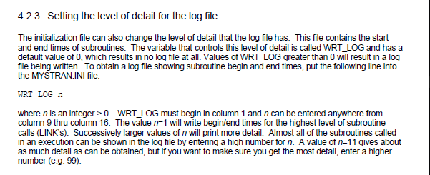

F04 is controlled by mystran.ini file, unless WRT_LOG set to >1 inside mystran.ini, F04 file is deleted at completion.