Appendix E: Derivation of RBE3 element constraint equations

Introduction

The RBE3 element is used for distributing applied loads and mass from a reference point to other points in the finite element model. The geometry and loads for a RBE3 are shown in Figure 1. Point d in the figure is the RBE3 reference (or dependent) point and is the grid where loads will be applied by the user. The RBE3 element will distribute these loads to other, independent, points i = 1,…,N, in the model, where N is the total number of independent grid points defined on the RBE3 Bulk Data entry. The RBE3 is not intended to add stiffness to the model as does a RBE2 element. As such, the RBE3 reference point should not be a grid that is attached to other elements in the model – it should be a stand alone grid only connected to other grids through the REB3 element definition. The following describes the nomenclature used in this appendix in deriving the “constraint” equations used in MYSTRAN for the RBE3 element.

Superscripts denote the location of a quantity:
“d” refers to the reference (or dependent) grid on the RBE3
“i” refers to the independent grids, the locations where the loads on point d will be distributed

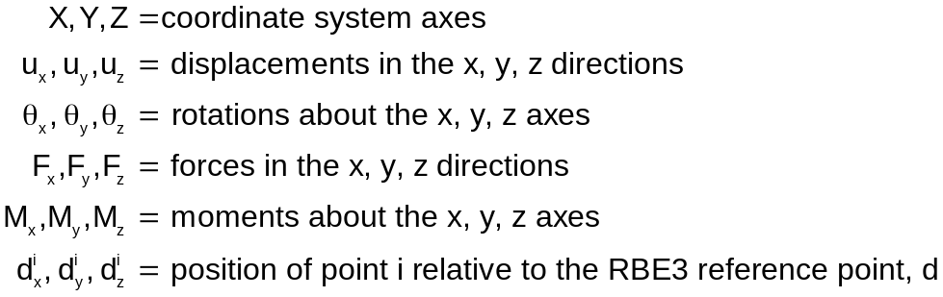

For the sake of simplicity and clarity, the following derivation of the RBE3 equations is done for conditions where the global coordinate systems of all grid points involved in the RBE3 are the same and are rectangular. The code in the MYSTRAN program is written for general conditions where the global system of all points may be different and non-rectangular.
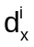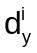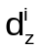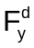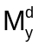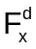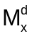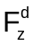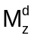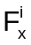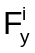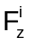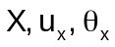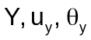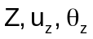
Point i (1 to N) is a typical point to which loads will be transferred from the reference point d via the RBE3
Point d is the RBE3 reference point shown with the loads applied. The loads will be transferred to the points i (typical point i shown above)
Fig 1: RBE3 geometry and loads

Equations for translational force components

In this section 3 equations will be developed that relate the forces applied at the RBE3 reference point to those where the loads will be distributed (points i = 1,…,N).

The sum of the forces on the points i = 1,…,N must equal the forces on the reference point d. Thus:

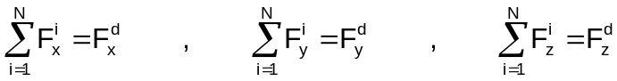

The moments at reference point due to the forces at the points i are:

Write the , etc, as:

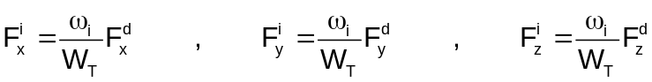

where 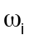 is the weighting factor (the WTi on the RBE3 Bulk Data entry) for the ith force and:

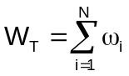

Equations 3 and 4 are sufficient for equations 1. Substitute equations 3 and 4 into 2 to get the following 3 equations:
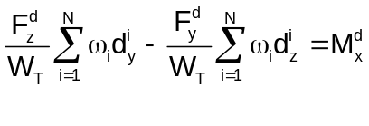
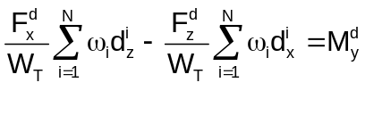
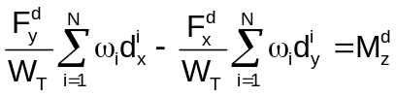

Define:

Using equation 8, equations 5-7 become:
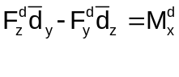
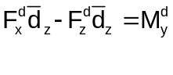
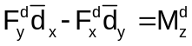

The work done by the forces and moments at the reference point, d, is 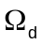:

where 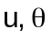 are the displacements and rotations of the reference point in the x, y, z directions. Similarly, the work done by the forces on the points I = 1,…,N is:

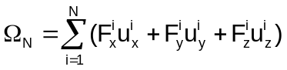
The 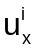, ec, are the displacements in the x, y and z directions at point I. Substitute equation 3 into 12 and 9, 10 and 11 into 12 and equate the work done by the two systems of forces:

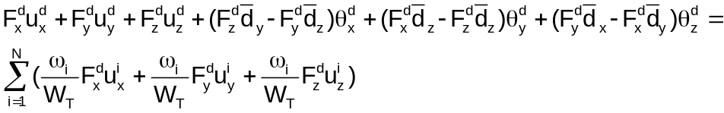

Rearrange:
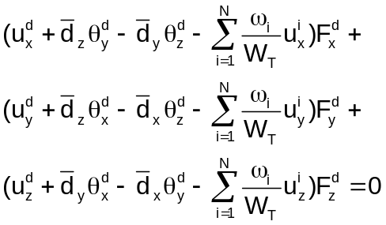
Since the , and are independent and, in general, not zero, equation 14 requires that:
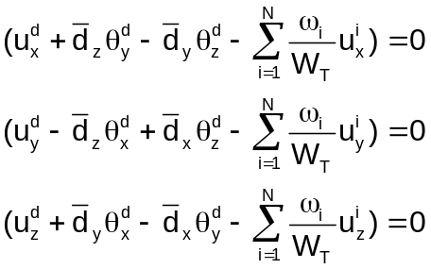

Equation 15 represents 3 constraint equations for the RBE3. However, there are only 3 equations and 6 unknowns. This will be resolved in the next section where we develop 3 more equations based on the moments at the reference point.

Equations for rotational moment components

In addition to the 3 equations developed in the last section there are also 3 equations that relate the moments applied at the RBE3 reference point to those where the loads will be distributed (points i = 1,…,N).

Figure 2 shows how the forces in the y-z plane relate to the RBE3 reference point moment about the x axis:

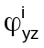
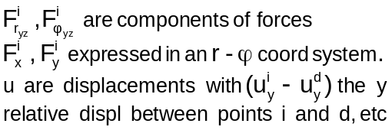
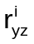
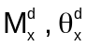
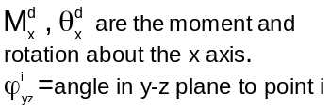

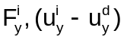
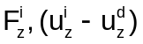
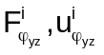
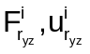
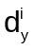
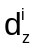
radius to point i from ref point d in the y-z plane
Figure 2: Relationship of moments and forces in the y-z plane

Using the 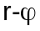components of the forces, the moments about the x axis of the forces at the i = 1,..,N points is:

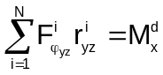

As before, express the forces at the i points using the weighting factors, :

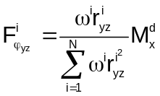

Note that if equation 17 were substituted into 16 it would be seen that 17 is a valid representation of the tangential force components.

The work done by 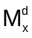 must equal that due to all of the 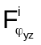, or:

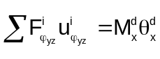

where 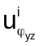is the tangential component of displacement at independent grid i in the y-z plane. Substitute equation 17 into 18:

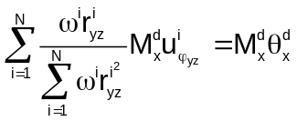
or:
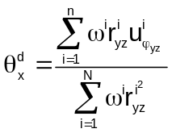

From Figure 2 it can be seen that:

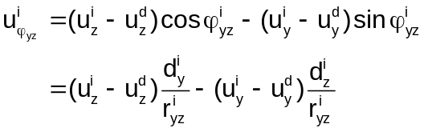
Therefore:
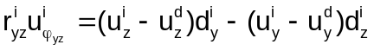
Define:

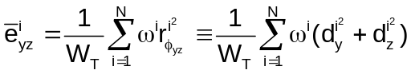
Substitute equations 20 and 21 into 19

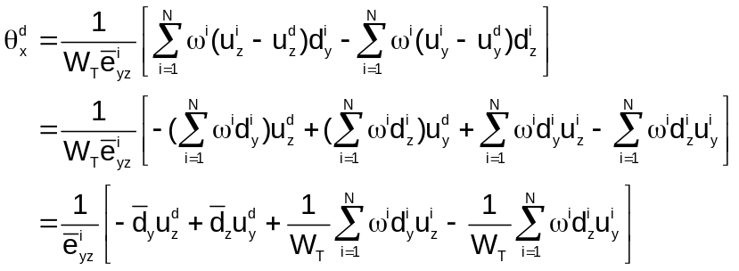

In reference to Figures 3 and 4, define:
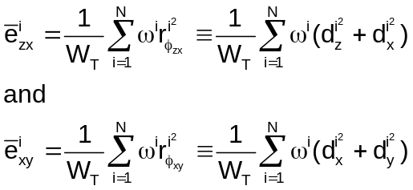

Then, 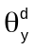and 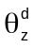 , by similar reasoning for 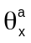 in equation 22 are:

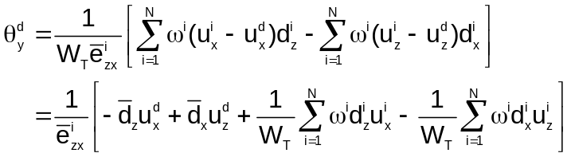

and
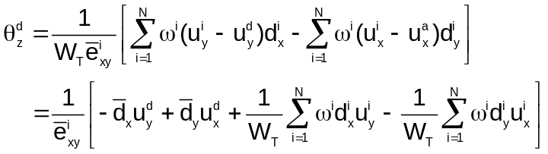
Thus, for the rotations:

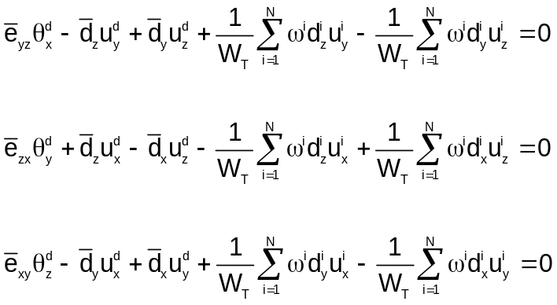

Equations 15 and 26 constitute 6 equations in the 6 unknown displacements and rotations at point a. They are summarized in matrix notation below at the end of this appendix.

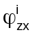
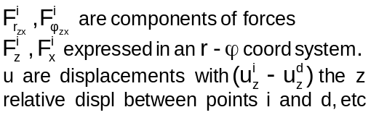
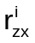
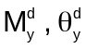
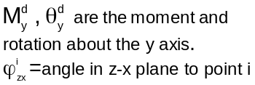

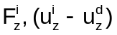
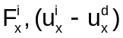
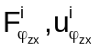
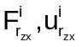
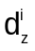
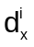
radius to point i from ref point d in the z-x plane
Figure 3: Relationship of moments and forces in the z-x plane

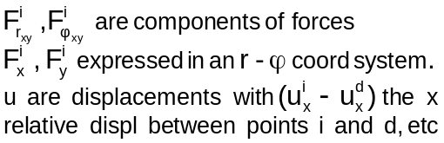
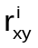
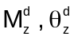
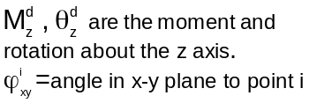
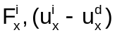
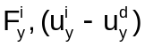
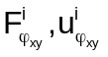
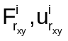
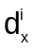
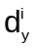
radius to point i from ref point a in the x-y plane
Figure 4: Relationship of moments and forces in the x-y plane

Summary of equations for the RBE3

In general, the equations for one RBE3 can be represented in matrix notation as:

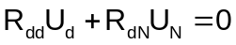

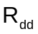is the square, d x d, matrix of coefficients for the dependent (or reference) grid denoted as REFGRID in field 4 of the RBE3 Bulk Data entry. It can have up to d = 6 dependent components (REFC in field 5). For all 6 components, and are:

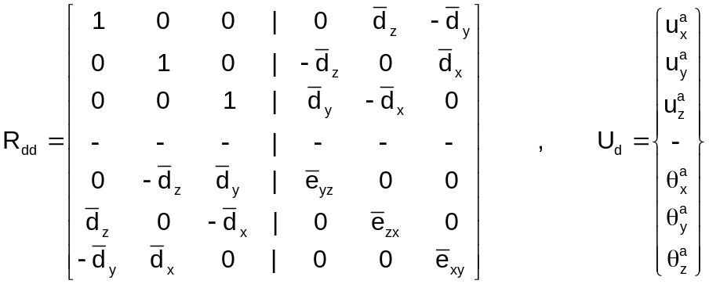

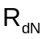is a rectangular, d x N, matrix of coefficients for the N independent grids on the RBE3
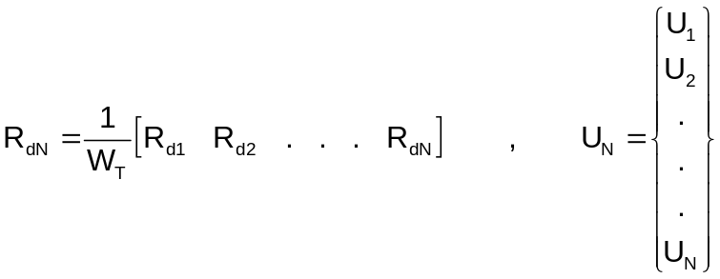

A typical sub-matrix in 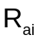is of size d by 3 with and . For d = 6:

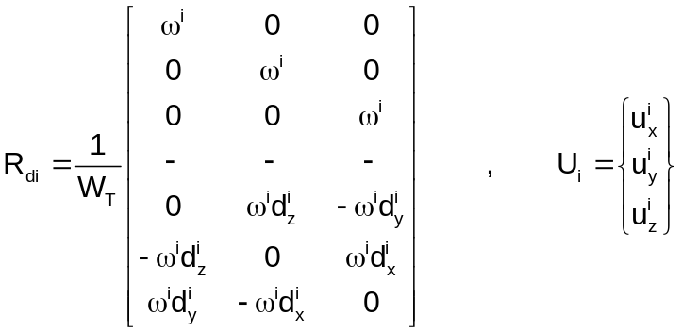

A RBE3 is processed by solving equation 27 for the dependent degrees of freedom, , in terms of the independent degrees of freedom, .

