Transformation of a stress tensor by a plane rotation

Define a stress tensor 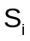 where the subscript i will indicate the coordinate system that the stresses are in. Then:

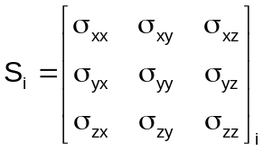

where 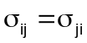and, for example, 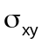 is the x-y plane shear stress (also called 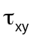)

We would like to express the stresses in coordinate system 2 as a transformation from system 1 where system 2 is rotated through an angle in the x-y plane from system 1 as shown below (note: z is perpendicular to the diagram):

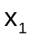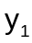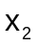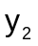

Since stress is a tensor, the coordinate transformation follows the rule:

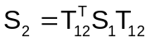

where 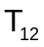is the plane coordinate transformation matrix which expresses coordinate system 1 in terms of coordinate system 2:

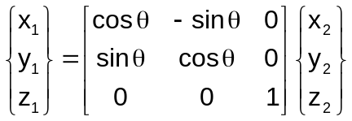

or

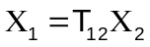

where:
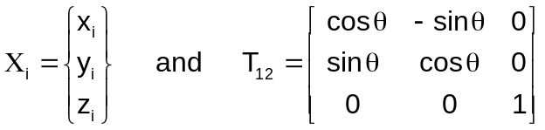

Performing the triple matrix product in equation 1.2 we can write a vector of the 6 stresses in coordinate system 2 in terms of those in system 1. Changing notation to the more familiar terms for stresses this becomes:

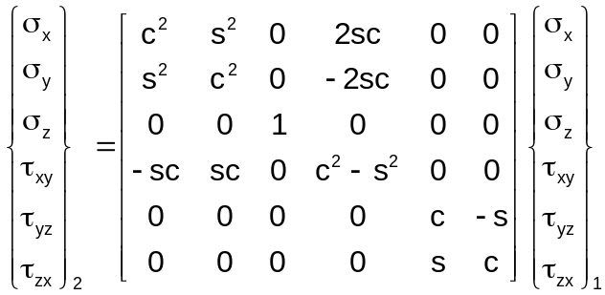
where
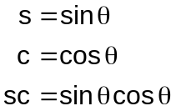

To demonstrate that equation 1.6 gives the more familiar standard equations for 2D stress transformations let us rewrite the 1st, 2nd and 3rd rows from equation 1.6 using some familiar trigonometric relationships:

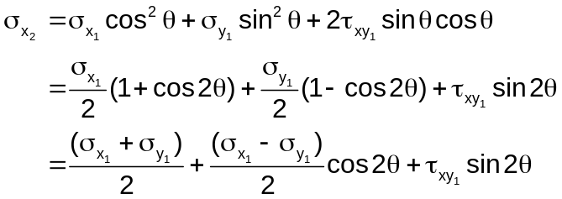

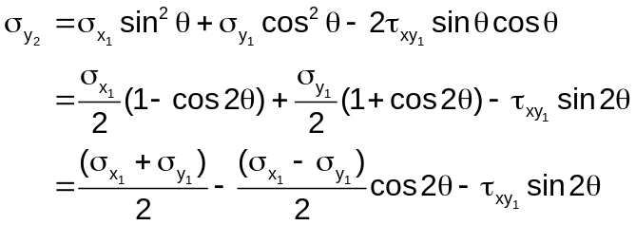

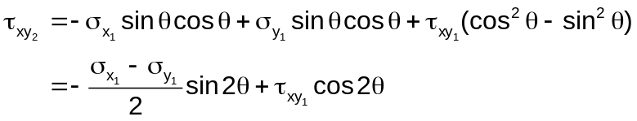

Equations 1.8, 1.9 and 1.10 are expressed in the more familiar plane stress coordinate transformations so that equation 1.6 is validated for at least this simple test.

Note that the transverse shears, 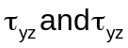, can be written in a more convenient format. From the 5th and 6th rows of equation 1.6:

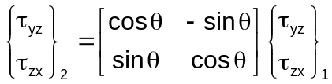

Rearranging the rows and renaming 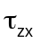 as 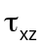, equation 1.11 can be written as:

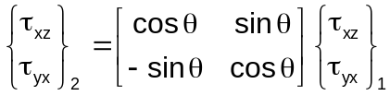

and 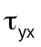are the two shear stresses that are quoted in the literature as plate transverse shear stresses.

The above equations apply equally well to strain coordinate transformations

Dr Bill Case, Oct 4 2007

