Appendix C: Equations for element stress/strain recovery

General discussion

For the 2D plate elements and 3D solid elements arrays called STRAIN and STRESS are calculated for each element. For 1D elements.. like the rod and beam. only the STRESS array is calculated. Both arrays STRAIN and STRESS can contain up to 9 rows and there is one of each these calculated for every subcase. The STRAIN and STRESS arrays are further subdivided as shown below:

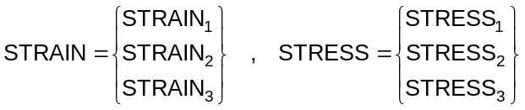

where STRAIN_{i} and STRESS_{i} each have 3 rows

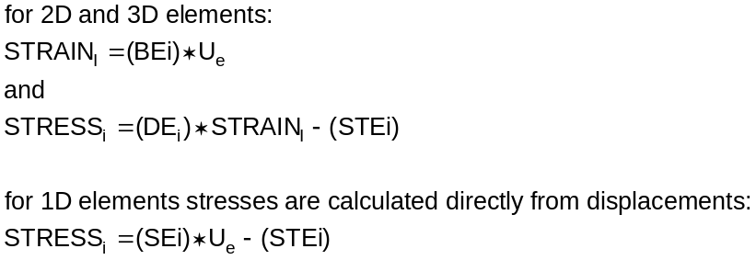

U_{e} are the displacements of the nodes of the element in the local element coordinate system (see Figures 3-2 through 3-6 in the main body of this manual) and are obtained from the G-set displacements, the solution for which is discussed in Appendix B. These G-set displacements for the nodes of an element are transformed to the local element coordinate system to obtain U_{e} which has a number of rows equal to 6n where n is the number of nodes for the element (e.g. n=4 for a quadrilateral plate element). There is one U_{e} for each subcase in the solution. The BE_{i} arrays each have 3 rows and 6n columns and are based on the strain-displacement relationships for individual elements. The SE_{i} are equal to material matrices times the BE_{i.} The STEi arrays contain the thermal stress effects, if there are any, and have 3 rows and as many columns as there are thermal subcases.. That is, if the input data deck has 5 subcases and two of these have thermal loads, then STE_{i} will have only 2 columns while U_{e} will have 5 columns. If a user outputs the SE_{i} and STE_{i} arrays, it is their responsibility to keep track of which subcases the columns of STE_{i} belong. MYSTRAN does this internally for its stress output calculations.

The following sections show what is contained in arrays STRESS_{i} for each of the element types. In that manner, it will be obvious how MYSTRAN uses the SEi and STEi arrays, generated internally in MYSTRAN, to obtain stresses. If desired, they are available to be output to a text or unformatted binary file through use of the Case Control entry ELDATA. They need not be output for the user to obtain element stresses, however, which are available in the normal text output file through use of the Case Control entry STRESS.

Rod element

The rod geometry and loading is shown in Figure 3-2 in the main body of this manual. It is a very simple element and has only two stresses that can be output: the axial stress and the torsional stress. It only uses the first 2 rows of array STRESS₁ with row 1 being the axial stress and row 2 the torsional stress. Array STRESS₁ is:

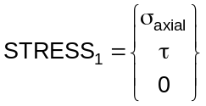

As an example of what is in arrays SE1 and STE1 for a simple element, the arrays are shown below for this rod element. More complicated elements won’t have a simple closed form for these matrices and will not be shown.

Array SE1 for the rod element is:

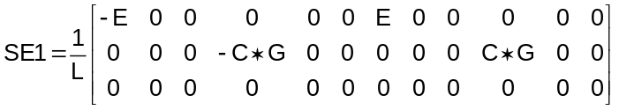

E and G are Young’s modulus and shear modulus from the Bulk Data material entry for the element, L is the element length and C is the torsional stress recovery coefficient from a PROD entry.

Array STE1 would have the following column for each subcase that has a thermal load:

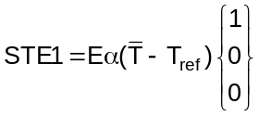

and T_{ref} are the coefficient of thermal expansion and reference temperature from the material Bulk Data entry for the element and is the average element temperature for the thermal subcase.

Bar element

The bar element geometry and loading is shown in Figures 3-3 and 3-4 in the main body of this manual. For the bar element, array STRESS uses all 3 rows of STRESS₁ and STRESS₂. The first row of STRESS₁ contains the actual axial stress in the bar and the third row of STRESS₂ contains the actual torsional stress. The second and third rows of STRESS₁ and the first two rows of STRESS₂ are not actual stress values. Rather, they are the four independent parameters needed to determine the bending stresses at points in the bar cross-section. Thus:

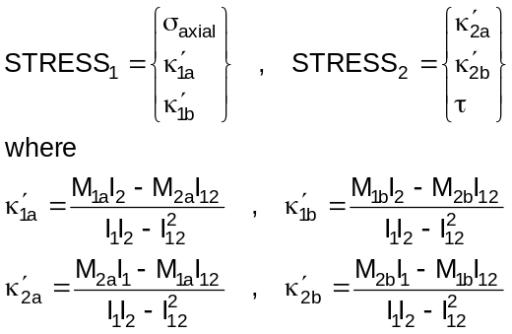

and

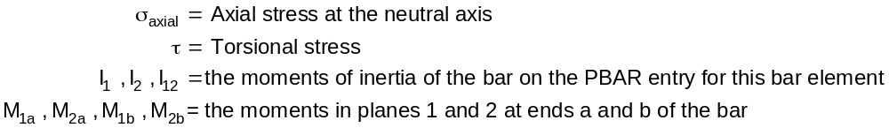

This can be put into the form of equation 9.2 as:

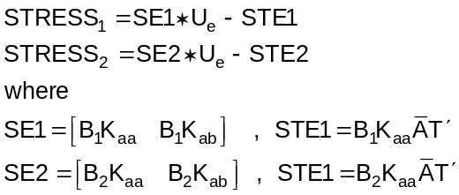

K_{aa} and K_{ab} are 6x6 partitions from the 1st 6 rows of the bar element stiffness matrix and B₁, B₂ and
are matrices of element properties as shown below:

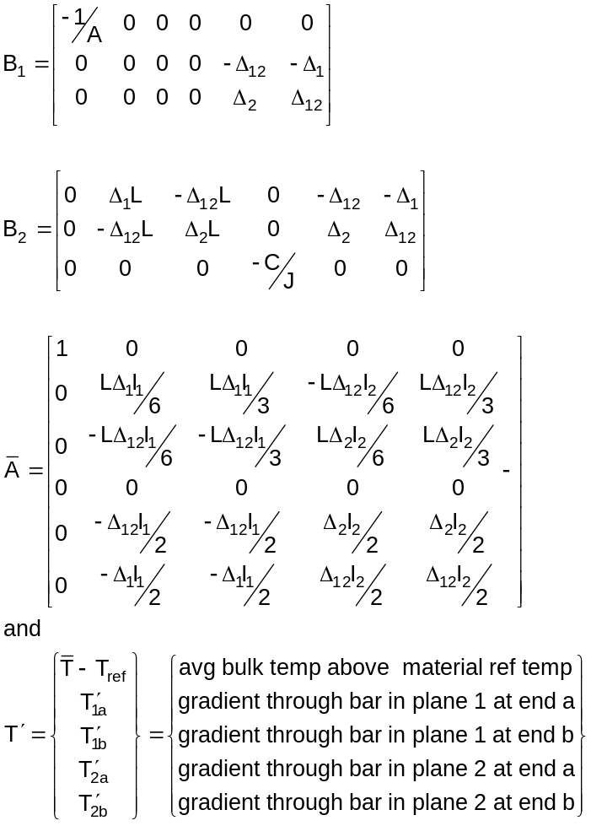

with the following bar properties:
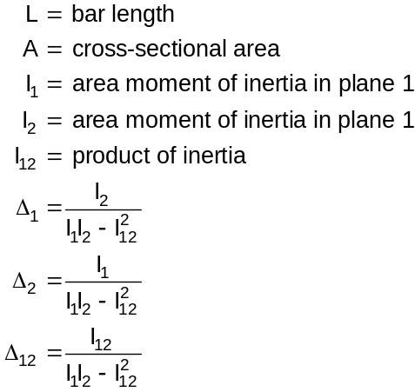

Stresses due to bending (i.e. not including axial stress at the neutral axis) at ends a and b of the bar element are obtained from:

where 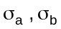 are the bending stresses at ends a and b of the bar and 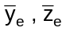 are the coordinates of a point on the bar cross section as measured in the local element coordinate system (see Figure 3-3 in the main body of this manual). It should be noted that temperature distributions through the depth of the bar that are higher order than linear are ignored

Plate elements

Triangular and quadrilateral plate element geometry, loading and stress conventions are shown in Figures 3-5 and 3-6 in the main body of this manual. They can use all three of the STRESS_{i} arrays.

Membrane stresses

STRESS₁ contains the membrane stresses (at the plate mid-plane)

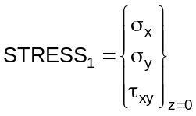

This can be put into the form of equation 9.2 as:

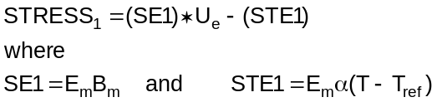

E_{m} is the 3x3 membrane material matrix, B_{m} is the element membrane strain-displacement matrix (developed internally in MYSTRAN), is the 3x1 vector of coefficients of thermal expansion for the material, T is the element average bulk temperature and 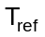 is the reference temperature for the element material.

Bending stresses

STRESS₂, times a fiber distance, contains the stresses due to bending, where:

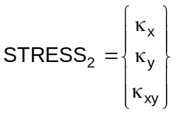

This can be put into the form of equation 9.2 as:

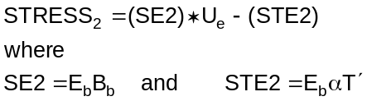

E_{b} is the 3x3 bending material matrix, B_{b} is the element bending strain-displacement matrix (developed internally in MYSTRAN), is the 3x1 vector of coefficients of thermal expansion for the material and 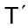 is the temperature gradient through the thickness of the plate element.

Combined membrane and bending stresses

The total bending and in-plane shear stresses at a fiber distance z are obtained from STRESS₁ and STRESS₂ as:

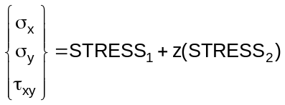

Transverse shear stresses

The average transverse shear stresses through the thickness of the plate (for TRIA3 and QUAD4 elements only) are obtained from STRESS₃:

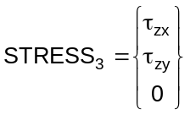

This can be put into the form of equation 9.2 as

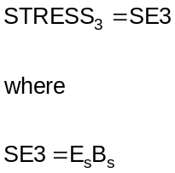

E_{s} is the 3x3 transverse shear material matrix and B_{s} is the element transverse shear strain-displacement matrix (developed internally in MYSTRAN).

The transverse shear stresses are not output in the normal output file even if stress output is requested in Case Control. However, the transverse shear stress resultants (integrals of shear stress through thickness) are output if there is a request in Case Control for element engineering forces

Solid elements

For the 3D solid elements HEXA, PENTA and TETRA arrays STRAIN and STRESS contain only the 6 actual strains and stresses for a 3D solid:

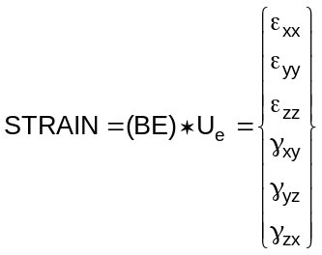

The BE are strain-displacement matrices that are based on the shape functions chosen for the particular 3D solid element. Once the strains have been calculated the stresses are determined from:

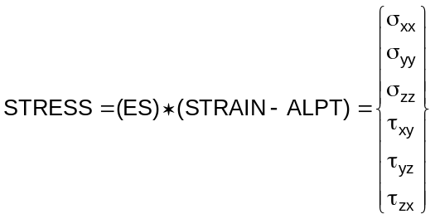

ES is the 6x6 material matrix for a solid and ALPT is the thermal distortion portion of the strains. For a homogeneous isotropic material these are:

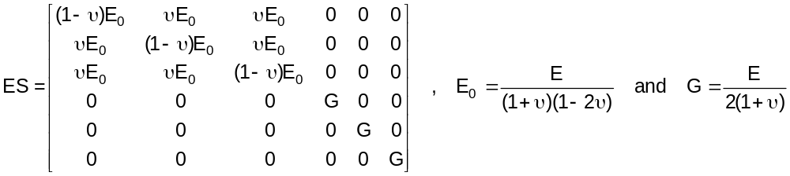

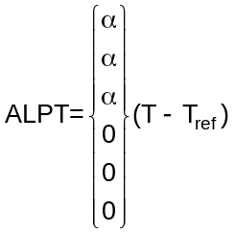

MYSTRAN does allow anisotropic element properties for solids and, in that case, ES and ALPT are different

