Corrected: 7/12/2020
PID must be unique among all PSHEAR property entries (minor).

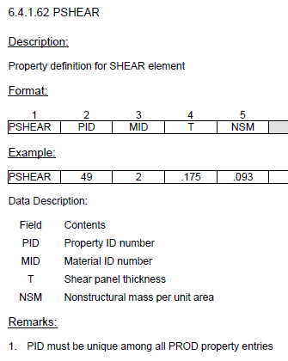

Corrected: 7/12/2020

GRID X2 value is an integer

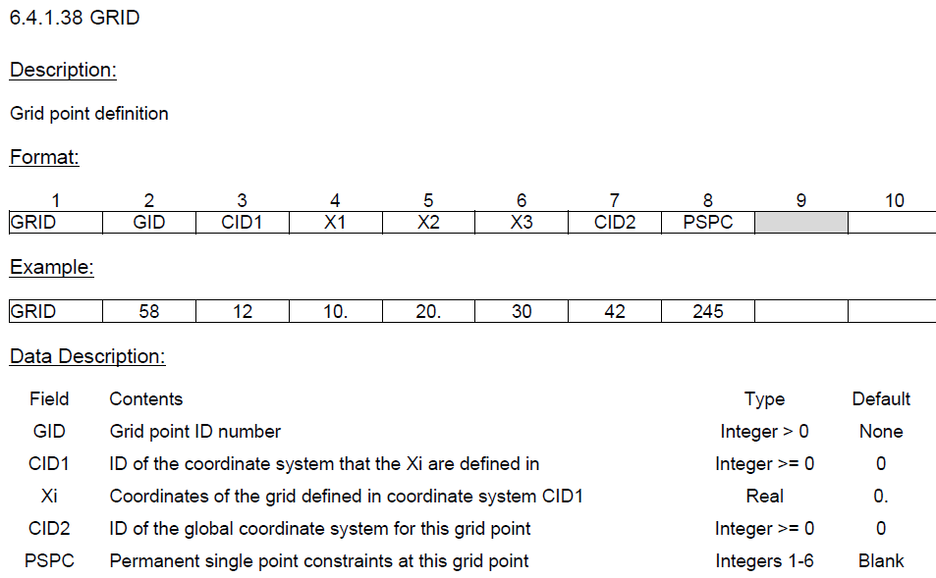

Corrected: 7/12/2020

Shear center for T, T1, T2 sections on PBARL is incorrect. It should be located at the intersection of the web and flange (major).
DIM2 on T1 is listed as DIM (minor).

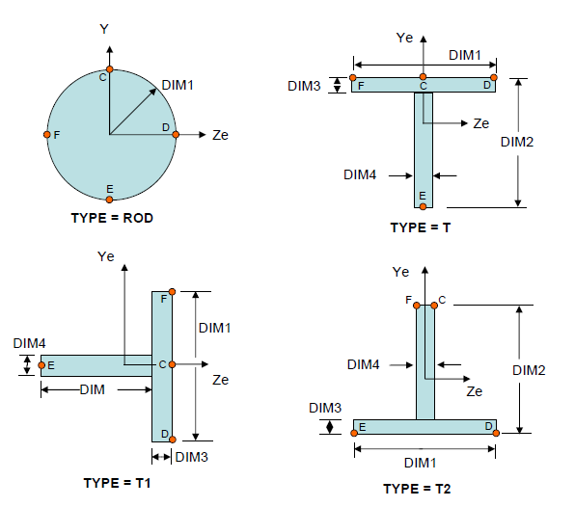

Per MSC QRG 2019.2

