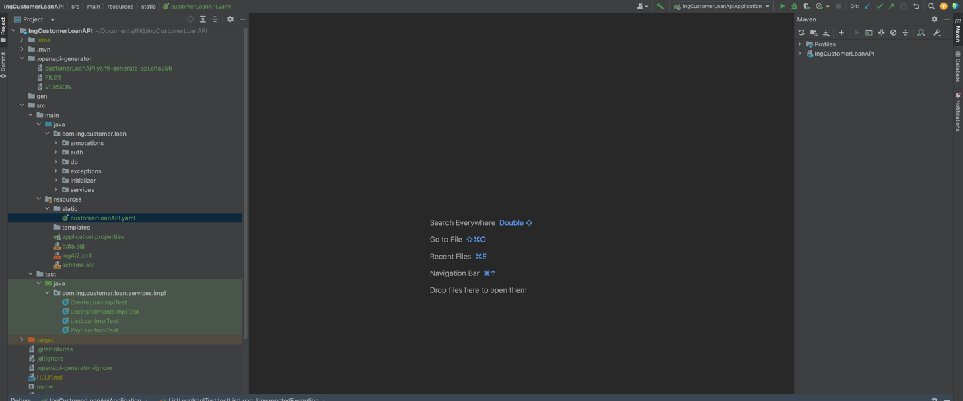

After cloned the project,

Build the application with below maven command;
mvn clean install
the project can be run directly because tomcat server is embeded.
After running “IngCustomerLoanApiApplication” application, swagger and h2b can be available below links;
Swagger link;
http://localhost:8080/swagger-ui/index.html

ADMIN CREDENTIAL: ADMIN/adminpass

h2db link;
http://localhost:8080/h2-console
DB CREDENTIAL: sa/sa

Initially, there are three customers, and these customers have no loans yet.
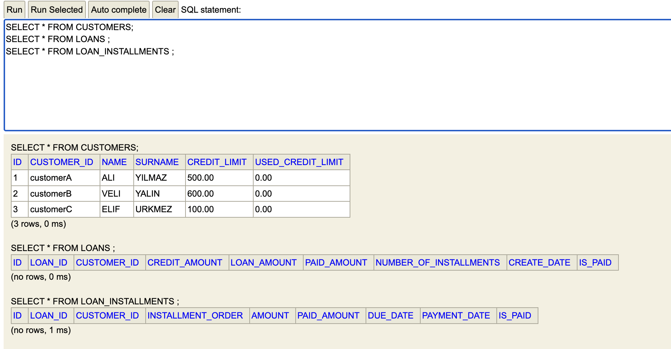

- createLoanAPI

With “createLoanAPI”, a loan can be requested with below request example.
(Note: to test API, you need to click “try it out” button)
requestBody:
{
"customerId": "customerA",
"LoanAmount": 200,
"interestRate": 0.5,
"installments": 6
}
And, press “Execute” button;

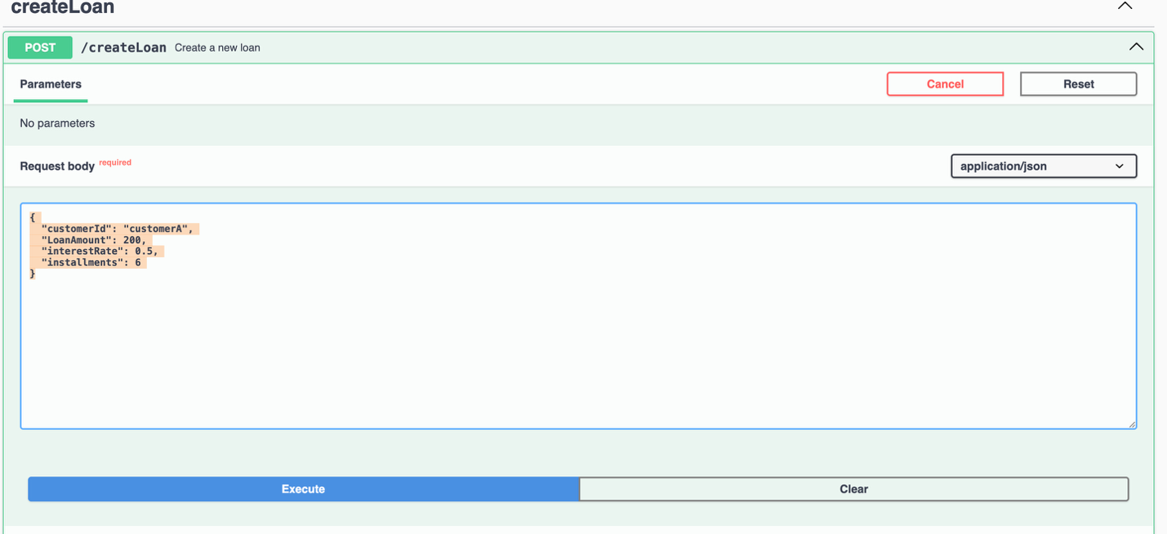

If a loan is created, LoanId and totalLoanAmount are returned
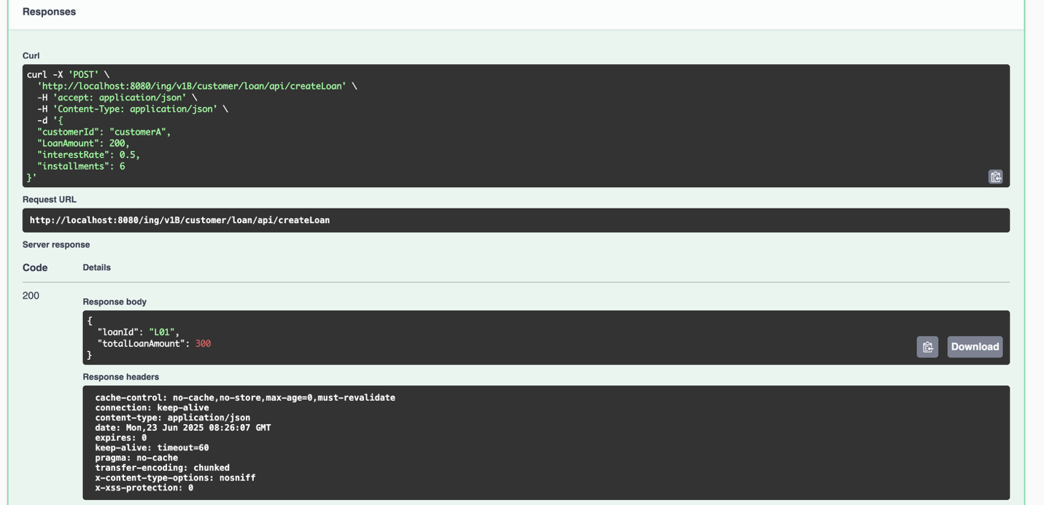
If the requested amount is exceed customer limit or any error is thrown;
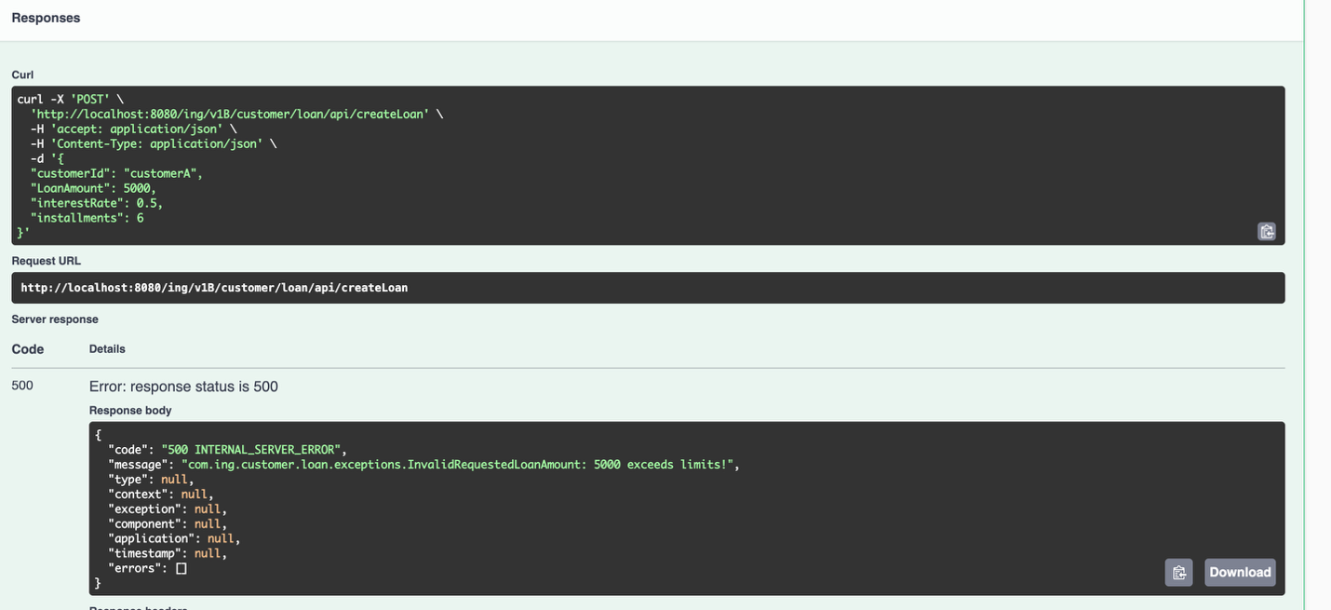

Important!: if any service returns an error, below object is responsible to pop up;
{
"code": "403",
"message": "Internal error in the service",
"type": "Null pointer",
"context": "Process query action",
"exception": "NullPointerException",
"component": "ProcessImpl",
"application": "Process_Backend",
"timestamp": "2019-01-13T18:27:41.511Z",
"errors": [
"string"
]
}

Loan Request Restrictions;
If you request different number of installments than 6,9,12,24, response should be like this;
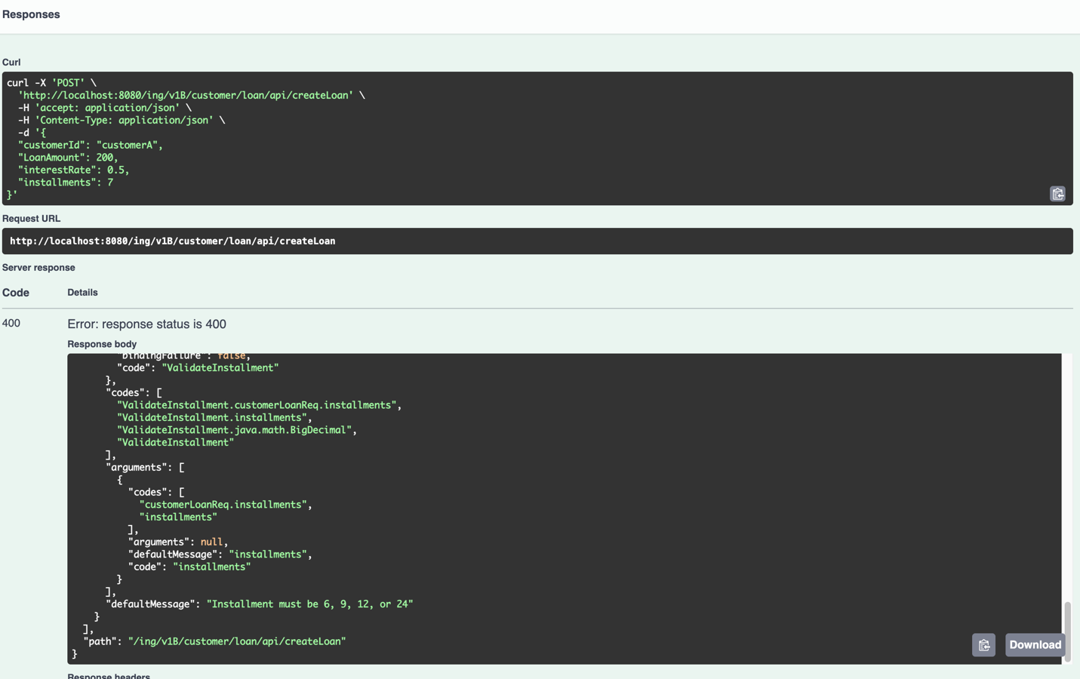

Because, number of installements and interest rate are controlled by custom and exist annonations.

Here are the tables are looked after successed loan request;

SELECT * FROM CUSTOMERS;
SELECT * FROM LOANS ;
SELECT * FROM LOAN_INSTALLMENTS ;

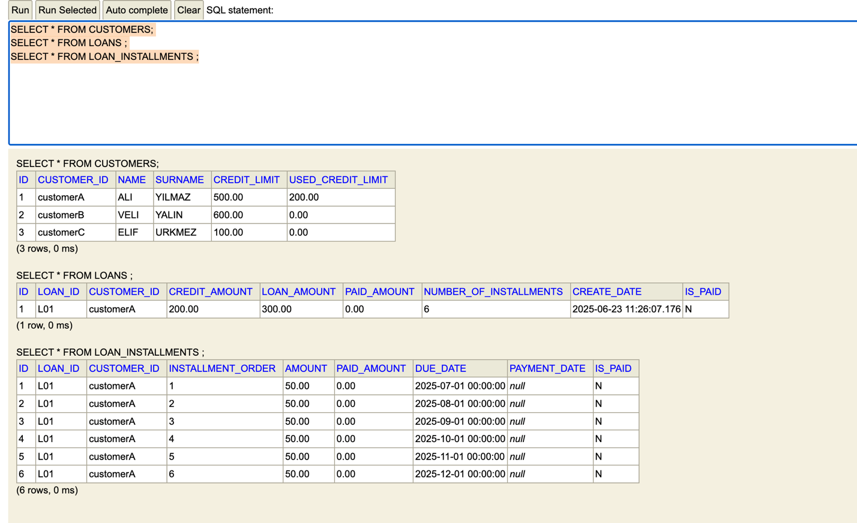

- listLoanAPI
With “listLoanAPI”, customer loan/loans can be listed;

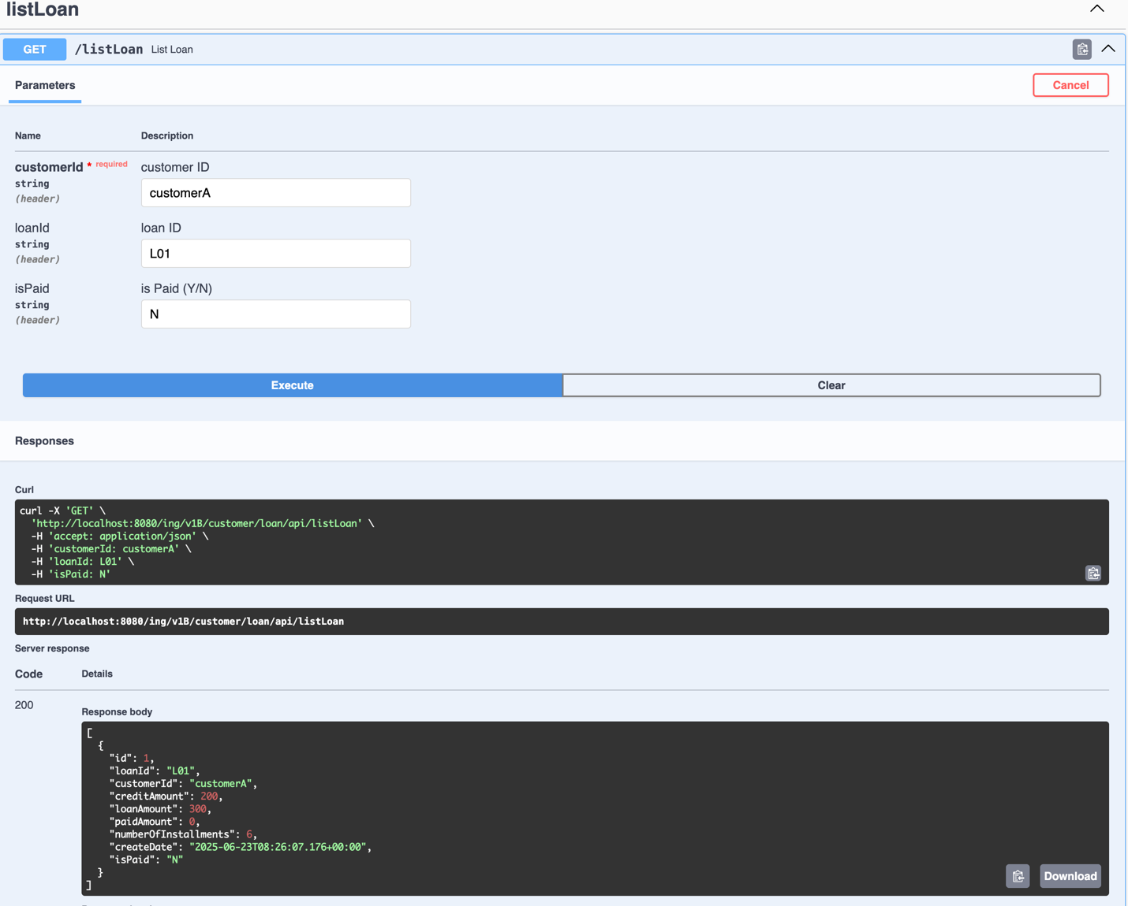

- listInstallmentAPI

With “ListInstallmentAPI”, customer paid/unpaid installments can be listed;
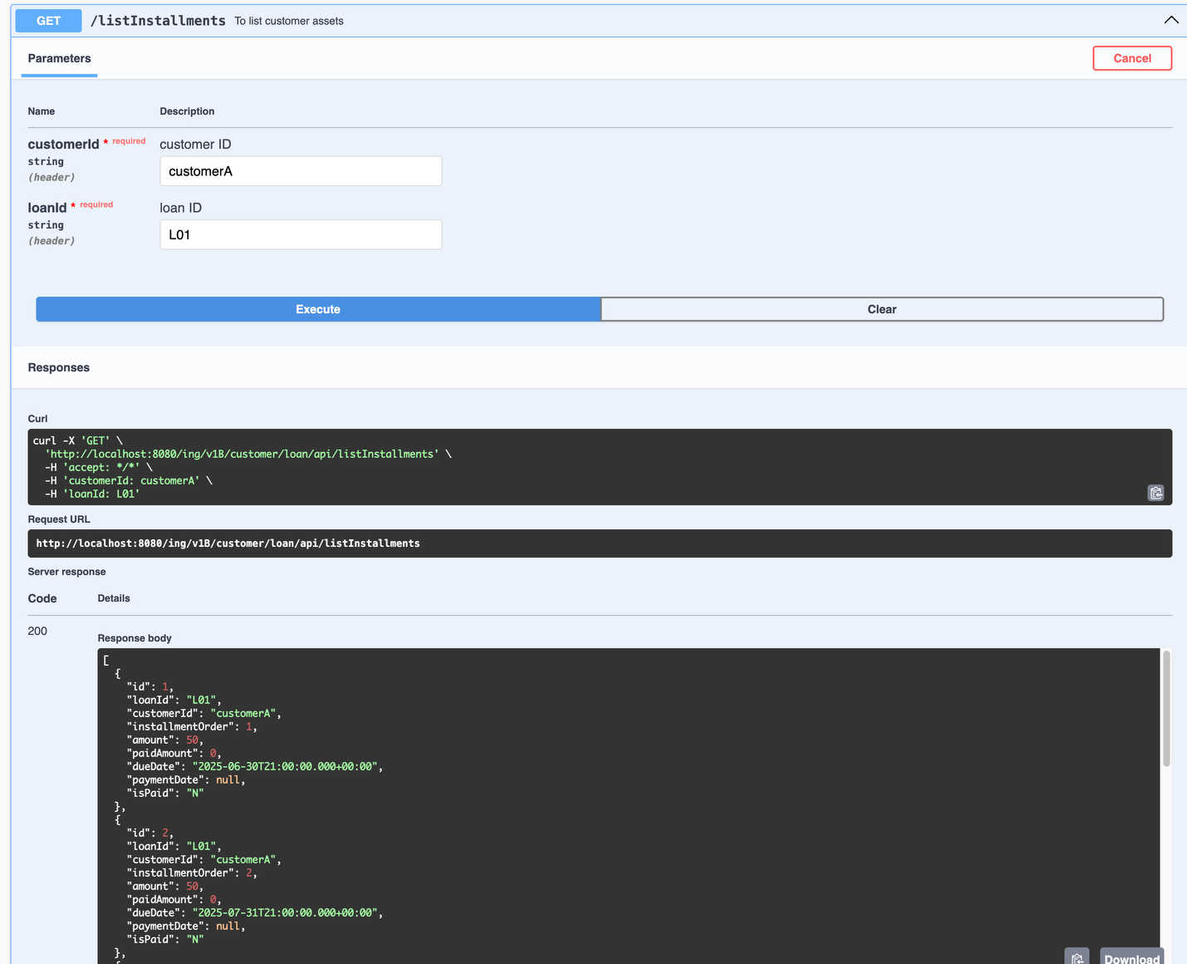

- payLoanAPI

With “payLoanAPI” , the installments can be paid.

RequestBody:
{
"loanId": "L01",
"customerId": "customerA",
"paidAmount": 60
}
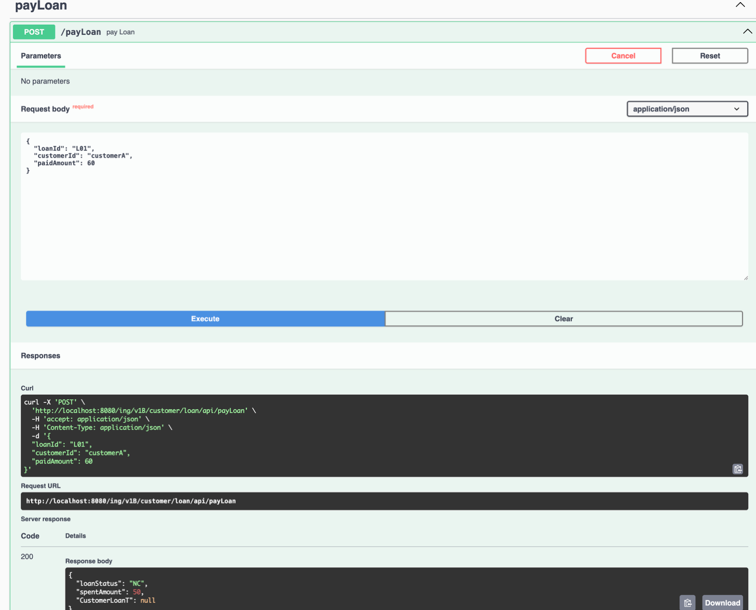
If the payment is succeed, response body should be like;

ResponseBody;
{
"loanStatus": "NC",
"spentAmount": 50,
"CustomerLoanT": null
}
loanStatus: “NC” means, installment successed, but all installments have not been completed yet.
spentAmount: means spent amount for the paid installment/installments

The screenshot for the successed payment on DB;
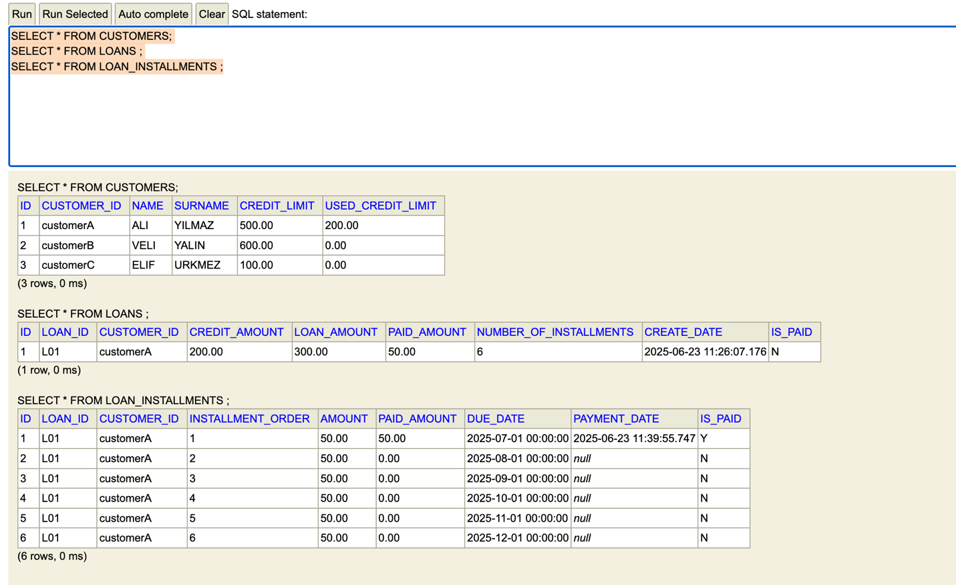

Payment Restrictions;
- Even you exceed to pay installment amount, and not enough to pay next installments or the installmenst are 3 months further, the payment is executed for only related installment/installments.
Note: Customer can close even more than three installments (passed due date installments + further installments)
- If paid amount is not enough, request is below;
{
"code": "500 INTERNAL_SERVER_ERROR",
"message": "com.ing.customer.loan.exceptions.InvalidPaidLoanAmount: You cannot pay less than 50.00",
"type": null,
"context": null,
"exception": null,
"component": null,
"application": null,
"timestamp": null,
"errors": []
}

Important Note!
If you want to test to complete the all installments for test purpose;

You need to commend below line in “PayLoanImpl” class

So;

After all installments are paid,

- “used_credit_limit” column is updated on “Customer” table
- “is_paid” and “paid_amount” columns are updated on “Loans” table
- “is_paid” and “payment_date” columns are updated on “Loan_installments” table

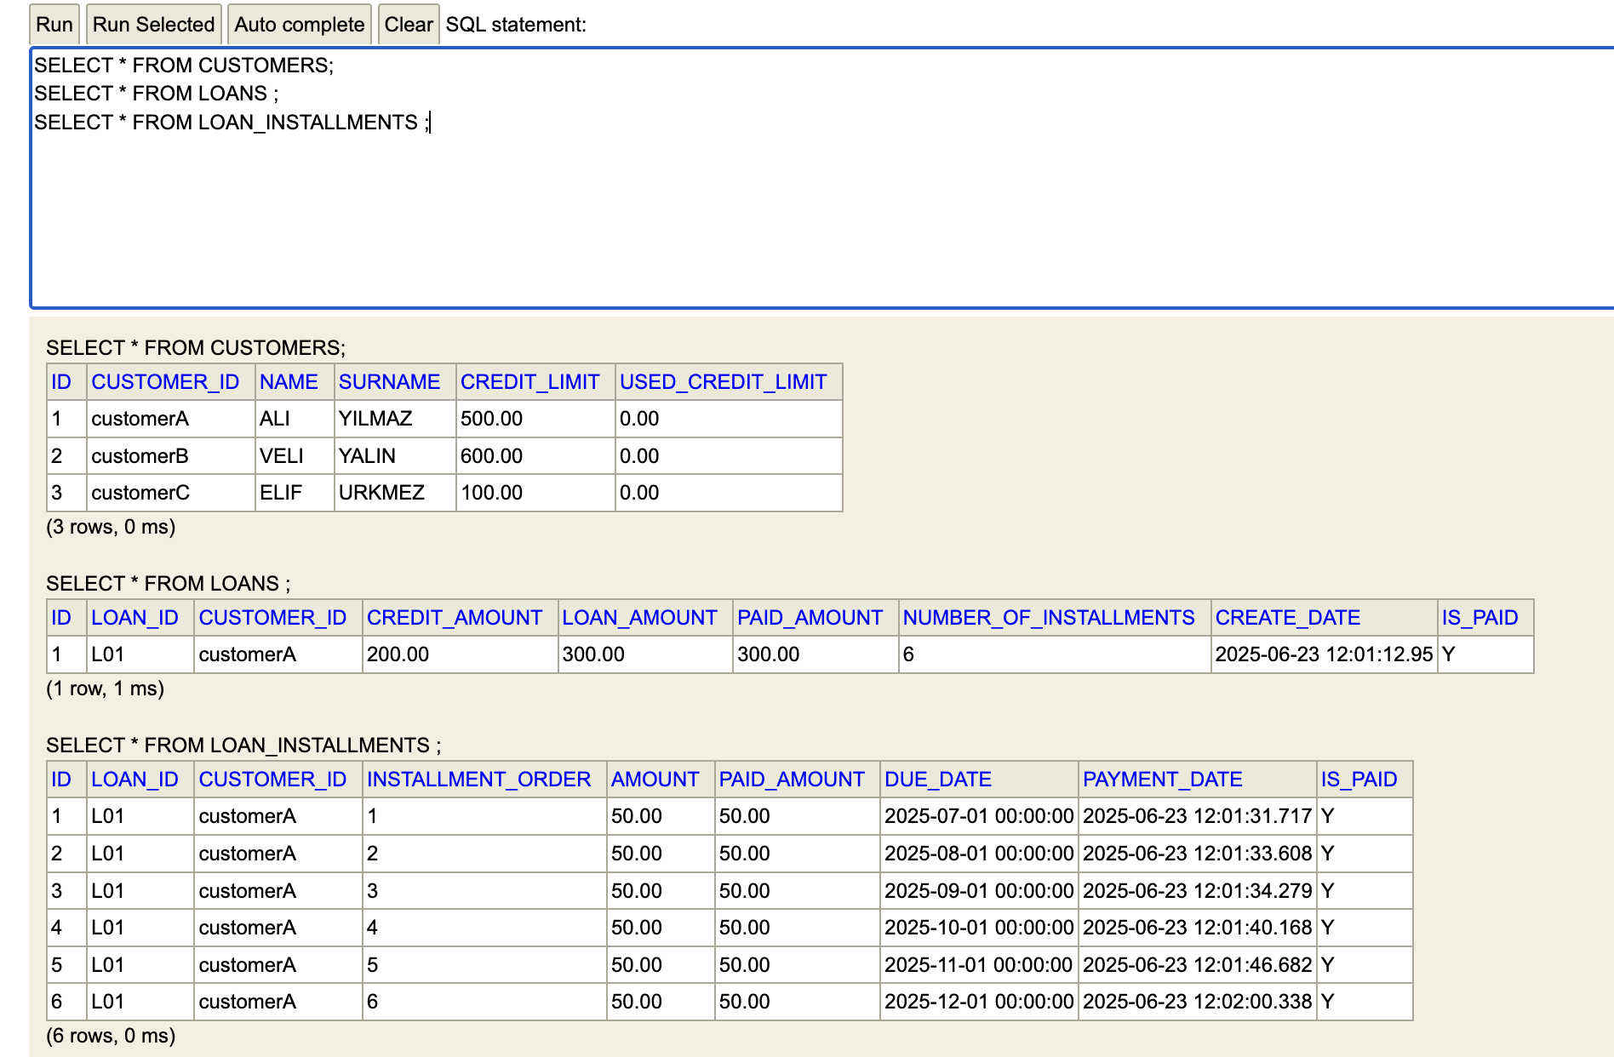
And the response of the service;

{
"loanStatus": "C",
"spentAmount": 50,
"CustomerLoanT": null
}
BONUSES:

Bonus1: If you login as ADMIN who has ADMIN_ROLE, application operates related customer in “customerId” property in the request. If not, the application checks logined user.
Bonus2: If the user pays earlier than dueDate, “0.001”*per day discount applied. If an installment is paid after dueDate, penalty will be applied!

Here is the award example as below;

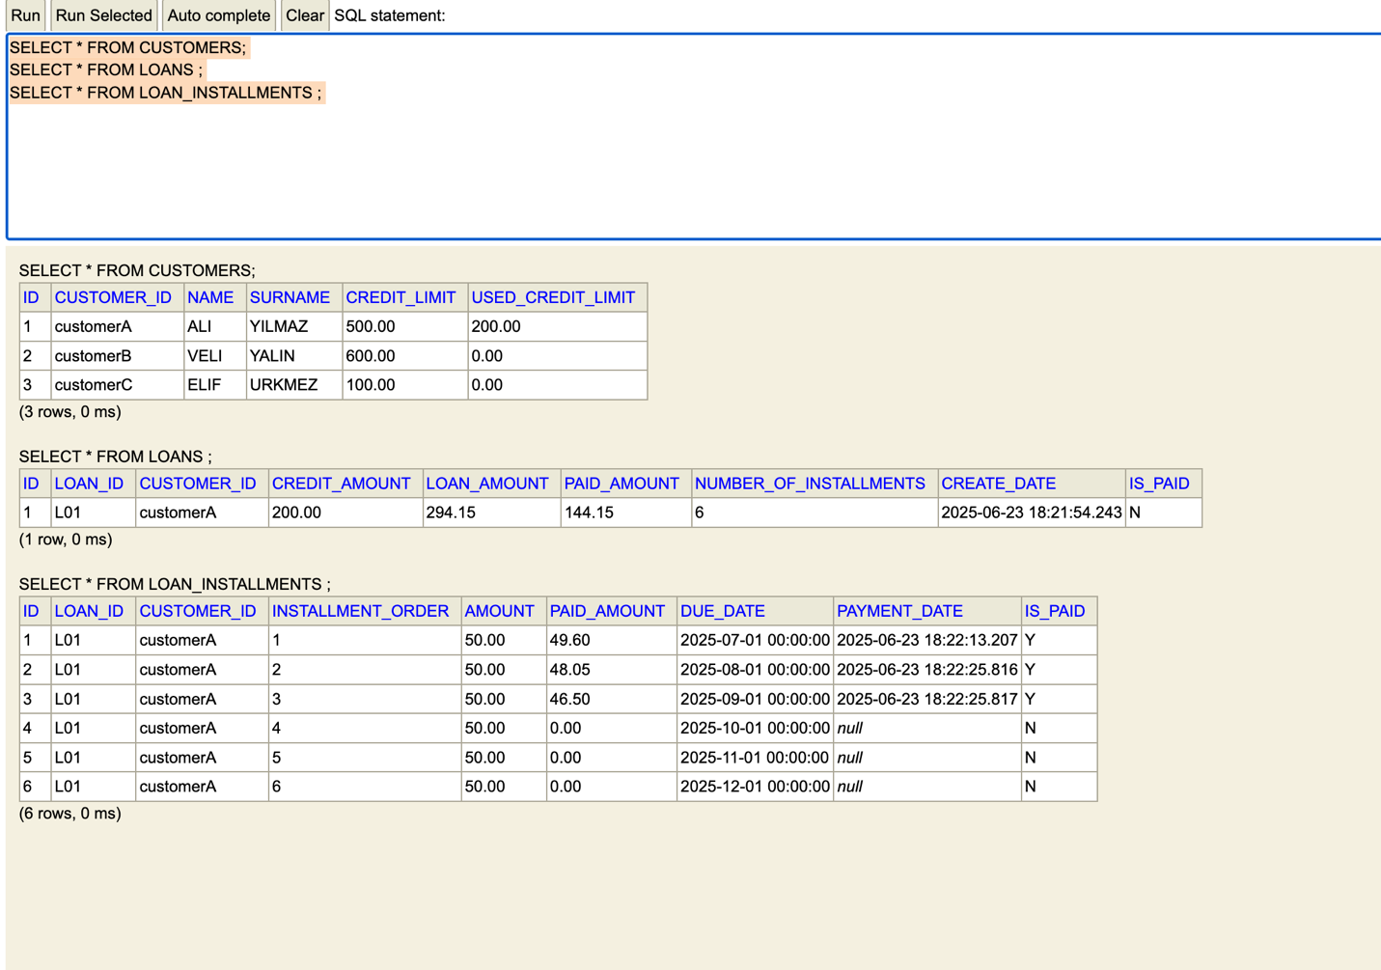

If payable three months rule is removed for test purpose, the award can be applied to all payments, and “paid_amount” and “loan_amount” column are updated on “loans” table.

