Exploratory Data Analysis for Fraudulent Job Posting Detection

Employment Scam Aegean Dataset - EMSCAD

Prepared by: Manne Yashwanth Manoj
20 August 2026

This report presents dataset quality, class imbalance, missing-value behaviour, textual patterns, categorical risk factors, and data-leakage findings.

Executive Summary
- The dataset contains 17,880 job advertisements.
- Only 866 advertisements are fraudulent, producing strong class imbalance.
- Accuracy alone is unsuitable because an all-genuine model reaches about 95.16 percent accuracy.
- Missing company profiles and absent company logos are strong fraud indicators.
- Fraudulent descriptions and requirements are generally shorter.
- Work-from-home and no-experience language show high fraud risk.
- Repeated advertisements and text templates create serious leakage risk.
- The primary evaluation should use a group-aware split and independent real-world testing.

Important methodological decision
For comparison with existing papers, a standard stratified evaluation may be reported separately. However, the main research claim should use leakage-safe group-aware validation so that repeated advertisements and templates cannot appear in both training and testing data.

Dataset Overview

Metric | Value
Total rows | 17880.00
Total columns | 18.00
Genuine posts | 17014.00
Fraudulent posts | 866.00
Fraud percentage | 4.84
Exact duplicate rows | 0.00
Extra content duplicate copies | 281.00

The fraudulent class represents approximately 4.84 percent of all records. Therefore, precision, recall, F1-score, PR-AUC and MCC should be treated as primary evaluation metrics.

Target-Class Distribution
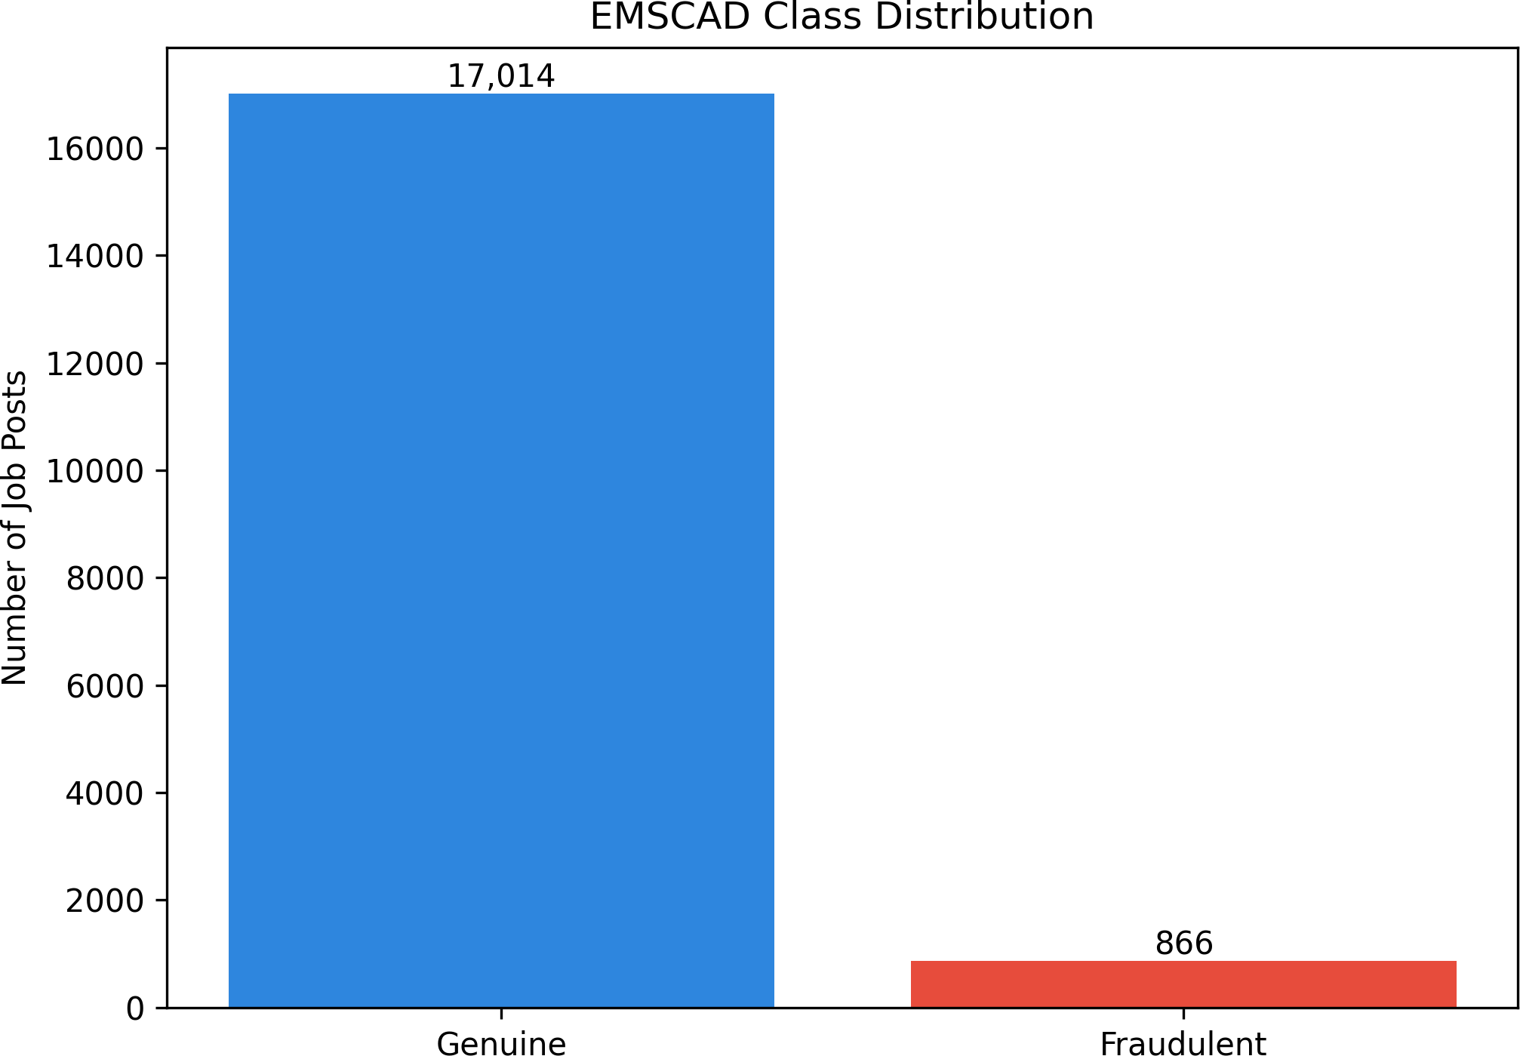
The dataset is highly imbalanced. A high accuracy score does not automatically mean that fraudulent jobs are detected.

Missing-Value Distribution
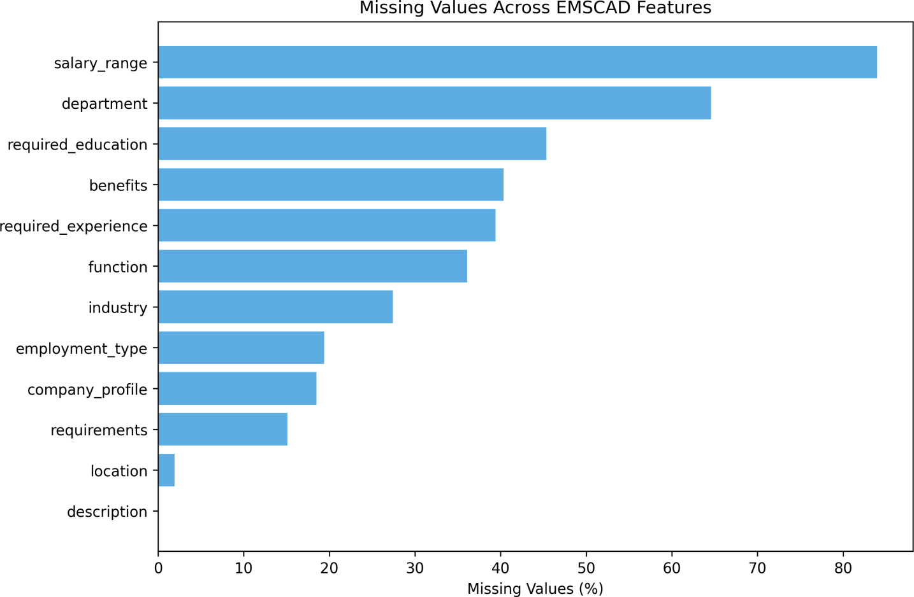

Salary range and department have the largest missing-value percentages. Missing status should be preserved as a model feature.

Binary Metadata Signals
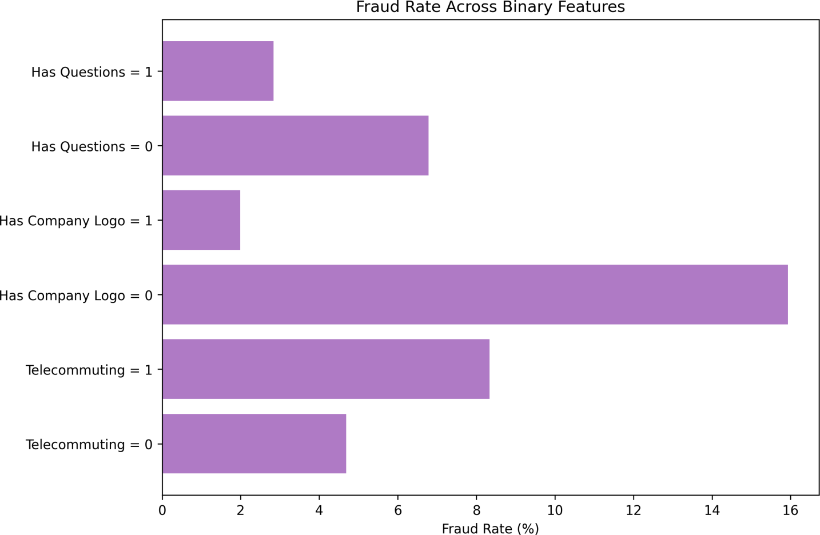

Company-logo availability, screening questions and telecommuting status provide useful metadata signals.

Missing-Field Count
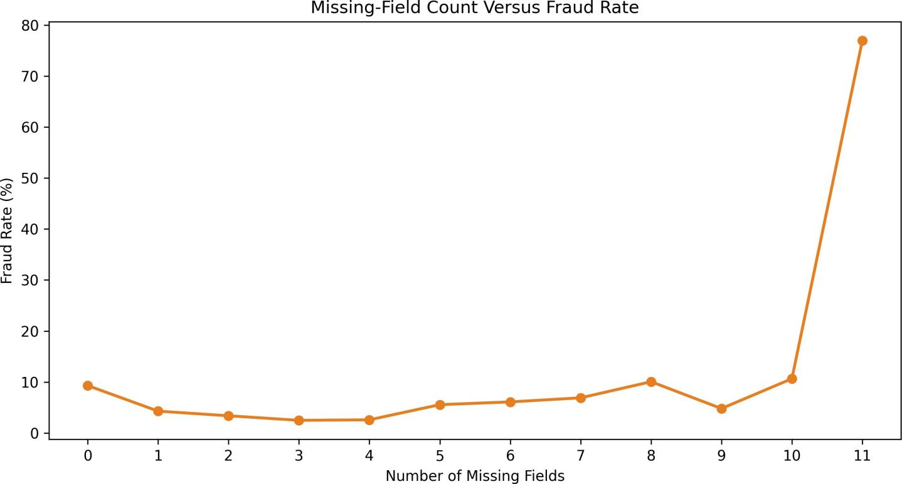
The relationship between total missing fields and fraud is non-linear, supporting non-linear feature interactions.

Text-Length Comparison
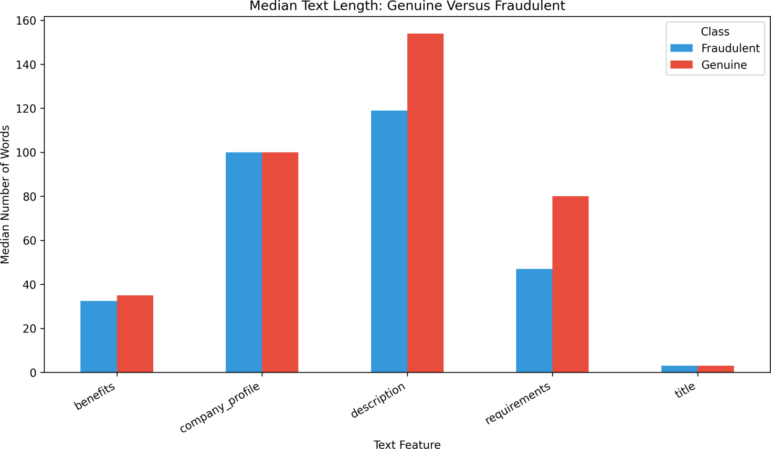
Fraudulent descriptions and requirements are generally shorter than genuine advertisements.

Industry and Function Risk
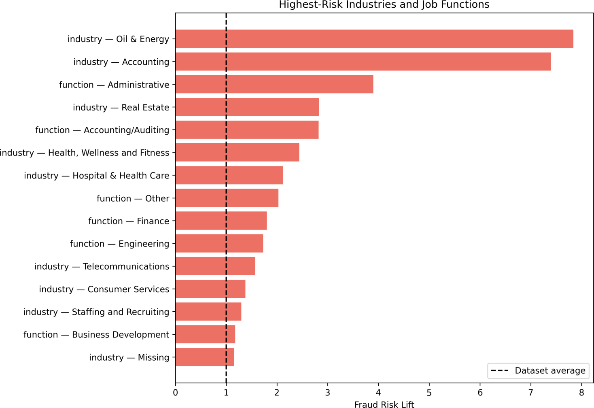
Some industries and job functions show much higher fraud rates, but these patterns may change in future real-world data.

Text-Based Risk Signals
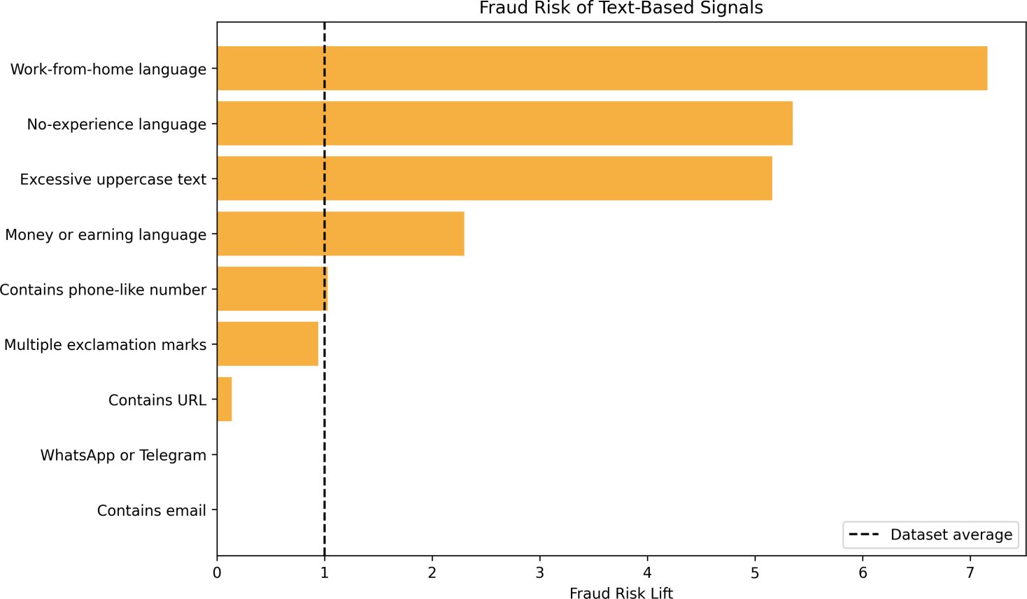
Work-from-home, no-experience and earning-related language show strong fraud associations.

Repeated Text Templates
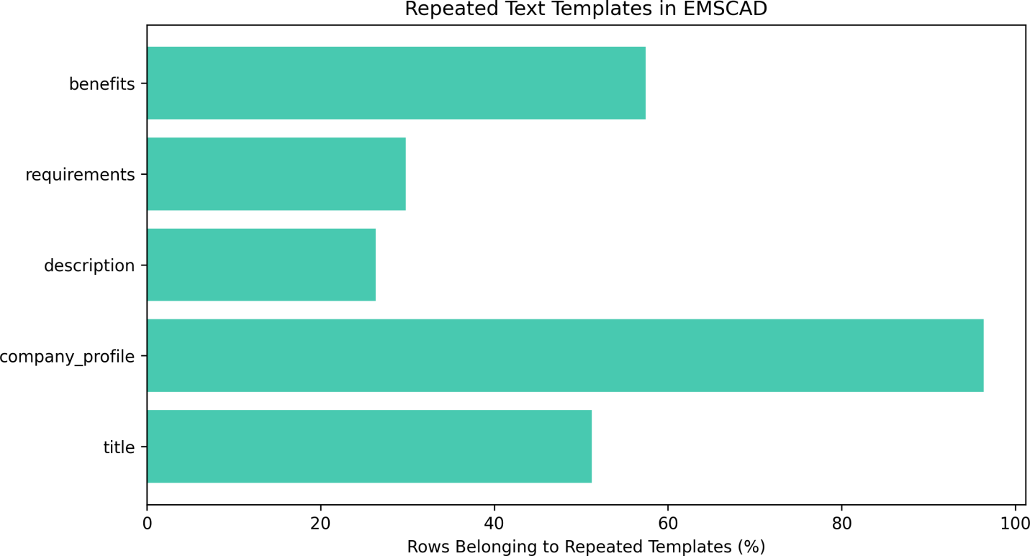
Large numbers of advertisements reuse text templates. Random splitting can therefore produce over-optimistic results.

Missing-Value Details

Feature | Missing count | Missing percentage
salary_range | 15,012 | 83.96
department | 11,547 | 64.58
required_education | 8,105 | 45.33
benefits | 7,212 | 40.34
required_experience | 7,050 | 39.43
function | 6,455 | 36.10
industry | 4,903 | 27.42
employment_type | 3,471 | 19.41
company_profile | 3,308 | 18.50
requirements | 2,696 | 15.08
location | 346 | 1.94
description | 1 | 0.01

Terms Associated With Fraudulent Posts

Term | Fraud documents (%) | Genuine documents (%) | Log-odds score
leveraging career | 9.01 | 0.00 | 8.13
aptitude staffing | 7.04 | 0.00 | 7.86
services town | 6.47 | 0.00 | 7.77
represented candidates | 6.47 | 0.00 | 7.77
participate referral | 6.47 | 0.00 | 7.77
following perks | 6.47 | 0.00 | 7.77
encouraged participate | 6.47 | 0.00 | 7.77
expert negotiations | 6.47 | 0.00 | 7.77
field employ | 6.00 | 0.00 | 7.69
url_0fa3f7c5e23a16de16a841e368006cae916884407d90b 154dfef3976483a71ae information | 6.00 | 0.00 | 7.69
recovery petroleum | 6.00 | 0.00 | 7.69
petroleum field | 6.00 | 0.00 | 7.69
people values | 6.00 | 0.00 | 7.69
production maximize | 6.00 | 0.00 | 7.69
provider products | 6.00 | 0.00 | 7.69
Several terms appear to represent specific organizations or repeated fraud campaigns. They must not be treated as universal fraud rules.

Terms Associated With Genuine Posts

Term | Fraud documents (%) | Genuine documents (%) | Log-odds score
university degree | 0.00 | 5.82 | -4.67
asia | 0.00 | 5.57 | -4.63
1500 | 0.00 | 5.46 | -4.61
medium large | 0.00 | 4.41 | -4.38
amp secure | 0.00 | 4.42 | -4.38
teaching experience | 0.00 | 4.36 | -4.37
tefl | 0.00 | 4.32 | -4.36
tesol | 0.00 | 4.30 | -4.36
help teachers | 0.00 | 4.30 | -4.36
student loans | 0.00 | 4.28 | -4.35
teachers safe | 0.00 | 4.27 | -4.35
secure jobs | 0.00 | 4.27 | -4.35
tefl tesol | 0.00 | 4.29 | -4.35
jobs abroad | 0.00 | 4.27 | -4.35
celta teaching | 0.00 | 4.27 | -4.35

Text-Template Leakage Audit

Feature | Non-empt y | Unique | Repeated groups | Rows repeated | Largest group | Fraud only | Genuine only | Mixed labels
title | 17,880 | 10,533 | 1,810 | 9,157 | 406 | 100 | 1,630 | 80
company_profile | 14,572 | 1,706 | 1,174 | 14,040 | 726 | 36 | 1,138 | 0
description | 17,878 | 14,442 | 1,269 | 4,705 | 417 | 94 | 1,174 | 1
requirements | 15,178 | 11,768 | 1,113 | 4,523 | 410 | 96 | 1,011 | 6
benefits | 10,646 | 5,806 | 1,275 | 6,115 | 726 | 58 | 1,207 | 10

Repeated and class-specific templates can allow a model to memorize campaigns instead of learning general fraud behaviour. Template or campaign groups must remain within a single data split.

Final EDA Conclusions
  - Keep the complete 17,880-row EMSCAD dataset for paper comparison.
  - Create missing-value indicators instead of blindly deleting incomplete columns.
  - Process long text, categorical metadata and engineered risk signals through separate model branches.
  - Parse salary and location into structured features.
  - Fit vectorizers, encoders, imputers and resampling methods using training folds only.
  - Prevent duplicate advertisements and repeated templates from crossing data splits.
  - Use PR-AUC, fraud recall, fraud precision, F1-score, MCC, ROC-AUC and accuracy.
  - Tune the classification threshold using validation data only.
  - Perform ablation studies to prove which proposed component adds value.
  - Test the final model using independent and recent real-world advertisements.

EDA Status: Completed

