# POWER BI (Business Intelligence)

<https://drive.google.com/drive/u/0/mobile/folders/1m-aT0FI4IJcaa-G5KaInF_Ro9ZL4NXe0>

**Install Power BI Desktop**: -> Microsoft Store

**Update Power BI Desktop**: -> File -> Options and Settings -> Preview Fields -> Mark necessary checkboxes and restart the application.

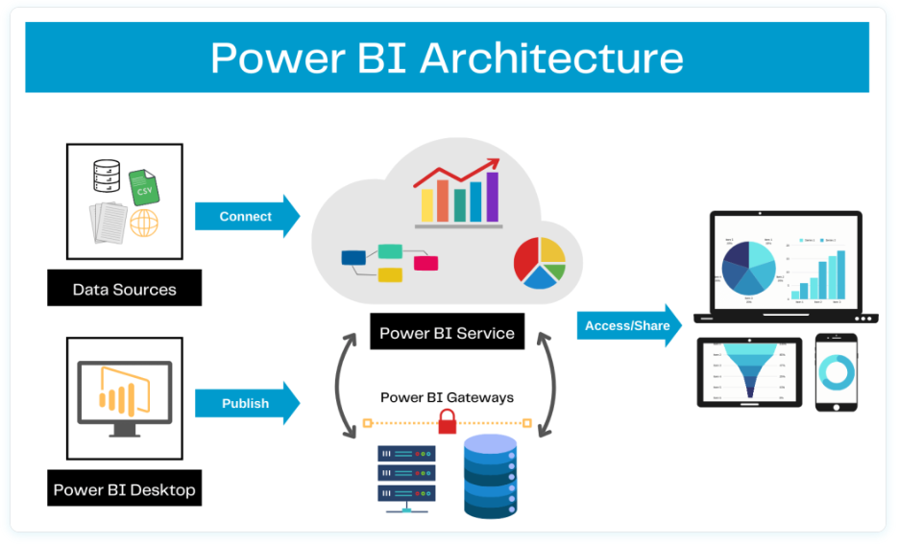

## Introduction to Power BI

**Power BI is a business intelligence (BI) and data visualization tool developed by Microsoft. It allows users to connect to various data sources, transform raw data, and create interactive reports and dashboards to gain insights. Power BI is widely used for data analysis, reporting, and decision-making.**

### Power BI Desktop

* A **Windows application** used for creating reports and dashboards.
* Provides features like **data modeling, visualization, and DAX (Data Analysis Expressions)**.

### Power BI Service (Power BI Online)

* A **cloud-based platform** where users can publish, share, and collaborate on Power BI reports and dashboards.
* Enables **automatic data refresh** and integration with other Microsoft services (e.g., Excel, Azure).

### Supporting Components of Power BI

**Power Query**

* A data transformation tool that allows users to clean, reshape, and combine data before analysis.

**Power Pivot**

* A data modeling component for creating relationships and measures using **DAX (Data Analysis Expressions)**.

**Power View**

* The visualization layer where users design interactive reports with charts, graphs, and KPIs.

**KPIs in Power BI are just visual indicators** that help track performance and data consistency. They **don’t change the data** but make it easier to understand whether you are meeting your goals.

## Basic Charts in Power BI Desktop

### Column Chart

### Stacked Column Chart

### Pie Chart **Basic Charts**

### Donut Chart

### Funnel Chart

### Ribbon Chart

### Include and Exclude:

It works like a filter where we can select multiple data points and make a separate view from the selected values.

### View data and Export:

Select customized data -> Right click -> click on (show data point as a table) -> click on three dots located at the right top corner -> click on export data.

We can also restrict the end user to do this operation of exporting data in settings field.

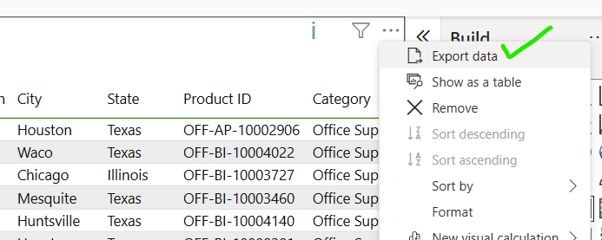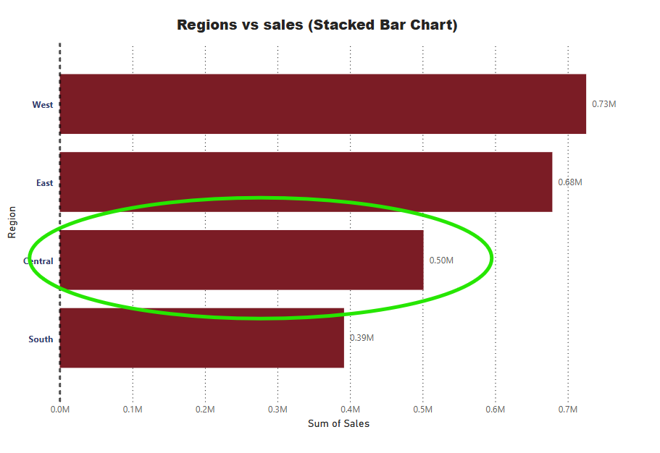

### Map

## Table and Matrix in PowerBI

### Creating a Simple Table

### Formatting in Table

### Conditional Formatting in Table

### Creating a Matrix in Power BI **Table and Matrix**

### Conditional Formatting in PowerBI

### Automatic Formatting in PowerBI

### Sub Total and Grand Total

### Number Formatting in Table and Matrix

## Other Charts in PowerBI Desktop

### Line Chart

### Drill Down in Line Chart

### Area Chart

### Line vs Column Chart

### Scatter Plot Other Charts

### Waterfall chart

### TreeMap

### Guage Chart

## Cards and Filters

### Number Card

### Text Card

### Date Card

### Multi-Row Card Cards and Filters

### Filter on Visual

### Filter on Page

### Filter on All Pages

### Drill Through

## Slicers in PowerBI Desktop

### Slicer For Text

### Format Text Slicer

### Data Slicer Slicers

### Format Data Slicer

### Number Slicer

## Advanced Charts in PowerBI

### Animated Bar Chart Race

### Drill Down Donut Chart

### Drill Down Column Chart

### Word Chart

### Sankey Chart

### Infographic

### Play Axis

### Scoller

### SunBurst Chart

### Histogram

## Insert Tab Operations

### Insert Images, Objects

### Creating Index page to navigate to the other pages

### Bookmark action

### Drillthrough Action

## Power BI Service Introduction

### Creating a SuperStore Report

### Create an account PowerBi service

### Publish Report to Power BI Service Account

### Export (PPT, PDF, PBIX) Report and Share

### Comment, Share and Subscribe to a report

### Create a Dashboard in a powerBI service

### Problem in PowerBI Dashboard and its solution

### Automatic Refresh – Data Gateway

### Create Report Directly in Power Bi service

## Text Functions in Power Query (Power BI)

### Merge

**Steps to Merge Columns in Excel Using Power Query:**

1. Open a **new** Excel workbook.
2. Go to the **Data** tab on the ribbon and select **Get Data** → **From File** → **From Workbook**.
3. Select an **Excel workbook** and choose the table or sheet that contains the dataset.
4. Click **Load** or **Transform Data** (if you want to make changes before loading). This opens the **Power Query Editor**.
5. In the **Power Query Editor**, select the **columns** you want to merge (hold **Ctrl** to select multiple columns).
6. Go to the **Transform** tab → Click **Merge Columns** in the **Text Column** group.
7. In the **Merge Columns** dialog box:
   * Choose a **separator** (e.g., space, comma, or custom).
   * Enter a **new column name** if required.
   * Click **OK**.
8. Go to the **Home** tab → Click **Close & Load** (top-left corner) to load the transformed dataset back into Excel.
9. Your dataset will now appear in Excel with the merged column.

**Steps to Merge Columns in Power BI Using Power Query:**

Follow Same steps like in excel but the only difference here is you will have ***Close & Apply***option at the 8th step.

### Split and Trim

**Steps to Split and Trim Columns in Power BI Using Power Query:**

1. **Go to the Data tab** → Click **Get Data** → **From File** → **From Workbook**.
2. Select the **Excel workbook** and choose the **table or sheet** containing the data where **Village, State, and City** are combined in a single column.
3. Click **Transform Data** to open the **Power Query Editor**.
4. Select the **column** that you want to split.
5. Go to the **Transform** tab → Click **Split Column** in the **Text Column** group.
6. Choose a **delimiter** (such as a comma, space, or custom separator) and click **OK**.
7. The column will be split into three different columns. You can **rename** them accordingly.
8. To **remove unwanted spaces**, select the newly created columns.
9. Click on **Format** (located beside the "Split Column" option) and choose **Trim** to remove extra spaces.
10. Click on Load and Apply button to apply and work on changes made.

### Upper, Lower and Proper

**Steps to Uppercase, Lowercase and Proper(Capitalize) Columns in Power BI Using Power Query:**

Follow same steps like above in 8th step you will be having all these options you can select whichever you require.

### Add Suffix and Prefix

Follow same steps like above in the format field you will find these prefix and suffix options

### Extract Left, Right and Mid Part from the Merged data

Same Steps will be repeated here also in order to make a new column from the existing merged column we need to go to text group in **transform tab** on ribbon and click extract. there you have different options like **length, First Characters, Last Characters, Range, text Before Delimiter, text after Delimiter and Text Between Delimiter**. Based on the type of text use different options.

Note: you want a new transformed column by putting existing column as it is you need to apply the above operations in **Add Column Tab** if you don’t want just to transform it you can apply the same operations in **Transform tab.**

### Extract Text with Delimiter

👆

## Date Functions in Power Query (Power BI)

### Year, Quarter, Month and Day

For all these operations, follow these steps:

**Go to** → **Transform Data**

**Navigate to** → **Add Column** Tab

**Locate** → **From Date and Time** Group

**Apply** the desired functions

### Difference between Dates, Earliest and Latest

### Name of Day and Name of Month

### Day of week/Month/Year & Week of Month /Year

### Extract Date from Date and Time

### Calculate age in 2 button clicks

### Which day of Year, Quarter, Month your Date of Birth is

## Number Functions in Power Query (Power BI)

This group helps in performing these operations

### Add, Subtract, Divide and Multiply

### Percentage, Percentile and Modulo

### Rounding the numbers

### IsEven, IsOdd and Sign

## Appending Files and Tables in Power BI

### Appending multiple csv files from a folder

### Append multiple csv files from a folder

### Get Data → Folder → Select the folder with CSV files.

### Click "Combine & Transform Data" to open Power Query.

### Power Query auto-merges files → Click OK.

### Apply transformations (remove nulls, change column types).

### Click "Close & Apply" to load data into Power BI.

### Append multiple excel tables/Sheets from single file

* Click on Get data -> Select excel workbook -> Click on Transform data
* Left side you will be shown what data you have selected.
* Now go to Home tab in Combine group -> Append queries -> Append queries as new
* Select how many tables you wanted to append if it is more than 2 click on more than 3 tables and double click on tables which you wanted to apply and click on ok. The data got appended.

### Append Excel tables with different number of columns

If you wanted to append tables or sheets having different columns placed randomly but same column names and different tables having some extra columns, you need to follow the same procedure as above you will be getting structured data and missing values is filled with null value.

### Append multiple Excel files from a folder

Select the Folder in get data and paste the folder path which has excel files

### Append different data source files in power query (Power BI)

First load the excel data by clicking on excel workbook and next get the csv format data by clicking on csv file in get data and append it in the power query by clicking on append queries which is present at the combine group in home tab.

## Merging files and Tables in Power BI – (VLOOKUP without formula)

### Merge Tables/Sheets in power query

### Merge data from multiple excel files/workbooks in power query

### Merge data from different data sources on power query

### Merge data having multiple matching columns or multiple criteria in power query

## Column from Examples and Conditional Column in Power BI

### Column from examples on Splitting Text

### Column from examples on Merging Text

### Column from examples on Data Column

### Column from examples on Alphabetic Data

### Conditional Column on One column

### Conditional column on two columns

### Conditional column comparing two common values

### Conditional column on dates

## Very Important Topics in Power BI

### Fill down and Fill up

### Grouping

### Transpose

### Unpivot

### Data types in Power Query

### Replace errors and values

### Keep rows and remove rows

### Add, Remove, Goto Columns

## M language in Power Query

### Introduction to M language

### M Functions – Date (ISIN)

### M Functions – Date (Add and Subtract)

### M Functions – Date ( Day, Month, Week, Year)

### M Functions – Text (Basic)

### Writing a small M code in Power BI

### Trick to get all 900 M Functions help