# Sales Insights Dashboard Power BI Project

## Problem Statement

**Problem Statement: Sales Insights Dashboard for AtliQ**

AtliQ is a leading hardware and peripheral distribution company operating across multiple regions: North, South, East, and West. With rising market competition, the company has been struggling to maintain its sales performance. Bhavin Patel, the Sales Director at AtliQ, has noticed a decline in sales but cannot pinpoint the exact reasons.

Every time he requests sales updates, regional managers send him bulky Excel files filled with raw data. He spends hours filtering, sorting, and analyzing numbers—yet still struggles to identify meaningful patterns. Is the drop due to supply chain delays? Are competitors offering better deals? Are certain regions underperforming? Without clear insights, making informed decisions becomes nearly impossible.

The lack of real-time visibility into sales trends makes it challenging for Bhavin to act quickly. While competitors are leveraging data-driven strategies to optimize their sales, AtliQ is still stuck in manual processes that slow down decision-making.

This is where Power BI comes in. By creating a **real-time Sales Insights Dashboard**, we can transform complex datasets into intuitive, interactive visualizations. Instead of scrolling through endless spreadsheets, Bhavin can **instantly** see sales trends, identify problem areas, and take action—right when it matters the most.

With Power BI, AtliQ can:  
✅ Track sales performance across all regions in real time  
✅ Identify underperforming areas and take proactive measures  
✅ Compare current sales trends with past performance  
✅ Detect market patterns and competitor impacts  
✅ Improve strategic decision-making with dynamic dashboards

This project aims to develop a **powerful, data-driven solution** that will help AtliQ **stay ahead of the competition** and **drive sales growth with actionable insights**.

**Power BI is not just a tool; it’s the game-changer that AtliQ needs.** 🚀

## Aims Grid (Project Management Tool)

|  |  |
| --- | --- |
| **Purpose** | **Stakeholders** |
| **To unlock sales insights that are not visible before for sales team for decision support & automate them to reduced manual time spent in data gathering** | * **Sales director** * **Marketing Team** * **Customer Service Team** * **Data and Analytics Team** * **IT** |

|  |  |
| --- | --- |
| **End Result** | **Success Criteria** |
| **An automated dashboard providing quick and latest sales insights in order to support data driven decision making** | * **Dashboard uncovering sales order insights with latest data available** * **Sales team able to take better decisions & prove 10% cost savings of total spend** * **Sales Analytics stop data gathering manually in order to save 20% of their business time and reinvest it value added activity** |

## Data Discovery( Identifying, Collecting, and Analyzing data)

Falcons are the stakeholders who had access to the sales system or software

Data Masters are power BI developers

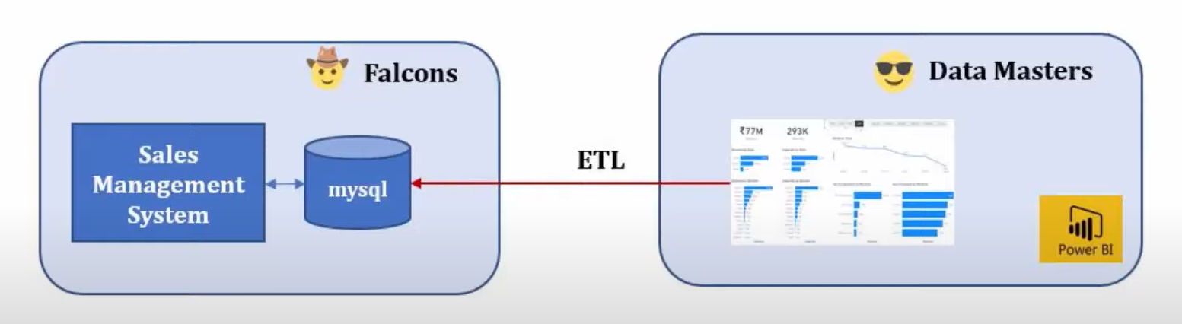

Generally we use Data warehouse when dealing with large datasets many real time projects about 80% will use this Data Warehouse instead of databases.

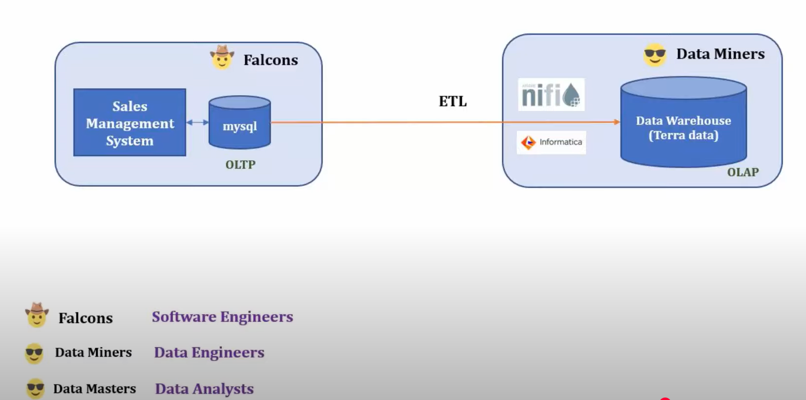

Data Engineers role is to transform the raw data in a suitable format and maintain the Data Warehouse infrastructure.

## Simple Data Analysis using SQL