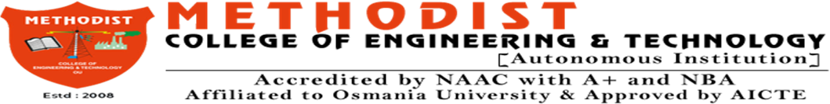

DEPARTMENT OF ARTIFICIAL INTELLIGENCE & DATA SCIENCE
B.E. VIII SEM (AI&DS) ABSTRACT SUBMISSION A.Y. 2025-26

TITLE: | DataFlow Hub: Centralized Learning Platform for Data Science  Projects Across Domains
DOMAIN: | Data Science
PLATFORM: | Web Application
ABSTRACT
Data science plays a crucial role across diverse domains such as healthcare, finance, e- commerce, and recommendation systems. Despite the availability of numerous resources, learners and practitioners often face challenges due to the fragmented nature of existing platforms, which either focus on theory without practical implementation or provide datasets without guided workflows. This lack of unified, end-to-end resources makes it difficult for users to acquire real- world, hands-on experience in building, evaluating, and deploying data science models.

The proposed project addresses this gap by developing a centralized, interactive, and click-based learning platform that enables users to work through complete data science pipelines with minimal coding effort. The system offers domain-specific datasets, preprocessing tools, model selection options, automated evaluation dashboards, and one-click deployment sandboxes. By integrating guided workflows and reusable templates, the platform provides an end-to-end learning environment that bridges the gap between theoretical knowledge and practical application. This approach democratizes data science education, making it more accessible, intuitive, and impactful for learners and professionals alike.

Keywords: Data Science, Learning Hub, Centralized Platform, Cross-Domain Applications, Data Analytics, Machine Learning, Collaborative Learning, Knowledge Sharing, Project Management, DataFlow.

S.NO. | ROLL NO | NAME OF STUDENT | CONTACT NO
1 | 160722747097 | M.Yethishwar | 9381676864
2 | 160722747126 | R.SaiKrishna | 9392529979
3 | 160722747096 | MD.Iftequaruddin | 8519859512

Guide: Mrs. Unnati Mohan Khanapurkar Assistant Professor, Dept. of CSE
Coordinator: Dr. K Prasanna, Professor, Dept. of CSE

