DataFlow Hub: A Centralized Platform for Data Science Projects across domains
Madavaram Yethishwar¹, Radhavrapu Sai Krishna2, Mohammed Iftequaruddin³, Mrs. Unnati Mohan Khanapurkar⁴

Students123, Department of Computer Science & Engineering, Methodist College of Engineering and Technology, Abids, Hyderabad, Telangana, 500001, India.
Professor4, Department of Computer Sceience & Engineering, Methodist College of Engineering and Technology, Abids, Hyderabad, Telangana, 500001, India.

ABSTRACT
Smart Classroom and Timetable Scheduling has become an essential component of modern educational systems, as efficiently managed classrooms and automated timetables play a significant role in improving academic operations and institutional productivity. With the expansion of student populations and increasing diversity in course structures, the need for flexible, accurate, and scalable scheduling mechanisms has become more important in universities, colleges, and training environments. This work focuses on integrating advanced computational models—specifically optimization-driven and AI-assisted frameworks—to support timetable generation by analysing institutional constraints. These models utilize academic datasets such as faculty availability, classroom capacity, program requirements, student group distributions, and departmental regulations to produce feasible, conflict-free schedules aligned with institutional objectives.
The motivation behind this project arises from the practical challenges associated with manual or semi-automated scheduling, which often struggles to address complex constraint combinations, adapt to sudden changes, and provide consistent outputs across varying institutional scenarios. Traditional systems also lack interpretability, making it difficult to understand how specific constraints influence generated timetables. Additionally, issues such as data inconsistencies, limited generalizability across institutions, and the gap between timetable creation and real-time classroom management further highlight the need for improved solutions.
To address these limitations, the proposed system incorporates AI-assisted optimization enhanced with dynamic constraint handling and explainability features.
The design includes a classroom-allocation mechanism based on resource utilization patterns, academic load balancing, and scheduling frequency.

Keywords:
Smart Classroom Management, Automated Timetable Scheduling, Optimization Algorithms, Resource Allocation.

INTRODUCTION

Background
Educational institutions today face growing challenges caused by increasing student numbers, diverse academic programs, and limited physical resources. Inefficient scheduling and classroom allocation often result in timetable conflicts, uneven workload distribution, and underutilized learning spaces. As campuses adopt digital solutions, the demand for automated and intelligent scheduling systems has increased significantly. Smart classroom technology further supports this need by enabling real-time monitoring, improved coordination, and optimized resource usage. Advances in optimization algorithms and AI-driven scheduling methods strengthen this direction, allowing more accurate, adaptable, and scalable timetable generation that aligns with institutional constraints and evolving academic requirements.

The Need / Motivation :
Traditional timetable planning methods, including manual scheduling and basic software tools, suffer from limitations such as human error, time consumption, and lack of adaptability to frequent academic changes. Institutions often struggle to manage overlapping classes, faculty availability, and uneven room utilization efficiently.

Therefore, there is a need for objective, automated, and intelligent scheduling tools capable of handling complex academic constraints. Smart scheduling systems can analyse institutional data without requiring continuous human intervention. This creates strong motivation to adopt AI-driven timetable generation for improved efficiency, reduced conflicts, and better academic coordination.

Existing Work:
Recent research between 2022 and 2025 shows rapid progress in automated timetable generation driven by optimization and AI-based architectures. Genetic algorithms, constraint- satisfaction models, and hybrid heuristic–AI frameworks have demonstrated significant improvements over traditional manual scheduling in handling complex academic constraints, resource limitations, and dynamic institutional requirements. Several studies extend scheduling systems toward smart-classroom integration by analysing room utilization, faculty workload, student group patterns, and real-time availability. Models such as GA-CSP schedulers, hybrid metaheuristics, and learning-based allocators have achieved high efficiency in timetable generation and show strong potential for intelligent academic management.

Drawbacks:
Despite these advancements, existing literature highlights multiple challenges that limit accurate timetable generation. Current academic datasets lack complete scheduling attributes and suffer from imbalance, missing information, structural inconsistencies, and limited real-world diversity across institutions. Most scheduling systems rely on static rules, ignoring dynamic changes essential for effective academic planning. Furthermore, scheduling constraints do not always directly correspond to practical institutional needs, leading to fragile generation pipelines. Optimization models, though powerful, often function as black boxes with limited interpretability, restricting their acceptance in administrative environments.

Proposed Approach:
The proposed approach aims to design an easy and reliable system that can generate academic timetables and manage classroom allocation using institutional data. The system is based on an optimization-driven scheduling model because it can capture both small and large
timetabling constraints more effectively than older rule-based methods. First, the input data such as course lists, faculty availability, student batches, and room details are collected, aligned, and pre-processed to remove inconsistencies. After this, the scheduling engine extracts important features such as time-slot constraints, room suitability, workload balance, and program- specific requirements.
To make timetable generation more accurate, the design also includes a dynamic adjustment component, which observes how scheduling conditions change over time instead of relying on a static dataset. This helps identify timetable stability or instability, which is important for academic planning. Finally, a simple scheduling- quality scoring module is conceptually defined to indicate possible levels of conflicts, resource utilization, or imbalance. Explainability tools like constraint-highlighting mechanisms are used to show which factors influenced the scheduling decisions, making the model easier for administrators to understand and trust.

FUNDAMENTALS OF CLASSROOM MANAGEMENT

Basics of Classroom Management :
Classroom management is a fundamental academic process that reflects how institutions organize teaching activities, allocate resources, and maintain effective learning environments. It influences scheduling efficiency, coordination practices, decision- making, and overall educational performance. Basic classroom-management factors commonly recognized in academic settings include room capacity, availability, equipment requirements, time-slot suitability, accessibility, and utilization. These factors are expressed through patterns such as classroom occupancy, faculty preferences, student distribution, and resource usage variations.

Basics of Timetable Automation:

Timetable automation is a branch of educational technology that uses computational algorithms to generate schedules automatically from institutional data such as courses, faculty availability, or room constraints. Unlike traditional manual

scheduling methods that require handcrafted planning, automated systems analyse patterns directly from large datasets, making them highly effective for complex tasks like timetable creation, classroom allocation, and workload balancing. Rule-based systems dominated scheduling tasks for years, but optimization-based and AI-assisted architectures—such as Genetic Algorithms and Constraint Satisfaction Models—have recently become popular. These models use structured constraint-processing mechanisms to capture both local scheduling requirements and global institutional relationships, enabling more accurate and robust timetable generation.

Overview of Classroom and Scheduling Concepts:
Classroom allocation plays a vital role in managing academic activities and ensuring that teaching spaces are utilized efficiently across an institution. Timetables provide a structured representation of when and where classes occur, making them essential for
coordinating faculty, students, and resources. Automated scheduling offers a powerful approach to generating these timetables without relying on manual planning, which is often slow and error-prone. By learning patterns from large collections of institutional data, scheduling systems can accurately identify constraints related to room capacity, faculty availability, overlapping student groups, or time-slot preferences. Modern optimization and AI-assisted architectures further enhance this capability by applying hierarchical constraint analysis to capture fine-grained scheduling requirements and broader institutional relationships. When combined, classroom-management principles and automated scheduling techniques form a strong foundation for systems designed to support academic planning through structured timetable generation.

LITERATURE SURVEY
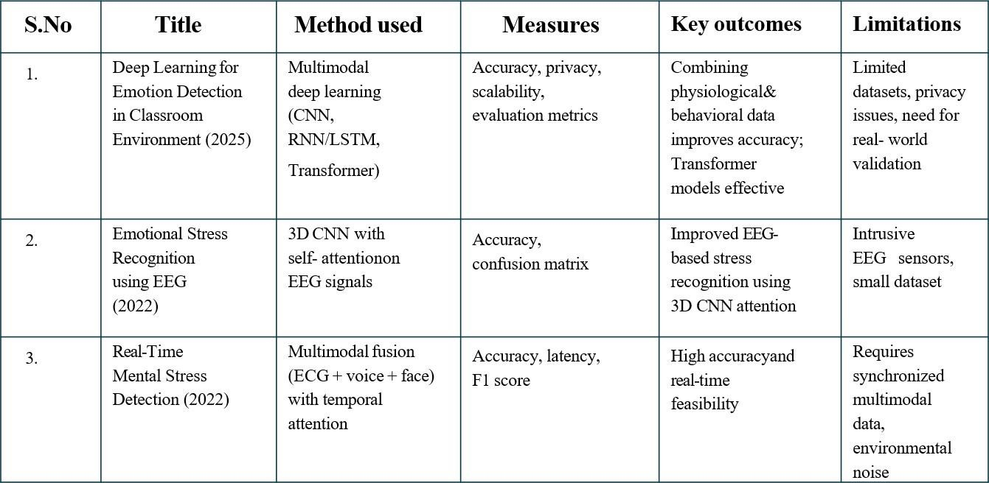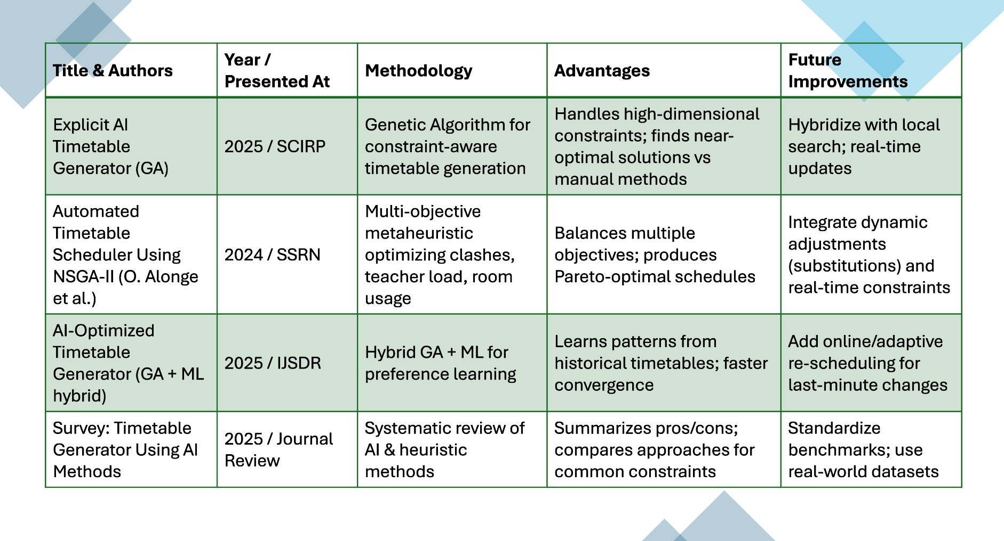

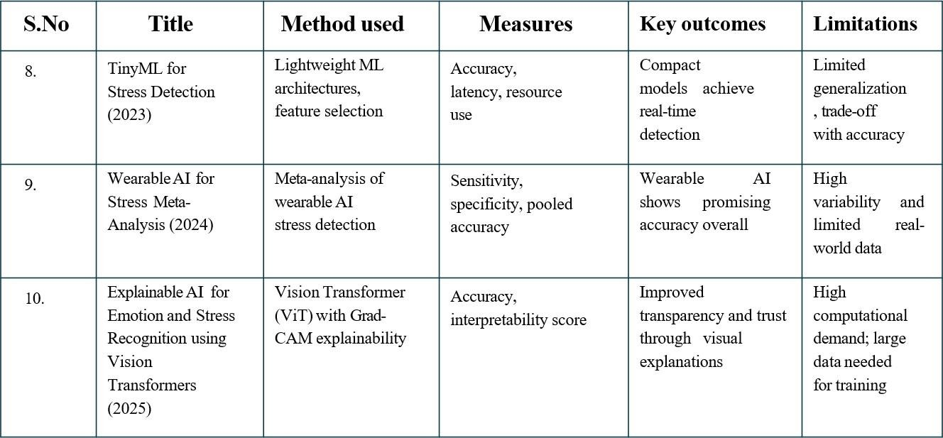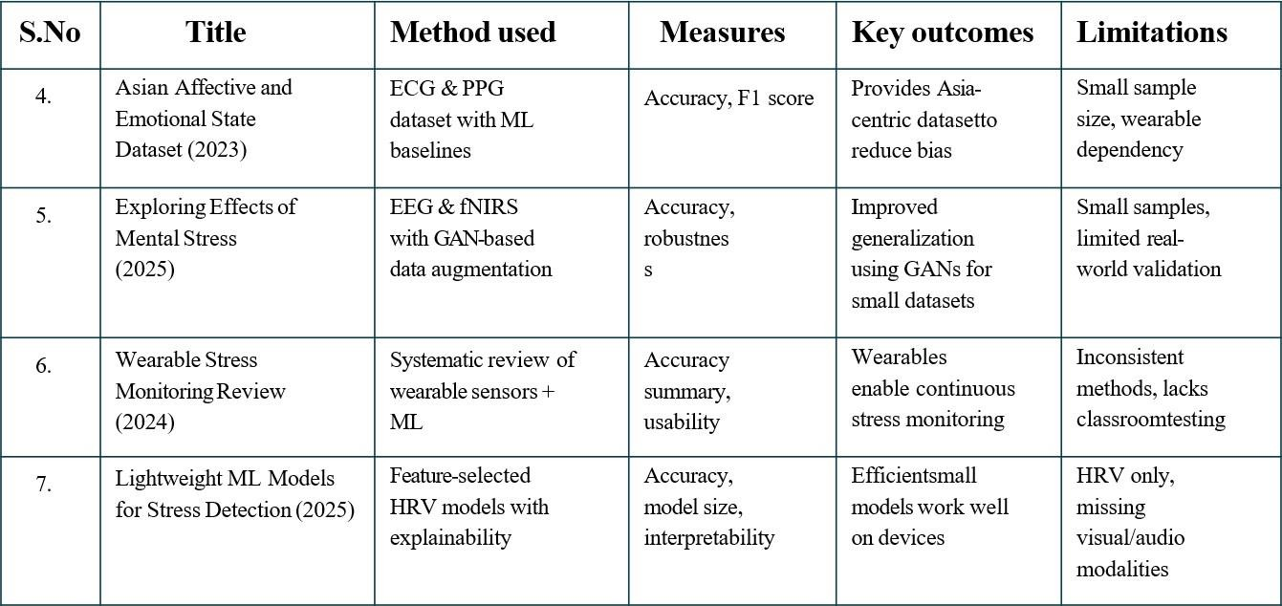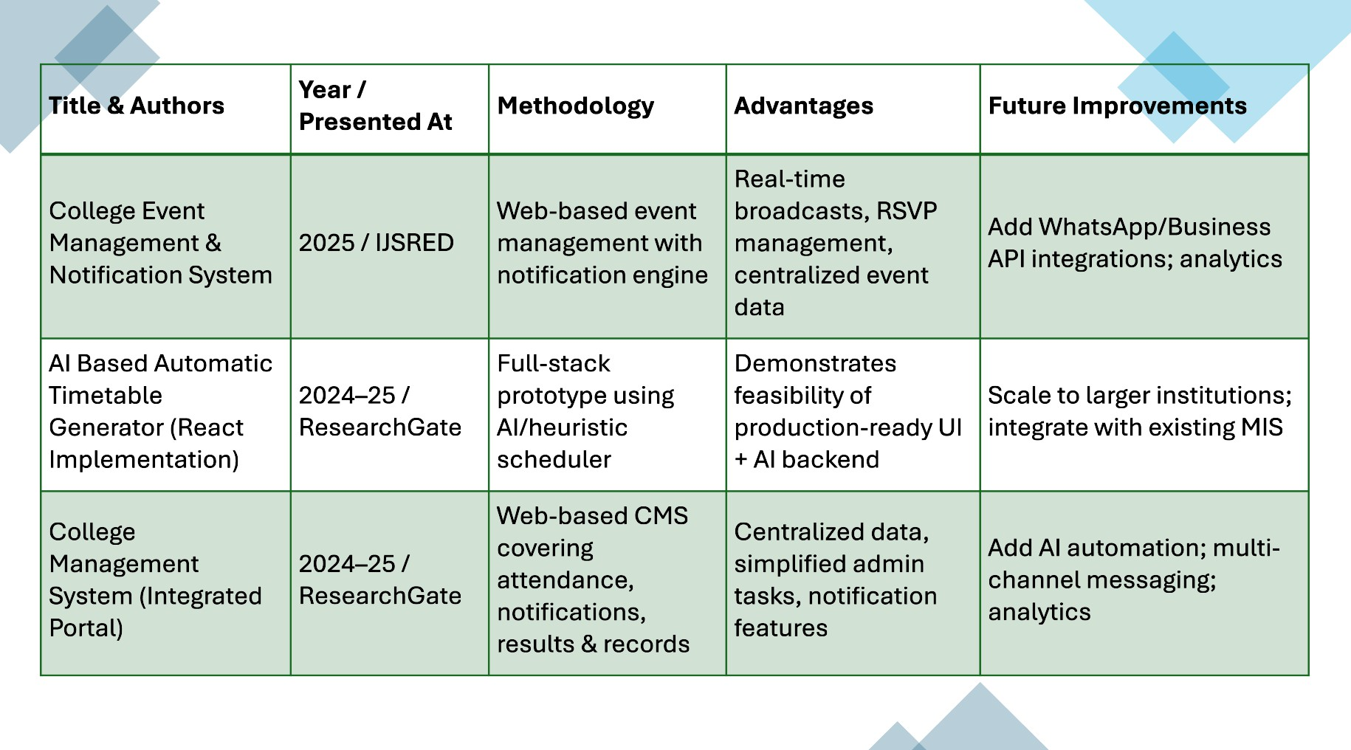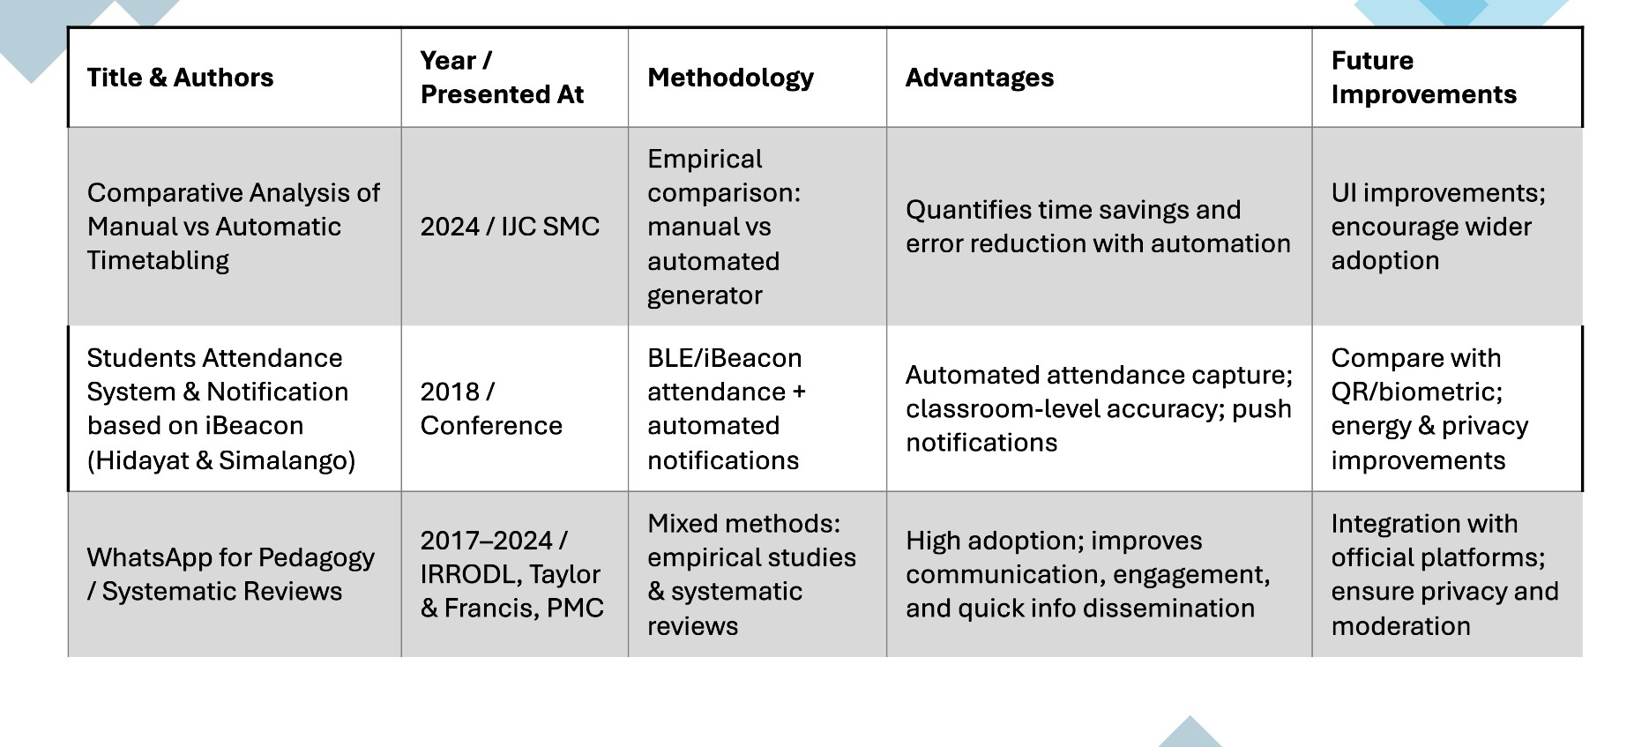

- CHALLENGES

Data Limitations in Institutional Scheduling
Many academic datasets used for timetable generation lack completeness, consistency, and balanced representation across departments. Missing room attributes, incomplete faculty availability, and uneven course distributions reduce scheduling accuracy. Such limitations cause models to overfit frequent patterns while misallocating resources in rare or specialized cases, ultimately weakening reliability for large or diverse institutions.
  - Real-World Variations Reduce Accuracy Scheduling systems are highly sensitive to real-world variations such as last-minute faculty changes, fluctuating room availability, equipment constraints, overlapping student groups, and unexpected institutional events. These dynamic conditions make stable prediction difficult, causing automated models to generate schedules that degrade when real operational shifts occur, especially in large and fast- changing environments.

Difficulty in Capturing Micro- Expressions
Fine-grained scheduling conflicts often occur for only a brief period within the academic planning process and reveal subtle resource mismatches that administrators may overlook. Literature shows that even advanced optimization models have difficulty identifying these intricate issues due to insufficient high-resolution scheduling data and the need for detailed constraint tracking. This affects timetable generation, where small inconsistencies are often more impactful than major, easily detectable conflicts.

  - Lack of Academic Constraint Labels Although scheduling datasets have clear structural information, detailed academic constraint labels (priority levels, preference rules, workload limits) are not available in most institutional records. Many systems rely on manually provided inputs, which may be inconsistent or subjective.

  - Demographic and Structural Bias Research shows that scheduling models may unintentionally prioritize certain departments, time slots, or faculty groups due to historical data patterns rather than actual needs. Such bias results in unfair distribution of teaching loads, room assignments, or timetable flexibility, reducing fairness and limiting suitability for diverse institutional environments.

  - Overfitting in Scheduling Models Optimization and AI-driven schedulers often contain high model capacity and require diverse datasets to generalize well. However, many institutional datasets are small or repetitive, causing models to overfit frequent scheduling structures. Without safeguards, models overfit and fail to scale.

Limited Explainability and Administrative Trust
For academic scheduling, interpretability is essential. Although constraint-highlighting tools help visualize decision paths, administrators report that explanations generated by automated models are not always intuitive or sufficiently detailed.
This gap between scheduling outputs and administrative reasoning reduces trust, especially when decisions affect faculty workload or room fairness.

Ethical and Privacy Concerns in Scheduling Systems
Recent discussions highlight ethical concerns involving academic data usage. Storing sensitive information such as faculty preferences, student groupings, and room usage patterns raises privacy risks. Without clear policies, model transparency, and controlled data handling, institutions face challenges in adopting large-scale scheduling automation despite technical improvements.

Lack of Temporal Understanding in Scheduling Models
Many scheduling datasets are static and do not capture temporal patterns such as seasonal course changes, faculty rotation cycles, or shifting classroom demand. However, effective planning often depends on understanding trends over time. Studies emphasize the need for stronger temporal modeling, which many current scheduling systems still lack in growing institutions.

FUTURE SCOPE
Future research in smart-classroom-based timetable automation presents several promising directions. As optimization techniques and AI- driven scheduling architectures continue to evolve, one major scope is the development of more efficient and lightweight models that can operate in real time on resource-limited academic systems. This would allow scheduling platforms to run on institutional portals, mobile teacher dashboards, and low-power administrative devices without compromising accuracy .

Another important direction is the expansion of high-quality academic datasets that represent diverse departments, program structures, instructor workloads, classroom profiles, and real-world operational variations. Many existing datasets still suffer from imbalance and limited diversity, which restrict the generalizability of current scheduling models. Larger and more representative datasets can greatly improve automated timetable performance.

Future work can also explore advanced constraint-augmentation techniques, improved preprocessing pipelines, and temporal modelling of academic patterns. Since scheduling behaviour often relates to long-term trends rather than single-semester data, analysing historical timetables or periodic scheduling cycles may provide deeper insight into demand peaks, workload shifts, or persistent resource shortages.

There is also scope for developing more structured timetable-quality scoring mechanisms that translate scheduling outputs into reliable administrative indicators. Techniques such as conflict-weighted scoring, trend-based evaluation, or frequency mapping of resource usage over time can make system decisions more meaningful and operationally relevant.

Lastly, enhancing interpretability through improved visual explanations, such as constraint- map visualisation or resource-specific highlight mechanisms, can strengthen administrator trust and support human review. As responsible AI becomes increasingly important, future systems may also incorporate stronger privacy controls and ethical safeguards to ensure safe and equitable scheduling in educational institutions.

CONCLUSION
Smart-classroom-driven timetable scheduling has emerged as a promising direction at the intersection of educational technology and computational optimization. Recent advances in AI-assisted scheduling, particularly hybrid architectures combining Genetic Algorithms, Constraint Satisfaction Models, and heuristic search techniques, have significantly enhanced the ability to capture fine-grained academic constraints and complex resource-allocation patterns. These developments provide a strong foundation for building systems capable of analysing institutional requirements and identifying potential issues such as room shortages, workload imbalance, and scheduling conflicts.
The literature surveyed between 2022 and 2025 demonstrates consistent progress in scheduling accuracy, adaptability, and interpretability, while also highlighting ongoing challenges such as limited dataset diversity, inconsistent academic metadata, and the need for reliable timetable- quality scoring mechanisms. The reviewed works collectively indicate that optimization-based automated scheduling approaches offer
considerable advantages over traditional manual methods, especially in handling real-world institutional variations and subtle conflict patterns.
Overall, the findings suggest a clear path forward for designing an AI-assisted timetable-scheduling framework. By integrating improved preprocessing, richer institutional datasets, explainable constraint-visualisation techniques, and structured score-based evaluation, future systems can become more reliable, interpretable, and suitable for real-world deployment. The conclusion reinforces that intelligent scheduling holds substantial potential for supporting efficient academic planning, providing for further research, ethical implementation, and expansion into practical smart-campus applications.

REFERENCES

- Çaylı, O., & Yılmaz, A. (2025). Smart Classroom Scheduling and Resource Optimization for Educational Institutions: Integrating AI and Multi-Objective Decision Support. The European Journal of Research and Development, 5(1), 95–112.

- Nugraha, T. A., Putra, K. T., & Hayati, N. (2017). University Course Timetabling with Genetic Algorithm: A Case Study. Journal of Electrical Technology UMY.

- Kristiadi, D., & Hartanto, R. (2018). Genetic Algorithm for Lecturing Schedule Optimization. Indonesian Journal of Computing and Cybernetics Systems.

- MDPI. (2022). Gradual Optimization of University Course Scheduling Problem Using Genetic Algorithm and Dynamic Programming. Algorithms, 18(3), 158.

- Patil, K. D., Sapar, G., Shaikh, A., & Divekar, P. (2024). Smart Timetable System Using AI and ML. Journal of Computer Networks and Virtualization

- Bello, R.-W., & Godwill, J. A. (2024). Hybrid Technologies and Genetic Algorithms Applied to School Lecture Timetable Generation. World Scientific News, (189), 288–310.

- Zandavi, S. M., Chung, V., & Anaissi, A. (2020). Multi-User Remote Lab: Timetable Scheduling Using Simplex Nondominated Sorting Genetic Algorithm. arXiv preprint.

- Dofadar, D. F., Khan, R. H., Hasan, S., Taj,
T. A., Shakil, A., & Majumdar, M. (2022). A Hybrid Evolutionary Approach to Solve University Course Allocation Problem. arXiv preprint.

- Al-Majmar, N. A., & Al-Shfaq, T. H. (2016). Solving of Lectures Timetabling Problem and Automatic Timetable Generation using Genetic Algorithm. International Journal of Advanced Research in Computer and Communication Engineering (IJARCCE), 5(9).

- IJCRT (2025). Smart TimeTable System Using Machine Learning. International Journal for Creative Research Thoughts (IJCRT), 13(4).

