# Sales Insights Dashboard Power BI Project

## Problem Statement

**Problem Statement: Sales Insights Dashboard for AtliQ**

AtliQ is a leading hardware and peripheral distribution company operating across multiple regions: North, South, East, and West. With rising market competition, the company has been struggling to maintain its sales performance. Bhavin Patel, the Sales Director at AtliQ, has noticed a decline in sales but cannot pinpoint the exact reasons.

Every time he requests sales updates, regional managers send him bulky Excel files filled with raw data. He spends hours filtering, sorting, and analyzing numbers—yet still struggles to identify meaningful patterns. Is the drop due to supply chain delays? Are competitors offering better deals? Are certain regions underperforming? Without clear insights, making informed decisions becomes nearly impossible.

The lack of real-time visibility into sales trends makes it challenging for Bhavin to act quickly. While competitors are leveraging data-driven strategies to optimize their sales, AtliQ is still stuck in manual processes that slow down decision-making.

This is where Power BI comes in. By creating a **real-time Sales Insights Dashboard**, we can transform complex datasets into intuitive, interactive visualizations. Instead of scrolling through endless spreadsheets, Bhavin can **instantly** see sales trends, identify problem areas, and take action—right when it matters the most.

With Power BI, AtliQ can:  
✅ Track sales performance across all regions in real time  
✅ Identify underperforming areas and take proactive measures  
✅ Compare current sales trends with past performance  
✅ Detect market patterns and competitor impacts  
✅ Improve strategic decision-making with dynamic dashboards

This project aims to develop a **powerful, data-driven solution** that will help AtliQ **stay ahead of the competition** and **drive sales growth with actionable insights**.

**Power BI is not just a tool; it’s the game-changer that AtliQ needs.** 🚀

## Aims Grid (Project Management Tool)

|  |  |
| --- | --- |
| **Purpose** | **Stakeholders** |
| **To unlock sales insights that are not visible before for sales team for decision support & automate them to reduced manual time spent in data gathering** | * **Sales director** * **Marketing Team** * **Customer Service Team** * **Data and Analytics Team** * **IT** |

|  |  |
| --- | --- |
| **End Result** | **Success Criteria** |
| **An automated dashboard providing quick and latest sales insights in order to support data driven decision making** | * **Dashboard uncovering sales order insights with latest data available** * **Sales team able to take better decisions & prove 10% cost savings of total spend** * **Sales Analytics stop data gathering manually in order to save 20% of their business time and reinvest it value added activity** |

## Data Discovery( Identifying, Collecting, and Analyzing data)

Falcons are the stakeholders who had access to the sales system or software

Data Masters are power BI developers

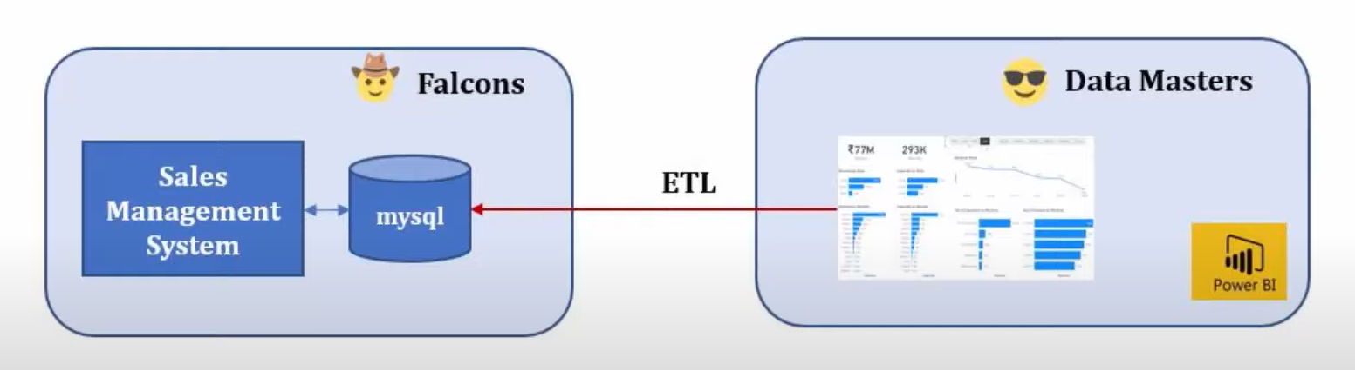

Generally we use Data warehouse when dealing with large datasets many real time projects about 80% will use this Data Warehouse instead of databases.

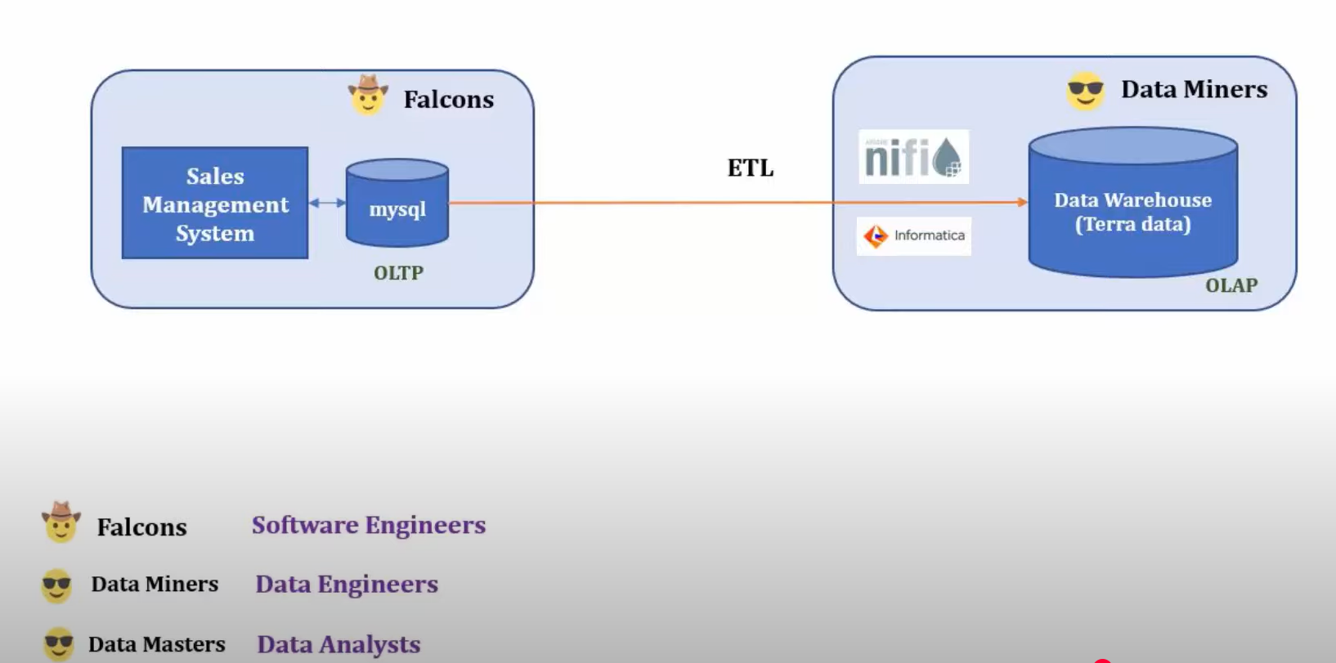

Data Engineers role is to transform the raw data in a suitable format and maintain the Data Warehouse infrastructure.

## 

## Understanding Schema

Markets table consists of three columns…

* **market_name**(Delhi, Hyderabad, Nagpur, Chenai…)
* **market_code**(Mark001, Mark002, Mark112)
* **zone**(Central/ North/South)

Product table consists of Two columns…

* **product_code**(Prod001, Prod002)
* **Product_type**(Own Brand, Distribution)

Customers table consists of Three columns…

* **customer_code**(Cus001, Cus002)
* **customer_name**(Unity stores, Sound)

Date table consists of Five columns…

* **date**(2018-09-09, 2017-02-22)
* **cy_date**(calender date) which is rounded to first day of the month(2018-09-01, 2017-02-01)
* **year**(2017, 2018)
* **month_name**(June, May)
* **date_yy_mmm**(custom format of date) 18-jun, 17-sep

Transactions table consists of Ten columns…

* Product_code, market_code, customer_code, order_date -> **Foreign Keys**
* **sales_qty**(1, 2, 3)
* **sales_amount**(102, 298)
* **currency**(INR, USD)
* **profit_margin_percentage(**0.32, -0.12)
* **profit_margin(**332.32, -18.98)
* **cost_price(**54.34, 434.43)

## connecting mysql database to power BI

Open Power BI -> get Data -> mysql database

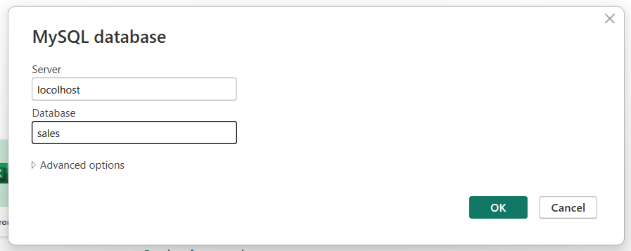

**Data modeling** is the process of **designing the structure of a database** or data system — basically, how data will be **stored, connected, and accessed**.

You create **a visual representation** (like diagrams) showing:

* What tables (or entities) exist
* What fields (columns) they have
* How they’re connected (relationships)

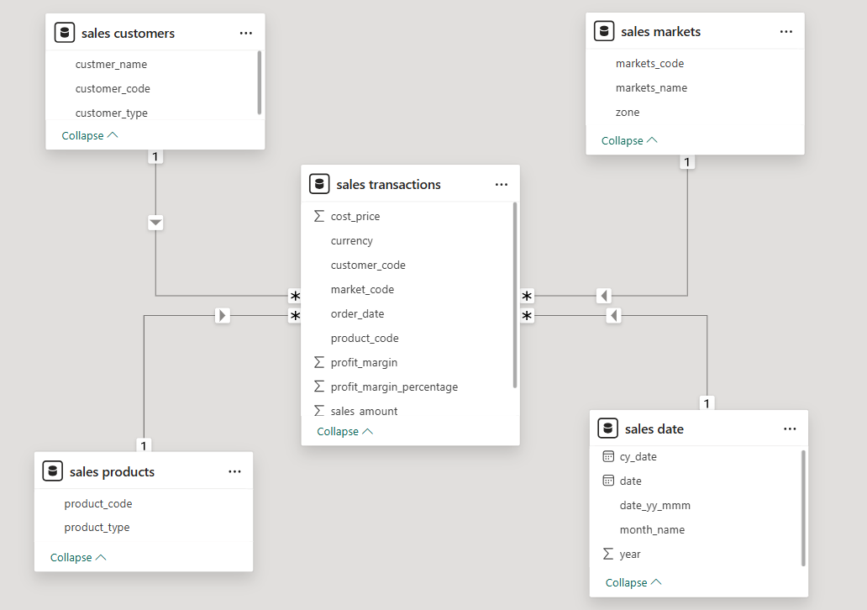

## Data cleaning

1. Removing blank rows from the markets table which contains markets like newyork, paris which doesnot contain zone by clicking on arrow placed right to the zone column name.
2. We have a rows with currency in USD so we need to convert it into INR for this we just created a new column using conditional column option and modified formula manually.
3. Replaced USD values in currency column to INR

Note: when you enable a option in power BI

Options -> report settings -> visual options -> change default visual interaction from cross highlighting to cross filtering.

It enables visuals to instead of just highligting the fields in other charts it hust filter outs and keeps the visuals where data is present to that particular filter.

## TABLEAU

In order to import data in tableau open the tablau software -> select data source appeared left side fo the window

You can create a data model by draging and dropping the tables in your database, tableau will automatically detects relationships with common column names otherwise we need to establish relationship manually like below

