Machine Learning (Week 2)

End-to-End Energy Dataset Training Workflow
SourceCode:
https://github.com/MYethishwar/AI-engineering/blob/main/Week%202%20Machine%20Learning/machine_learning_done_when.ipynb
Live HuggingFace Deployment APP: https://huggingface.co/spaces/MYethishwar/Energy-Prediction-System-Using-Linear-Logistic-Regression
Sample Dataset:
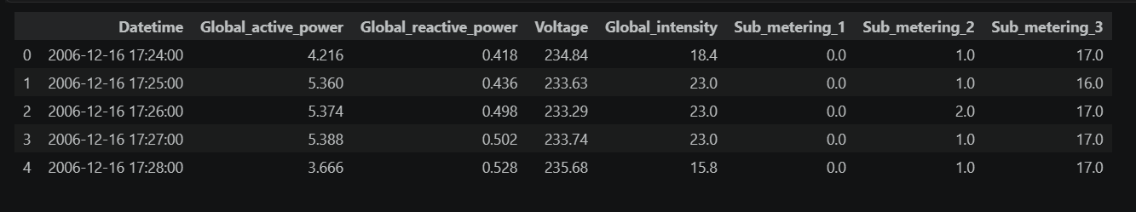
Relationship between features: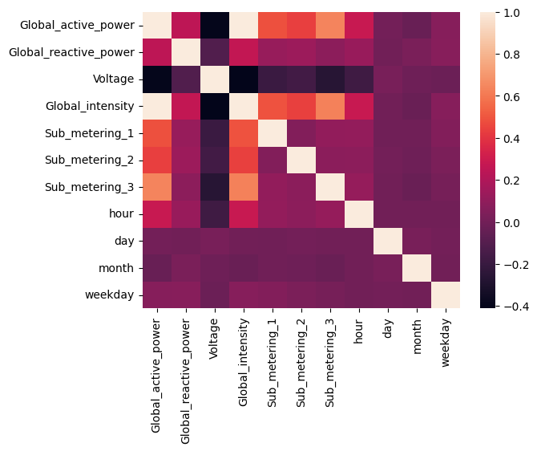

Structure of the data
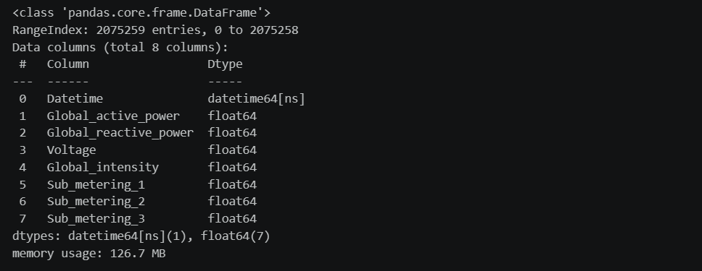

Data Distribution of each feature: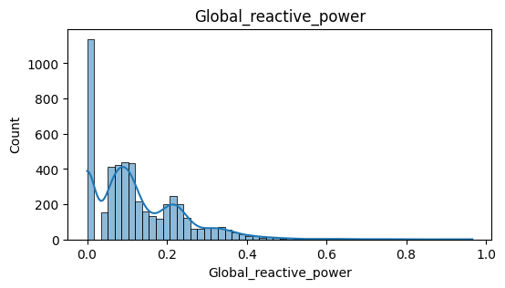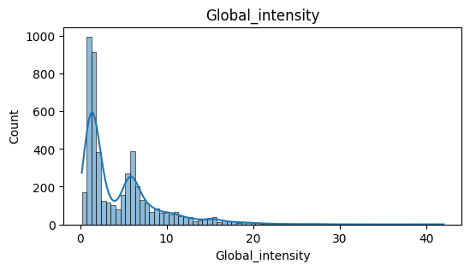 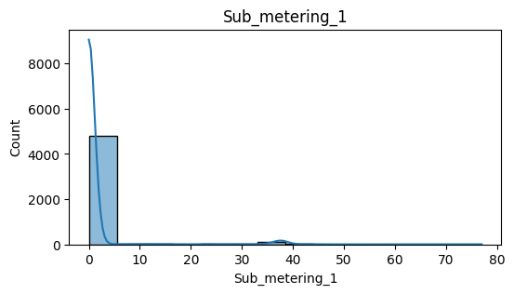 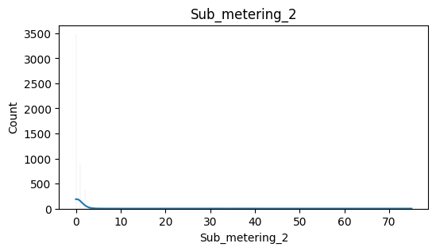 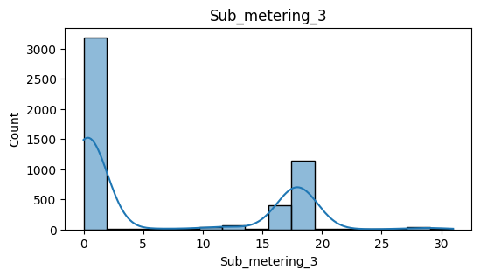

Training report
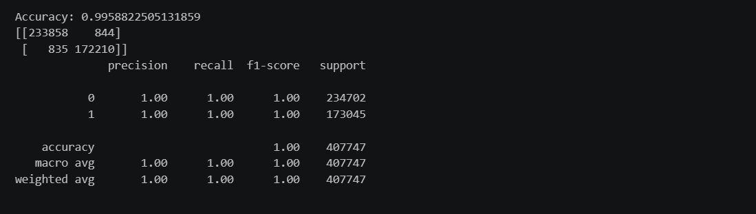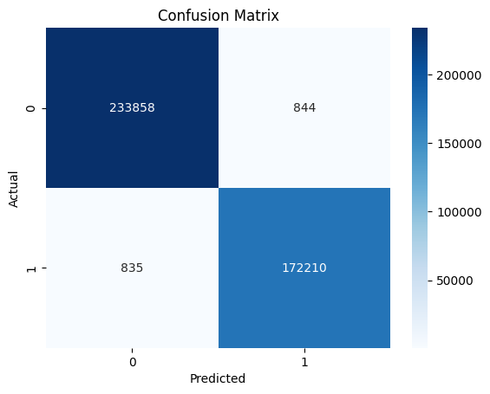

Project workflow and my approach:
During this week, a complete Machine Learning workflow was implemented using the Household Power Consumption dataset. The work focused on both regression and classification approaches for analyzing and predicting household energy consumption patterns.
The following tasks were completed:
- Defined the business problem and identified the prediction objectives.
- Collected and imported the Household Power Consumption dataset.
- Performed data preprocessing and cleaning.
- Conducted Exploratory Data Analysis (EDA).
- Converted data types and handled missing values.
- Created additional time-based features through feature engineering.
- Performed duplicate and outlier analysis.
- Conducted correlation analysis for feature selection.
- Developed and trained a Linear Regression model for energy consumption prediction.
- Evaluated regression model performance using standard metrics.
- Serialized and saved the trained regression model using Pickle.
- Created a classification target variable for energy usage categorization.
- Developed and trained a Logistic Regression model.
- Evaluated classification performance using accuracy, confusion matrix, and classification report.
- Visualized classification results.
- Serialized and saved the trained classification model.

Workflow Implementation

Step 1: Problem Definition
The objective of the project was to analyze household electrical consumption data and develop machine learning models capable of:
- Predicting total active power consumption.
- Classifying energy usage into different consumption categories.
The target variable selected was:
Global_active_power
Input features included:
- Voltage
- Global_intensity
- Global_reactive_power
- Sub_metering_1
- Sub_metering_2
- Sub_metering_3

Step 2: Data Collection and Import
The Household Power Consumption dataset was collected and imported into Python using Pandas.
Dataset Characteristics:
- Time-series household energy consumption data.
- Contains electrical measurements recorded over time.
- Data initially stored in text format with semicolon-separated values.
Activities performed:
- Imported dataset into a DataFrame.
- Parsed date and time columns.
- Combined date and time into a single datetime field.
- Loaded data into a structured format for further analysis.

Step 3: Data Preprocessing
Several preprocessing operations were performed to improve data quality.
Data Type Conversion
Numerical columns initially stored as object datatype were converted into numeric format.
Missing Value Handling
- Missing values were identified.
- Null records were removed due to the large dataset size.
- Data integrity was maintained while minimizing information loss.
Duplicate Handling
- Duplicate records were detected.
- Duplicate entries were removed.

Step 4: Feature Engineering
Additional features were extracted from the datetime column to capture temporal patterns.
Generated Features:
- Hour
- Day
- Month
- Weekday
These features help models understand energy consumption behavior across different time periods.

Step 5: Exploratory Data Analysis (EDA)
EDA was performed to understand data distribution and identify patterns.
Analysis conducted:
- Distribution plots
- Histogram analysis
- Boxplot analysis
- Correlation analysis
Key Observations
- Global Active Power showed a right-skewed distribution.
- Voltage exhibited relatively stable behavior.
- Sub-metering variables contained a large number of zero values.
- Energy consumption features demonstrated strong relationships with the target variable.

Step 6: Outlier Analysis
Outliers were examined using boxplots.
Observation:
High-value observations represented genuine energy consumption events rather than noise.
Decision:
- Outliers were retained.
- No outlier removal was performed to preserve real-world consumption behavior.

Step 7: Feature Selection
Correlation analysis was performed to identify the most relevant predictors.
Selected Features:
- Global_intensity
- Sub_metering_1
- Sub_metering_2
- Sub_metering_3
- Voltage
- Global_reactive_power
These features were used as input variables for model training.

Linear Regression Model Workflow

Data Splitting
The dataset was divided into:
- Training Set: 80%
- Testing Set: 20%
Purpose:
- Train the model on historical data.
- Evaluate performance on unseen data.

Model Training
Algorithm Used:

Linear Regression
The model was trained to predict:

Global_active_power
using the selected electrical measurement features.

Model Evaluation
Evaluation Metrics:
- Mean Absolute Error (MAE)
- R² Score
Regression Output
[Insert Regression Metrics Screenshot Here]

Model Serialization
The trained model was saved using Pickle.
Generated File:
linear_regression_model.pkl
Purpose:
- Model reuse
- Deployment readiness
- Faster inference without retraining

Logistic Regression Model Workflow

Classification Problem Creation
To enable classification, a new target variable was generated.
Method:
- Mean value of Global Active Power was calculated.
- Values above the mean were labeled as High Usage (1).
- Values below the mean were labeled as Low Usage (0).
Generated Target:
usage_type

Data Splitting
The classification dataset was divided into:
- Training Set: 80%
- Testing Set: 20%

Model Training
Algorithm Used:

Logistic Regression
Objective:
Predict whether household energy consumption belongs to:
- High Usage Category
- Low Usage Category

Model Evaluation
Evaluation Techniques:
- Accuracy Score
- Confusion Matrix
- Classification Report
Metrics evaluated:
- Accuracy
- Precision
- Recall
- F1-Score
Classification Output
[Insert Classification Metrics Screenshot Here]

Confusion Matrix
[Insert Confusion Matrix Screenshot Here]

Model Serialization
The trained classification model was saved using Pickle.
Generated File:
logistic_model.pkl

Overall Outcome
This week's implementation successfully established a complete end-to-end machine learning pipeline for household energy consumption analysis. The workflow included data collection, preprocessing, feature engineering, exploratory analysis, regression modeling, classification modeling, evaluation, and model persistence. Both Linear Regression and Logistic Regression models were developed and prepared for future integration into analytical or deployment environments.

