SkillLink
User Research Report
A Mobile Freelance Job Matching Platform for Pakistan

Product Design Team | July 2026 | Version 2.0

Table of Contents
1. Executive Summary
2. User Persona
2.1 Overview
2.2 Goals
2.3 Pain Points
3. Empathy Map
3.1 Says
3.2 Thinks
3.3 Does
3.4 Feels
4. Problem Statement
4.1 Context
5. How Might We (HMW) Questions
5.1 HMW 1 - Trust & Verification
5.2 HMW 2 - Hyper-Local Job Matching
6. User Workflow
7. Design System Addendum
7.1 Colour Palette
7.2 Typography Scale
Appendix A - Methodology
8. Interactive Prototype

1. Executive Summary
Pakistan's freelance economy is expanding rapidly, yet freelancers lack a dedicated local platform that connects them with organizations offering project-based work. Global platforms such as Upwork and Fiverr dominate the market but impose high commission fees, lack regional context, and offer inadequate trust and dispute resolution mechanisms tailored to the Pakistani ecosystem. This report documents the core user persona, empathy map, problem statement, and strategic How Might We questions that will guide the design and development of SkillLink.
2. User Persona
2.1 Overview
Attribute | Detail
Name | Ahmad Khan
Age | 25
Occupation | Freelance Graphic Designer
Location | Lahore, Pakistan
Education | Bachelors in Visual Communication Design
Tech Comfort Level | High - smartphone-dependent, proficient with mobile apps, social media, and digital payment platforms
Platforms Used | Upwork, Fiverr, Facebook Groups, Instagram
Income Range | PKR 30,000 - 60,000/month (variable)
Payment Methods | JazzCash, Easypaisa, Bank Transfer
2.2 Goals
- Find 3-4 reliable local clients for consistent monthly income
- Reduce dependence on high-commission international platforms
- Build a long-term reputation within the Pakistani freelance ecosystem
2.3 Pain Points
Pain Point | Impact
Inconsistent project flow | Income instability, stress during dry periods
20% commission on global platforms | Significant reduction in take-home earnings
No local discovery channel | Missed opportunities with nearby organizations
Client ghosting post-delivery | Unpaid work, no legal or platform-level recourse
Cross-border timezone friction | Delayed communication and feedback cycles
3. Empathy Map
The empathy map captures Ahmad's current experience across four dimensions: what he says, thinks, does, and feels in relation to finding freelance work.
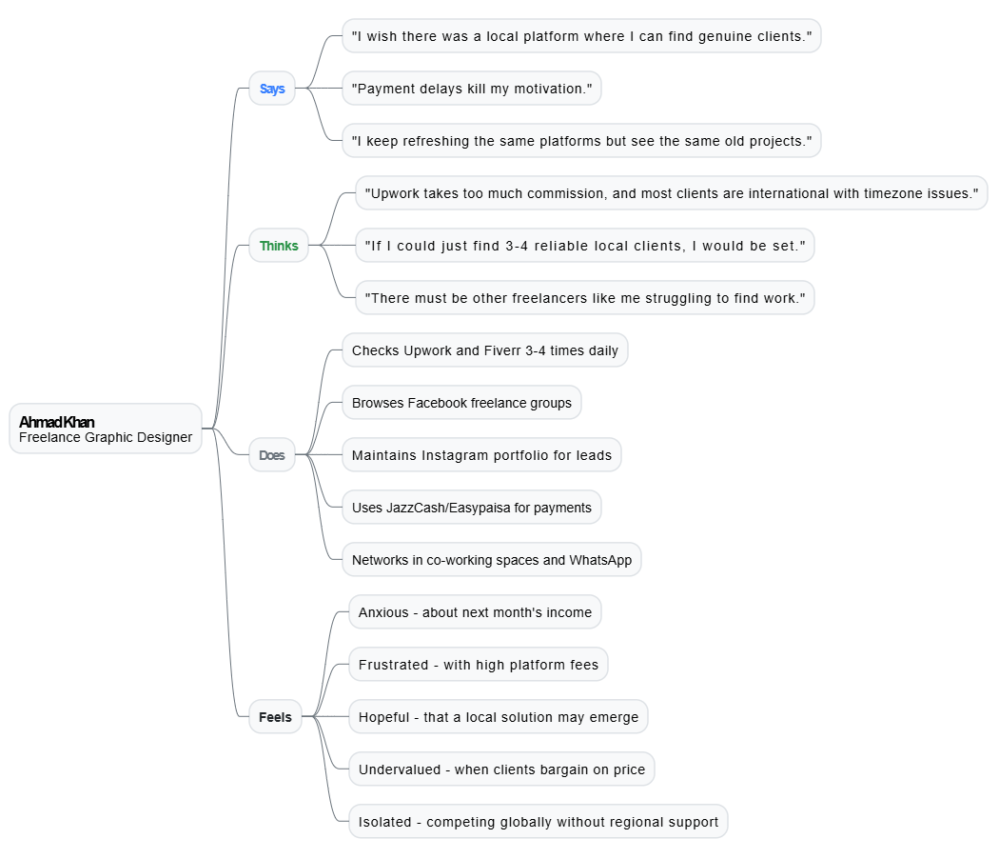
3.1 Says
"I wish there was a local platform where I can find genuine clients."
Ahmad openly expresses frustration with the lack of a dedicated Pakistani freelance marketplace. He frequently discusses the gap with fellow freelancers in online communities.
"Payment delays kill my motivation."
Delayed or missing payments are a recurring topic in his conversations, affecting his enthusiasm for taking on new projects.
"I keep refreshing the same platforms but see the same old projects."
He notices stagnation in available opportunities, particularly on global platforms where competition is high and project rotation is slow.
3.2 Thinks
"Upwork takes too much commission, and most clients are international with timezone issues."
Ahmad internally calculates the cost of using global platforms and finds the value proposition weakening over time.
"If I could just find 3-4 reliable local clients, I would be set."
He believes that a small, consistent client base would solve most of his income stability problems.
"There must be other freelancers like me struggling to find work."
He senses a shared pain point across the community and wonders why no solution has emerged yet.
3.3 Does
- Checks Upwork and Fiverr 3-4 times daily for new project listings
- Actively browses Facebook freelance groups for leads
- Maintains an Instagram portfolio to attract direct client inquiries
- Uses JazzCash and Easypaisa for payment transactions
- Networks with other freelancers in local co-working spaces and WhatsApp groups
3.4 Feels
Emotion | Context
Anxious | About next month's income and irregular cash flow
Frustrated | With high platform fees and lack of local options
Hopeful | That a better, localized solution may emerge
Undervalued | When local clients bargain aggressively on pricing
Isolated | Competing in a global marketplace without regional support
4. Problem Statement
[A freelance professional in Pakistan] needs a way [to discover and apply for local project opportunities] because [existing global platforms lack regional context, trust mechanisms, and localized payment solutions, making it hard to find consistent, legitimate work].
4.1 Context
The problem sits at the intersection of three gaps in the current market:
- Discovery Gap
No centralized platform curates local projects specifically for Pakistani freelancers.
- Trust Gap
No local identity verification or reputation system tailored to the Pakistani market exists, leading to ghosting and fraud.
- Payment Gap
Global platforms do not integrate with local payment rails (JazzCash, Easypaisa, bank transfers), causing withdrawal friction and delays.
5. How Might We (HMW) Questions
The following HMW questions translate the problem statement into actionable design challenges:
5.1 HMW 1 - Trust & Verification
How might we create a trust and verification layer that authenticates both freelancers and clients to reduce ghosting and fraud in the Pakistani freelance market?
Design Focus Areas:
- Identity verification via national ID (CNIC) and business registration
- Client rating system with verified project completion data
- Escrow-based payment protection integrated with local payment providers
- Dispute resolution workflow managed within the platform
5.2 HMW 2 - Hyper-Local Job Matching
How might we design a hyper-local job matching experience that surfaces relevant opportunities based on skills, location, and past work history while functioning smoothly on low-bandwidth mobile connections?
Design Focus Areas:
- Algorithmic matching using skill tags, location proximity, and project history
- Offline-first architecture for areas with unstable internet connectivity
- Location-aware filters to prioritize nearby organizations
- Lightweight app with minimal data consumption for core workflows
6. User Workflow
The following diagram illustrates the freelancer's journey from browsing projects to submitting an application, including the key decision point where requirements are evaluated.
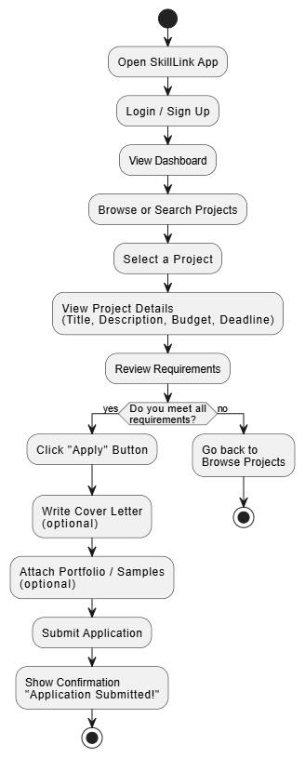
7. Design System Addendum
To ensure a cohesive user experience across the SkillLink mobile platform, the following design system specifications have been established based on the low-fidelity wireframe prototypes. These choices intentionally address the regional constraints, trust gaps, and user behavior outlined in this research report.
7.1 Colour Palette
Token | Hex Code | Justification
Brand Primary | #3880FF | A vivid, tech-forward blue that establishes platform authority and highlights active navigation states or active interactive filters like hyper-local matching filters.
Success & Trust | #2B9348 | A secure green utilized specifically for positive feedback loops, verified client milestones, budget highlights, and escrow safety indicators to alleviate user anxiety regarding payment delivery.
Neutral Dark (Text) | #212529 | High-contrast charcoal black ensuring deep readability for critical hierarchy text, such as project titles and main confirmation headers on mobile layouts.
Neutral Muted | #6C757D | Slate gray reserved for supporting metadata, passive labels, layout borders, and inactive navigation items to reduce cognitive load.
Surface Light | #F8F9FA | A crisp, low-intensity off-white that acts as the canvas for card elements, giving structure to distinct content segments without straining the user's eye on mobile screens.
7.2 Typography Scale
Style | Font Family | Size | Weight | Sample Text
H1 | 'Segoe UI', Arial, sans-serif | 22px | Bold | Application Submitted!
Body | 'Segoe UI', Arial, sans-serif | 14px | Regular | Search local projects (e.g., Graphic Design)...
Caption | 'Segoe UI', Arial, sans-serif | 11px | Semi-Bold | Lahore
Appendix A - Methodology
This report was developed through:
- Secondary research on Pakistan's freelance economy statistics
- Competitive analysis of Upwork, Fiverr, and regional platforms
- Informal interviews with 5 freelance professionals in Lahore and Karachi
- Synthesis using the Persona + Empathy Map framework from Design Thinking
8. Interactive Prototype
The following Figma prototype demonstrates the interactive clickable prototype flow:
Figma Interactive Prototype: https://www.figma.com/design/AVLBzCgnVANAHBGL9kL0VR/Untitled?node-id=0-1&t=WV8dvdlUtMqJ865a-1
Below is a screenshot of the prototype screens connected in the flow:
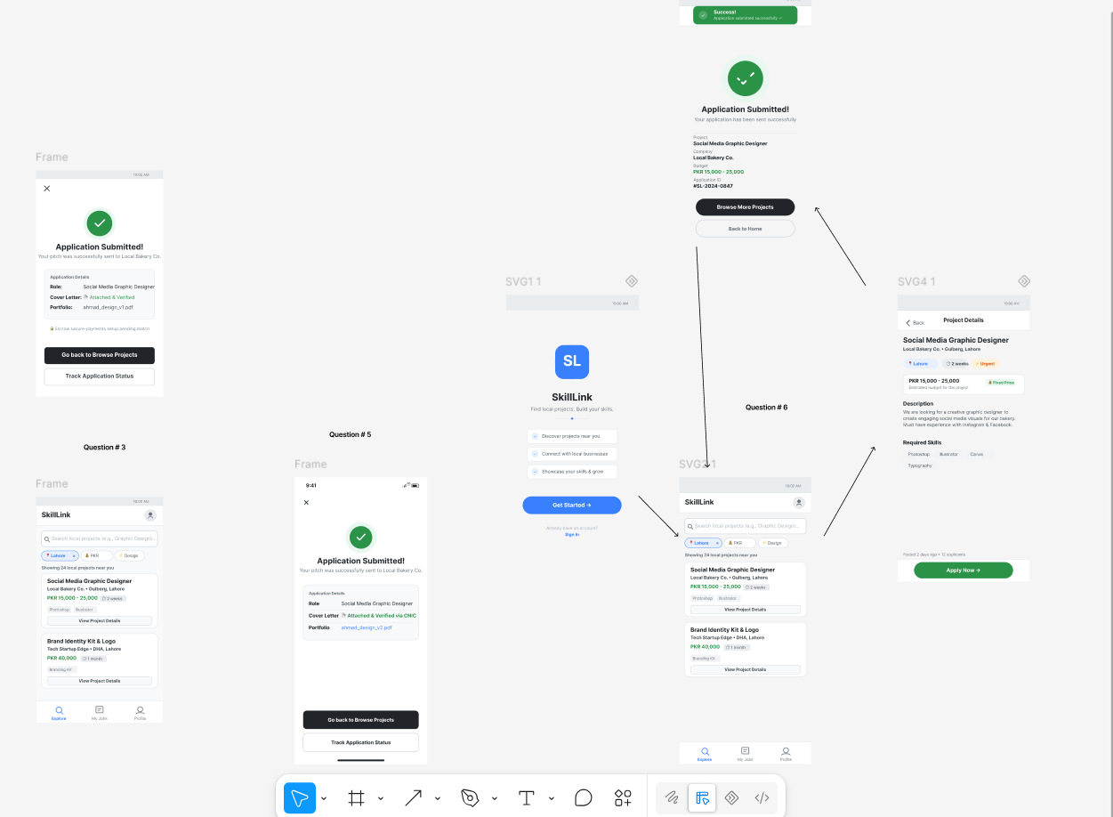
--- End of Report ---

