Q1.

CODE:

package Q01;  
  
import javax.swing.*;  
  
public class Q1 {  
 public static void main(String[] args) {  
 JFrame frame = new JFrame("Welcome to Java");  
 frame.setSize(800, 600);  
 frame.setDefaultCloseOperation(JFrame.*EXIT_ON_CLOSE*);  
 frame.setVisible(true);  
 }  
}

OUTPUT:

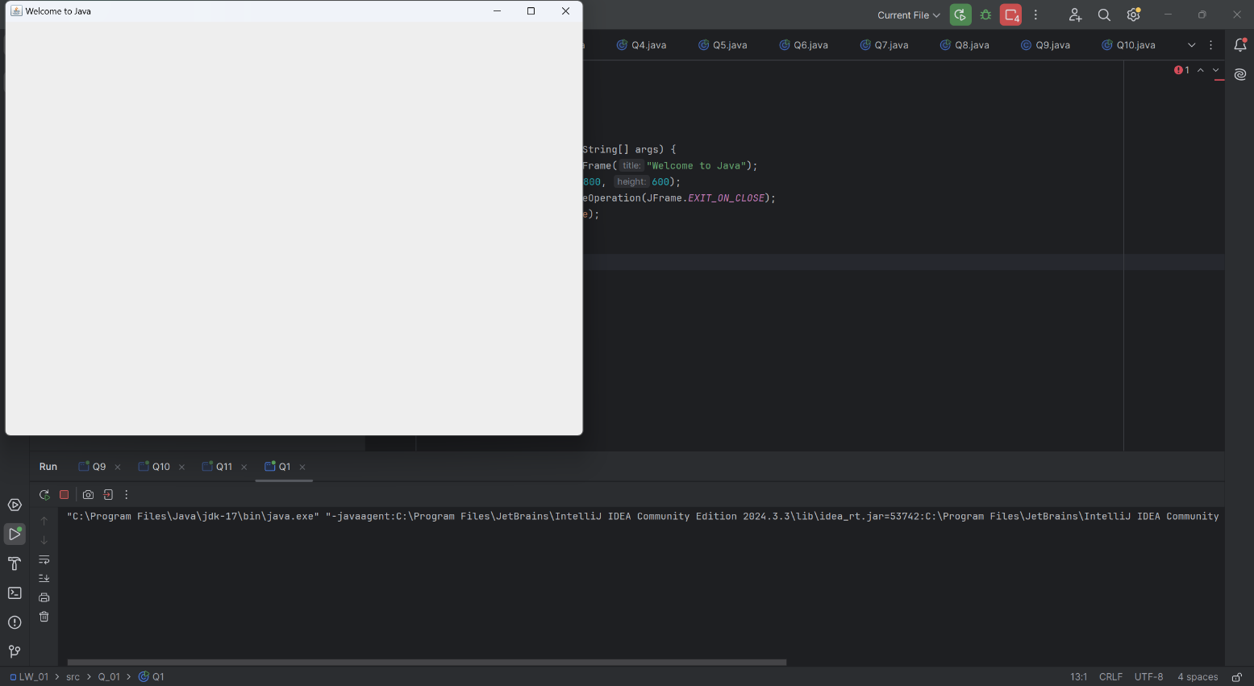

Q2.

CODE:

package Q_02;  
  
import javax.swing.*;  
import java.util.Scanner;  
  
public class Q2 {  
 public static void main(String[] args) {  
 Scanner scanner = new Scanner(System.*in*);  
  
 System.*out*.print("Enter First Name: ");  
 String firstName = scanner.nextLine();  
  
 System.*out*.print("Enter Last Name: ");  
 String lastName = scanner.nextLine();  
  
 String fullName = firstName + " " + lastName;  
  
 JFrame frame = new JFrame(fullName);  
 frame.setSize(800, 600);  
 frame.setDefaultCloseOperation(JFrame.*EXIT_ON_CLOSE*);  
 frame.setVisible(true);  
  
 scanner.close();  
 }  
}

OUTPUT:

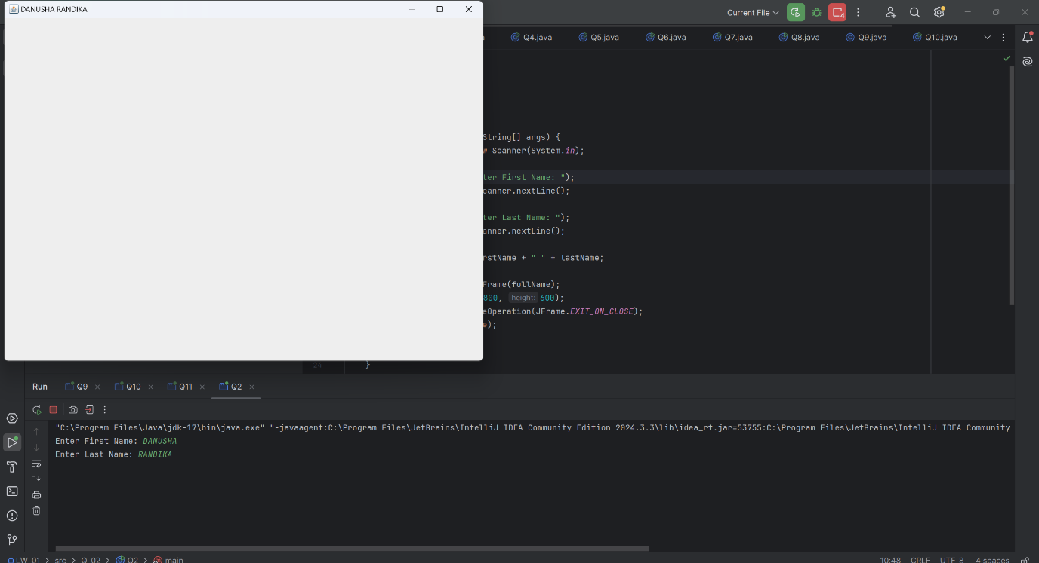

Q3.

CODE:

package Q_03;  
  
import java.util.Scanner;  
  
public class Q3 {  
 public static void main(String[] args) {  
 Scanner scanner = new Scanner(System.*in*);  
  
 System.*out*.print("Enter First Name: ");  
 String firstName = scanner.nextLine();  
  
 System.*out*.print("Enter Middle Name: ");  
 String middleName = scanner.nextLine();  
  
 System.*out*.print("Enter Last Name: ");  
 String lastName = scanner.nextLine();  
  
 String formattedName = firstName + " " + middleName.charAt(0) + ". " + lastName;  
  
 System.*out*.println("Formatted Name: " + formattedName);  
  
 scanner.close();  
 }  
}

OUTPUT:

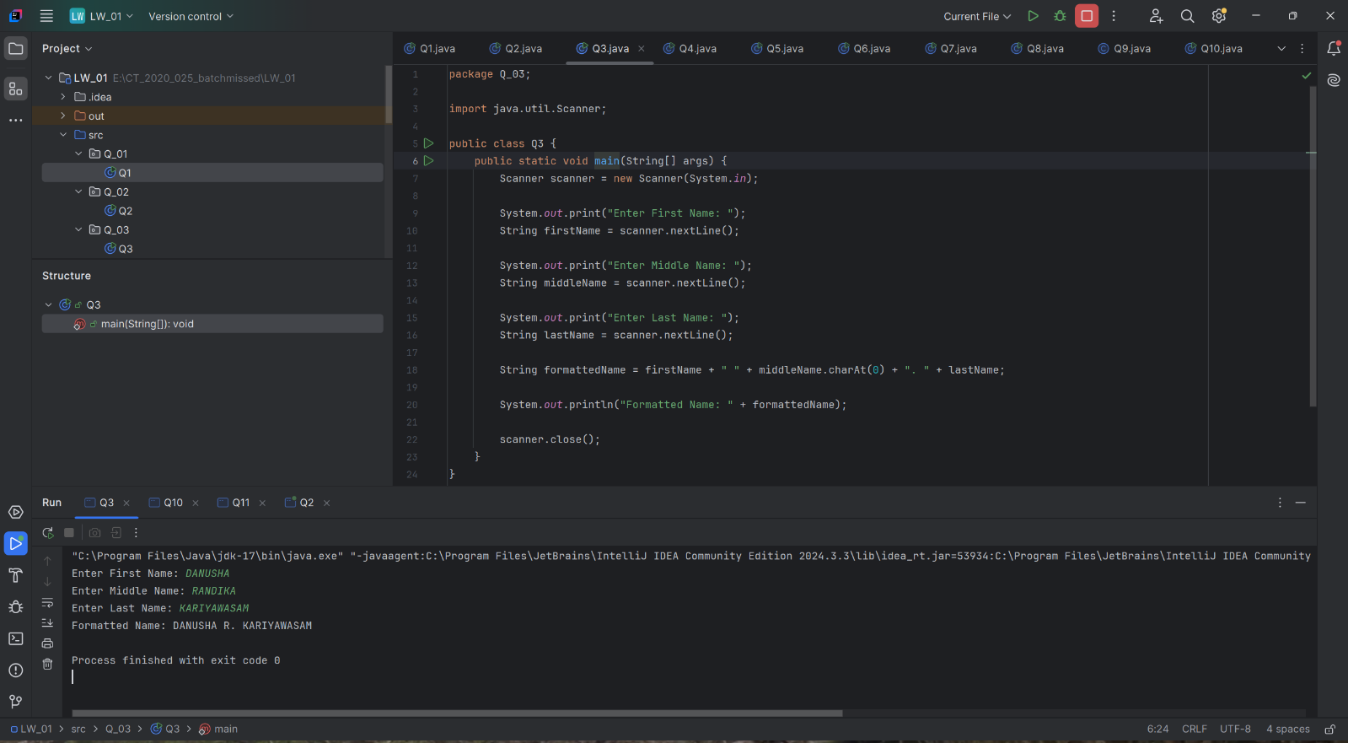

Q4.

CODE:

package Q_04;  
  
import java.time.LocalDate;  
import java.time.format.DateTimeFormatter;  
  
public class Q4 {  
 public static void main(String[] args) {  
 LocalDate today = LocalDate.*now*();  
 DateTimeFormatter formatter = DateTimeFormatter.*ofPattern*("d MMM yyyy");  
  
 System.*out*.println("Today's Date: " + today.format(formatter));  
 }  
}

OUTPUT:

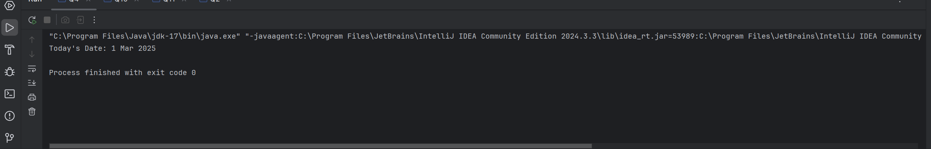

Q5.

CODE:

package Q_05;  
  
import java.time.LocalDate;  
import java.time.format.DateTimeFormatter;  
  
public class Q5 {  
 public static void main(String[] args) {  
 LocalDate today = LocalDate.*now*();  
 DateTimeFormatter formatter = DateTimeFormatter.*ofPattern*("EEEE, MMM d, yyyy");  
  
 System.*out*.println("Today's Date: " + today.format(formatter));  
 }  
}

OUTPUT:

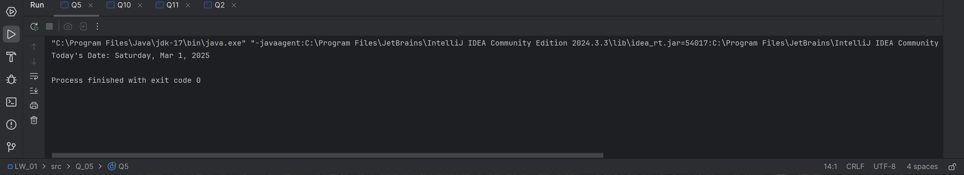

Q6.

CODE:

package Q_06;  
  
import javax.swing.*;  
import java.util.Scanner;  
  
public class Q6 {  
 public static void main(String[] args) {  
 Scanner scanner = new Scanner(System.*in*);  
  
 System.*out*.print("Enter frame width: ");  
 int width = scanner.nextInt();  
  
 System.*out*.print("Enter frame height: ");  
 int height = scanner.nextInt();  
  
 scanner.nextLine(); // Consume newline  
  
 System.*out*.print("Enter frame title: ");  
 String title = scanner.nextLine();  
  
 JFrame frame = new JFrame(title);  
 frame.setSize(width, height);  
 frame.setDefaultCloseOperation(JFrame.*EXIT_ON_CLOSE*);  
 frame.setVisible(true);  
  
 scanner.close();  
 }  
}

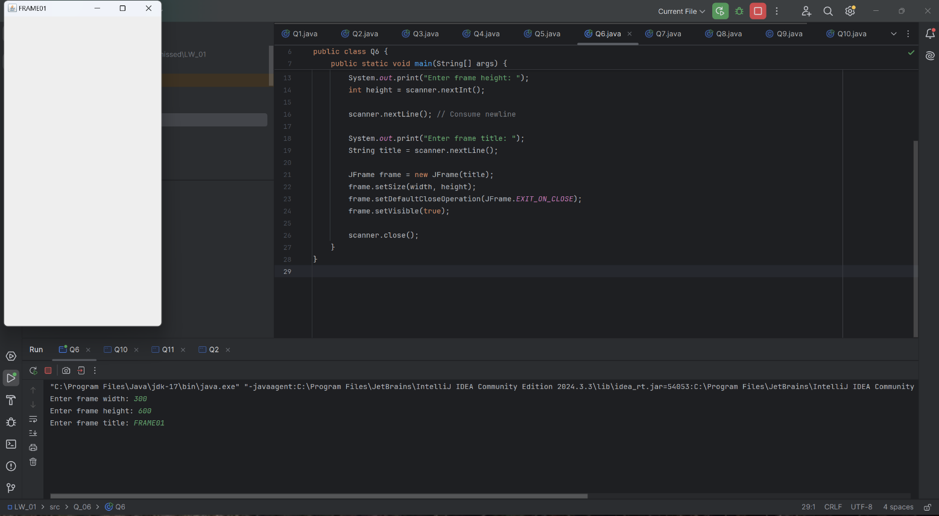OUTPUT:

Q7.

CODE:

package Q_07;  
  
import javax.swing.*;  
import java.text.SimpleDateFormat;  
import java.util.Date;  
  
public class Q7 {  
 public static void main(String[] args) {  
 SimpleDateFormat timeFormat = new SimpleDateFormat("hh:mm:ss a");  
 String time = timeFormat.format(new Date());  
  
 JFrame frame = new JFrame(time);  
 frame.setSize(400, 300);  
 frame.setDefaultCloseOperation(JFrame.*EXIT_ON_CLOSE*);  
 frame.setVisible(true);  
 }  
}

OUTPUT:

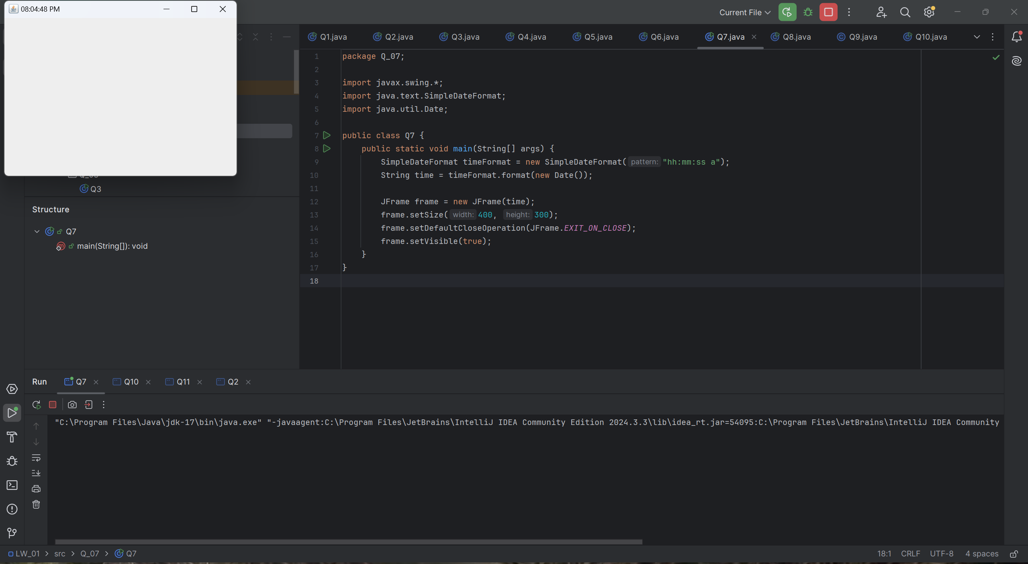

Q8.

CODE:

package Q_08;  
  
import java.util.Scanner;  
  
public class Q8 {  
 public static void main(String[] args) {  
 Scanner scanner = new Scanner(System.*in*);  
  
 System.*out*.print("Enter a string with '!': ");  
 String input = scanner.nextLine();  
  
 String[] parts = input.split("!", 2); // Split into two parts  
  
 if (parts.length == 2) {  
 System.*out*.println(parts[0].trim());  
 System.*out*.println(parts[1].trim());  
 } else {  
 System.*out*.println("No '!' found in the input.");  
 }  
  
 scanner.close();  
 }  
}

OUTPUT:

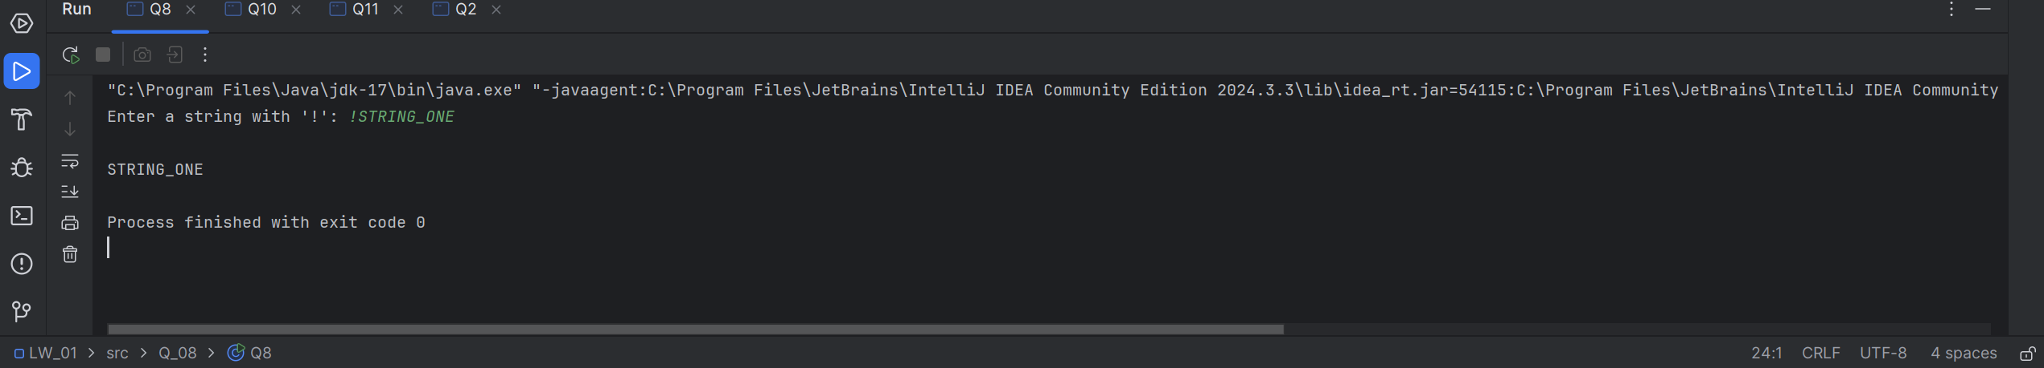

Q9.

CODE:

package Q_09;  
  
import java.util.Scanner;  
  
public class Q9 {  
 public static void main(String[] args) {  
 Scanner scanner = new Scanner(System.*in*);  
  
 System.*out*.print("Enter a string: ");  
 String input = scanner.nextLine();  
  
 int length = input.length();  
 System.*out*.println(length);  
 System.*out*.println(input.charAt(0));  
 System.*out*.println(input.charAt(length - 1));  
  
 scanner.close();  
 }  
}

OUTPUT:

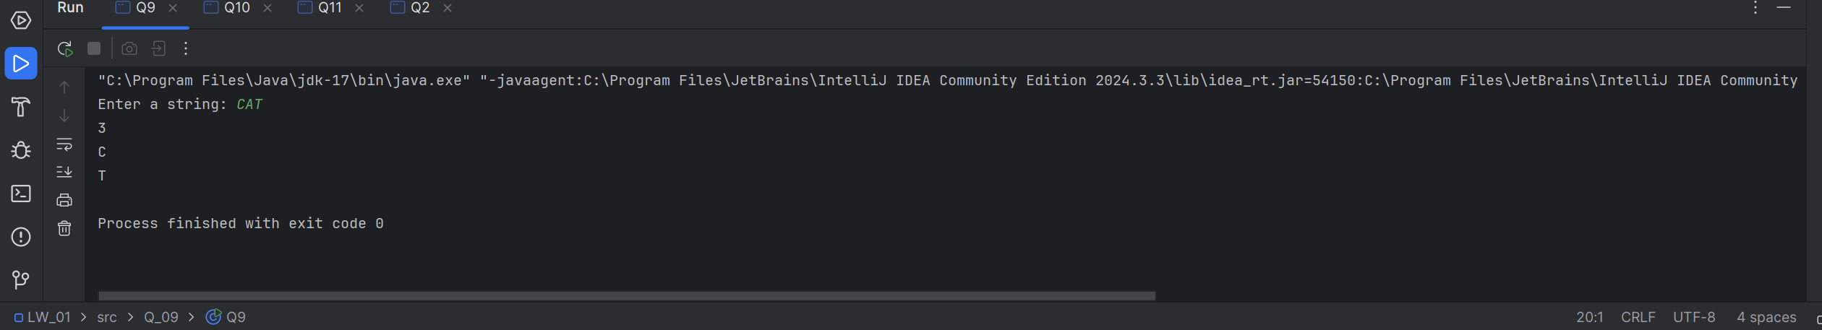

Q10.

CODE:

package Q_10;  
  
import java.util.Scanner;  
  
public class Q10 {  
 public static void main(String[] args) {  
 Scanner scanner = new Scanner(System.*in*);  
  
 System.*out*.print("Enter an odd-length word: ");  
 String word = scanner.nextLine();  
  
 if (word.length() % 2 == 1) {  
 int middleIndex = word.length() / 2;  
 System.*out*.println("Middle character: " + word.charAt(middleIndex));  
 } else {  
 System.*out*.println("The word length is not odd.");  
 }  
  
 scanner.close();  
 }  
}

OUTPUT:

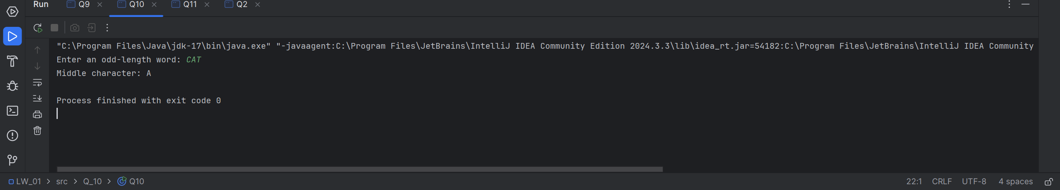

Q11.

CODE:

package Q_11;  
  
import java.util.Scanner;  
  
public class Q11 {  
 public static void main(String[] args) {  
 Scanner scanner = new Scanner(System.*in*);  
  
 System.*out*.print("Enter your full name (First Middle Last): ");  
 String firstName = scanner.next();  
 String middleName = scanner.next();  
 String lastName = scanner.next();  
  
 String formattedName = lastName + ", " + firstName + " " + middleName.charAt(0) + ".";  
 System.*out*.println(formattedName);  
  
 scanner.close();  
 }  
}

OUTPUT:

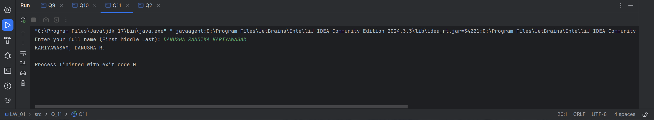

Q12.

CODE:

package Q_12;  
  
import javax.swing.*;  
  
public class Q12 {  
 public static void main(String[] args) {  
 JFrame frame = new JFrame("My First Frame");  
 frame.setSize(300, 200);  
 frame.setLocation(100, 50); // 100 pixels from left, 50 pixels from top  
 frame.setDefaultCloseOperation(JFrame.*EXIT_ON_CLOSE*);  
 frame.setVisible(true);  
 }  
}

OUTPUT:

