CT/2021/044 – T.H.M.C.Thilakshana

Q_01

**Code**

package Q_01;  
  
import javax.swing.plaf.synth.SynthOptionPaneUI;  
  
public class Q01 {  
 public static void main(String[] args) {  
 final double pie=(3.14);  
 //a)  
 double A=2,B=3,C=4,X=5,Y=6,R=7;  
 double sqrta =Math.*sqrt*(B*B+4*A*C);  
 System.*out*.println(sqrta);  
  
 //b)  
 double sqrtb=Math.*sqrt*(X+4*(Y*Y*Y));  
 System.*out*.println(sqrtb);  
  
 //c)  
 double cbrt=Math.*cbrt*(X*Y);  
 System.*out*.println(cbrt);  
  
 //d)  
 double area=pie*R*R;  
 System.*out*.println(area);  
  
 }  
}

**Output**

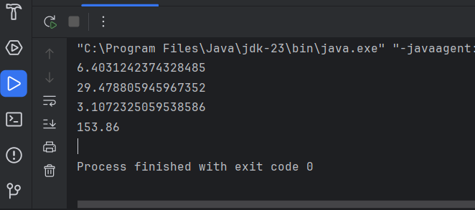

**Q_02**

**Code**

package Q_02;  
  
import java.util.Scanner;  
  
public class Q02 {  
 public static void main(String[] args) {  
 Scanner inpt=new Scanner(System.*in*);  
 System.*out*.println("Enter Length ");  
 double inc=inpt.nextDouble();  
 System.*out*.println("Inches :"+(inc/2.54));  
 System.*out*.println("Feet : "+((inc/2.54)/12));  
 }  
}

**Output**

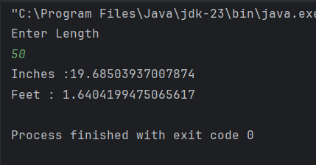

**Q_03**

**Code**

package Q_03;  
  
import java.util.Scanner;  
  
public class Q03 {  
 public static void main(String[] args) {  
 Scanner cels=new Scanner(System.*in*);  
 System.*out*.print("Enter Temperature : ");  
 double cel=cels.nextDouble();  
 double fr=(1.8*cel)+32;  
 System.*out*.println("Temperature in Fahrenheit : "+fr);  
 }  
}

**Output**

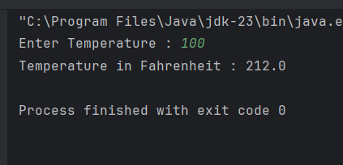

**Q_04**

**Code**

package Q_04;  
  
import java.util.Scanner;  
  
public class Q04 {  
 public static void main(String[] args) {  
 Scanner BW=new Scanner(System.*in*);  
 System.*out*.print("Enter Your Body Weight : ");  
 double BWT=BW.nextDouble();  
 double clri=BWT*19;  
 System.*out*.println("Number Of Calories : "+clri);  
  
 }  
}

**Output**

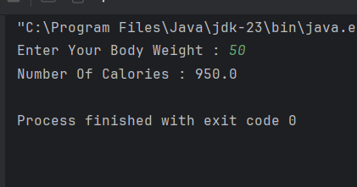

**Q_05**

**Code**

package Q_05;  
  
import java.util.Scanner;  
  
public class Q05 {  
 public static void main(String[] args) {  
 Scanner frn=new Scanner(System.*in*);  
 System.*out*.print("Enter Temperature : ");  
 double frnh=frn.nextDouble();  
 double cel=(0.556)*(frnh-32);  
 System.*out*.println("Temperature in celsius : "+cel);  
 }  
}

**Output**

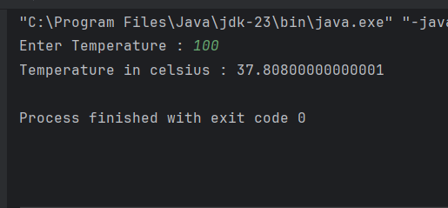

**Q_06**

**Code**

package Q_06;  
  
import java.time.Year;  
import java.util.Date;  
import java.util.Scanner;  
  
public class Q06 {  
 public static void main(String[] args) {  
 Scanner inpt=new Scanner(System.*in*);  
 System.*out*.print("Enter Born year : ");  
 int yr=inpt.nextInt();  
 int yr_count = Year.*now*().getValue()-yr;  
 System.*out*.println("You were born in "+yr+" and will be "+yr_count+" this year");  
 }  
}

**Output**

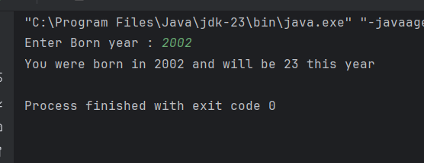

**Q_07**

**Code**

package Q_07;  
  
import java.util.Scanner;  
  
public class Q07 {  
 public static void main(String[] args) {  
 Scanner Weight=new Scanner(System.*in*);  
 System.*out*.println("Enter Your Weight : ");  
 int w=Weight.nextInt();  
  
 Scanner Height=new Scanner(System.*in*);  
 System.*out*.println("Enter Your Height : ");  
 int h=Height.nextInt();  
  
 double bmi=w/((h/100.0)*(h/100.0));  
 if (bmi<=25 && bmi>=20){  
 System.*out*.println("BMI Value is Normal");  
 }  
 else System.*out*.println("BMI Value is not Normal");  
 }  
}

**Output**

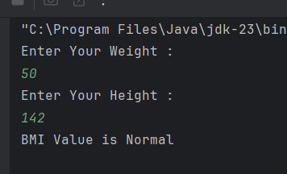

**Q_08**

**Code**

package Q_08;  
  
  
import java.util.Scanner;  
  
public class Q08 {  
 public static void main(String[] args) {  
 Scanner inpt=new Scanner(System.*in*);  
 System.*out*.print("Enter Radius : ");  
 float r=inpt.nextFloat();  
 double pie=3.14;  
 //float r3=r*r*r;  
 double V=1.33*pie*(r*r*r);  
 System.*out*.println("Volume Of the Sphere : "+V);  
  
 }  
}

**Output**

**Q_09**

**Code**

package Q_09;  
  
import java.util.Scanner;  
  
public class Q09 {  
 public static void main(String[] args) {  
 Scanner scanner = new Scanner(System.*in*);  
  
 System.*out*.print("Enter invest amount (P): ");  
 double invest = scanner.nextDouble();  
  
 System.*out*.print("Enter annual interest rate (R %): ");  
 double rate = scanner.nextDouble();  
  
 System.*out*.print("Enter number of years (N): ");  
 int years = scanner.nextInt();  
  
 double amount = invest * Math.*pow*(1 + (rate / 100), years);  
  
 System.*out*.printf("The amount after %d years is: %.2f", years, amount);  
 }  
}

**Output**

**Q_010**

**Code**

package Q_10;  
  
import java.util.Scanner;  
  
public class Q010 {  
 public static void main(String[] args) {  
 final int MONTHS_IN_YEAR = 12;  
 Scanner scanner = new Scanner(System.*in*);  
  
 System.*out*.print("Enter loan amount: ");  
 double loanAmount = scanner.nextDouble();  
  
 System.*out*.print("Enter annual interest rate (%): ");  
 double annualInterestRate = scanner.nextDouble();  
  
 System.*out*.print("Enter loan period (years): ");  
 int loanPeriod = scanner.nextInt();  
  
 double monthlyInterestRate = annualInterestRate / 100.0 / MONTHS_IN_YEAR;  
 int numberOfPayments = loanPeriod * MONTHS_IN_YEAR;  
  
 double monthlyPayment = (loanAmount * monthlyInterestRate) /  
 (1 - Math.*pow*(1 / (1 + monthlyInterestRate), numberOfPayments));  
 double totalPayment = monthlyPayment * numberOfPayments;  
  
 System.*out*.printf("Monthly payment: $%.2f%n", monthlyPayment);  
 System.*out*.printf("Total payment: $%.2f%n", totalPayment);  
 }  
}

**Output**

