Project Documentation: Birth and Death Certificate Registry Website

# Table of Contents

## 1. Introduction

## 2. Defining & Analyzing Current Problem

## 2.1 Constraints

## 3. Designing Possible Solutions

## 3.1 Brainstorming for Ideas

## 3.2 Site Map

## 3.3 Storyboard (Sketch)

## 4. Producing a Solution

## 4.1 Final Design (Sketch)

## 5. Self-Evaluation

## 5.1 Student 1

## 5.2 Student 2

## 5.3 Student 3

## 6. Conclusion

## 7. References

## 8. Appendices

## 1. Introduction

This documentation outlines the work undertaken by the project team to develop a Birth and Death Certificate Registry website. The website serves as a solution to the problem of providing easy access to essential documents like birth and death certificates. This document provides insights into the project's objectives, problem analysis, design considerations, the development process, self-evaluation, and concludes with the achieved outcomes.

# 2. Defining & Analyzing Current Problem

The current problem revolves around the difficulties people face in accessing birth and death certificates. The constraints associated with this problem include the lack of a user-friendly platform to apply for these certificates efficiently.

# 2.1 Constraints

- Inefficient access to vital documents.

- Lack of a streamlined application process.

- Limited availability of digital records.

# 3. Designing Possible Solutions

To address the problem, the project team brainstormed ideas, created a site map for navigation, and developed a storyboard (sketch) to visualize the website's structure.

# 3.1 Brainstorming for Ideas

Ideas discussed included creating a secure, user-friendly web application that allows individuals to easily apply for birth and death certificates, with a focus on accuracy and reliability in record maintenance.

# 3.2 Site Map

The site map outlines the structure of the website, including user authentication, application forms, and certificate status tracking.

# 3.3 Storyboard (Sketch)

A storyboard was created to visualize the user experience, including the user's journey from logging in to submitting certificate applications.  
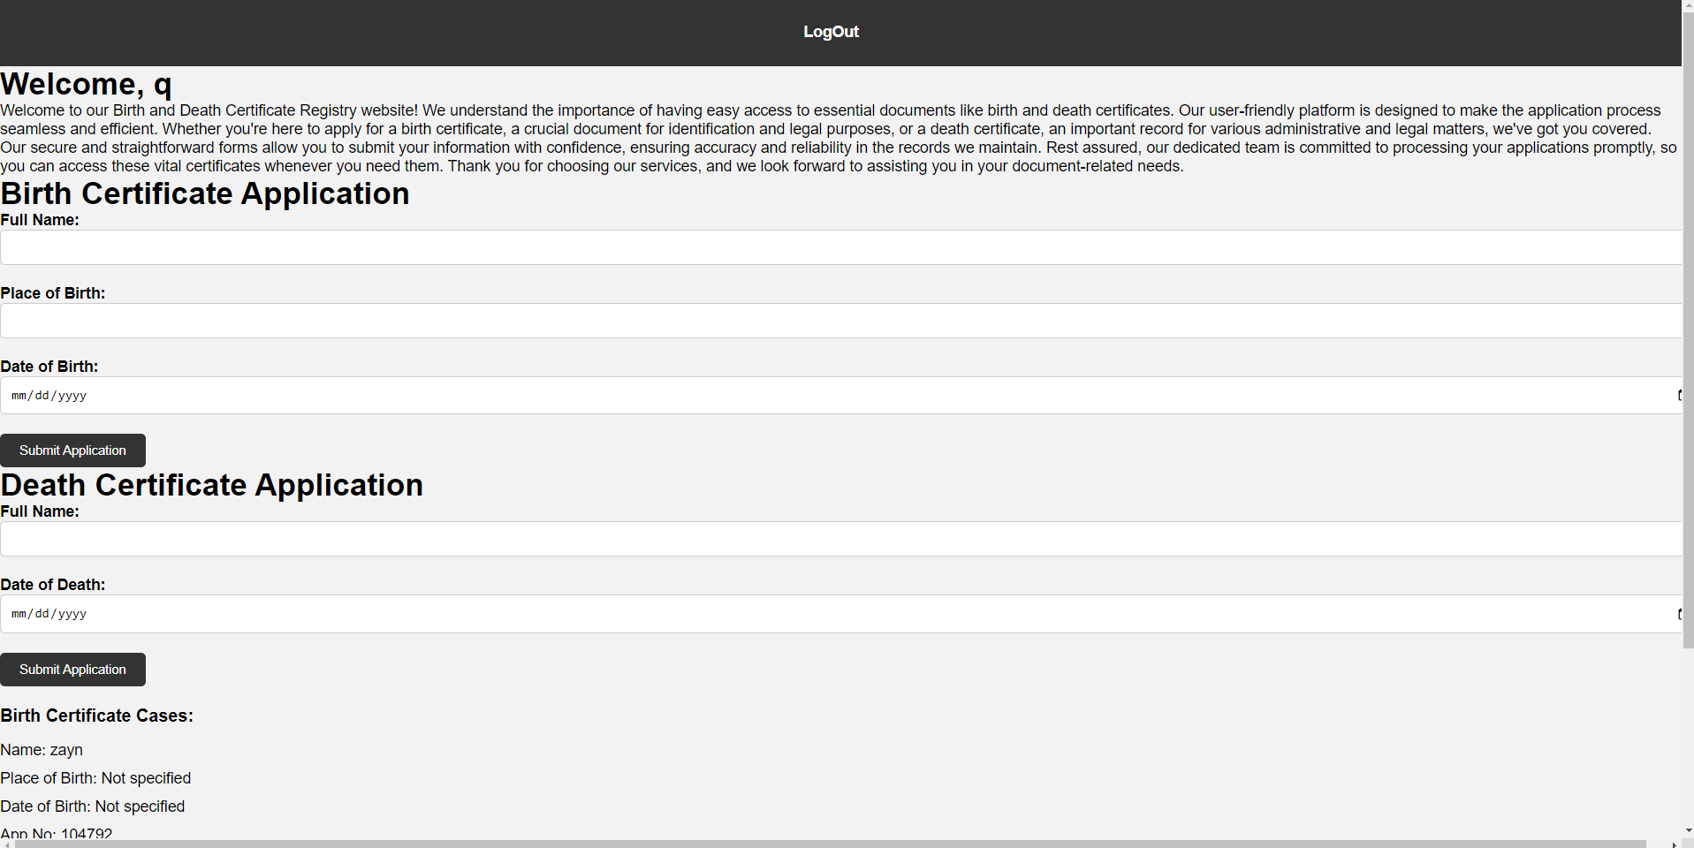

# 4. Producing a Solution

The project team developed the Birth and Death Certificate Registry website, focusing on the final design to ensure a user-friendly experience.

# 4.1 Final Design (Sketch)

The final design sketch encompasses a clean and intuitive user interface, application forms for birth and death certificates, and a status tracking feature.

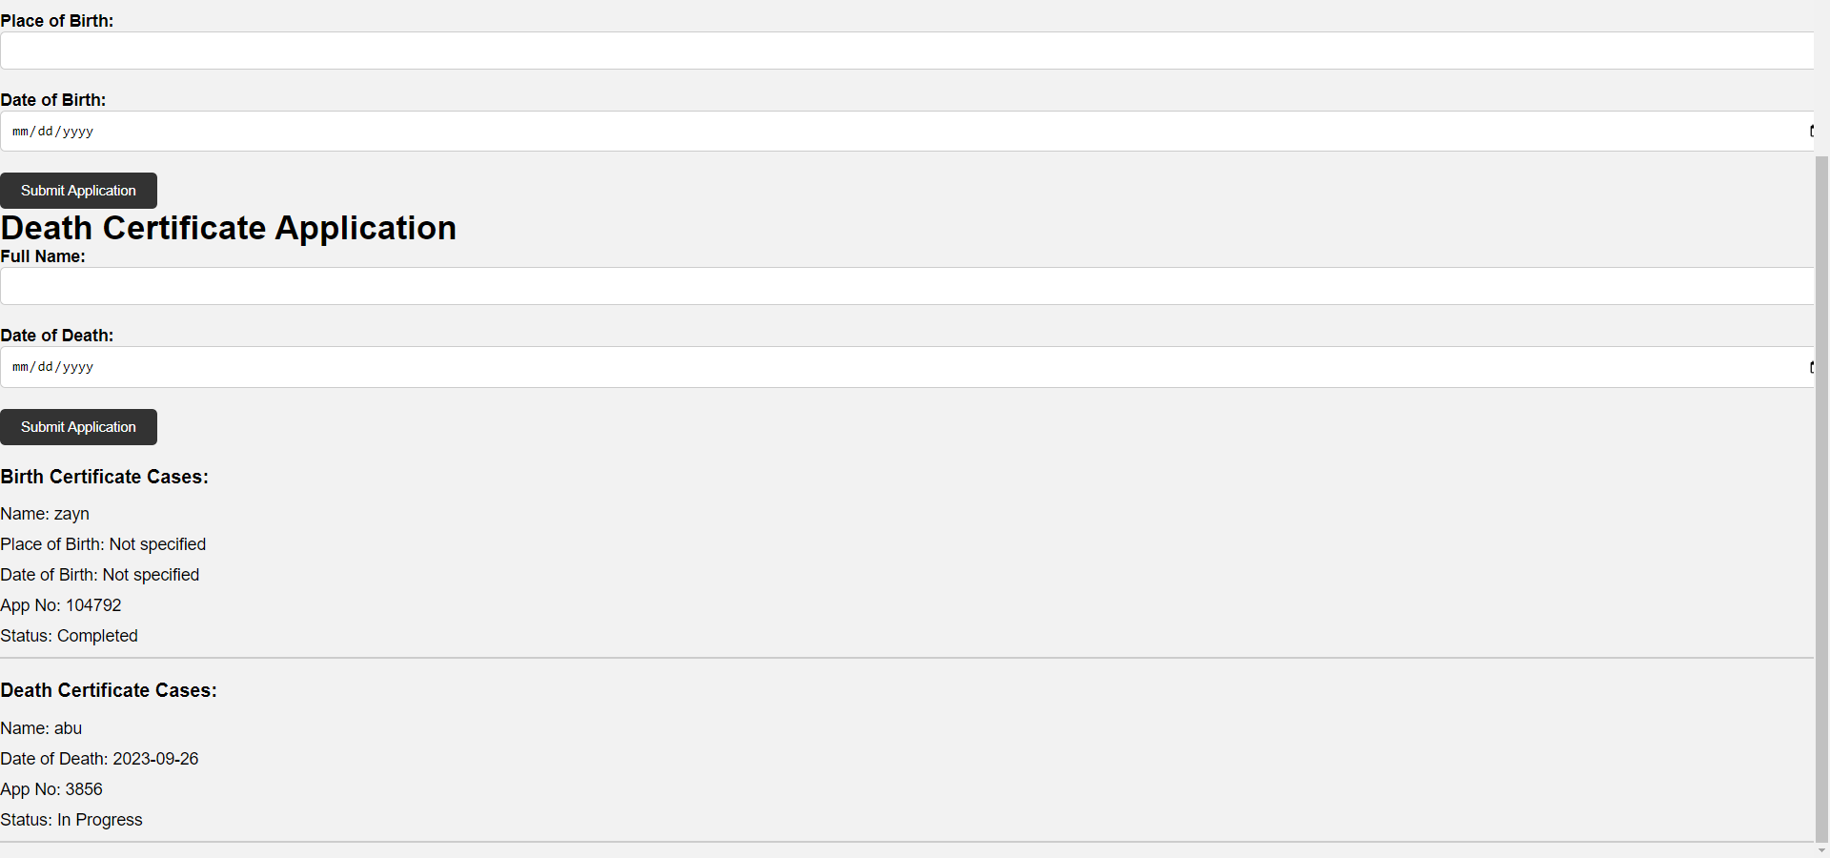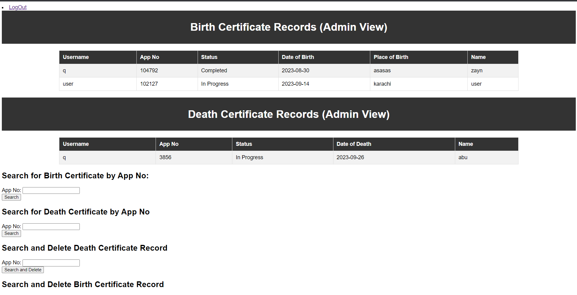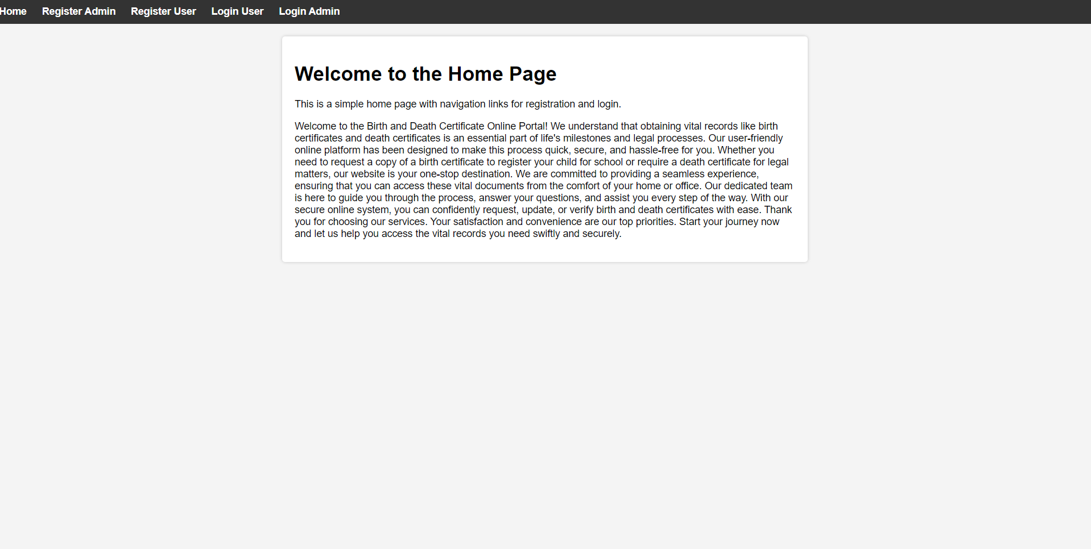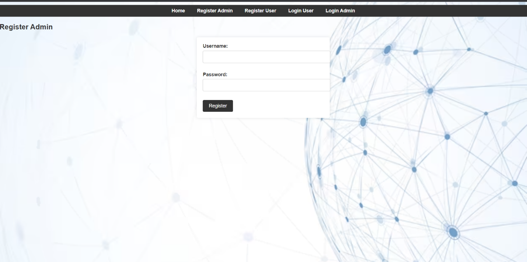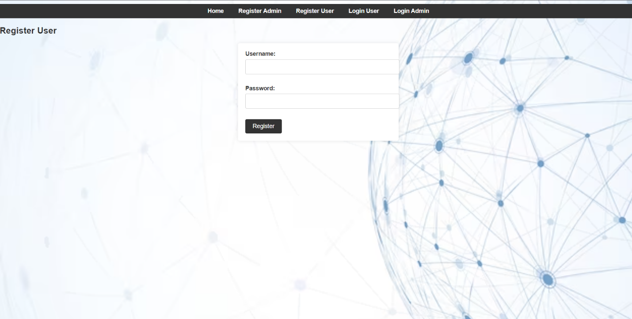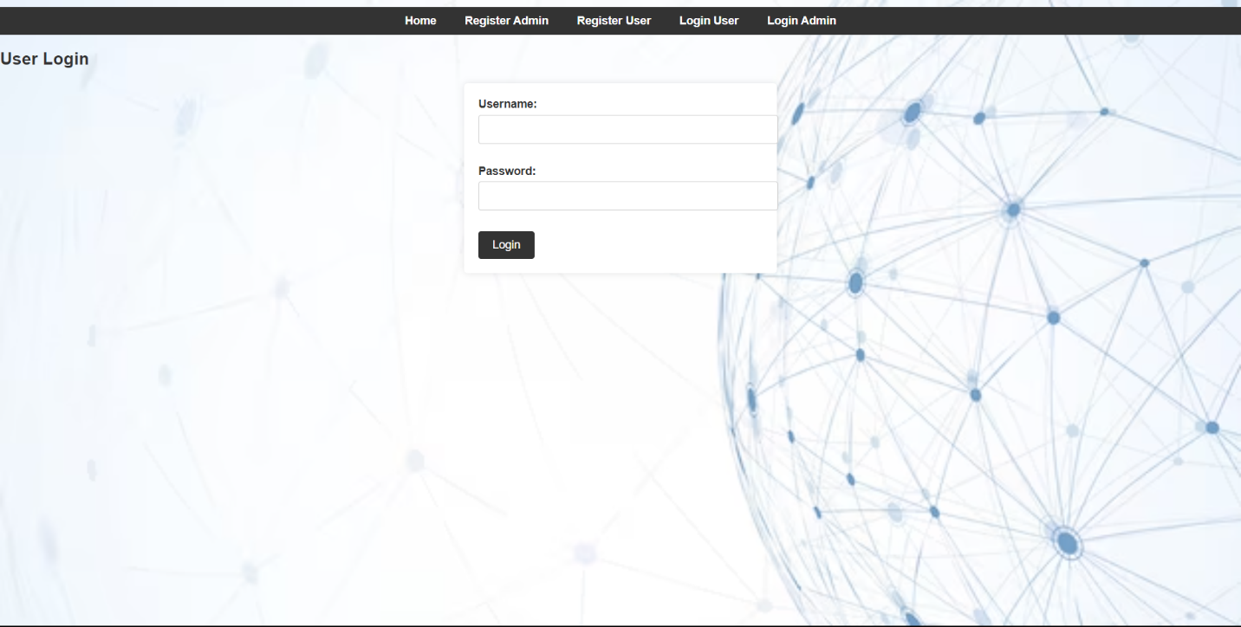

# 5. Self-Evaluation

Individual team members evaluated their contributions to the project.

# 5.1 Student 1

Student 1 contributed to the website's front-end development, ensuring a responsive and visually appealing design.

# 5.2 Student 2

Student 2 was responsible for back-end development, implementing user authentication and database functionality.

# 5.3 Student 3

Student 3 played a crucial role in testing and quality assurance, identifying and resolving issues in the website's functionality.

# 6. Conclusion

The Birth and Death Certificate Registry website provides a user-friendly solution to the problem of accessing vital documents. It streamlines the application process, ensuring accuracy and reliability in record maintenance. The project team successfully designed and developed the website, taking into account user experience and functionality.

7. References

Codecademy (https://www.codecademy.com):

freeCodeCamp (<https://www.freecodecamp.org>):

LeetCode (https://leetcode.com):

8. Appendices

