MCTR1010 - Image Processing for Mechatronics

Project Milestone 03 Report
Team Number: 12 Semester: Spring 2026

1. Image Processing Techniques
To extract the necessary features for the system's closed-loop actuation, a sequential image processing pipeline is applied to the live camera feed. The sequence of operations is described below:
- Grayscale Conversion: The initial colored frames captured by the camera are converted into a single-channel grayscale format to reduce computational complexity and focus purely on light intensity.
- Contrast Enhancement: The contrast of the grayscale image is improved using two steps. First, histogram equalization distributes the intensities more evenly. Second, an absolute scaling process is used to further amplify the contrast and brightness, ensuring features stand out.
- Noise Reduction (Blurring): A Gaussian blur filter is applied. This step is crucial to smooth the image and eliminate high-frequency noise that could cause false edge detection.
- Edge Detection: The Canny edge detection algorithm is applied to the blurred image. This isolates the distinct boundaries and structural outlines within the camera's field of view, resulting in a binary image where only the edges are highlighted.

2. Image Comparison
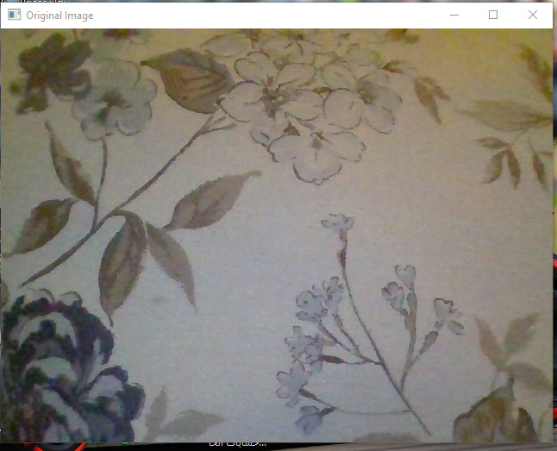
Caption: Figure 1 - Original image captured by the system.
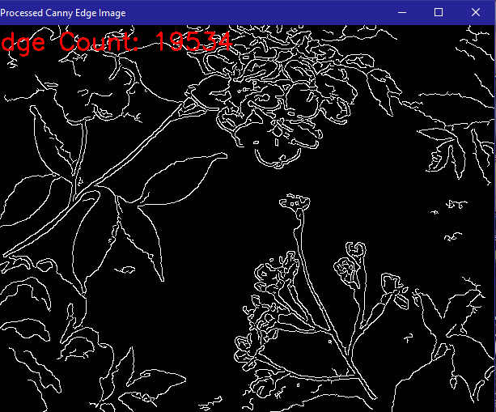
Caption: Figure 2 - Processed image after grayscale conversion, contrast enhancement, blurring, and edge detection.

3. Commentary on Results
The applied processing pipeline successfully isolates the structural features of the environment. The histogram equalization and contrast scaling proved highly effective in highlighting hidden contours, while the Gaussian blur prevented the Canny edge detector from picking up granular visual noise. The final binary image provides a clean and quantifiable representation of the edges present in the frame.

4. System Actuation and Closed-Loop Response
Extracted Image Features The primary image feature extracted and used to actuate the system is the total count of detected edge pixels present in the processed binary image. This numerical value serves as the feedback variable representing the density of visual structures in front of the camera.
Closed-Loop Operations and Logic The system operates on a proportional closed-loop control method. A predefined setpoint of 10,000 edge pixels is established. The system continuously calculates the error between the current edge count and this setpoint.
The actuation logic dictates that if the detected edge count is less than the setpoint (positive error), the system moves forward. If the edge count exceeds the setpoint (negative error), the system reverses. To ensure smooth but responsive actuation, the motor's speed (PWM) is calculated proportionally to the magnitude of the error. This allows the system to reach maximum speed quickly when the error is large, while a defined deadband prevents the motors from jittering when the edge count is extremely close to the setpoint.

5. Response Figures
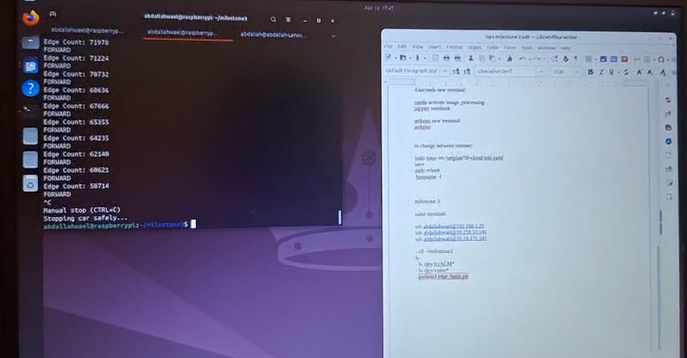
Caption: Figure 3 - Hardware actuating based on the proportional control loop feedback.
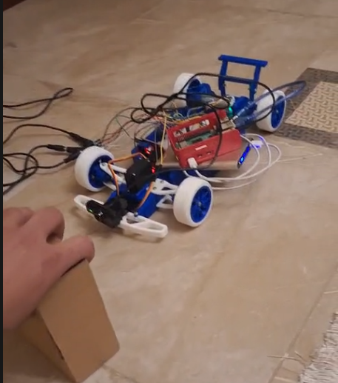
Caption: Figure 4 - System adjusting to changes in the visual field.

6. Commentary on System Response and Limitations
System Response and Output: The implementation of the proportional controller yields a highly responsive system. Because the motor speed is directly tied to the deviation from the setpoint, the system accelerates rapidly when it is far from the target state and dynamically decelerates as the visual feedback approaches the setpoint. This results in a much smoother physical output compared to a basic on/off logic, preventing the hardware from violently jerking while maintaining the required operational speed.
Limitations: During the implementation of this system, several limitations were observed:
- Sensitivity to Ambient Lighting: Because the core feature relies on edge detection and contrast enhancement, sudden changes in environmental lighting or shadows can drastically alter the total edge count, causing the system to actuate unexpectedly even if the physical geometry of the scene has not changed.
- Motion Blur at High Speeds: While the proportional controller allows the system to reach maximum speed quickly, moving too fast can introduce motion blur in the camera feed. This blur reduces the effectiveness of the Canny edge detector, artificially dropping the edge count and temporarily confusing the control loop.
- Processing Latency: Executing the multi-step image processing pipeline and calculating the proportional response introduces a slight delay. The actuation commands sent to the microcontroller are based on frames that are slightly older than the real-time physical state of the system.

