zaid naeem
[Company name] [Company address]
Matrix REport and FEature Importance chart

Contents
Model Metrics Report 2
Feature Importance chart 4

Model Metrics Report
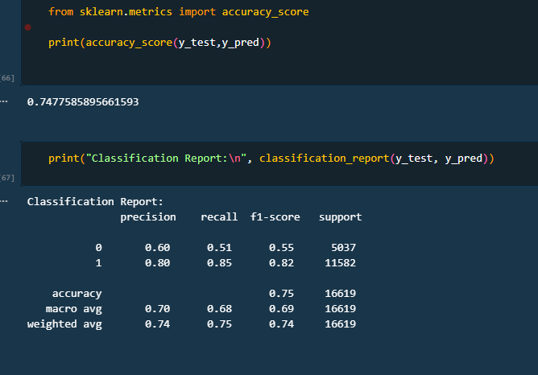

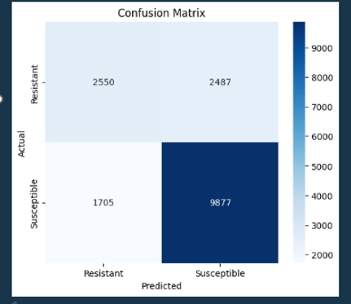

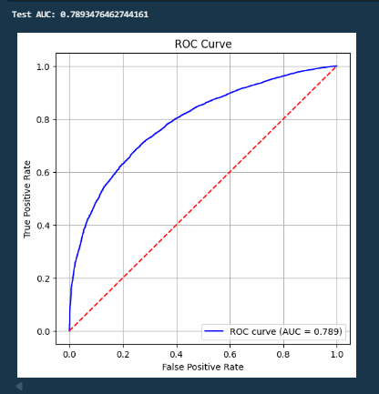

Feature Importance chart
