
PROJECT PROPOSAL

Muhammad Zaid Naeem
SP24-BCS-098
SECTION A

Contents
1. Abstract 3
2. Domain Description 3
3. Requirement Specification 4
1. Functional Requirements 4
2. Non-Functional Requirements 4
4. Assumptions 5
5. Entity Relationship Diagram (ERD) 6
5.1 Entities & Attributes 6
5.2 Relationships & Labels 9
5.3 Validation 9
5.4 Description 9
6. Screen Shots of the Developed Frontend / GUI 10
1. Login Page 10
2. Admin Portal 11
3. Admin Profile Edit 11
4. Admin management screen 12
5. Doctor management screen 13
6. Branch management screen 14
7. Room Management screen 15
8. Appointment management screen 16
9. Doctor Portal 16
10. Doctor Profile 17
11. Doctor appointment 17
7. Screen Shots of the Developed Reports 18
Branch Report 18
1. Daily 18
2. Weekly 18
3. Monthly 18
Room Report 19
1. Daily 19
2. Weekly 19
3. Monthly 19
Doctor Report 20
1. Daily 20
2. Weekly 20
3. Monthly 20
Patient Report 21
1. Daily 21
2. Weekly 21
8. Normalization up to Third Normal Form (3NF) 22
1. Unnormalized Form (UNF) 22
2. First Normal Form (1NF) 22
3. Second Normal Form (2NF) 23
4. Third Normal Form (3NF) 24
9. Denormalization Opportunities 26
10. Conclusion 26
11. Recommendations 26

Abstract
The Hospital Management System (HMS) is a database-driven application designed to automate and manage the core operational activities of a hospital, including administration, doctors, patients, rooms, branches, appointments, room assignments, and reporting. The system aims to reduce manual paperwork, improve data accuracy, enhance data retrieval speed, and support managerial decision-making through structured and analytical reports. This project demonstrates the practical application of fundamental database concepts such as requirement analysis, entity-relationship modeling, normalization, indexing, and report generation.

Domain Description
The domain of this project is Healthcare Information Systems. Hospitals manage large volumes of sensitive data related to administration, doctors, patients, rooms, branches, appointments, room assignments, and reporting. Manual handling of such data is time-consuming, error-prone, and inefficient. A centralized Hospital Management System provides a structured and reliable platform to store, manage, and retrieve information while ensuring data consistency, integrity, security, and efficient coordination across multiple hospital branches.

Requirement Specification

Functional Requirements
- Register and manage patient records.
- Register and manage doctor profiles and specialties.
- Schedule, update, and cancel appointments.
- Track appointment status (Scheduled, Completed, Cancelled).
- Generate branch-level reports to summarize operations and appointments per branch.
- Generate room-level reports to analyze room utilization and occupancy.
- Generate patient activity reports showing appointment history and visit patterns.
- Generate doctor activity reports reflecting workload, completed, scheduled, and cancelled appointments.
- Provide export functionality to allow reports to be exported in Excel format.
- Ensure proper error handling with meaningful error messages for invalid inputs, failed transactions, and system exceptions.
- Maintain authentication for system users (Admin, Doctor).

Non-Functional Requirements
- The database must be accessible by all hospital branches through a secure network.
- The system must support real-time updates across all branches to ensure data consistency.
- The system design should ensure strong data integrity with minimal redundancy.
- The database should be scalable to support the growing number of branches and patients.
- All client-side interfaces must be Python-based and should use secure database connectivity mechanisms.

Assumptions
- Admin and patient entities exist at the hospital level.
- Doctor and room entities exist at the branch level.
- Each admin, doctor, and patient has a unique CNIC.
- A patient can have multiple appointments.
- A doctor can have multiple appointments.
- A doctor and a patient are assigned to only one room per appointment.
- Each appointment is linked to exactly one patient and one doctor.
- The system is designed for use within a single hospital organization.

Entity Relationship Diagram (ERD)
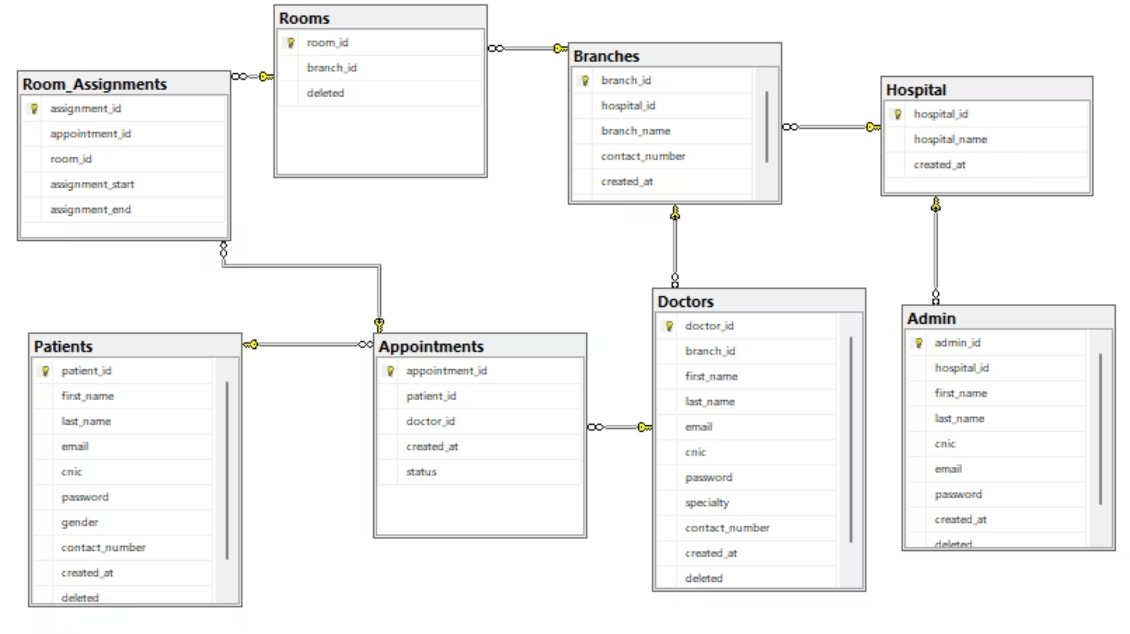

Entities & Attributes
Hospital
- hospital_id (PK)
- hospital_name
- created_at
Branches
- branch_id (PK)
- hospital_id (FK)
- branch_name
- contact_number
- created_at
Admin
- admin_id (PK)
- hospital_id (FK)
- first_name
- last_name
- cnic (Unique)
- email
- password
- created_at
- deleted
Doctors
- doctor_id (PK)
- branch_id (FK)
- first_name
- last_name
- email
- cnic (Unique)
- password
- specialty
- contact_number
- created_at
- deleted
Patients
- patient_id (PK)
- first_name
- last_name
- email
- cnic (Unique)
- password
- gender
- contact_number
- created_at
- deleted
Rooms
- room_id (PK)
- branch_id (FK)
- deleted
Appointments
- appointment_id (PK)
- patient_id (FK)
- doctor_id (FK)
- created_at
- status
Room_Assignments
- assignment_id (PK)
- appointment_id (FK)
- room_id (FK)
- assignment_start
- assignment_end

Relationships & Labels
- A Hospital has multiple Branches (1-to-Many).
- A Hospital manages multiple Admins (1-to-Many).
- A Branch employs multiple Doctors (1-to-Many).
- A Branch contains multiple Rooms (1-to-Many).
- A Patient books multiple Appointments (1-to-Many).
- A Doctor handles multiple Appointments (1-to-Many).
- Each Appointment belongs to exactly one Patient and one Doctor (Many-to-One).
- Each Appointment is assigned to one Room through Room_Assignments.
- A Room can be assigned to multiple Appointments over time (Many-to-Many via Room Assignments).
- A doctor can be assigned to multiple patients over time (Many-to-Many via Appointments).

Validation
- Primary keys uniquely identify each entity.
- Foreign keys enforce referential integrity between related tables.
- CNIC fields in Admin, Doctor, and Patient entities are enforced as unique.
- Deleted fields are used for soft deletion to preserve historical data.
- Appointment status ensures controlled and valid state transitions.

Description
The ERD accurately reflects the hierarchical structure of the hospital system. The hospital operates through branches, each branch manages its doctors and rooms, and patients interact with doctors via appointments. Room assignments are handled separately to ensure flexibility and prevent scheduling conflicts. This design ensures scalability, data consistency, and efficient reporting across hospital operations.

Screen Shots of the Developed Frontend / GUI

Login Page

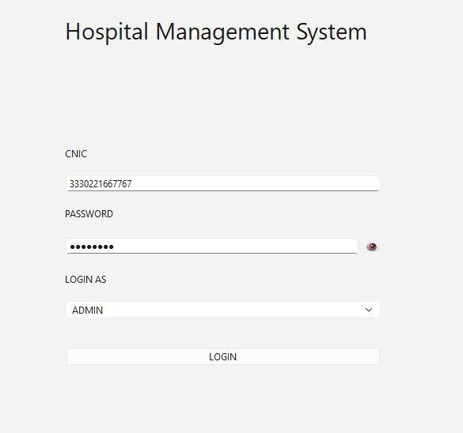

Admin Portal
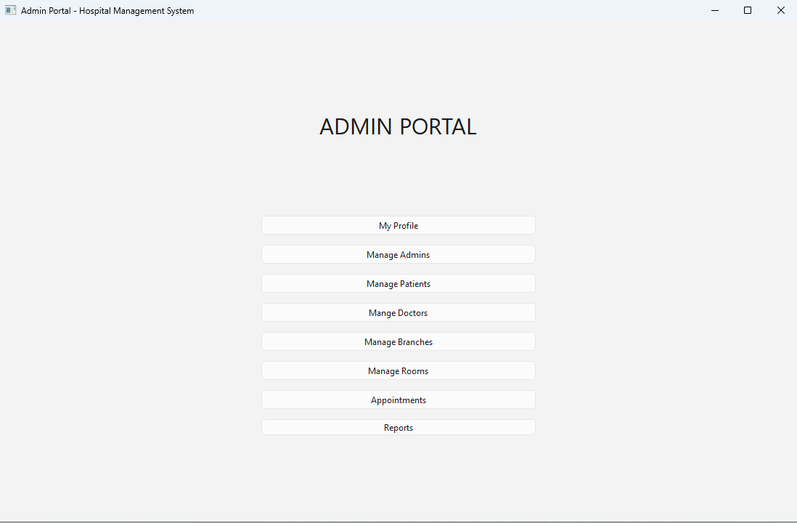

Admin Profile Edit

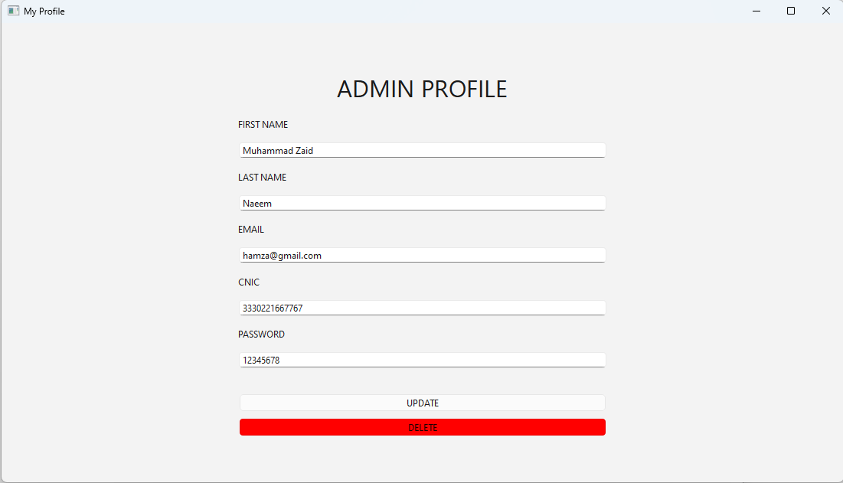

Admin management screen
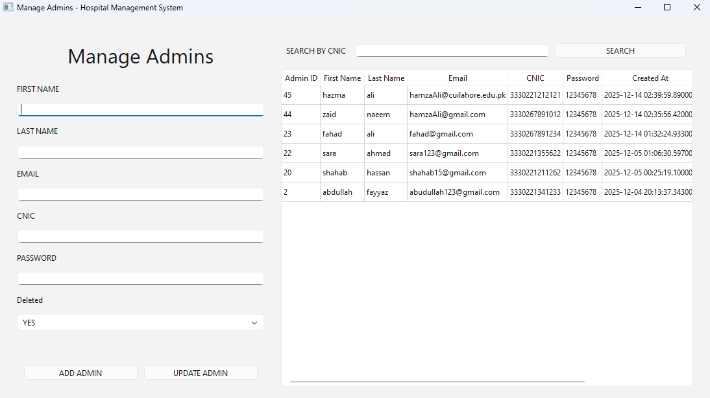

Doctor management screen
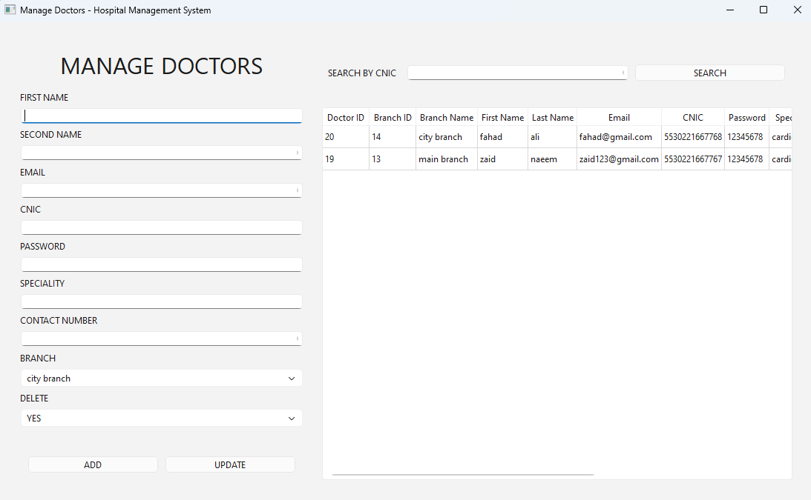

Branch management screen
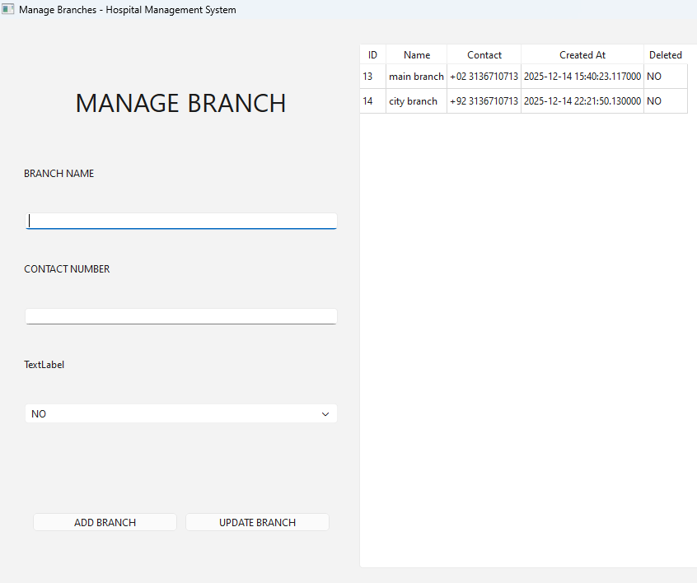

Room Management screen
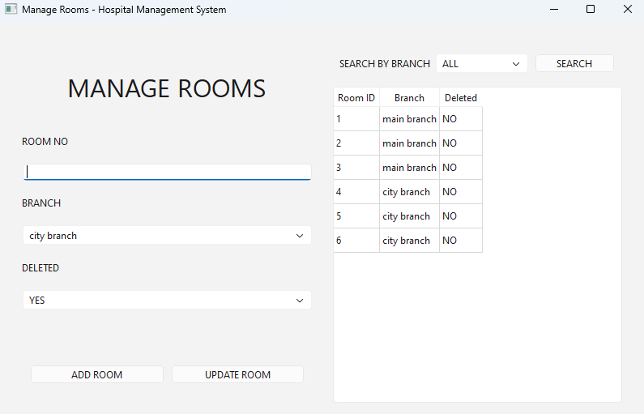

Appointment management screen
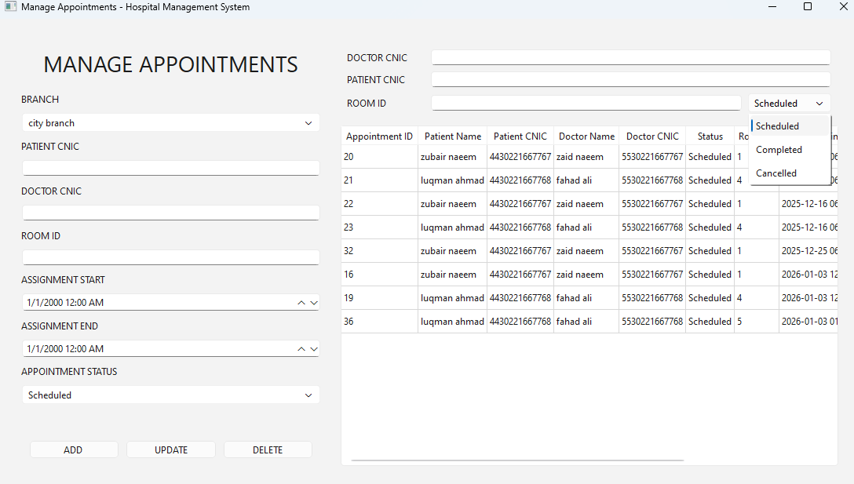

Doctor Portal
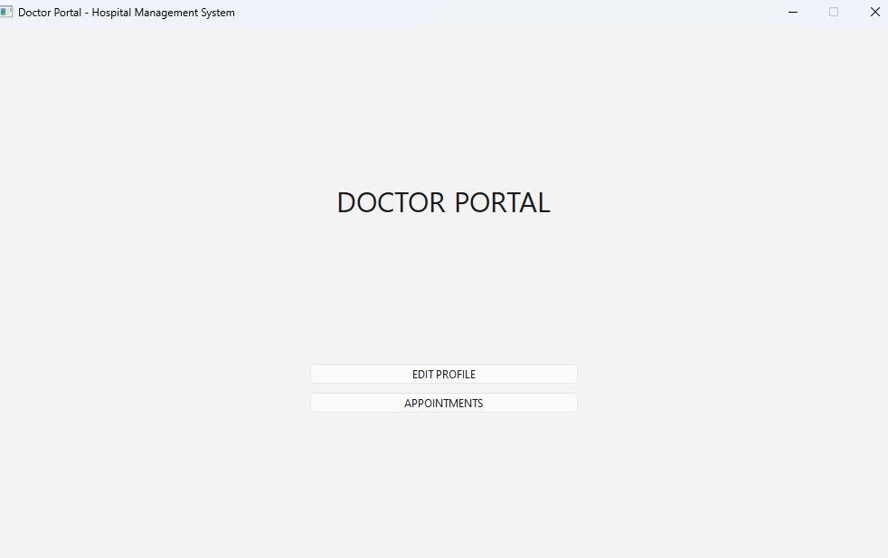

Doctor Profile
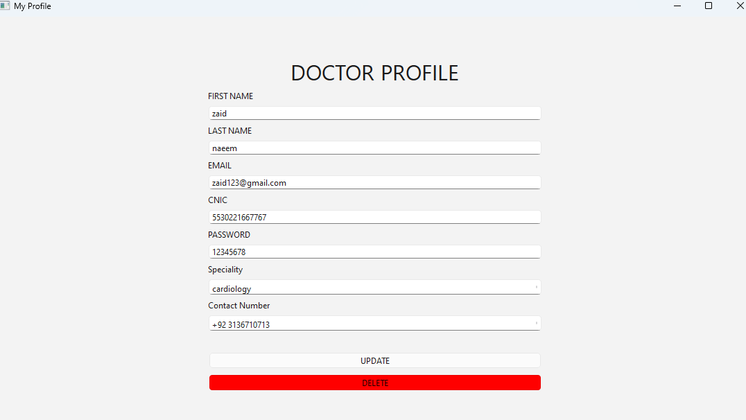

Doctor appointment
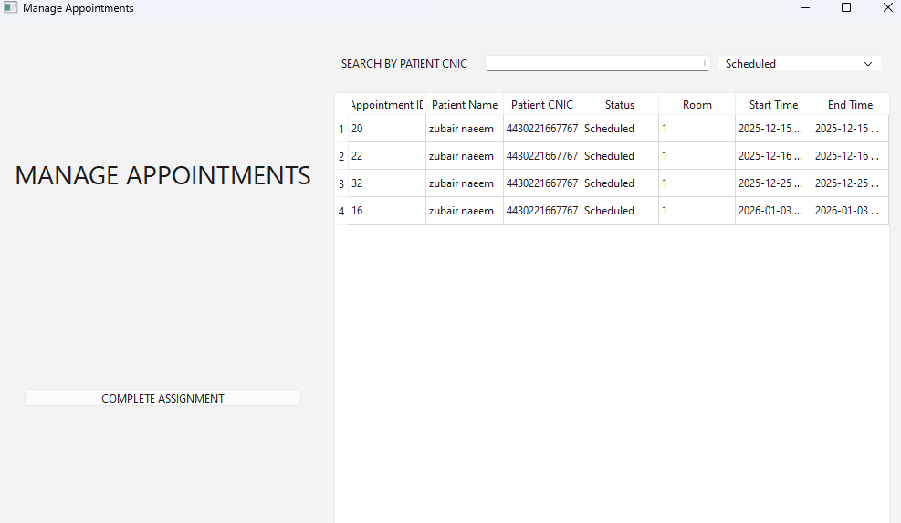

Screen Shots of the Developed Reports

Branch Report

1. Daily
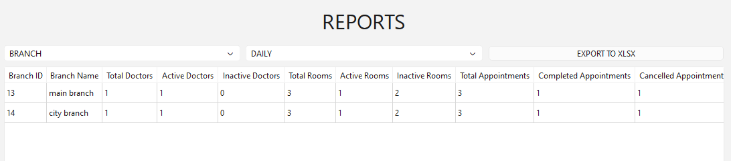

2. Weekly
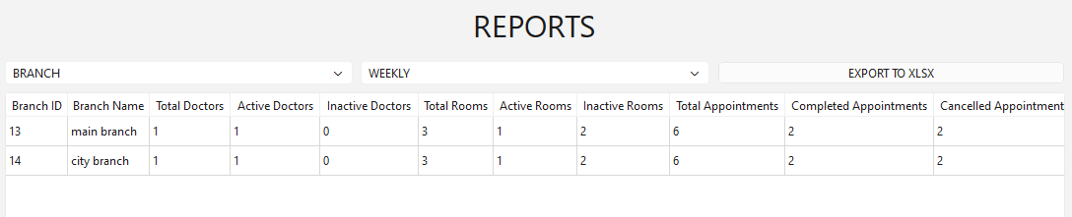

3. Monthly
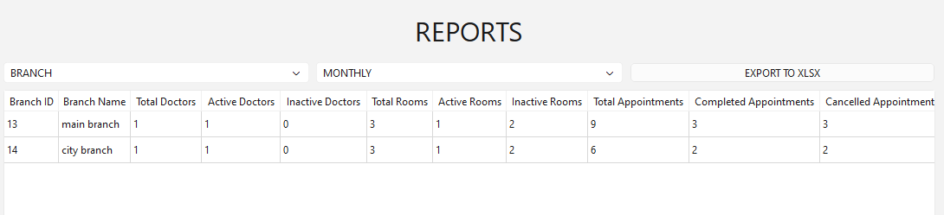

Room Report

1. Daily
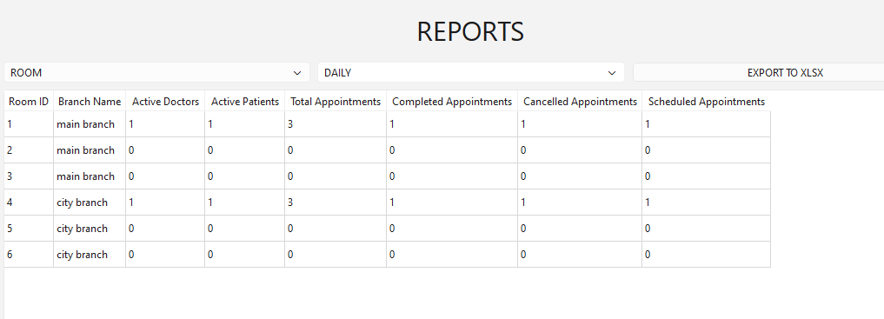

2. Weekly
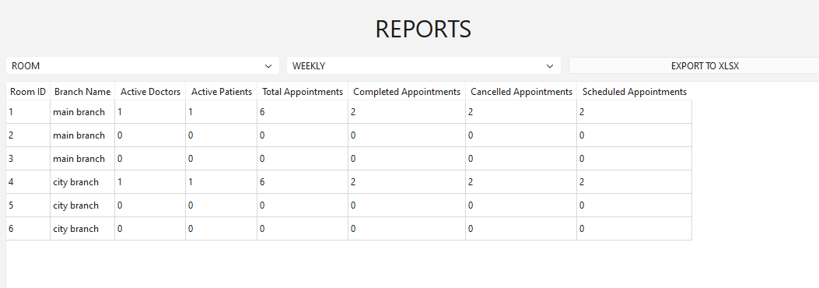

3. Monthly
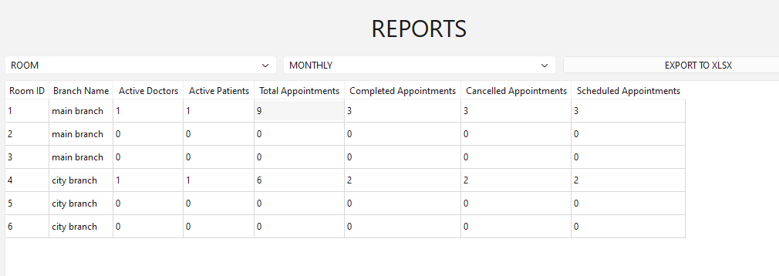

Doctor Report

1. Daily
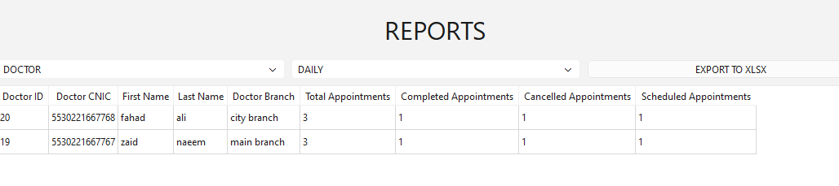

2. Weekly
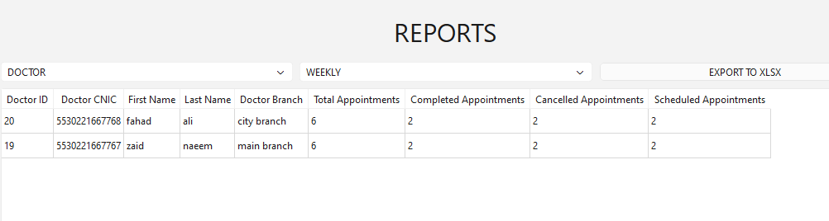

3. Monthly
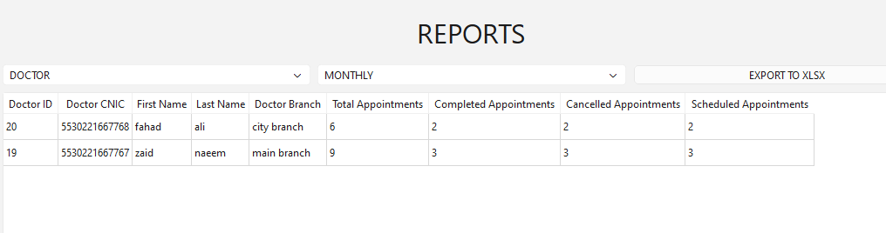

Patient Report

1. Daily
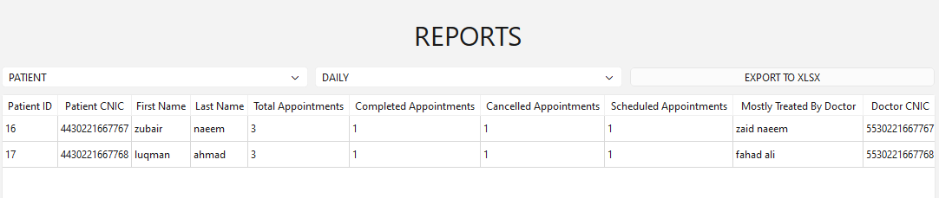

2. Weekly
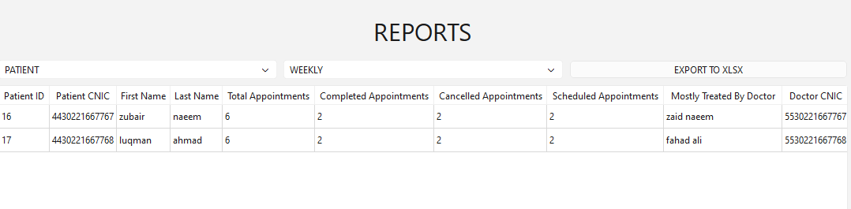
3. Monthly
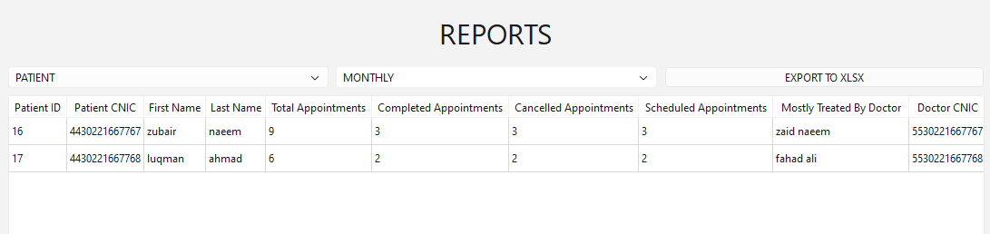

Normalization up to Third Normal Form (3NF)

Unnormalized Form (UNF)
In the unnormalized state, we have a "Universal Table" or a large report containing all information. This form suffers from repeating groups (e.g., a single Hospital row containing multiple Branches, or a Branch row containing multiple Doctors) and data redundancy.

Hospital_Name | Branch_Name | Doctor_Name | Patient_Name | Appointment_Time | Room_ID | Assignment_Start | Assignment_End | Admin_Name
City Hospital | Main Branch, North Branch | Dr. Ali, Dr. Sara | John Doe | 10:00 AM | 101, 102 | 10:00 | 11:00 | Admin User

Anomalies:
- Repeating Groups: A single hospital entry contains lists of branches and doctors.
- Insertion Anomaly: We cannot add a new doctor without assigning them to an appointment or repeating hospital data.
- Update Anomaly: If the Hospital Name changes, we must update it in every single row where that hospital appears.

First Normal Form (1NF)

Definition
A relation is in 1NF if it contains only atomic (indivisible) values and there are no repeating groups. We must also identify a Primary Key.
Steps Taken:
- Removed repeating groups.
- Ensured every cell contains a single value.
- Selected a Composite Primary Key to uniquely identify each row: (Appointment_ID, Room_ID).

Appointment_ID (PK) | Room_ID (PK) | Patient_Name | Doctor_Name | Branch_Name | Hospital_Name | Appointment_Time | Assignment_Start
1001 | 101 | John Doe | Dr. Ali | Main Branch | City Hospital | 10:00 AM | 10:00
1001 | 102 | John Doe | Dr. Sara | Main Branch | City Hospital | 10:00 AM | 10:00

Anomalies
- Update Anomaly
  - Same data is repeated in many rows.
  - Updating one place requires updating all other repeated values.
- Insert Anomaly
  - You cannot insert a new fact unless other unnecessary values are also provided.
  - Example: Cannot add a new branch unless you also add doctor/patient data.
- Delete Anomaly
  - Deleting one record may remove important information.
  - Example: Deleting an appointment removes the only record of a branch or doctor.

3. Second Normal Form (2NF)

Definition: A relation is in 2NF if it is in 1NF and contains no partial dependencies. Every non-key attribute must be fully functionally dependent on the entire Primary Key.

Hospital Table
Hospital_ID (PK) | Hospital_Name | Admin_Name | Branch_Name
1 | City Hospital | Admin User | North Branch

Anomalies

- Update Anomaly
  - Due to transitive dependencies, changing one non-key attribute requires updating many rows.
- Insert Anomaly
  - You cannot insert a record because required dependent values are missing.
  - Example: Cannot add an hospital without adding branch data.
- Delete Anomaly
  - Deleting a row may also delete valuable related information stored in the same row.

Third Normal Form (3NF)

Definition: A relation is in 3NF if it is in 2NF and contains no transitive dependencies. Non-key attributes should not depend on other non-key attributes.

Denormalization Opportunities
- Storing doctor_name in the Appointment table for faster report generation.
- Storing branch_name in the Rooms table to reduce joins and improve query performance in reports.

Conclusion
The Hospital Management System successfully applies database design principles to solve a real-world healthcare problem. The project demonstrates effective use of ER modeling, normalization, constraints, and reporting. The system improves efficiency, accuracy, and accessibility of hospital data.

Recommendations
- Add audit logs for data changes
- Integrate billing and pharmacy modules
- Apply encryption for sensitive data

