MediSync AI: AI-Powered Hospital Management System | - Muhammad Zaid Naeem  - SP24-BCS-098-A  - Assignment #02

1. Abstract
This report presents the conceptual design and proposal for a Hospital Management System that efficiently manages patient records, staff operations, appointments, prescriptions, billing, and other core hospital activities across multiple branches. The report analyzes the hospital’s operational workflow and data management needs, identifies requirements, and proposes a relational database model capable of supporting all major hospital functions.
The system is intended to improve data accuracy, speed of access, and coordination among departments such as Outpatient, Pharmacy, Billing, and Emergency (Ambulance Services). The proposed design supports multi-branch operations, ensuring centralized yet distributed access to all hospital data.

2. Domain Description
The proposed database is for a multi-branch hospital network, where each branch delivers complete healthcare services including consultations, emergency services, pharmacy, patient accommodation, and record management.
Each branch operates several key departments:
- Patients and Appointments
- Doctors and Nurses
- Pharmacy and Laboratory
- Billing and Finance
- Ambulance and Emergency Services
Currently, most hospital data is either manually recorded or managed using spreadsheets, leading to data redundancy, inefficiency, and poor inter-departmental coordination. For example, patient records are difficult to track across branches, billing lacks transparency, and scheduling conflicts occur frequently.
The proposed system automates all these processes within a centralized relational database, ensuring consistency, scalability, and real-time access across branches.

3. Requirement Specification

Functional Requirements

 | Function | Entity/Module | Priority
 | Manage branch details (add, update, delete, view). | Branches | High
 | Register new patients and maintain medical history. | Patients | High
 | Manage departments within each branch. | Departments | Normal
 | Maintain staff details including doctors, nurses, and workers. | Staff, Doctors, Nurses, Workers | High
 | Schedule and manage appointments. | Appointments | High
 | Record patient prescriptions and doctor recommendations. | Prescription | High
 | Generate and manage patient billing information. | Billing | High
 | Manage medical inventory and pharmacy sales. | Medicine, Pharmacy | High
 | Maintain medical records and track prescribed medicines. | Medical Records, Medical Records Medicine | High
 | Assign patients to rooms and record cleaning services. | Rooms, Room Assignments, Cleaning Service | Normal
 | Manage ambulance availability and service logs. | Ambulance, Ambulance Log | Normal

Non-Functional Requirements

- The database must be accessible by all branches through a secure network.
- The system must support real-time updates across all branches.
- The design should ensure data integrity and minimal redundancy.
- The database should scale with the growing number of branches and patients.
- All client-side interfaces must be Python-based, using secure database connectivity.

4. Assumptions
- Each hospital branch has unique departments and staff.
- A patient can visit multiple branches, but medical history remains centralized.
- Each doctor may serve in multiple departments within a branch.
- Billing is generated per appointment, linked to one patient and branch.
- Medicines are tracked by stock quantity and expiry date for pharmacy control.
- Each room assignment is unique per patient stay, and linked to specific staff.
- Ambulances are branch-specific, with multiple service records maintained.

5. Entity Relationship Diagram
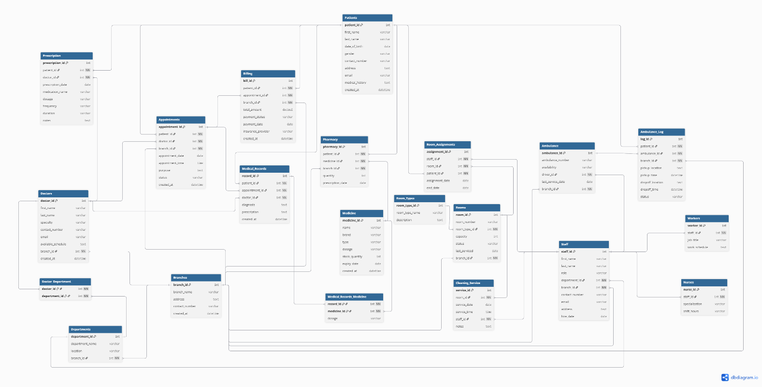

Entities & Attributes

Entity | Key Attributes
Branches | branch_id (PK), branch_name, address, contact_number, created_at
Patients | patient_id (PK), first_name, last_name, date_of_birth, gender, contact_number, email, address, medical_history, created_at
Departments | department_id (PK), department_name, location, branch_id (FK)
Staff | staff_id (PK), first_name, last_name, role, department_id (FK), branch_id (FK), contact_number, email, address, hire_date
Doctors | doctor_id (PK), first_name, last_name, specialty, contact_number, email, available_schedule, branch_id (FK), created_at
Appointments | appointment_id (PK), patient_id (FK), doctor_id (FK), branch_id (FK), appointment_date, appointment_time, purpose, status, created_at
Prescription | prescription_id (PK), patient_id (FK), doctor_id (FK), prescription_date, medication_name, dosage, frequency, duration, notes
Billing | bill_id (PK), patient_id (FK), appointment_id (FK), branch_id (FK), total_amount, payment_status, payment_date, insurance_provider, created_at
Medicine | medicine_id (PK), name, brand, type, dosage, stock_quantity, expiry_date, created_at
Pharmacy | pharmacy_id (PK), medicine_id (FK), patient_id (FK), branch_id (FK), quantity, prescription_date
Medical Records | record_id (PK), patient_id (FK), doctor_id (FK), appointment_id (FK), diagnosis, prescription, created_at
Medical Records Medicine | record_id (FK), medicine_id (FK), dosage
Rooms | room_id (PK), room_number, room_type_id (FK), capacity, status, last_serviced, branch_id (FK)
Room Assignments | assignment_id (PK), room_id (FK), staff_id (FK), patient_id (FK), assignment_date, end_date
Ambulance | ambulance_id (PK), ambulance_number, availability, driver_id (FK), last_service_date, branch_id (FK)
Ambulance Log | log_id (PK), ambulance_id (FK), patient_id (FK), branch_id (FK), pickup_location, pickup_time, dropoff_location, dropoff_time, status

Relationships & Labels
Relationship | Type | Description
Branch – Departments | 1:N | Each branch has multiple departments
Department – Staff | 1:N | Each department includes multiple staff
Branch – Doctors | 1:N | A branch employs multiple doctors
Branch – Staff | 1:N | A branch has many staff
Branch – Rooms | 1:N | Each branch contains many rooms
Branch – Ambulance | 1:N | Each branch owns several ambulances
Branch – Ambulance_Log | 1:N | Each branch maintains multiple ambulance logs
Patient – Appointments | 1:N | A patient can have many appointments
Doctor – Appointments | 1:N | A doctor attends many appointments
Appointments – Billing | 1:1 | Each appointment generates one bill
Patient – Medical_Records | 1:N | Each patient has multiple medical records
Medical_Records – Medicine | M:N | Handled through Medical_Records_Medicine
Rooms – Assignments | 1:N | One room can have many assignments
Staff – Assignments | 1:N | One staff member can have many assignments
Ambulance – Ambulance_Log | 1:N | One ambulance has many logs
Patient – Ambulance_Log | 1:N | A patient can appear in multiple ambulance logs

Validation
The model ensures:
- Completeness: All hospital activities are represented.
- Normalization: M:N relationships are resolved through link tables.
- Integrity: Foreign keys maintain valid references.
- Security: Staff roles define data modification privileges.
- Scalability: Multi-branch structure allows easy expansion.

Description
The ER model outlines a comprehensive hospital database supporting multiple branches.
It captures all core functions from patient registration to discharge, including appointments, billing, pharmacy management, room allocation, and ambulance services.
Every interaction is traceable, and each branch can operate semi-independently while maintaining centralized synchronization with the main hospital database. This ensures both data reliability and operational efficiency across the network.

6. Conclusion
The proposed Hospital Management Database System offers a complete, integrated solution to manage operations across multiple branches. It ensures data consistency, faster decision-making, and improved patient service quality. The system is scalable, secure, and well-suited for implementation with Python-based interfaces for branch-level management and central control.

7. Recommendations
- Use a centralized relational database (SQL SERVER BASED) to store and manage all hospital data securely across branches.
- Develop Python-based desktop for managing patients, billing, pharmacy, and staff operations.
- Ensure proper deployment and maintenance of the system across all branches for smooth and reliable operation.

