Are you up for some dessert?
Name: ____________________________ Class: ____________ Date: ______________
1 Look at the list of traditional British, American and Australian dishes. Which of them are sweet and which are savoury?
 | SWEET 🍰 | SAVOURY 🥧
  - biscuits and gravy (US) | - s’mores (US)
  - crumble (UK) | - shepherd’s pie (UK)
  - Vegemite on toast (AUS) | - tater tots (US)
  - macaroni and cheese / mac and cheese (US) | - lamingtons (AUS)
2 Discuss the questions.
- What other traditional British, American and Australian dishes do you know?
- Which of them have you tried?
- Which are your favourites?
- Which do you prefer: sweet or savoury food?
3 Match the halves to complete the phrases.
 | 📖 Word help  condiment: a substance, like salt or sauce, that you add to your food to improve its taste  susceptible: easily influenced or harmed by something  nutrient: any substance that you need to live and grow  My answers:  a __ b __ c __ d __ e __ f __ g __
  a) flavours | 1) for fries
  b) condiments* | 2) to overeating
  c) susceptible* | 3) room for more food
  d) various | 4) of ice cream
  e) make | 5) in eating more
  f) second | 6) helping/serving
  g) interested | 7) nutrients*
4 Watch the video (to 1:58) and answer the questions.
🎬 https://youtu.be/lTtfqECMEb8
- How did they run the experiment?

- What were the findings?

- What is sensory-specific satiety?

5 Complete the gaps with the words in the box. Watch the rest of the video (from 1:58) and find more information to prove the statements.
condiments | flavours | interested | nutrients | susceptible

a) People became less …………………… in food after having one serving of it.
b) Sensory-specific satiety helps us get various …………………… .
c) Sensory-specific satiety can backfire* and make us …………………… to overeating.
d) People tend to eat more food if it has multiple …………………… or if it’s served with …………………… .
*backfire: have the opposite effect to what you expected/intended
6 Discuss the questions.
- What do you think about the experiment?  - How often do you have a second helping of food?  - Can you often make room for dessert even when you are full?  - Are you susceptible to overeating at a buffet or a dinner party? | 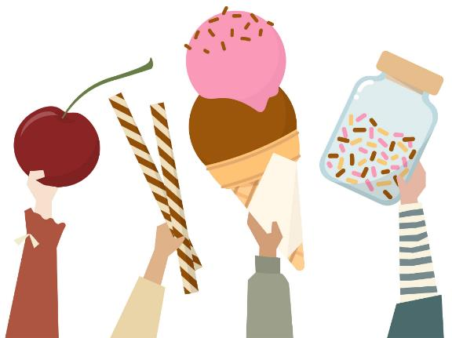
7 Match the phrases to the appropriate responses. Most phrases have more than one response.
a) Help yourself to some more cake. | 1) Thank you! Same to you.
b) Enjoy your meal! | 2) Here you go.
c) Can I top you up? | 3) Yes, please.
d) Could you pass me the potatoes, please? | 4) Thanks, I’m full.
e) Are you enjoying the food? | 5) Yes, it’s delicious.
f) Are you up for some dessert? | 6) Thank you, I can definitely make room for some more.
My answers: | 7) Bon appetit to you too.
a) ___ b) ___ c) ___ | 8) No, thanks. I’ve had enough.
d) ___ e) ___ f) ___ | 9) I am. I think I will even have a second serving.
 | 10) No, the burger was too much for me.
8 In pairs, create short conversations using the phrases from ex. 7 for each situation.
Situation 1  You are at a dinner party but the food is not to your liking. The host really wants you to try more dishes. | Situation 2  You are having afternoon tea at your best friend’s house. | Situation 3  You have invited people over and are treating them to your special dish.

