Project Proposal

Weather Conditions and Bike-Sharing Demand in London

Group Info:

CISC7204-Assgn01-MC663472-QIU_QIZU

CISC7204-Assgn01-MC661324 MA _LEKAI

1. Project Title
Research question: How were daily temperature, precipitation, and wind speed associated with daily Santander Cycle hires in London during 2015-2016?
Region: London, United Kingdom
Domain: Urban transportation and weather
Study period: 1 January 2015 to 31 December 2016

2. Project Purpose

Outcomes
This project will apply a complete data science workflow to a real urban mobility question. It will combine public bicycle-hire and meteorological data to produce a reproducible analysis that answers the research question through statistics and clear visual evidence. The completed work will also demonstrate how open data can support transportation planning and demand analysis.

Skills
The project will develop practical skills in acquiring data from an API and an open government portal, cleaning and validating dates, merging datasets, checking data quality, calculating descriptive statistics and correlations, fitting a multiple linear regression model, and designing scatter plots and grouped comparisons. It will also strengthen reproducible Python and Jupyter workflows.

Knowledge
The analysis will build knowledge of the Santander Cycle Hire Scheme, NASA POWER meteorological variables, the relationship between weather and daily mobility, and the distinction between statistical association and causation in observational data.

3. Data Sources
Transport for London, Number of Bicycle Hires:
(https://data.london.gov.uk/dataset/number-of-bicycle-hires-2r84d)
This dataset provides the daily number of Santander Cycle hires. The analysis uses records from 1 January 2015 to 31 December 2016.
NASA POWER Daily Meteorological Data:
(https://power.larc.nasa.gov/api/temporal/daily/point?parameters=T2M,PRECTOTCORR,WS2M&community=RE&longitude=-0.1278&latitude=51.5074&start=20150101&end=20161231&format=CSV)
NASA POWER supplies daily weather data for central London at 51.5074 latitude and -0.1278 longitude. The selected variables are daily mean temperature at 2 metres (T2M), corrected precipitation (PRECTOTCORR), and wind speed at 2 metres (WS2M).

4. Project Tasks
1. Define the region, domain, study period, research question, and three directional hypotheses.
2. Acquire the TfL daily bicycle-hire workbook and request matching NASA POWER daily weather data for central London.
3. Clean dates and numeric fields, replace NASA missing-value codes, remove invalid records, and restrict both sources to 2015-2016.
4. Merge the datasets by date using one-to-one validation, then check the date range, duplicate dates, and missing values.
5. Calculate descriptive statistics plus Pearson and Spearman correlations between daily hires and each weather variable.
6. Create three scatter plots with fitted trend lines, compare rain and dry days, and compare bicycle hires across temperature groups.
7. Fit a multiple linear regression with standardized weather variables while controlling for day of the week, month, and year.
8. Interpret the findings in relation to the research question, distinguish association from causation, and report data and model limitations.

Planned deliverables
- A written project proposal containing the research design, data sources, success criteria, and collaboration plan.
- A reproducible Jupyter Notebook containing data preparation, statistical analysis, and visualizations.
- A three-panel scatter-plot figure and supporting grouped comparisons.
- A concise interpretation of the statistical and visual findings, including limitations.

Visualization Justification
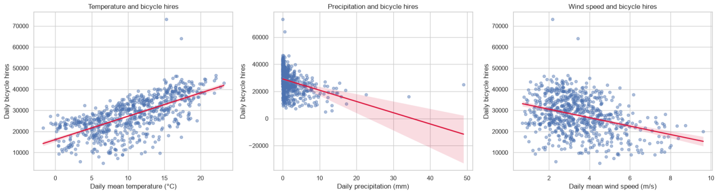
The main visualization will be a three-panel scatter-plot figure showing daily bicycle hires against temperature, precipitation, and wind speed. Each panel uses the same outcome variable and includes a fitted linear trend line, so the direction and approximate strength of the three relationships can be compared directly. The side-by-side design makes the visual evidence easy to scan while preserving the individual daily observations rather than reducing them to averages alone.
This figure directly addresses the research question by showing whether warmer days tend to have more hires and whether wetter or windier days tend to have fewer hires. The visual patterns will be interpreted alongside Pearson and Spearman correlations and a multiple regression with calendar controls. This combination prevents the conclusion from relying only on a fitted line and makes clear that the results describe association, not proof that weather alone causes changes in bicycle demand.

6. Criteria for Success
- The merged dataset covers every day from 1 January 2015 through 31 December 2016, with no duplicate dates or unresolved missing values in the analysis variables.
- The data-cleaning and merging steps are documented and reproducible from the supplied data sources.
- Every visualization has a clear title, labelled axes, units, and a direct connection to the research question.
- The analysis reports effect direction, magnitude, and statistical evidence without defining success as confirmation of the original hypotheses.
- The regression includes the three weather variables and the stated calendar controls, and its interpretation remains associational rather than causal.
- The Jupyter Notebook runs from start to finish and reproduces the reported tables, figures, and statistics.
- The final interpretation acknowledges the single NASA grid point and other unmeasured influences such as holidays, events, disruptions, and system changes.

Verified preliminary results
Running the current project code produced 731 matched daily observations from 1 January 2015 to 31 December 2016, with no duplicate dates and no missing values. Temperature had a positive association with daily hires (Pearson r = 0.666; Spearman rho = 0.697), while precipitation (Pearson r = -0.345; Spearman rho = -0.484) and wind speed (Pearson r = -0.345; Spearman rho = -0.316) had negative associations. All six correlation tests produced p < .001.
Dry or nearly dry days averaged 30,142 hires compared with 23,505 on rain days, equivalent to a 22.0% lower mean on rain days. Mean hires increased from 20,833 on days at or below 5 degrees C to 36,697 on days above 15 degrees C. In the standardized multiple regression with day-of-week, month, and year controls, the coefficients were 0.422 for temperature, -0.343 for precipitation, and -0.169 for wind speed; the model R-squared was 0.783. These values are preliminary analytical results, not criteria that the project must achieve.

7. Project Collaboration

Division of work
- Ma Lekai will lead topic development, proposal and report writing, interpretation, limitations, project coordination, and final document integration.
- Qiu Qizu will lead data cleaning and merging, statistical analysis, regression modelling, visualization, and reproducibility checks.
- Both members will select and verify the data sources, review each other's work, discuss the findings, and approve the final submission.

Ground rules and project roles
- The team will communicate regularly through WeChat and record decisions that affect the research question, methods, or conclusions.
- Each member will complete assigned work by the agreed internal deadline and notify the other member early if a delay or technical problem arises.
- Each member will review the other member's contribution so that both understand the complete project and can verify the final output.
- Ma Lekai will act as project coordinator and report editor; Qiu Qizu will act as data-analysis and visualization lead.
- Both members will complete a final check of links, statistics, figures, formatting, and submitted files before upload.

