Volatility-Scaled Historical Simulation for an Equity Portfolio: Value at Risk, Expected Shortfall, Backtesting and Stress Testing
Marwan Itani
QFI Internship Project #3, October 2026

Abstract. We measure the market risk of an equally weighted portfolio of ten large US stocks over 04 June 2012 to 16 October 2026 (3,614 trading days). Value at Risk (VaR) and Expected Shortfall (ES) are estimated by historical simulation, both unscaled and with past returns rescaled by EWMA, GARCH(1,1) and GJR-GARCH(1,1) volatility. Forecasts are produced out of sample with periodic re-estimation and evaluated with the Kupiec and Christoffersen tests and the Basel traffic light. All four models deliver unconditional coverage close to the nominal 1% at the 99% level, but plain historical simulation produces clustered exceptions (Christoffersen p < 0.001). Over the full evaluation period GJR-GARCH scaling is the only specification that passes every test at both 95% and 99%; when the evaluation starts in May 2015 it fails the independence test narrowly at 99% (p = 0.046), so the ordering of the scaled models depends on the sample, while the rejection of unscaled simulation does not. Today's one-day 99% VaR is $297,000 on a $10 million position; a replay of the 2008 crisis on current holdings would cost $4.41 million.
Keywords: Value at Risk; Expected Shortfall; filtered historical simulation; GJR-GARCH; backtesting; stress testing

1. Introduction and summary
A single risk number is only useful if it reacts when conditions change. Historical simulation, the method most banks still use for regulatory VaR, treats every day in its estimation window as equally likely to repeat tomorrow. When volatility rises quickly, as in February 2020, the window is still dominated by calm days and the estimate lags. Rescaling past returns to current volatility (Hull and White, 1998; Barone-Adesi et al., 1999) addresses this without imposing a distribution on returns. This report applies the three volatility models named in the project brief to that rescaling step, compares them with the unscaled benchmark, and asks which version of the forecast survives a formal backtest.
The portfolio holds Apple, Microsoft, NVIDIA, JPMorgan Chase, Exxon Mobil, Amazon, Meta, Alphabet, Tesla and UnitedHealth in equal proportions, rebalanced monthly, with a current value of $10 million. Four results stand out. First, portfolio returns show the usual stylised facts: excess kurtosis of 9.0, negative skewness and strong dependence in squared returns (Ljung-Box Q(10) on squared returns of 2,291). Second, the GJR-GARCH estimates attribute almost all of the volatility response to negative shocks (α = 0.024 against γ = 0.155). Third, in 3,114 out-of-sample days every model breaks its 99% VaR roughly as often as it should, but only the scaled models, and most clearly the GJR-scaled one, do so at times that look independent; the margin between the scaled models is small and depends on the start of the evaluation period. Fourth, stress scenarios show how far VaR understates crisis losses: the worst 250-day window in the sample implies a one-day VaR of 9.6% of value, about 3.2 times today's estimate.
Section 2 describes the data and the cleaning steps. Section 3 builds the portfolio. Section 4 sets out the VaR, ES and volatility models and Section 5 reports today's estimates. Sections 6 and 7 present the backtests and the model comparison, Section 8 the stress tests and Section 9 a decomposition of risk by holding. Sections 10 and 11 discuss limitations and possible extensions.

2. Data
Daily adjusted closing prices are taken from Yahoo Finance, with Tiingo configured as a fallback source. Adjusted prices correct for splits and dividends, so a stock split does not appear as a price collapse. The sample begins in June 2012 because Meta, the most recent listing among the ten names, started trading in May 2012; starting earlier would leave one series incomplete for the first part of the sample. The SPDR S&P 500 ETF (SPY) is used as the market benchmark and the 13-week Treasury bill yield as the risk-free rate. Holdings quoted in other currencies would be converted to US dollars at the daily exchange rate; none of the ten stocks requires it.
Cleaning aligns all series on a common trading calendar, fills isolated gaps of up to five days with the last available price, and flags prices that remain unchanged for more than five consecutive days. For these ten liquid stocks no gaps had to be filled and no stale prices were found; all 6 automated validation checks (complete dates, positive prices, finite returns, weights summing to one, and returns aligned with the prices of days t-1 and t) were passed. Returns are continuously compounded, r_{t} = ln(P_{t}/P_{t-1}). We considered winsorizing returns at the 1st and 99th percentiles. It would alter 740 observations, 209 of them in 2020 and 92 in March 2020 alone. Since these are genuine market moves rather than data errors, and since the purpose of the exercise is to measure tail risk, we do not winsorize.
Table 1. Descriptive statistics of daily log returns, 04 June 2012 to 16 October 2026.
Stock | Return p.a. | Volatility p.a. | Skewness | Kurtosis | Min | Max
AAPL | 23.4% | 28.2% | -0.23 | 9.6 | -13.8% | 14.3%
MSFT | 24.7% | 26.6% | -0.04 | 12.2 | -15.9% | 14.4%
NVDA | 59.1% | 44.6% | 0.17 | 10.7 | -20.8% | 26.1%
JPM | 21.1% | 25.7% | -0.09 | 15.5 | -16.2% | 16.6%
XOM | 10.2% | 25.7% | -0.21 | 9.8 | -13.0% | 11.9%
AMZN | 24.8% | 32.2% | 0.12 | 9.2 | -15.1% | 14.3%
META | 25.5% | 39.6% | -0.33 | 23.9 | -30.6% | 25.9%
GOOGL | 24.8% | 27.7% | 0.15 | 9.5 | -12.4% | 15.1%
TSLA | 44.1% | 56.6% | 0.03 | 7.6 | -23.7% | 21.8%
UNH | 16.8% | 28.3% | -1.89 | 32.6 | -25.3% | 12.0%
Note. Return p.a. is the annualised mean log return converted to a simple rate; volatility is the daily standard deviation times √252. Kurtosis is raw (3 for a normal distribution).
Table 1 summarises the individual series. Every stock has kurtosis well above the normal value of 3, ranging from 7.6 for Tesla to 32.6 for UnitedHealth, whose distribution is dominated by a handful of large negative days (skewness -1.89). NVIDIA and Tesla combine the highest average returns with the highest volatility. Figure 1 plots the growth of one dollar in each stock; the dispersion of outcomes, from $4 for Exxon to $782 for NVIDIA, already suggests that the weighting scheme will matter for risk.
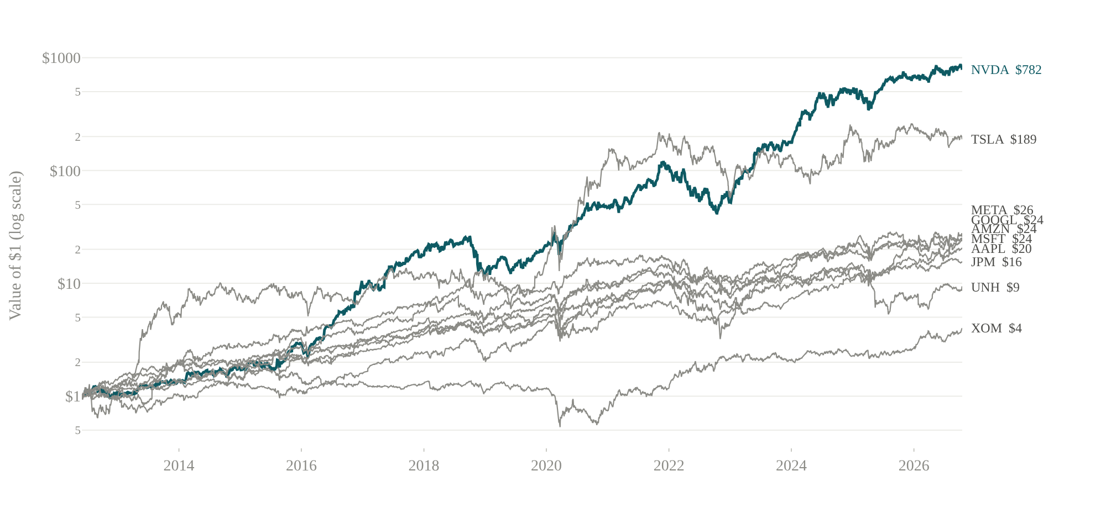
Figure 1. Value of $1 invested in each stock on 1 June 2012 (log scale). NVIDIA, the best performer, is highlighted.

3. Portfolio construction
The portfolio aggregates simple returns, since log returns do not add across assets. With weights w_{i,t-1} fixed at the previous close, the portfolio return is R_{p,t} = Σ_{i} w_{i,t-1} R_{i,t} and the daily profit and loss is V_{t-1} R_{p,t}. Between rebalancing dates the weights drift with relative performance; on the last trading day of each month they are reset to the target. The dollar series are scaled so that the portfolio is worth $10 million today, which keeps the risk figures in later sections comparable with the position actually held. Two checks confirm the accounting: target weights sum to one at every rebalance, and the daily P&L equals the sum of the stock-level contributions on every day.
Table 2. Performance of alternative weighting rules, June 2012 to October 2026.
Weighting rule | Return p.a. | Volatility p.a. | Sharpe ratio | Max drawdown
Equal weight, monthly rebalancing | 31.6% | 21.9% | 1.27 | -34.9%
Equal weight, buy and hold | 38.9% | 33.2% | 1.10 | -59.5%
Market-cap weight, monthly | 24.9% | 22.5% | 1.01 | -39.7%
Inverse-volatility weight, monthly | 26.6% | 20.0% | 1.18 | -33.7%
Note. Sharpe ratios use a flat 2% risk-free rate because T-bill data were unavailable for this run. The S&P 500 (SPY) returned 15.2% a year over the same period. Market-cap weights use current share counts throughout.
The equally weighted, monthly rebalanced portfolio earned 31.6% a year with volatility of 21.9%, against 15.2% for the S&P 500, and has a beta of 1.19 to the index. Table 2 shows that the rebalancing rule is itself a risk decision. Buy and hold produced the highest return in hindsight (38.9%), but only because NVIDIA and Tesla came to dominate the portfolio; its maximum drawdown was -59.5%, against -34.9% with monthly rebalancing. The inverse-volatility rule had the lowest volatility and the smallest drawdown, at the cost of a lower return.
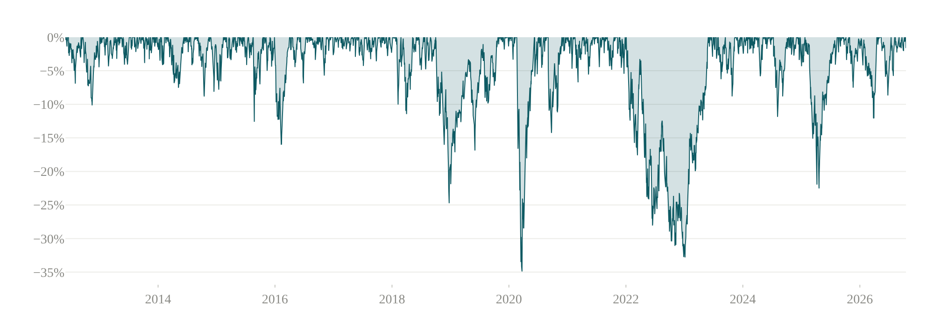
Figure 2. Drawdown of the equally weighted portfolio: the percentage fall from the highest value reached to date.
Figure 2 shows the drawdown path. The two deepest episodes differ in character. The COVID crash took the portfolio 34.9% below its peak in 23 trading days and recovered within 52 more; the 2022 decline was almost as deep (32.8%) but lasted 253 trading days. A one-day risk measure says nothing about the second kind of episode, which is one reason the stress tests in Section 8 are needed.
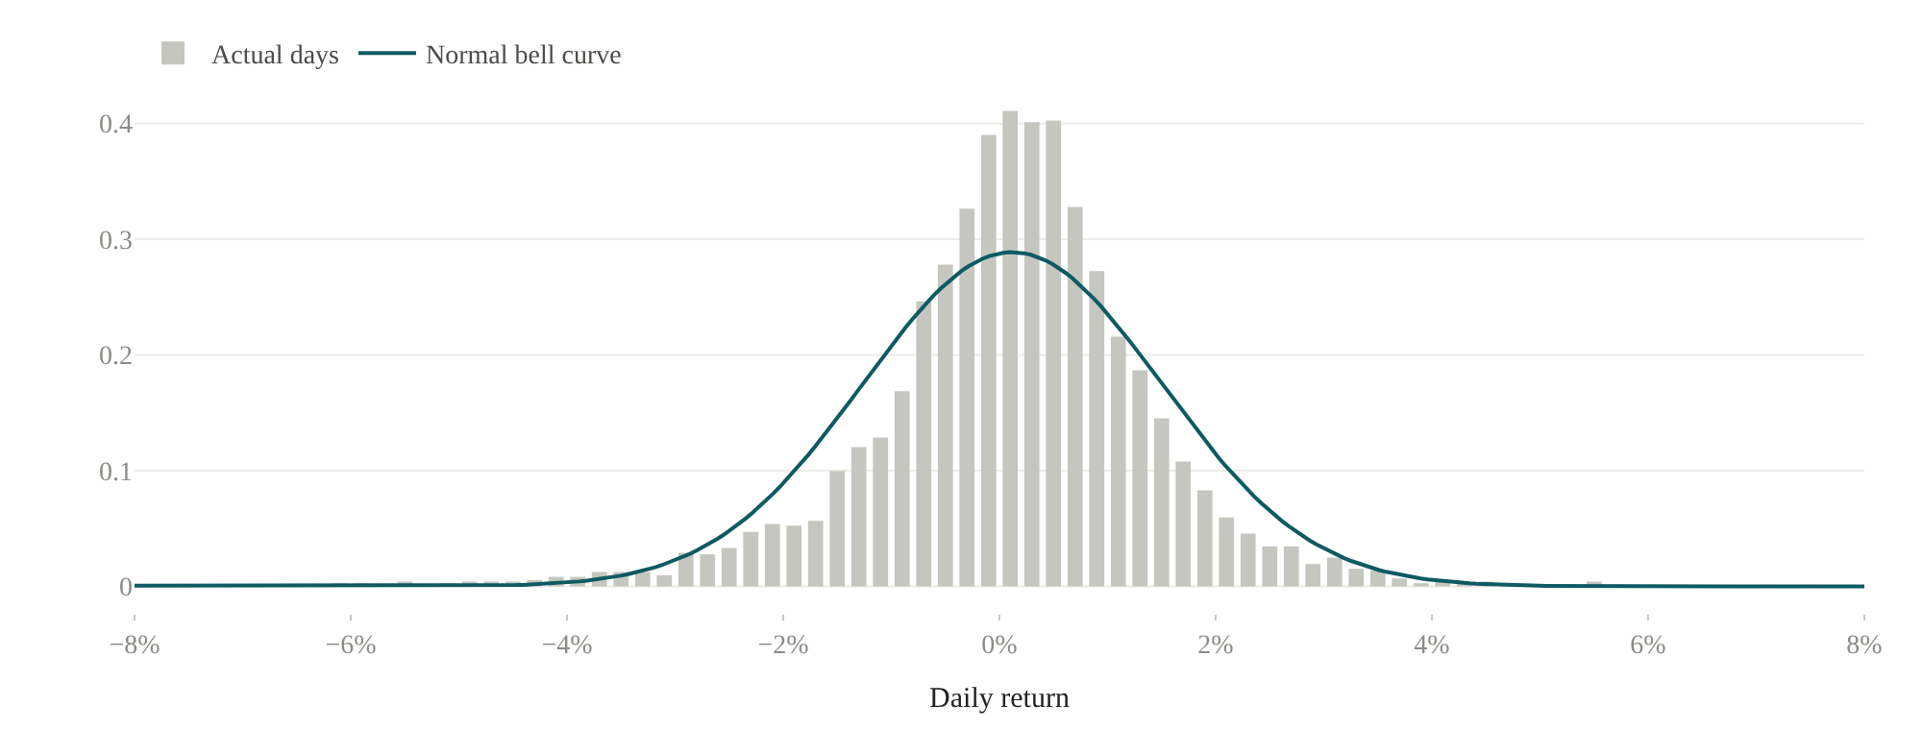
Figure 3. Histogram of daily portfolio returns against a normal density with the same mean and variance.
Figure 3 compares the distribution of daily portfolio returns with a normal density. The Jarque-Bera statistic is 12,476 (p < 0.001), with skewness of -0.53 and kurtosis of 12.0. Squared returns are strongly autocorrelated (Ljung-Box Q(10) = 2,291) and Engle's (1982) ARCH-LM test with five lags gives 700 (p < 0.001). Returns themselves also show some linear dependence (Q(10) = 134), which we leave unmodelled; at a daily horizon its effect on the quantiles is small next to that of changing volatility.

4. Methodology

4.1 Historical simulation VaR and Expected Shortfall
Let L_{j} = -(exp(r_{j}) - 1) denote the loss, as a fraction of value, in scenario j, where the scenarios are the N most recent daily portfolio returns. With tail probability p = 1 - c for confidence level c, the tail contains k = ⌈pN⌉ scenarios. Ordering losses from largest to smallest, L₍₁₎ ≥ L₍₂₎ ≥ ..., we define
VaR_{c} = L_{(k)}, ES_{c} = (1/k) Σ_{j=1..k} L_{(j)} (1)
so that VaR is the k-th largest loss and ES the average of the k largest. With N = 500 and c = 99%, k = 5. ES is the coherent measure (Acerbi and Tasche, 2002) and by construction ES ≥ VaR. We report results for windows of 250, 500 and 750 days and confidence levels of 95%, 99% and 99.5%, with 500 days and 99% as the baseline.

4.2 Volatility models
All three models produce a one-step-ahead conditional standard deviation σ_{t} that uses information up to t-1 only. The EWMA estimator of RiskMetrics (J.P. Morgan, 1996) is
σ²_{t} = λ σ²_{t-1} + (1 - λ) r²_{t-1} (2)
with λ = 0.94. It has no mean reversion, so its forecast is flat at every horizon. The GARCH(1,1) model of Bollerslev (1986) adds a constant that anchors volatility to a long-run level, and the GJR-GARCH model of Glosten et al. (1993) lets negative shocks carry extra weight:
σ²_{t} = ω + (α + γ I_{t-1}) ε²_{t-1} + β σ²_{t-1}, I_{t-1} = 1 if ε_{t-1} < 0 (3)
with γ = 0 giving GARCH(1,1). Persistence is α + γ/2 + β and the long-run variance ω/(1 - α - γ/2 - β). Parameters are estimated by maximum likelihood with normal innovations and a zero mean. Table 3 reports full-sample estimates; the out-of-sample forecasts in Section 6 re-estimate the parameters every 63 trading days on data available at that date and filter σ_{t} forward with fixed parameters in between.
Table 3. Maximum-likelihood estimates for daily portfolio returns (percent), June 2012 to October 2026.
 | GARCH(1,1) | GJR-GARCH(1,1)
ω (×10⁶) | 5.74 | 6.47
α | 0.117 | 0.024
γ | – | 0.155
β | 0.851 | 0.865
Persistence | 0.968 | 0.967
Long-run volatility p.a. | 21.2% | 22.3%
Half-life (days) | 21.2 | 20.7
Log-likelihood | -5,781.9 | -5,733.1
AIC | 11,569.9 | 11,474.2
Note. Persistence is α + γ/2 + β. Half-life is ln(0.5)/ln(persistence).
Table 3 shows the asymmetry clearly. In the GJR model the response to a positive shock is small (α = 0.024) while a negative shock adds γ = 0.155. The likelihood-ratio statistic for γ = 0 is 97.7, far above the 1% critical value of 6.63, and the AIC also favours the asymmetric model. Both models are highly persistent, with a half-life of about 21 trading days. Dividing returns by the GJR volatility reduces kurtosis from 12.0 to 4.5 and removes the dependence in squared returns (Ljung-Box Q(10) on squared standardised residuals = 11.7, p = 0.30).
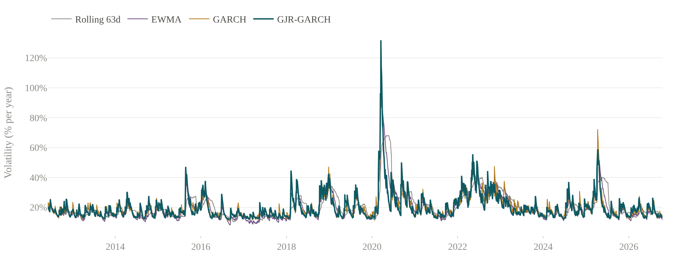
Figure 4. Annualised conditional volatility of the portfolio: 63-day rolling standard deviation, EWMA (λ = 0.94), GARCH(1,1) and GJR-GARCH(1,1).
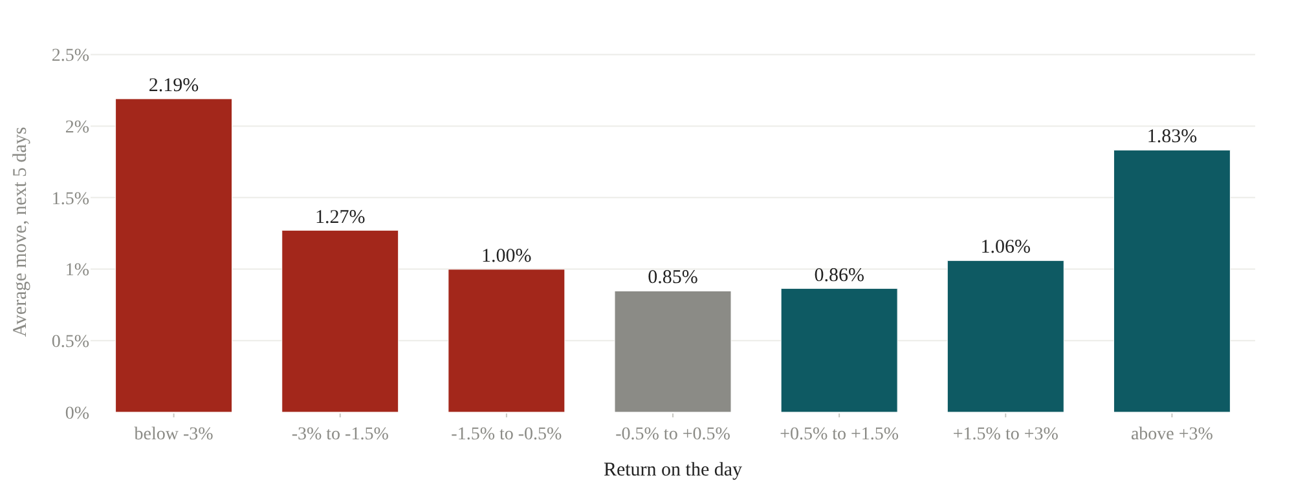
Figure 5. Average absolute daily return over the five days following a day in each return bucket. No model is involved.
Figure 4 plots the four volatility estimates. The conditional models react within a day to the March 2020 shock and decay over the following weeks, while the rolling estimate rises more slowly and then drops abruptly when the crash leaves its window. Figure 5 checks the asymmetry without any model: after a day with a loss of more than 3%, the following five days moved 2.19% on average, against 1.83% after a gain of the same size and 0.85% after a quiet day. Clustering is also visible in the regime split: 66 of the 77 days with losses beyond 3% fall in the third of the sample with the highest GJR volatility.

4.3 Volatility-scaled historical simulation
Following Hull and White (1998), each historical return is rescaled by the ratio of the volatility forecast for tomorrow to the volatility prevailing on the day it occurred,
r̃_{j} = r_{j} · σ_{T+1} / σ_{j}, j = T-N+1, ..., T (4)
and equation (1) is then applied to the rescaled sample. A loss of 2% from a period half as volatile as today enters the scenario set as a loss of about 4%. We label the resulting models EWMA-HS, GARCH-HS and GJR-HS, and the unscaled benchmark HS. Ten-day figures use the square-root-of-time rule, VaR₁₀ = √10 · VaR₁; the platform also offers overlapping ten-day returns, which assume nothing about independence but rest on far fewer effective observations.

5. Value at Risk and Expected Shortfall estimates
Table 4. One-day and ten-day 99% VaR and ES on 16 October 2026 for a $10 million portfolio (500-day window).
Model | VaR 1-day | VaR % | ES 1-day | VaR 10-day | ES 10-day
HS | $337,000 | 3.37% | $463,000 | $1.06 million | $1.47 million
EWMA-HS | $247,000 | 2.47% | $285,000 | $782,000 | $901,000
GARCH-HS | $279,000 | 2.79% | $324,000 | $881,000 | $1.02 million
GJR-HS | $297,000 | 2.97% | $338,000 | $939,000 | $1.07 million
Note. Ten-day figures apply the square-root-of-time rule.
Table 4 reports current estimates. The scaled models give lower figures than plain historical simulation ($247,000 to $297,000, against $337,000) because current volatility is below its sample average while the 500-day window still contains the April 2025 sell-off. Across confidence levels and windows the GJR-HS estimate ranges from 1.34% (95%, 250 days) to 3.34% (99.5%, 500 days) of portfolio value; at 99% it is 2.30%, 2.97% and 2.74% for windows of 250, 500 and 750 days. The validation checks in the brief hold for every model: VaR is positive, increases with the confidence level, is larger at ten days than at one, and is below ES.
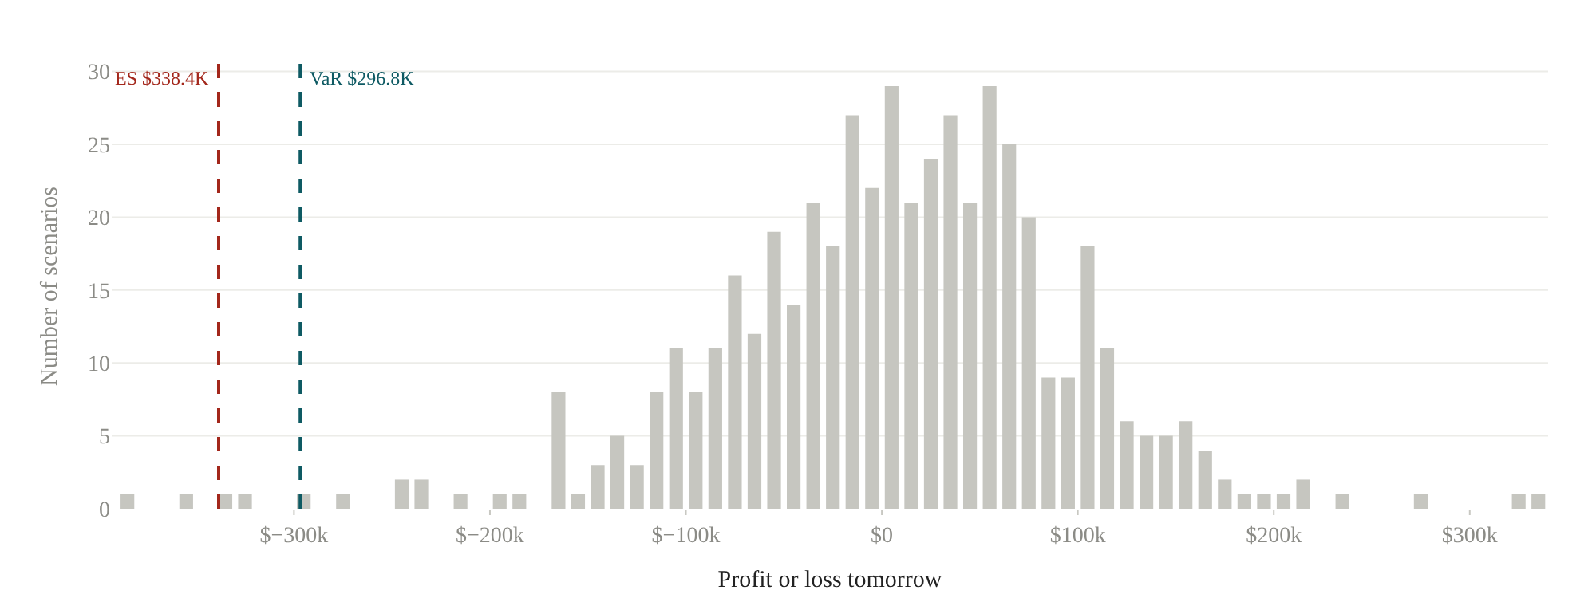
Figure 6. The 500 GJR-scaled scenarios for tomorrow's profit and loss with the 99% VaR and ES marked.

6. Backtesting
Each model produces a one-day 99% and 95% VaR forecast for every day from 02 June 2014, the first date with 500 days of history, to 16 October 2026: 3,114 forecasts in all. An exception occurs when the realised loss exceeds the forecast. Let x be the number of exceptions in T days. The Kupiec (1995) proportion-of-failures statistic compares the observed rate π̂ = x/T with p:
LR_{POF} = -2 ln[(1 - p)^{T-x} p^{x}] + 2 ln[(1 - π̂)^{T-x} π̂^{x}] ~ χ²(1) (5)
Christoffersen's (1998) independence test compares the probability of an exception following a non-exception day, π₀₁, with the probability following an exception day, π₁₁. Its statistic is asymptotically χ²(1), and adding it to LR_{POF} gives the conditional coverage test, χ²(2). The Basel traffic light classifies the number of 99% exceptions in the latest 250 days: zero to four green, five to nine yellow, ten or more red (Basel Committee, 1996). We verified the implementation on the textbook case of 10 exceptions in 250 days, for which LR_{POF} = 12.96.
Table 5. Backtest results, 02 June 2014 to 16 October 2026 (3,114 days).
Model | 99%: exc. | Kupiec | Indep. | Cov. | 95%: exc. | Kupiec | Indep. | Cov.
GJR-HS | 34 | 0.612 | 0.056 | 0.143 | 158 | 0.850 | 0.699 | 0.912
EWMA-HS | 32 | 0.877 | 0.044 | 0.130 | 148 | 0.523 | 0.072 | 0.161
GARCH-HS | 33 | 0.740 | 0.005 | 0.017 | 151 | 0.698 | 0.899 | 0.920
HS | 36 | 0.393 | < 0.001 | 0.002 | 167 | 0.358 | < 0.001 | < 0.001
Note. Expected exceptions: 31.1 at 99% and 155.7 at 95%. Columns report the number of exceptions and the p-values of the Kupiec, Christoffersen independence and conditional coverage tests. Models are ordered by the ranking in Section 7.
Table 5 gives the results. None of the models can be rejected on the number of exceptions: at 99% they record between 32 and 36 against 31.1 expected, and all Kupiec p-values exceed 0.35. The timing is another matter. Plain HS fails the independence test at both levels (p < 0.001 at 99% and < 0.001 at 95%), and GARCH-HS fails it at 99% (p = 0.005). EWMA-HS fails it narrowly at 99% (p = 0.044). GJR-HS passes every test at both confidence levels over this period, although its 99% independence p-value is only just above 5%; Section 7 shows that this result is not robust to the start date.
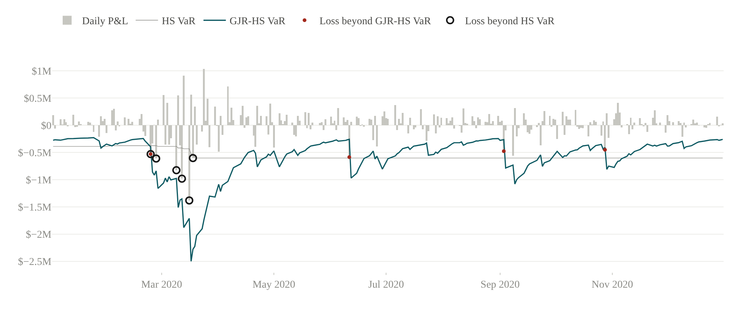
Figure 7. Daily P&L in 2020 against the one-day 99% VaR of the HS and GJR-HS models, both computed with data available at the time.
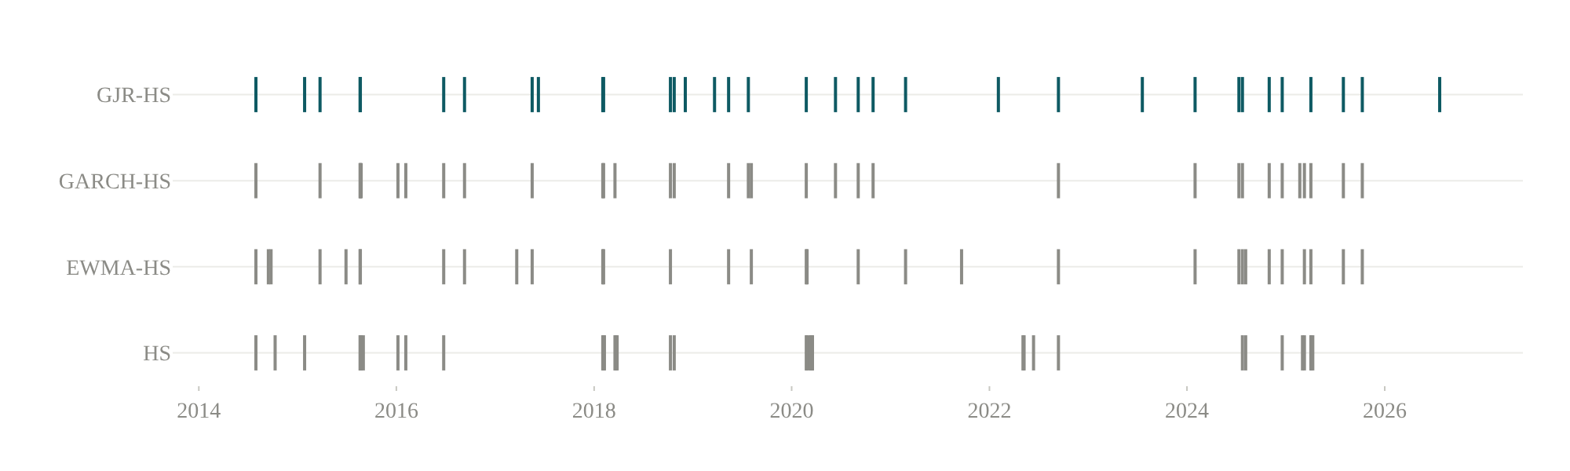
Figure 8. Dates of 99% VaR exceptions by model, June 2014 to October 2026.
Figure 7 shows where the difference comes from. In late February and March 2020 the HS forecast barely moved, from about $380,000 to $600,000, while daily losses reached $1.4 million; it was exceeded six times in under four weeks. The GJR-HS forecast rose above $2 million at the height of the crisis and was exceeded once in that period. Figure 8 shows the same pattern over the whole sample: the HS exceptions come in groups in August 2015, early 2018, March 2020 and April 2025, while the GJR-HS exceptions are spread out. Measured by the traffic light, HS spent 980 days in the yellow zone over the period, against 262 for GJR-HS; all four models are currently green.

7. Model comparison
Table 6. Comparison of the 99% VaR models over the backtest period.
Model | Exc./exp. | Mean VaR | SD of VaR | Mean ES | Worst loss | Zone | Rank
GJR-HS | 1.09 | $363,000 | $187,000 | $419,000 | $1.38 million | Green | 1
EWMA-HS | 1.03 | $389,000 | $199,000 | $447,000 | $1.38 million | Green | 2
GARCH-HS | 1.06 | $361,000 | $167,000 | $412,000 | $1.38 million | Green | 3
HS | 1.16 | $401,000 | $113,000 | $489,000 | $1.38 million | Green | 4
Note. Exc./exp. is the ratio of actual to expected exceptions. SD of VaR is the standard deviation of the daily forecast. Zone refers to the latest 250 days.
Table 6 collects the metrics listed in the brief. We rank models first on whether they pass all three tests, then on the distance between actual and expected exceptions, and finally on the average VaR, since a model that achieves correct coverage with less capital is preferable. GJR-HS ranks first. Its average VaR ($363,000) is close to the lowest and below that of plain HS ($401,000), so the better coverage does not come from holding more risk capital on average. It comes from moving the forecast: the standard deviation of the GJR-HS forecast is 1.6 times that of HS. The scaled model holds less in calm periods and more in turbulent ones, which is what a risk forecast should do.
Table 7. Sensitivity of the backtest to its start date: 02 June 2014 against 29 May 2015.
Model | 99% exc. (full) | Indep. p (full) | 99% exc. (2015) | Indep. p (2015) | 95% indep. (full) | 95% indep. (2015)
HS | 36 | < 0.001 | 33 | < 0.001 | < 0.001 | < 0.001
EWMA-HS | 32 | 0.044 | 28 | 0.030 | 0.072 | 0.064
GARCH-HS | 33 | 0.005 | 31 | 0.004 | 0.899 | 0.817
GJR-HS | 34 | 0.056 | 31 | 0.046 | 0.699 | 0.832
Note. Full: 3,114 days from 02 June 2014. 2015: 2,864 days from 29 May 2015, the first date with 750 days of history, as in the project brief. Indep. is the p-value of the Christoffersen independence test.
The ranking rests on p-values close to the 5% threshold, so we repeat the backtest from 29 May 2015, the first date with 750 days of prior data, which is the convention in the project brief. Table 7 reports the result. At 99% no model now passes all three tests. GJR-HS records 31 exceptions and an independence p-value of 0.046, EWMA-HS 0.030 and GARCH-HS 0.004, and with no model passing every test the ranking rule places EWMA-HS first. Three conclusions survive the change. Plain HS is rejected clearly in both samples (p < 0.001 at 99%). At 95% all three scaled models pass every test in both samples and GJR-HS ranks first in both. And no model is rejected on the number of exceptions. We therefore read the evidence as favouring volatility scaling over unscaled simulation, with GJR-HS the most reliable of the scaled models rather than the only adequate one. With about 30 expected exceptions, differences of a few hundredths in the independence p-value are within sampling noise.

8. Stress testing
Historical scenarios apply each stock's actual daily returns over a crisis window to today's holdings, held without rebalancing. Meta and Tesla were not listed in 2008; for that window their returns are replaced by β_{i} times the SPY return, with β_{i} estimated over the latest 500 days. Hypothetical scenarios move each stock by β_{i} times a market shock, shock one sector, double volatility (scaling every scenario in the GJR-HS set by two), or push all pairwise correlations halfway towards one and rescale VaR by the implied change in portfolio volatility. For historical scenarios the stressed VaR and ES are computed on the 250 days ending at the end of each crisis window.
Table 8. Stress scenarios applied to the current $10 million portfolio, ranked by loss.
Scenario | Type | Loss | Loss % | Worst day | Stressed VaR
2008 financial crisis | Historical | $4.41 million | 44.1% | 13.1% | 9.6%
COVID crash 2020 | Historical | $3.46 million | 34.6% | 13.7% | 8.3%
Inflation shock 2022 | Historical | $2.52 million | 25.2% | 5.0% | 4.9%
Tech selloff 2021-22 | Historical | $2.33 million | 23.3% | 4.9% | 4.9%
Market -20% | Hypothetical | $2.24 million | 22.4% | 22.4% | –
Tariff shock April 2025 | Historical | $1.17 million | 11.7% | 5.8% | 4.3%
Market -10% | Hypothetical | $1.12 million | 11.2% | 11.2% | –
Volatility x2 | Hypothetical | $585,000 | 5.8% | 5.8% | 5.8%
Market -5% | Hypothetical | $559,000 | 5.6% | 5.6% | –
Technology -15% | Hypothetical | $441,000 | 4.4% | 4.4% | –
Correlation spike (50% to 1) | Hypothetical | $420,000 | 4.2% | 4.2% | 4.2%
Banking stress 2023 | Historical | $-163,000 | -1.6% | 2.3% | 4.9%
Note. Loss is the cumulative change in value over the scenario. For volatility and correlation shocks the loss shown is the stressed one-day 99% VaR. Negative values are gains.
Table 8 ranks the scenarios. The 2008 crisis is the most severe, with a loss of $4.41 million (44.1%), followed by the COVID crash (34.6%). A uniform 20% market decline costs 22.4% because the portfolio's average beta exceeds one; Tesla (β = 2.28) and NVIDIA (β = 1.85) are the most sensitive holdings and Exxon (β = 0.17) the least. The banking stress of March 2023 would have produced a small gain, since technology stocks rallied while regional banks fell. Searching every 250-day window in the sample, the highest one-day VaR for today's portfolio is 9.6%, for the window ending in December 2008. This Basel 2.5 stressed VaR (Basel Committee, 2009) is 3.2 times the current estimate.
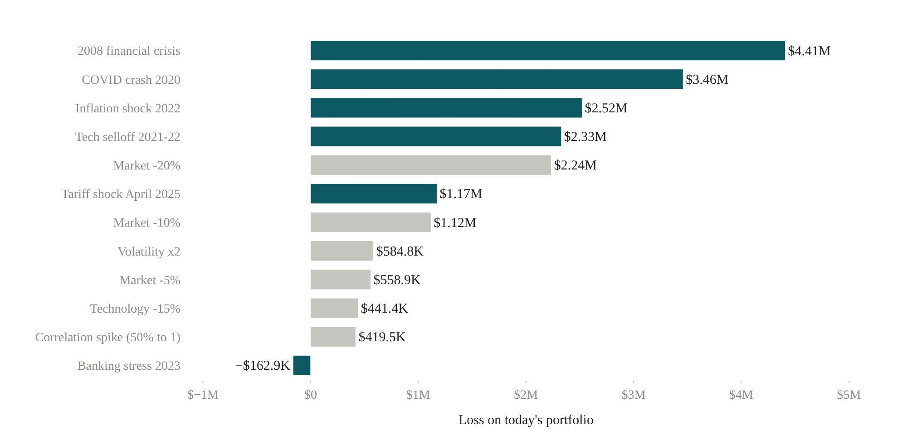
Figure 9. Loss on the current portfolio under each stress scenario. Dark bars are historical replays, light bars hypothetical shocks.

9. Risk decomposition and decision support
To identify the sources of risk we allocate ES to holdings by the Euler principle. Each stock's contribution is its weight times its average return across the k scenarios in the portfolio's loss tail, so that the contributions sum exactly to ES. The VaR allocation averages over the scenarios ranked next to the VaR scenario and is rescaled to sum to VaR.
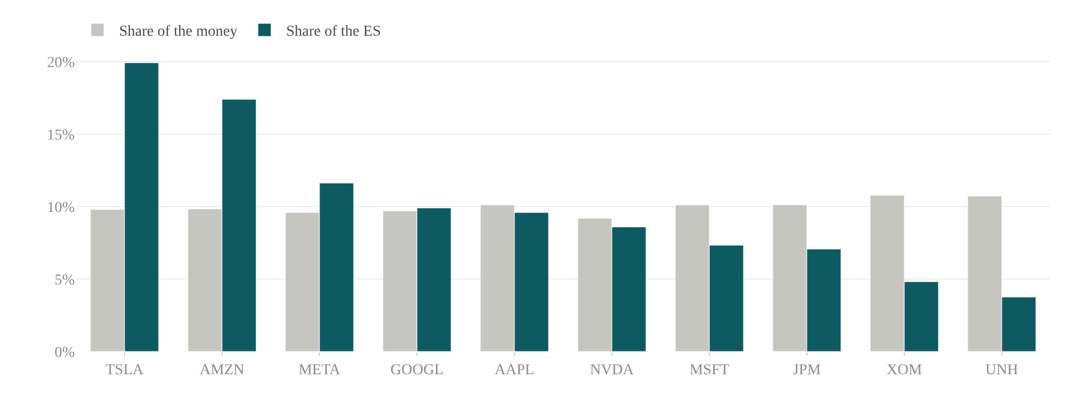
Figure 10. Share of portfolio value and share of 99% ES contributed by each stock (GJR-HS scenarios).
Figure 10 shows that risk is concentrated. Tesla and Amazon each hold about 10% of the capital but contribute 20% and 17% of ES; Exxon and UnitedHealth contribute 5% and 4%. The sum of the ten stand-alone VaRs is $496,000, against a portfolio VaR of $307,000, a diversification benefit of 38%. Over the last 500 days the tracking error relative to the S&P 500 was 9.3% a year. The same scenario set supports three decision tools. The best single hedge, a short position of about $10.30 million in SPY, reduces VaR by 59%; the best single-stock hedge is a short of $2.50 million in TSLA (45%). Minimising ES with the linear programme of Rockafellar and Uryasev (2000), subject to a 25% cap per stock, lowers ES from $330,000 to $229,000, but the historical return of the optimised weights is 21.2% a year against 29.4%. Because the weights are fitted to the last 500 days, their historical maximum drawdown is not lower than that of the equal-weight portfolio, a reminder that an in-sample optimum is not a forecast.

10. Limitations
Several simplifications qualify the results. The universe is ten large US stocks that are in the sample because they exist and are large today, so the data carry survivorship bias and the high average returns should not be read as expected returns. The ten-day figures rely on the square-root-of-time rule, which ignores volatility mean reversion and the autocorrelation found in Section 3. The GARCH parameters are estimated with normal innovations; a Student-t specification is available in the platform but was not used for the reported results. With roughly 31 expected exceptions at 99%, the backtests have limited power, and the independence test in particular can only detect fairly strong clustering; Section 7 shows that a later start date is enough to move the 99% verdict on GJR-HS across the 5% line. Stand-ins for stocks that did not trade in 2008 assume that their market sensitivity was the same then as now. Market-capitalisation weights use today's share counts throughout the sample. Finally, the data come from a single free vendor; the Tiingo fallback reduces but does not remove that dependence.

11. Future improvements
Four extensions would address these points. Simulating ten-day paths from the fitted GJR model, rather than scaling the one-day figure, would capture mean reversion in volatility. A Student-t or skewed-t innovation distribution could be compared with the normal specification using the same backtests. An ES backtest, such as that of Acerbi and Szekely (2014), would test the tail beyond VaR directly, which matters now that the Basel framework uses ES for capital. A point-in-time universe, rebuilt from historical index membership, would remove the survivorship bias.

References
Acerbi, C., and Szekely, B. (2014). Backtesting expected shortfall. Risk, 27(11), 76–81.
Acerbi, C., and Tasche, D. (2002). On the coherence of expected shortfall. Journal of Banking & Finance, 26(7), 1487–1503.
Barone-Adesi, G., Giannopoulos, K., and Vosper, L. (1999). VaR without correlations for portfolios of derivative securities. Journal of Futures Markets, 19(5), 583–602.
Basel Committee on Banking Supervision (1996). Supervisory framework for the use of “backtesting” in conjunction with the internal models approach to market risk capital requirements. Basel: BIS.
Basel Committee on Banking Supervision (2009). Revisions to the Basel II market risk framework. Basel: BIS.
Bollerslev, T. (1986). Generalized autoregressive conditional heteroskedasticity. Journal of Econometrics, 31(3), 307–327.
Christoffersen, P. F. (1998). Evaluating interval forecasts. International Economic Review, 39(4), 841–862.
Engle, R. F. (1982). Autoregressive conditional heteroscedasticity with estimates of the variance of United Kingdom inflation. Econometrica, 50(4), 987–1007.
Glosten, L. R., Jagannathan, R., and Runkle, D. E. (1993). On the relation between the expected value and the volatility of the nominal excess return on stocks. Journal of Finance, 48(5), 1779–1801.
Hull, J., and White, A. (1998). Incorporating volatility updating into the historical simulation method for value-at-risk. Journal of Risk, 1(1), 5–19.
J.P. Morgan/Reuters (1996). RiskMetrics: Technical document (4th ed.). New York: J.P. Morgan.
Kupiec, P. H. (1995). Techniques for verifying the accuracy of risk measurement models. Journal of Derivatives, 3(2), 73–84.
Rockafellar, R. T., and Uryasev, S. (2000). Optimization of conditional value-at-risk. Journal of Risk, 2(3), 21–41.

