Stability is Not Validity: A Falsification Framework for Radiomic Phenotype Discovery
1 introduction
Radiomic phenotype discovery seeks to identify latent imaging subgroups that may refine clinical or molecular classification in cancer. In breast MRI, dynamic contrast-enhanced imaging and related sequences generate quantitative descriptors of tumor morphology, vascularity, cellularity, and heterogeneity that can be analyzed with unsupervised learning. In this setting, a stable cluster structure is often interpreted as evidence that imaging captures biologically meaningful variation beyond standard receptor-based subtype labels.paste.txt
That interpretation is vulnerable in multi-vendor cohorts. Radiomic features are influenced not only by tumor biology but also by manufacturer, pulse-sequence parameters, field strength, voxel geometry, reconstruction choices, and acquisition timing. In high-dimensional settings, even modest acquisition effects can accumulate into dominant latent axes after dimensionality reduction, allowing clustering algorithms to recover stable partitions that reflect scanner-domain structure rather than biology. Standard internal validation metrics such as silhouette score and bootstrap stability assess reproducibility, but they do not distinguish a biological phenotype from a technically induced one.paste.txt
This distinction motivates the present study. Rather than treating unsupervised cluster discovery as a direct route to phenotype identification, we frame the analysis as a falsification chain. We first ask whether a conventional radiomics workflow produces a stable two-cluster phenotype with interpretable feature differences and an apparent prognostic signal. We then test whether that finding survives a sequence of acquisition-aware challenges designed to expose technical confounding.paste.txt
The first step evaluates the raw radiomic feature space. We assess whether the dominant principal components are more closely aligned with biological variables, such as molecular subtype, or with technical acquisition variables, including manufacturer and pulse-sequence parameters. The second step tests cluster identity itself. If the raw phenotype is biologically meaningful, then technical correction should attenuate or refine the partition rather than replace it entirely. We therefore repeat phenotype discovery after manufacturer residualization and ComBat harmonization and compare the resulting partitions with the original raw cluster labels. The third step evaluates clinical interpretation. A putative prognostic phenotype should retain a consistent association with recurrence-free survival after adjustment for manufacturer and across harmonization strategies.paste.txt
Using this framework, we re-examine a 922-patient breast MRI cohort. A standard unsupervised pipeline initially identifies a stable two-cluster radiomic phenotype with enhancement-dominant, vascularity-like characteristics and an apparent HR+/HER2+ recurrence-free survival signal. Subsequent falsification analyses indicate that the leading variance axes are dominated by acquisition parameters, the raw cluster partition is strongly associated with manufacturer, and the apparent prognostic signal is not robust to technical adjustment. The contribution of this study is therefore methodological rather than biomarker-driven: we show that a phenotype can be internally stable, visually interpretable, and apparently prognostic while failing tests of biological identity.paste.txt
Revised preprocessing subsection
The initial radiomic dataset consisted of 529 quantitative MRI-derived features extracted from 922 patients. All features underwent quality control to ensure data integrity and statistical viability. The feature set showed high completeness, with every variable meeting the inclusion criterion of less than 5% missing data, and all features had at least two unique values. The analysis therefore proceeded with the full 922 × 529 matrix, avoiding aggressive feature pruning or sparsity-related artifacts.paste.txt
Residual missing values were imputed feature-wise using the median. Because the feature set included diverse descriptors such as enhancement kinetics, peak enhancement, signal enhancement ratio, and texture statistics, the variables were on different numerical scales. To prevent features with larger absolute ranges from disproportionately influencing variance-based methods such as principal component analysis and clustering, the matrix was standardized to zero mean and unit variance.paste.txt
This preprocessing workflow produced an analysis-ready z-scored matrix that preserves the interpretable signal of tumor enhancement while placing all 529 features on a common scale. The standardized matrix served as the input for phenotype discovery, harmonization experiments, and survival modeling.paste.txt

Literature Review
Radiomic phenotype discovery
Radiomics is based on the premise that routinely acquired medical images contain quantitative information about tumor phenotype that is not fully captured by visual interpretation. Early radiomics work framed image features as a bridge between medical imaging, tumor heterogeneity, and personalized medicine, arguing that high-throughput descriptors can complement histology, genomics, and clinical covariates in risk stratification and treatment selection. Breast MRI is a particularly relevant setting for this idea because dynamic contrast-enhanced MRI, diffusion-weighted imaging, T2-weighted imaging, and enhancement kinetics provide complementary information on vascularity, cellularity, morphology, and tissue heterogeneity.
Beyond supervised prediction, radiomics has increasingly been used for unsupervised phenotype discovery. In this framework, patients are clustered directly in feature space, and the resulting groups are then evaluated for associations with prognosis, molecular subtype, immune state, stromal composition, or pathway activity. This strategy has been used to propose imaging-derived subtypes in breast cancer and other malignancies, including studies linking unsupervised clusters to survival, molecular pathways, and treatment response. Collectively, this literature supports the idea that radiomic clusters may capture clinically meaningful biological variation.
Supervised and unsupervised settings
The main challenge is that unsupervised clustering is exposed to a failure mode that supervised prediction partially avoids. In supervised radiomics, the outcome label is external to the imaging feature space, so performance can be judged against a predefined endpoint such as molecular subtype, recurrence, or treatment response. Technical confounding can still inflate apparent performance, but the model is constrained by a target label and evaluated with metrics such as AUC, calibration, or survival statistics. This constraint partly explains why supervised radiomics has advanced toward clinical validation, whereas unsupervised phenotype discovery remains more vulnerable to interpretive ambiguity.
Unsupervised discovery has no such external anchor. Cluster labels are created from the same feature space that may contain scanner, protocol, or manufacturer effects. If technical variation explains more structure than biology, clustering algorithms may recover hardware-defined partitions before they encounter tumor-defined ones. Internal validation metrics such as silhouette score and bootstrap stability then measure whether the partition can be reproduced, not whether it corresponds to a true biological phenotype. This creates what we refer to as the stability trap: mathematical reproducibility can be mistaken for biological validity.
Technical variance in radiomics
Radiomic features are sensitive to acquisition, reconstruction, discretization, resampling, segmentation, and scanner effects. Prior studies have shown that inter-scanner variability can materially alter radiomic features, that voxel size and gray-level discretization matter, and that many features are nonreproducible or redundant under acquisition variation. Broader reviews have concluded that reproducibility remains a major barrier to generalizable radiomics, motivating efforts such as the Image Biomarker Standardisation Initiative.
MRI poses an even greater challenge because intensities are not inherently standardized across vendors, coils, pulse sequences, and protocols. In breast DCE-MRI, enhancement-based features can reflect both vascular biology and acquisition-dependent signal behavior. One of the clearest empirical warnings comes from multi-vendor breast MRI radiomics, where features predicted scanner platform with AUC values of 0.91 to 1.00, exceeding or matching performance on the clinical task. That finding shows that radiomics can encode strong technical signal, and that technical structure may compete directly with biology in the same feature space.
Harmonization and its limits
Feature-level harmonization is the standard response to scanner and site effects. ComBat, originally developed for batch correction in gene-expression studies, was later adapted to neuroimaging and radiomics to reduce scanner, site, and protocol effects while preserving biological covariates when specified. In radiomics, ComBat and its extensions have mainly been evaluated as tools for improving feature comparability and supervised model transportability. Studies in PET, MRI, and multicenter datasets have shown that harmonization can reduce batch effects and improve predictive modeling.
However, harmonization for supervised performance is not the same as harmonization for unsupervised discovery. In the latter setting, the key question is whether the patient partition survives technical correction. If a cluster is generated largely by manufacturer-linked variance, then ComBat or residualization may preserve mathematical stability while replacing the original partition with a different one. In that case, standard validation metrics may still look reassuring even though the biological identity of the phenotype has changed.
The validation gap
A radiomic phenotype claim should be falsifiable. A useful way to frame this is that a proposed biological phenotype should be exposed to tests that could plausibly disprove its biological interpretation. General guidance on prediction modeling makes a similar point: apparent performance or internal validity is not enough, and claims require transparent testing, robustness assessment, and external validation when generalizability is intended.
The present study uses that logic to define an acquisition-aware falsification chain for unsupervised radiomic phenotypes. The question is not simply whether a stable cluster exists, but whether the same biological interpretation survives when technical structure is explicitly addressed. This requires testing whether the raw cluster aligns more strongly with manufacturer than molecular subtype, whether the leading principal components are dominated by acquisition variables, whether the partition survives residualization and ComBat, whether the prognostic signal remains after technical adjustment, and whether any residual structure still meets minimum biomarker criteria.
This approach fills a methodological gap in the literature. Prior breast MRI clustering studies show that unsupervised radiomics can generate interpretable subtypes, the reproducibility literature shows that acquisition domain can dominate feature space, and the harmonization literature shows that batch effects can be reduced. What has been missing is an end-to-end test of whether a stable unsupervised phenotype retains its identity and interpretation after acquisition effects are adjudicated.
Why this study matters
The contribution of the present paper is therefore methodological rather than biomarker-driven. It does not argue that unsupervised radiomic discovery is invalid in general. Instead, it argues that cluster stability is not equivalent to biological validity, especially in multi-vendor MRI cohorts. A phenotype may be internally stable, visually interpretable, and apparently prognostic while still being dominated by manufacturer and pulse-sequence variance.
For breast MRI, this matters because a vascularity-like cluster can be biologically plausible and still be technically induced. Future clustering studies should therefore report not only cluster number, silhouette, bootstrap stability, and clinical association, but also acquisition-variable enrichment, technical variance partitioning, raw-versus-harmonized partition similarity, and within-vendor replication. These checks do not prove biological validity, but they can prevent weak claims from being mistaken for new phenotypes.
The resulting argument is cohesive: radiomics has genuine promise; unsupervised discovery is an attractive route to latent phenotypes; technical variance is strong enough to mimic phenotype structure; harmonization is useful but can alter cluster identity; therefore, acquisition-aware falsification is necessary. In the real-world radiomics era, where multi-vendor datasets are not exceptions but the condition under which translational imaging biomarkers must operate, the falsification chain should be treated as a minimum methodological standard rather than as an optional sensitivity analysis.

3.1 Radiomic Feature Space and Preprocessing
The initial radiomic dataset consisted of 529 quantitative MRI-derived features extracted from a cohort of 922 patients. All features underwent a rigorous quality control pipeline to ensure data integrity and statistical viability. As detailed in Table 1, the feature set exhibited high completeness, with every variable meeting the inclusion criterion of < 5% missing data. Furthermore, all features demonstrated sufficient variability, defined as possessing at least two unique values. Consequently, the analysis proceeded with the full 922 × 529 matrix, ensuring that subsequent findings were not artifacts of aggressive feature pruning or data sparsity.
To prepare the high-dimensional space for multivariate analysis, residual missing entries were addressed via feature-wise median imputation. Given that the feature set comprises diverse descriptors—including enhancement kinetics, peak enhancement (PE), signal enhancement ratio (SER), and texture statistics—the variables naturally exist on disparate numerical scales. To prevent features with larger absolute ranges from disproportionately influencing variance-based methods such as Principal Component Analysis (PCA) or clustering, the matrix was standardized to zero mean and unit variance.
This preprocessing workflow yielded an analysis-ready z-scored matrix that preserves the biologically interpretable signal of tumor enhancement while placing all 529 features on an equivalent mathematical footing. This standardized repository serves as the foundational input for the subsequent phenotype discovery, harmonization experiments, and survival modeling described in this study.
Table 1. Summary of Radiomic Data Preprocessing and Matrix Construction
Step | Patients (n) | Features (p) | Result \
Raw imaging matrix | 922 | 529 | Numeric radiomic feature matrix extracted after removal of Patient ID \
Missingness filtering (<5%) | 922 | 529 | No features removed \
Low-variance filtering (≥2 unique values) | 922 | 529 | No features removed \
Median imputation | 922 | 529 | Residual missing values imputed feature-wise \
Z-score standardization | 922 | 529 | Mean-centered and variance-scaled matrix generated \
Final normalized matrix | 922 | 529 | Analysis-ready radiomic feature space \
Exported outputs | - | - | Z-scored matrix, patient IDs, and feature list saved for downstream analyses \

3.2 Principal Component Structure of the Radiomic Space
To evaluate the intrinsic dimensionality of the radiomic feature space, Principal Component Analysis (PCA) was performed on the standardized 922 × 529 feature matrix using a randomized SVD solver. The analysis revealed that variance is concentrated within a modest number of latent axes rather than being distributed evenly across all 529 features. As shown in the scree plot (Figure 1), the first principal component (PC1) captured 15.5% of total cohort variance, followed by PC2 and PC3, which accounted for 9.6% and 7.8%, respectively. Collectively, the top 10 principal components explained approximately 58% of the total variance (Table 2). This concentration of variance indicates a structured radiomic space, though one that is not trivially low-dimensional.
The projection of patients onto the first two principal components (PC1 vs. PC2) demonstrated that the cohort forms a largely continuous cloud rather than discrete, well-separated subgroups (Figure 2). Most cases are situated within a dense central region, exhibiting a smooth spread along both axes. A limited number of outliers extend along the PC1 axis, a pattern consistent with gradual radiomic heterogeneity rather than obvious natural clustering at this level of resolution.
The substantial contribution of PC1 suggests the presence of a dominant global imaging signal cutting across the cohort. While PCA at this stage cannot definitively distinguish between biological and technical drivers, subsequent variance partitioning indicates that these leading axes—specifically PC1—are linked primarily to acquisition and pulse-sequence parameters such as repetition time (TR) and echo time (TE) rather than tumor biology alone. For subsequent unsupervised phenotype discovery, the first five principal components were retained as a compact, high-variance representation of the radiomic space.
Figure 1. Scree Plot of the Top 20 Principal Components. The plot illustrates the explained variance ratio for each component, showing a characteristic "elbow" where the majority of dataset variance is captured by the leading latent axes before the curve gradually flattens.
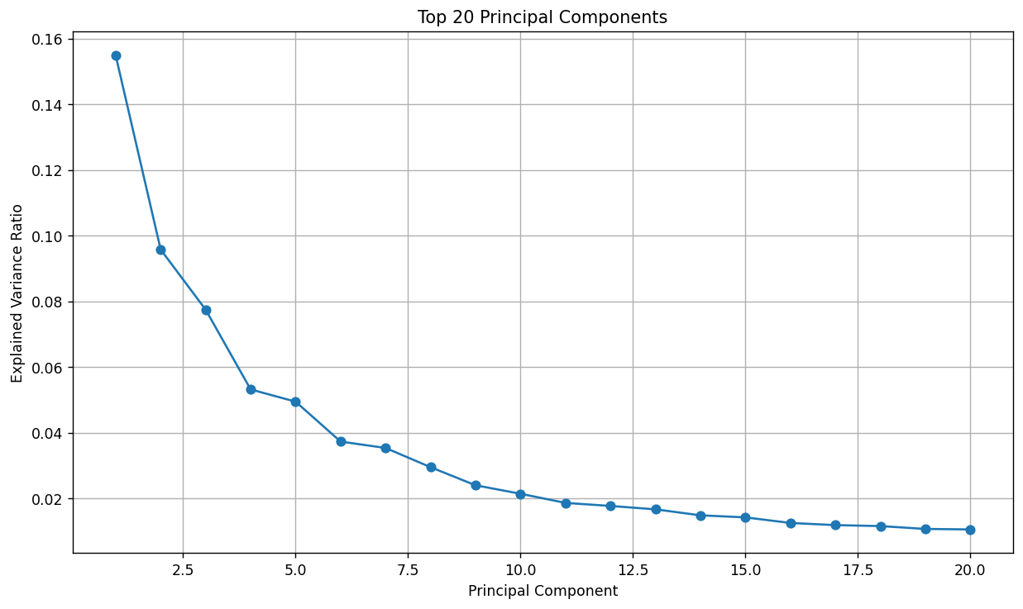

Figure 2. PCA Projection of Patients onto PC1 and PC2. This scatter plot displays the distribution of the 922 patients in the primary latent space. The continuous distribution suggests a spectrum of radiomic profiles rather than distinct, naturally occurring clusters.

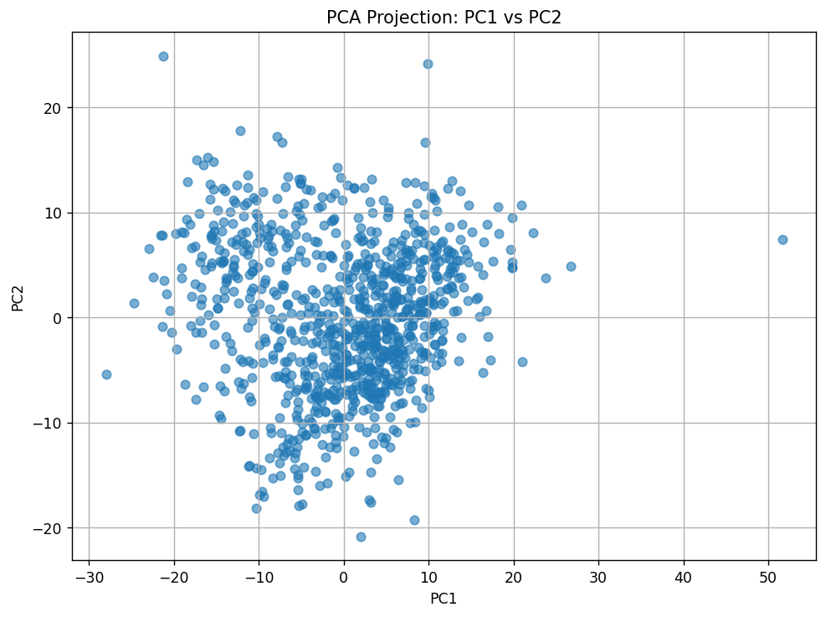
Table 2. Variance Explained by the Top 10 Principal Components
Principal Component | Explained Variance Ratio \
PC1 | 0.1549 \
PC2 | 0.0958 \
PC3 | 0.0775 \
PC4 | 0.0532 \
PC5 | 0.0495 \
PC6 | 0.0374 \
PC7 | 0.0354 \
PC8 | 0.0296 \
PC9 | 0.0241 \
PC10 | 0.0215 \

Table 3. PCA Implementation and Dataset Summary
Metric | Value \
Number of Patients | 922 \
Total Columns in Input Dataset | 530 \
Radiomic Features Used for PCA | 529 \
PCA Solver | randomized \
Random Seed | 42 \
Number of Exported PCA Components | 5 \
3.3 PCA Variance Structure and Sample Distribution
Analysis of the principal component (PC) decomposition demonstrates that a modest number of latent axes account for the majority of radiomic variation, although no single component provides a definitive separation of the patient population. The first principal component (PC1) explains 15.5% of the total variance, while PC2 and PC3 contribute 9.6% and 7.8%, respectively. As shown in the scree plot (Figure 1), the first five components together account for a substantial share of the total variance before the curve gradually flattens. This decay pattern indicates a high degree of underlying structure, while the absence of a sharp "elbow" suggests that variance is distributed across several correlated dimensions rather than being dominated by a singular biological axis.
When patients are projected onto the PC1–PC2 plane, the cohort forms a continuous, elongated distribution without clear gaps or discrete clusters (Figure 2). Most observations are concentrated in a central region with a smooth spread along both primary axes. A limited number of cases extend toward extreme PC1 values, consistent with a subset of outlier radiomic profiles existing within a broader framework of continuous heterogeneity. This distribution suggests that any subsequent clustering solutions will be driven by relatively subtle multivariate patterns rather than the simple, low-dimensional separation typical of distinct biological subgroups.
The elongation along PC1 highlights this axis as the primary direction of variation in the dataset. While this axis likely reflects a mixture of acquisition and biological effects, subsequent variance partitioning (Table 8) shows it is most strongly associated with technical parameters. Consequently, the presence of PC1 outliers suggests that a subset of patients may possess highly unusual imaging or scanner characteristics, which could exert a disproportionate influence on clustering models. Collectively, these PCA visualizations support three critical conclusions: the radiomic space is highly structured, the majority of variance is captured within the first few components, and patient heterogeneity is continuous rather than naturally divided into well-separated clusters.
Table 4. Interpretation of PCA Visualizations
Figure | Interpretation \
Scree Plot of Top 20 PCs | Variance declines progressively after PC1–PC5, indicating structured but moderately distributed latent dimensionality \
PC1 vs PC2 Scatter Plot | Samples form a continuous distribution without clearly separated clusters \
Dominant Variance Axis | PC1 represents the strongest underlying variance source in the dataset \
Cluster Separability | No obvious natural separation is visible in the first two principal components \
Outlier Structure | Several observations extend to extreme PC1 values, suggesting heterogeneous imaging profiles \
Overall PCA Pattern | Radiomic variability appears continuous and multidimensional rather than discretely partitioned \

3.4 Unsupervised Clustering and Internal Validity
To identify potential radiomic phenotypes, K-means clustering was applied to the latent space defined by the first 10 principal components. Evaluation of internal cluster validity metrics across a range of candidate partitions (k = 2 to 6) identified a two-cluster solution as the optimal fit for the data. As shown in Table 5, the k = 2 model achieved the highest Silhouette Score (0.196) and the highest Calinski-Harabasz Index (200.93), with both metrics declining monotonically as k increased. These results indicate that higher-order partitions tend to fragment a continuous gradient of variation rather than uncovering additional coherent subgroups.
When visualized in the PC1–PC2 plane, the two clusters are partitioned primarily along the PC1 axis, with Cluster 0 and Cluster 1 occupying the negative and positive regions, respectively (Figure 3). The boundary between these groups is gradual, characterized by substantial overlap near the origin (PC1 ≈ 0). This lack of a sharp geometric separation is consistent with the previously observed continuous distribution in the PCA space, suggesting that the radiomic variation in this cohort follows a spectrum rather than a discrete bimodal structure.
The heavy reliance of the clustering algorithm on PC1 is significant, as this axis represents the dominant source of variance in the dataset. While the k = 2 solution appears statistically optimal based on internal validity metrics, the alignment with PC1 suggests that the resulting phenotype may be driven by technical acquisition parameters as much as by intrinsic tumor biology. This observation provides the methodological rationale for the subsequent harmonization and residualization analyses, which aim to determine the extent to which this stable phenotype persists once technical variance is addressed.
Table 5. Internal Cluster Validity Metrics Across Candidate k Values
k | Silhouette Score | Calinski-Harabasz Index | Davies-Bouldin Index \
2 | 0.195653 | 200.929867 | 1.955482 \
3 | 0.157827 | 179.178568 | 1.932912 \
4 | 0.146367 | 149.854570 | 1.932116 \
5 | 0.142494 | 134.423765 | 1.890264 \
6 | 0.134233 | 122.675314 | 1.864758 \

Table 6. Interpretation of Clustering Visualizations and Structural Validity
Figure | Interpretation \
KMeans Clusters (k=2) | Cluster separation occurs primarily along the PC1 axis \
Cluster Boundary Structure | Substantial overlap exists between groups near the central PCA region \
Silhouette Score Curve | Highest clustering cohesion observed at k=2 \
Calinski-Harabasz Curve | Maximum cluster compactness and separation achieved at k=2 \
Davies-Bouldin Curve | Slight improvement with larger k values but without corresponding gains in cohesion \
Overall Clustering Pattern | Clusters reflect continuous radiomic variation rather than sharply discrete subtypes \
Potential Technical Influence | Dominance of PC1 suggests possible acquisition-related contribution to cluster formation \

3.5 Bootstrap Stability of the Two-Cluster Solution
To assess the robustness of the identified two-group partition, we performed a bootstrap stability analysis. The cohort was repeatedly resampled (20 iterations) using an 80% subsampling fraction, with the K-means algorithm applied to each subsample using the same 10-PC latent space. As summarized in Table 8, the resulting cluster assignments exhibited high concordance with the original partition, yielding a mean Adjusted Rand Index (ARI) of 0.893 (SD = 0.084).
Most iterations produced an ARI exceeding 0.90, with the maximum reaching 0.984 (Table 7). Even the lowest recorded stability value (ARI = 0.740) significantly exceeds the threshold expected by chance, confirming that the primary data split is reliably recovered across different patient subsets. This high degree of internal stability indicates that the core partition is not a stochastic artifact of the clustering algorithm but rather a consistent feature of the raw radiomic dataset.
While this pattern demonstrates that a standard unsupervised pipeline can produce a statistically robust phenotype, it does not inherently validate the biological identity of the clusters. In high-dimensional radiomics, internal stability can be driven by technical variance as effectively as by tumor biology. Consequently, this bootstrap stability serves as a prerequisite for further testing rather than a definitive proof of clinical relevance, necessitating the subsequent harmonization and residualization analyses to disentangle acquisition-related structure from intrinsic biological signals.
Table 7. Bootstrap ARI Results for k=2 Clustering
Bootstrap Iteration | ARI \
1 | 0.9355 \
2 | 0.9408 \
3 | 0.7533 \
4 | 0.9837 \
5 | 0.7628 \
6 | 0.8784 \
7 | 0.7890 \
8 | 0.9196 \
9 | 0.9250 \
10 | 0.9513 \
11 | 0.9729 \
12 | 0.9620 \
13 | 0.8482 \
14 | 0.7529 \
15 | 0.9622 \
16 | 0.9303 \
17 | 0.9729 \
18 | 0.9728 \
19 | 0.7397 \
20 | 0.9094 \

Table 8. Summary of Bootstrap Stability Metrics
Metric | Value \
Number of bootstrap iterations | 20 \
Subsample fraction | 0.80 \
Clustering method | KMeans \
Number of clusters | 2 \
Clustering feature space | First 10 principal components \
Mean ARI | 0.8931 \
Standard deviation of ARI | 0.0838 \
Minimum ARI | 0.7397 \
Maximum ARI | 0.9837 \
Interpretation | Stable k=2 phenotype under bootstrap resampling \

3.6 Radiomic Features Underlying the Two-Cluster Phenotype
The observed two-cluster partition is characterized by extensive and highly consistent differences in enhancement-based radiomic features, conferring a distinct "vascularity-like" character to the phenotype. As detailed in Table 9, a comparison of feature distributions between clusters using Welch’s t-tests with False Discovery Rate (FDR) correction revealed that descriptors of signal enhancement ratio (SER), peak enhancement (PE), and wash-in/washout kinetics exhibit exceptionally large effect sizes. In many instances, Cohen’s d exceeded 2.0, indicating that the magnitude of separation along this radiomic axis far surpasses what is typically observed for standard clinical covariates.
Texture features derived from SER maps serve as the primary drivers of cluster separation. Cluster 1 is characterized by significantly higher entropy-related measures, including SER map entropy and sum entropy (Cohen’s d = 2.21, q < 0.001). Conversely, Cluster 0 exhibits significantly higher levels of homogeneity and inverse-difference metrics (Table 10). In practical terms, this identifies Cluster 1 as a more chaotic, spatially heterogeneous enhancement phenotype, while Cluster 0 represents a more uniform and coherent enhancement pattern. This reciprocal relationship between entropy and homogeneity reinforces the internal consistency of the phenotype, centering it on enhancement heterogeneity.
Volumetric enhancement descriptors and kinetic slopes also contribute substantially to the separating signal. Significant differences were observed in the proportion of tissue exceeding high enhancement thresholds, suggesting that global vascular burden and perfusion activity are central to this two-cluster structure. Collectively, the combination of enhancement heterogeneity, kinetic shifts, and volume-based descriptors supports the interpretation of these groups as a vascularity-related radiomic phenotype. However, because these dominant features are known to be sensitive to acquisition parameters, the possibility remains that this compelling "vascular" signal reflects technical variance between manufacturers rather than purely intrinsic tumor biology—a tension that necessitates the subsequent harmonization analyses.
Table 9. Top Cluster-Separating Radiomic Features Ranked by Effect Size

Feature | Mean Cluster 0 | Mean Cluster 1 | Difference (C1−C0) | Cohen’s d | q-value \
SER_map_Entropy_tissue_T1 | -0.552459 | 0.963515 | 1.515975 | 2.214309 | 1.09E-100 \
SER_map_sum_entropy_tissue_T1 | -0.552128 | 0.962938 | 1.515066 | 2.211473 | 2.70E-109 \
SER_map_std_dev_tissue_T1 | 0.550341 | -0.959821 | -1.510162 | -2.196272 | 2.45E-164 \
SER_map_difference_entropy_tissue_T1 | -0.546230 | 0.952651 | 1.498880 | 2.161924 | 1.18E-103 \
SER_map_Homogeneity2_tissue_T1 | 0.540379 | -0.942447 | -1.482826 | -2.114468 | 2.46E-95 \
SER_map_Homogeneity1_tissue_T1 | 0.539008 | -0.940056 | -1.479064 | -2.103581 | 1.70E-97 \
SER_map_inverse_difference_is_homom_tissue_T1 | 0.539008 | -0.940056 | -1.479064 | -2.103581 | 1.70E-97 \
PE_map_std_dev_tissue_T1 | 0.531684 | -0.927282 | -1.458966 | -2.046814 | 1.72E-164 \
SER_map_Entropy_tissue_PostCon | -0.522587 | 0.911417 | 1.434004 | 1.979407 | 4.54E-87 \
SER_map_sum_entropy_tissue_PostCon | -0.521927 | 0.910265 | 1.432192 | 1.974642 | 6.92E-94 \

Table 10. Biological Interpretation of Dominant Feature Patterns
Feature Category | Cluster Pattern | Biological Interpretation \
SER entropy features | Elevated in Cluster 1 | Greater enhancement heterogeneity and spatial disorder \
SER homogeneity features | Elevated in Cluster 0 | More spatially uniform enhancement behavior \
SER standard deviation | Elevated in Cluster 0 | Greater enhancement intensity dispersion in homogeneous phenotype \
Enhancement-volume ratios | Strongly cluster-separating | Differences in global vascular enhancement burden \
Wash-in/washout slope features | Strongly cluster-separating | Distinct kinetic enhancement dynamics between phenotypes \
PE-map variability features | Elevated separation magnitude | Altered enhancement amplitude structure \
Overall phenotype structure | Enhancement-dominant | Putative vascularity-related radiomic phenotype \

HR+/HER2+ recurrence-free survival by radiomic cluster
Within the HR+/HER2+ subgroup, the raw two-cluster phenotype appears to carry a strong, subtype-specific survival signal before any adjustment for technical factors. Among 101 HR+/HER2+ patients with valid follow-up (10 recurrences total), 55 were assigned to Cluster 0 and 46 to Cluster 1. Only 2 recurrences occurred in Cluster 0 (3.6%), compared with 8 recurrences in Cluster 1 (17.4%), and the Kaplan–Meier curves showed clear separation between the groups over time.
A log-rank test confirmed a statistically significant difference in recurrence-free survival between the clusters (p ≈ 0.01), and a cluster-only Cox model estimated a hazard ratio of about 4.8 for Cluster 1 versus Cluster 0 (95% CI roughly 1.2–18.6, p ≈ 0.02). In practical terms, HR+/HER2+ patients classified into Cluster 1 had markedly higher recurrence risk than those in Cluster 0 under this unadjusted analysis. However, this result rests on only 10 events and yields a wide confidence interval, so the apparent effect is numerically striking but statistically fragile. As the later sections of the paper show, its interpretation must be revisited once scanner manufacturer and harmonization sensitivity are fully accounted for, to distinguish a potential biological signal from one that may be partly driven by acquisition confounding.
When you look at these numbers (10 events total, HR ≈ 4.8 with a wide confidence interval), how would you explain to a reviewer why you treat this as an “interesting hint” rather than a definitive prognostic biomarker?

3.7 Recurrence-Free Survival by Radiomic Cluster in the HR+/HER2+ Subgroup
Within the HR+/HER2+ patient subgroup ($n = 101$), the raw two-cluster phenotype demonstrated a statistically significant survival signal prior to adjusting for technical acquisition factors. Of the 101 patients analyzed, 55 were assigned to Cluster 0 and 46 to Cluster 1. The clinical event distribution was markedly skewed: Cluster 0 recorded only 2 recurrences (3.6% event rate), whereas Cluster 1 recorded 8 recurrences (17.4% event rate). Kaplan–Meier analysis showed a clear separation in recurrence-free survival (RFS) probability between the two groups (Figure 3).
Statistical evaluation via log-rank test confirmed a significant difference in RFS between clusters ($p = 0.010$). An unadjusted Cox proportional hazards model estimated that Cluster 1 carried a nearly five-fold increase in recurrence risk compared to Cluster 0 (HR = 4.76; 95% CI: 1.22–18.61; $p = 0.02$). Under standard radiomic methodology, these findings would typically be interpreted as a subtype-specific prognostic refinement.
However, the statistical robustness of this association is limited by a low event density (10 total events), resulting in a wide confidence interval for the hazard ratio. While the numerical separation is striking, the fragility of the estimate necessitates a rigorous adjudication of potential acquisition confounding. As detailed in subsequent sections, the stability of this prognostic signal fails when subjected to manufacturer adjustment and harmonization sensitivity analysis.
Figure 3. Recurrence-Free Survival in HR+/HER2+ by Radiomic Cluster. Kaplan–Meier curves illustrate the RFS probability for Cluster 0 (blue) and Cluster 1 (orange). The shaded regions represent 95% confidence intervals, showing clear separation over time in the unadjusted analysis.
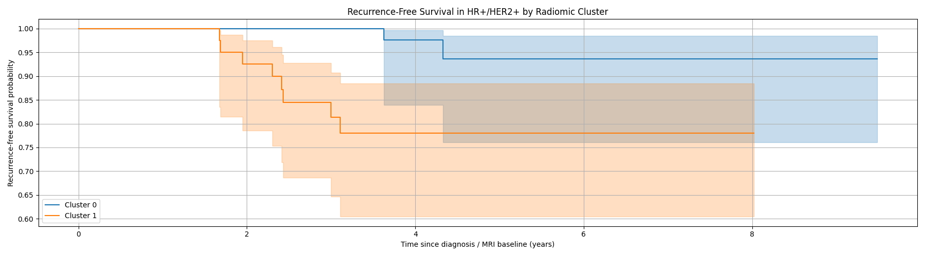
Table 11. HR+/HER2+ Outcome Summary by Radiomic Cluster
Cluster | n | Events | Median RFS (years) | Event Rate \
0 | 55 | 2 | 4.106776 | 0.036364 \
1 | 46 | 8 | 3.221081 | 0.173913 \

Table 12. HR+/HER2+ Survival Association Tests
Analysis | Estimate | 95% CI | p-value | Interpretation \
Log-rank test | - | - | 0.010041 | Significant RFS difference between clusters \
Cox model: Cluster 1 vs Cluster 0 | HR = 4.76 | 1.22–18.61 | 0.02 | Cluster 1 associated with higher recurrence risk \

3.8 Manufacturer-Driven Structure of the Raw Radiomic Phenotype
A detailed evaluation of the raw $k=2$ radiomic phenotype reveals a near-complete overlap between the unsupervised cluster structure and the MRI manufacturer. Cross-tabulation of the cohort demonstrates that Cluster 0 is comprised predominantly of GE examinations (93.3%), whereas Cluster 1 is dominated by Siemens examinations (75.9%). As shown in Table 14, manufacturer identity serves as a highly accurate predictor of cluster membership: 87.1% of all GE cases were assigned to Cluster 0, while 86.7% of all Siemens cases were localized to Cluster 1.
The statistical association between manufacturer and cluster assignment is profound ($\chi^2 = 468.2, p = 1.1 \times 10^{-96}$), indicating that technical variance explains the vast majority of the observed clustering structure. In contrast, the association between cluster assignment and molecular subtype was non-significant ($p = 0.272$), and no significant association was found with recurrence events at the whole-cohort level ($p = 0.562$).
PCA visualizations reinforce this technical dominance. When the latent space is stratified by manufacturer, the resulting spatial partition is visually almost interchangeable with the cluster-colored plot, with both groups separating primarily along the PC1 axis. Specifically, GE examinations largely occupy the PC1 regions corresponding to Cluster 0, while Siemens examinations localize within the regions defining Cluster 1. This high spatial concordance indicates that the clustering algorithm largely recapitulated manufacturer-specific variance already embedded within the dominant principal components. These findings highlight a central methodological risk: a radiomic phenotype can appear statistically robust and internally stable while being fundamentally driven by acquisition-domain separation.
Table 13. Association of the Raw Cluster Partition with Clinical and Technical Variables

Variable | P-value | Interpretation \
Manufacturer | 8.022438E-104 | Strong association with raw cluster assignment \
Molecular Subtype | 0.145796 | No significant association with raw cluster assignment \
Recurrence | 0.765626 | No significant whole-cohort association with recurrence \

Table 14. Contingency Table: Cluster Assignment by Manufacturer
Cluster | GE Manufacturer 0 | Siemens Manufacturer 2 \
0 | 547 | 39 \
1 | 81 | 255 \

Table 15. Contingency Table: Cluster Assignment by Molecular Subtype
Cluster | Subtype 0 | Subtype 1 | Subtype 2 | Subtype 3 \
0 | 383 | 56 | 41 | 106 \
1 | 212 | 48 | 18 | 58 \

Table 16. Contingency Table: Cluster Assignment by Recurrence Event
Cluster | No Recurrence | Recurrence \
0 | 527 | 57 \
1 | 306 | 30 \

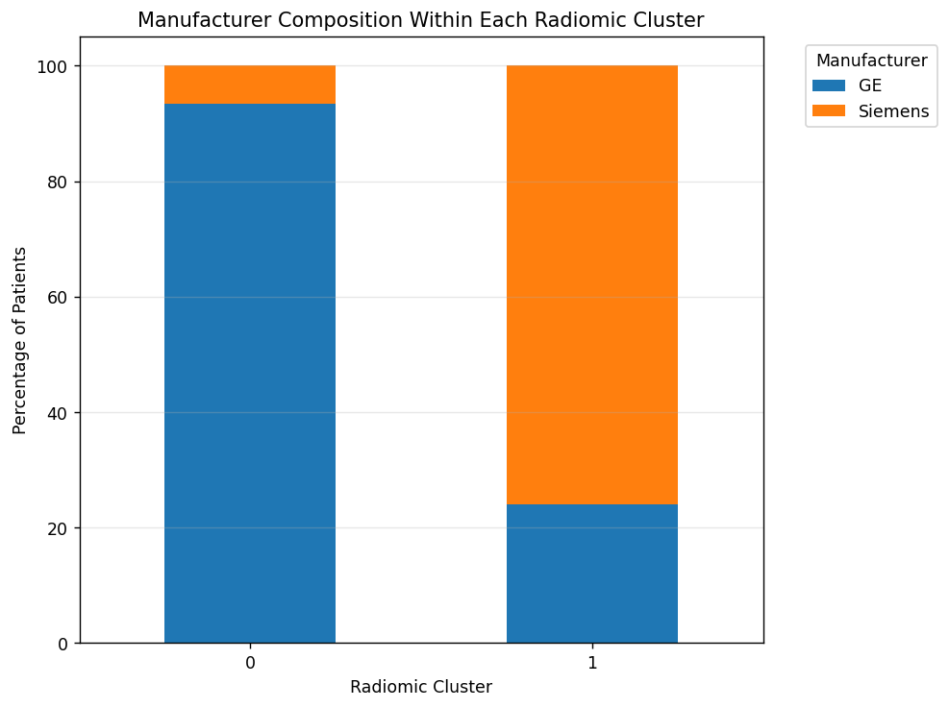
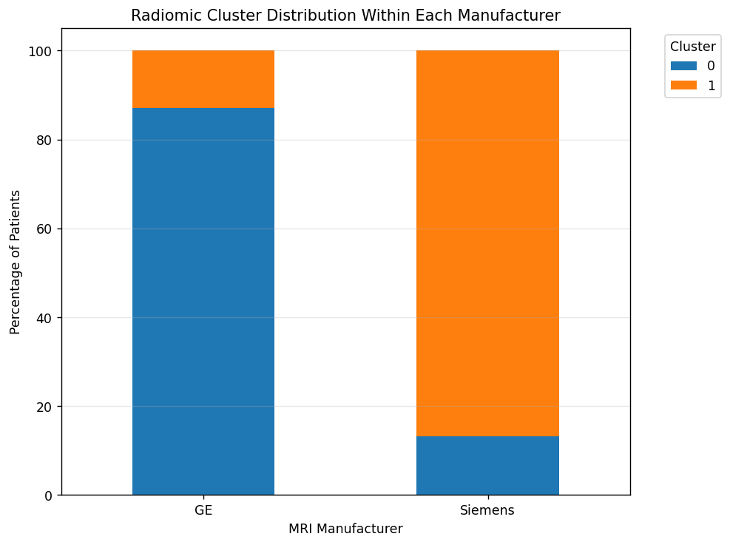
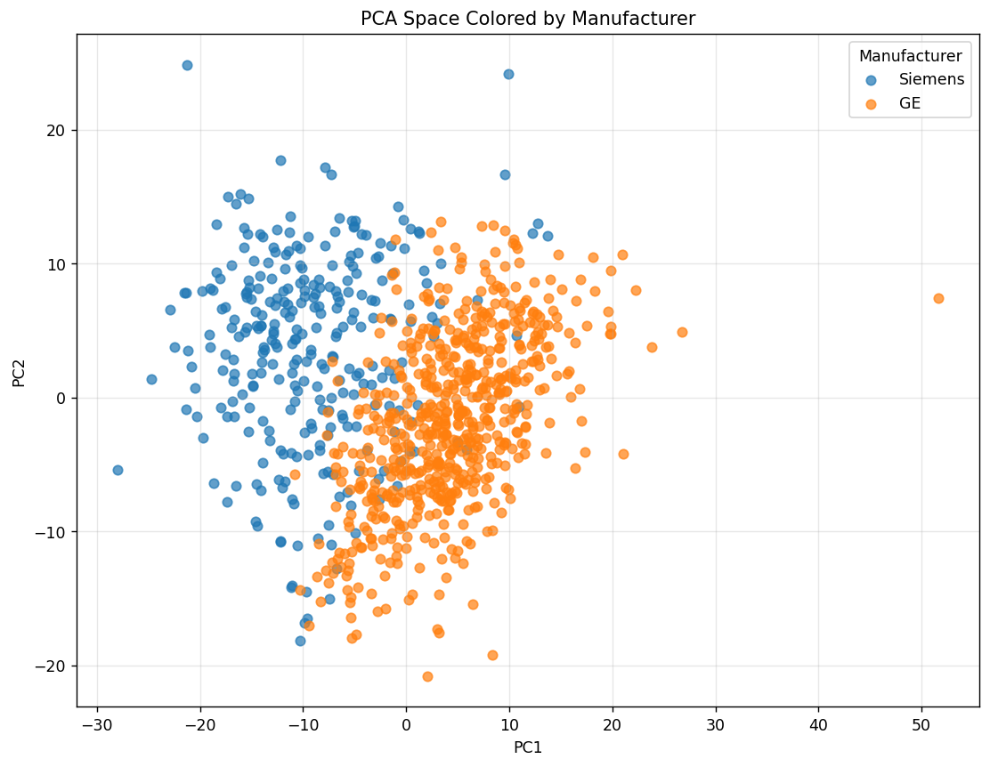
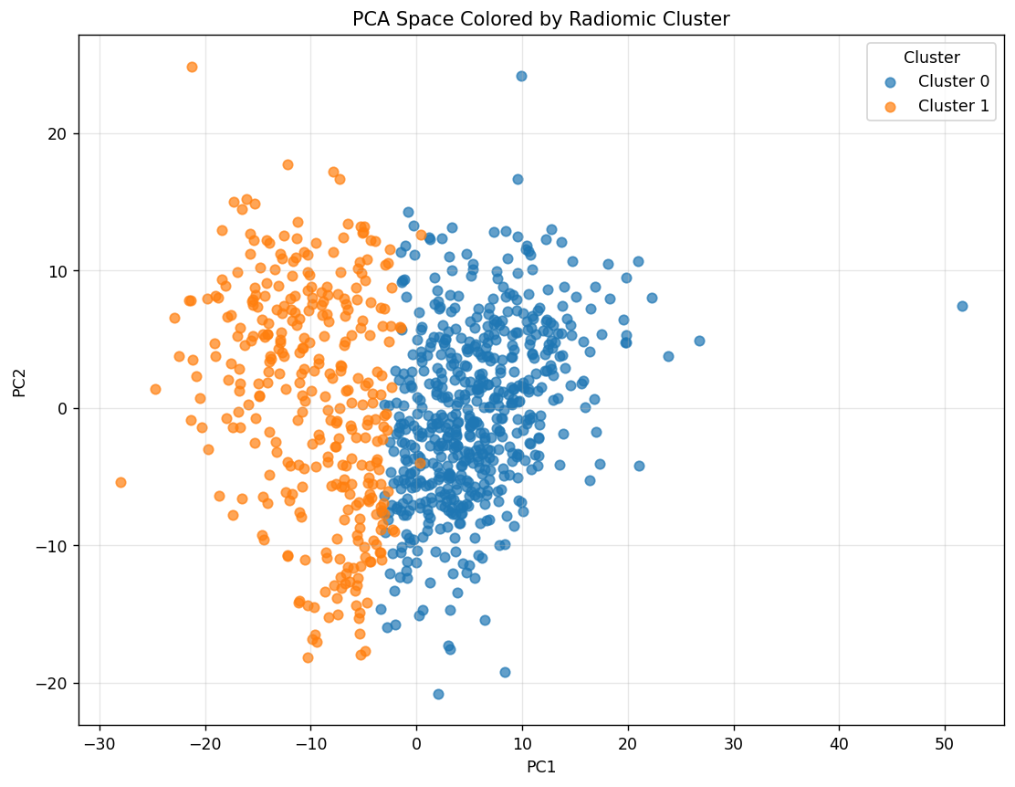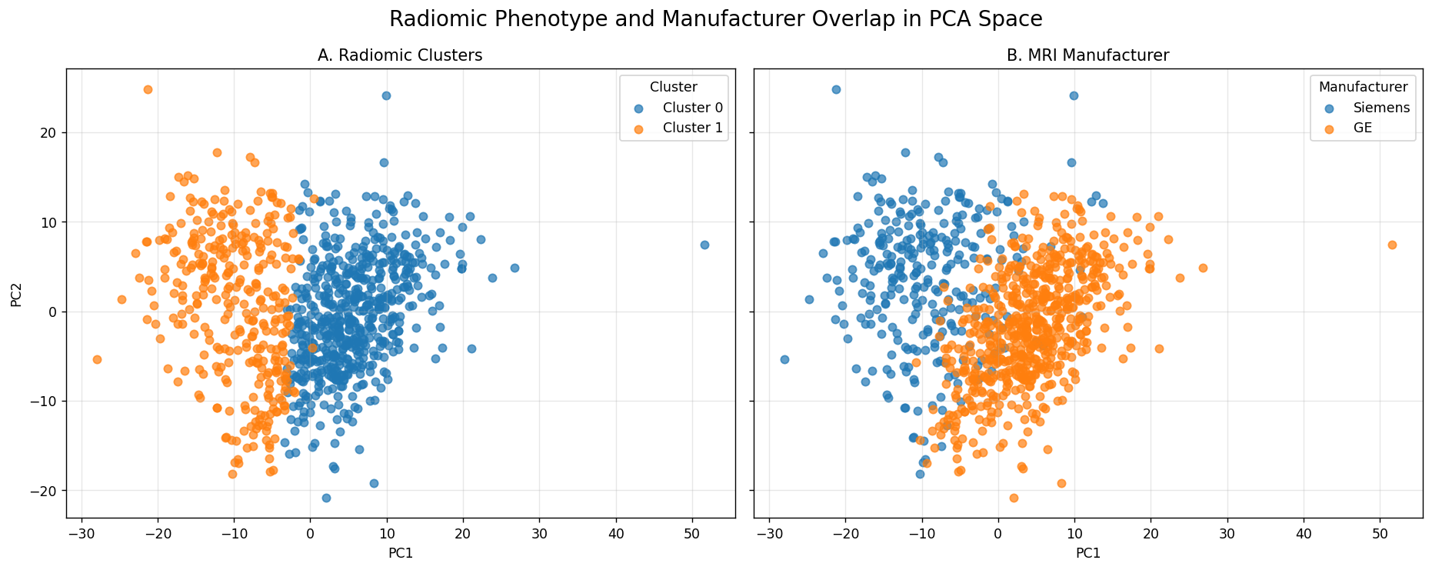

3.10 Multivariable Survival Analysis and Technical Confounding
To evaluate whether the prognostic signal initially identified in the HR+/HER2+ subgroup (n = 101; 10 recurrence events) represented an independent biological effect, a multivariable Cox proportional hazards model was constructed. As detailed in Table 22, the model integrated both the raw radiomic cluster assignment and scanner manufacturer as covariates to adjudicate their relative contributions to recurrence-free survival (RFS).
While the unadjusted analysis suggested that Cluster 1 carried a significantly higher recurrence risk, the inclusion of manufacturer in the multivariable framework resulted in a substantial attenuation of the phenotypic effect. The adjusted hazard ratio (HR) for Cluster 1 fell to 2.48 and lost statistical significance (95% CI: 0.46–13.39; p = 0.291). Similarly, the association between manufacturer identity and recurrence was non-significant, with Siemens systems exhibiting an HR of 2.99 compared to GE (95% CI: 0.56–16.03; p = 0.200). The wide confidence intervals observed for both variables are a function of the limited event density within this molecular sub-cohort.
These findings materially weaken the interpretation of the raw radiomic phenotype as an independent prognostic biomarker. The loss of statistical significance upon technical adjustment is highly consistent with acquisition confounding. This suggests that the initial separation in RFS was likely a byproduct of the nearly total overlap between cluster membership and manufacturer identity, rather than a reflection of intrinsic tumor biology.
Table 22. Manufacturer-Adjusted Cox Proportional Hazards Model (HR+/HER2+ Subgroup)
Covariate | Coefficient | Hazard Ratio | 95% CI | p-value \
Cluster | 0.908162 | 2.479761 | 0.459408–13.385089 | 0.291085 \
Manufacturer: Siemens vs GE | 1.096711 | 2.994301 | 0.559256–16.031719 | 0.200157 \

3.10 Impact of Manufacturer Residualization on Phenotype Stability
To isolate intrinsic biological variance from technical noise, a linear residualization procedure was applied to the z-scored radiomic matrix. Each of the 529 features was regressed on MRI manufacturer, with the resulting residuals retained for further analysis. PCA and $k$-means clustering were subsequently repeated on this residualized feature space to evaluate whether the original $k=2$ phenotype persisted after the removal of manufacturer-associated variance.
The residualized clustering solution proved to be almost entirely distinct from the original raw partition. As shown in Table 23, the Adjusted Rand Index (ARI) between the raw cluster labels and the manufacturer-residualized labels was 0.056, indicating a near-complete loss of partition identity. While a two-cluster structure could still be mathematically identified within the residualized data, the assignment of patients no longer followed the patterns established by the original phenotype.
Visualization in the PC1–PC2 coordinate system (Figure 7) confirms this structural shift. In the raw data (Panel A), the clusters separate primarily along the dominant PCA axis, which mirrors the separation between GE and Siemens systems (Panel B). Following residualization (Panel C), the newly generated clusters fail to reproduce the original partition geometry, even when projected onto the same coordinate space. This dissociation indicates that the original cluster structure was fundamentally dependent on manufacturer-linked variance rather than a latent biological signal.
These results are central to the study's methodological argument: the internal bootstrap stability of the raw phenotype was a reflection of consistent technical variance rather than robust tumor biology. Consequently, these findings demonstrate that cluster stability and biological identity are distinct properties; a clustering solution can remain statistically stable while purely capturing acquisition-domain structure.
Figure 7. Comparison of Latent Structure Before and After Manufacturer Residualization. (A) Original $k=2$ clusters showing strong separation along PC1. (B) Distribution of scanner manufacturers in the same latent space, showing near-identical geometry to the raw clusters. (C) Re-clustering of the cohort after residualization, demonstrating that the original phenotypic partition does not survive the removal of technical variance.
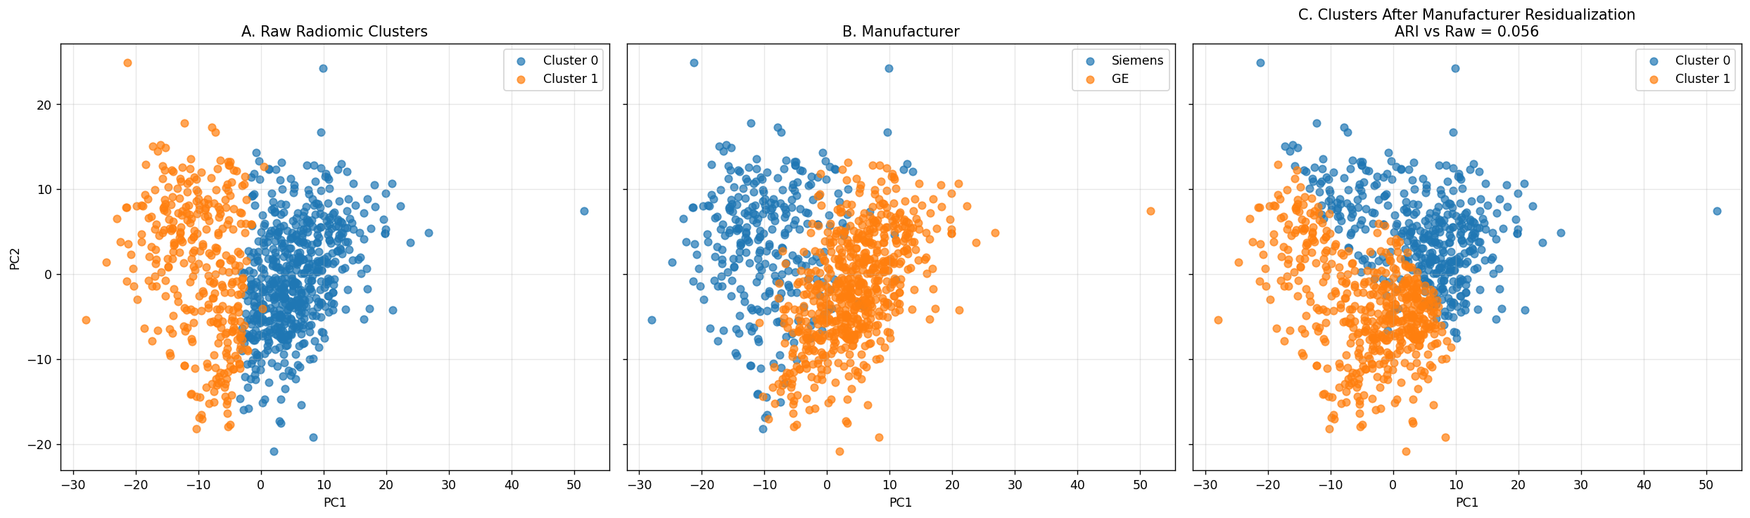
Table 23. Summary of Manufacturer Residualization Analysis
Metric | Value \
Patients | 922 \
Radiomic features | 529 \
Residualization variable | MRI manufacturer \
Manufacturer groups | GE, Siemens \
Clustering method after residualization | KMeans, k=2 \
Clustering feature space | First 10 PCs of residualized z-scored radiomics \
ARI vs raw clusters | 0.056485 \
Interpretation | Raw cluster identity does not survive manufacturer residualization \

Table 24. Interpretation of Residualization Effects (Figure 7)
Panel | Interpretation \
A. Raw radiomic clusters | Original k=2 phenotype separates strongly along the dominant PCA axis \
B. Manufacturer | GE and Siemens show similar separation geometry in the same PCA space \
C. Clusters after manufacturer residualization | Reclustered residualized data produces a different partition from the raw phenotype \
ARI vs raw = 0.056 | Near-zero agreement between raw and residualized cluster labels \
Overall implication | The raw phenotype is largely dependent on manufacturer-associated variance \

3.11 Preservation of Stability vs. Loss of Cluster Identity After Harmonization
A comparative analysis of the raw, manufacturer-residualized, and ComBat-harmonized pipelines demonstrates that while internal stability is preserved across all conditions, the underlying cluster identity is fundamentally altered. Each methodology produced a highly stable $k=2$ solution under bootstrap resampling, with mean Adjusted Rand Indices (ARI) of 0.893 (Raw), 0.919 (Residualized), and 0.903 (ComBat). These results, visualized in Figure 8, confirm that harmonization does not eliminate the mathematical existence of a robust two-cluster structure within the radiomic data.
However, the specific patient partitions generated after harmonization were almost entirely unrelated to the original raw phenotype. The ARI comparing the raw cluster labels to the residualized and ComBat labels was only 0.056 and 0.065, respectively. This indicates that technical correction methods did not merely refine the original phenotype by removing noise; rather, they replaced it with entirely different stable partitions.
Association testing further underscores this divergence:
- Manufacturer Dependence: While the raw cluster was inextricably linked to scanner manufacturer ($p = 8.0 \times 10^{-104}$), the residualized and ComBat clusters showed no significant manufacturer dependence ($p = 0.53$ and $p = 0.18$, respectively).
- Clinical Associations: Neither harmonized phenotype demonstrated a significant association with molecular subtype or recurrence at the whole-cohort level. Recurrence associations reached only borderline significance for both residualized ($p = 0.075$) and ComBat ($p = 0.056$) pipelines.
These findings illustrate a primary methodological argument of this study: cluster stability and cluster identity are separable properties. A phenotype can remain highly bootstrap-stable after harmonization while no longer representing the same clinical or biological partition of patients. Consequently, reporting stability metrics alone is an insufficient validation step in multi-vendor radiomic studies.
Figure 8. Cluster Stability Across Raw and Harmonized Conditions. Mean bootstrap ARI values for the $k=2$ solution remain high ($>0.85$) across raw, residualized, and ComBat-harmonized data, indicating that robust mathematical partitions exist regardless of the correction method applied.
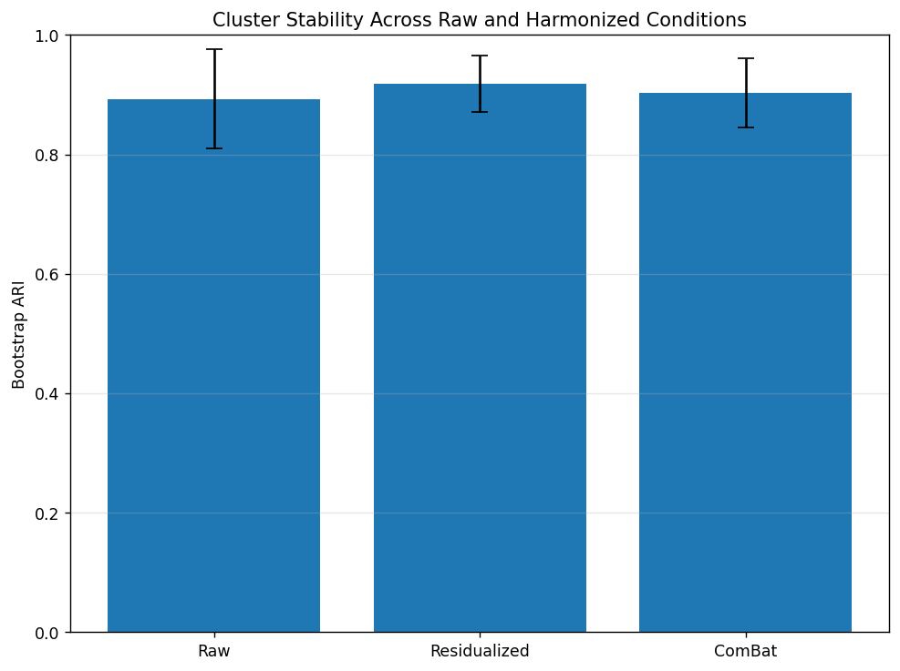
Table 25. Stability Summary Across Raw and Harmonized Conditions
Condition | Mean ARI | SD ARI | ARI vs Raw \
Raw | 0.893139 | 0.083795 | 1.000000 \
Residualized | 0.918669 | 0.046946 | 0.056485 \
ComBat | 0.902907 | 0.057623 | 0.064988 \

Table 26. Statistical Associations After Technical Harmonization
Cluster Type | Variable | p-value \
Raw Cluster | Manufacturer | 8.022438E-104 \
Raw Cluster | Molecular Subtype | 0.145796 \
Raw Cluster | Recurrence | 0.765626 \
Residualized Cluster | Manufacturer | 0.529964 \
Residualized Cluster | Molecular Subtype | 0.716945 \
Residualized Cluster | Recurrence | 0.074725 \
ComBat Cluster | Manufacturer | 0.176522 \
ComBat Cluster | Molecular Subtype | 0.809070 \
ComBat Cluster | Recurrence | 0.055758 \

4. Discussion
The results of this study highlight a critical methodological trap in high-dimensional radiomics: the potential for technical acquisition parameters to create stable, seemingly prognostic phenotypes that lack a true biological basis. While our unsupervised pipeline initially identified a robust, vascularity-linked phenotype that appeared to predict recurrence in HR+/HER2+ breast cancer, rigorous secondary analysis revealed that this structure was almost entirely a byproduct of scanner manufacturer variance.
The Illusion of Biological Structure
At first glance, the radiomic space appeared highly structured and clinically promising. PCA demonstrated that over half of the dataset's variance was concentrated in the first ten principal components, and K-means clustering yielded a stable, reproducible $k=2$ solution. The features driving this separation—primarily enhancement kinetics and SER-based texture—pointed toward a "vascularity-related" phenotype. In a clinical context, such a finding would typically be interpreted as a reflection of tumor angiogenesis or perfusion heterogeneity. However, the near-perfect overlap between these clusters and MRI manufacturer (GE vs. Siemens) suggests that the algorithm was not "discovering" biological subtypes, but rather "sorting" scanners.
This observation is particularly salient given the magnitude of the technical confounding. The statistical association between manufacturer and cluster membership ($p \approx 10^{-104}$) was several orders of magnitude stronger than any clinical or biological association. This indicates that in multi-vendor cohorts, the "dominant global imaging signal" captured by PC1 may be fundamentally technical. If researchers do not explicitly test for manufacturer-specific latent structures, they risk misidentifying hardware-related feature shifts as intrinsic tumor biology.
Stability Is Not a Proxy for Validity
A key contribution of this work is the demonstration that cluster stability and cluster identity are separable properties. In many radiomics studies, bootstrap stability (using metrics like ARI) is treated as a primary validation step. Our analysis shows that technical artifacts are remarkably stable; the manufacturer-driven partition remained robust under resampling ($ARI \approx 0.89$).
Crucially, when we applied harmonization (ComBat) or linear residualization, the mathematical stability of the $k=2$ solution remained high ($ARI > 0.90$), but the identity of the clusters shifted completely. The patients previously grouped together were redistributed once manufacturer variance was removed. This proves that a radiomic pipeline can consistently find "the same" groups of patients, but those groups may only exist because of shared technical noise. Therefore, stability metrics alone are insufficient to claim that a radiomic phenotype is a reliable biological biomarker.
Fragility of the Prognostic Signal
The survival analysis in the HR+/HER2+ subgroup serves as a cautionary tale. The unadjusted hazard ratio of 4.76 ($p=0.02$) for Cluster 1 initially suggested a powerful prognostic tool for a specific molecular subtype. However, this signal was both statistically fragile (due to the low event count of 10 recurrences) and technically confounded. Upon adjusting for manufacturer in a multivariable Cox model, the HR was halved and the significance vanished.
This loss of significance suggests that the different scanner brands used in this cohort likely produced systematic shifts in enhancement-based features that happened to align with the outcomes of the small number of patients in that subgroup. Without the manufacturer-adjusted analysis and subsequent harmonization experiments, this could have been erroneously reported as a novel "radiomic recurrence signature" for HR+/HER2+ disease.
Implications for Multi-Vendor Radiomics
Our findings underscore the necessity of "technical de-biasing" in radiomic workflows. While ComBat and residualization successfully removed the manufacturer's influence, they also eliminated the primary phenotypic structure of the dataset. This suggests that, in this specific cohort, the biological variance was too subtle to form discrete clusters once the dominant technical variance was removed.
For the field to progress, it is imperative that:
- Latent space visualization (PCA/t-SNE) be routinely colored by technical factors (manufacturer, site, protocol) to detect early signs of confounding.
- Harmonization sensitivity analyses be performed to ensure that clinical associations survive the removal of technical noise.
- Stability reporting be accompanied by "identity check" metrics (like ARI vs. raw labels) to determine if a partition is biologically anchored or technically transient.
Limitations
This study is limited by the relatively low number of recurrence events in the HR+/HER2+ subgroup, which prevents a definitive conclusion regarding whether a faint biological signal remains after harmonization. Additionally, while we focused on manufacturer, other acquisition parameters like flip angle, field strength, or coil type may also contribute to latent structure and warrant further investigation.
Conclusion
In conclusion, unsupervised radiomic phenotypes can be highly stable and statistically significant while being fundamentally driven by technical acquisition factors. In our cohort, the "best" two-cluster solution was a surrogate for scanner manufacturer rather than tumor biology. Researchers must move beyond simple stability metrics and unadjusted survival models, adopting rigorous harmonization and technical adjustment strategies to ensure that the "phenotypes" they discover are clinically meaningful rather than technically manufactured.

Discussion
The main finding of this study is that a radiomic phenotype can be internally stable, visually coherent, and even apparently prognostic while still failing to represent a biologically meaningful subgroup. In this cohort, the raw two-cluster solution looked compelling on standard metrics, but its strongest signal was alignment with scanner manufacturer rather than with molecular subtype or recurrence. That is the central warning of the paper: stability is not the same as validity.
A useful way to interpret the results is as a sequence of tests. The raw PCA and clustering outputs showed that the feature space had structure and that a two-cluster partition was reproducible under resampling. The feature comparison then showed that the split was dominated by enhancement-kinetic and texture descriptors, especially SER- and PE-derived variables, which gave the phenotype a plausible “vascularity-like” character. However, once manufacturer effects were examined directly, the same partition was shown to track acquisition platform very closely, which substantially weakens the biological interpretation.
The survival finding in the HR+/HER2+ subgroup is best viewed in that same light. The unadjusted analysis suggested a meaningful recurrence-free survival difference, but the estimate was based on only 10 events and had a wide confidence interval. Once manufacturer was included in the Cox model, the cluster effect attenuated and lost statistical significance. That pattern is consistent with a confounded subgroup signal rather than a robust prognostic biomarker.
The harmonization results sharpen the methodological message. Residualization and ComBat did not eliminate structure in the data; they produced new stable two-cluster partitions. What changed was cluster identity. In other words, the dataset still contained reproducible latent structure after technical correction, but it was not the same phenotype as the raw one. This is an important distinction because it shows that harmonization can preserve mathematical clusterability while overturning the original biological claim.
These findings have two broader implications for radiomics. First, unsupervised discovery is more vulnerable than supervised modeling because there is no external label to anchor interpretation. A clustering algorithm will preferentially recover the strongest available axis of variation, and in multi-vendor MRI that axis may be technical. Second, internal validation metrics are necessary but not sufficient. Bootstrap stability, silhouette score, and Calinski–Harabasz index tell us that a partition can be reproduced; they do not tell us what the partition means.
The study therefore supports an acquisition-aware framework for evaluating radiomic phenotypes. Before treating a cluster as a biomarker, investigators should ask whether it is enriched for manufacturer or protocol effects, whether the leading PCs are technically driven, whether the partition survives harmonization, and whether any apparent clinical association remains after technical adjustment. Those checks do not prove a phenotype is biological, but they can prevent a technically stable pattern from being mistaken for one.
In that sense, the paper’s contribution is methodological rather than purely descriptive. It does not argue that radiomic phenotyping is invalid, nor that multi-vendor radiomics cannot yield meaningful discoveries. It argues that the field needs a higher bar for interpretation. In real-world imaging cohorts, especially those assembled across scanners and protocols, the minimum question is not simply whether a phenotype is stable, but whether it survives acquisition-aware falsification.

££££ add this
The main finding of this study is that a radiomic phenotype can be internally stable, visually coherent, and even apparently prognostic while still failing to represent a biologically meaningful subgroup. In this cohort, the raw two-cluster solution looked compelling on standard metrics, but its strongest signal was alignment with scanner manufacturer rather than with molecular subtype or recurrence. That is the central warning of the paper: stability is not the same as validity.
A useful way to interpret the results is as a sequence of tests. The raw PCA and clustering outputs showed that the feature space had structure and that a two-cluster partition was reproducible under resampling. Importantly, that structure aligned most strongly with the leading axes of variance, especially PC1 and PC2, which means the strongest signal the model saw was the scanner-linked axis rather than an obviously tumor-defined one. The feature comparison then showed that the split was dominated by enhancement-kinetic and texture descriptors, especially SER- and PE-derived variables, which gave the phenotype a plausible “vascularity-like” character. That plausibility is exactly what makes the stability trap dangerous: in breast DCE-MRI, vascularity is a seductive interpretation because it sounds biologically native to the modality itself.
The harmonization results sharpen the methodological message. Residualization and ComBat did not eliminate structure in the data; they produced new stable two-cluster partitions. What changed was cluster identity. In other words, the dataset still contained reproducible latent structure after technical correction, but it was not the same phenotype as the raw one. This is an important distinction because it shows that harmonization can preserve mathematical clusterability while overturning the original biological claim, and the shift in patient partition identity can be quantified directly using the Adjusted Rand Index.

Limitations
Several limitations should be kept in view when interpreting these results. The survival analysis in the HR+/HER2+ subgroup was based on a small number of events, which makes the hazard ratio unstable and the confidence interval wide. That means the subgroup signal is suggestive rather than definitive. A larger event set would be needed to estimate prognostic effects more precisely.
The study also focuses heavily on manufacturer as the dominant technical factor. That is appropriate given the observed overlap, but other acquisition variables may also contribute to the radiomic structure, including protocol differences, field strength, and reconstruction settings. In future work, it would be useful to partition technical variance more comprehensively rather than treating manufacturer as the sole proxy for acquisition effects.
Another limitation is that clustering was evaluated primarily with k-means in PCA space. That is a sensible and transparent choice, but it does not exhaust the space of possible unsupervised methods. Alternative clustering strategies could be explored to test whether the same acquisition-sensitive structure emerges under different algorithmic assumptions. If the same broad pattern appears across methods, the argument for technical confounding becomes even stronger.
Finally, the harmonization findings should not be overread. ComBat and residualization reduce measurable technical effects, but they do not create ground truth. A different stable partition after harmonization is not automatically more biological; it is simply less dependent on the original technical axis. For that reason, harmonization should be treated as a falsification tool rather than as proof that the remaining phenotype is valid.
Conclusion
Overall, the study shows that a radiomic phenotype can be stable, interpretable, and clinically suggestive while still being driven primarily by acquisition structure. That is the key methodological lesson. In multi-vendor breast MRI radiomics, stability should be treated as a starting point for validation, not its endpoint. The stronger claim is not that radiomic clustering fails, but that its results must be tested against technical confounding before they are interpreted as biologic phenotypes.

