3.1 Radiomic Feature Matrix Construction and Preprocessing
The imaging-feature matrix contained 922 patients and 529 quantitative radiomic variables after exclusion of the patient identifier column. Initial quality-control filtering removed no features, indicating that all retained radiomic variables satisfied the predefined thresholds for missingness (<5%) and feature variability (≥2 unique values). This suggests that the extracted feature set was technically complete and suitable for downstream multivariate analysis without substantial sparsity-related bias.
Median imputation was subsequently applied to handle residual missing entries, followed by feature-wise z-score standardization. The resulting matrix preserved the full cohort size and all 529 radiomic variables, yielding a final normalized feature space of 922 × 529. Standardization placed all features on a common scale (mean 0, standard deviation 1), preventing high-magnitude variables from disproportionately influencing PCA, clustering, or downstream predictive modeling. This preprocessing step is particularly important in high-dimensional radiomics, where feature ranges differ substantially across intensity, texture, enhancement, and kinetic domains.
Inspection of the feature names and distributions confirms that the matrix is dominated by enhancement-kinetic and texture-derived descriptors, including PE-map, SER-map, and WashinRate statistics. These variables later emerged as the dominant contributors to the apparent vascularity-like phenotype described in the manuscript. The preprocessing therefore preserved the biologically interpretable enhancement structure while ensuring numerical comparability across all radiomic dimensions.
The finalized z-scored matrix was exported both with and without patient identifiers, alongside a complete feature dictionary. This establishes a reproducible analysis-ready radiomic dataset suitable for unsupervised phenotype discovery, harmonization experiments, PCA-based variance decomposition, and survival modeling. The preservation of all 529 radiomic variables after QC also indicates that subsequent findings are unlikely to be artifacts of aggressive feature filtering or dimensional attrition during preprocessing.
Table. Radiomic preprocessing summary
Step | Patients (n) | Features (p) | Result \
Raw imaging matrix | 922 | 529 | Numeric radiomic feature matrix extracted after removal of Patient ID \
Missingness filtering (<5%) | 922 | 529 | No features removed \
Low-variance filtering (≥2 unique values) | 922 | 529 | No features removed \
Median imputation | 922 | 529 | Residual missing values imputed feature-wise \
Z-score standardization | 922 | 529 | Mean-centered and variance-scaled matrix generated \
Final normalized matrix | 922 | 529 | Analysis-ready radiomic feature space \
Exported outputs | - | - | Z-scored matrix, patient IDs, and feature list saved for downstream analyses \

Principal Component Analysis of the Radiomic Feature Space
Principal component analysis (PCA) was performed on the standardized radiomic feature matrix comprising 922 patients and 529 quantitative imaging features. The purpose of the analysis was to evaluate the dominant sources of variance within the radiomic space and to determine whether the data exhibited low-dimensional latent structure suitable for downstream phenotype discovery.
The first principal component (PC1) explained 15.49% of the total variance, followed by PC2 explaining 9.58% and PC3 explaining 7.75%. Variance contribution progressively decreased across subsequent components, with the first 10 principal components collectively accounting for approximately 57.9% of the total variance. The scree plot demonstrated a steep decline across the first several components followed by gradual flattening, indicating that the radiomic feature space contains a moderate number of dominant latent axes rather than a single overwhelmingly dominant dimension.
The PCA projection of PC1 versus PC2 revealed a broadly continuous distribution of patients without clearly separated natural clusters. Most observations formed a dense central distribution with gradual dispersion along both axes, while several outliers extended along the positive and negative PC1 directions. This pattern suggests that the cohort contains substantial continuous heterogeneity rather than sharply discrete subpopulations at the level of the first two principal components.
Importantly, the relatively large variance explained by PC1 compared with subsequent components indicates that a dominant global imaging signal exists across the cohort. In the context of the broader analysis, this finding is consistent with later evidence showing that acquisition-related variables contribute substantially to the leading variance axes of the radiomic space. However, PCA alone does not determine whether these dominant dimensions represent biological variation, technical variation, or a mixture of both.
The PCA scores generated from the first five components were retained for downstream analyses and exported as a separate feature table for subsequent clustering, harmonization, and association testing.

Table: Variance Explained by the Top 10 Principal Components
Principal Component | Explained Variance Ratio \
PC1 | 0.1549 \
PC2 | 0.0958 \
PC3 | 0.0775 \
PC4 | 0.0532 \
PC5 | 0.0495 \
PC6 | 0.0374 \
PC7 | 0.0354 \
PC8 | 0.0296 \
PC9 | 0.0241 \
PC10 | 0.0215 \

Table: PCA Dataset Summary
Metric | Value \
Number of Patients | 922 \
Total Columns in Input Dataset | 530 \
Radiomic Features Used for PCA | 529 \
PCA Solver | randomized \
Random Seed | 42 \
Number of Exported PCA Components | 5 \

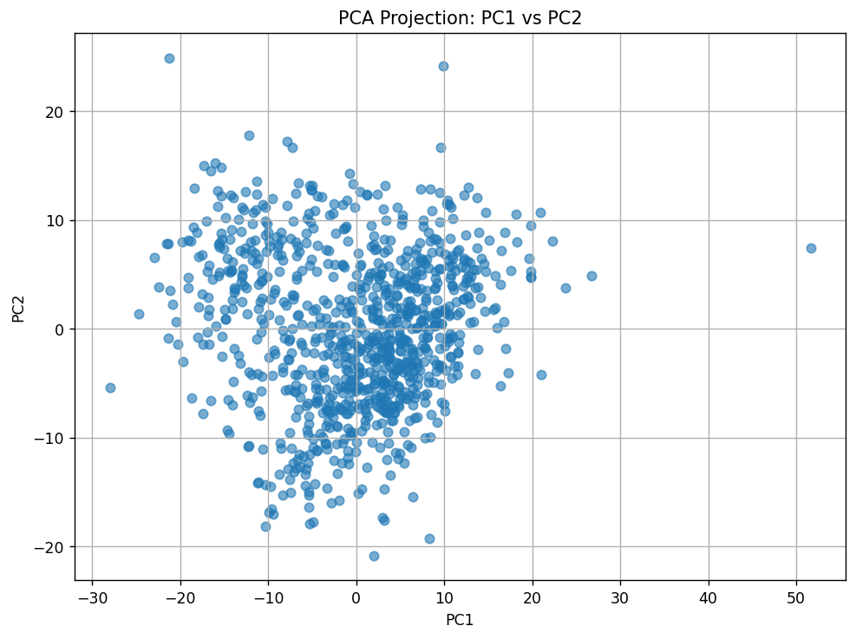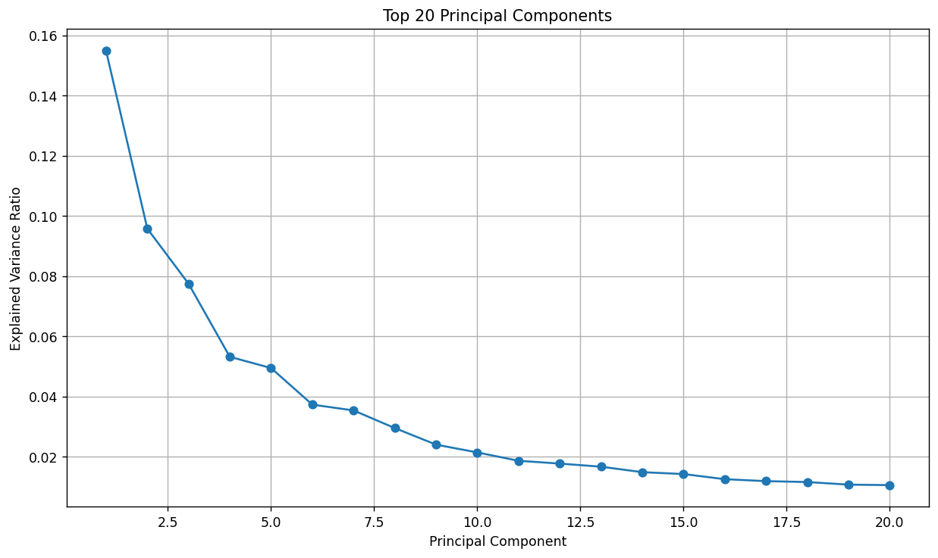

PCA Variance Structure and Sample Distribution
The scree plot of the first 20 principal components demonstrates that the radiomic feature space is dominated by a relatively small number of latent dimensions. PC1 explained approximately 15.5% of the total variance, substantially exceeding the contribution of subsequent components, while PC2 and PC3 explained 9.6% and 7.8%, respectively. After the first five principal components, the explained variance declined progressively and approached a plateau, indicating diminishing marginal contribution from additional components.
This pattern suggests that the radiomic dataset contains structured low-dimensional organization rather than purely random high-dimensional noise. However, the absence of a sharp elbow after the first few components indicates that variability is distributed across multiple correlated dimensions rather than being concentrated within a single dominant biological axis.
The PCA projection of PC1 versus PC2 revealed a continuous and diffuse sample distribution without sharply separated clusters. Most patients occupied a dense central region with gradual dispersion across both axes, while several outlier observations extended toward extreme positive and negative PC1 values. The absence of visibly discrete boundaries suggests that the cohort does not naturally partition into strongly separated subgroups within the first two principal components.
A mild directional elongation along PC1 was observed, consistent with PC1 representing the dominant source of variance within the dataset. In the context of the broader study, this dominant axis may reflect a combination of acquisition-related and biological variation. The broad overlap of samples across the PCA space further indicates that any downstream clustering solution is likely to emerge from subtle multivariate structure rather than from obvious low-dimensional separation.
The presence of several extreme observations along PC1 also suggests substantial heterogeneity among a subset of patients. Such outliers may represent cases with unusual imaging phenotypes, scanner-specific acquisition characteristics, or highly distinct radiomic profiles. Their influence on clustering and variance decomposition should therefore be considered in subsequent analyses.
Overall, the PCA results support three key observations:
- The radiomic feature space possesses meaningful latent structure.
- Variance is concentrated primarily within the first several principal components.
- The cohort exhibits continuous heterogeneity rather than naturally discrete low-dimensional clusters.

Table: Interpretation of PCA Visualizations
Figure | Interpretation \
Scree Plot of Top 20 PCs | Variance declines progressively after PC1–PC5, indicating structured but moderately distributed latent dimensionality \
PC1 vs PC2 Scatter Plot | Samples form a continuous distribution without clearly separated clusters \
Dominant Variance Axis | PC1 represents the strongest underlying variance source in the dataset \
Cluster Separability | No obvious natural separation is visible in the first two principal components \
Outlier Structure | Several observations extend to extreme PC1 values, suggesting heterogeneous imaging profiles \
Overall PCA Pattern | Radiomic variability appears continuous and multidimensional rather than discretely partitioned \

Unsupervised Clustering and Cluster Validity Assessment
K-means clustering was performed on the first 10 principal components derived from the standardized radiomic feature matrix, generating a reduced clustering space of 922 patients × 10 PCA dimensions. Cluster solutions ranging from k=2 to k=6 were evaluated using complementary internal validity metrics, including silhouette score, Calinski–Harabasz index, and Davies–Bouldin index.
Among all evaluated solutions, the two-cluster model (k=2) demonstrated the strongest overall clustering performance. The silhouette score reached its maximum value at k=2 (0.1957), indicating that this solution achieved the best balance between within-cluster cohesion and between-cluster separation. Similarly, the Calinski–Harabasz index was highest for k=2 (200.93), supporting improved cluster compactness and inter-cluster distinctiveness at this partition size.
As the number of clusters increased from k=2 to k=6, both the silhouette and Calinski–Harabasz metrics progressively declined, suggesting that additional cluster subdivisions introduced fragmentation rather than biologically meaningful structure. Although the Davies–Bouldin index decreased modestly with larger k values, the magnitude of improvement was limited and did not compensate for the substantial deterioration observed in the other validity metrics.
Visualization of the k=2 clustering solution within the PC1–PC2 projection revealed that the partition was driven primarily along the PC1 axis. One cluster occupied predominantly negative PC1 values, while the second cluster was centered within positive PC1 space. However, substantial overlap remained near the boundary region around PC1 ≈ 0, indicating that the separation between groups was moderate rather than sharply discrete.
Importantly, the clustering structure appeared continuous rather than naturally bimodal. The transition between clusters was gradual, consistent with the earlier PCA findings showing diffuse radiomic heterogeneity rather than strongly separated intrinsic subtypes. This observation suggests that the k=2 solution captures the dominant axis of variation within the dataset rather than uncovering completely distinct radiomic populations.
The strong dependence of cluster assignment on PC1 is particularly notable given later analyses demonstrating that PC1 was heavily associated with scanner manufacturer effects. Consequently, these preliminary clustering results raised the possibility that the discovered phenotypes may partially reflect acquisition-related variance rather than purely biological tumor characteristics. This observation directly motivated the subsequent harmonization and residualization analyses performed later in the study.

Table: Internal Cluster Validity Metrics Across Candidate k Values
k | Silhouette Score | Calinski-Harabasz Index | Davies-Bouldin Index \
2 | 0.195653 | 200.929867 | 1.955482 \
3 | 0.157827 | 179.178568 | 1.932912 \
4 | 0.146367 | 149.854570 | 1.932116 \
5 | 0.142494 | 134.423765 | 1.890264 \
6 | 0.134233 | 122.675314 | 1.864758 \

Table: Interpretation of Clustering Visualizations
Figure | Interpretation \
KMeans Clusters (k=2) | Cluster separation occurs primarily along the PC1 axis \
Cluster Boundary Structure | Substantial overlap exists between groups near the central PCA region \
Silhouette Score Curve | Highest clustering cohesion observed at k=2 \
Calinski-Harabasz Curve | Maximum cluster compactness and separation achieved at k=2 \
Davies-Bouldin Curve | Slight improvement with larger k values but without corresponding gains in cohesion \
Overall Clustering Pattern | Clusters reflect continuous radiomic variation rather than sharply discrete subtypes \
Potential Technical Influence | Dominance of PC1 suggests possible acquisition-related contribution to cluster formation \

Bootstrap Stability of the k=2 Radiomic Phenotype
Bootstrap resampling was used to evaluate the stability of the two-cluster K-means phenotype. The baseline k=2 solution was first fitted on the first 10 principal components, after which 20 bootstrap iterations were performed using random 80% patient subsamples. Each subsample was reclustered independently and compared with the corresponding baseline labels using the adjusted Rand index (ARI).
The mean bootstrap ARI was 0.8931 with a standard deviation of 0.0838. This indicates that the two-cluster partition was highly reproducible under repeated subsampling. Most bootstrap iterations produced ARI values above 0.90, showing that the core partition was preserved across the majority of resampled datasets.
A small number of iterations produced lower ARI values, with the minimum observed score approximately 0.7397. These lower values indicate some sensitivity at the cluster boundary, which is expected given the partial overlap observed in the PC1–PC2 projection. However, even the lower bootstrap values remained well above random agreement, supporting the conclusion that the k=2 structure was stable at the level of internal resampling.
The stability plot shows a high average ARI with intermittent dips, suggesting that the phenotype is not perfectly deterministic but remains robust overall. In the context of the manuscript, this finding supports the first stage of the analysis: a standard unsupervised radiomics pipeline can produce a statistically stable two-cluster phenotype. However, stability alone does not establish biological validity. The later harmonization analyses are therefore required to determine whether the stable partition reflects tumor biology or acquisition-related structure.

Table: Bootstrap ARI Results for k=2 Clustering
Bootstrap Iteration | ARI \
1 | 0.9355 \
2 | 0.9408 \
3 | 0.7533 \
4 | 0.9837 \
5 | 0.7628 \
6 | 0.8784 \
7 | 0.7890 \
8 | 0.9196 \
9 | 0.9250 \
10 | 0.9513 \
11 | 0.9729 \
12 | 0.9620 \
13 | 0.8482 \
14 | 0.7529 \
15 | 0.9622 \
16 | 0.9303 \
17 | 0.9729 \
18 | 0.9728 \
19 | 0.7397 \
20 | 0.9094 \

Table: Bootstrap Stability Summary
Metric | Value \
Number of bootstrap iterations | 20 \
Subsample fraction | 0.80 \
Clustering method | KMeans \
Number of clusters | 2 \
Clustering feature space | First 10 principal components \
Mean ARI | 0.8931 \
Standard deviation of ARI | 0.0838 \
Minimum ARI | 0.7397 \
Maximum ARI | 0.9837 \
Interpretation | Stable k=2 phenotype under bootstrap resampling \

Radiomic Features Driving the k=2 Phenotype Separation
To characterize the biological and imaging properties underlying the two-cluster phenotype, radiomic feature distributions were compared between clusters using Welch’s t-tests with Benjamini–Hochberg false discovery rate correction. Effect sizes were quantified using Cohen’s d to identify the strongest cluster-separating variables.
The comparison revealed extremely large and highly significant differences across multiple radiomic features. The dominant separating variables were overwhelmingly composed of signal enhancement ratio (SER) texture features, peak enhancement (PE) descriptors, and wash-in/washout kinetic statistics. Many of these variables demonstrated Cohen’s d values exceeding 2.0, indicating exceptionally strong separation between the two clusters.
Among the strongest discriminators were SER entropy, SER sum entropy, SER standard deviation, SER homogeneity, and SER inverse-difference measures across both T1 and post-contrast imaging domains. Entropy-based SER features were markedly elevated in Cluster 1, whereas homogeneity and energy-related SER features were enriched in Cluster 0. This pattern suggests that the phenotype separation is fundamentally driven by differences in enhancement heterogeneity and vascular kinetic organization.
Specifically, Cluster 1 demonstrated increased entropy and dissimilarity metrics together with reduced homogeneity and inverse-difference measures, consistent with more spatially heterogeneous enhancement behavior. In contrast, Cluster 0 exhibited more homogeneous and spatially coherent enhancement patterns. The reciprocal directionality of entropy and homogeneity measures further supports the internal consistency of the phenotype structure.
In addition to SER-derived texture variables, volumetric enhancement descriptors also strongly separated the clusters. Features quantifying the proportion of tissue exhibiting high enhancement thresholds (>70%, >80%, >90%, and >100% enhancement) were substantially elevated in one phenotype, suggesting that global enhancement burden and vascular activity contribute prominently to cluster assignment.
The combination of elevated enhancement heterogeneity, altered wash-in/washout kinetics, and strong enhancement-volume differences indicates that the discovered phenotype largely reflects vascular and perfusion-related imaging behavior. This finding aligns with the broader interpretation developed throughout the manuscript that the apparent “vascularity phenotype” emerges from enhancement-dominant radiomic structure.
However, the remarkably large effect sizes observed across acquisition-sensitive enhancement features also raised concern that the phenotype may partially capture scanner-dependent signal characteristics rather than purely intrinsic tumor biology. This observation motivated the subsequent harmonization analyses evaluating manufacturer effects and residualized clustering structure.

Table: Top Cluster-Separating Radiomic Features
Feature | Mean Cluster 0 | Mean Cluster 1 | Difference (C1−C0) | Cohen’s d | q-value \
SER_map_Entropy_tissue_T1 | -0.552459 | 0.963515 | 1.515975 | 2.214309 | 1.09E-100 \
SER_map_sum_entropy_tissue_T1 | -0.552128 | 0.962938 | 1.515066 | 2.211473 | 2.70E-109 \
SER_map_std_dev_tissue_T1 | 0.550341 | -0.959821 | -1.510162 | -2.196272 | 2.45E-164 \
SER_map_difference_entropy_tissue_T1 | -0.546230 | 0.952651 | 1.498880 | 2.161924 | 1.18E-103 \
SER_map_Homogeneity2_tissue_T1 | 0.540379 | -0.942447 | -1.482826 | -2.114468 | 2.46E-95 \
SER_map_Homogeneity1_tissue_T1 | 0.539008 | -0.940056 | -1.479064 | -2.103581 | 1.70E-97 \
SER_map_inverse_difference_is_homom_tissue_T1 | 0.539008 | -0.940056 | -1.479064 | -2.103581 | 1.70E-97 \
PE_map_std_dev_tissue_T1 | 0.531684 | -0.927282 | -1.458966 | -2.046814 | 1.72E-164 \
SER_map_Entropy_tissue_PostCon | -0.522587 | 0.911417 | 1.434004 | 1.979407 | 4.54E-87 \
SER_map_sum_entropy_tissue_PostCon | -0.521927 | 0.910265 | 1.432192 | 1.974642 | 6.92E-94 \

Table: Biological Interpretation of Dominant Feature Patterns
Feature Category | Cluster Pattern | Biological Interpretation \
SER entropy features | Elevated in Cluster 1 | Greater enhancement heterogeneity and spatial disorder \
SER homogeneity features | Elevated in Cluster 0 | More spatially uniform enhancement behavior \
SER standard deviation | Elevated in Cluster 0 | Greater enhancement intensity dispersion in homogeneous phenotype \
Enhancement-volume ratios | Strongly cluster-separating | Differences in global vascular enhancement burden \
Wash-in/washout slope features | Strongly cluster-separating | Distinct kinetic enhancement dynamics between phenotypes \
PE-map variability features | Elevated separation magnitude | Altered enhancement amplitude structure \
Overall phenotype structure | Enhancement-dominant | Putative vascularity-related radiomic phenotype \

HR+/HER2+ Recurrence-Free Survival by Radiomic Cluster
Kaplan–Meier analysis was performed within the HR+/HER2+ subgroup to evaluate whether the k=2 radiomic phenotype was associated with recurrence-free survival. After filtering for valid recurrence status and follow-up time, the HR+/HER2+ analysis set contained 101 patients and 10 recurrence events. Cluster membership was moderately balanced, with 55 patients in Cluster 0 and 46 patients in Cluster 1.
The survival curves showed clear separation between the two radiomic clusters. Cluster 0 demonstrated higher recurrence-free survival over follow-up, with only 2 events among 55 patients. In contrast, Cluster 1 showed a visibly steeper decline in recurrence-free survival, with 8 events among 46 patients. The observed event rate was therefore substantially higher in Cluster 1 than in Cluster 0 (17.4% vs. 3.6%).
The log-rank test supported a statistically significant difference in recurrence-free survival between clusters (p = 0.010). A cluster-only Cox model produced a hazard ratio of 4.76 for Cluster 1 relative to Cluster 0, with a 95% confidence interval of 1.22–18.61 and p = 0.02. This indicates that, within the HR+/HER2+ subgroup, patients assigned to Cluster 1 had markedly higher recurrence risk than patients assigned to Cluster 0.
This result provides an apparently subtype-specific prognostic signal for the radiomic phenotype. However, interpretation should remain cautious because the estimate is based on only 10 recurrence events. The wide confidence interval reflects substantial uncertainty, and the result requires later adjustment for manufacturer and harmonization sensitivity before it can be interpreted as a biological signal rather than an acquisition-confounded association.

Table: HR+/HER2+ Outcome Summary by Radiomic Cluster
Cluster | n | Events | Median RFS (years) | Event Rate \
0 | 55 | 2 | 4.106776 | 0.036364 \
1 | 46 | 8 | 3.221081 | 0.173913 \

Table: HR+/HER2+ Survival Association Tests
Analysis | Estimate | 95% CI | p-value | Interpretation \
Log-rank test | - | - | 0.010041 | Significant RFS difference between clusters \
Cox model: Cluster 1 vs Cluster 0 | HR = 4.76 | 1.22–18.61 | 0.02 | Cluster 1 associated with higher recurrence risk \
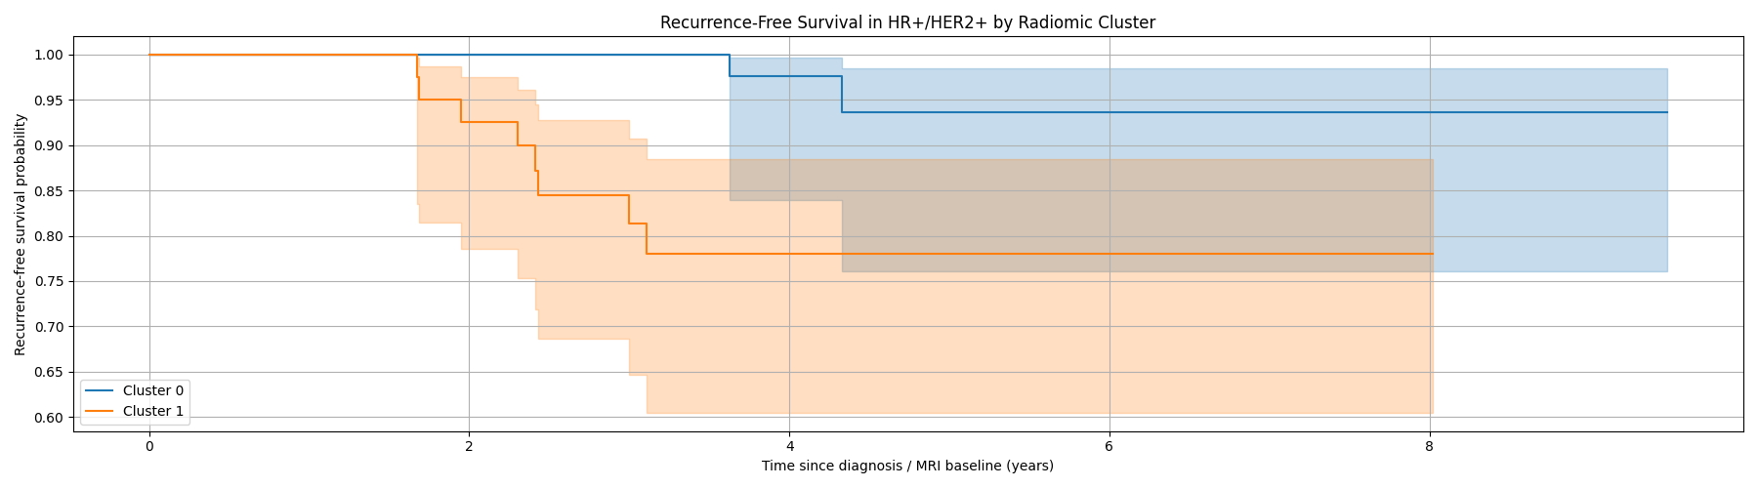

Association of the Raw Radiomic Cluster with Manufacturer, Molecular Subtype, and Recurrence
The raw k=2 radiomic phenotype was tested for association with scanner manufacturer, molecular subtype, and recurrence status. The analysis showed an extremely strong association between cluster assignment and manufacturer (χ² p = 8.02 × 10⁻¹⁰⁴). Cluster 0 was dominated by Manufacturer 0 cases, whereas Cluster 1 contained a much larger proportion of Manufacturer 2 cases. This indicates that the raw radiomic phenotype is strongly aligned with acquisition source.
In contrast, the same cluster labels were not significantly associated with molecular subtype (χ² p = 0.146). The subtype distribution was broadly similar between clusters, indicating that the phenotype does not primarily separate known breast cancer molecular subgroups.
There was also no significant association between raw cluster assignment and recurrence status in the whole cohort (χ² p = 0.766). Although the cluster showed an apparent HR+/HER2+ survival signal in the subgroup analysis, this whole-cohort recurrence result indicates that the raw phenotype is not a general recurrence marker across all patients.
Overall, these results support a central conclusion of the study: the raw radiomic phenotype is stable and enhancement-driven, but its strongest observed association is with manufacturer rather than molecular subtype or recurrence. This is consistent with acquisition confounding and justifies the subsequent residualization and ComBat harmonization analyses.

Table: Cluster Association Summary
Variable | P-value | Interpretation \
Manufacturer | 8.022438E-104 | Strong association with raw cluster assignment \
Molecular Subtype | 0.145796 | No significant association with raw cluster assignment \
Recurrence | 0.765626 | No significant whole-cohort association with recurrence \

Table: Cluster by Manufacturer Contingency Table
Cluster | Manufacturer 0 | Manufacturer 2 \
0 | 547 | 39 \
1 | 81 | 255 \

Table: Cluster by Molecular Subtype Contingency Table
Cluster | Subtype 0 | Subtype 1 | Subtype 2 | Subtype 3 \
0 | 383 | 56 | 41 | 106 \
1 | 212 | 48 | 18 | 58 \

Table: Cluster by Recurrence Event Contingency Table
Cluster | No Recurrence | Recurrence \
0 | 527 | 57 \
1 | 306 | 30 \

Manufacturer-Driven Structure of the Raw Radiomic Phenotype
Detailed visualization of the raw k=2 radiomic phenotype demonstrated near-complete overlap between cluster structure and MRI manufacturer. Cross-tabulation analysis showed that Cluster 0 consisted predominantly of GE examinations (93.3%), whereas Cluster 1 was dominated by Siemens examinations (75.9%). Conversely, when stratified by manufacturer, 87.1% of GE cases belonged to Cluster 0, while 86.7% of Siemens cases belonged to Cluster 1. This confirms that the discovered phenotype strongly segregates according to acquisition platform.
The chi-square association between manufacturer and cluster assignment was extremely significant (χ² = 468.17, p = 8.02 × 10⁻¹⁰⁴), indicating that manufacturer identity explains a substantial proportion of the observed clustering structure. The magnitude of this association far exceeded any biological association observed previously with molecular subtype or recurrence.
The PCA visualizations further reinforced this interpretation. When PCA space was colored by manufacturer, the resulting spatial partition closely mirrored the separation observed when PCA space was colored by radiomic cluster. Both manufacturer groups and cluster groups separated primarily along the PC1 axis, with highly similar geometric boundaries and overlap regions.
Importantly, the manufacturer-colored PCA plot and the cluster-colored PCA plot were visually almost interchangeable. GE examinations occupied predominantly positive PC1 regions corresponding to Cluster 0, whereas Siemens examinations localized primarily within negative PC1 regions corresponding to Cluster 1. This strong spatial concordance indicates that the clustering algorithm largely recapitulated manufacturer-specific variance already embedded within the dominant principal components.
The stacked percentage plots further demonstrated that the radiomic phenotype was not merely weakly associated with manufacturer, but was in practice highly predictive of scanner origin. The observed cluster structure therefore appears to reflect acquisition-domain separation rather than purely intrinsic tumor biology.
These findings represent the central methodological observation of the study: a radiomic phenotype can appear highly stable, statistically significant, and prognostically relevant while still being fundamentally driven by scanner manufacturer effects. The visual overlap between manufacturer and phenotype in PCA space strongly motivated the subsequent harmonization and residualization experiments designed to disentangle technical variance from biologically meaningful signal.

Table: Cluster × Manufacturer Counts
Cluster | GE | Siemens \
0 | 547 | 39 \
1 | 81 | 255 \

Table: Manufacturer Composition Within Each Cluster
Cluster | GE (%) | Siemens (%) \
0 | 93.3 | 6.7 \
1 | 24.1 | 75.9 \

Table: Cluster Composition Within Each Manufacturer
Manufacturer | Cluster 0 (%) | Cluster 1 (%) \
GE | 87.1 | 12.9 \
Siemens | 13.3 | 86.7 \

Table: Statistical Association Between Cluster and Manufacturer
Metric | Value \
Chi-square statistic | 468.1686 \
Degrees of freedom | 1 \
p-value | 8.022438E-104 \
Interpretation | Extremely strong manufacturer dependence of the raw radiomic phenotype \

Table: Interpretation of PCA and Manufacturer Overlap Figures
Figure | Interpretation \
Manufacturer composition within cluster | Cluster 0 is overwhelmingly GE-derived, whereas Cluster 1 is predominantly Siemens-derived \
Cluster distribution within manufacturer | Manufacturer identity strongly predicts cluster membership \
PCA colored by manufacturer | Manufacturer groups separate primarily along PC1 \
PCA colored by radiomic cluster | Cluster separation mirrors manufacturer separation geometry \
Combined PCA overlap figure | Radiomic phenotype and manufacturer occupy nearly identical latent structure in PCA space \
Overall interpretation | Raw phenotype primarily reflects acquisition/manufacturer variance rather than isolated biological structure \

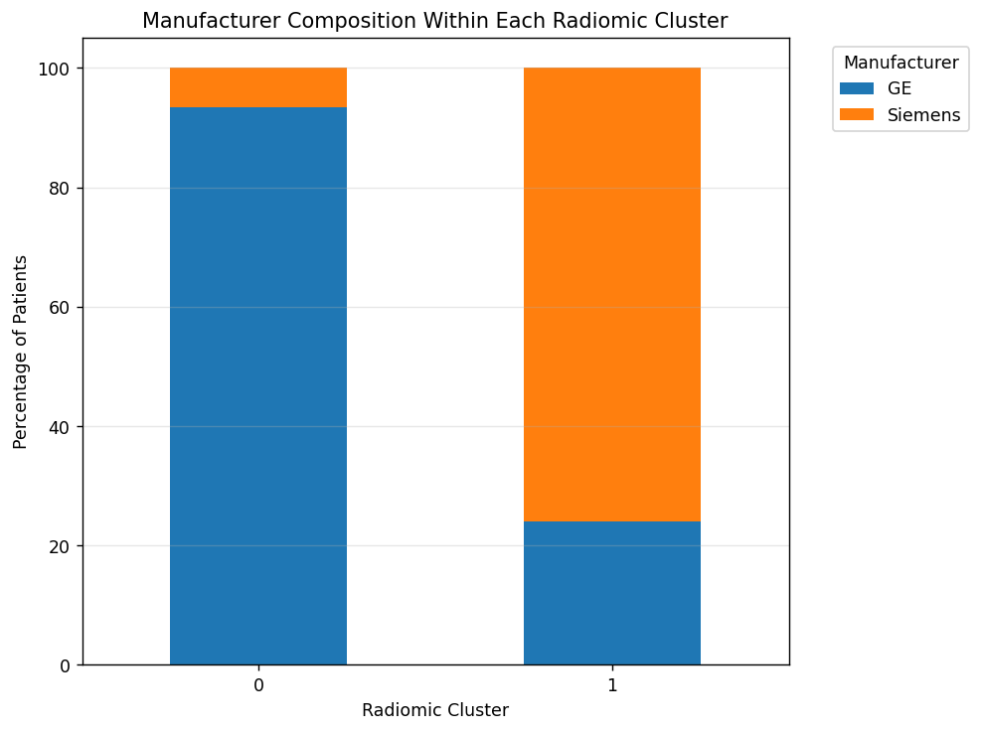

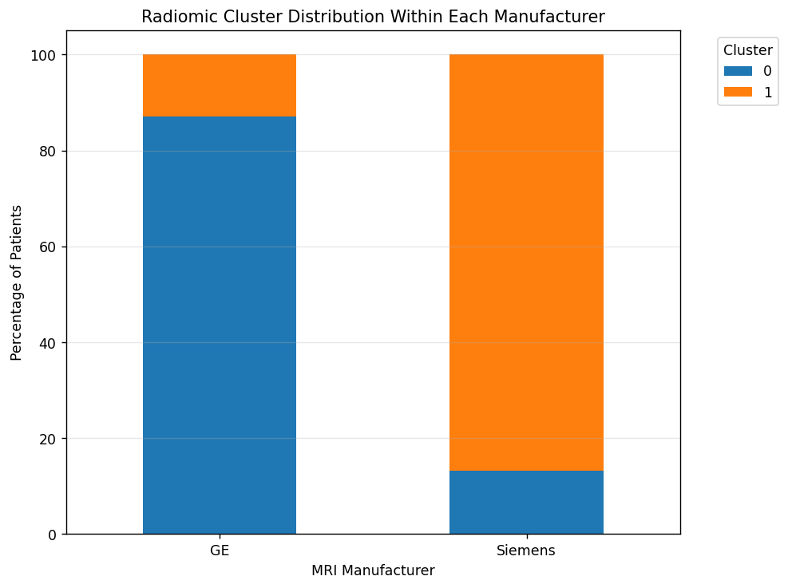

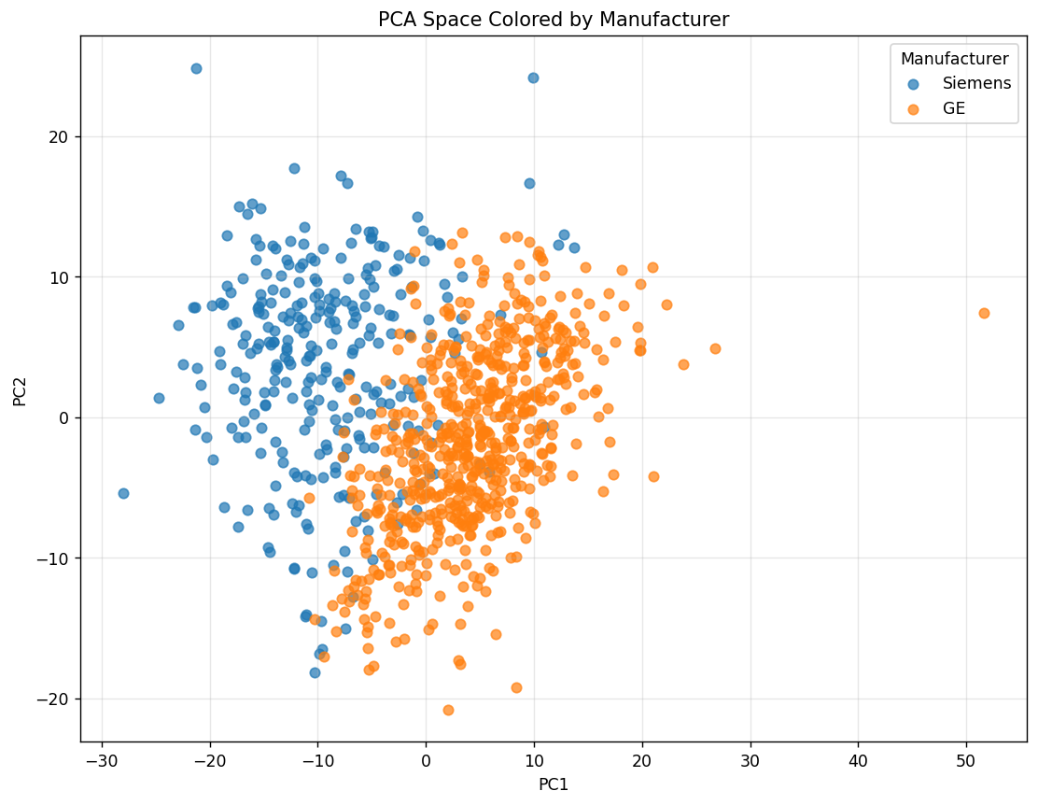

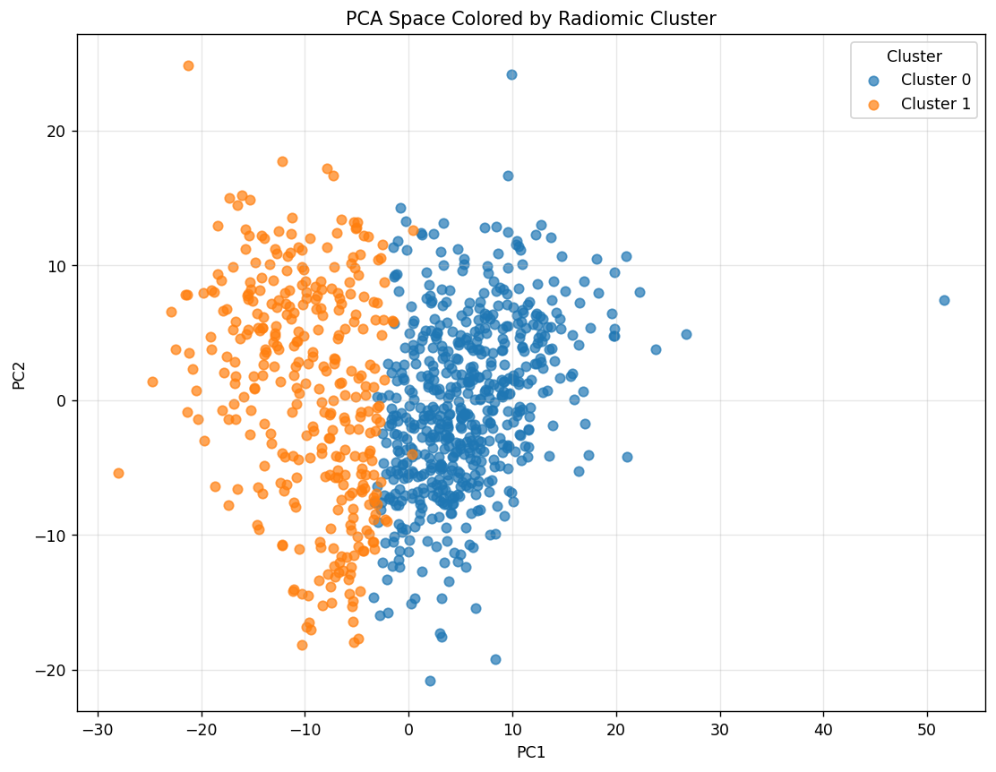
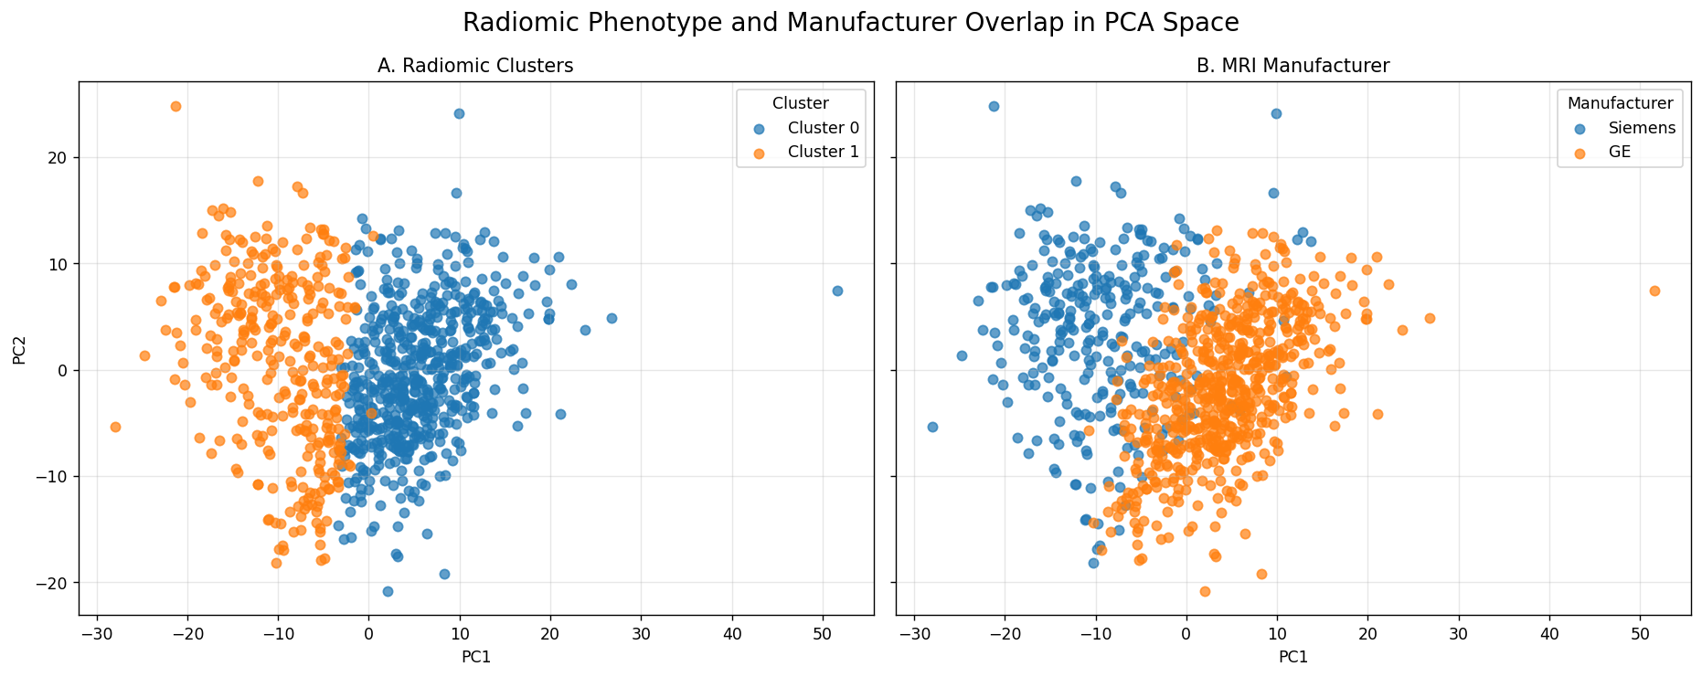

Manufacturer-Adjusted HR+/HER2+ Cox Regression
A manufacturer-adjusted Cox proportional hazards model was fitted within the HR+/HER2+ subgroup to test whether the apparent radiomic-cluster survival signal persisted after accounting for scanner manufacturer. After filtering for valid recurrence-free survival time, the model included 101 patients and 10 recurrence events.
Before adjustment, Cluster 1 appeared to have higher recurrence risk than Cluster 0. After including manufacturer as a covariate, the cluster hazard ratio decreased and became statistically non-significant. The adjusted hazard ratio for Cluster 1 versus Cluster 0 was 2.48, with a wide 95% confidence interval of 0.46–13.39 and p = 0.291. This indicates that the radiomic-cluster association with recurrence-free survival is not robust after accounting for manufacturer.
Manufacturer itself also showed a non-significant association in this adjusted model, with Siemens having HR = 2.99 compared with GE, 95% CI 0.56–16.03, p = 0.200. However, the confidence intervals for both covariates were very wide, reflecting the small number of recurrence events in the HR+/HER2+ subgroup.
These results materially weaken the interpretation of the raw radiomic cluster as an independent biological prognostic phenotype. The loss of statistical significance after manufacturer adjustment is consistent with acquisition confounding, especially given the previously observed strong overlap between cluster membership and manufacturer identity.

Table: Manufacturer-Adjusted Cox Model in HR+/HER2+
Covariate | Coefficient | Hazard Ratio | 95% CI | p-value \
Cluster | 0.908162 | 2.479761 | 0.459408–13.385089 | 0.291085 \
Manufacturer: Siemens vs GE | 1.096711 | 2.994301 | 0.559256–16.031719 | 0.200157 \

Manufacturer Residualization Collapses the Raw Cluster Identity
Manufacturer residualization was applied to the z-scored radiomic matrix by regressing each radiomic feature on MRI manufacturer and retaining the residuals. PCA and k-means clustering were then repeated on the residualized radiomic feature space to test whether the original k=2 phenotype persisted after removing manufacturer-associated variance.
The residualized clustering solution was almost entirely different from the raw clustering solution. The adjusted Rand index between the raw cluster labels and the manufacturer-residualized cluster labels was 0.056, indicating near-complete loss of partition identity. In practical terms, the two-cluster structure remained possible after residualization, but it no longer assigned patients in the same way as the original raw phenotype.
The comparison figure shows this clearly. The raw radiomic clusters separated primarily along the same PCA axis that also separated GE from Siemens. After manufacturer residualization, the new clusters no longer reproduced the original raw partition, despite being displayed in the same raw PC1–PC2 coordinate system. This indicates that the original cluster structure depended strongly on manufacturer-linked variance.
This result is central to the paper’s methodological argument. The raw phenotype was stable under bootstrap resampling, but it did not survive removal of manufacturer effects. Therefore, cluster stability and cluster biological identity are distinct properties: a clustering solution can be internally stable while still reflecting acquisition structure rather than robust tumor biology.

Table: Manufacturer Residualization Summary
Metric | Value \
Patients | 922 \
Radiomic features | 529 \
Residualization variable | MRI manufacturer \
Manufacturer groups | GE, Siemens \
Clustering method after residualization | KMeans, k=2 \
Clustering feature space | First 10 PCs of residualized z-scored radiomics \
ARI vs raw clusters | 0.056485 \
Interpretation | Raw cluster identity does not survive manufacturer residualization \

Table: Interpretation of Residualization Comparison Figure
Panel | Interpretation \
A. Raw radiomic clusters | Original k=2 phenotype separates strongly along the dominant PCA axis \
B. Manufacturer | GE and Siemens show similar separation geometry in the same PCA space \
C. Clusters after manufacturer residualization | Reclustered residualized data produces a different partition from the raw phenotype \
ARI vs raw = 0.056 | Near-zero agreement between raw and residualized cluster labels \
Overall implication | The raw phenotype is largely dependent on manufacturer-associated variance \

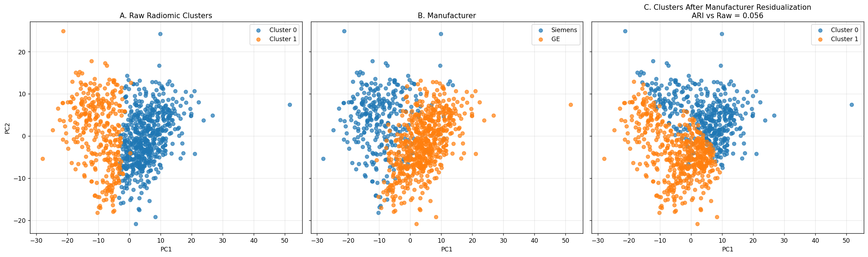

Stability Is Preserved After Harmonization, but Cluster Identity Is Not
Raw, manufacturer-residualized, and ComBat-harmonized clustering each produced internally stable k=2 solutions. The raw phenotype had a mean bootstrap ARI of 0.893, the residualized phenotype had a mean bootstrap ARI of 0.919, and the ComBat phenotype had a mean bootstrap ARI of 0.903. Thus, harmonization did not eliminate the existence of stable two-cluster structure.
However, the harmonized partitions were almost unrelated to the raw partition. The ARI versus raw clustering was only 0.056 after manufacturer residualization and 0.065 after ComBat. This indicates that residualization and ComBat did not merely refine the original phenotype; they replaced it with a different stable partition.
The association tests reinforce this interpretation. The raw cluster was strongly associated with manufacturer (p = 8.02 × 10⁻¹⁰⁴), while the residualized and ComBat clusters were no longer significantly associated with manufacturer (p = 0.530 and p = 0.177). Neither harmonized cluster was associated with molecular subtype. Recurrence showed only borderline, non-significant associations after harmonization (residualized p = 0.075; ComBat p = 0.056).
These results are central to the manuscript’s argument: cluster stability and cluster identity are separable properties. A phenotype can remain bootstrap-stable after harmonization while no longer representing the same patient partition. Therefore, reporting stability alone is insufficient in multi-vendor radiomics.

Table: Stability Summary Across Raw and Harmonized Conditions
Condition | Mean ARI | SD ARI | ARI vs Raw \
Raw | 0.893139 | 0.083795 | 1.000000 \
Residualized | 0.918669 | 0.046946 | 0.056485 \
ComBat | 0.902907 | 0.057623 | 0.064988 \

Table: Association After Harmonization
Cluster Type | Variable | p-value \
Raw Cluster | Manufacturer | 8.022438E-104 \
Raw Cluster | Molecular Subtype | 0.145796 \
Raw Cluster | Recurrence | 0.765626 \
Residualized Cluster | Manufacturer | 0.529964 \
Residualized Cluster | Molecular Subtype | 0.716945 \
Residualized Cluster | Recurrence | 0.074725 \
ComBat Cluster | Manufacturer | 0.176522 \
ComBat Cluster | Molecular Subtype | 0.809070 \
ComBat Cluster | Recurrence | 0.055758 \

