DASE7506 Mini project 2

Ma Yingyue 3036805743

Compact linear selection of competing mathematical solutions

Abstract
Selecting a correct solution from competing language model outputs requires distinguishing answer reliability from the apparent fluency of a reasoning trace. We examine this problem when four solutions and fixed numerical representations are supplied for each mathematical question. A regularized linear selector combines solution embeddings with local statistics of candidate text, numerical content and arithmetic expressions. Training uses candidate correctness labels from questions with distinct parsed answers, while model selection remains confined to validation data. The selected configuration achieved 93.73% accuracy over 798 validation questions and 85.92% on 355 answer disagreement questions, compared with 69.01% for majority voting on that subset. On 467 held out test questions, all containing answer disagreement, it selected a correct final answer for 380 questions, yielding 81.37% accuracy. A fresh CPU prediction process followed by independent scoring took 2.31 s locally, and the inference bundle occupied 19,205 bytes. Controlled feature comparisons favored local over larger feature sets, while the examined tree ensembles provided no additional validation gain. These findings support compact supervised selection when solution representations are already available and establish the importance of answer agreement when interpreting benchmark accuracy.
Keywords Answer selection; mathematical reasoning; fixed representations; linear verification; computational efficiency

Introduction
A mathematical solution can contain fluent explanations and explicit calculations while returning an incorrect number. When a language model supplies several solutions to the same question, selecting among them becomes a separate prediction problem. Outcome verifiers address this problem by learning to rank completed solutions using final answer supervision [1]. Their evaluation must distinguish the ability to choose a correct answer from the ability to validate every intermediate reasoning step.
Agreement between independently generated answers offers a useful selection signal. Self consistency aggregates multiple reasoning paths by their final answers [2], whereas a learned verifier can assign different scores to candidates that share similar surface structure. Process supervision introduces a further distinction by labeling individual reasoning steps [3]. The benchmark considered here provides only final answer supervision. Its candidate texts therefore support numerical outcome selection, but they do not provide ground truth for stepwise logical validity.
This study examines how much selection accuracy can be obtained from fixed solution embeddings and inexpensive numerical and textual statistics. The selector is trained on groups whose candidates disagree on their parsed answers and is compared with majority voting, embedding based models, larger feature sets and tree models. The analysis separates validation questions with answer disagreement from those for which all valid parsed answers coincide. This distinction links the learned ranking problem to the composition of the evaluation bank and prevents an aggregate accuracy from obscuring the cases that require an actual choice.

Methods

Selection with multiple correct candidates
For question $i$, the inputs comprise four candidate texts $t_{ij}$ and their supplied embeddings $e_{ij}$. Each embedding has 1,024 components. Candidate indices identify positions within a question and have no semantic class meaning across questions. Let $P$ denote the fixed numerical parser and $a_{i}^{∗}$ the reference answer. The parser converts accepted numerical expressions to canonical rational values, allowing equivalent fractions and decimals to match. With a valid reference value, candidate correctness is defined by
$y_{ij}=1\left\{P\left(t_{ij}\right)=P\left(a_{i}^{∗}\right)\right\},j∈\left\{0,1,2,3\right\}$ (1)
Several candidates can satisfy Eq. (1), and any such selection receives credit. The learning problem is therefore formulated with binary candidate labels rather than a single correct class index. A question belongs to the answer disagreement subset when its candidates contain at least two distinct valid parsed values. For a given split, this subset is
$ℋ=\left\{i:|\left\{P\left(t_{ij}\right):P\left(t_{ij}\right)≠∅\right\}|≥2\right\}$ (2)
Invalid parses are excluded from the set in Eq. (2). Membership depends on the supplied candidate answers rather than on a confidence threshold, reference difficulty label or number of correct candidates. Every benchmark group contains at least one correct final answer [4]. A group outside this subset consequently has a correct answer at every valid candidate position, an observation used when interpreting the evaluation results.

Representation and group centered learning
The implementation constructs a pool of 208 engineered features. These include candidate length and formatting, lexical overlap with the question, numerical relationships, restricted arithmetic consistency checks, linguistic cues, answer agreement and embedding similarity statistics. The arithmetic checks evaluate a bounded set of parsed expressions adjacent to equality signs. They test local numerical consistency rather than the semantic validity of an entire solution. The selected model uses the 75 features designated as local, concatenated with the supplied embedding,
$x_{ij}=\left[e_{ij};f_{ij}^{\text{local}}\right]∈ℝ^{1099}$ (3)
The local subset includes quantities derived from an individual candidate and its question, together with question level scalars shared by the four candidates. Explicit answer voting features and group relative ranks are excluded from this subset. The larger comparator uses all 208 engineered features and therefore has 1,232 input dimensions. The engineered feature comparator retains embedding norm and similarity statistics; it is not a purely textual model. Feature extraction computes the complete feature pool before selecting the columns required by a particular model.
The final selector uses the 2,114 training questions in the answer disagreement subset. On these questions, each engineered coordinate is divided by its population standard deviation across all candidates, with a lower bound of 0.1. The 1,024 embedding coordinates retain unit scale. No global feature mean is subtracted. Let $D$ be the resulting diagonal scale matrix and ${\overline{x}}_{i}$ the mean of the four candidate vectors for a question. The training representation is
$z_{ij}=D^{−1}\left(x_{ij}−{\overline{x}}_{i}\right),{\overline{x}}_{i}=\frac{1}{4}\sum_{j=0}^{3}{x_{ij}}$ (4)
All scaling statistics are estimated from the selected training questions before group centering. Question shared coordinates become zero under this transformation. The four candidate labels are then expanded into 8,456 binary training examples. A logistic model with an unpenalized intercept is optimized using the summed loss formulation
$\min_{θ,b}\sum_{i∈ℋ}{\sum_{j=0}^{3}{\left[log\left(1+exp\left(u_{ij}\right)\right)−y_{ij}u_{ij}\right]}}+\frac{{\left\|θ\right\|}_{2}^{2}}{2C}$ (5)
Here $u_{ij}$ denotes $θ^{T}z_{ij}+b$, and $C$ controls the strength of coefficient regularization. The selected value is 0.01. Equation (5) is equivalent to the mean logistic loss with a penalty coefficient of $\frac{1}{2CM}$ for $M$ candidate examples. This normalization follows the scikit-learn implementation used in the experiments [6]. Optimization uses L-BFGS, a maximum of 1,000 iterations and a tolerance of 0.0001; the selected model converged in 32 iterations.

Inference and ranking invariance
The scale transformation is absorbed into the exported coefficients by setting $β=D^{−1}θ$. The deployed model evaluates the uncentered input directly. This gives the same within question ranking as the training score because
$θ^{T}z_{ij}+b=β^{T}x_{ij}+b−β^{T}{\overline{x}}_{i}$ (6)
The final two terms on the right of Eq. (6) are shared by the four candidates for question $i$. Neither the group mean nor the intercept therefore needs to be retained for selection. Inference uses the exported coefficient vector and restricts the decision to candidates accepted by the parser,
${\hat{j}}_{i}=\underset{j:P\left(t_{ij}\right)≠∅}{\text{arg max}}β^{T}x_{ij}$ (7)
Tied scores are resolved by the earliest candidate index. A group with no valid parsed candidate raises an error. The exported scores are used solely for ranking; they are not interpreted as calibrated correctness probabilities. This construction preserves the training score ordering while retaining only a single coefficient vector for inference.

Comparators and score fusion
Majority voting selects the earliest candidate whose valid parsed answer has the highest frequency. Linear comparators use raw embeddings, centered embeddings, embeddings with local features, embeddings with the full feature pool, or engineered features alone. The centered embedding, embedding plus local feature and embedding plus full feature families are evaluated on disagreement training groups at C values of 0.01, 0.03 and 0.1. The all group raw and centered embedding controls use C = 0.01 and C = 0.1, respectively. Tree comparators use LightGBM [7]. Three classifiers have 400 boosting iterations, a learning rate of 0.035 and leaf count and minimum child sample settings of (7, 80), (15, 80) and (15, 160). A ranking comparator uses 400 iterations, a learning rate of 0.04, 15 leaves and a minimum child sample count of 50. The boosting classifiers use answer disagreement training groups, whereas the ranking model uses all training groups.
Fusion combines the best validation selected linear model with each tree model. Each component score is centered over the four candidates and divided by its within question root mean squared deviation, bounded below by 0.00000001. With these standardized scores denoted by ${\tilde{s}}_{ij}^{\left(m\right)}$, the combined score is
$s_{ij}^{\text{fusion}}=\left(1−α\right){\tilde{s}}_{ij}^{\text{linear}}+α{\tilde{s}}_{ij}^{\text{tree}}$ (8)
The tree weight $α$ takes values of 0.1, 0.2, 0.35 and 0.5. The parser mask is applied after score combination. The complete search contains 33 configurations, comprising one majority rule, 16 learned single models and 16 fusion settings. Selection prioritizes the number of correct choices on validation disagreement groups, then the number on the full validation bank, with the first configuration retained on a tie. The final selected configuration uses a single linear model.

Experimental design

Benchmark and evaluation protocol
The experiments use the supplied DASE7506 MP2 bank derived from GSM8K [1,4]. Candidate texts and fixed representations were prepared with Qwen3-0.6B [5]; its parameters are not loaded by the selector. The bank contains 4,755 training, 798 validation and 467 test questions, each with four candidates. The splits are disjoint. Table 1 gives their composition under the answer disagreement definition in Eq. (2). Training references supervise model estimation, validation references determine model selection, and test references are used only after the selected configuration has been fixed.
Table 1. Question counts and answer disagreement composition of the supplied benchmark splits.
Split | Questions | Disagreement groups | Other groups
Training | 4,755 | 2,114 | 2,641
Validation | 798 | 355 | 443
Test | 467 | 467 | 0

The official evaluator checks the final numerical answer at the selected candidate index. Selection accuracy over a split of $N$ questions is
$Acc=\frac{100}{N}\sum_{i=1}^{N}{y_{i,{\hat{j}}_{i}}}$ (9)
The same definition is evaluated on the disagreement subset by restricting both the sum and its denominator. No single target index is imposed when several candidates are correct. Model comparisons in Table 2 use validation results; the held out test score is reported only for the selected model. Since every method uses the same parser mask, all 443 validation groups outside the disagreement subset contribute a correct choice. The two validation selection criteria thus induce the same ordering on the recorded configurations.

Implementation and resource measurement
All learned models use seed 20261023. The recorded environment is Python 3.10.9, NumPy 2.2.6, SciPy 1.15.2, scikit-learn 1.6.1 and LightGBM 4.7.0. Computation runs on a Windows machine with an Intel processor recorded as Family 6 Model 186 Stepping 2, with 14 physical and 20 logical cores. OpenMP is limited to four threads and BLAS libraries to one. GPU use is disabled during evaluation. The measurements refer to this local machine, rather than the reference Xeon Platinum 8457C platform.
Evaluation time is measured externally across a fresh prediction process followed by a fresh independent scoring process, including startup, imports, loading, preprocessing and scoring. Peak working set is recorded for the child processes. Each split has one measured execution, so the timing results describe individual local runs rather than a distribution of repeated measurements. Source fingerprints, asset hashes, selected settings and evaluator outputs are saved with the run. The main.py entry point performs data validation, training, validation and test evaluation, and figure generation in a new output directory.

Results

Selection accuracy on competing answers
The selected model chose a correct answer for 748 of 798 validation questions, yielding 93.73% overall accuracy. Its disagreement subset accuracy was 85.92%, corresponding to 305 of 355 questions. Majority voting reached 86.22% overall and 69.01% on disagreement groups. The gain of 60 correct validation choices was therefore concentrated entirely in the subset that required choosing between different numerical answers. Table 2 summarizes the single model configurations, including their recorded fitting costs.
Table 2. Validation selection accuracy and model fitting time for the single model configurations.
Model | C | All groups  (%) | Disagreement  (%) | Fit time  (s)
Majority voting | – | 86.22 | 69.01 | 0.000
Raw embeddings, all groups | 0.01 | 90.23 | 78.03 | 25.661
Centered embeddings, all groups | 0.1 | 91.73 | 81.41 | 5.183
Centered embeddings, disagreement | 0.01 | 91.60 | 81.13 | 0.920
Centered embeddings, disagreement | 0.03 | 92.86 | 83.94 | 1.465
Centered embeddings, disagreement | 0.1 | 91.73 | 81.41 | 1.943
Embeddings + local (selected) | 0.01 | 93.73 | 85.92 | 0.983
Embeddings + local | 0.03 | 92.98 | 84.23 | 1.394
Embeddings + local | 0.1 | 92.86 | 83.94 | 1.985
Embeddings + all | 0.01 | 91.35 | 80.56 | 1.204
Embeddings + all | 0.03 | 91.73 | 81.41 | 1.773
Embeddings + all | 0.1 | 92.23 | 82.54 | 2.683
Engineered features, linear | 0.1 | 90.10 | 77.75 | 0.375
Boosting, leaves 7, minimum 80 | – | 89.97 | 77.46 | 1.779
Boosting, leaves 15, minimum 80 | – | 90.48 | 78.59 | 2.644
Boosting, leaves 15, minimum 160 | – | 90.23 | 78.03 | 3.477
Ranking trees, all groups | – | 90.85 | 79.44 | 4.948

At C = 0.01 with the same training subset and centering convention, the embedding model obtained 81.13% disagreement accuracy, whereas the embedding plus local feature model obtained 85.92%. The 17 additional correct choices support the usefulness of the local feature set as a whole. They do not isolate arithmetic consistency from lexical, length or formatting signals, because these feature families were not separately ablated. The raw embedding comparator and the centered all group comparator use different C values, so their difference does not isolate a centering effect.
On the held out test bank, the selected model returned 380 correct choices among 467 questions, for an accuracy of 81.37%. Every test group contains at least two distinct valid parsed answers. Its comparison with the 85.92% validation disagreement result is therefore more informative about this selection setting than a direct comparison with the 93.73% full validation result. The test result leaves 87 questions with an incorrect selected final answer.

Feature scope and regularization
The local feature configuration outperformed the full feature configuration at each matched C value in the evaluated grid. Figure 1 shows that the local model achieved its highest validation disagreement accuracy at C = 0.01, while the full feature model improved as C increased over the grid. Additional group relative and embedding similarity statistics consequently provided no gain over the selected local representation in these comparisons.
The fixed C = 0.1 comparison in Figure 2 separates feature scope under the same centering and training subset conventions. Embeddings alone achieved 81.41% disagreement accuracy, embeddings plus local features achieved 83.94%, embeddings plus all features achieved 82.54%, and engineered features alone achieved 77.75%. These results favor combining the supplied representation with selected local statistics. The engineered feature model retains embedding summary statistics, so its score does not measure the removal of all embedding information.
Restricting the centered embedding model to answer disagreement training groups preserved the aggregate validation result at C = 0.1. Both training sets produced 732 correct choices overall and 289 on disagreement groups. Recorded model fitting time decreased from 5.18 s with all training groups to 1.94 s with the restricted subset. This comparison supports a reduction in fitting cost for that configuration, rather than an accuracy improvement. It also changes the number of examples and hence the mean loss interpretation of the regularization term. An all group training control for the final local feature model was not included.
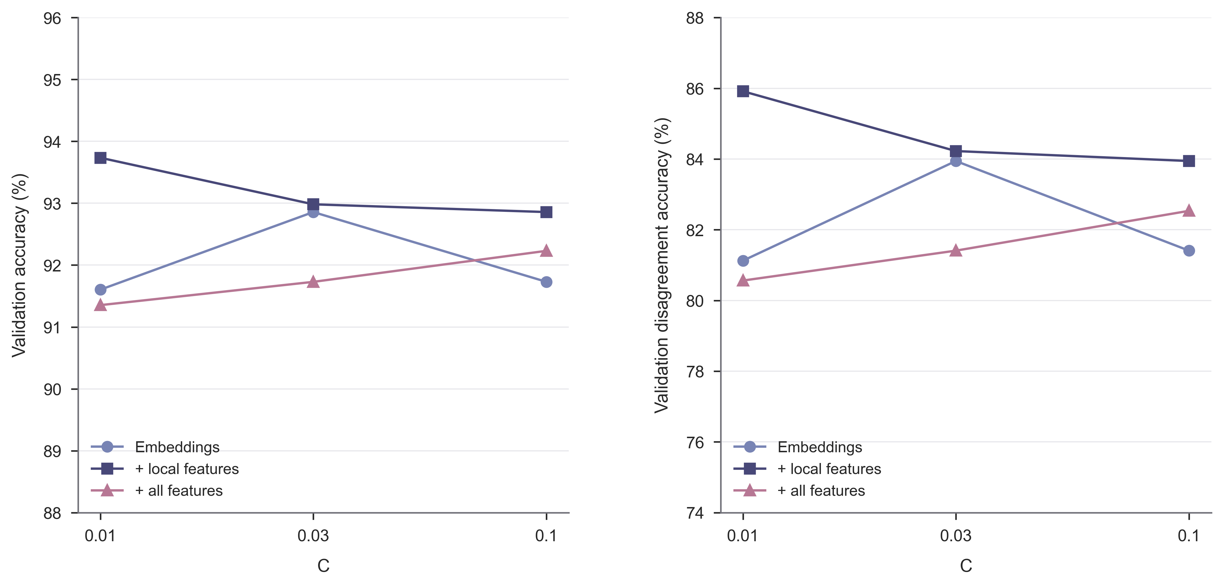
Figure 1. Validation accuracy across regularization settings for three centered linear feature configurations trained on answer disagreement groups.
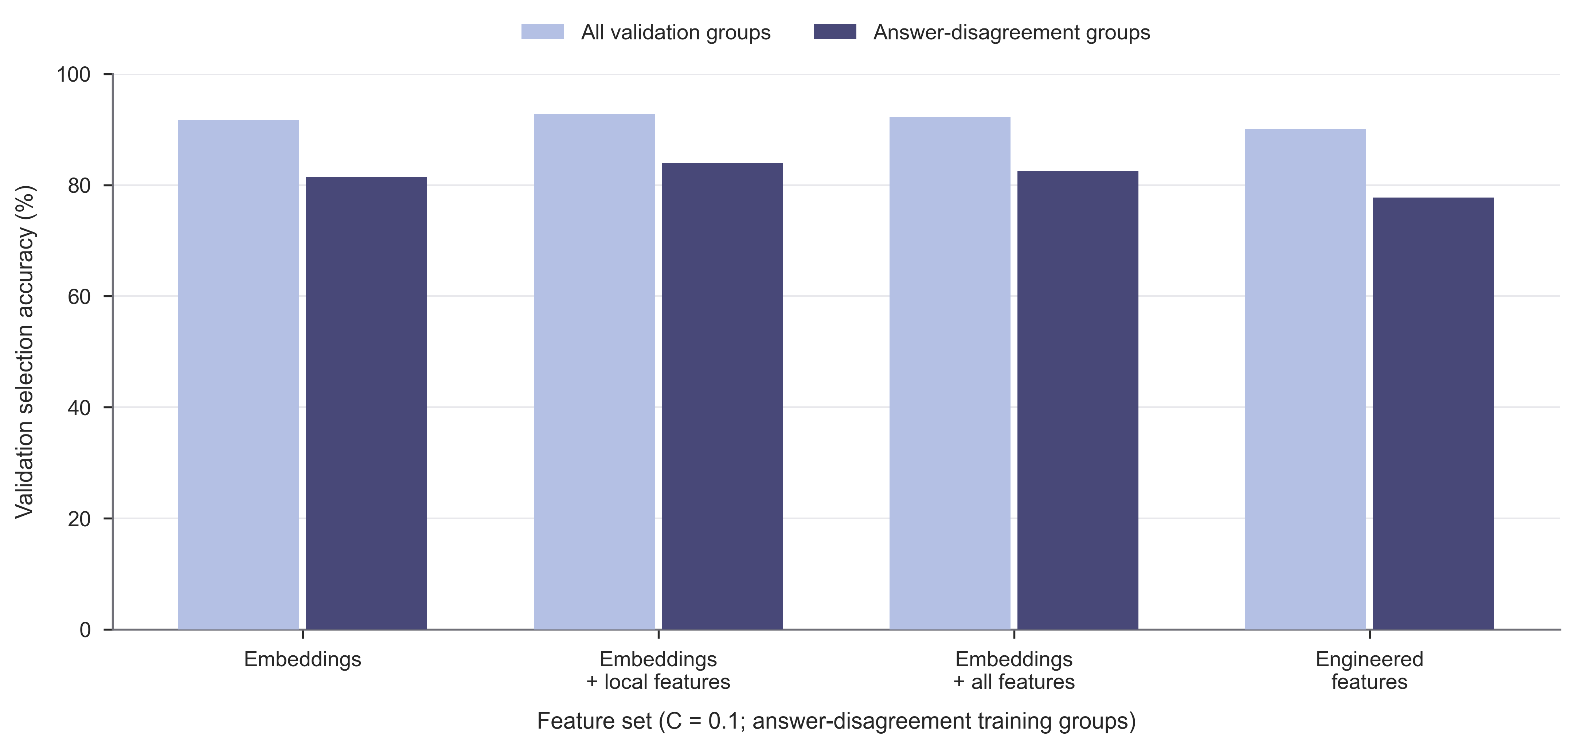
Figure 2. Validation accuracy for four feature sets with C fixed at 0.1 and identical answer disagreement training groups.

Additional model capacity and fusion
The best standalone tree comparator was the ranking model, with 90.85% full validation accuracy and 79.44% disagreement accuracy. These results were below those of the selected linear model. The ranking model also differs from the boosting classifiers in its training groups and several settings, so this comparison does not isolate the effect of the ranking objective.
None of the 16 tested fusion settings exceeded the selected linear model. The strongest fusion used the ranking model with a tree weight of 0.2 and achieved 747 correct validation choices, including 304 on disagreement groups. Its disagreement accuracy of 85.63% was one correct choice below the linear model. Figure 3 shows the complete weight sweep. The results describe these components and weights; they do not establish that ensembles are generally ineffective. Each fusion setting reuses existing component fits, and the component training times are not counted repeatedly as new training runs.
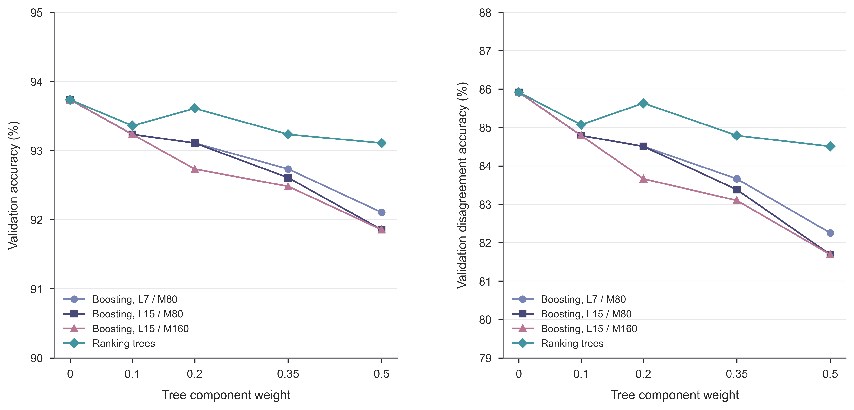
Figure 3. Validation accuracy as the tree component weight varies in score fusion with the selected linear model.

Computational footprint
The selected model was fitted in 0.98 s in the complete recorded run. Shared feature construction over training and validation inputs required 25.86 s, and the internal training and search timer recorded 90.12 s. These quantities represent different parts of the computation and are not interchangeable. In particular, the short selected model fit time excludes feature extraction and the other candidate configurations.
Complete local test evaluation took 2.31 s, including 1.90 s for the fresh prediction process and 0.40 s for independent scoring. Validation evaluation took 3.30 s. Figure 4 pairs the accuracy results with these complete timings, and Table 3 separates the measured resource quantities. The test bank is smaller than the validation bank, so their total execution times should not be interpreted as an algorithmic speedup.
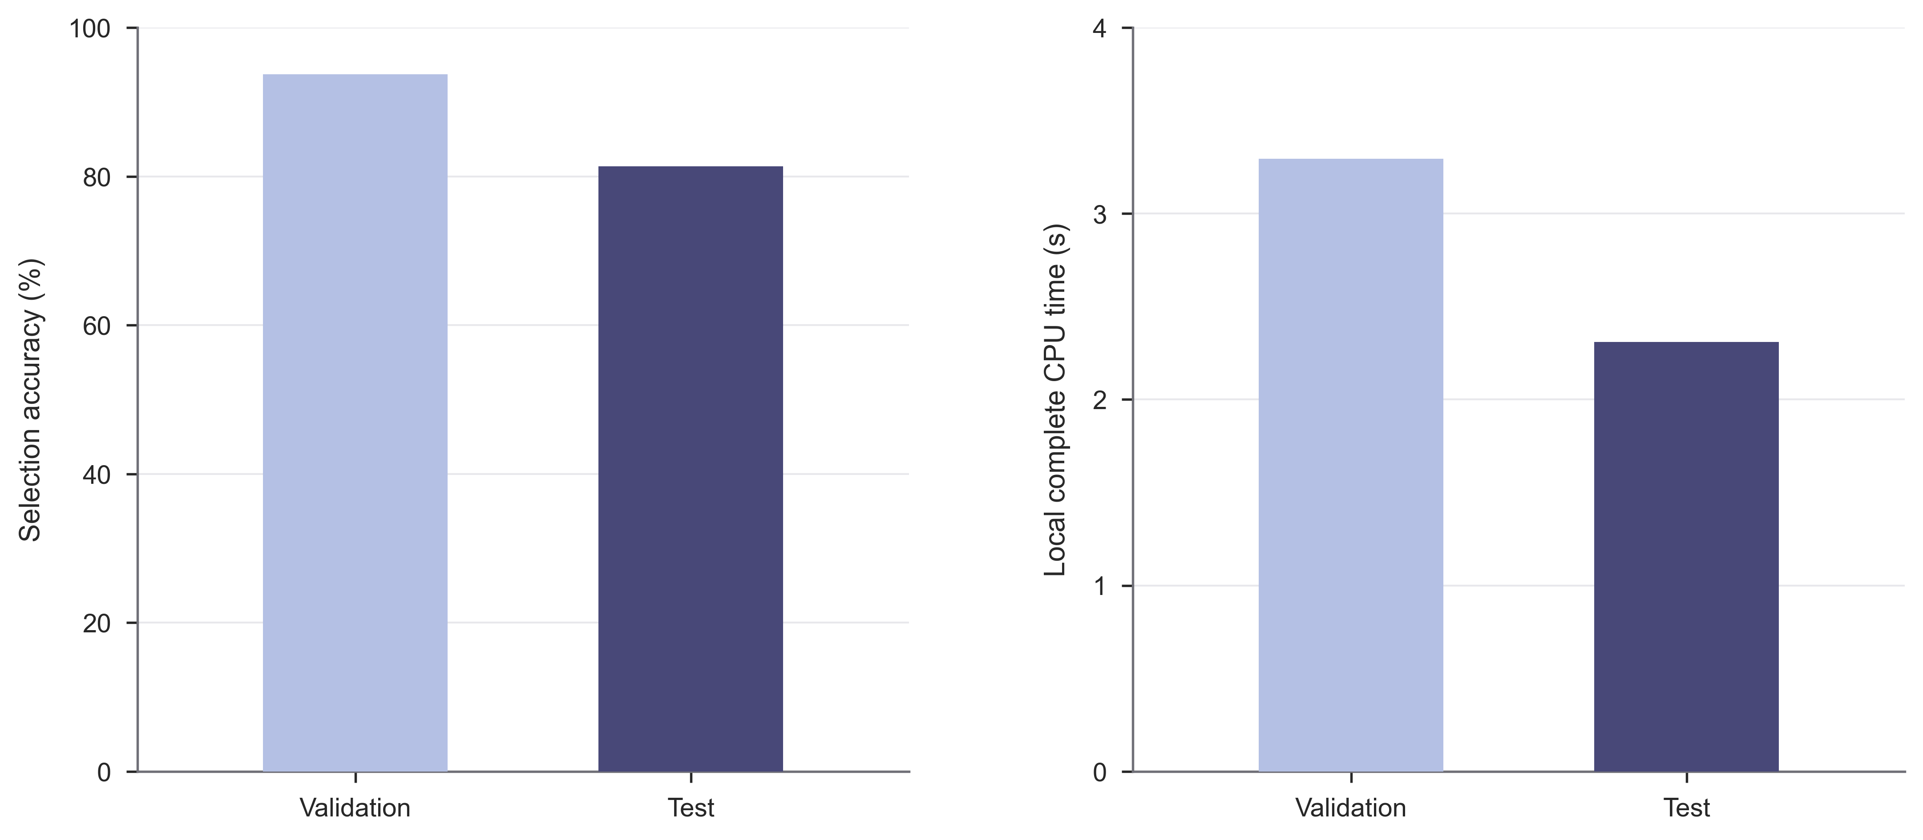
Figure 4. Selection accuracy and complete CPU evaluation time for the selected model on the validation and test banks.
Table 3. Local resource measurements for the selected model with fresh prediction and independent scoring processes.
Resource | Validation | Test
Complete evaluation time (s) | 3.295 | 2.310
Prediction process time (s) | 2.848 | 1.905
Scoring process time (s) | 0.447 | 0.405
Peak observed working set (MiB) | 95.14 | 68.24
Inference bundle (bytes) | 19,205 | 19,205

The inference bundle contains a 9,068 byte coefficient archive and a 10,137 byte configuration file, totaling 19,205 bytes. Scaling is already absorbed into the exported coefficients. Supplied benchmark arrays are excluded from this additional asset count. Both local evaluation times are below 30 s and the bundle is below 16 MiB. Eligibility on the designated reference processor remains a separate hardware measurement; the local records do not certify that platform.

Discussion
A linear score over fixed representations and local candidate statistics selected correct numerical answers more often than majority voting on validation disagreement groups, while requiring a small additional inference bundle. The feature comparisons show that increasing the number of engineered coordinates was not sufficient to improve selection. Within the evaluated grid, the local representation offered the strongest validation result, and score fusion with the available tree models did not improve it.
Answer agreement is central to interpreting these results. The 443 validation groups with a single valid parsed value are automatically resolved by the validity mask under the benchmark construction rule. A high overall validation score therefore combines a substantial set of guaranteed choices with the learned decisions on disagreement groups. Reporting the disagreement subset alongside the official full bank metric exposes this distinction while preserving the original evaluation definition. The all disagreement test bank supplies a separate evaluation of the selected model under competing answers.
Recent work has examined complementary verification settings. Confidence-informed self-consistency weights sampled reasoning paths when aggregating answers [8]; process reward models evaluate intermediate steps in mathematical reasoning [9]; and learned self-verification trains language models to assess their own generated answers [10]. In contrast, the present experiments hold four supplied candidates and their representations fixed and learn only a compact selector supervised by final-answer correctness.
The evidence concerns final numerical correctness on one supplied bank. A candidate can earn credit despite an incorrect intermediate step, and features describing arithmetic, wording or formatting can correlate with correctness without identifying its cause. The experiments do not separate these explanations or evaluate calibrated uncertainty. Training and selection use one seed, and model comparisons are confined to validation data. Only the selected configuration is evaluated on the test bank. These boundaries rule out claims of statistical significance, stepwise proof validation or transfer to other generators and benchmarks.

Conclusion
A compact linear selector combining fixed solution embeddings with local numerical and textual statistics achieved 81.37% accuracy on 467 test questions with competing parsed answers. Its validation advantage over majority voting arose entirely on answer disagreement groups, and its local inference and scoring footprint remained small. The controlled comparisons favor the selected local representation over the larger engineered feature set and the tested score fusions. Together, the results support a resource efficient approach to numerical answer selection and show why agreement composition must accompany aggregate benchmark accuracy.

Data and code availability
The benchmark inputs, references, fixed parser and evaluator are distributed through the DASE7506 MP2 repository [4], with GSM8K attribution and its retained license. The accompanying project contains the selection and training code, the main.py entry point, model assets, dependency records, experiment records and official evaluator outputs. The coefficient archive is identified by the SHA-256 prefix 8b634c0d3cd7b6c3; complete asset and source hashes are retained with the checkpoint. No external datasets or additional pretrained weights were loaded for selector training or evaluation.

AI assistance
Codex assisted with implementation, experiment analysis, visualization and manuscript drafting. Numerical statements and the mathematical description were checked against the saved code, experiment records and official evaluator outputs.

