# Search Engine Optimization

There are a range of things that can be done to a website that will improve SEO, leading to the website being more easily found via search engines. This paper presents 5 aspects that have been applied to the project website showing pre optimisation and post optimisation html code. A final section touches on elements to avoid or that are of little value to SEO.

## Semantic Tags

HTML5 provides a range of tags that improve the structure of HTML. Semantic tags aim to improve accessibility and SEO by indicating the purpose of a particular element (Pavlik, 2022). Earlier HTML specifications were restricted to a small set of tags that results in many layers of <div> tags. HTML5 allows websites to use tags such as <section> and <article> to better show the purpose of an element and what is contains. Some other semantic tags include <strong>, <code>, <header>, and <aside>.

Through the use of semantic tags, search engines can better determine the important elements of a web page. Therefore, understanding the purpose of these tags and how to properly use them is critical to effectively optimising for search engines.

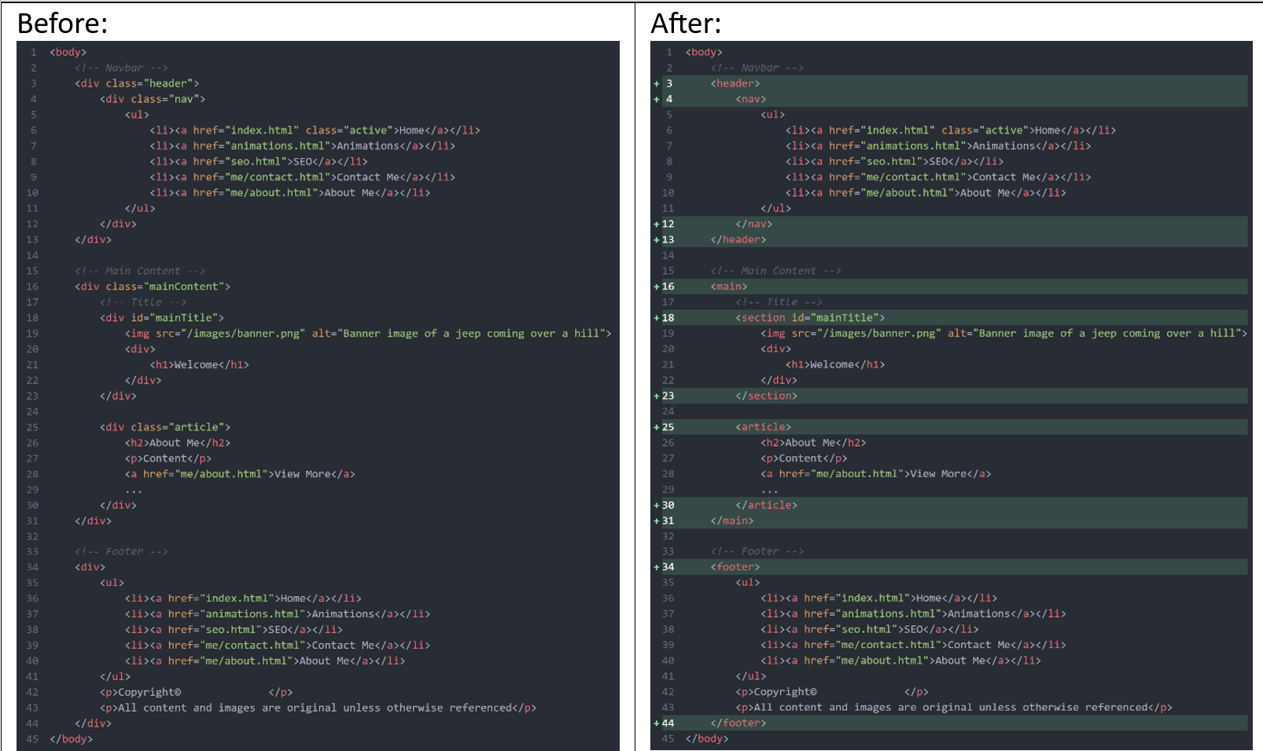

## Keywords and titles

Web pages should have descriptive titles so that users and search engines can easily identify what will be on the page. The body of the pages should have all of the relevant keywords for the content within the text elements. Researching relevant keywords and creating interesting titles can increase the amount of people who see the web page in search results and can attract more people to click on the link. It should be noted that Google (2023) recommends against excessive keywords. Google also notes that certain locations such as the domain name and the keyword meta tag is not used by Google for searching.

## Descriptive path names to improve URL readability

This includes using descriptive URLs, for example: `/me/contact.html` instead of `/page2.html`.

Directories can be used to group pages such as putting all the articles within an `articles` directory and having a separate directory for store items called `store`. Another step is to reduce duplicated content by only having 1 URL for a particular page. Where separate URLs are desired, the use of redirect links is a neutral compromise.

|  |  |
| --- | --- |
| Before: | After: |

## Site content and presentation

Site design and content has an impact not only on SEO but also for the general user experience. This includes having well formatted content (that is; headings, paragraphs, splitting up content into sections, etc.) and also ensuring the content doesn’t have any grammatical or spelling errors. The content on the page should also be unique and not just a copy of someone else’s content, it should also be up to date and kept relevant (Google, 2023).

The site should also be easy to operate and avoid using overly intrusive or obstructive advertisements (DigitalSail, 2023~~)~~ There should also be links between web pages with relevant content.

Links to other pages should also have relevant text so that users and search engines are able to tell what the link is for without having to follow the link.

Example of good link text:

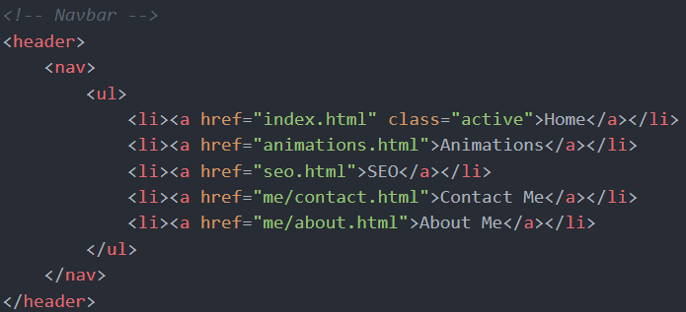

## Visual content

Including images is another way to improve SEO, this allows search engines to show the page with an image which can help to draw more people to click on the page. When including images, alt text should be used to provide a description of the image, this allows search engines to know what the is in the image and also improves accessibility for screen readers. Images should also be placed near the relevant text to relate the 2 elements together. Similarly, any videos should have descriptive titles and descriptions about the video, transcripts of the video can also be useful.

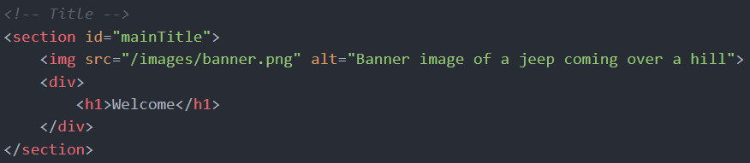

## Things not to do

Some past methods of improve SEO are no longer relevant or as effective and therefore shouldn’t be focused on. This includes the length of content, the “keywords” meta tag, and the name or words in the domain name.

## References

Google. (2023, March 21). *SEO Starter Guide: the Basics | Google Search Central | Documentation*. Google Developers. https://developers.google.com/search/docs/fundamentals/seo-starter-guide

Pavlik, V. (2022, December 2). *HTML5 Semantic Tags: What Are They and How To Use Them!* Semrush Blog. https://www.semrush.com/blog/semantic-html5-guide/

DigitalSail. (2023, September 25). *Can Ads Affect SEO Ranking?* Www.linkedin.com. https://www.linkedin.com/pulse/can-ads-affect-seo-ranking-digitalsail