# COMP30080 – Assignment 5

Jack Duffy - 13363475  
Owen Phelan - 13437591  
Matt Condon - 13523107

## Part 1:

|  |  |  |  |  |  |  |  |
| --- | --- | --- | --- | --- | --- | --- | --- |
| Operation | MemRead | MemWrite | RegWrite | ALUControl | MemToReg | RegDst | ALUSRC |
| Lw 00 | 1 | 0 | 1 | 01 | 1 | 0 | 1 |
| Sw 01 | 0 | 1 | 0 | 01 | 0 | 0 | 1 |
| Add 11 | 0 | 0 | 1 | 01 | 0 | 1 | 0 |
| Addi 10 | 0 | 0 | 1 | 01 | 0 | 0 | 1 |

Truth Table for the Control Unit of the Processor:

Control Circuit Implementation (representation of Truth Table):  
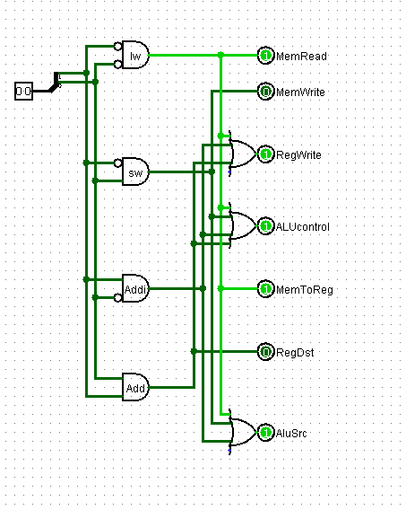

## Part 2:

**Structure of instructions:**

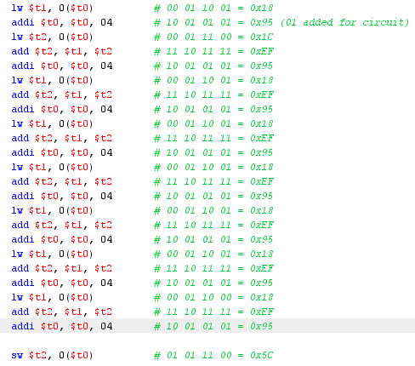

Each instruction altered to 8 bit binary representation, then represented in hex format.  
These hex values were then stored in Program RAM.

## Functional units from previous assignment integrated into single functional processor:

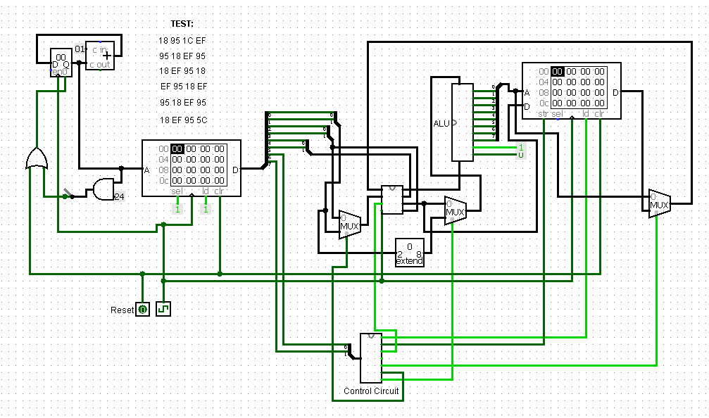

**Examples with Student Numbers:  
13523107:**

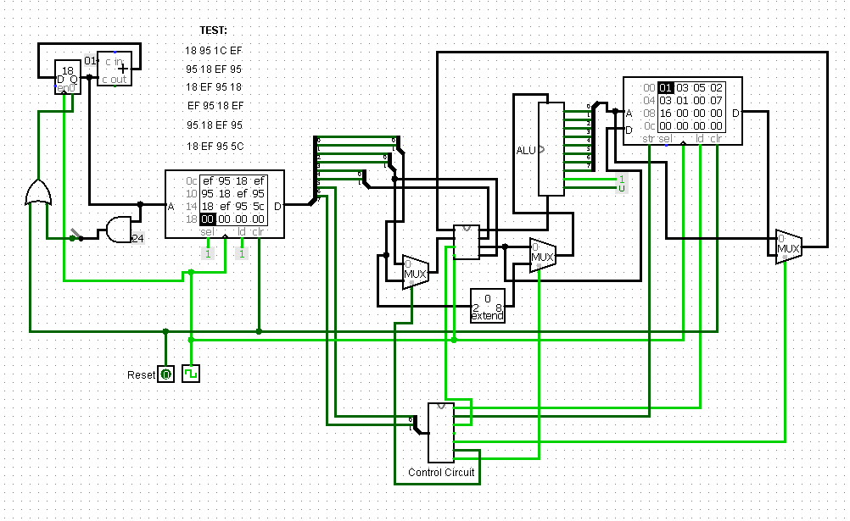  
**Gives result:** 16 (22 when converted from hex to decimal)  
**Compared to MIPS:** 

**13363475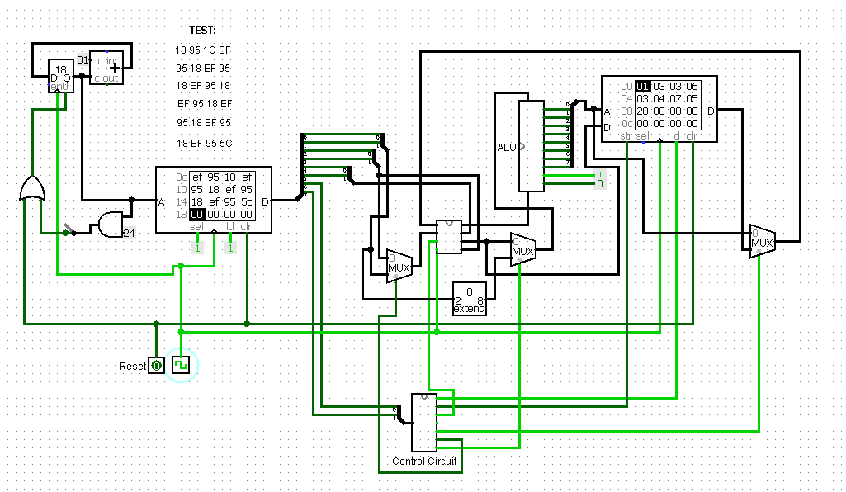 Gives result:** 20 (32 when converted from hex to decimal)  
**Compared to MIPS:** 