
app.diagrams.net

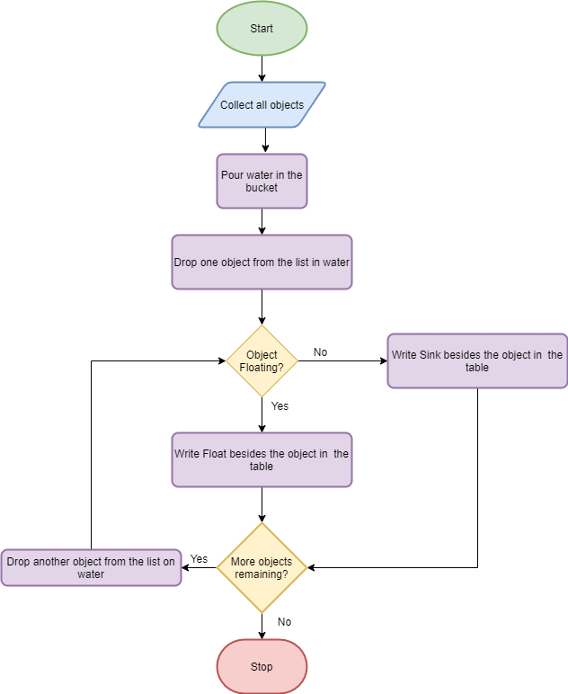

Student: AYMAN ISLAM AHMED AHMED ABBAS

app.diagrams.net



Student: BADER MASHAN MATAR ALSHAMMARI

app.diagrams.net



Student: BAYBARS AHMAD TAHA ALRAWASHDEH

app.diagrams.net



Student: TURKI FALEH SALEM AL-SHAMRY

app.diagrams.net



Student: KHALID MSHARI FALAH ALHARBI

app.diagrams.net



Student: RAIF ABDULADHEEM HASSAN ALMALKI

app.diagrams.net



Student: RYAF RAED SAFAR ALHARTHI

app.diagrams.net



Student: ZAYED BARRAK SALEH ALSHAMMARI

app.diagrams.net



Student: ABDUL RAHMAN MUSLAT MUHAMMAD AL-MUTAIRI

app.diagrams.net



Student: ABDULLAH SABER ABDULLAH ALSHAMMERI

app.diagrams.net



Student: ALI MOHAMED SAYED ABDELAAL

app.diagrams.net



Student: AMMAR BASHIR ALHAJI - LABARAN

app.diagrams.net



Student: AYAD MASHAL MUSHARAD ALANZI

app.diagrams.net



Student: MUHAMMAD MARZOUK A ALDHAFEERI

app.diagrams.net



Student: MOHAMMED MUNIF MOHAMMED ALSHAMMARI

app.diagrams.net



Student: MASHARI ABDULLAH KHALIF ABDULLAH ALBANI

app.diagrams.net



Student: MASHAAL AHMAD TURKI AL HARBI

app.diagrams.net



Student: MUATH MOHAMMED MOBARAK AL QAHTANI

app.diagrams.net



Student: WADAH BIN ABDUL RAHMAN AL-RASHEED

