1. Install Ubuntu Desktop Version

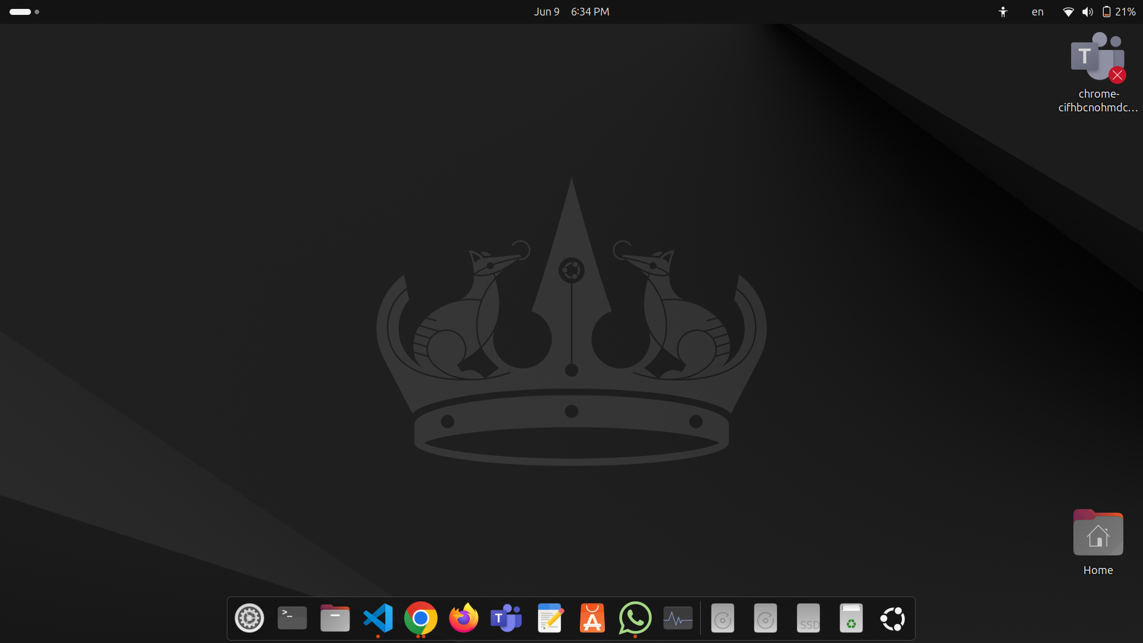

2. What is the different between cat and more command?

cat file.txt

more file.txt

cat => Displays the entire content of a file

more => Displays the content of a file one screen at a time.

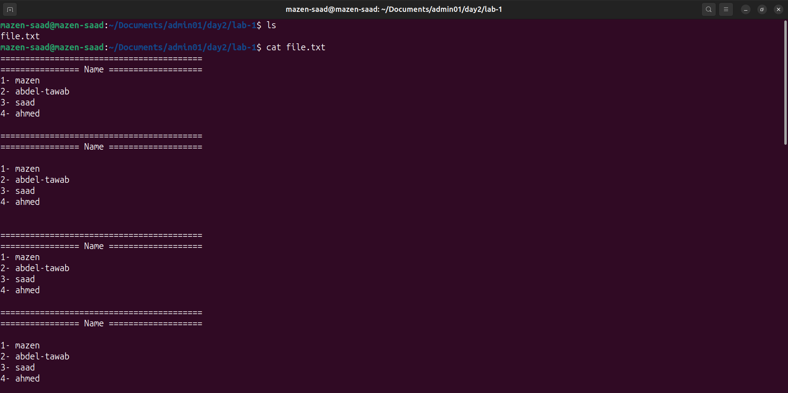

3. What is the difference between rm and rmdir using man?

rm: Removes files or directories.

rmdir: Removes empty directories.

man rm

man rmdir

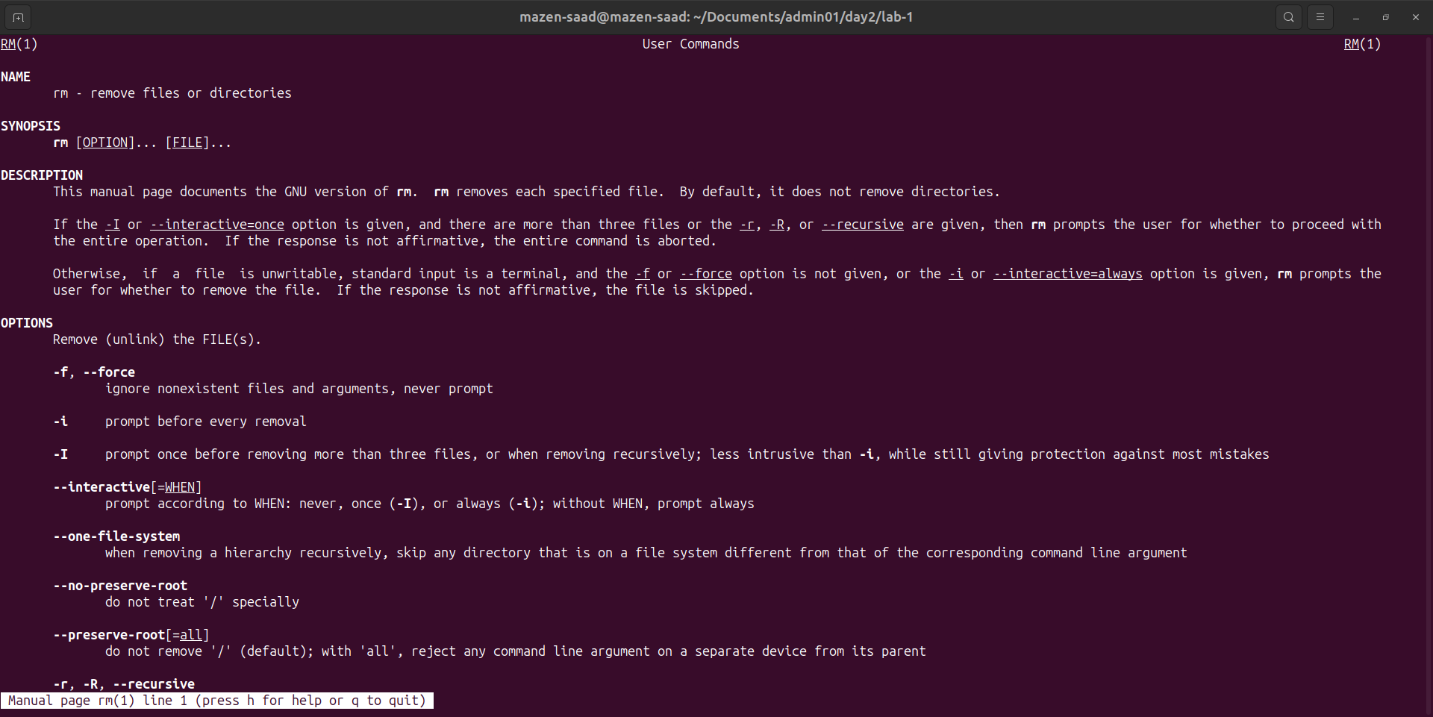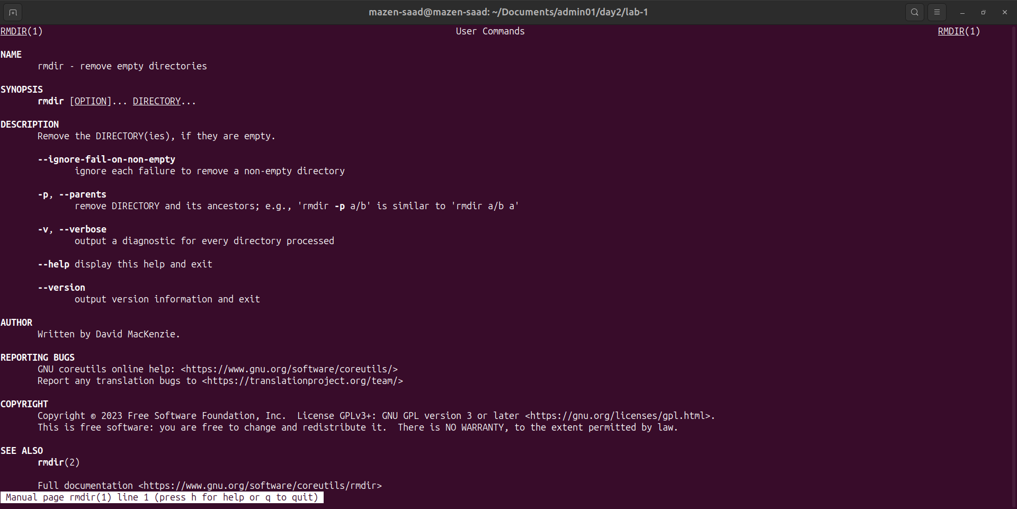

4. Create the following hierarchy under your home directory:

dir1

├── dir12

├── dir11

└── file1

docs

├── mycv

cd ~

mkdir -p ~/Documents/dir1/{dir11,dir12} ~/Documents/docs

touch ~/Documents/docs/mycv ~/Documents/dir1/dir11/file1

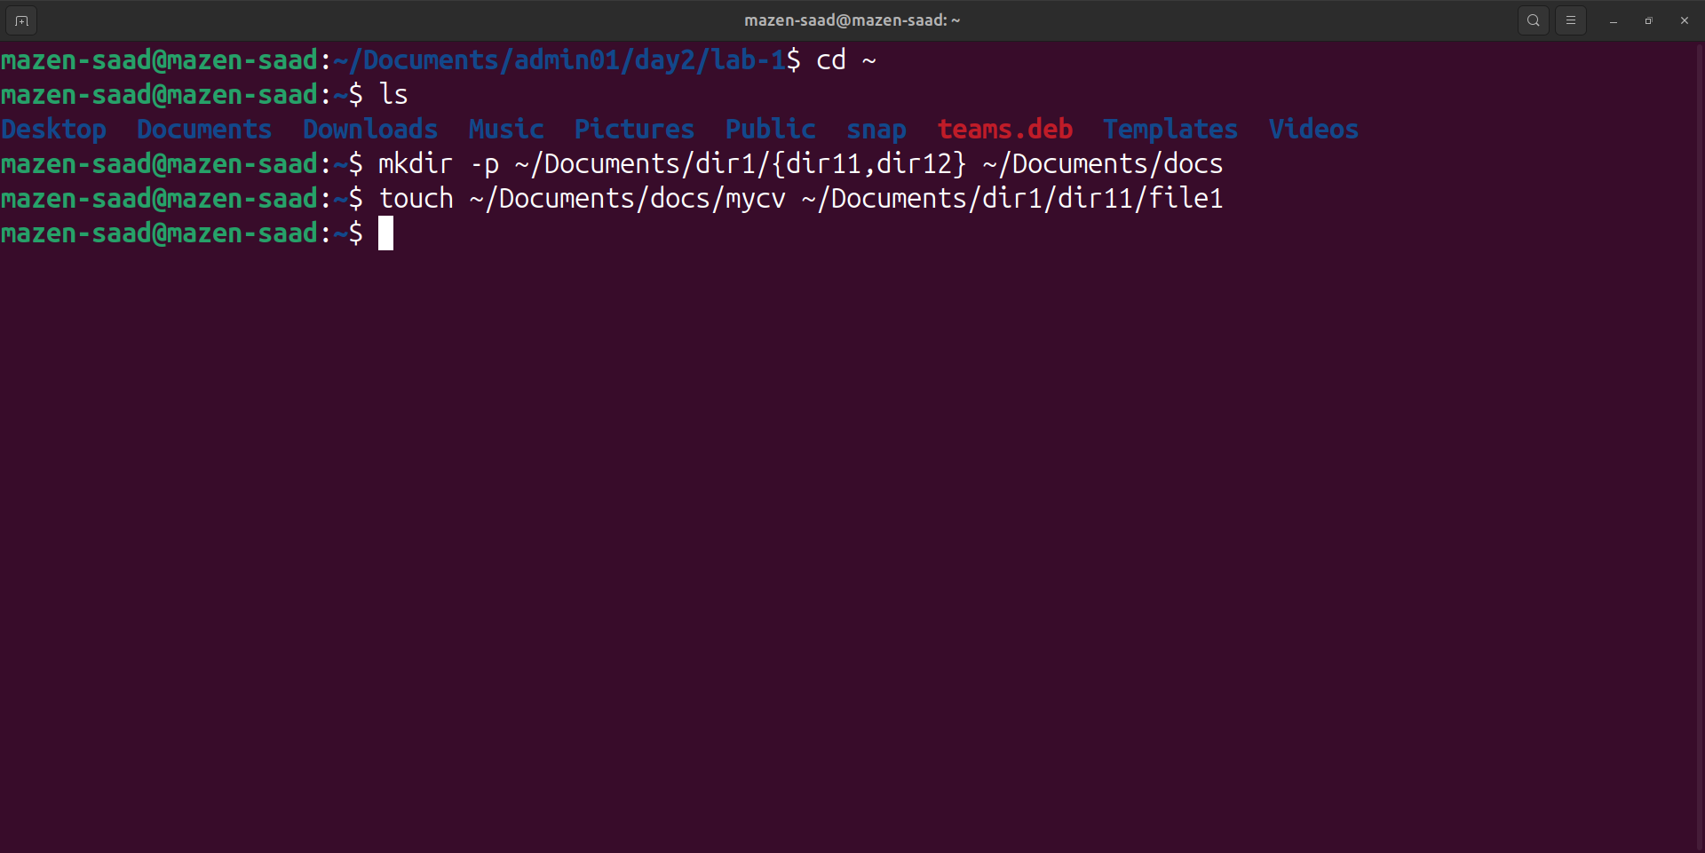

5. Remove dir11 in one-step. What did you notice? And how did you overcome that?

rm -rf dir11 #-r removes directories

rm -r ~/Documents/dir1/dir11

note: deletion of directories and their contents.

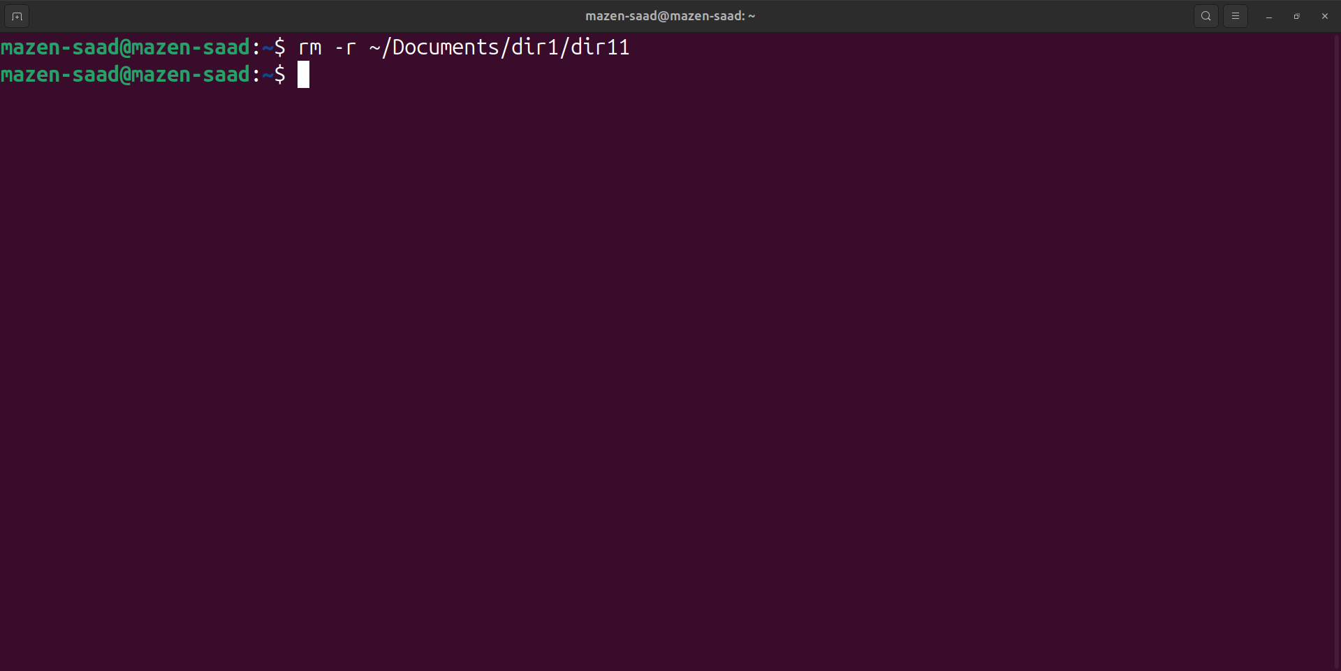

6. Then remove dir12 using rmdir –p command. State what happened to the hierarchy

(Note: you are in your home directory).

rmdir -p ~/Documents/dir1/dir12

note: -p removes parent directories if empty

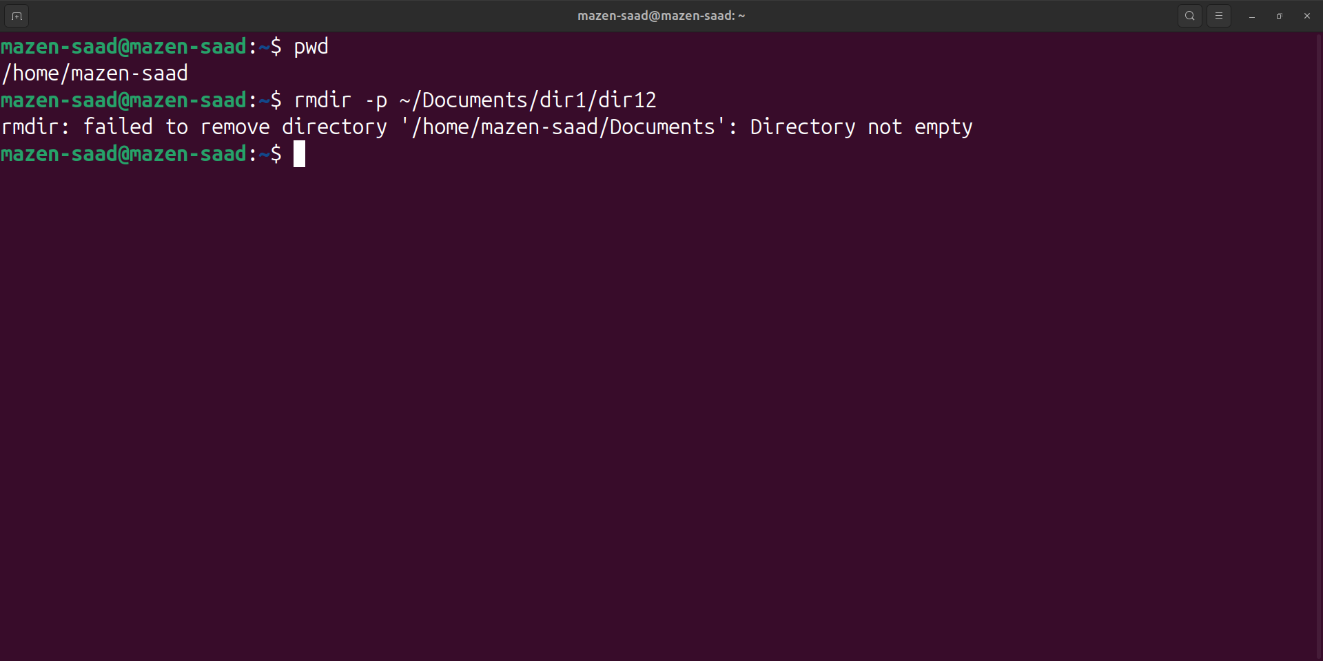

7. Copy the /etc/passwd file to your home directory making its name is mypasswd.

cp /etc/passwd ~/Documents/mypasswd

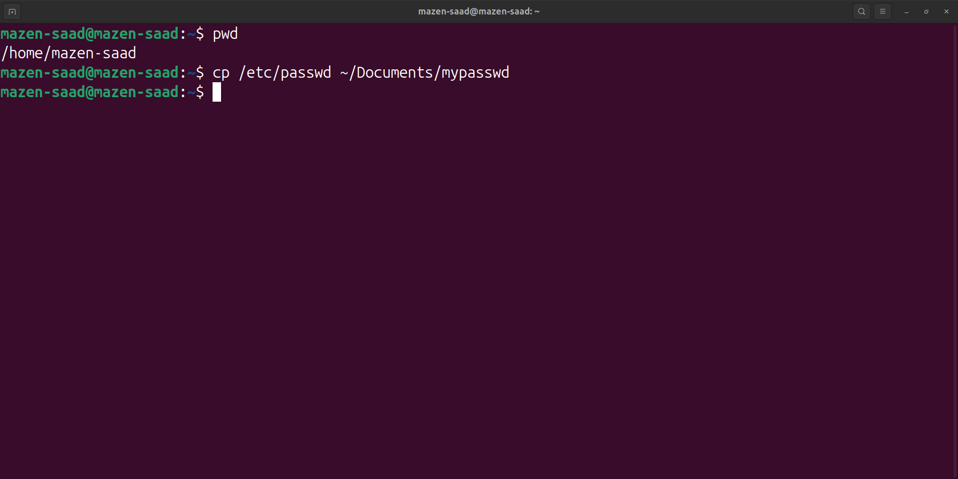

8. Rename this new file to be oldpasswd.

mv ~/Documents/mypasswd ~/Documents/oldpasswd

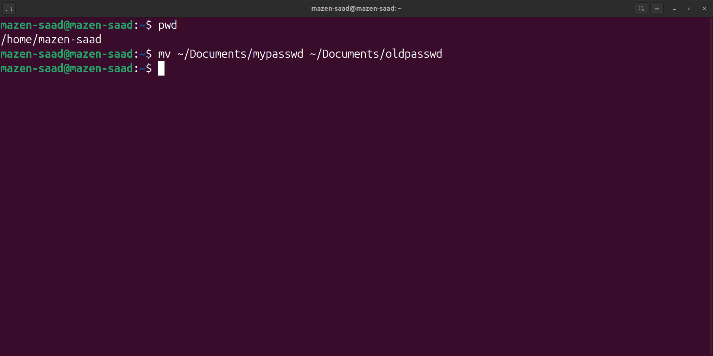

9. The output of the command pwd was /home/user. Write the absolute and relative path for the file mycv

Absolute: /home/user/Documents/docs/mycv

Relative: Document/docs/mycv

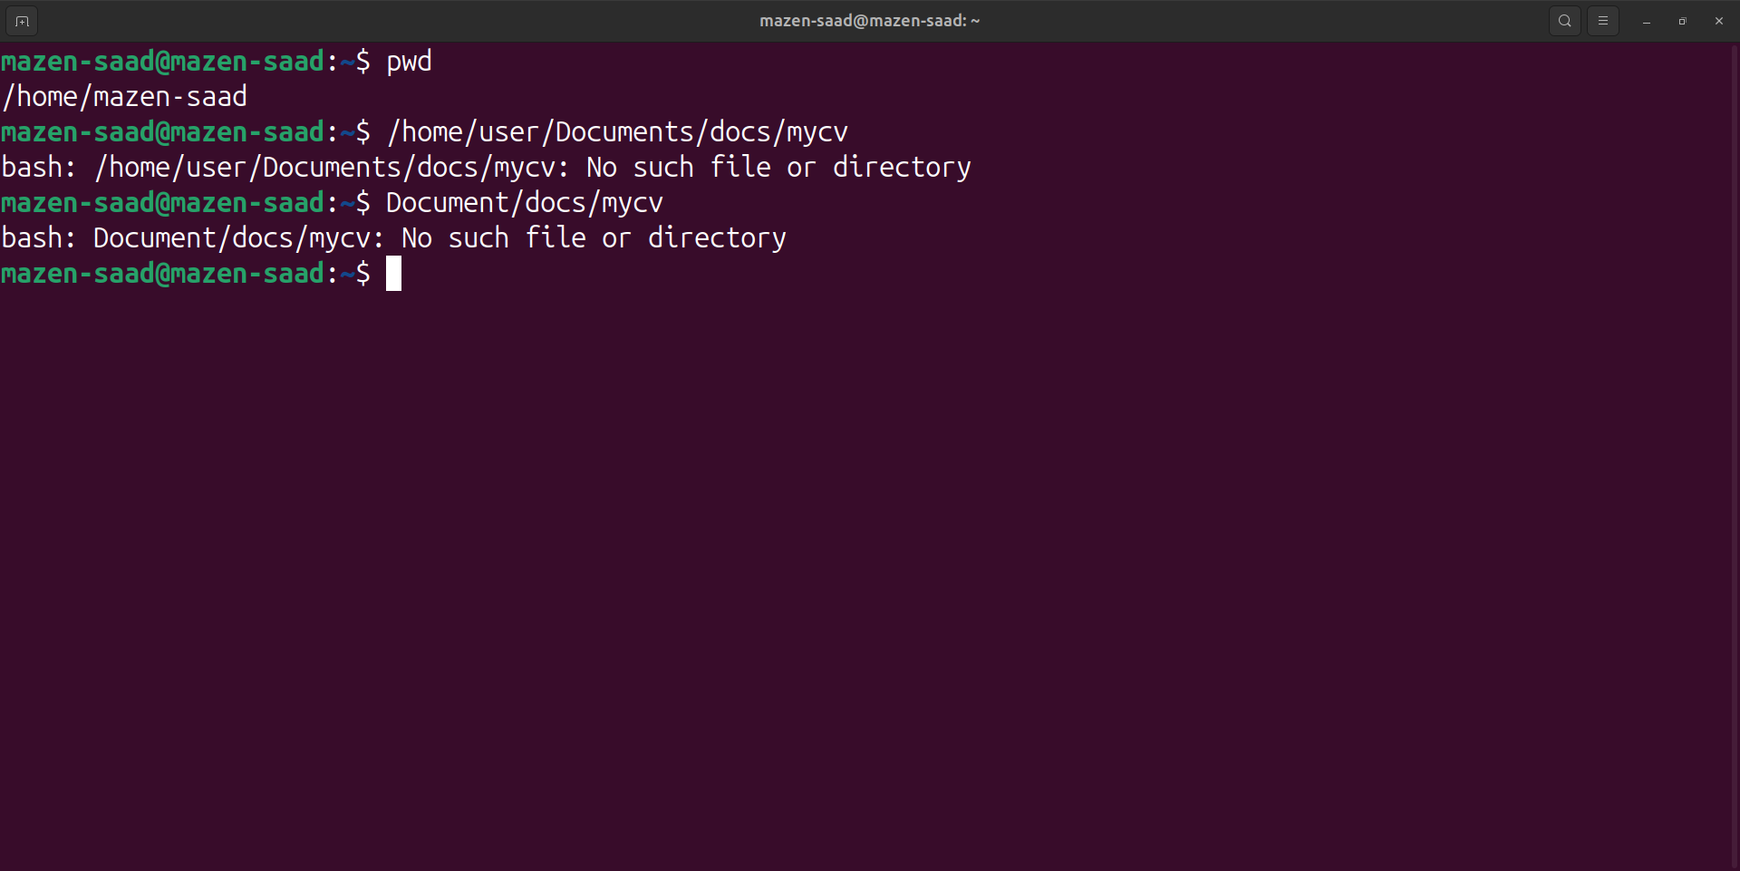

10. You are in /usr/bin, list four ways to go to your home directory

cd $HOME

cd

cd ~

cd /home/mazen-saad

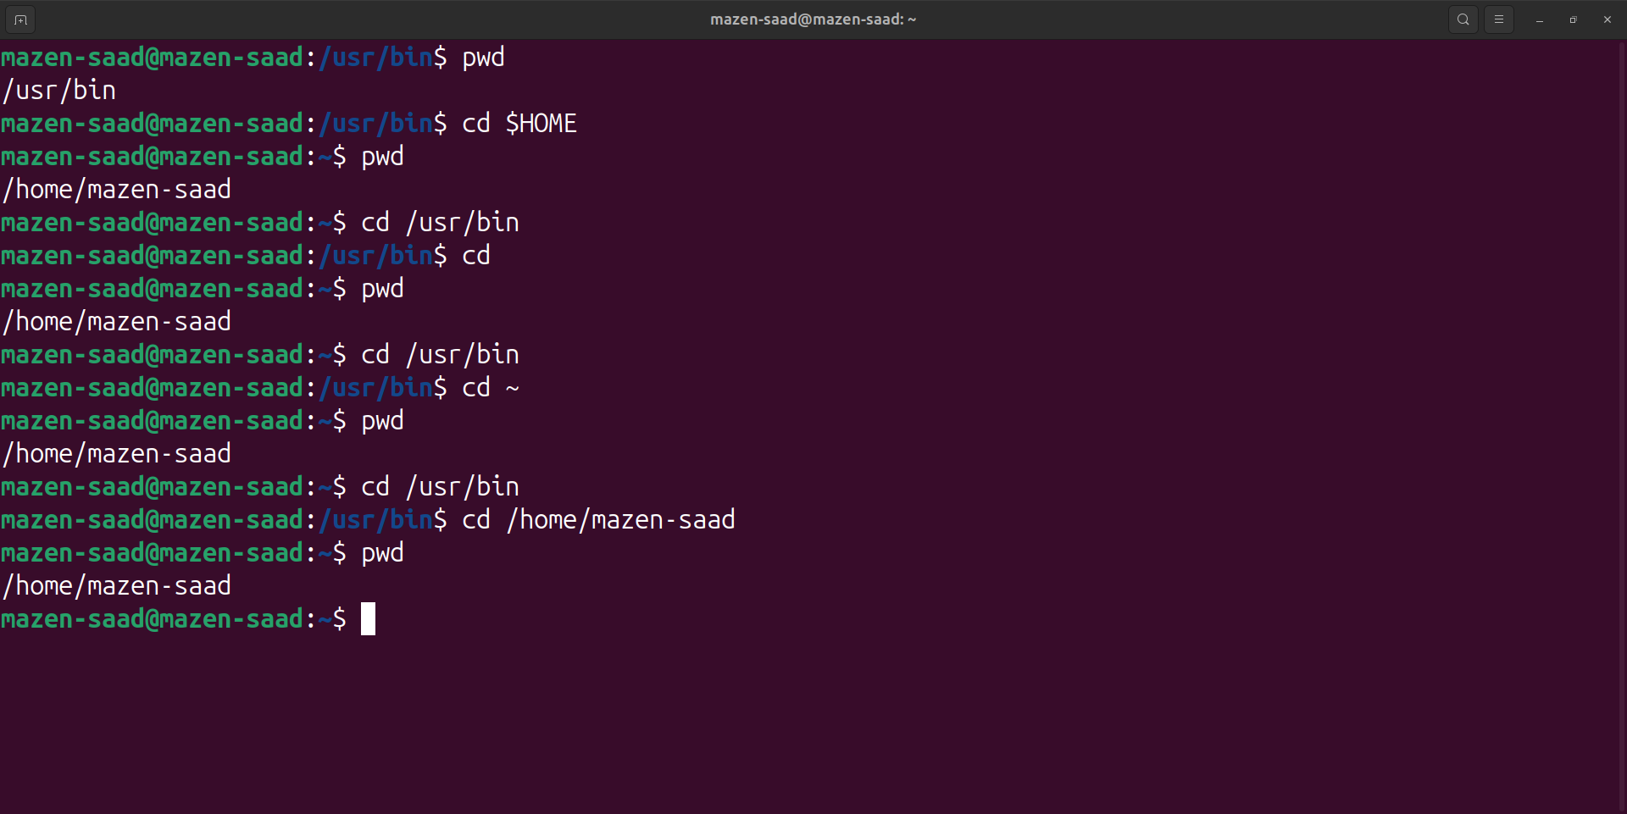

11. List Linux commands in /usr/bin that start with letter w

ls /usr/bin/w\*

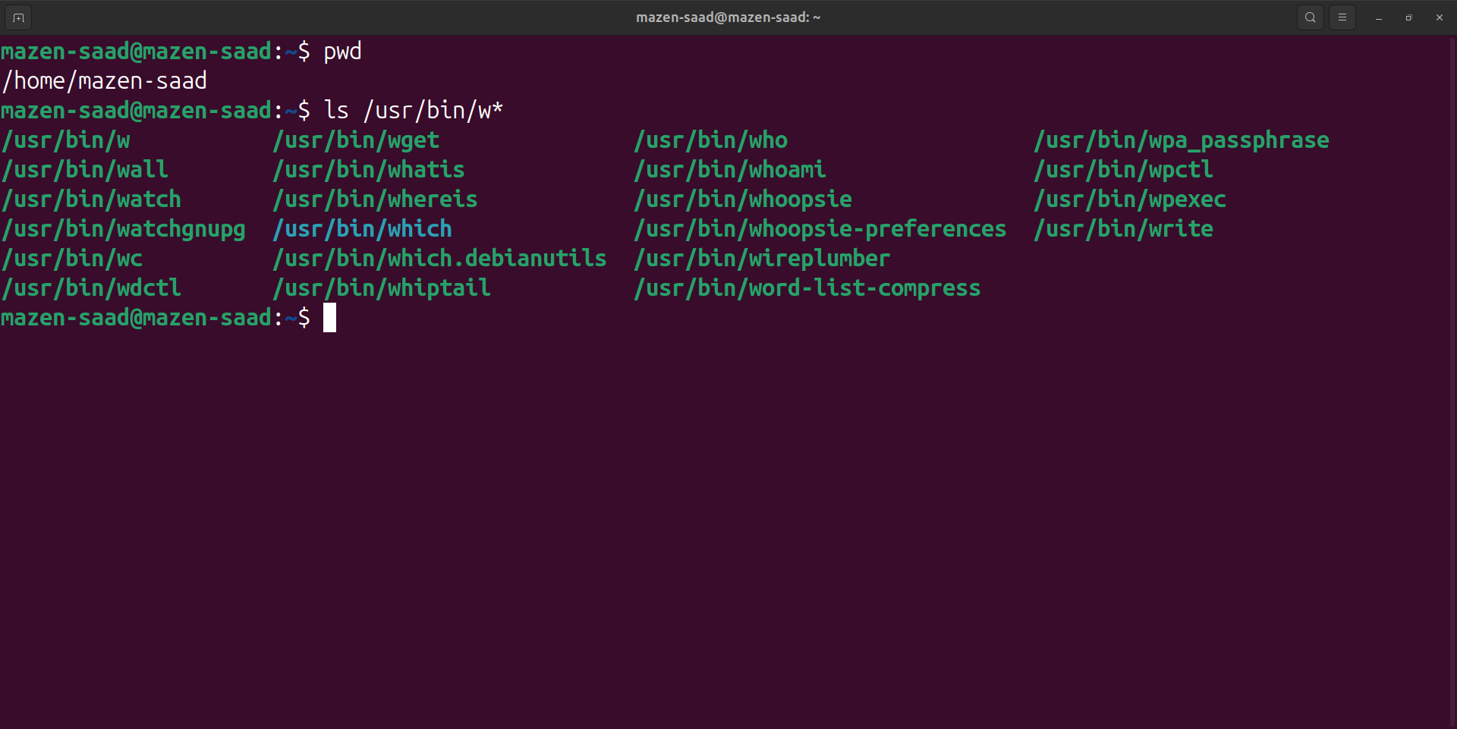

12. Display the first 4 lines of /etc/passwd

head -n4 /etc/passwd

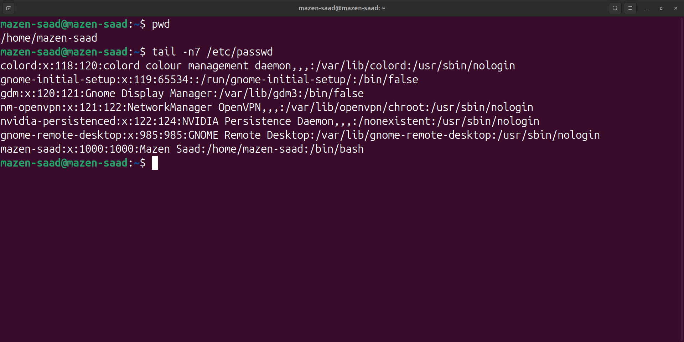

13. Display the last 7 lines of /etc/passwd

tail -n7 /etc/passwd



14. Display the man pages of passwd the command and the file sequentially in one command.

man passwd /etc/passwd

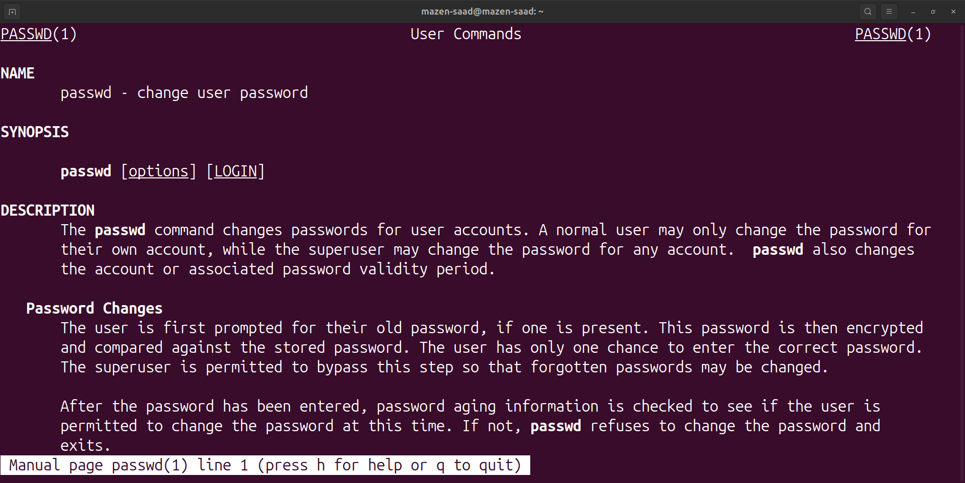

15. Display the man page of the passwd file.

man /etc/passwd

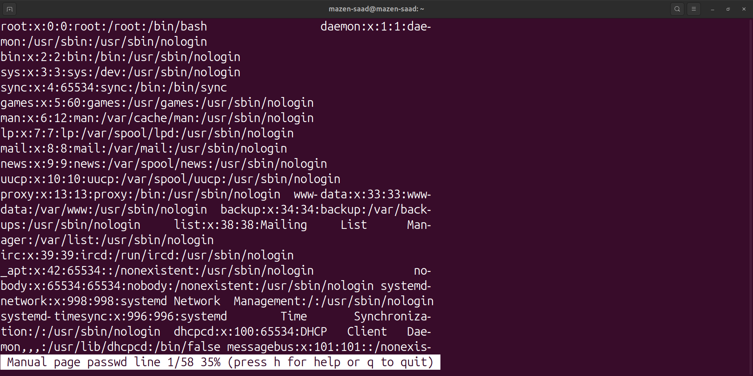

16. Display a list of all the commands that contain the keyword passwd in their man page.

man -f passwd

