**مازن عبدالتواب سعد**

**Lab 2**

1. Using vi write your CV in the file mycv. Your CV should include your name, age, school, college, experience,...

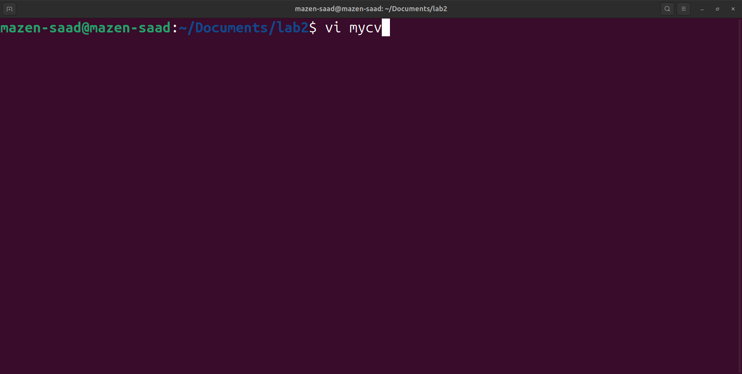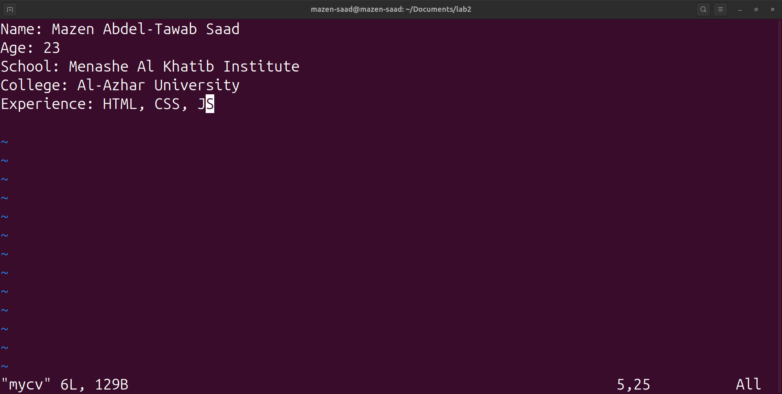

2. Open mycv file using vi command then: ( Without using arrows state how to)

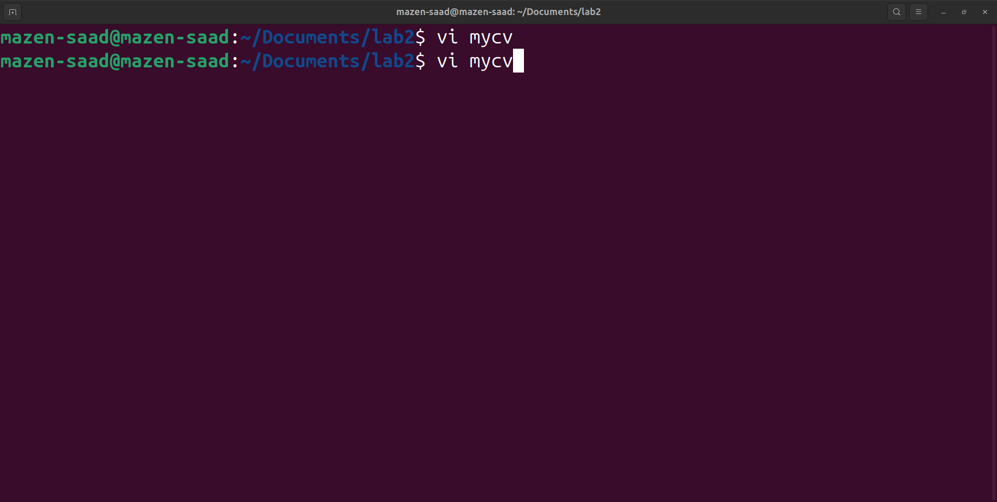

3. Move the cursor down one line at time.

Using the letter => j

4. Move the cursor up one line at time.

Using the letter => k

5. Search for word age

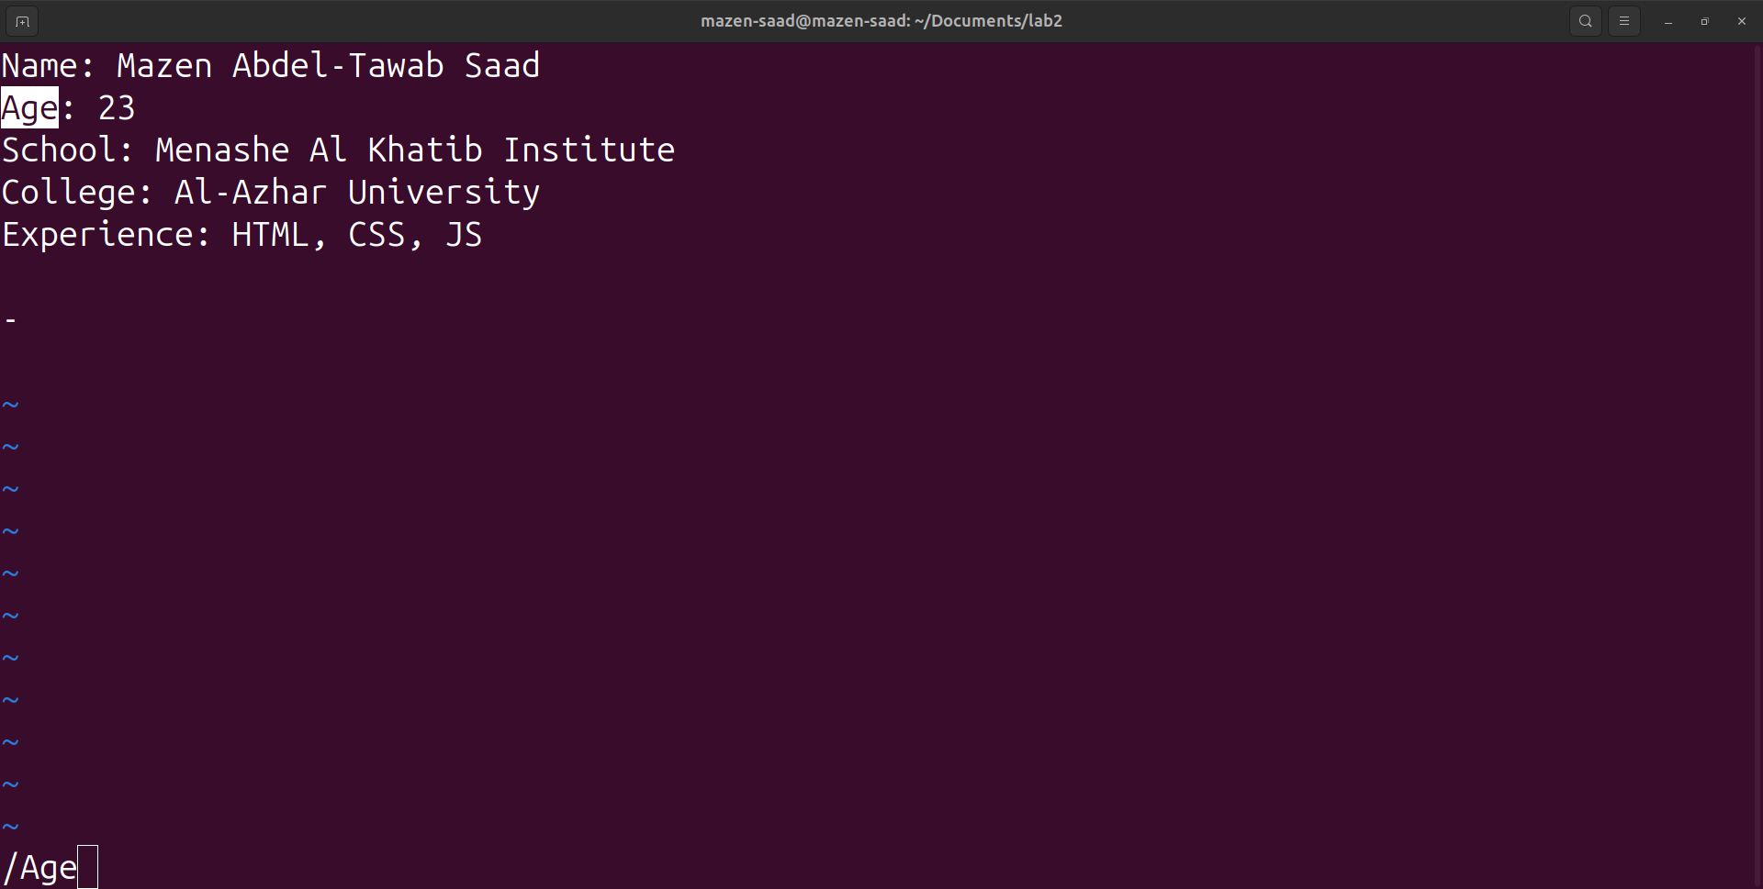

6. Step to line 5 (assuming that you are in line 1 and file is more than 5 lines).

solution =>

:5

or

5G

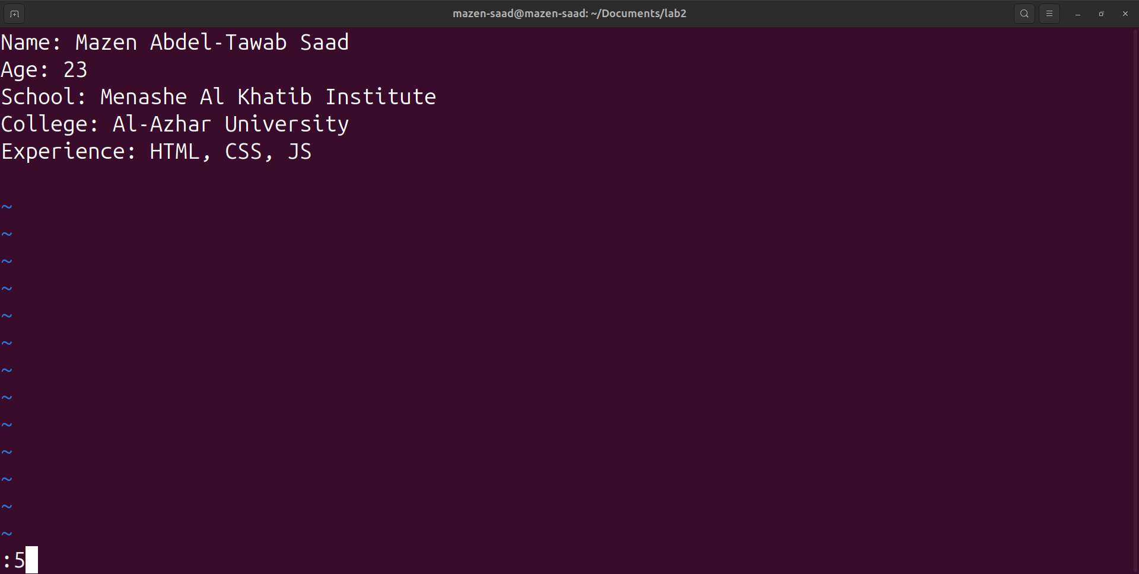

7. Delete the line you are on and line 5.

Delete the line I am on => dd

Delete line 5 => :5d

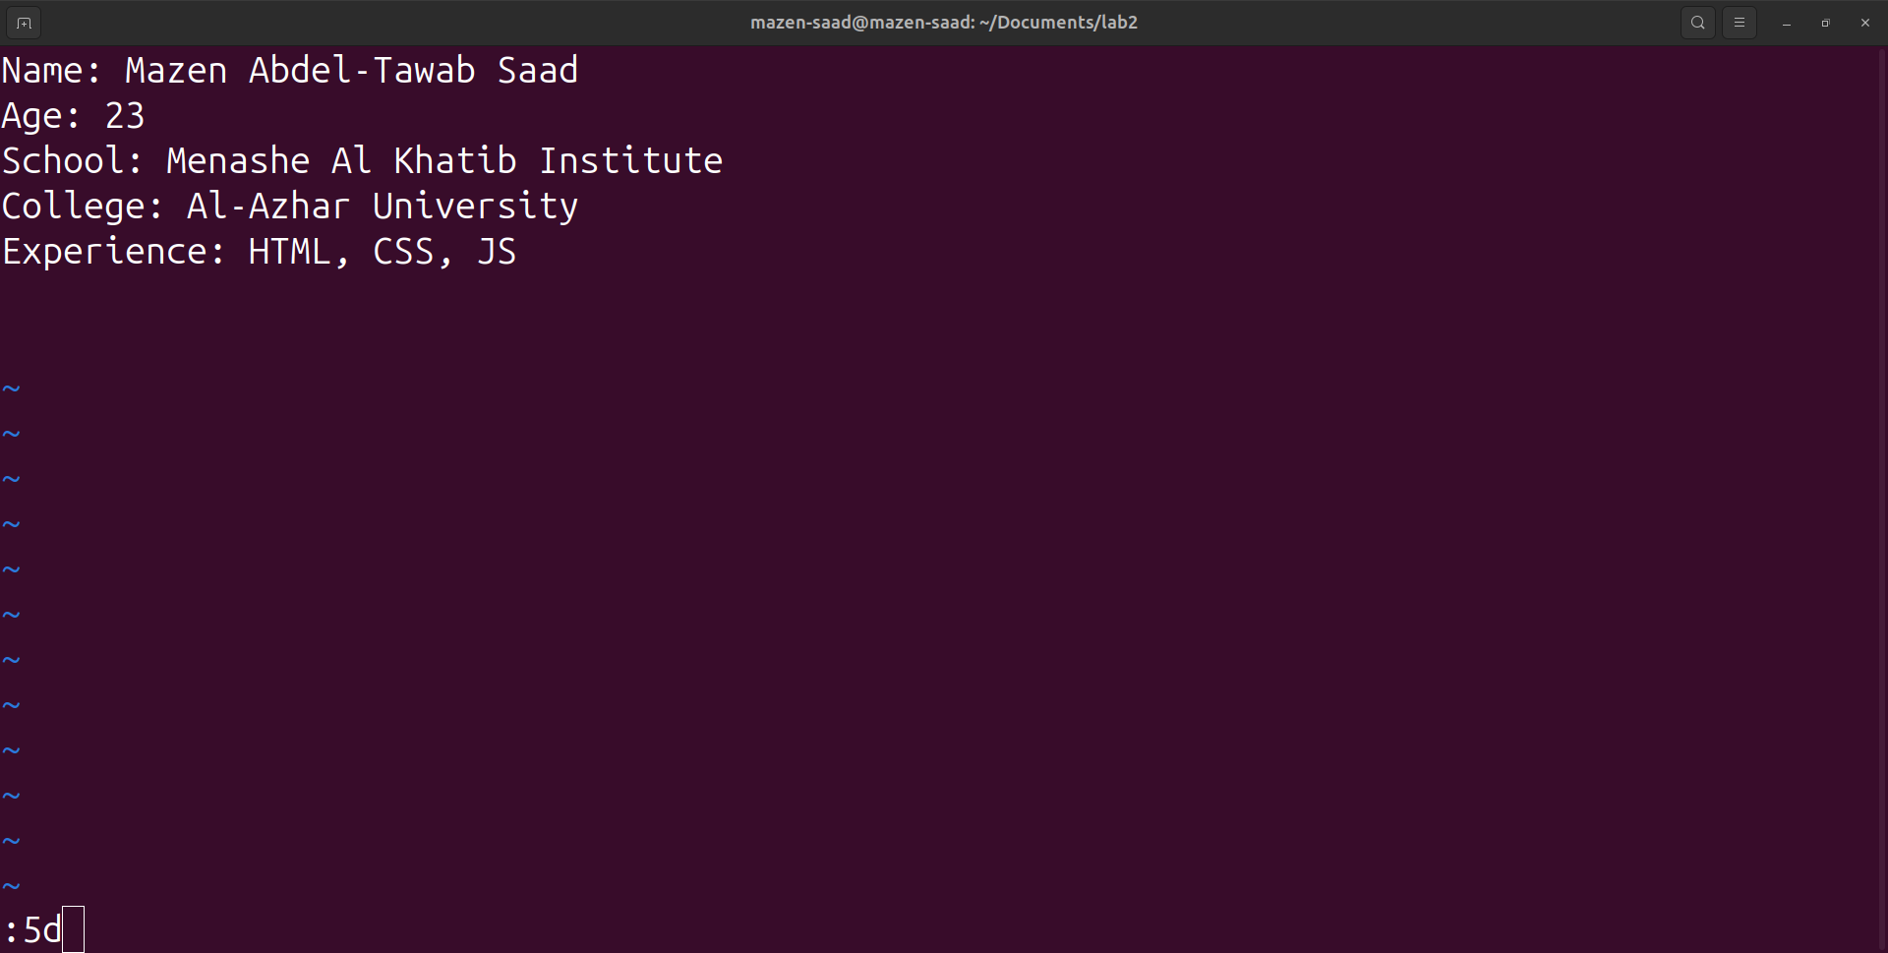

8. How to step to the end of line and change to writing mode in one-step.

Using the letter => A

9. Create a user account with the following attribute

a. username: islam

b. Fullname: Islam Askar

c. Password: islam

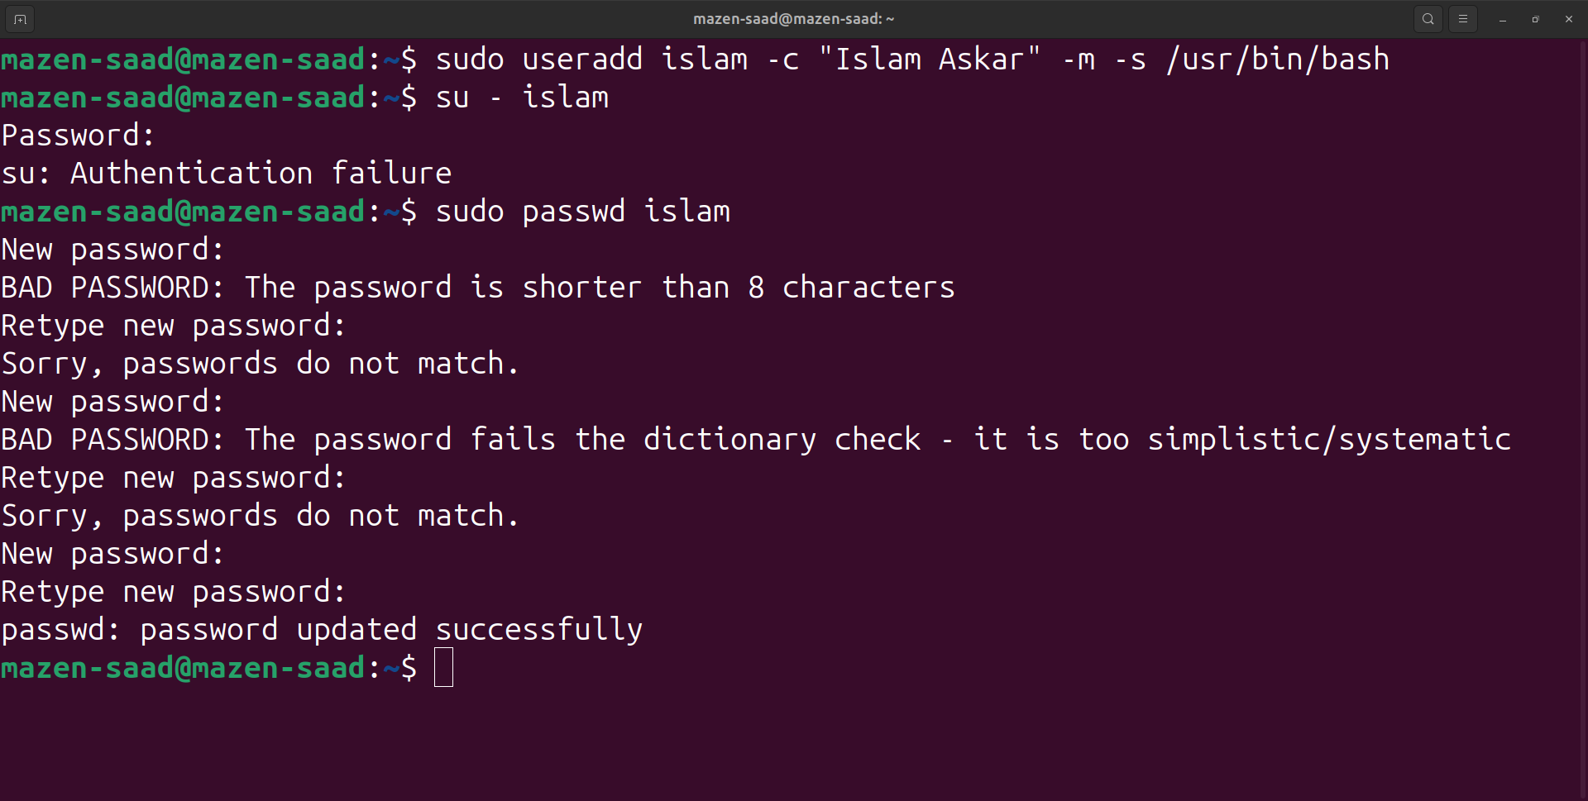

10. Create a user account with the following attribute

a. Username: baduser

b. Full name: Bad User

c. Password: baduser

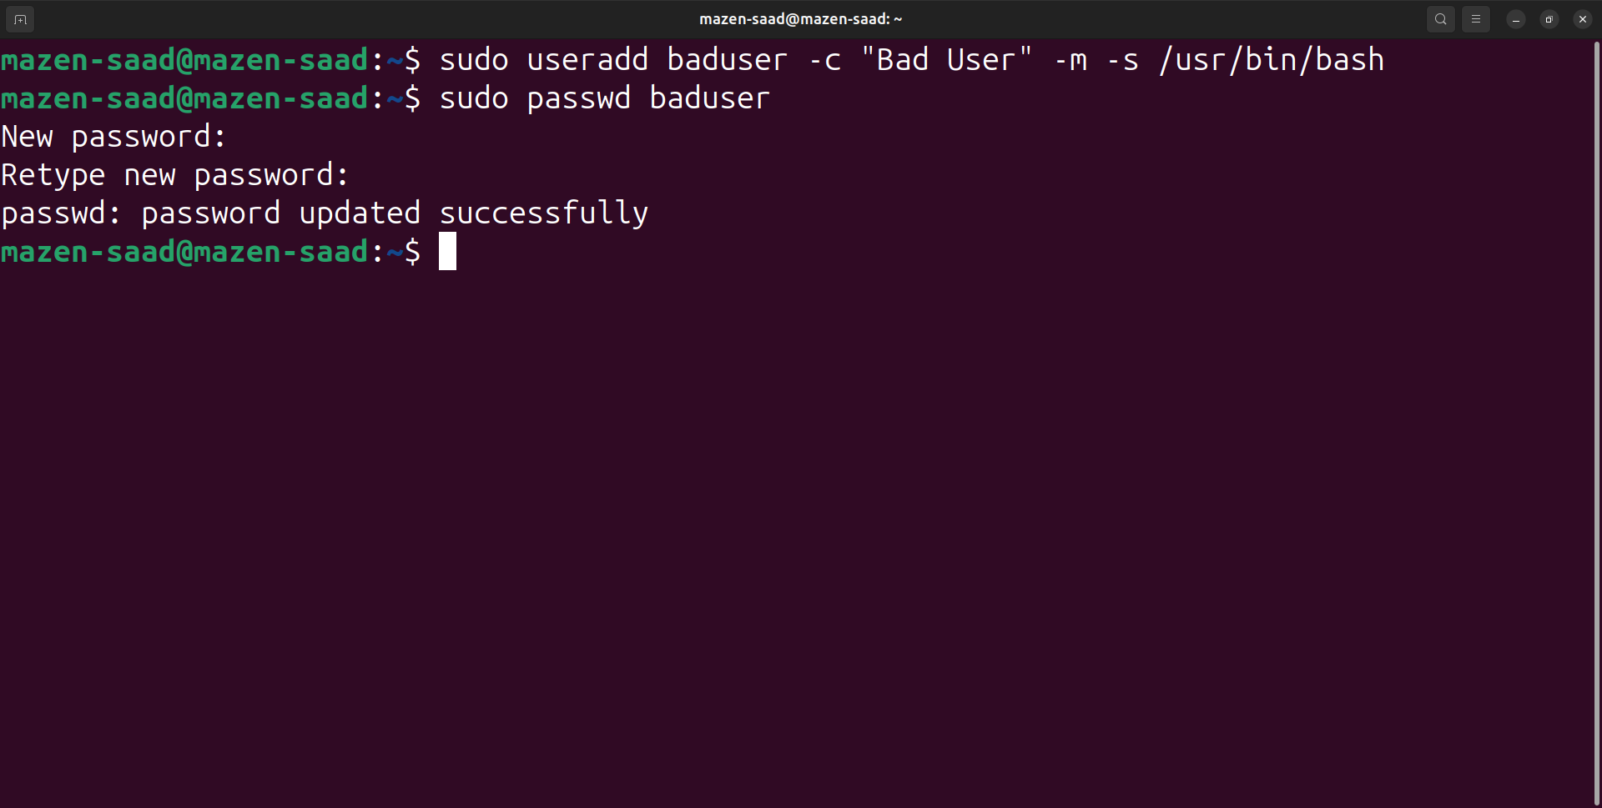

11. Create a supplementary (Secondary) group called pgroup with group ID of 30000

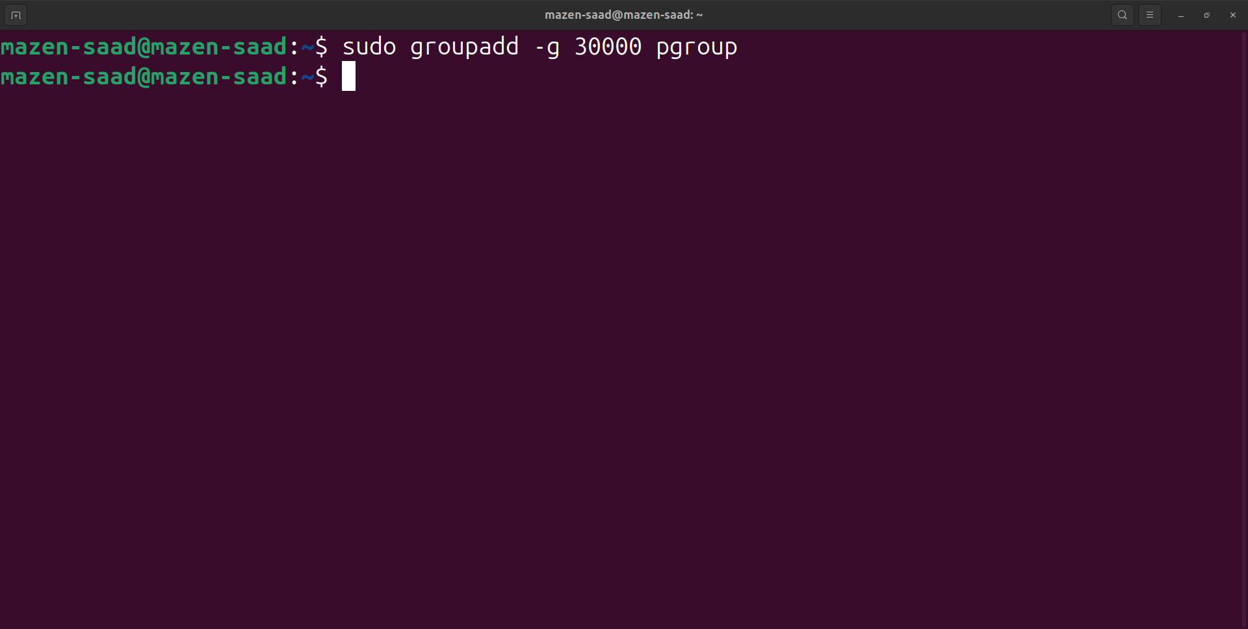

12. Create a supplementary group called badgroup

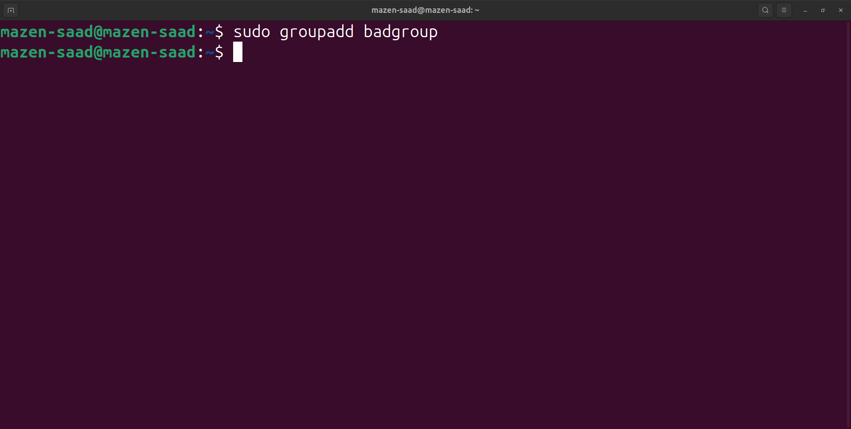

13. Add islam user to the pgroup group as a supplementary group

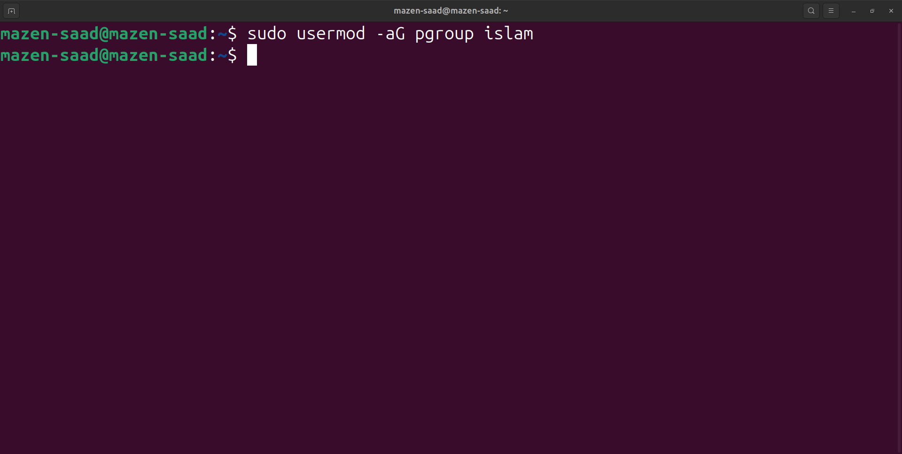

14. Modify the password of islam's account to password

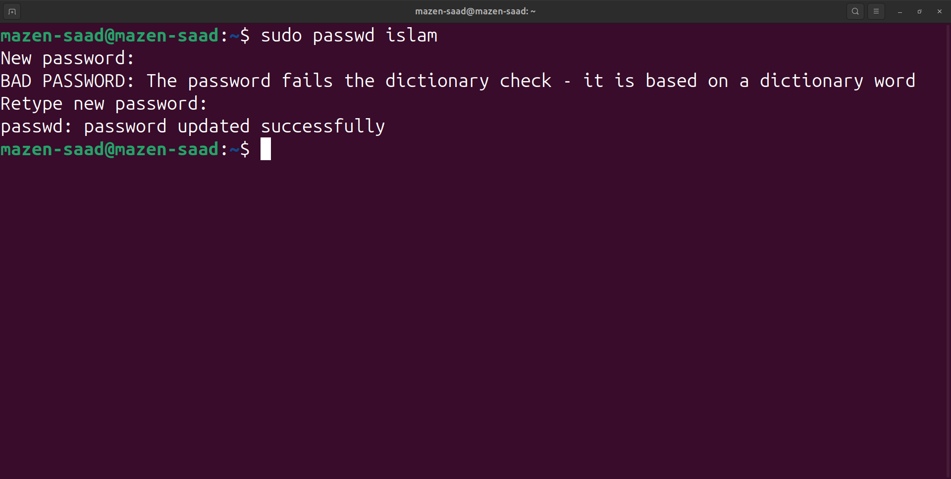

15. Modify islam's account so the password expires after 30 days

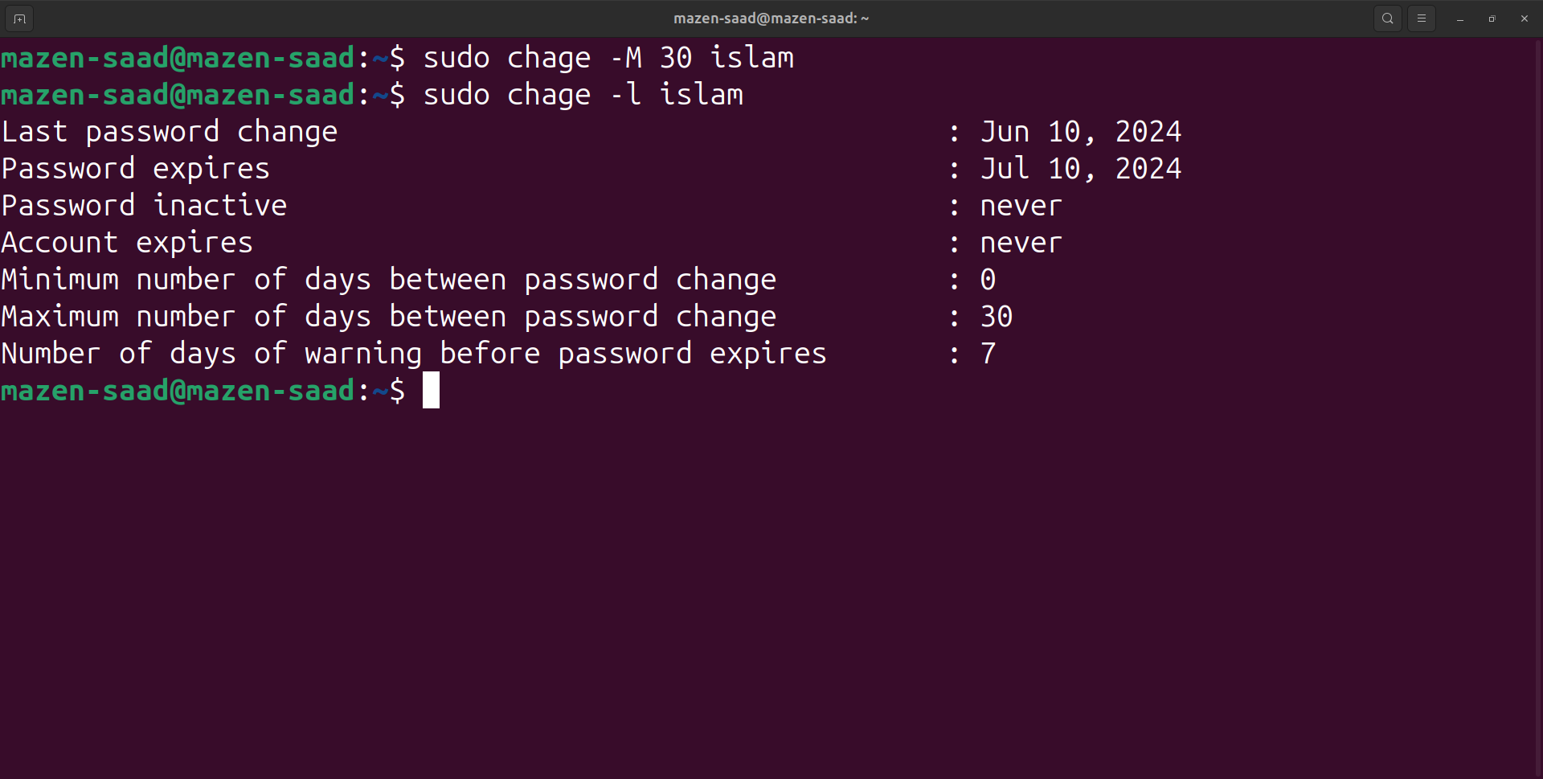

16. Lock bad user account so he can't log in

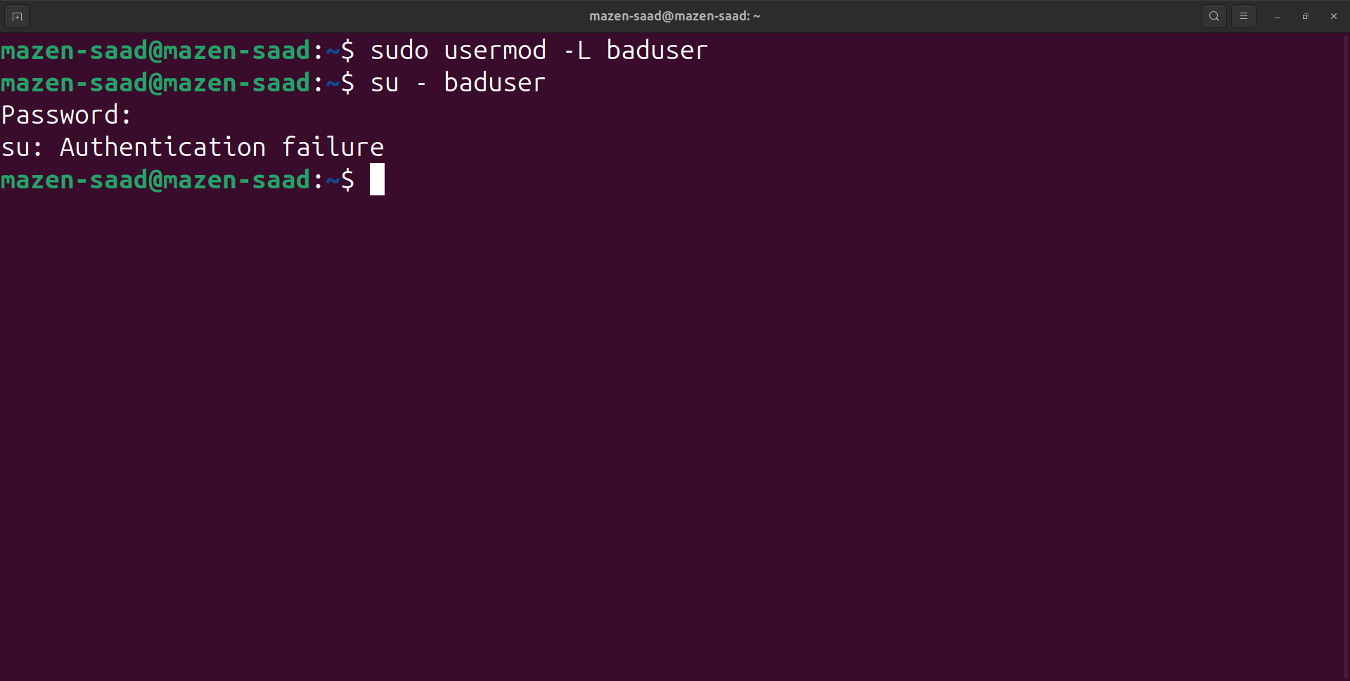

17. Delete bad user account

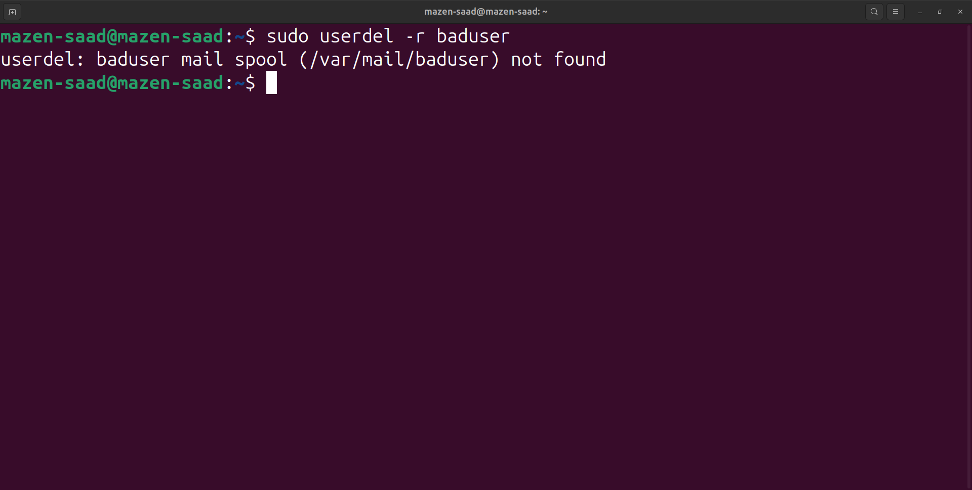

18. Delete the supplementary group called badgroup.

